Severe Thunderstorms

Instructor guidance | Content
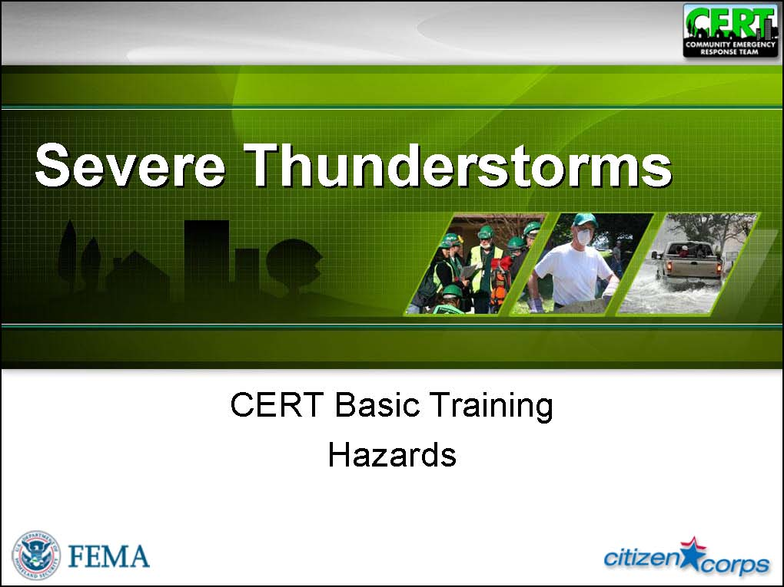  Display Slide Th-0  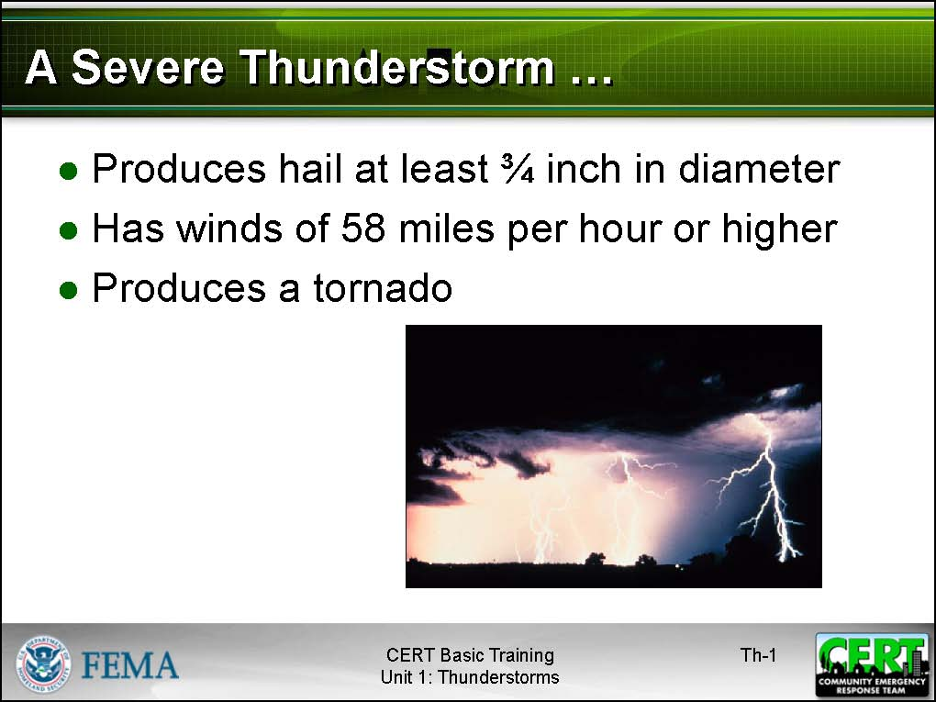  Display Slide Th-1  http://earthobservatory.nasa.gov/Newsroom/NasaNews/ReleaseImages/20050111/02_thunderstorm_night.jpg | Severe Thunderstorms  Explain that, while all thunderstorms are dangerous, the National Weather Service (NWS) defines a severe thunderstorm as one that:  - Produces hail at least three-quarters of an inch in diameter.  - Has winds of 58 miles per hour or greater.  - Produces a tornado.  Tell the group that thunderstorms may occur singly, in clusters, or in lines. Some of the most severe weather occurs when a single thunderstorm affects one location for an extended time.
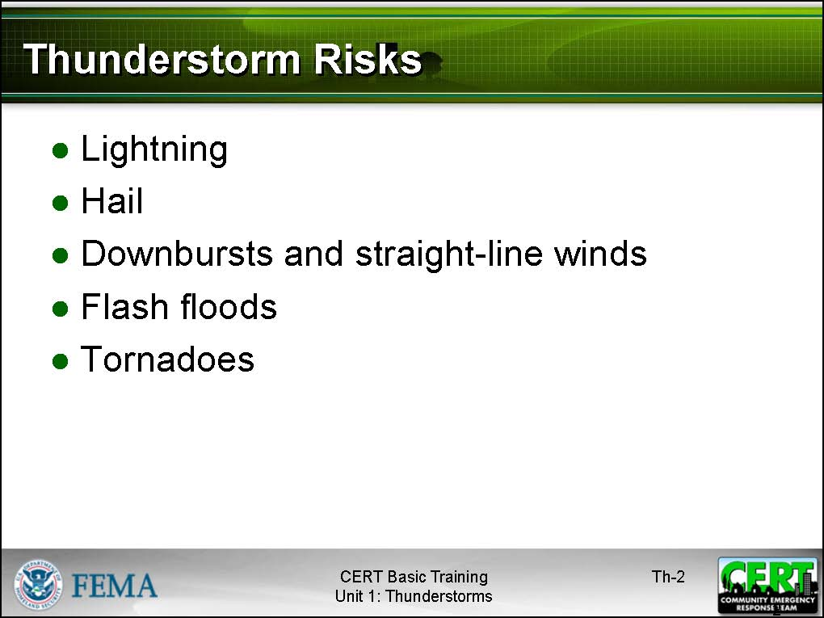  Display Slide Th-2  Lightning will be covered in more detail in a few minutes. | Explain that the risks associated with severe thunderstorms include:  - Lightning. Although most victims of lightning strikes do survive, 75 to 100 people in the United States are killed each year by lightning—more than are killed each year by tornadoes. Lightning also causes an estimated 5 billion dollars in economic losses each year in the United States.  - Hail. Hail can be smaller than a tear or as large as a softball and can cause destruction to automobiles, glass surfaces, roofs, plants, and crops. Pets and livestock are particularly vulnerable to hail.  - Downbursts and straight-line winds. Thunderstorms can produce winds as high as 150 miles per hour, strong enough to flip cars, vans, and trucks. These winds can have disastrous effects on air travel.  - Flash floods. Heavy rain from thunderstorms can cause flash flooding. Flash floods are the number one cause of death associated with thunderstorms.  - Tornadoes. Some thunderstorms may spawn tornadoes.
 | Remind the group that the National Weather Service (NWS) Storm Prediction Center issues watches and warnings of hazardous weather, including severe thunderstorms. Keep your NOAA Weather Radio handy!
Allow the participants time to respond. | What is the difference between a Severe Thunderstorm Watch and a Severe Thunderstorm Warning?
Because different communities have different warning systems, take time at this point to discuss how your community issues severe thunderstorm warnings. | Explain that:  - A watch is issued when severe thunderstorms are possible in and near the watch area. Citizens should be alert for approaching storms.  - A warning is issued when severe weather has been reported by spotters or indicated by radar. Warnings indicate imminent danger to life and property to those in the path of the storm.
Explain the NWS “30/30” lightning rule. If the time delay between seeing lightning and hearing thunder is less than 30 seconds, there is a risk of a lightning strike. Stay indoors for 30 minutes after hearing the last clap of thunder. | Lightning  Stress that lightning often strikes outside areas of heavy rain and can occur as far as 10 miles away from any rainfall.  Emphasize that the participants are in danger from lightning if they can hear thunder. In fact, more than 50 percent of lightning deaths occur after the thunderstorm has passed.
Allow the participants time to respond. | How can you prepare for severe thunderstorms?
 | Stress that there is a need to prepare for severe thunderstorms and there are steps that they can take.
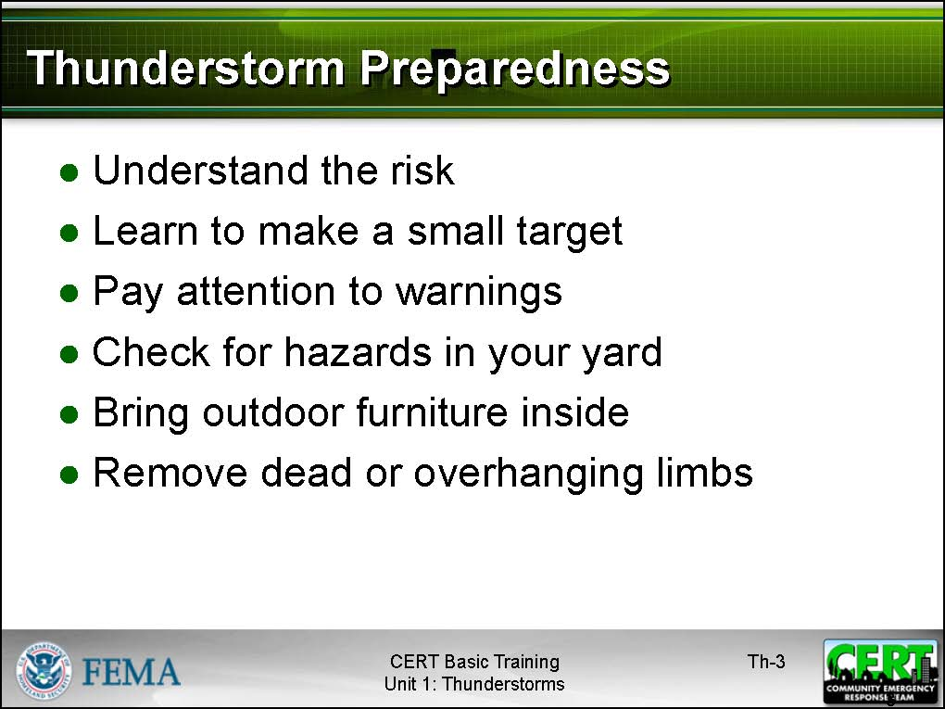  Display Slide Th-3 | Emphasize key steps in thunderstorm preparedness:  - Understand the risk. Severe thunderstorms can occur year-round and at any hour. Take time to learn about the severe thunderstorm risk in your area—including whether and how often severe thunderstorms are accompanied by tornadoes.  - Learn to make a small target. Practice squatting low to the ground, making the smallest target possible while minimizing contact with the ground.  - Pay attention to warnings. Use a NOAA Weather Radio with a tone-alert feature or listen to local radio or television for Emergency Alert System (EAS) broadcasts. Learn the community’s warning system and never ignore warnings.
Suggest that participants also take measures to protect their property, including those measures that are required for high wind:
- Check for hazards in your yard. Be aware of potential lightening rods – swing sets, trees, etc.
- Bring outdoor furniture inside or otherwise secure it to keep it from blowing. Small objects can become deadly projectiles in a high wind.
 | - Remove dead or overhanging limbs from trees and shrubbery. Strategically remove branches to allow the wind to pass through. Strong winds can break weak limbs and carry them at high speed, causing damage to property or injury to humans and animals. And lightening can and will strike the weakest part of a tree.
 | If the community is at high risk for severe thunderstorms, or if sections of the community are particularly vulnerable, suggest that participants living in those areas purchase and install lightning rods. Lightning detectors can also help protect you.
Allow the participants time to respond. | What should you avoid during a severe thunderstorm?
 | Summarize the discussion using the information from the slide.
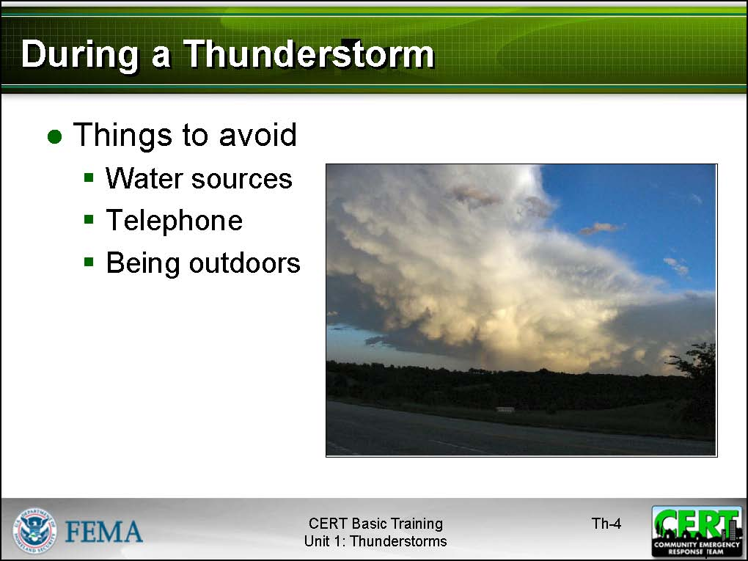  Display Slide Th-4  www.crh.noaa.gov/.../thunderstorm2.jpg | Be sure to stress that, during a thunderstorm, the participants should avoid:  - Water sources. If boating or swimming, get to land immediately. Stay away from bodies of water and wet sand. If indoors, stay away from running water. Electricity from lightning can travel through plumbing.  - The telephone. Electricity from lightning can also travel through phone lines. Note that cell phones are considered safe to use indoors, though there is some risk when used outdoors during a storm.  - The outdoors. A sturdy building is the safest place to be during a severe thunderstorm. Avoid unprotected areas and unprotected shelters in open areas.  Suggest that participants turn off air conditioning and appliances. Electricity from lightning can enter a room through appliances. Also, turning off and unplugging appliances can eliminate the risk of damage from surges that accompany lightning strikes in close proximity to the home.
Allow the participants time to respond. | What should you do if you get caught outside during a severe thunderstorm?
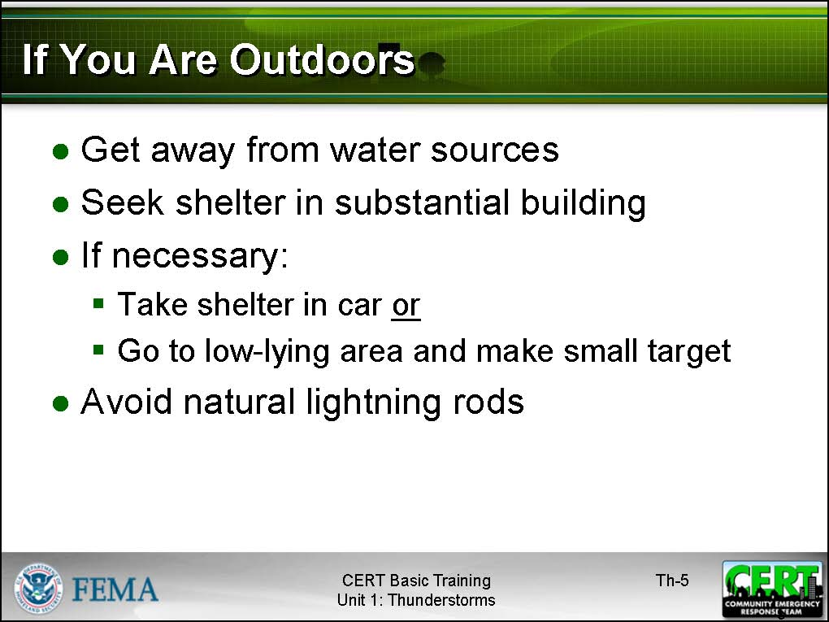  Display Slide Th-5 | Summarize the discussion by making the points shown in the slide.  Reinforce that, if caught outdoors in a severe thunderstorm, the participants should:  - Avoid water sources. Get out of pools or lakes. Get off the beach.  - Seek shelter in a substantial, permanent, enclosed structure. Avoid unprotected shelters, such as golf carts and baseball dugouts. Remember that isolated shelters in otherwise open areas are a target for lightning. Temporary shelters, such as gazebos, are subject to being blown in a strong wind and offer little protection from hail.  - If there are no permanent shelters within reach, take shelter in a car. Keep all windows closed and do not touch anything that is metal. If in the woods, find an area that is protected by low trees (not a single tall tree in the open). As a last resort, go to a low-lying area, away from trees, poles, and metal objects. (Avoid areas that are subject to flooding.) Squat low to the ground, and place your hands on your knees with your head between them. Make as small a target as possible. Do not lie flat on the ground.  - Avoid natural lightning rods, such as golf clubs, tractors, fishing rods, and camping equipment. Lightning is attracted to all of these items.
Allow the participants time to respond. | What should you do if you’re driving in a severe thunderstorm?
Be sure to include the following points in the discussion:
- Pulling safely to the side of the road, keeping a good distance from trees or other tall objects that could fall on the vehicle, and ensuring that the emergency flashers are on.
- Avoiding contact with metal surfaces inside the vehicle.
- Avoiding flooded roadways. Most flood fatalities are caused by people attempting to drive through high water. The depth of water is not always obvious. The roadbed may be washed out or rapidly rising water could stall the engine or engulf the vehicle.
Allow the participants time to respond. | What should you be careful with following a thunderstorm?
Be sure to cover the points below in the discussion:
- Listen to EAS for updated information. Some areas may be inaccessible and there may be damage in others. Local EAS broadcasts will provide current information on continuing risks and protective measures to take.
- Avoid storm-damaged areas. These areas are not safe immediately following a severe thunderstorm. Entry may increase personal risk and interfere with professional responders.
- Watch for fallen power lines and trees, and report them immediately.
 | Does anyone have additional questions, comments, or concerns about severe thunderstorms?

