Unit 7: Disaster Psychology

In this unit you will learn about:

- Disaster Psychology: The psychological impact of a disaster on rescuers and victims and how to provide “psychological first aid.”
- Caring for Yourself, Your Buddy, and Victims: Steps one can take individually and as part of a CERT before, immediately following, and after a disaster.

[This page intentionally left blank]

Objectives | At the conclusion of this unit, the participants should be able to:  - Describe the disaster and post-disaster emotional environment for victims and rescuers.  - Describe the steps that rescuers can take to relieve their own stress and that of other disaster survivors.
Scope | The topics that will be discussed in this unit are:  - Introduction and Unit Overview  - Disaster Trauma  - Team Well-Being  - Working with Survivors’ Trauma  - Unit Summary
Estimated Completion Time | 45 minutes (This time does not include the video.)  Please note that the estimated time depends on how much of the video you choose to show the participants. You may show as little or as much of the video as you think is appropriate. If you use the video in its entirety, the lesson will run approximately 1 hour and 15 minutes. Please note that the video should not be used in place of teaching the unit.
Training Methods | The lead instructor will begin this unit by welcoming the participants to Unit 7: Disaster Psychology, and will introduce the instructors for the session. The instructor will then present a brief overview of this session.  Next, the instructor will explain the importance of having an understanding of the disaster and post-disaster emotional environment and the impact that the emotional crisis may have on CERT members as well as victims. The instructor will present the psychological and physiological symptoms that victims and rescue personnel may exhibit and provide some suggestions for how CERT members can help survivors cope with disaster trauma and control their own stress.
Resources Required | - Community Emergency Response Team Instructor Guide  - Community Emergency Response Team Participant Manual  - Visuals 7-0 through 7-21
Other Resources |  | If time permits, all or portions of the 43-minute video CERT Training: Disaster Psychology are recommended for this unit. The video describes the physical, emotional, and psychological reactions to a disaster and techniques for CERT members to take care of themselves and assist others in coping with the stress. The video is available for download at the national CERT Web site: www.citizencorps.gov/cert/.
Equipment |  | The following equipment is required for this unit:  - A computer with PowerPoint software  - Computer projector and screen
Preparation |  | Working with a representative of the community in which you will be teaching, identify any potentially culturally sensitive topics in this module. Develop strategies for presenting any such topics in ways that will be engaging and appropriate for participants.  It is particularly important in this unit to be aware of how your target audience may feel about topics such as trauma or coping with stressors. Encourage participants to discuss ways that people within their community may cope with psychological trauma. Avoid forcing your own coping mechanisms onto others.  In particular, look closely at the topic on What Not to Say. Make specific note of phrases that might be culturally inappropriate to the target audience. In the topic, Managing a Death Scene, ensure that you understand culturally appropriate ways of dealing with death. Treat this topic with reverence and respect participants’ cultural backgrounds.

Notes | A suggested time plan for this unit is as follows:  Introduction and Unit Overview 5 minutes  Disaster Trauma 5 minutes  Team Well-Being 10 minutes  Working with Survivors’ Trauma 20 minutes  Unit Summary 5 minutes  Total Time: 45 minutes
Acknowledgement | The information from this unit has been provided by Victor Welzant, Psy.D. and George Everly, Jr., Ph.D. of the International Critical Incident Stress Foundation; and Joanne Tortorici Luna, Ph.D., California State University, Long Beach, and Culver City, California, CERT. The Federal Emergency Management Agency wishes to thank them for their assistance.

Unit 7: Disaster Psychology

Instructor guidance | Content
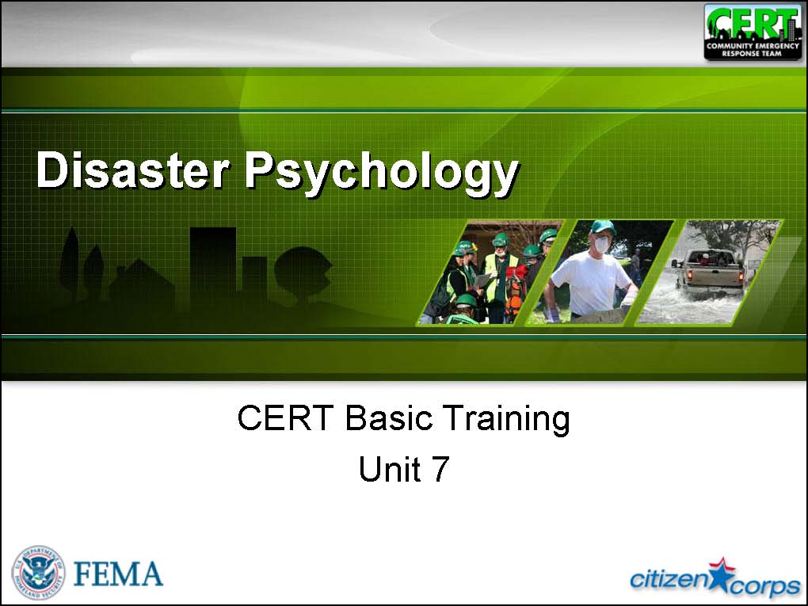  Display Slide 7-0 | Introductions and Unit Overview  Welcome  Introduce the instructors for this unit.  Ask any new instructors to briefly describe their experience with disaster psychology.
 | Briefly review Unit 6: CERT Organization.
Correct response:  The Incident Command System (ICS) | The CERT organization is based on a proven management system used by emergency responders. What is it called?
Correct response:  - The first person to arrive on the scene  - Establishes the basic ICS structure for the incident | Who becomes the CERT Incident Commander/Team Leader (IC/TL)?  What does that person do?
Correct response:  The Command Post | What is the place called where the IC/TL stays?
Correct response:  “Is it safe for CERT members to attempt the rescue?” | What is the key question that CERT Incident Commanders/Team Leaders must always ask?
Correct response:  - Damage assessment  - Status of personnel resources  - Communications between command levels and groups  - Incident status  - Victim treatment provided | Documentation is an essential part of the CERT’s job. What kinds of information should a CERT document?
Correct response:  The IC/TL | Who handles media inquiries?
 | Explain that CERT members might see and hear things during a disaster that are unpleasant and uncomfortable.
Discuss the participants’ responses. Probe for both physical and emotional situations. | Has anyone ever been involved in a large-scale emergency or disaster?  How were you impacted?
 | Stress the need for CERT members to prepare themselves for their role during and following a disaster by learning about the possible impact of disasters on them and others, emotionally and physically. This knowledge will help CERT members understand and manage their reactions to the event and to work better with others.
 | Remind the group that they recently learned about team organization. Point out that team organization concepts can help them both operationally and psychologically. Working together and looking out for each other are important aspects of successful teams.
 | Tell the group that this unit will address basic techniques for providing psychological first aid and “field expedient” trauma intervention.
 | Stress that psychological first aid is not therapy; rather, it is a set of techniques to provide emotional intervention during field operations. The techniques to be covered in this unit will help manage one’s personal situation so that the needs of all survivors, including victims and CERT members, can be met.
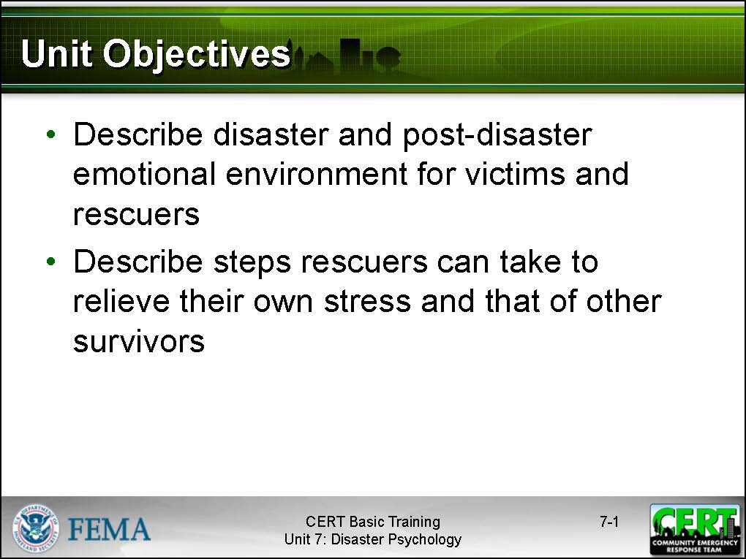  Display Slide 7-1 | Unit Objectives  Tell the participants that at the end of this unit, they should be able to:  - Describe the disaster and post-disaster emotional environment for victims and rescuers.  - Describe the steps that rescuers can take to relieve their own stress and that of other disaster survivors.
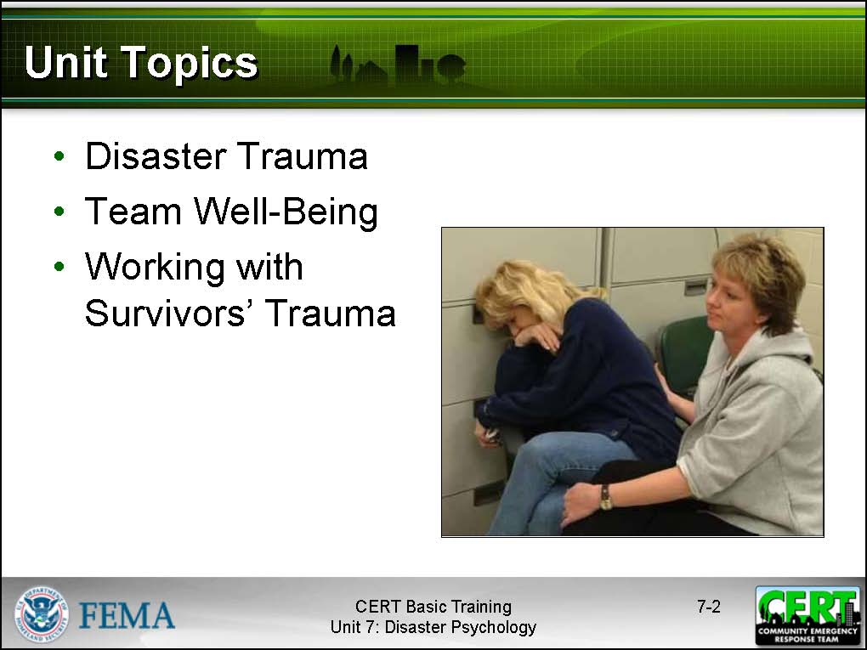  Display Slide 7-2 | Unit Topics  Preview the unit topics by telling the group that the unit will provide them with an understanding of the following components of psychological first aid:  - Disaster Trauma  - Team Well-being  - Working with Survivors’ Trauma
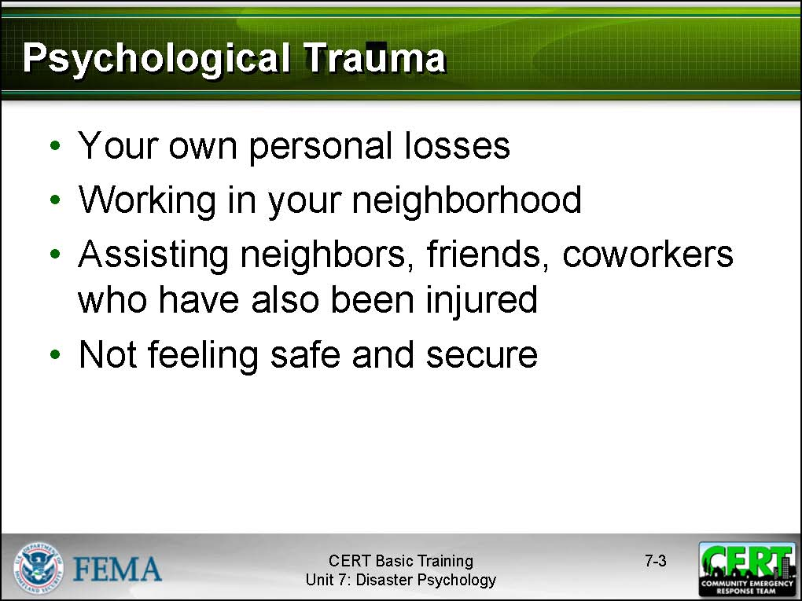  Display Slide 7-3 | Disaster Trauma  Introduce this section by telling the participants that, during a disaster, they may see and hear things that will be extremely unpleasant.  Direct psychological trauma could result from:  - Your own personal losses  - Working in your neighborhood  - Assisting neighbors, friends, coworkers who have been injured  - Not feeling safe and secure
 | Explain that vicarious trauma, which is also referred to as compassion fatigue or secondary victimization, is a natural reaction to exposure to a survivor’s trauma. A person who identifies too strongly with a survivor may take on that survivor’s feelings. Explain that vicarious trauma is an “occupational hazard” for helpers.
 | Warn the participants against over-identifying with the survivors. Caution them against taking on the survivors’ feelings as their own as it can affect their ability to do their job as rescuers and can also have longer term impact. Advise the group members that taking ownership of others’ problems will compound their own stress and impact the CERT’s overall effectiveness.
 | Explain that CERT members need to be alert to signs of disaster trauma in themselves, as well as in disaster victims and other survivors, so that they can take steps to alleviate stress.
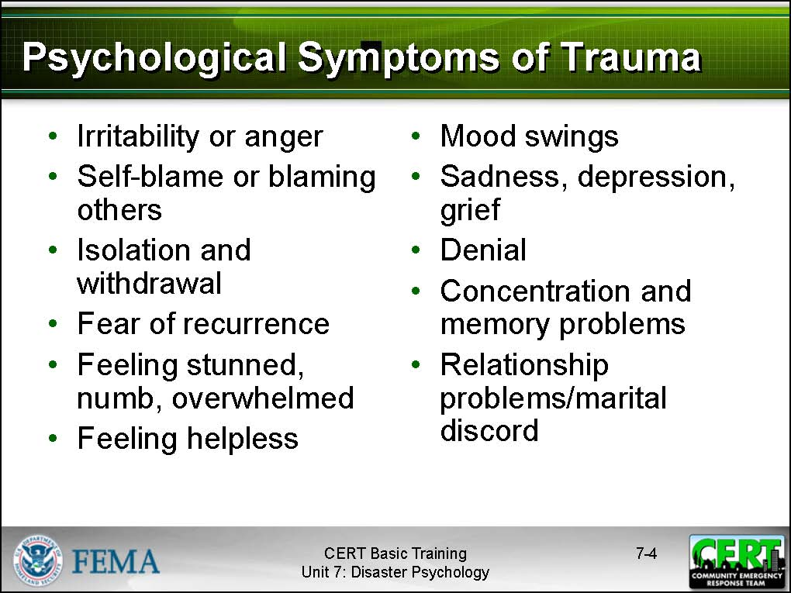  Display Slide 7-4 | Possible Psychological Symptoms  Give examples of the types of disaster-related psychological and physiological responses that you may experience or observe others experiencing.  - Irritability or anger  - Self-blame or the blaming of others  - Isolation and withdrawal  - Fear of recurrence  - Feeling stunned, numb, or overwhelmed  - Feeling helpless  - Mood swings  - Sadness, depression, and grief  - Denial  - Concentration and memory problems  - Relationship conflicts/marital discord
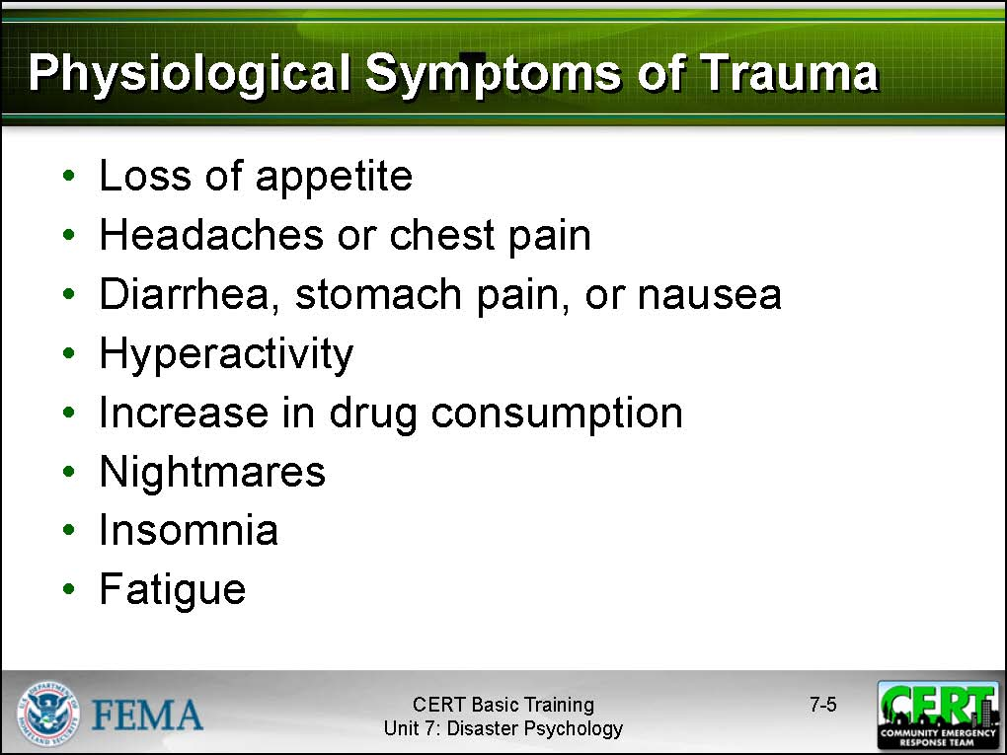  Display Slide 7-5 | Possible Physical Symptoms  - Loss of appetite  - Headaches or chest pain  - Diarrhea, stomach pain, or nausea  - Hyperactivity  - Increase in alcohol or drug consumption  - Nightmares  - The inability to sleep  - Fatigue or low energy
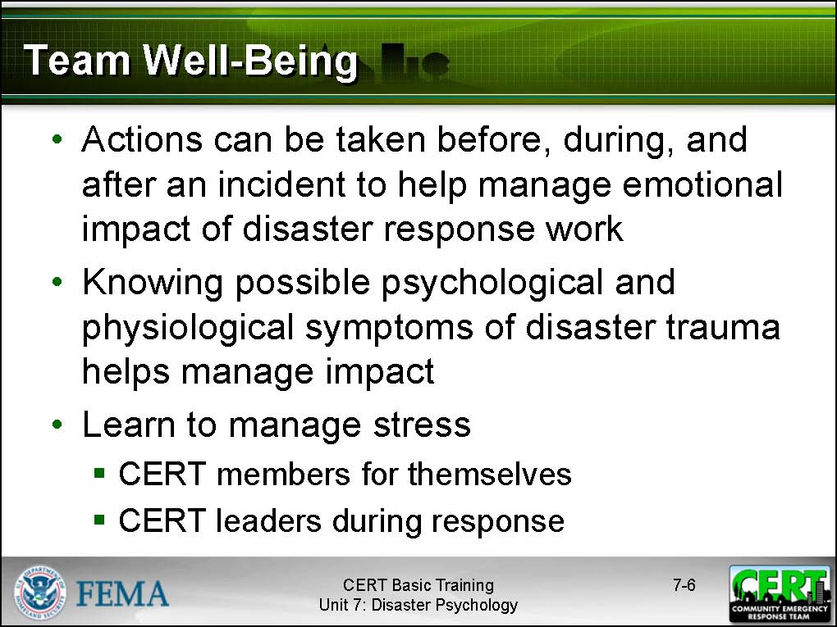  Display Slide 7-6 | Team Well-Being  Introduce team well-being by explaining that there is a range of actions that can be taken before, during, and after an incident to help manage the emotional impact of disaster response work.  Explain that knowing in advance the possible psychological and physiological symptoms of disaster trauma that were just covered in this unit is one step in managing the impact.  Some other aspects of stress management for CERT responders include actions that CERT members can take for themselves and actions that CERT leaders can take during a response.
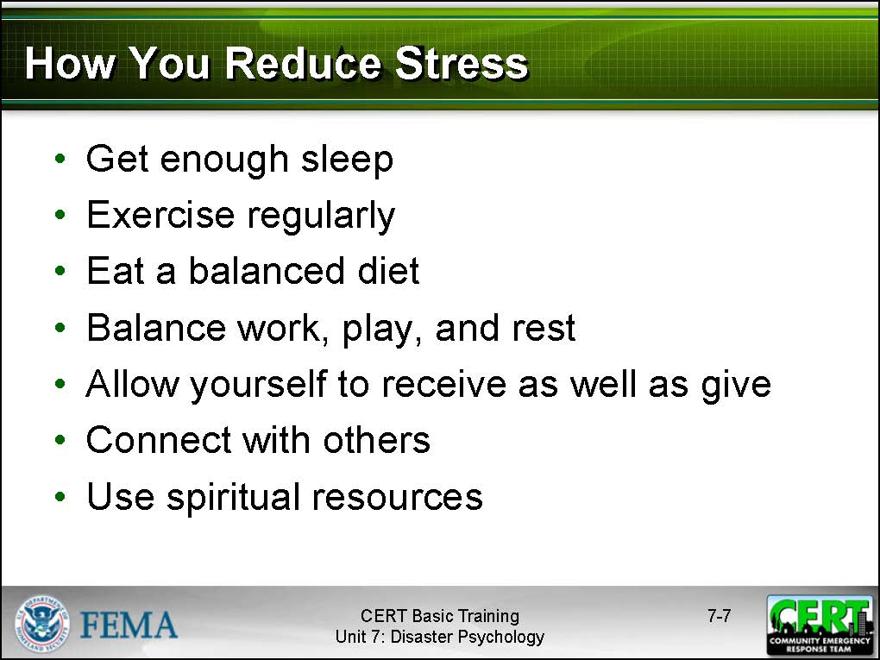  Display Slide 7-7 | How You Reduce Stress  Remind the participant that they should spend some time thinking about other ways to reduce stress personally.  Emphasize that only they know what makes them able to reduce stress within themselves and that expending the effort required to find personal stress reducers is worthwhile before an incident occurs.  Remind the participants that they can take the following preventive steps in their everyday lives:  - Get enough sleep.  - Exercise regularly.  - Eat a balanced diet.  - Balance work, play, and rest.  - Allow themselves to receive as well as give; they should remember that their identity is broader than that of a helper.  - Connect with others.  - Use spiritual resources.
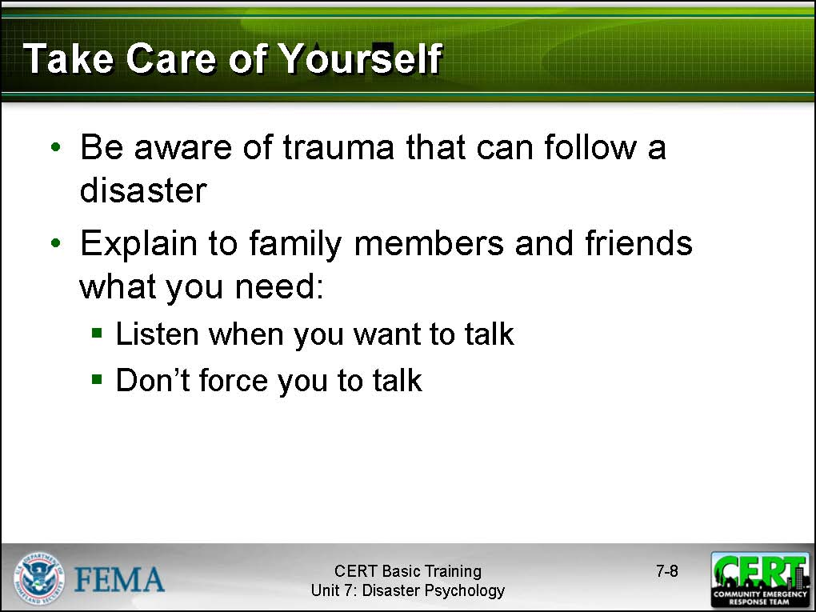  Display Slide 7-8 | Explain that, in addition to preventive steps, participants should also be aware of trauma that can follow a disaster. They should explain to their family members and friends how to support them when they return from a disaster area. Family and friends should:  - Listen when you want to talk.  - Don’t force you to talk if you don’t want to.  Participants might also want to share with their loved ones and friends the information on possible disaster-related psychological and physiological symptoms that were discussed earlier in the unit.
 | Point out that experienced rescue workers find these steps helpful in controlling their stress levels, but that, in some cases, it might be necessary to seek help from mental health professionals.
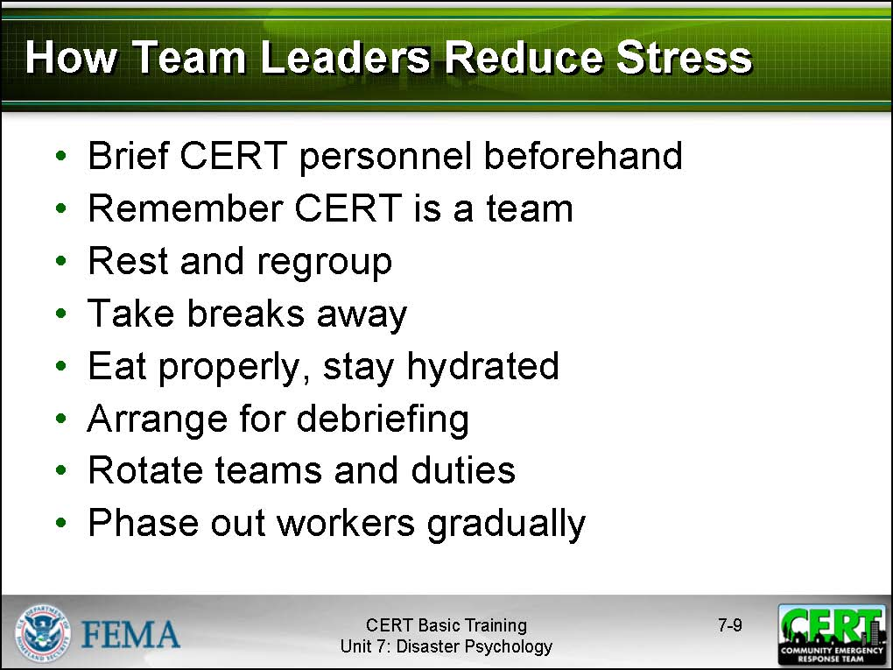  Display Slide 7-9 | How Team Leaders Reduce Stress During the Incident  Explain that there are steps that CERT leaders can take to reduce the stress on rescue workers before, during, and after an incident:  - Brief CERT personnel before the effort begins on what they can expect to see and what they can expect in terms of emotional response in the survivors and themselves.  - Emphasize that the CERT is a team. Sharing the workload and emotional load can help defuse pent-up emotions.  - Encourage rescuers to rest and regroup so that they can avoid becoming overtired.  - Direct rescuers to take breaks away from the incident area, to get relief from the stressors of the effort.
 | - Encourage rescuers to eat properly and maintain fluid intake throughout the operation. Explain that they should drink water or other electrolyte-replacing fluids and avoid drinks with caffeine or refined sugar.
This will be discussed in more detail later in the unit. | - Arrange for a debriefing 1 to 3 days after the event in which workers describe what they encountered and express their feelings about it in a more indepth way.
 | - Rotate teams for breaks or new duties (i.e., from high-stress to low-stress jobs). Encourage team members to talk with each other about their experiences. This is very important for their psychological health.
 | - Phase out workers gradually. Gradually phase them from high- to low-stress areas of the incident. For example, do not stand down and send home a team member that has just completed a high-stress operation; instead, assign them a low-stress responsibility so they can decompress gradually.
 | - Conduct a brief discussion (defusing) with rescue workers after their shift during which they can describe what they encountered and express their feelings about it.
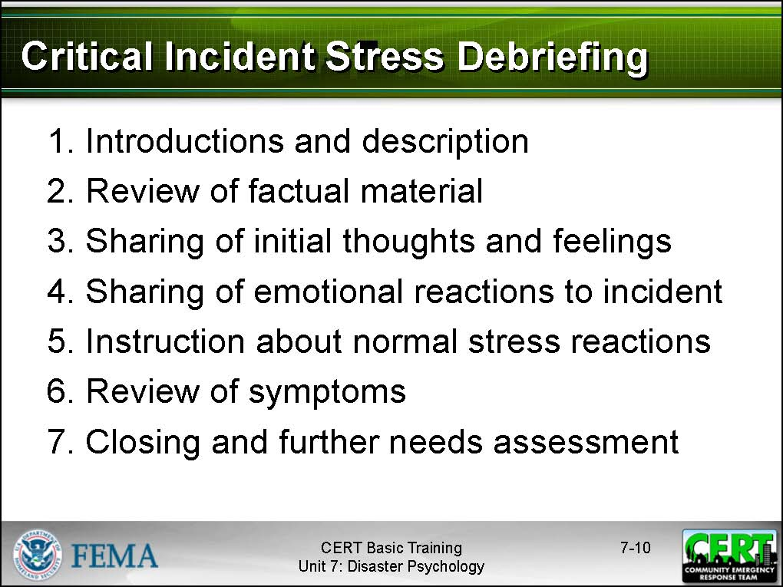  Display Slide 7-10 | Critical Incident Stress Debriefing (CISD)  Point out that a critical incident stress debriefing or CISD is one type of intervention that may be helpful for a CERT. CISD is one of several components of critical incident stress management (CISM).
CERT leaders may invite a mental health professional trained in critical incident stress management (CISM) to conduct a critical incident stress debriefing (CISD). CISM is a short term healing process that focuses on helping people deal with their trauma one incident at a time. It is intended to lessen the chance of someone experiencing post-traumatic stress disorder and get them back to their daily lives as quickly as possible.
Explain that a CISD is a formal group process held between 1 to 3 days after the event. It is designed to help emergency services personnel and volunteers cope with a traumatic event.
Explain that CISD would not be used as a stand-alone intervention but would be used in conjunction with other types of intervention, such as defusing, debriefing, and following up with the individual.
Explain that a CISD has seven phases:
- Introductions and a description of the process, including assurance of confidentiality
- Review of the factual material about the incident
- Sharing of initial thoughts and feelings about the incident
- Sharing of emotional reactions to the incident
- Review of the symptoms of stress experienced by the participants
- Instruction about normal stress reactions
- Closing and further needs assessment
Emphasize that participation in a CISD should be voluntary.
Say that, as the CERT program sponsor, an agency may assist in arranging CISD services for the CERTs. If so, explain how participants should access those services.
If a CISD is unavailable in the agency, suggest that participants contact the Red Cross or a community mental health agency to schedule a CISD.
Emphasize that, while it may be beneficial, pastoral counseling is not a substitute for disaster counseling from a professional.
 | Explain that the next section will deal with how to handle survivors’ trauma.
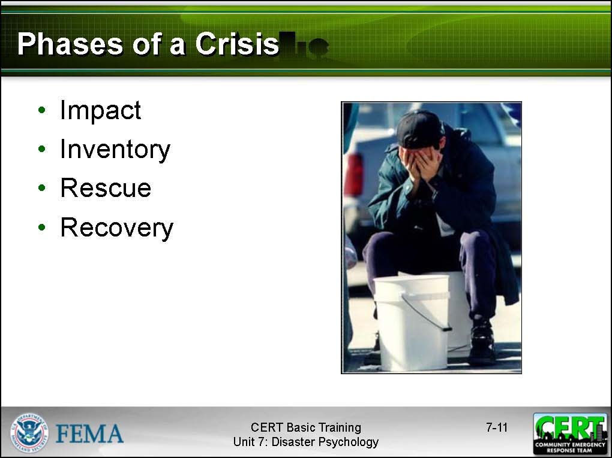  Display Slide 7-11 | Working with Survivors’ Trauma  Identify the emotional phases of a crisis survivors go through and whom and what rescuers might encounter at each phase.  - In the impact phase, survivors generally do not panic and may, in fact, show no emotion.  - In the inventory phase, which immediately follows the event, survivors assess damage and try to locate other survivors. During this phase, routine social ties tend to be discarded in favor of the more functional relationships required for initial response activities (e.g., search and rescue).  - In the rescue phase, as emergency services personnel (including CERTs) respond, survivors are willing to take direction from these groups without protest. This is why CERT identification (helmets, vests, etc.) is important.  Survivors are likely to be very helpful and compliant during the rescue phase.
- In the recovery phase, the survivors appear to pull together against their rescuers, the emergency services personnel.
- Survivors may express anger or blame to the rescuers as they transition to the recovery phase.
 | Tell the participants that they should expect that survivors will show psychological effects from the disaster — and that they should expect that some of the reaction will be directed toward them.
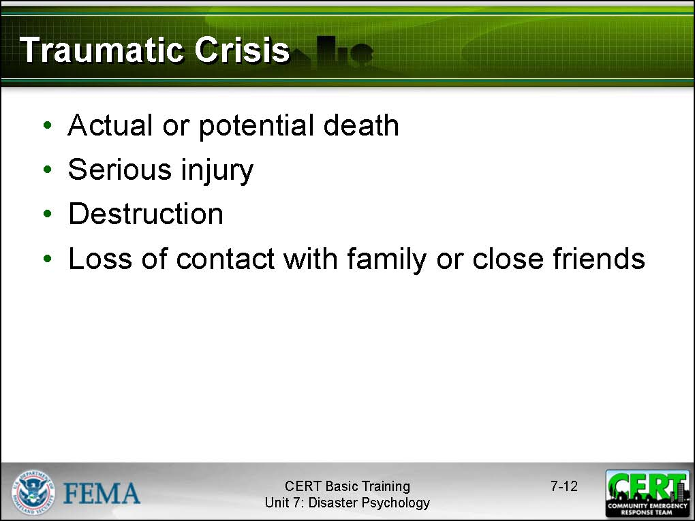  Display Slide 7-12 | Traumatic Crisis  Introduce this section by defining a crisis as an event that is experienced or witnessed in which people’s ability to cope is overwhelmed:  - Actual or potential death or injury to self or others  - Serious injury  - Destruction of their homes, neighborhood, or valued possessions  - Loss of contact with family members or close friends
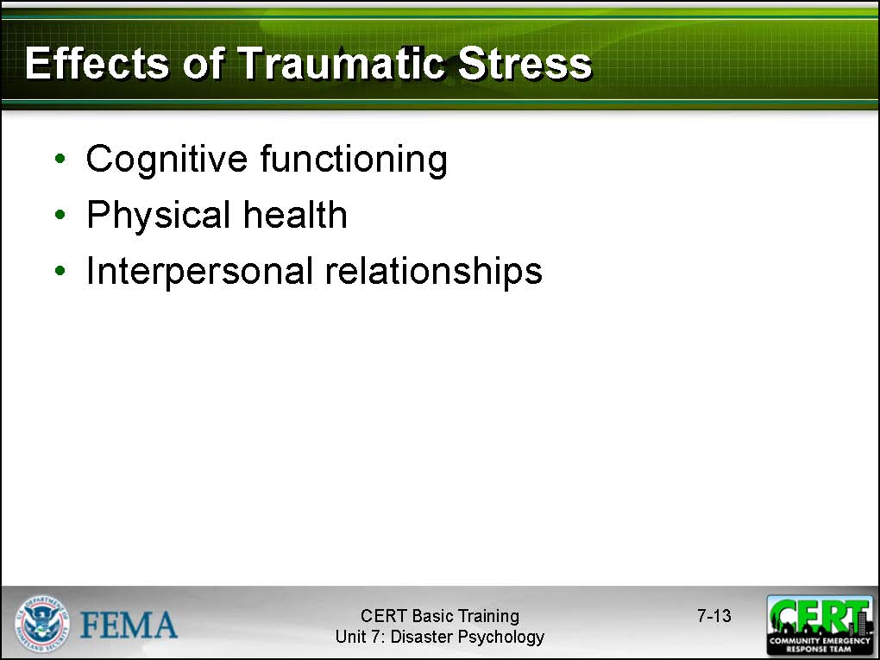  Display Slide 7-13 | Traumatic stress may affect:  - Cognitive functioning. Those who have suffered traumatic stress may act irrationally, in ways that are out of character for them, and have difficulty making decisions. They may have difficulty sharing or retrieving memories.  - Physical health. Traumatic stress can cause a range of physical symptoms — from exhaustion to health problems.  - Interpersonal relationships. Those who survive traumatic stress may undergo temporary or long-term personality changes that make interpersonal relationships difficult.
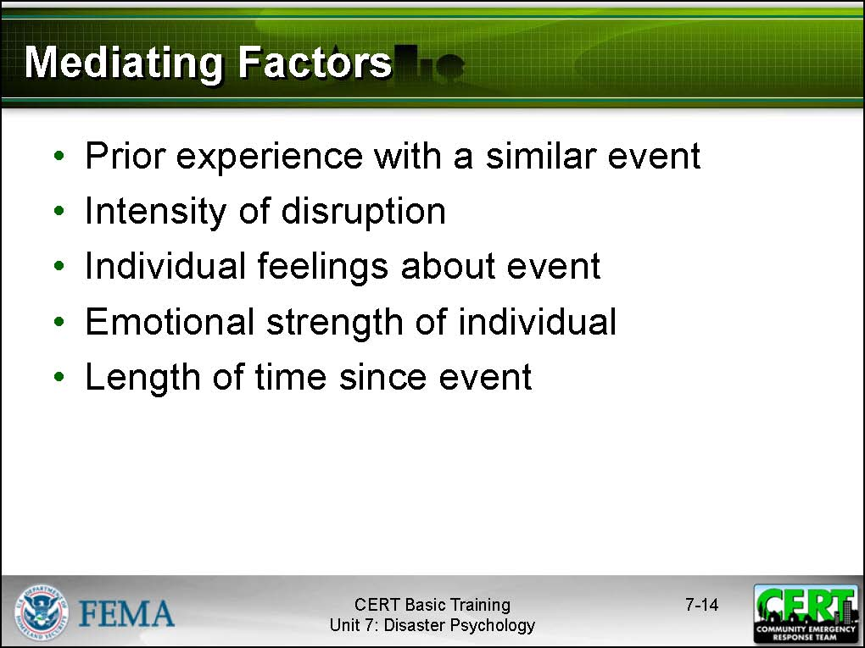  Display Slide 7-14 | Mediating Factors  Explain that the strength and type of personal reaction to trauma vary depending on:  - The person’s prior experience with the same or a similar event; the emotional effect of multiple events can be cumulative, leading to greater stress reactions.  - The intensity of the disruption in the survivors’ lives; the more the survivors’ lives are disrupted, the greater their psychological and physiological reactions may become.  - The meaning of the event to the individual; the more catastrophic the victim perceives the event to be to him or her personally, the more intense his or her stress reaction will be.  - The emotional well-being of the individual and the resources (especially social) that he or she has to cope; people who have had other recent traumas may not cope with additional stresses.  - The length of time that has elapsed between the event’s occurrence and the present; the reality of the event takes time to “sink in.”  CERT members can’t know — and should never assume to know — what someone is thinking or feeling. Keep the phases in mind.
 | Caution the group, however, that they should not take the survivors’ surface attitudes personally. Rescuers may expect to see a range of responses that will vary from person to person, but the responses they see will be part of the psychological impact of the event — and probably will not relate to anything that the CERTs have or have not done.
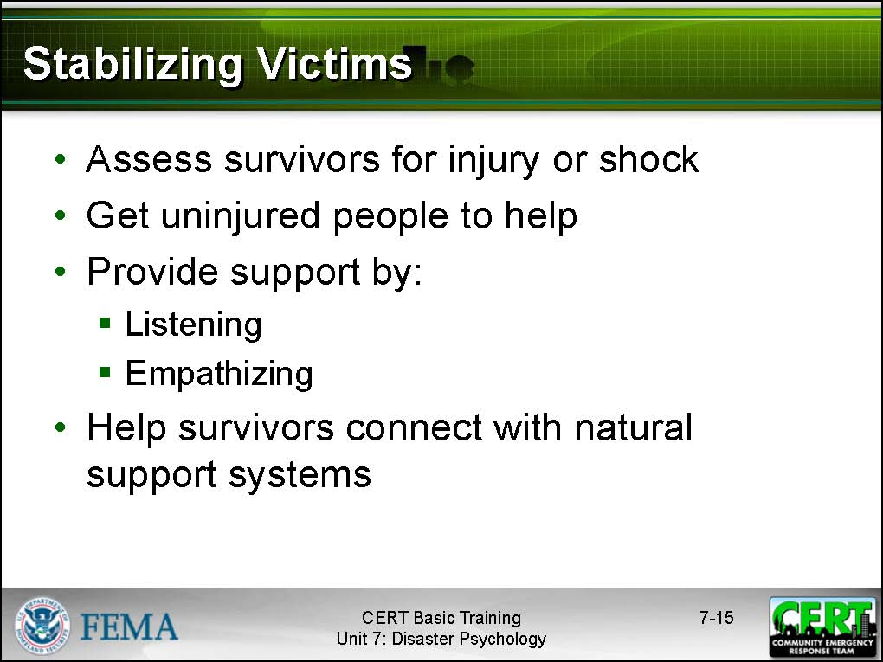  Display Slide 7-15 | Stabilizing Victims  Explain that the goal of onscene psychological intervention on the part of CERT members should be to stabilize the incident scene by stabilizing individuals. While any medical needs must be addressed first, you can provide psychological intervention. Suggest that they do this in the following ways:  - Observe individuals to determine their level of responsiveness and whether they pose a danger to themselves or to others.  - Get uninjured people involved in helping. Engaging survivors in focused activity helps them cope, so give them constructive jobs to do such as organizing supplies. This strategy is especially effective for survivors who are being disruptive.
- Help survivors connect to natural support systems, such as family, friends, or clergy.
- Provide support by:
- Listening to them talk about their feelings and their physical needs. Victims often need to talk about what they’ve been through — and they want someone to listen to them.
- Empathizing. Caring responses show victims that someone else shares their feelings of pain and grief.
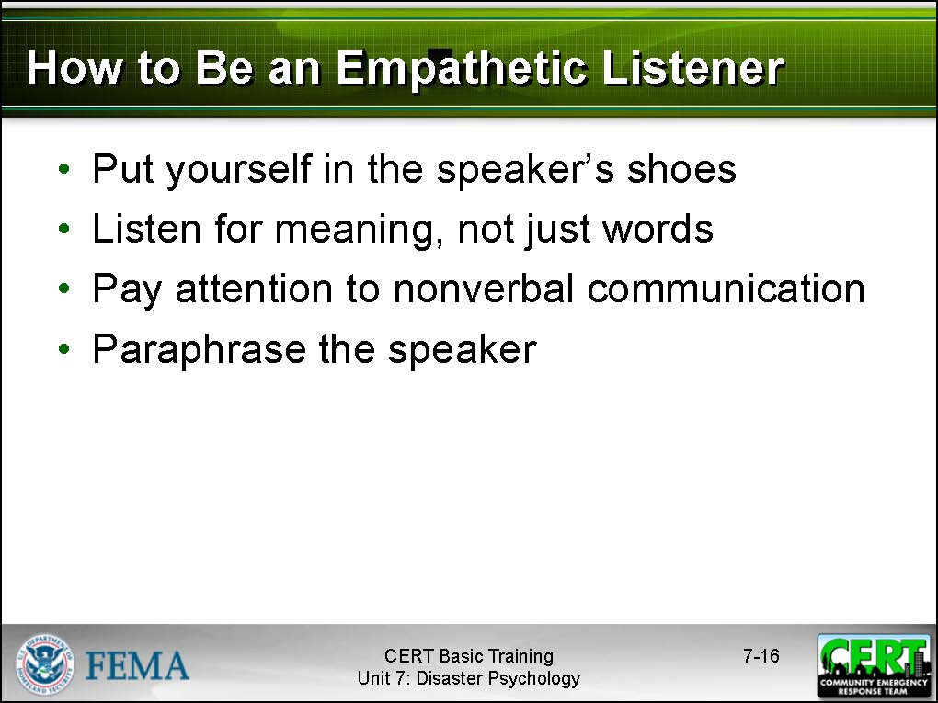  Display Slide 7-16 | Being an Empathetic Listener  Explain that being an empathetic listener requires the listener to listen and let the victim talk. Good listeners will:  - Put him- or herself in the speaker’s shoes in order to better understand the speaker’s point of view. Draw upon past experiences, or try to imagine how the speaker is feeling. In order to limit the effects of vicarious trauma, be careful not to completely take on the speaker’s feelings.  - Listen for meaning, not just words, and pay close attention to the speaker’s nonverbal communication, such as body language, facial expressions, and tone of voice.  - Paraphrase the speaker periodically to make sure that he or she has fully understood what the speaker has said and to indicate to the speaker that he or she is listening. This reinforces the communication process.
 | Stress that survivors that show evidence of being suicidal, psychotic, or unable to care for themselves should be referred to mental health professionals for support. (This will be infrequent in most groups of survivors.)
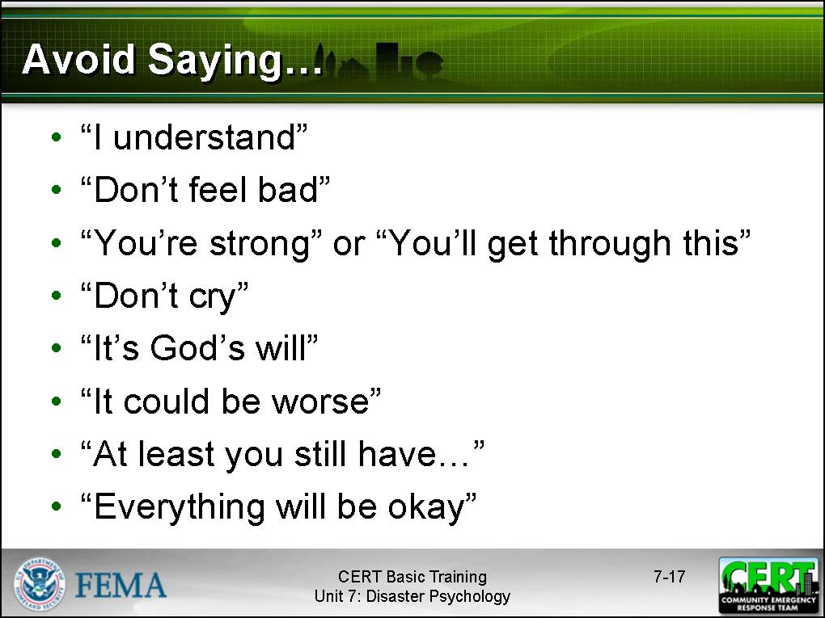  Display Slide 7-17 | What Not to Say  Tell the participants that, when providing support, they should avoid saying the following phrases. On the surface, these phrases are meant to comfort the survivors, but they can be misinterpreted.  - “I understand.” In most situations we cannot understand unless we have had the same experience.  - “Don’t feel bad.” The survivor has a right to feel bad and will need time to feel differently.  - “You’re strong” or “You’ll get through this.” Many survivors do not feel strong and question if they will recover from the loss.  - “Don’t cry.” It is okay to cry.  - “It’s God’s will.” With a person you do not know, giving religious meaning to an event may insult or anger the person.  - “It could be worse,” “At least you still have …”, or “Everything will be okay.” It is up to the individual to decide whether things could be worse or if everything can be okay.  Emphasize that these types of responses, rather than provide comfort, could elicit a strong negative response or distance the survivor from the listener.  Point out that it is okay to apologize if the survivor reacts negatively to something that was said.
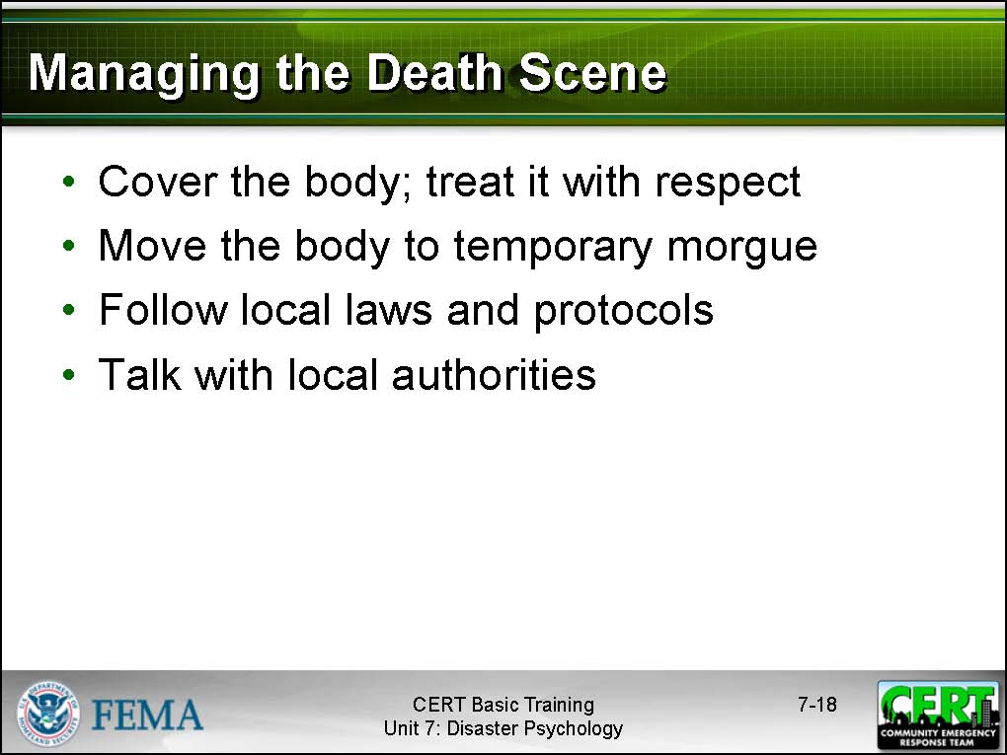  Display Slide 7-18 | Managing the Death Scene  Explain that one unpleasant task that CERT members may face is dealing with a victim who dies while under the team’s care. The guidelines below (T.W. Dietz, 2001; J.M. Tortorici Luna, 2002) are for dealing with this situation:  - Cover the body; treat it with respect. Wrap mutilated bodies tightly.  - If the person has died while at the treatment area, move the body to your team’s temporary morgue. (If the person was tagged as “dead” during triage, do not remove from the incident area.)  - Follow local laws and protocols for handling the deceased.  - Talk with local authorities to determine the plan.
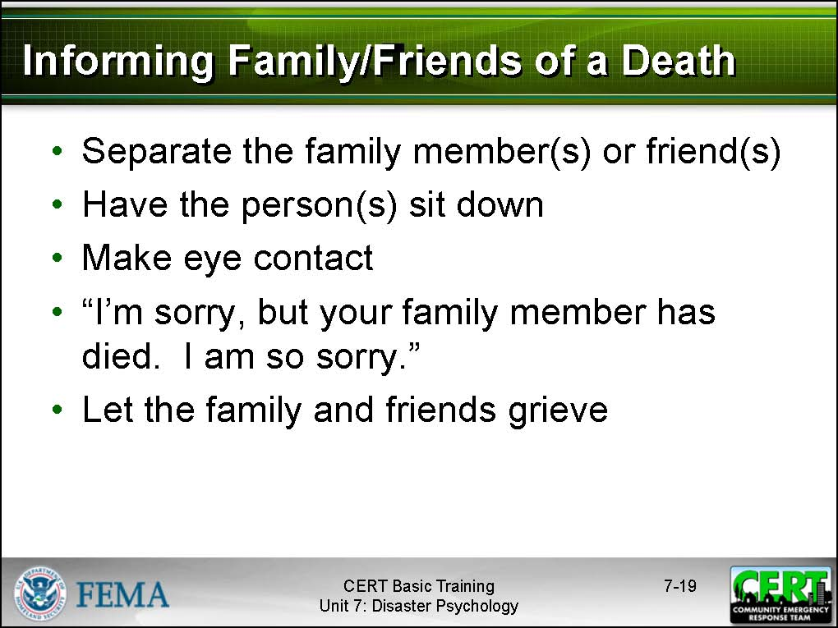  Display Slide 7-19 | Informing the Family and Friends of a Death  In some cases, family members or friends may not know of the death of their loved one, and CERT members may have to tell them. Suggest that, in this situation, CERT members should:  - Separate the family members and friends from others in a quiet, private place.  - Have the person(s) sit down, if possible.  - Make eye contact and use a calm, kind voice.  - Use the following words to tell the family members and friends about the death: “I’m sorry, but your family member has died. I am so sorry.” It is okay to reference the deceased person’s name or their relation to the survivor if you know it.  - Let the family and friends grieve.
 | Does anyone have any questions about the types of emotional and physiological responses that they can expect to see during and following a disaster?
After answering all of the participants’ questions, pose some “What would you do if …” questions to ensure that they understand the concepts of this section.
For example, ask the participants, “What would you do if you were attempting to rescue a victim and the victim became hysterical?”
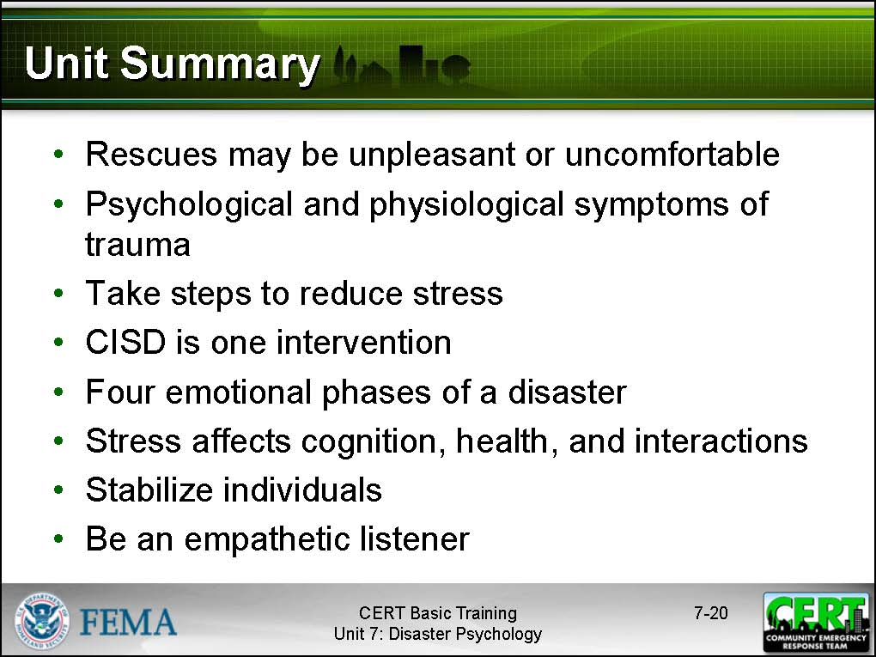  Display Slide 7-20 | Unit Summary  - During a disaster, rescuers may be exposed to things that are extremely unpleasant or uncomfortable. These experiences will be stressful and may be traumatic.  - Over-identifying with survivors may subject rescuers to vicarious trauma.  - There are both psychological and physiological symptoms of trauma that may be observed in victims and rescuers after a disaster.  - CERT leaders can take steps to reduce stress on rescue workers before, during, and after an incident.  - CERT members can take steps to personally reduce stress.
- The critical incident stress debriefing (CISD) is one component of critical incident stress management. CISD has seven phases and is an intervention for dealing with trauma.
- Research shows that survivors go through distinct emotional phases following a disaster.
- Impact phase
- Inventory phase
- Rescue phase
- Recovery phase
- Traumatic stress may affect cognitive functioning, physical health, and interpersonal reactions.
- Different people react differently to traumatic stress based on a variety of mediating factors.
- A traumatic crisis occurs when a person’s ability to cope is overwhelmed.
- The goal of onscene psychological intervention is to stabilize the incident by stabilizing individuals.
- Provide support for survivors by being an empathetic listener.

 | Does anyone have any questions about anything covered in this unit?

Instructor guidance | Content
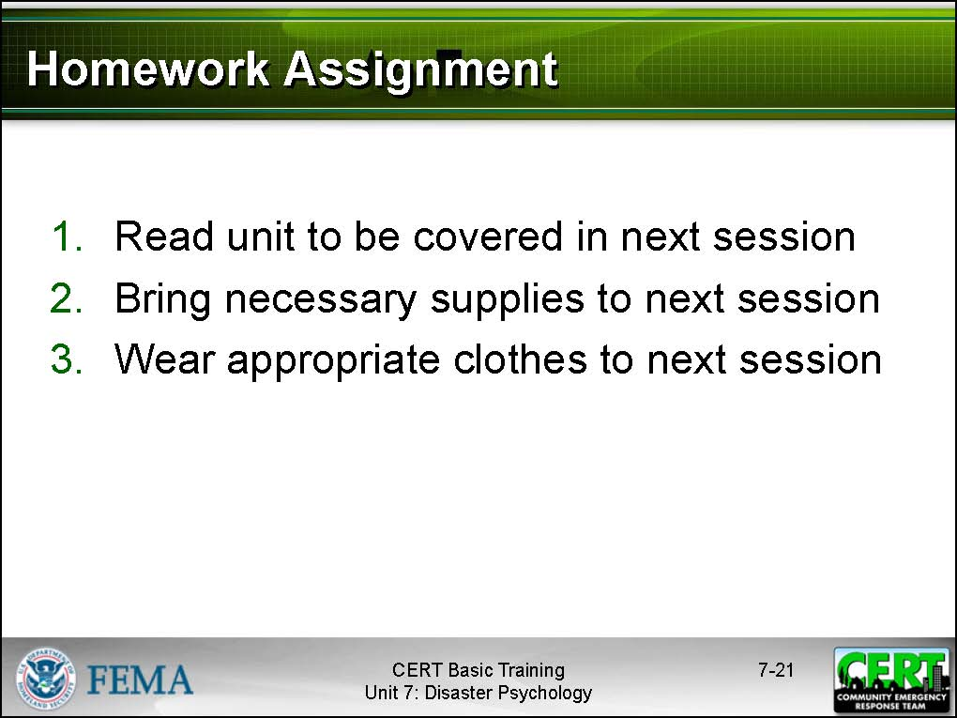  Display Slide 7-21 | Homework Assignment  Ask the group to read and become familiar with the unit that will be covered in the next session.  Thank the participants for attending the session. Remind them of the time and location of the next session, if necessary.

[This page intentionally left blank]

