Unit 2: Your Role as Instructor

In this unit you will learn about:

- The Role of the CERT Basic Training Course Instructor. The various roles of a CERT Basic Training instructor and the qualities that he or she should possess.
- The Qualities and Attributes of a Good Presenter. What an instructor needs to possess and learn in order to be most effective.

[This page intentionally left blank]
Learning Objectives/ Performance Outcomes | At the conclusion of this unit, the participants will be able to:  - Describe the roles of the CERT instructor.  - State the qualities of an effective CERT instructor.  - List the qualities of a good presenter.  - Explain how to develop a teaching style that conveys those qualities.
Scope | The topics that will be discussed in this unit are:  - Unit Overview  - The CERT Basic Training Instructor  - Good CERT Basic Training Instructor Qualities  - Good Presenter Qualities  - The Model Presenter  - Unit Summary
Estimated Completion Time | 30 minutes
Training Methods | The instructor begins by asking what the goal of every CERT Basic Training class is. The instructor then explains that an effective instructor needs to prepare people to help themselves, their families, and their neighbors in the event of a catastrophic disaster.  During the unit the instructor reviews the six primary roles of the CERT Basic Training instructor:  - Subject matter expert  - Trainer  - Evaluator  - Friend and coach  - Role model  - Classroom manager
Training Methods (continued) | Next the instructor leads a discussion about the qualities of a good CERT Basic Training instructor, followed by a discussion about the importance of how an instructor presents the information.  The instructor conducts a small group activity to get participants thinking about the qualities that make a good presenter (as opposed to a good instructor).  Finally, the instructor leads the class through a series of questions and discussions regarding voice and body language of a good presenter.
Resources Required | - Community Emergency Response Team Train-the-Trainer Instructor Guide (for Train-the-Trainer instructors)  - Community Emergency Response Team Train-the-Trainer Participant Manual (for all participants)  - Community Emergency Response Team Basic Training Instructor Guide (for all participants)  - PowerPoint slides 2-1 to 2-43
Equipment | The following additional equipment is required for this unit:  - A computer with PowerPoint software  - A computer projector and screen  - Easel pad and easel or whiteboard  - Markers  - “Super Trainer” handout for each participant
Preparation | Print out copies of the “Super Trainer” handout for each participant, which can be found in the Appendix of this unit.

Notes | A suggested time plan for this unit is as follows:  Unit Overview 1 minute  The CERT Basic Training Instructor 10 minutes  Good CERT Basic Training Instructor Qualities 3 minutes  Good Presenter Qualities 3 minutes  The Model Presenter 12 minutes  Unit Summary 1 minute  Total Time: 30 minutes
Remarks | This unit emphasizes that the focus of learning in any training is on the participant. It’s not about the instructor. This unit also stresses the importance of being a good presenter as well as a good instructor.

Unit 2: Your Role as Instructor

Instructor Guidance | Content
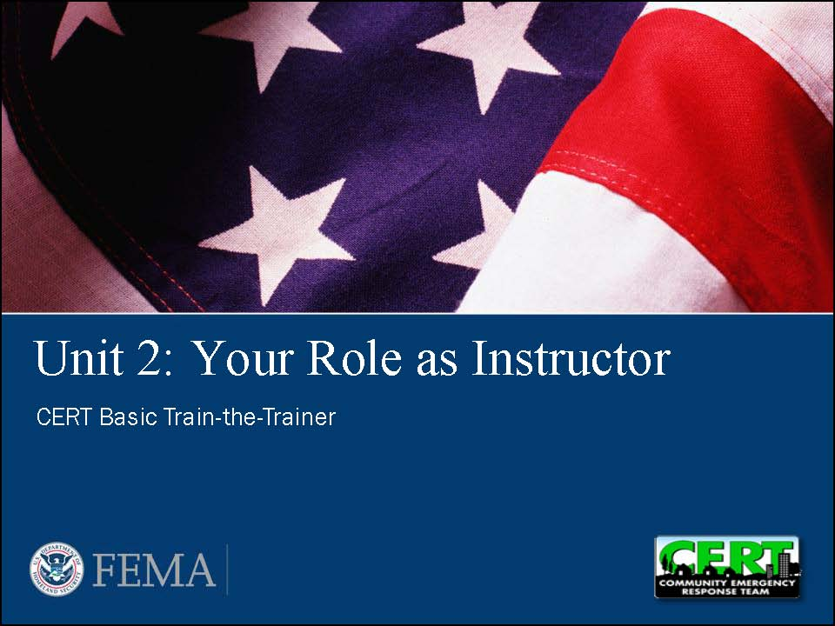  Display Slide 2-1 | Unit Overview  Say that this unit looks at what roles and qualities make an instructor effective. The unit also examines the qualities that make an instructor a good presenter.
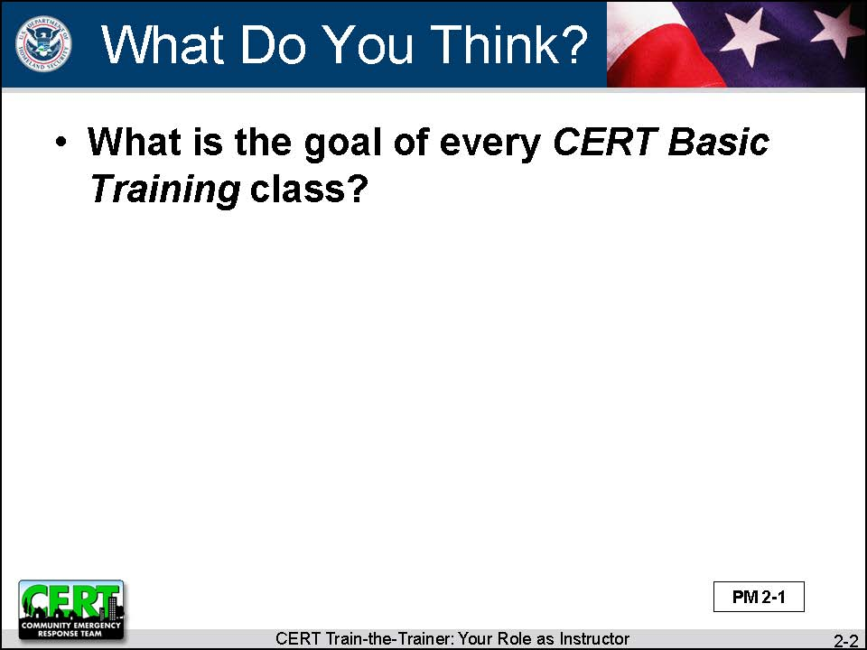  Display Slide 2-2  Conduct a class discussion based on this question. | Start by asking:  What is the goal of every CERT Basic Training class?
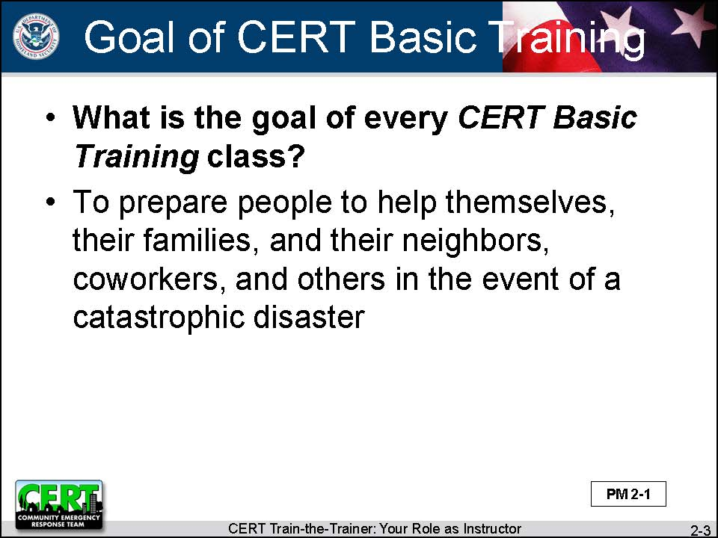  Display Slide 2-3 | Summarize the discussion by reviewing the slide.  The goal of every CERT Basic Training class is to prepare people to help in the event of a catastrophic disaster:  - Themselves  - Their families  - Their neighbors, coworkers, and others  Say that this unit looks at what an effective instructor needs to be in order to accomplish the goals of every CERT Basic Training class.
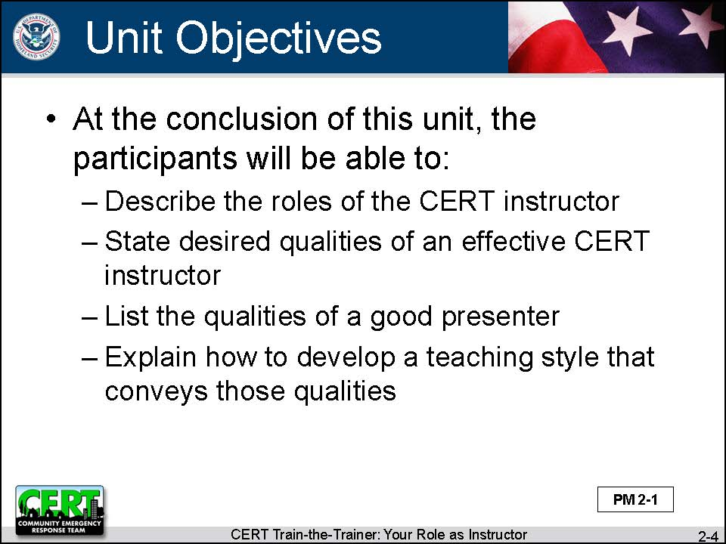  Display Slide 2-4 | Give the unit’s learning objectives.  At the conclusion of this unit, the participants will be able to:  - Describe the roles of the CERT instructor  - State the desired qualities of an effective CERT instructor  - List the qualities of a good presenter  - Explain how to develop a teaching style that conveys those qualities
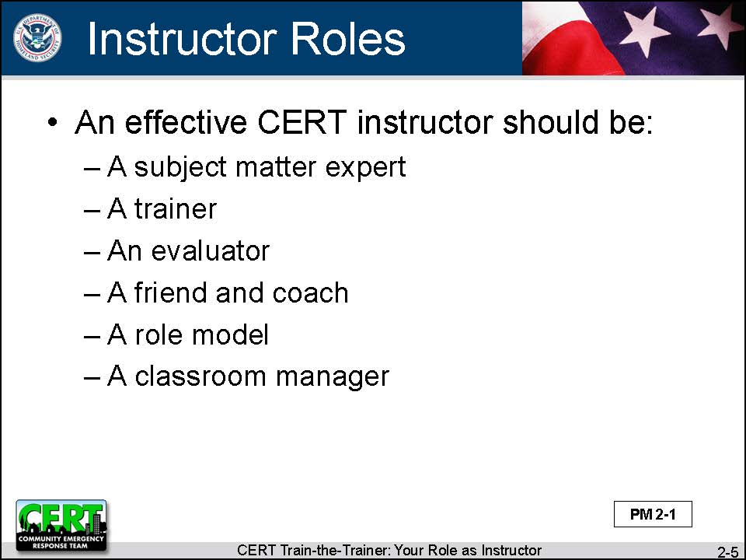  Display Slide 2-5 | State the various roles of the instructor.  Six instructor roles are examined:  - A subject matter expert  - A trainer  - An evaluator  - A friend and coach  - A role model  - A classroom manager
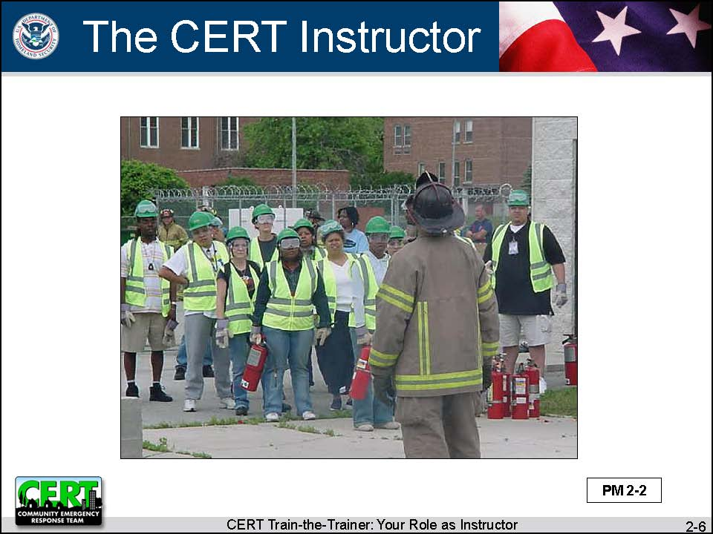  Display Slide 2-6 | The CERT Basic Training Instructor  Explain that an effective instructor has many talents and wears many hats.
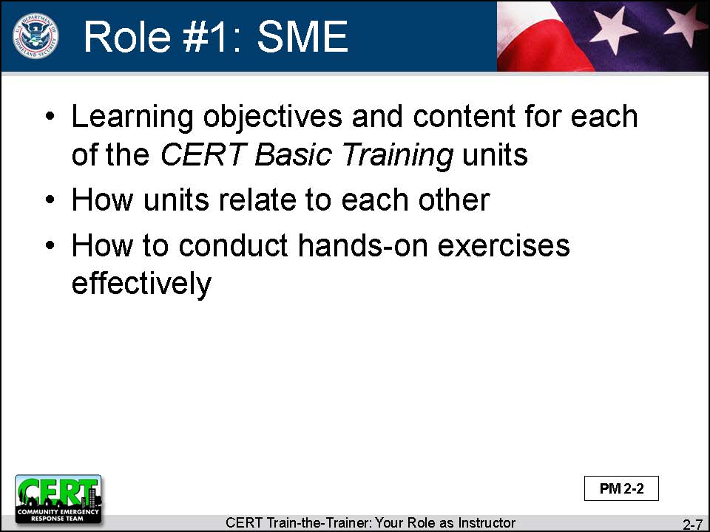  Display Slide 2-7 | Role #1: Subject Matter Expert (SME)  Say that the instructor has to know the CERT Basic Training course curriculum:  - What is in each of the CERT Basic Training units  - Learning objectives  - Content  - How the units relate to each other  - How to conduct the hands-on exercises effectively
In this course, there will be a review of each of the nine units in the CERT Basic Training course. These review units will focus on the hands-on activities and how to conduct them effectively.
You will become more knowledgeable of the CERT Basic Training curriculum every time you review, practice, and teach the material.

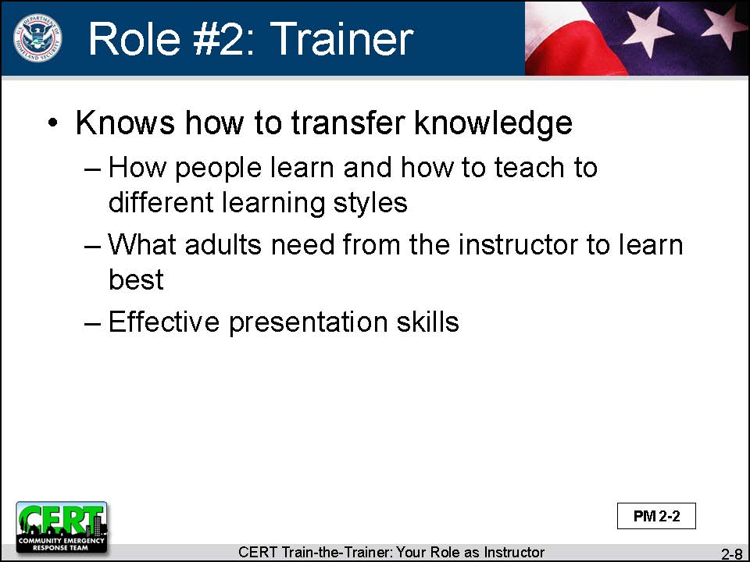  Display Slide 2-8 | Role #2: Trainer  Explain that some people think that, if you know the information, you can teach it. Sometimes this is true. But many people who are subject matter experts don’t know how to get the information out of their heads and into someone else’s head.
An effective instructor knows how to transfer knowledge to participants. A skilled trainer can:
- Teach to different learning styles
- Provide a learning environment where adults can learn best
- Present content effectively
One of the greatest tools for being a good trainer is to follow the CERT Basic Training Course Instructor Guide as it is written. It employs sound adult learning principles.
In this course, we will talk about:
- How to maximize learning
- The attributes of a good presenter
Both of these will help you be a better trainer.

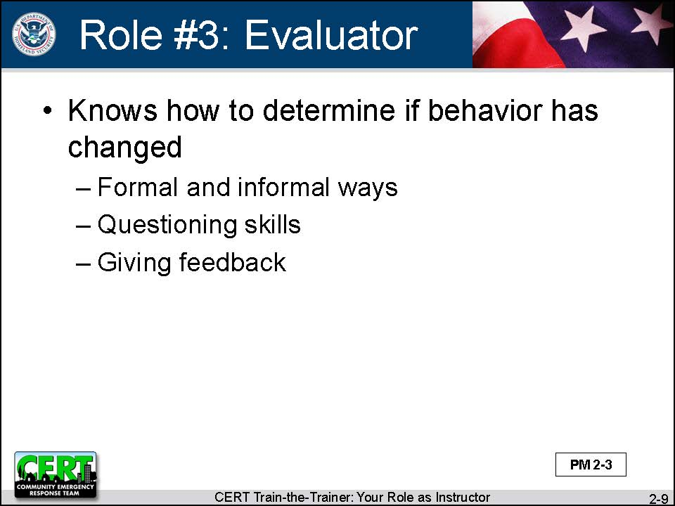  Display Slide 2-9 | Role #3: Evaluator  Tell participants that it is not enough to know the material and to know the best ways to transfer knowledge.  Good learning involves a change in behavior. For example, a participant can not only say what a pressure bandage is but he or she can show the instructor the correct way to apply a pressure bandage.  The instructor needs to see that the participants’ behavior has changed, that they have learned the new skill. There are both formal and informal ways to evaluate whether progress that has been made.  In this course, Unit 5 discusses evaluating progress and how and when to do it. The unit also covers how to ask good questions and how to give useful feedback. These are all ways to evaluate progress.
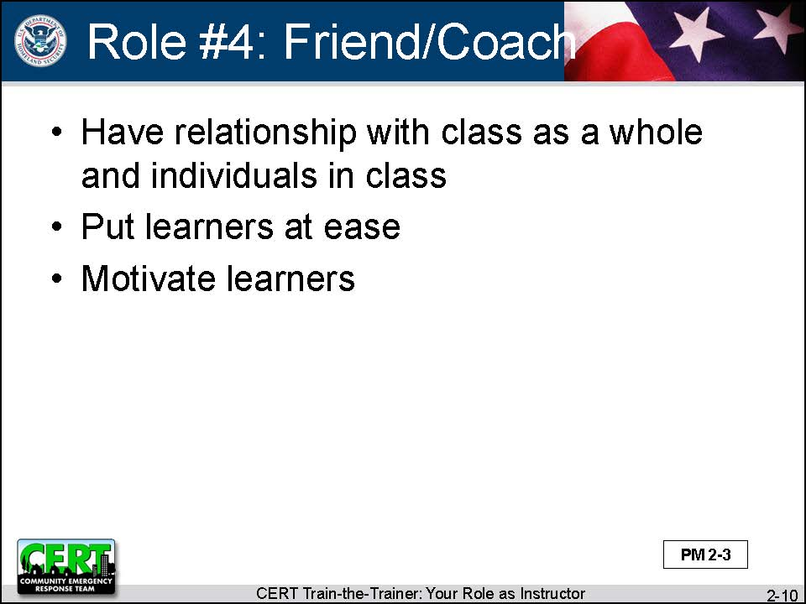  Display Slide 2-10 | Role #4: Friend and Coach  Explain that an effective instructor has a relationship with the class as a whole and with the individuals in the class.  The instructor makes a point of meeting each person and getting to know something about that person. This helps to put the participants at ease and make them feel part of the class.  In this course, there is a unit on getting to know your audience.  Part of this role of friend/coach requires the instructor to be a motivator. This is particularly important as many participants will be there for different reasons (as further discussed in Unit 11, Manage the Classroom). Your job is to identify what is motivating the participants to be in class (family safety vs. community response) and to reinforce that motivation.
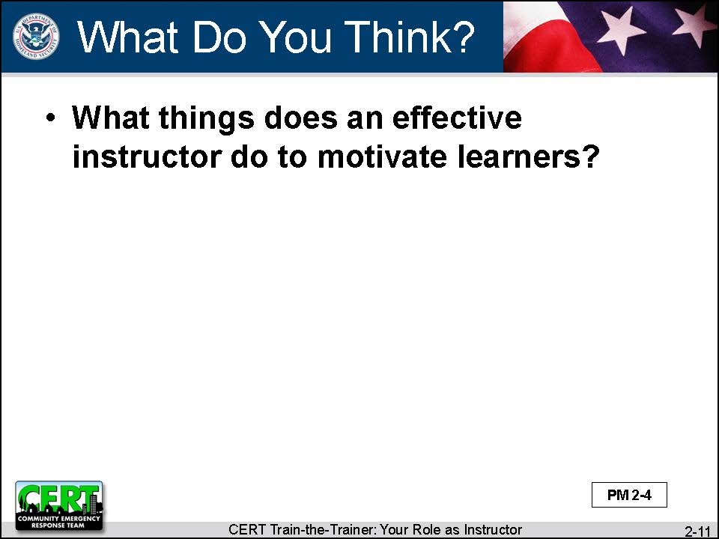  Display Slide 2-11  Conduct a class discussion based on this question. | Ask the class:  What things does an effective instructor do to motivate learners?
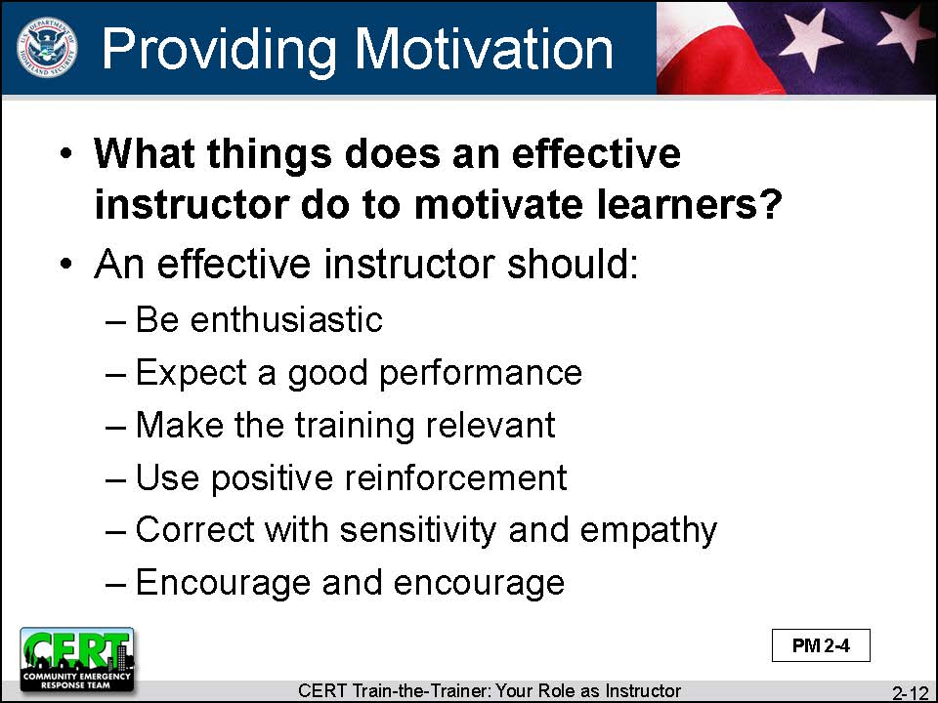  Display Slide 2-12 | Summarize the discussion by reviewing the slide.  A good instructor should:  - Be enthusiastic  - Expect a good performance  - Make the training relevant  - Use positive reinforcement  - Correct with sensitivity and empathy  - Encourage and encourage
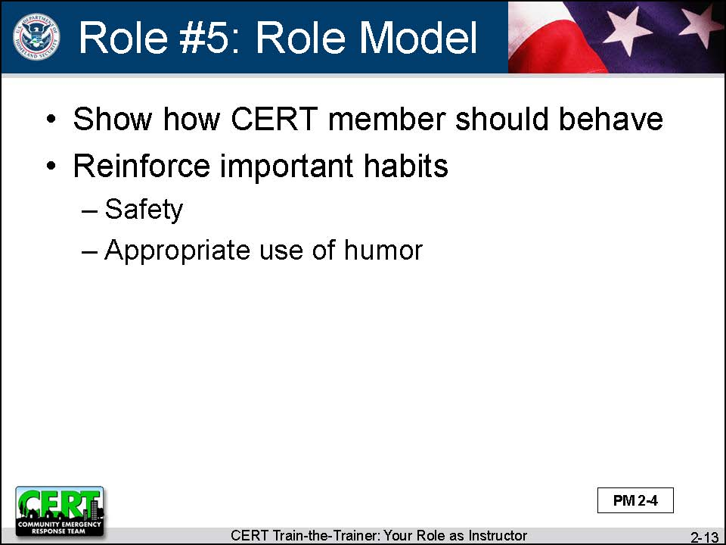  Display Slide 2-13 | Role #5: Role Model  Tell participants that instructors must be ambassadors for CERT. Participants look to the instructor to show and reinforce behavior and important habits, e.g., safety, appropriate use of humor.
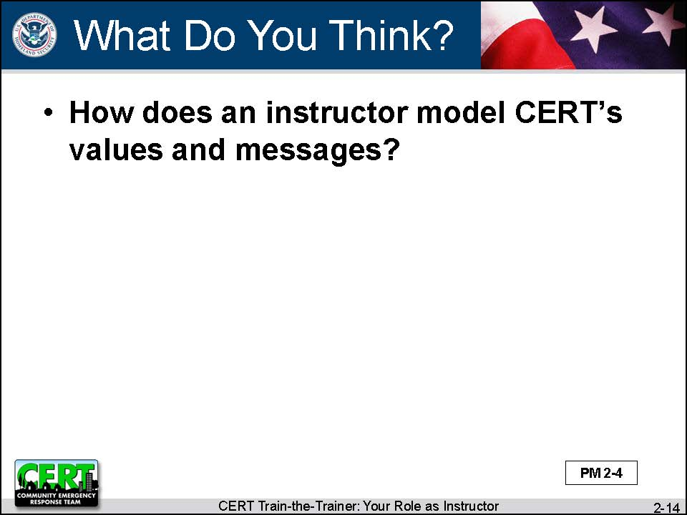  Display Slide 2-14  Conduct a class discussion based on this question. | Ask the class:  How does an instructor model CERT’s values and messages?
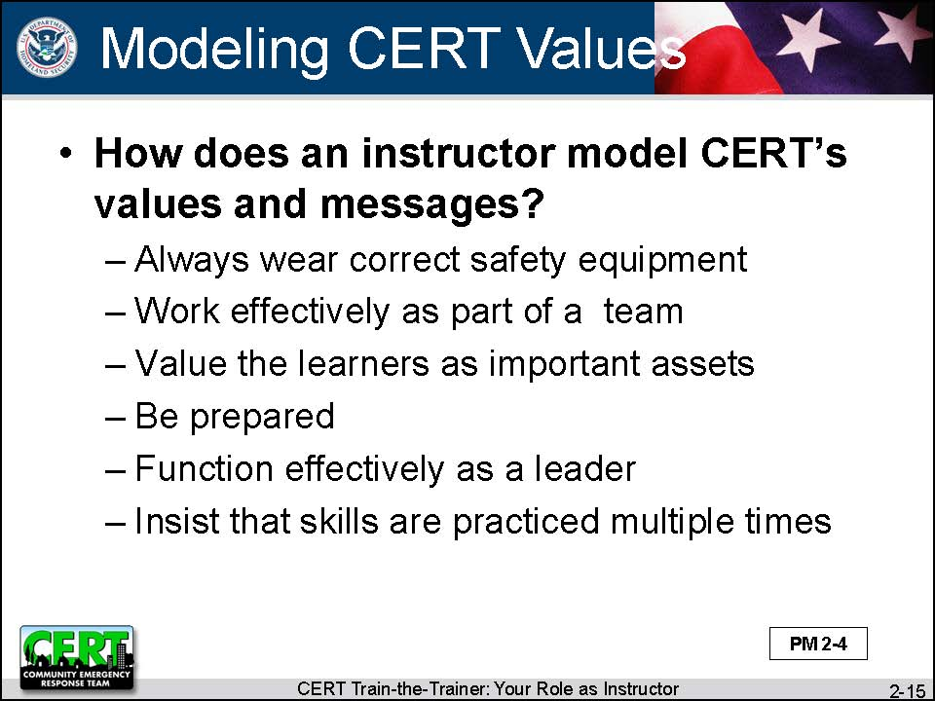  Display Slide 2-15 | Summarize the discussion by reviewing the slide.  An instructor can model CERT values and messages in the following ways:  - Always wear correct safety equipment.  - Work effectively as part of a team.  - Value the participants as important assets.  - Be prepared.  - Function effectively as a leader.  - Insist that skills are practiced multiple times.
 | Throughout this course, there will be reminders about values and messages that should be modeled.
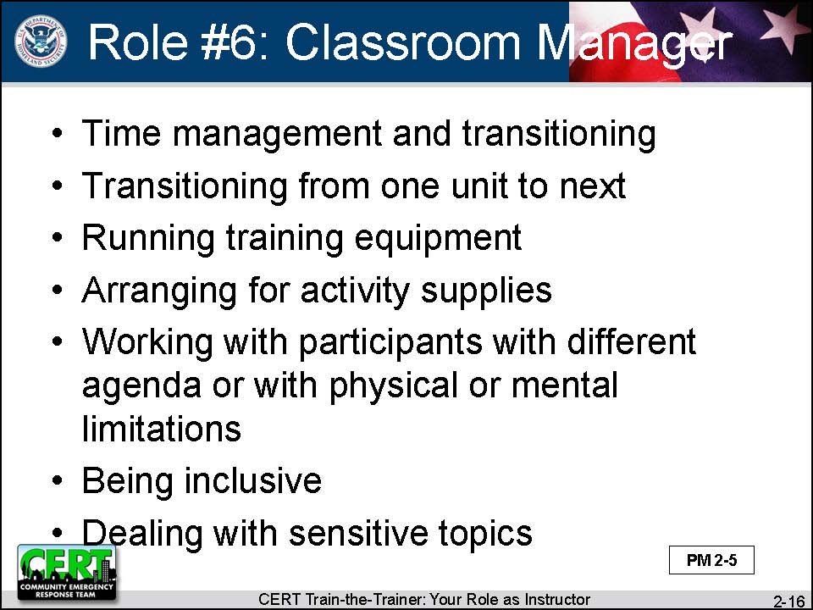  Display Slide 2-16 | Role # 6: Classroom Manager  Tell participants that it is not enough to know the CERT Basic Training curriculum and how to teach effectively. An instructor also needs to know how to manage the classroom. This includes skills such as:  - Time management (sticking to the schedule but also being flexible in terms of schedule “glitches”)  - Transitioning smoothly from one unit to the next  - Being able to run the training equipment  - Arranging for activity supplies  - Working with participants with a different agenda or with physical or mental limitations  - Being inclusive (not making anyone feel left out)  - Dealing with sensitive topics, e.g., touching
 | In this course, Unit 11 will teach more about managing the classroom successfully.
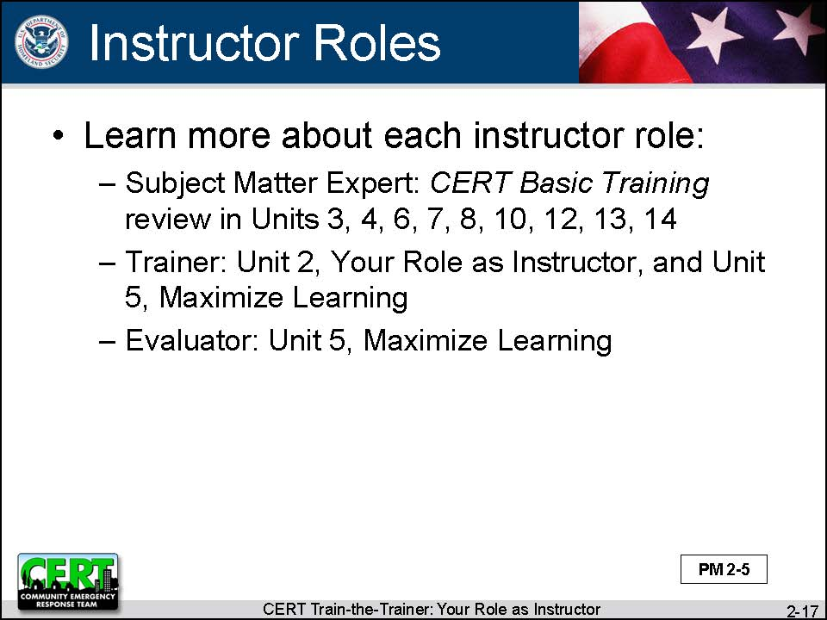  Display Slide 2-17 | Explain that, in this course, there are many opportunities to learn more about the six roles of an instructor. Refer to the next two slides that list other units of this course that offer additional information on each role.  - Subject Matter Expert: CERT Basic Training review in Units 3, 4, 6, 7, 8, 10, 12, 13, 14  - Trainer: Unit 2, Your Role as Instructor, and Unit 5, Maximize Learning  - Evaluator: Unit 5, Maximize Learning
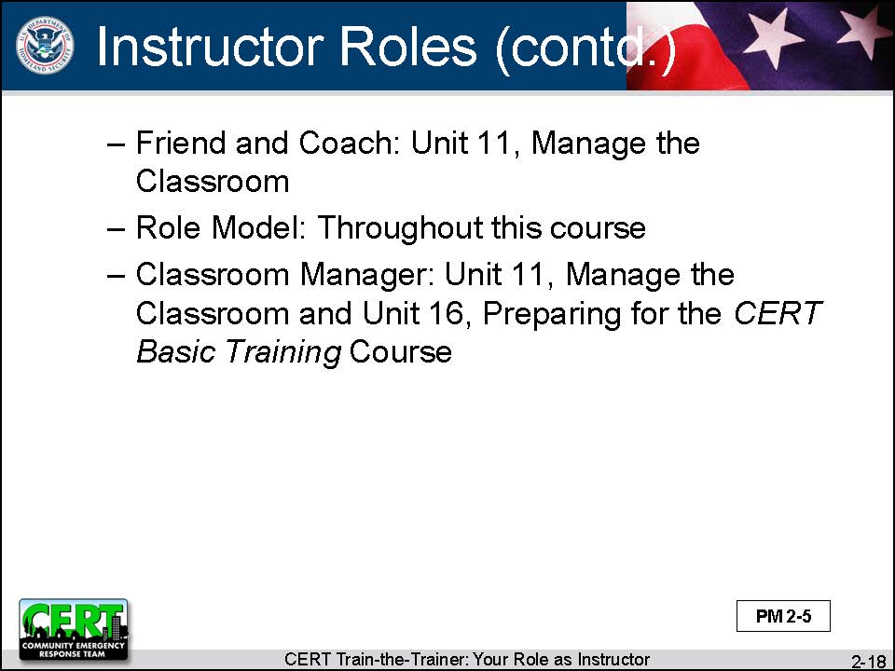  Display Slide 2-18 | - Friend and Coach: Unit 11, Manage the Classroom  - Role Model: Throughout this course  - Classroom Manager: Unit 11, Manage the Classroom, and Unit 16, Preparing for the CERT Basic Training Course
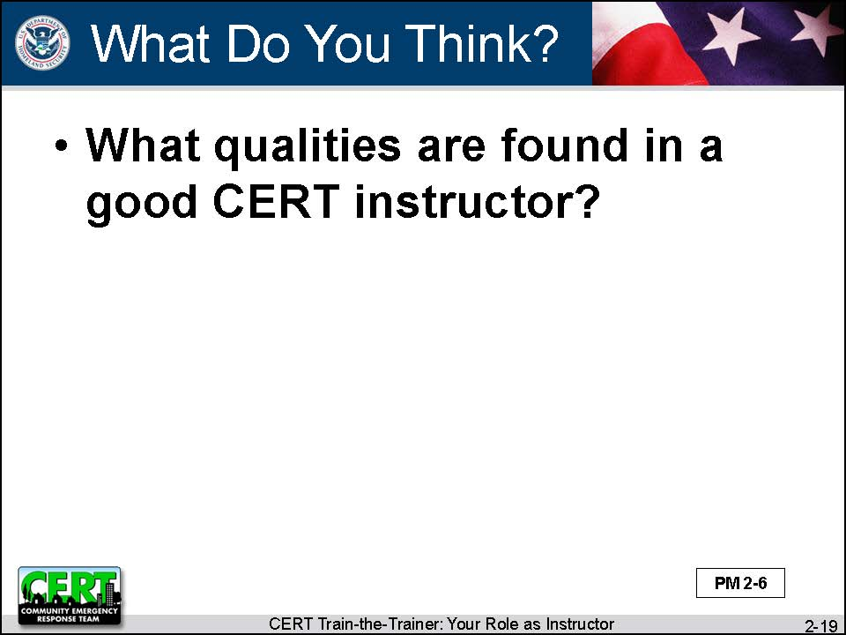  Display Slide 2-19  Conduct a class discussion based on this question. | Good CERT Basic Training Instructor Qualities  Ask the class:  What qualities are found in a good CERT instructor?
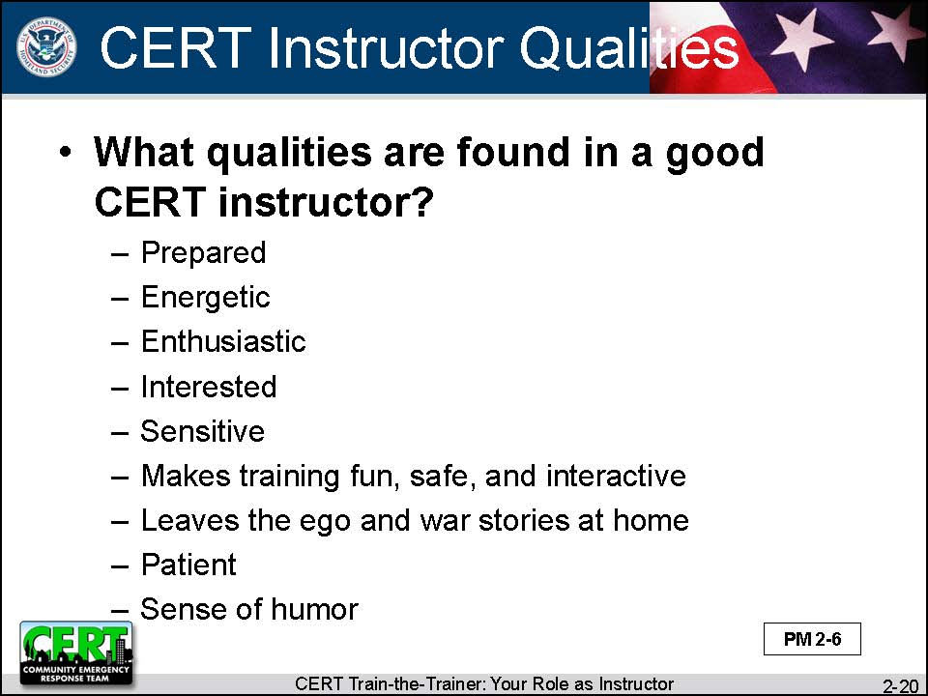  Display Slide 2-20 | Summarize the discussion by reviewing the slide:  A good CERT instructor should have these qualities:  - Prepared  - Energetic  - Enthusiastic  - Interested  - Sensitive  - Makes training fun, safe, and interactive  - Leaves the ego and war stories at home  - Patient  - Sense of humor
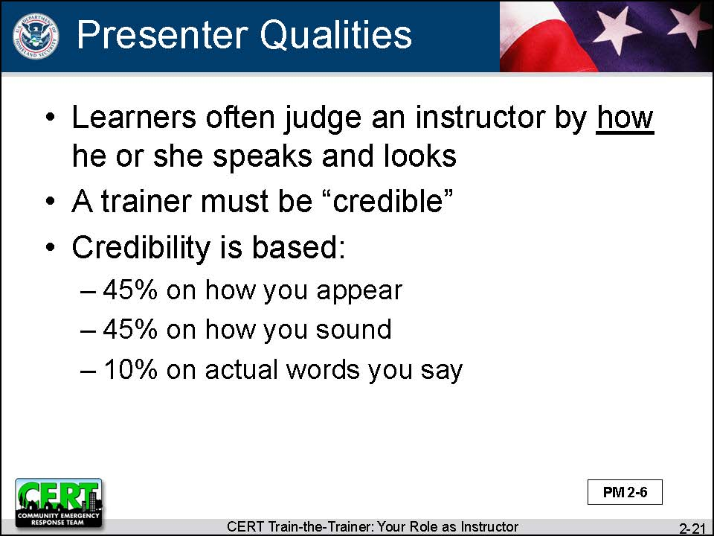  Display Slide 2-21 | Good Presenter Qualities  Say that so far we have discussed the qualities of a good instructor. Now we are going to discuss the qualities of a good presenter.
Some people think that the most important thing about an instructor is what they have to say. Do they know what they are talking about, or are they only full of hot air?
But participants often judge an instructor differently – not by what he or she says but by how she says it and by how he looks.
To maximize learning, a trainer must first be credible. Credibility is based:
- 45% on how you appear
- 45% on how you sound
- 10% on the actual words you say
 | For the rest of this unit, the focus will be on the “how” of an instructor’s presentation.
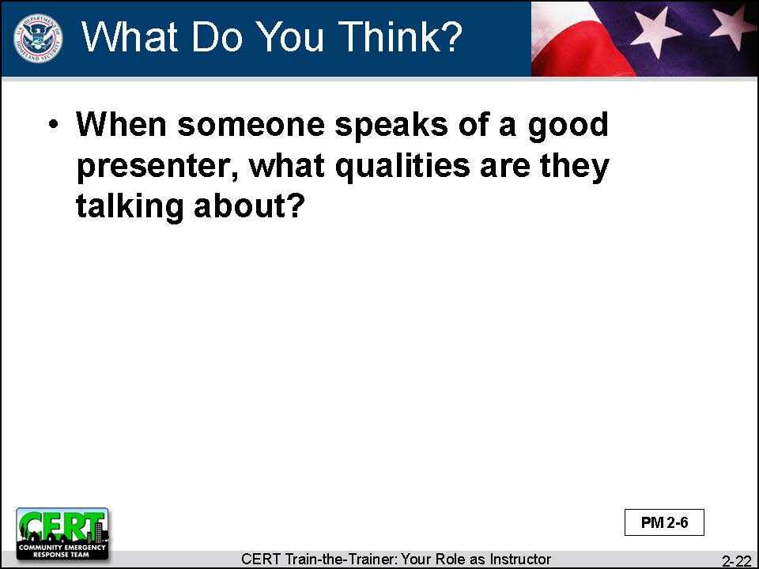  Display Slide 2-22  Conduct a class discussion based on this question. | Ask the class:  When someone says that Mary Lou or Bobby Joe is a good presenter, what qualities are they talking about?
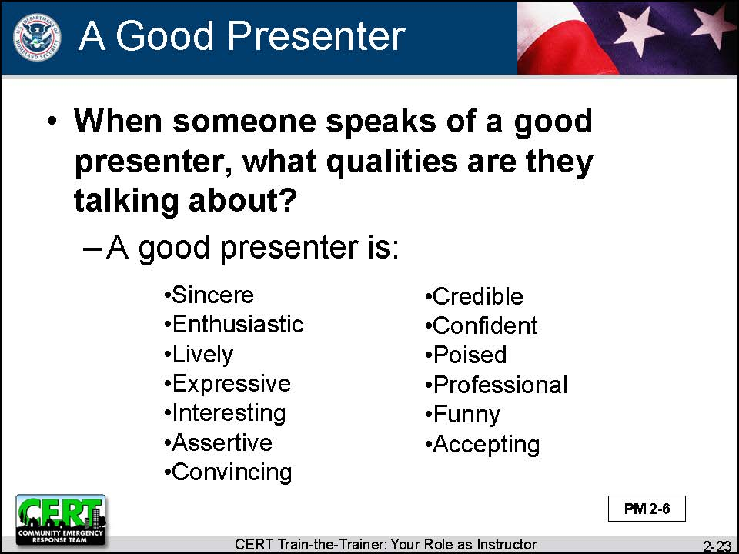  Display Slide 2-23 | Summarize the discussion by reviewing the slide.  A good presenter is:  - Sincere  - Enthusiastic  - Lively  - Expressive  - Interesting  - Assertive  - Convincing  - Credible  - Confident  - Poised  - Professional  - Funny  - Accepting
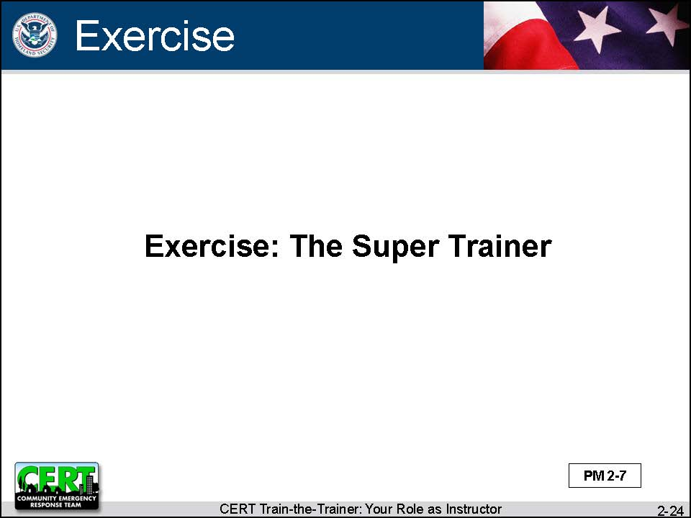  Display Slide 2-24 | The Model Presenter  Exercise: The Super Trainer
 | Purpose: This exercise allows participants to share their knowledge of qualities that make an instructor a good presenter
Instructions: Follow the steps below to conduct the exercise.
- Ask the class to break into small groups.
- Provide each group with the “Super Trainer” handout.
- Explain that the class is going to look at the body language of a good presenter.
- Ask each group to fill in the blank boxes on the handout with qualities that make a good presenter.
 | Debrief: Use the series of questions on the following pages to draw out the information participants discussed in their groups.
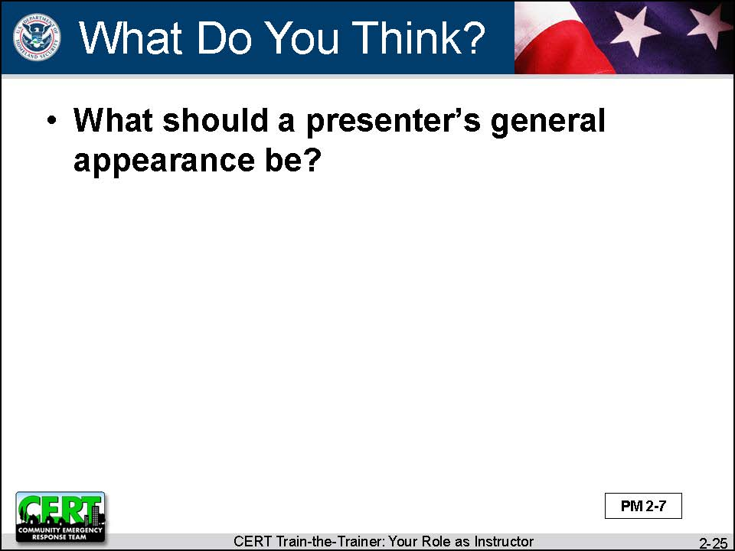  Display Slide 2-25  Conduct a class discussion based on this question. | Ask the class:  First, what should a presenter’s general appearance be?
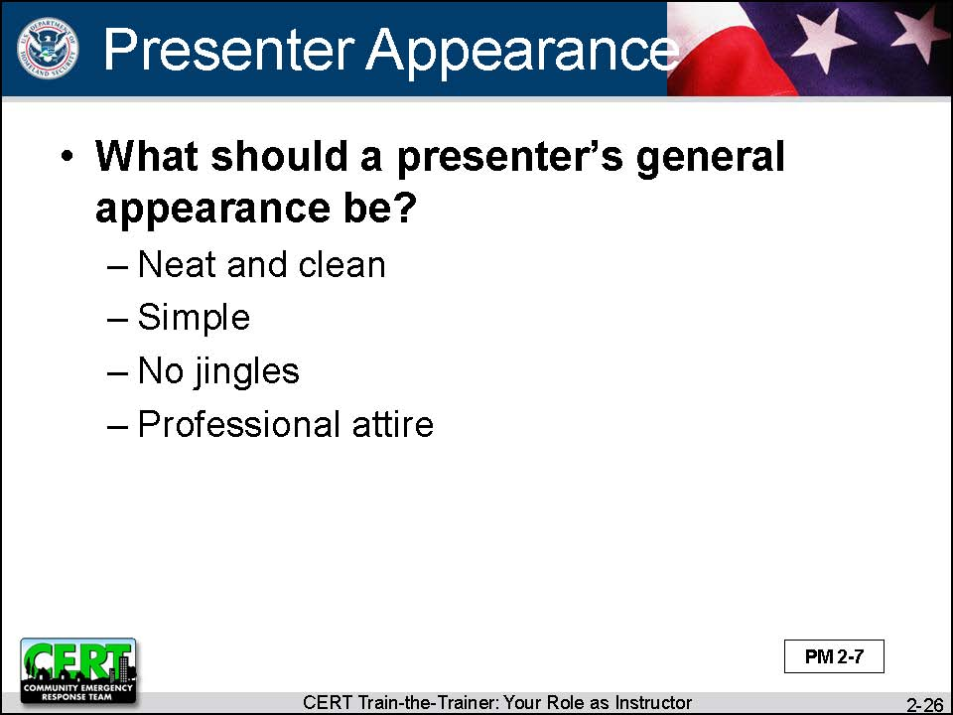  Display Slide 2-26 | Summarize the discussion by reviewing the slide.  A presenter should:  - Be neat and clean, top to bottom  - Wear simple dress  - Have no jingles (jewelry or in pockets)  - Wear correct attire (proper dress makes you appear professional)
Ask if anyone would be willing to volunteer to help teach the rest of this lesson. Explain that you are looking for someone who might be willing to do a little role-playing.
Remark on the volunteer’s appearance (neat and clean, no jingles).
Remark that the volunteer may not be wearing correct attire as this is not a CERT Basic Training class.
You might also ask the volunteer to demonstrate some of the “bad” behaviors, e.g., a scowl, a belligerent stance (crossed arms, etc.), pacing. | Tell participants that you are going to start at the top in your creation of the model presenter. Ask the volunteer to try to do whatever the class tells him or her to do. Let participants know that they can record responses in their Participant Manuals.
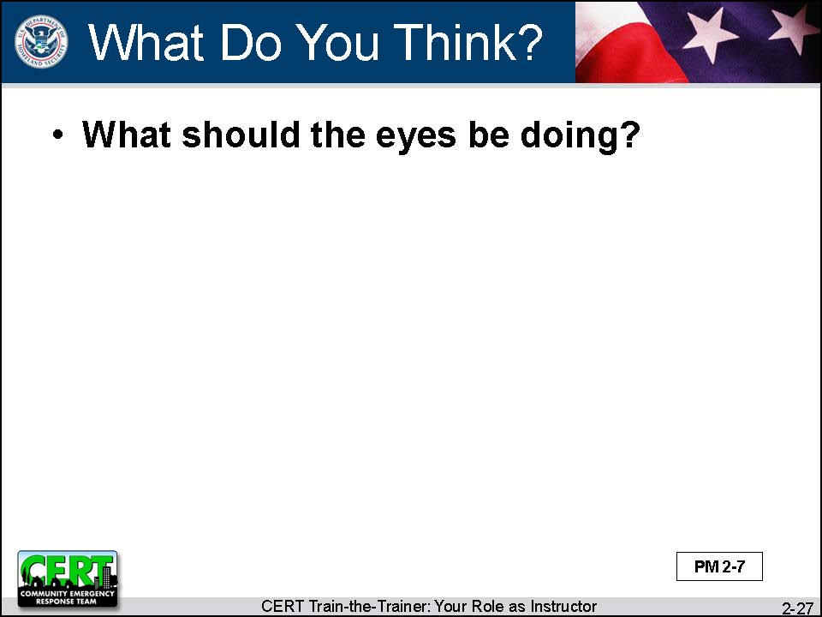  Display Slide 2-27  Conduct a class discussion based on this question. | Ask the class:  Let’s start with the eyes. What should the eyes be doing?
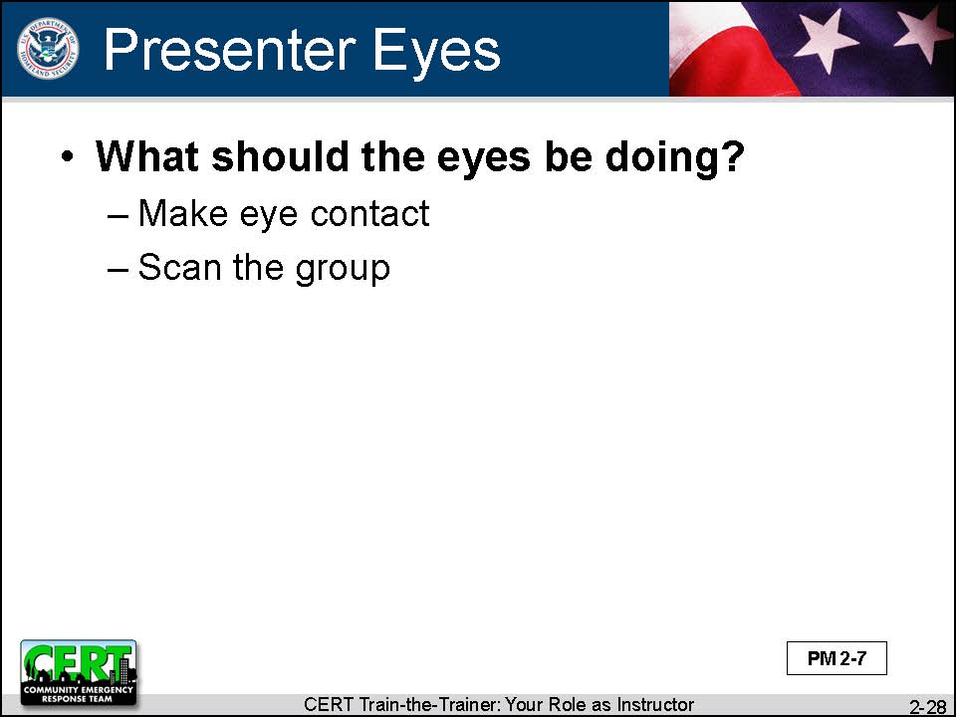  Display Slide 2-28 | Summarize the discussion by reviewing the slide.  - Make eye contact more often than not (don’t stare at notes or PowerPoint slides).  - Make sure to scan the group; this makes you appear sincere.
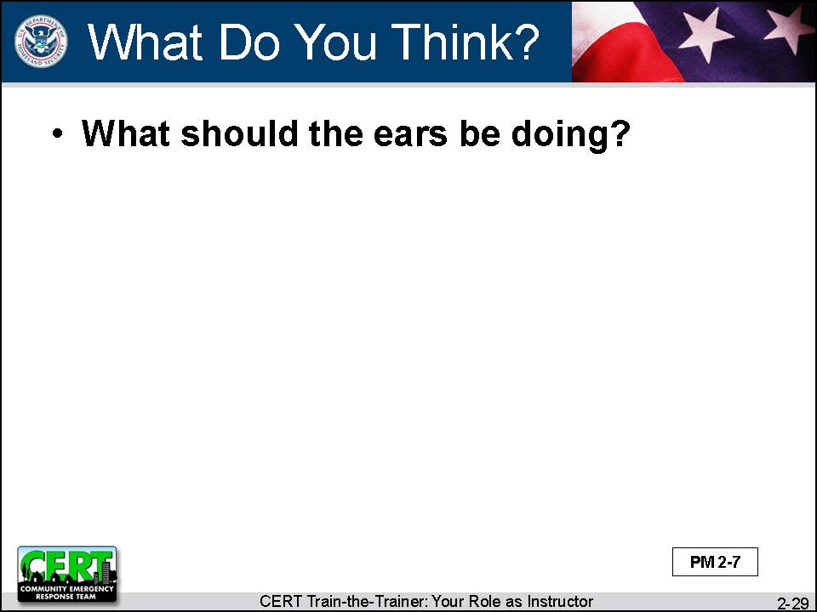  Display Slide 2-29  Conduct a class discussion based on this question. | Ask the class:  Now the ears. What should the ears be doing?
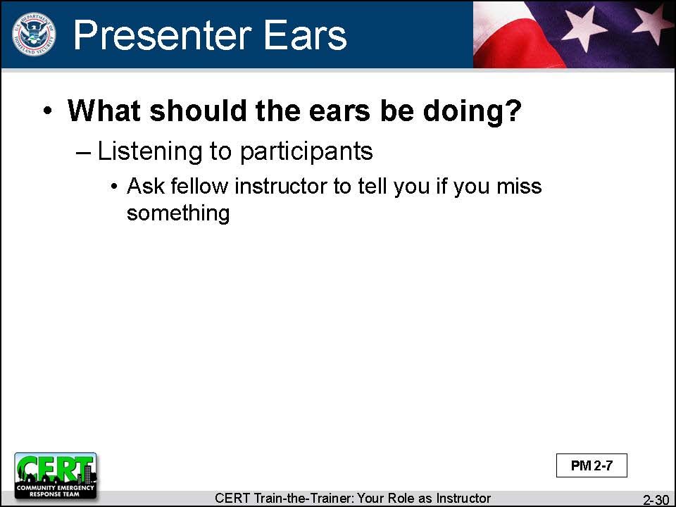  Display Slide 2-30 | Summarize the discussion by reviewing the slide.  The presenter’s ears should be:  - Listening to the participants and what is going on in the classroom  - Sometimes it’s hard to monitor everything so ask your fellow instructor to let you know if you miss something
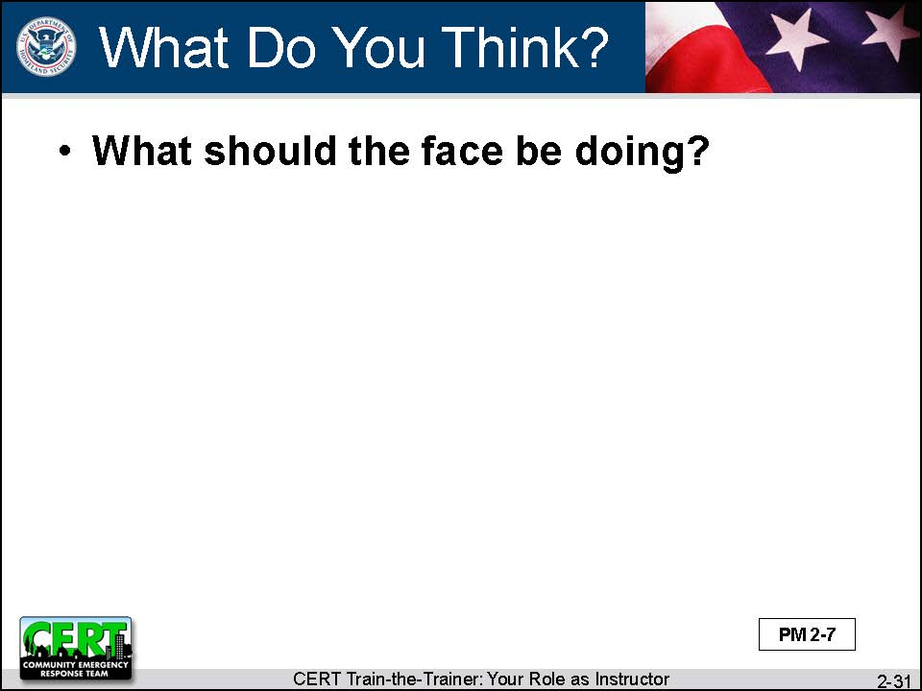  Display Slide 2-31  Conduct a class discussion based on this question. | Ask the class:  Next the face. What should the face be doing?
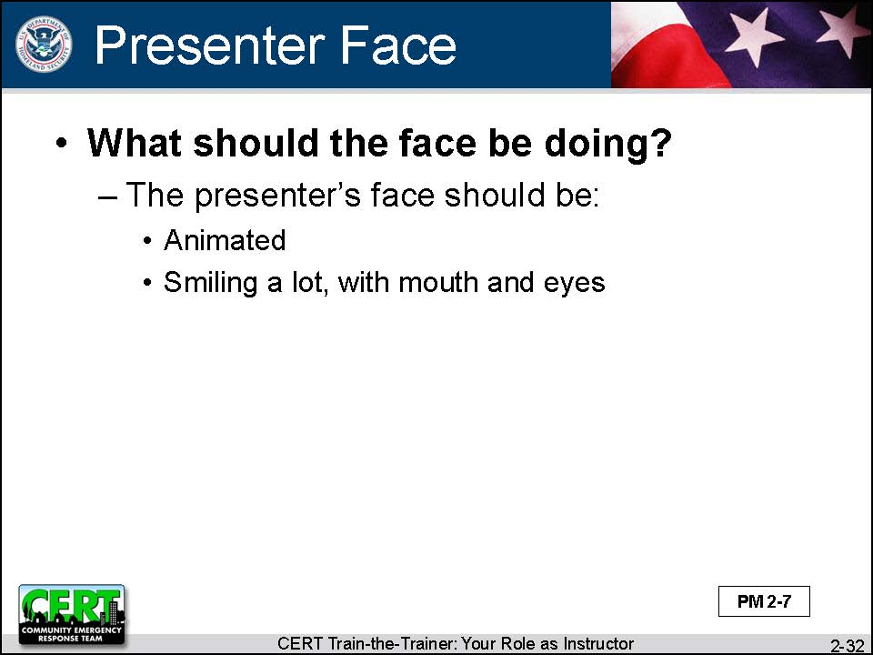  Display Slide 2-32 | Summarize the discussion by reviewing the slide.  The presenter’s face should be:  - Animated  - Smiling a lot, with mouth and eyes
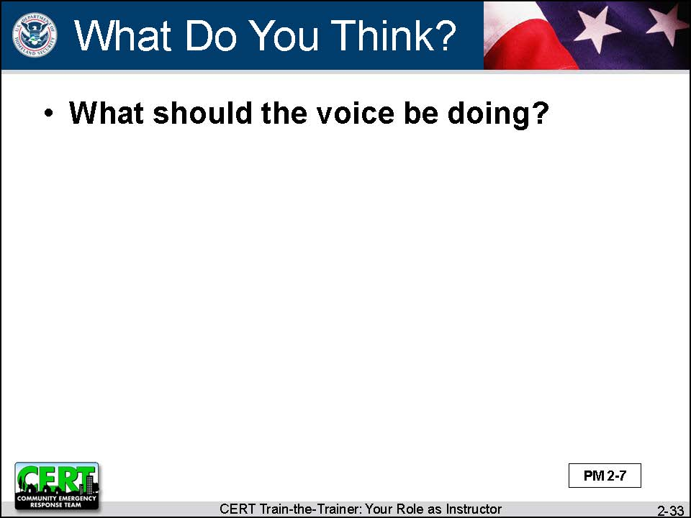  Display Slide 2-33  Conduct a class discussion based on this question. | Ask the class:  Let’s talk about the voice. What should the voice be doing?
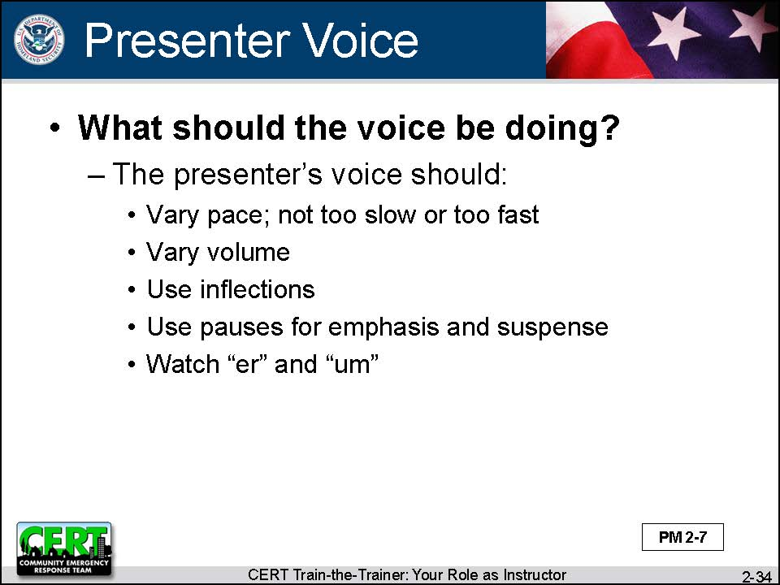  Display Slide 2-34 | Summarize the discussion by reviewing the slide.  The presenter’s voice should:  - Vary pace, but never be so slow that people get bored or so fast that people can’t keep up  - Vary volume  - Use inflections  - Use pauses for emphasis and to add suspense  - Watch “er” and “um”
 | A strong, powerful voice is one of a presenter’s greatest tools. It helps you keep control of the class. Be a 7-8 on a scale of 1-10.
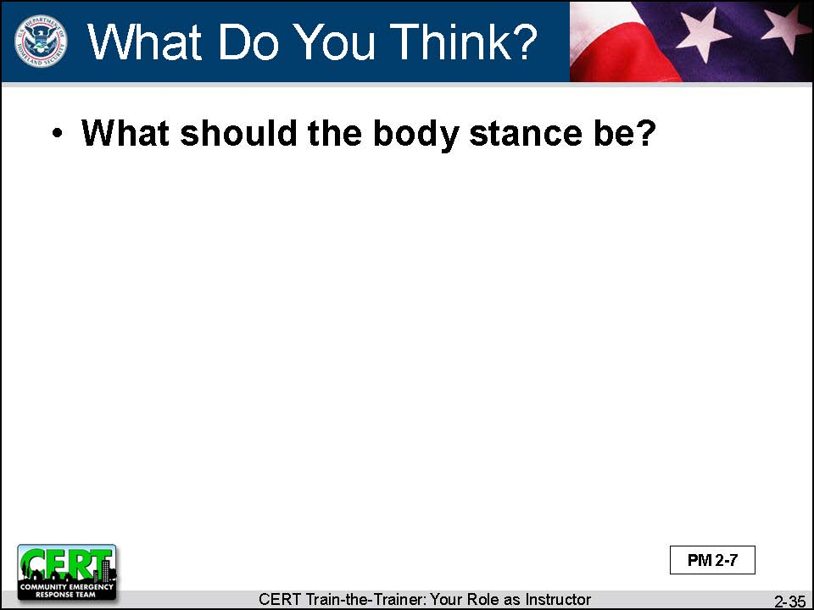  Display Slide 2-35  Conduct a class discussion based on this question. | Ask the class:  Next let’s look at the body. What should the body stance be?
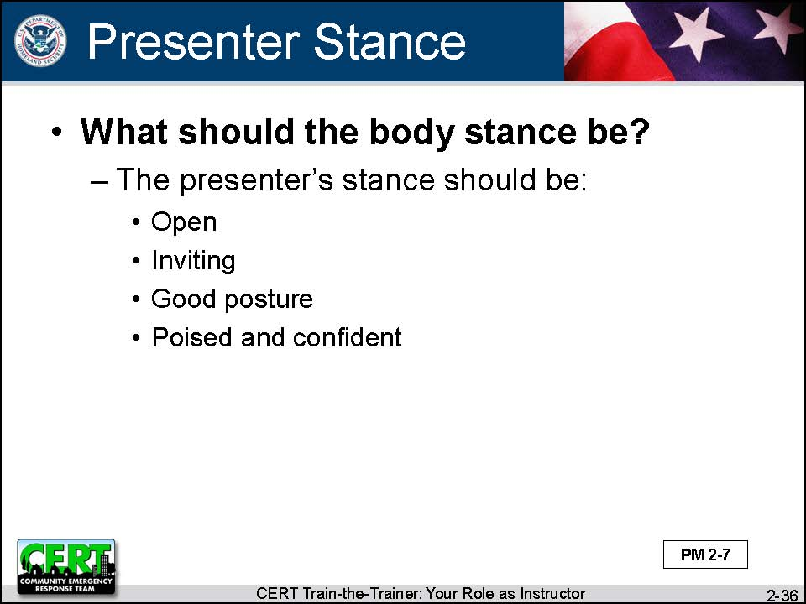  Display Slide 2-36 | Summarize the discussion by reviewing the slide.  The presenter’s stance should be:  - Open  - Don’t cross arms or slouch.  - Inviting  - Smile and make eye contact with participants.  - Good posture  - Poised and confident
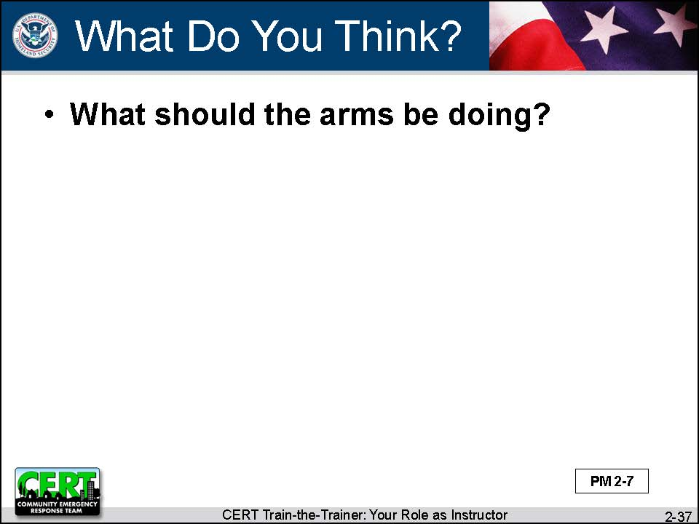  Display Slide 2-37 | Ask the class:  What about the arms? What should the arms be doing?
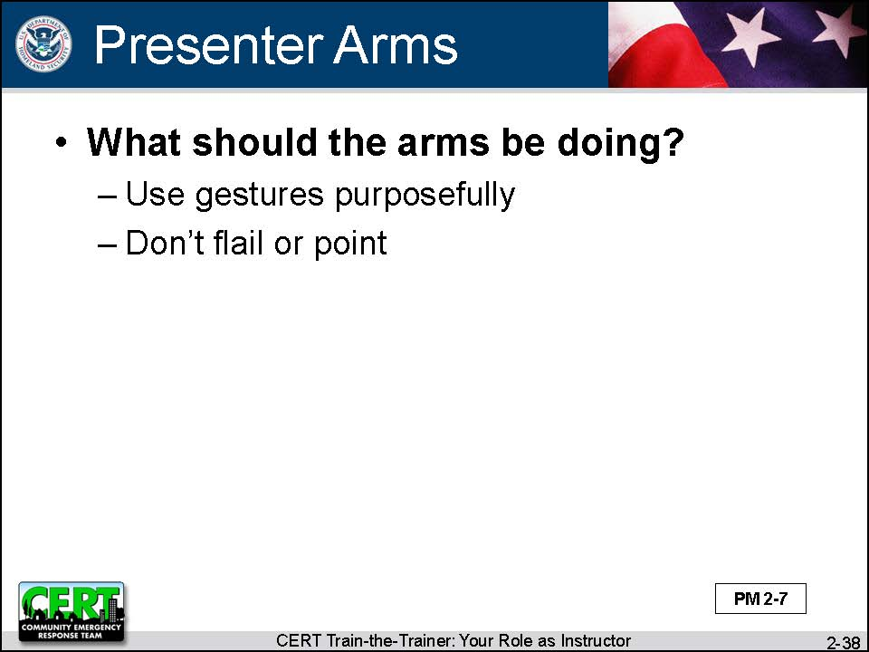  Display Slide 2-38 | Summarize the discussion by reviewing the slide.  - Use gestures purposefully.  - Don’t flail or point.
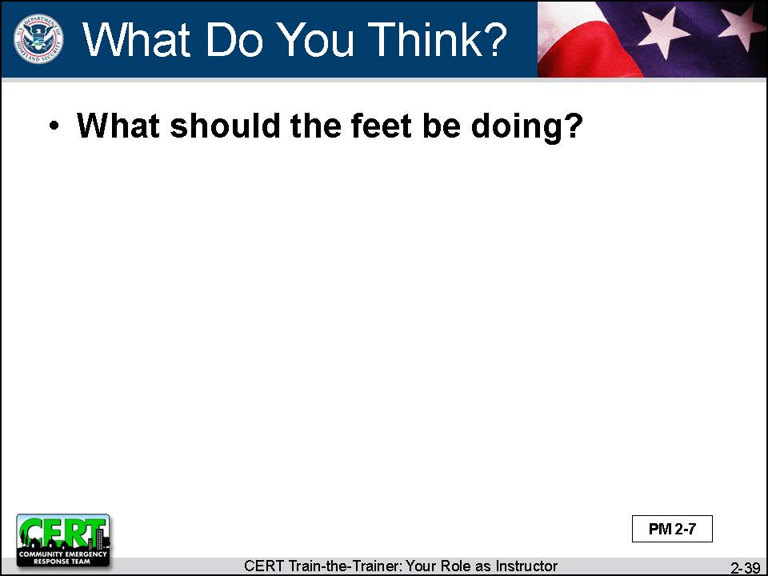  Display Slide 2-39  Conduct a class discussion based on this question. | Ask the class:  And the feet. What should the feet be doing?
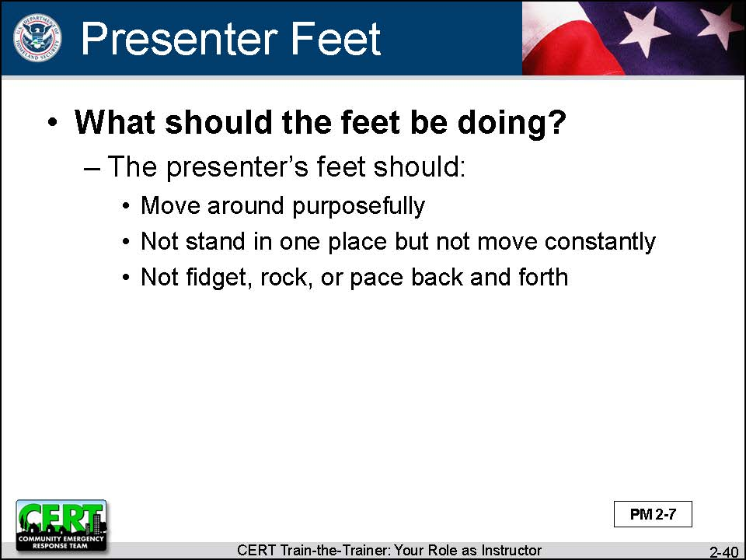  Display Slide 2-40 | Summarize the discussion by reviewing the slide.  The presenter’s feet should:  - Move around purposefully (to maintain interest of participants)  - Not stand in one place but not move constantly  - Not fidget, rock, or pace back and forth
Before you continue, thank the volunteer for helping you out. Allow the volunteer to sit down.
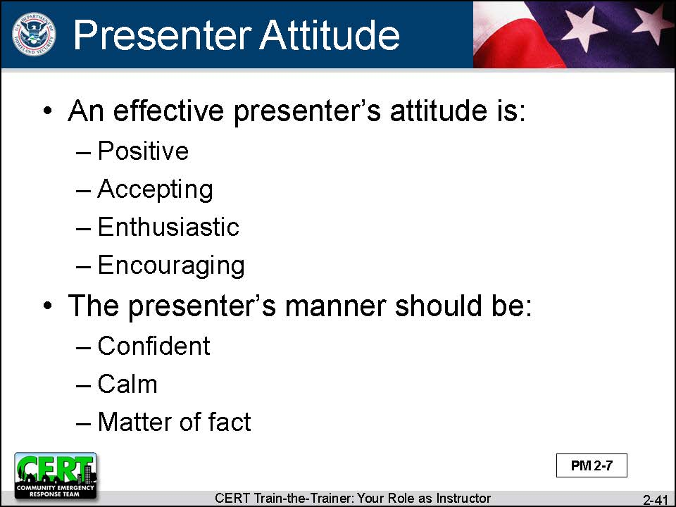  Display Slide 2-41 | Say that the final thing to look at is the overall attitude and manner of the presenter. An effective presenter’s attitude is:  - Positive  - Accepting  - Enthusiastic  - Encouraging  However, while the presenter projects energy, his or her manner is confident, calm, and matter of fact. The presenter is in control.
Say that good teaching is a performance. An instructor has to get into the role to be effective. Some of us really need to dig deep for some acting skills to be a good presenter.
In the end, every instructor has to find his or her own style. But it must be a style with the qualities required of a good presenter.

Instructor Guidance | Content
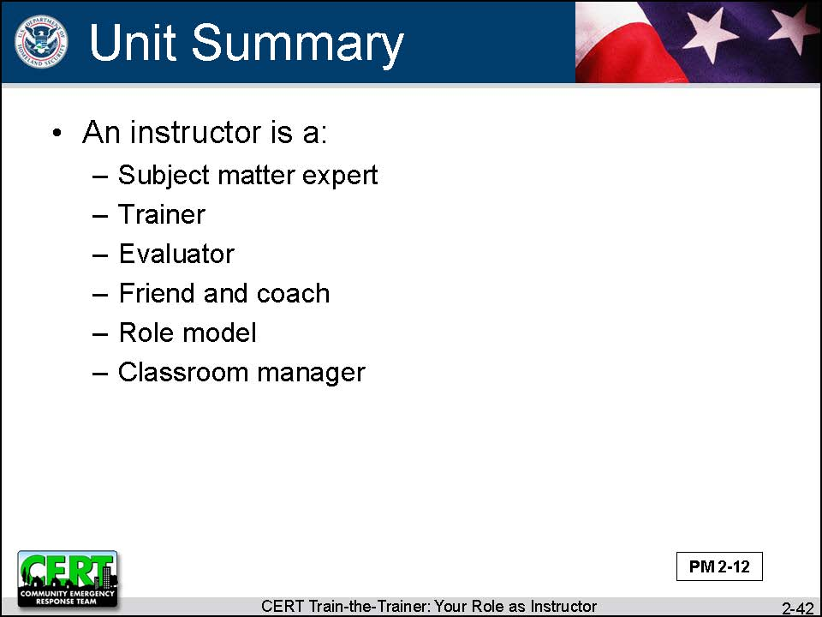  Display Slide 2-42  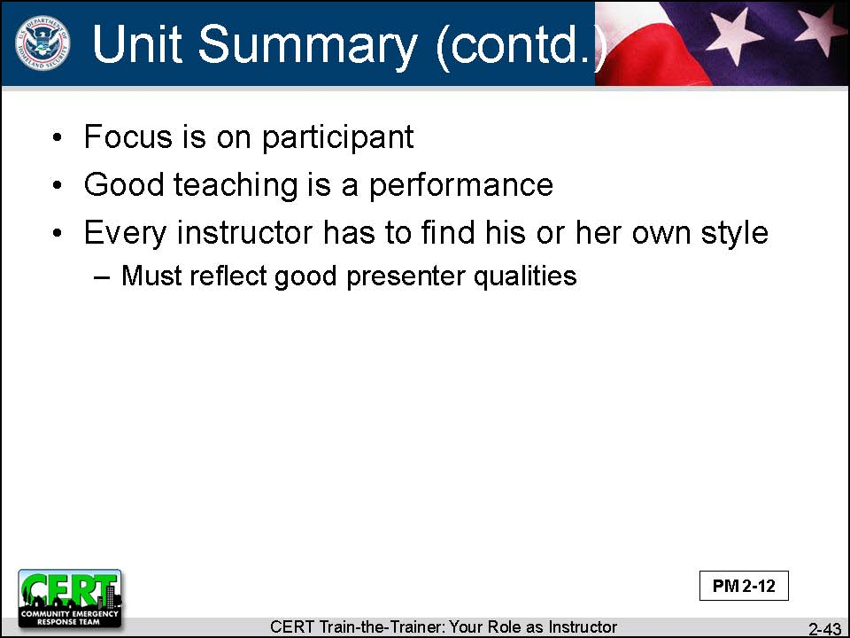  Display Slide 2-43 | Unit Summary  As an instructor, you need to be a:  - Subject matter expert  - Trainer  - Evaluator  - Friend and coach  - Role model  - Classroom manager  At all times, the focus is on the participant. Training is not about what the instructor knows but how well the instructor transfers his or her knowledge to the participant.  In addition to all of the roles you need to fulfill to be an effective instructor, you also need to embody the qualities that make a credible, engaging presenter.
 | Do you have any questions about anything covered in this unit?
Transition
The next unit will review Unit 1 of the CERT Basic Training course.

APPENDIX

[This page intentionally left blank]

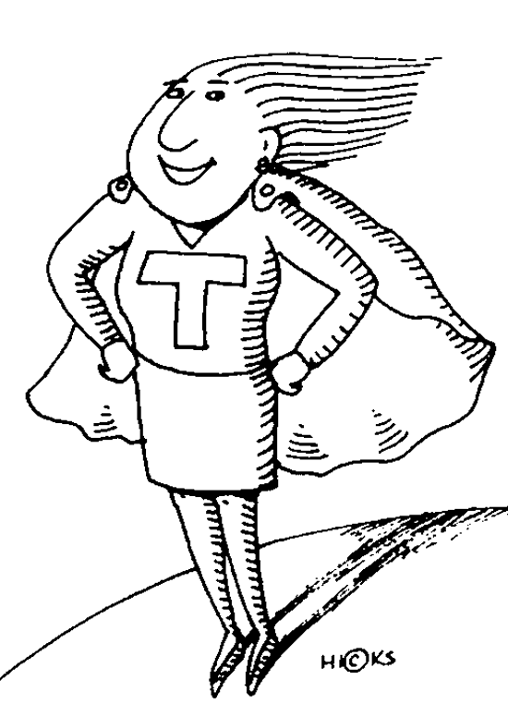
General Appearance:
Eyes:
Ears:
Face:
Voice:
Body/Stance:
Arms:
Feet:
The Model Presenter/
Trainer

[This page intentionally left blank]

