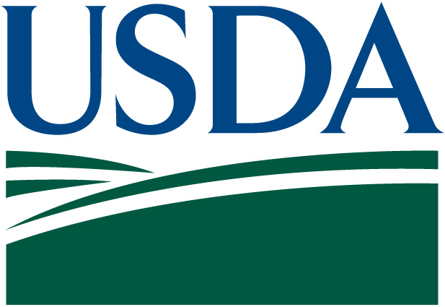
United States
Department of
Agriculture

IT Strategic Plan

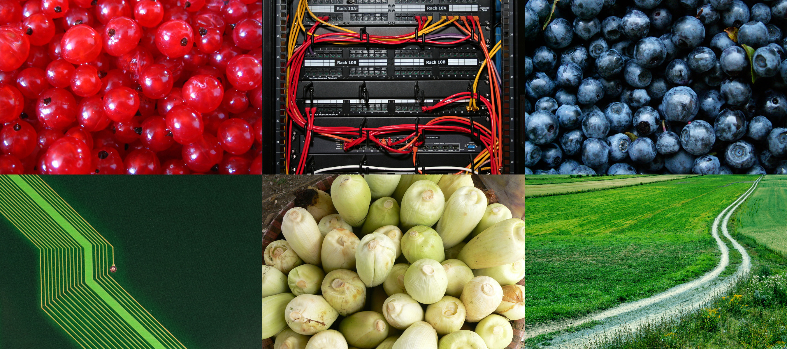

FY 2007-2011

U.S. Department of Agriculture (USDA)
INFORMATION TECHNOLOGY STRATEGIC PLAN
FY 2007 – 2011
Message from the Chief Information Officer
September 2006
We live in a transformation era, one in which the dynamic nature of information is becoming far more strategic than ever before. Information can be collected from the swipe of a card. It can be delivered or accessed with the touch of a button. And it can be processed in seconds, not days.
Recent events have highlighted as never before the strategic importance of information in protecting American lives and carrying out the fundamental purpose of government. The United States Department of Agriculture (USDA) is committed to ensuring that information relevant to our national security is gathered, properly protected, and shared appropriately.
We are in a challenging environment, dealing with all the changes in technology and the workplace. The expectations of what information technology (IT) can do to benefit the USDA and its customers continue to grow. We have been working hard to provide day-to-day IT services, while keeping our eye on where the Department is headed strategically, and also transforming the IT organization to meet future requirements.
This plan serves as a valuable planning tool and an effective communication vehicle. It integrates the business and IT visions and has been an important instrument in facilitating the dialogue between the IT community and the business leaders of the Department.
We at the USDA believe that information should be used to enable more effective decision-making, to determine, for example, which programs are best meeting the needs of our customers, which customers may need a greater breadth of our services, which channels are most effectively distributing our services, and how well we are truly performing in our quest to positively impact the Nation’s economy. When information can be used for this fundamental level of decision-making, we can truly transform our Department into what we envision ourselves becoming: a high-performance organization.
There are many initiatives underway to implement our strategic plan. Last fall, three Department-wide optimization initiatives were approved by the Department’s Executive Information Technology Investment Review Board; they include email consolidation, network consolidation, and lastly, data center consolidation. These initiatives, together with an overall assessment of the Department’s IT Program and implementation of a multi-year action plan to implement recommendations from various reviews, are positive steps we’re taking toward ensuring achievement of the USDA’s mission.
Much work has been done, but much still remains. We must commit ourselves to integrate more across the agencies with USDA, as well as with other federal and state agencies to ensure the achievement of the Presidential Management Agenda goals. We are confident that the spirit of collaboration and participation embodied in the IT Leadership Council and amongst Agency Leadership will assure sustained success in pursuit of our vision. We are pleased to present the USDA IT Strategic Plan, 2007-2011. We look forward to your support in carrying out this plan, which will help assure the Department’s continued success.

David M. Combs Jerry E. Williams
Chief Information Officer Deputy Chief Information Officer
Table of Contents
1 Executive Summary 5
2 Introduction 9
2.1 Purpose 10
2.2 Scope of the USDA IT Strategic Plan 12
2.3 Business-Driven USDA IT Strategic Planning Framework 13
3 IT Mission, Vision, and Guiding Principles 14
3.1 Mission 14
3.2 Vision 14
3.3 IT Guiding Principles 14
3.4 Ensuring Civil Rights 15
4 USDA Strategic Goals 16
5 Overview of IT Goals 18
5.1 Summary of IT Goals 18
6 IT Strategy and Business Alignment Goals 20
6.1 Continue Alignment of IT with the USDA’s Strategic Plan 20
6.2 Performance Measures 21
7 IT Organization and Skills Goals 23
7.1 Manage the IT workforce to ensure consistency in skill levels and service delivery 23
7.2 Become a center of excellence and employer of choice 24
7.3 Emphasize customer-focused support 24
7.4 Implement Department efforts to streamline and cut costs 24
7.5 Close skill gaps 24
7.6 Performance Measures 25
8 IT Management and Governance Goals 26
8.2 Contract Management – Better manage IT-related contracts to maximize value and performance 26
8.3 IT Portfolio Management – Continue to improve IT portfolio management 27
8.4 IT Reporting - Develop effective and efficient IT reporting processes 27
8.5 Performance Measures 27
9 Technology and Architecture Goals 29
9.1 Enterprise Architecture 30
9.2 Align Infrastructure to Directly Support Strategic Business Goals 30
9.3 Sustain a Robust Information Security Management Program 33
9.4 Participate on Government-wide Information Technology Solutions and Initiatives which Support USDA Strategic Goals 33
9.5 Performance Measures 34
10 Conclusion 36
Appendix A – Business-Driven USDA IT Strategic Planning Framework Detail 39
Appendix B – USDA IT Strategic Planning Legislation 41
President’s Management Agenda 42
Relationship among USDA’s Corporate Planning Documents 42
IT Capital Planning 43
Appendix C – USDA Shared Services 45
Appendix D – USDA Participation in Presidential E-Government Initiatives 47

Executive Summary

Over the past few decades, Information Technology (IT) has changed dramatically. IT continues to rapidly change the way in which both industry and the Federal government conduct their business. It is for this reason that attention to IT planning becomes critical to the achievement of an organization’s mission, in terms of both business performance and management. As agencies’ IT becomes increasingly complex, processes must be put into place to increase efficiency and reduce the cost of maintaining IT.
In FY 2005, the United States Department of Agriculture (USDA) spent about $87 billion–of this, USDA’s IT budgets comprise approximately $2 billion. The Office of the Chief Information Officer (OCIO), along with the Agency CIOs, ensures that these funds are used to expand the capacities of the Department and its employees. With regard to IT, USDA is focused on the following themes:
- Investing in its most important IT asset – its IT employees;
- Ensuring that financial investments in IT improve the results of programs within the Department;
- Ensuring information is appropriately secure and protected;
- Identifying areas where optimization and/or common solutions can be leveraged across the Department; and
- Ensuring that IT projects are delivered on time, within budget, and produce expected results and outcomes.
The success of the OCIO and the Agency CIOs depends on one core requirement, which is the effective and efficient management and dissemination of information, and dovetails with the Secretary’s vision:
To be a dynamic organization that is able to enhance agricultural trade, improve farm economies and quality of life in rural America, protect the Nation’s food supply, improve the Nation’s nutrition, and protect and enhance the Nation’s natural resource base and environment.
In the current era of government transformation, realizing this vision necessitates the efficient and effective management and dissemination of information. Thus, being information-driven is the mandate that drives the OCIO and the Agency CIOs, and is embodied in the Department’s IT mission:
We provide the information technology leadership and governance that enables the programs and operations of the Department to deliver their respective missions in an efficient, effective, and secure manner through the use of information technology solutions and services.
In support of that mission and, more directly, in support of the Department’s mission, vision, goals, objectives, and strategies, this USDA IT Strategic Plan further identifies the IT implications of the business strategies and derives the IT goals that must be pursued. These IT goals are grouped in interrelated IT categories, which are described in Figure 1: IT Categories and their Interrelationships.
Figure 1: IT Categories and their Interrelationships
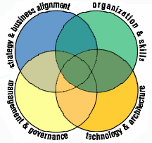
Aligning the IT organization’s structure, skills and sourcing strategy with the needs of the Department, while promoting employee learning and satisfaction
Managing IT resources and operations to ensure effective and efficient support of business and financial goals
Defining and operating the technology solutions, underlying architecture and processes for IT’s long-term support of business capabilities
Ensuring that the IT organization and technology is aligned with the Department’s goals and objectives throughout the entire cycle of innovation, planning and delivery
The IT Goals by category are summarized in Figure 2.
Figure 2: Summary of IT Goals by Category
Manage the IT workforce to ensure consistency in skill levels and service delivery
Become a center of excellence & employer of choice
Emphasize customer-focused support
Implement Department efforts to streamline & reduce costs
Close skill gaps
Support the tracking, measurement and management of performance, and tie performance with budget and investment decisions
Better manage IT-related contracts to maximize value and performance
Continue to improve IT portfolio management
Develop effective and efficient IT reporting processes

IT Management and Governance
Continue the alignment between IT and USDA’s Strategic Plan
Position and utilize the enterprise architecture as a management and governance tool

IT Strategy and Business Alignment
Technology and Architecture
Implement tools and processes to utilize the enterprise architecture
Align infrastructure to directly support strategic business goals
Sustain a robust information security management program
Participate on government-wide information technology solutions which support USDA strategic goals
IT Organization and Skills
These IT goals represent a blueprint for implementing IT that supports the USDA’s Strategic Plan. Following the USDA IT Strategic Plan, by 2012, will enable customers, both inside and outside the Department, to interface with a quality-focused, highly productive, responsive organization, one that exceeds customer requirements through continuous improvements of both products and services. Goals in support of E-Government will have reduced reliance upon, and, in some cases eliminated, inefficient paper processes. Electronic communications of applications and documents with our customers will occur seamlessly, facilitated by an integrated customer-facing approach, a modernized infrastructure, and Department-wide systems that bring USDA closer to meeting its overall vision. The Department, the OCIO and Agency CIOs can announce success or measure progress when this vision has become a reality.

Figure 3 depicts the representation of how USDA IT Strategic Planning will occur and the linkage between the USDA Strategic Plan, the USDA IT Strategic Plan, and the Agency USDA IT Strategic Plans. For example, this Plan represents the “IT Bridge” or “enabler” that defines how IT mechanizes the departmental goals at the agency level. The driving forces are the strategies, goals, and required performance measures as laid out in this five-year plan.

Figure 3: USDA’s IT Strategic Planning Diagram 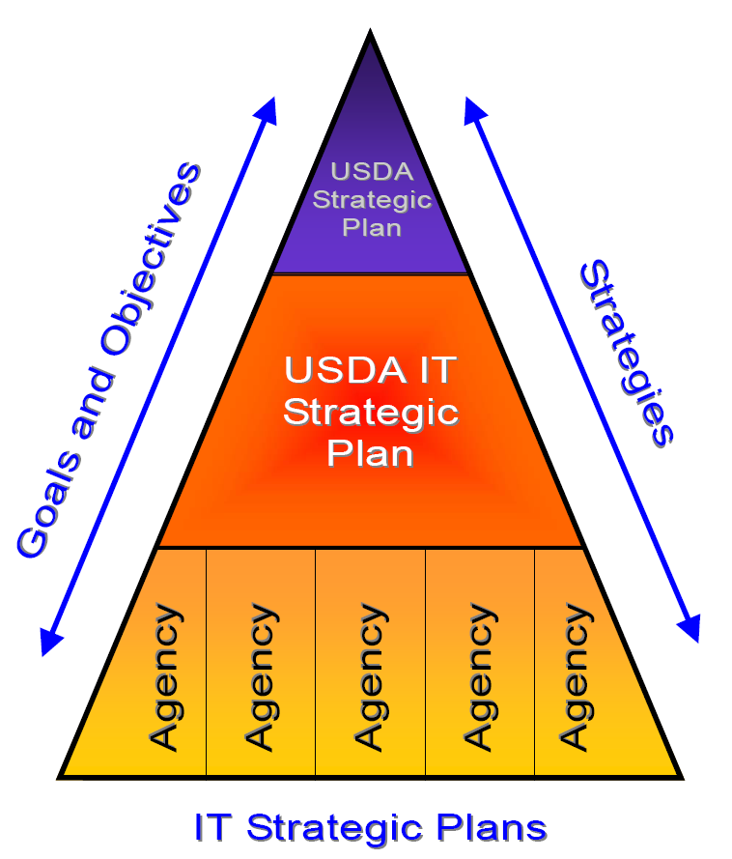

Introduction

Carrying on the tradition of Abraham Lincoln’s legacy and serving all Americans, the USDA leads the Federal anti-hunger effort; is the steward of our nation's 192 million acres of national forests and rangelands; is the country's largest conservation agency; brings housing, modern telecommunications, and safe drinking water to rural America; is responsible for the safety of the nation’s food; is a research leader allowing us to grow more food and fiber using less water and pesticides; and helps ensure open markets for U.S. Agricultural products.
USDA and its more than 100,000 employees directly touch the lives of virtually every American every day. Evolving over 140 years, USDA is one of the most complex Departments in the Federal Government, with more than 300 programs advancing progress in a diverse array of significant public responsibilities. In FY 2005, USDA spent more than $87 billion of our fellow Americans’ money to expand the economic security and opportunities available to farmers and ranchers, to safeguard the Nation’s food supply, to enhance the quality of life in rural America, to promote nutrition and health, and to protect our natural resources.
The USDA has always been driven to provide service to the American people - whether farmers, consumers, rural people, or those interested in nutrition, scientific research, our Nation's natural resources, food safety, or the protection and security of our food system. USDA employees achieve results every day, as they strive to provide the best government service.
The USDA IT Strategic Plan is the Department’s roadmap towards meeting its overall mission. It describes the goals which IT resource organizations should strive to achieve and it will govern the direction of the Department-wide IT program. We are taking major strides towards fully implementing mandated requirements, maturing our overall processes, and fulfilling a best-practice model. The ongoing IT governance and infrastructure is already being realized, as evidenced by the Department’s:
- Managing IT investments throughout the capital planning and investment control (CPIC) process;
- Leveraging the enterprise architecture (EA) and using the target architecture (TA) to reduce redundancies, improve data sharing and interoperability, and systematically fill the gaps in our IT environment;
- Ongoing commitment to maintaining a secure IT infrastructure that meets or exceeds national standards;
- Implementing an aggressive E-Government Strategy;
- Improving the quality, accessibility and sharing of data in our systems;
- Leveraging our IT resources through growing enterprise services and shared IT solutions; and
- Applying effective records management processes.
This Plan focuses on areas of the Departmental picture that are important to the ongoing success of USDA. The topics that are included in this document cover a wide spectrum of interests, but together they provide an overview of the USDA Strategic Plan for meeting the demands of an information and technology-rich transformational environment.
There are many challenges USDA will face. It has become clear that resources, including funding and people, are limited, so it is vital to make smart investments, integrate architectures, ensure secure IT environments, ensure an adequate IT workforce to meet these challenges, and leverage resources through enterprise solutions and increased partnerships. Our ultimate commitment is to sustain and improve performance within our mission areas and guarantee efficient and effective customer-oriented business operations. We want to ensure success through viable goals and performance measures that are applied to a value chain that moves from effective management of Inputs (i.e., investment in IT resources and maintenance of effective IT governance and control mechanisms) through the Work processes (implementation of procedures to meet rigorous standards to supply the targeted services or systems required by our customers) to accountable Results that provide successful outcomes supporting our mission and that ultimately determine if our processes and structures can deliver the “bottom line”.
Meeting these challenges requires new thinking and new ways of doing business; and it requires
focus: Are we fulfilling our mission? Are we delivering anticipated outcomes? Are we efficient in how we manage our programs? How do we know? Can the public review our progress?
(See Figure 4 below).
Figure 4: INPUTS, WORK, & RESULTS Chart
INPUTS:
Resources – Funding, Human Capital, Enterprise Services as shared solutions. | Controls – Capital Planning CPIC process, USDA IT governance (e-Board (Investment Review Board), E-Government Team, USDA EA Team, etc.).
WORK:
Process – IT project management and procedures to ensure compliance with CPIC. IT Security Enterprise Architecture, Knowledge Management, OMB’s A-130 and other guidelines and mandates to conduct operations according to efficient, legal and established criteria that are fully compliant with federal standards. | Output – The actual quantity, quality or timeliness of work products and services supplied to customers and users.
RESULTS:
Feedback – The way our customers and users view IT products or services (as evidenced by the demand made for output or satisfaction communicated). | Outcome – The ways in which IT users benefit and the strategic results that are actually experienced by customers using the IT system or service.

Purpose
The OCIO and Agency CIOs must leverage technology to ensure that the resources provided to us by Congress and the American people reach those who need them, with minimal expense and maximum impact, and build on USDA's long history of previous accomplishments. Technology and accurate information enable the professional public servants at USDA to spend the taxpayers' money wisely and aid in our goal of improving programs every year.
Therefore, the USDA remains committed to Department-wide strategic planning and to USDA IT Strategic Planning, especially in an era when information and technology contributes significantly to cost and value. It is through the Department mission and vision that the strategic goals of the Department are created and linked. Each of these goals has associated objectives, performance metrics, and strategies. Since the IT mission is to support the strategic direction of the business agenda, it is critical that all IT goals directly support one or more of the Department’s strategies.
The USDA IT Strategic Plan establishes a vision for how information and technology will be used to fulfill the overall strategies and objectives of the Department. The Plan:
- Links IT to the USDA’s strategies, objectives and operational needs (see Figure 5: Completion Dates of Strategic Planning Baseline Documentation);
- Provides the long-term direction for IT planning;
- Helps coordinate and integrate IT activities horizontally across program areas and vertically between headquarters and field offices;
- Creates mechanisms to systematically manage and direct USDA’s IT resources and programs; and
- Fulfills the strategic planning requirements of the Paperwork Reduction Act (PRA) of 1995, as amended, Office of Management and Budget (OMB) Circular A-130, and the Clinger-Cohen Act.
This document represents the Department’s guidance to effectively manage information and deploy technology in support of the Department’s strategic direction. Figure 5: Completion Dates of Strategic Planning Baseline Documentation depicts the baseline documentation that was used along with the associated document completion dates. These documents remain in effect to the extent that they elaborate on and provide detailed actions related to the USDA IT Strategic Plan.
Figure 5: Completion Dates of Strategic Planning Baseline Documentation
USDA’s DEPARTMENT STRATEGIC PLAN
USDA’s DEPARTMENT STRATEGIC PLAN
Other IT
-
related planning
documents
Other IT
-
related planning
documents
IT Security Plan
IT Security Plan
E
-
Government Program Plan
E
-
Government Program Plan
EA Migration & Sequencing Plan /
EA Blueprint
EA Migration & Sequencinglan /
EA Blueprint
USDA IT STRATEGIC PLAN
USDA IT STRATEGIC PLAN
Strategic Planning Documents Hierarchy
Key Dates
Draft completed:
August 2004
Draft completed:
July 2004
Completed:
May, 2006
CCCompleted:
Updated:
DInserecember 121111020La0203
JInsune 200E-411
st
Varies
USDA’s DEPARTMENT STRATEGIC PLAN
USDA STRATEGIC PLAN
Other IT
-
related planning
documents
Other IT
-
related planning
documents
IT Security Plan
Cyber Security Strategic Plan
E
-
Government Program Plan
E
-
Government Strategic Plan
EA Migration & Sequencing Plan /
EA Blueprint
USDA IT STRATEGIC PLAN
USDA IT STRATEGIC PLAN
Strategic Planning Documents Hierarchy
Key Dates
Completed:
September, 2006
Final completed:
April 2006
Previously updated for FY 02-06
Last Update: August, 2004

Varies
EA Concept of Operations/
EA Version 2.0

Scope of the USDA IT Strategic Plan
The USDA IT Strategic Plan encompasses information management, information technology, information resources management, information systems, and information services activities across the USDA. Additionally, the plan addresses a broad spectrum of technology services, products, and telecommunications technologies provided by the USDA OCIO and Agency CIOs. This plan applies to all organizations in the Department, including headquarters; state and field offices; loan processing and servicing centers; data centers and the National Finance Center. This plan also applies to all IT-related resources within the USDA, including the staff and IT-related resources working in areas outside of the IT organizations.
Figure 6 depicts the representation of how USDA IT Strategic Planning will occur and the linkage between the USDA Strategic Plan, the USDA IT Strategic Plan, and the Agency IT Strategic Plans. The driving forces are the strategies, goals, and objectives as laid out in this five-year plan.

Figure 6: USDA's IT Strategic Planning Diagram

Business-Driven USDA IT Strategic Planning Framework
The Department’s approach is a business-driven USDA IT Strategic Planning process that closely links IT goals to the needs and strategies of the business. In an era of “doing more with less,” USDA believes this is the most appropriate approach to clearly identify how limited resources could be allocated and expended on IT goals. Additional detail on this approach is in Appendix A – Business-Driven USDA IT Strategic Planning Framework Detail.

IT Mission, Vision, and Guiding Principles

Mission
The IT mission is to foster an environment in which information and technology are used to support and enhance business decisions and Department operations. Today, a seamless, secure IT business infrastructure is critical to supporting effective and efficient Agriculture operations.
We provide the information technology leadership and governance that enables the programs and operations of the Department to deliver their respective missions in an efficient, effective, and secure manner through the use of information technology solutions and services.
In doing so, the IT mission spans a wide range of areas and includes enhancing the business capabilities in the Department by providing: a secure IT environment, effective IT leadership, a capable and adequate IT workforce, and excellent customer service. These assets yield prudent IT investments, interoperable architectures, accurate records and data management support, as well as leadership in E-Government strategies, enterprise-wide solutions, and services to best support the Department’s core mission.

Vision
In an environment that is driven by information, the high-quality information must be delivered to those who need it, when they need it. The IT vision is:
To be a catalyst for change and a world class leader in delivering technology solutions and services that directly contribute to mission accomplishment; and an essential partner in business transformation, resulting in excellent customer service, strong partnerships, secure infrastructures, and cost efficient performance.
We envision IT at the USDA as having a proactive role not only as a business partner, but also as an integral part of the Department’s overall business. Our focus on an integrated enterprise approach will leverage benefits for USDA agencies and offices and improve mission performance. Implementing IT as an integrated and vital component within all of USDA’s lines of business is also a means of business transformation. It supports meeting the Department’s mission and goals through developing modernization blueprints, implementing data sharing opportunities, providing enterprise integration services, consolidating Department networks and data centers, and migrating to a single messaging system.

IT Guiding Principles
The following guiding principles direct decision-making at different levels of the organization. These principles form the common values embraced and demonstrated by the OCIO and Agency CIOs and provide broad guidance for IT planning and architecture decisions into the future:
- Support USDA’s mission by delivering information management solutions in a professional, effective, and prompt manner;
- Use the EA to make informed business decisions;
- Ensure that all Departmental/Department-specific IT goals and investments are customer-focused, results-oriented, and cost-effective;
- Promote sharing and implementing best practices, collaborating on projects and goals, and ensuring interoperability across USDA;
- Provide a high-quality, innovative and secure IT infrastructure that proactively assures confidentiality, integrity and accessibility and protects USDA data and information systems; and
- Attract, develop, and retain a competent, creative, and highly motivated workforce.

Ensuring Civil Rights
The DR 4300-010, “Civil Rights Accountability Policy and Procedures,” issued January 18, 2006, is incorporated into this USDA IT Strategic Plan. It is the policy of USDA to treat customers and employees fairly and equitably, with dignity and respect, regardless of race, color, national origin, sex, religion, age, disability, political beliefs, sexual orientation, marital or familial status, parental status and protected genetic information, or because all or part of an individual’s income is derived from public assistance. Retaliation against customers or employees for opposition to discrimination of any kind in contravention of this policy will not be tolerated.
Managers and supervisors are responsible and accountable for maintaining a civil rights program that will accomplish the strategic civil rights goals. Agency officials, managers, supervisors and other employees shall be held accountable for discrimination, retaliation, civil rights violations, or related misconduct. Discrimination, retaliation, civil rights violations, or related misconduct will be evaluated, in accordance with this policy and with the governing Federal and USDA regulations regarding discipline and adverse actions, by agency human resources (HR) offices, in conjunction with the Office of Human Capital Management (OHCM), to determine if disciplinary or other corrective action is warranted.
The Civil Rights goal fully supports the Department’s strategic goals, objectives and management initiatives: To ensure USDA provides fair and equitable services and benefits to all customers and upholds the civil rights of its employees.

USDA Strategic Goals

The USDA Strategic Plan for FY 2005-2010 identifies key policy and management objectives that will be integrated with USDA’s budget priorities and that provide accountability through a series of annual performance plans. Central to the Plan is effective management of the Department’s resources in an effort to best deliver its multifaceted programs. USDA is strongly committed to strategic planning and to the goals and strategies outlined in this Plan. Within this framework, USDA intends to continue improvement by remaining flexible and open to new opportunities and change.
USDA is working to strengthen its management through vigorous execution of the President’s Management Agenda (PMA). Better management will result in more efficient program operations that offer improved customer service and more effective stewardship of taxpayer funds. USDA expects to:
- Ensure an efficient, high-performing, diverse workforce, aligned with mission priorities;
- Work cooperatively with partners and the private sector;
- Enhance internal controls, data integrity, and financial management information and sustain unqualified audit opinion;
- Reduce spending and burden on citizens, partners and employees by simplifying access to the Department’s information. This enhancement is added by implementing business processes and information technology to make services available electronically;
- Link budget decisions and program priorities more closely with program performance and consider the full cost of programs;
- Efficiently and effectively manage real property; and
- Transform IT enterprise infrastructure to be cost effective and transparent across all agencies and geographic regions.
Figure 7: Strategic Alignment Depiction reflects the overall alignment between the USDA vision, strategies, and how the USDA IT Strategic mission, vision, and goals align with the Department.
Figure 7: Strategic Alignment Depiction

Overview of IT Goals

The USDA Strategic Plan calls for a Department that is more citizen-centered, more responsive to a changing marketplace, and more results-oriented. To achieve this, the USDA must transform itself into an information-driven, technology-enabled organization that collects quality data, analyzes trends and customer needs, markets its products and services, provides excellent customer management, and integrates its products and services to address customer needs. Developing the right mix of technology-based capabilities, such as Internet applications, knowledge-based systems, and network computing, can translate into a new way of doing business as well as contribute to business value, growth opportunities, and lower operational costs. In 2007, USDA plans to invest over $2 billion in IT assets and services. The success of these IT investments directly influences the ability of organizations within USDA to execute business plans and fulfill missions.
USDA believes that information should be used to enable more effective decision-making, to determine, for example, which programs are best meeting the needs of our customers, which customers may need a greater breadth of our services, which channels are most effectively distributing our services, and how well we are truly performing in our quest to positively impact the Nation’s economy. When information can be used for this fundamental level of decision-making, we can truly transform our Department into what we envision ourselves becoming: a high-performance organization. The following examples reflect the close linkage between USDA IT Strategic Goals and the USDA Strategic Goals identified in Chapter 4.
- All current E-Government plans and initiatives are heavily dependent upon their underlying IT investments.
- The Food and Nutrition Service is heavily dependent upon Electronic Benefit Transfer (EBT) to carry out its $15 billion Food Stamp Program. More than 75 percent of food stamp benefits are currently being issued via EBT.
- The Risk Management Agency uses computers to help identify patterns of fraud, waste and abuse in crop insurance activity that can be very difficult to discern with the human eye alone.
- The Rural Development mission area is highly dependent upon its information systems to manage its $60 billion loan portfolio.
- State-of-the-art commercial-off-the-shelf geographic information systems (GIS) are used in managing land conservation, wildlife, and resource use decisions.

Summary of IT Goals
The USDA IT efforts for the next several years will be driven by the USDA’s IT Strategic Plan and will focus on four IT categories as illustrated in Figure 8: IT Categories and their Interrelationships.
Figure 8: IT Categories and their Interrelationships
Define and operate the technology solutions, underlying architecture and processes for IT’s long-term support of business capabilities
Align the IT organization’s structure, skills and sourcing strategy with the needs of the Department, while promoting employee learning and satisfaction
Manage IT resources and operations to ensure effective and efficient support of business and financial goals
Ensure the IT organization and technology are aligned with the Department’s goals and objectives throughout the entire cycle of innovation, planning and delivery

These four IT categories organize the business strategies and their respective IT goals. Figure 9 provides an overview of the groupings that are used within each categorization for the Department’s strategies and related IT goals. These goals are discussed in detail in the subsequent four sections.
Figure 9: IT Goals Categories
Manage the IT workforce to ensure consistency in skill levels and service delivery
Become a center of excellence & employer of choice
Emphasize customer-focused support
Implement Department efforts to streamline & cut costs
Close skill gaps
Support the tracking, measurement and management of performance, and tie performance with budget and investment decisions
Better manage IT-related contracts to maximize value and performance
Continue to improve IT portfolio management
Develop effective and efficient IT reporting processes

IT Management and Governance
Continue the alignment between IT and USDA’s Strategic Plan
Position and utilize the enterprise architecture as a management and governance tool

IT Strategy and Business Alignment
Technology and Architecture
Implement tools and processes to utilize the enterprise architecture
Align infrastructure to directly support strategic business goals
Sustain a robust information security management program
Collaborate on government-wide information technology solutions which support USDA strategic goals
IT Organization and Skills

IT Strategy and Business Alignment Goals

This business-driven USDA IT Strategic Plan assumes that the primary function of IT is to support the Department’s mission, vision, goals, objectives and strategies. That logic falters when the Department’s goals are not well-understood throughout the Department, from the senior executives to the front-lines; when the business expects more from IT than the current infrastructure will allow; or when the IT organization fails to articulate its limitations to satisfying business needs. Therefore, the Department’s ability to meet its mission through the effective use of technology relies upon clear communication between the program offices and the OCIO, as well as those performing IT-related functions within the Department.
Communication has improved between the business and the IT organization within the Department through the Executive Information Technology Investment Review Board (E-Board). The E-Board was established pursuant to the requirements of the Clinger-Cohen Act, and is comprised of senior-level policy executives. The E-Board ensures that USDA IT investments are managed as strategic business resources. The Deputy Secretary oversees this process as part of his responsibility for day-to-day operations of the Department. This governing body is a key element of the CPIC process.
Additional goals will ensure that the IT organization and technology are aligned with the business goals and objectives throughout the entire cycle of innovation, planning and delivery. These IT Strategy and Business Alignment Goals are:
Continued alignment of IT with the USDA’s Department Strategic Plan; and
Positioning and utilizing the EA as a management and governance tool.

Continue Alignment of IT with the USDA’s Strategic Plan
Department-wide communication of all updates to the USDA's Department Strategic Plan is critical because the updated Plan will form the foundation for all other strategic planning documents prepared within the Department. The update of the USDA’s Department Strategic Plan will also be the continuing driver behind IT goals and spending priorities.
As part of the preparation process for this IT Strategic Plan, in-depth interviews were conducted with the Department CIO, Deputy CIO, five Agency CIOs, and all of the Associate CIOs (ACIOs). One of the goals for this effort was to seek insight into ways in which the Department OCIO can improve its operations. An overwhelming theme emerged: the need for better communications – internally within the Department OCIO, and externally between the Department OCIO and the 29 Agency CIOs, as well as the field offices around the country. The common communication challenges encountered can be categorized into three primary areas:
- Internal Communications, within the Department OCIO (Horizontal Communications);
- External, Department-wide Communications (Vertical Communications); and
- External, Third-Party Communications (Third Party Communications).
The development of a sound, executable, and visible communications strategy as part of the Department’s IT Strategic Plan will uniquely position USDA’s IT Program to become a government center of excellence demonstrating best practices in streamlined IT operations. The development and execution of the USDA IT Communications Plan is scheduled to begin in early FY 2007.

Position and Utilize the EA as a Management and Governance Tool
The Department believes that the USDA EA is much more than a static document produced to meet regulatory requirements. Properly positioned and utilized, the EA is first and foremost a management and governance tool.
The EA provides a comprehensive view into the various layers of the Department. The foundation of the EA is made up of the Federal Enterprise Architecture Framework (FEAF) layers. These layers include the Business Architecture, Applications Architecture, Data Architecture, and Technical Architecture. These layers are further categorized by domains. There are: external portions of the architecture (usually national or federal); common/enterprise USDA-wide portions; and Agency portions. USDA is using the Open Group Architecture Framework (TOGAF) as the Department’s EA Methodology.

Alignment is derived from addressing both business and technology architectures and establishing clear linkage between business strategies and enabling technology. The importance of the EA lies in its ability to highlight the impact a business change may have on the underlying technologies, and vice versa. As such, the EA can be used to predict the impact of both IT and business decisions. EA Program emphasis is on investment support systems, security and e-Government projects. The EA can also be used to measure progress on attaining business and technology performance goals, as required by the Federal Enterprise Architecture (FEA) Performance Reference Model. The USDA EA will go deeper and become integrated with the Department’s strategic planning, CPIC process, software development, and COTS/ GOTS evaluation and selection processes.
To position the EA to be used as a management tool USDA will:
- Define and implement an EA action plan to improve the maturity level of the architecture discipline within USDA;
- Establish department-wide EA configuration controls and strategies.
- Identify and recommend changes regarding new enterprise-wide standards
- Integrate capital planning and EA;
- Ensure department transition plans are aligned with changing business needs and strategic priorities; and
- Ensure PMA compliance.

Performance Measures
The following represents the performance measures for the IT Strategy and Alignment Goals:
On an annual basis, ensure the USDA IT Strategic Plan is aligned with the USDA Strategic Plan. If there are any revisions, ensure the USDA IT Strategic Plan accommodates those revisions as appropriate in the next update to its USDA IT Strategic Plan.
In FY 2007, begin marketing and communicating the final USDA IT Strategic Plan for exposure and awareness of the IT vision and direction for IT at USDA.
Beginning in FY 2007, develop an action plan to mature the current level of the USDA EA. Update the plan on an annual basis to ensure consistency with OMB guidance and progression of technology throughout the Department.
Integrate the components of the IT Strategic Plan into IT employee performance standards.

IT Organization and Skills Goals

Because IT has evolved beyond a basic support structure into a value-added provider of infrastructure, technology, information services, as well as transformational, customer-centric solutions, the OCIO and the Agency CIO organizations will be structured to meet these added demands. Efforts already underway to organizationally focus the OCIO and other Agency CIO organizations are intended to provide internal customers greater responsiveness through side-by-side partnership, while also delivering projects on time and within budget. In order to keep pace with the Department’s information requirements, existing IT reporting relationships, IT performance evaluations, and IT skill assessments will continue to be periodically evaluated.
The IT organization and skills goals focus on aligning the IT organization’s structure, skills and sourcing strategy with the needs of the business, while promoting employee learning and satisfaction.
The following sections discuss these five major goals:
- Manage the IT workforce to ensure consistency in skill levels and service delivery;
- Become a center of excellence and employer of choice;
- Emphasize customer-focused support;
- Implement Department efforts to streamline and cut costs; and
- Close skill gaps, i.e. project management and Contracting Officer Technical Representative (COTR) skills.

Manage the IT workforce to ensure consistency in skill levels and service delivery
To achieve the overall goals of the USDA IT Strategic Plan, the OCIO and the Agency CIOs must work in concert with USDA agencies and offices to ensure that the IT workforce has the knowledge, skills and abilities to make those goals a reality.
Key to the success of this goal is the development of an IT Human Capital Management Plan. This plan will outline the goals, objectives and timelines to ensure consistency in individual skill levels, with special emphasis on customer service and service delivery. The IT Human Capital Management Plan will link to the USDA Human Capital Management Plan as well as the USDA Strategic Plan. It will focus primarily on these areas:
- Strategic alignment/human capital planning;
- Workforce planning and deployment;
- Accountability system;
- Talent management; and
- Leadership development and succession planning.

Become a center of excellence and employer of choice
Like any world-class organization, USDA seeks to ensure mission success by hiring and retaining a top-notch workforce. We intend to become a government IT center of excellence, and believe that building an established reputation for excellence will make the USDA an employer of choice for IT professionals within government as well as the private sector.
To that end, the Department intends to explore third party certification for its IT organization. Examples of such certifications include Capability Maturity Model Integration (CMMI), International Organization for Standardization (ISO) 9000, or National Institute for Standards and Technology (NIST) compliance. A brief overview of these certifications is presented below:
- CMMI is a process improvement approach that provides organizations with the essential elements of effective processes. It can be used to guide process improvement across a project, a division, or an entire organization. CMMI helps integrate traditionally separate organizational functions, set process improvement goals and priorities, provide guidance for quality processes, and provide a point of reference for appraising current processes. CMMI is trademarked by the Carnegie Mellon Software Engineering Institute, a federal funded research and development center.
- ISO 9000 has become an international reference for quality management requirements in business-to-business dealings. ISO is the world's largest developer of standards.
- Consistent with Section 12(d) of P.L. 104-113, the National Technology Transfer and Advancement Act of 1995, directs agencies to use voluntary consensus standards in lieu of government-unique standards except where inconsistent with law or otherwise impractical. It also provides guidance for agencies participating in voluntary consensus standards bodies and describes procedures for satisfying the reporting requirements in the Act. The policies contained in OMB A-119 are intended to reduce to a minimum the reliance by agencies on government-unique standards.

Emphasize customer-focused support
The USDA IT community is extremely customer-oriented and will continue to emphasize customer-service as a priority throughout the Department and Agency IT organizations. Customer satisfaction will be continually measured through surveys and other service-oriented tools.

Implement Department efforts to streamline and cut costs
There are many initiatives underway to implement our strategic plan. Last fall, three Department-wide optimization initiatives were approved by the Department’s IT Review Board; they include email consolidation, network consolidation, and lastly data center consolidation. These initiatives, together with an overall assessment of the Department’s IT Program and implementation of a multi-year action plan to implement recommendations from various reviews, are positive steps we’re taking toward ensuring achievement of the USDA’s mission.

Close skill gaps
Although the Department will continue to outsource delivery of some IT services to the private sector, those services will always be managed by USDA Federal employees. In order to execute those management responsibilities, the Department OCIO and Agency CIOs will work diligently to ensure that USDA employees with management and contractual oversight duties are well trained and well prepared to execute those duties.
Creating clear direction, efficiency, timely response, and quality outcomes requires project managers who are agile – adept at change. The IT Leadership Team of the Department will seek certification of USDA program managers by the Project Management Institute (PMI), the world’s leading association for the project management profession. It administers a globally recognized, rigorous education, and/or professional experience and examination-based professional credentialing program.
The IT Leadership Team will develop a plan to ensure a group of employees is targeted each year to attend PMI training so that succession planning in the area of project management does not become an issue. While this is a positive step forward, leadership is committed to ensuring that all employees have a project management mentality in terms of completing projects on time and on budget. Therefore, the USDA IT employees will be coached on EVM and the Clinger-Cohen Act project management regulations, as well as the ramifications that a missed project deadline or cost overrun has on other projects in the IT portfolio. Furthermore, the PMI’s Organizational Project Management Maturity Model (OPM3) will be considered for utilization for assessment and guidance on prioritizing and planning increased maturity in this area.
The requirement for technical and effective Contracting Officer and Technical Representatives (COTRs) is ever increasing in the Government workplace. As the Department outsources more, the need for highly trained COTRs is a strong requirement and a necessity to ensure a fair and equitable contract management program exists to produce resource investments.

Performance Measures
The following represents the performance measure for IT Organization and Skills Goals.
Develop a Human Capital Management Plan.

IT Management and Governance Goals

In an environment characterized by doing more with less, fiscal prudence takes on a critical level of importance. Increased emphasis must be placed on the decision-making process to ensure that budgeted dollars are being spent in those areas that support the strategic direction of the Department. For example, a coherent and collaborative process for approval and evaluation of projects must be in place to apply the proper controls over any potential expenditure. Furthermore, once expenditures have been approved, checkpoints must be implemented and enforced to enable fiscal management and project accountability throughout the project lifecycle.
Business-aligned IT management and governance will not only ensure business-focused IT investments, but it will also contribute to operational improvements resulting in a lower fixed cost structure. The following sections discuss IT Management and Governance goals:
8.1 Performance Management – Support the tracking, measurement and management of performance, and tie performance with budget and investment decisions.
A focus on Department planning and management will result in clearly defined goals, aligned business strategies, and the coordination of operational support systems, all of which when combined will enable the Department to clearly identify progress against objectives and performance targets. This level of performance management will also ensure that IT dollars are allocated properly.
The Performance Management goals support the OMB’s Program Assessment Rating Tool (PART) assessments as well as the Government Performance and Results Act (GPRA) of 1993. Together, these legislative actions specify that budget and performance results should link to strategic goals and align with strategic plans, and they specify requirements to evaluate program effectiveness.
This alignment is ensured by mapping performance indicators from the Department Strategic Plan against the FEA Performance Reference Model (PRM). The business must categorize these indicators and work with the OCIO and Agency CIOs to establish a linkage between the Mission and Business Results, Customer Results, Processes and Activities, and Technology. This linkage is required to establish a clear line of sight from the Mission and Business Results performance areas through to the Technology performance areas.
The IT Leadership Group determined that a primary performance indicator would be the establishment of a Departmental Change Management Board (CMB) to protect against downtime and risks to systems. Implementing a CMB comprised of leaders from Cyber Security, Enterprise Application Development, Enterprise Architecture, Network Operations, and Management will assure all changes are appropriately reviewed and system risks are minimized.

Contract Management – Better manage IT-related contracts to maximize value and performance
In July 2003, the Office of Federal Procurement Policy (OFPP) issued a report, “Performance-Based Service Acquisition: Contracting for the Future,” outlining recommendations to improve the quality and increase the use of performance-based service acquisition (PBSA). An interagency task force representing agencies that award a significant dollar amount of service contracts and task orders developed these recommendations. The Federal Acquisition Regulation (FAR) encourages use of PBSA to the maximum extent practicable except for the exclusions identified in FAR 37.102 as identified below:

- Architect-engineer services acquired in accordance with 40 U.S.C. 541-544,
- Construction,
- Utility services, or
- Services that are incidental to supply purchases.

The USDA leadership has been identifying inter- and intra-Department opportunities for joint contract purchases. Contract management refers to the ability to consolidate buying power in order to achieve lowest per-unit costs. Performance-based contract management refers to the ability to manage those contracts against predetermined performance expectations. It also includes the discipline, once a contract is in place, to discretely and accurately track time and expense against performance for all projects within a contract. This discipline will improve the Department’s financial performance and the performance of the IT portfolio.

IT Portfolio Management – Continue to improve IT portfolio management
In an effort to maximize ROI and achieve the most value for each dollar spent, it is important to leverage existing IT resources where possible, avoid redundant projects, focus on cross-Department improvements rather than piece-meal enhancements, and implement the tools and processes necessary to achieve more effective and efficient IT portfolio management. Adoption of a portfolio approach to managing IT projects enables a comprehensive view of all concurrent and completed IT investments, bring logic and structure to investment decisions and improve the dialogue with the business. Furthermore, the skills and tools necessary to manage these projects to against the business objectives or goals must be available.
Initial steps towards a portfolio management approach have been taken by implementing the CPIC process. The E-Board oversees Department IT investments. Additionally, WorkLenz is being used to document major projects, and several internal tools are being used to manage major projects.
However, more remains to be accomplished. The Department will begin to approach its IT investments in a portfolio approach, clearly identifying portions of the budget targeted for maintenance activities versus focused business investments versus pure strategic investments. Projects can then be divided into budgets based on these types of investments, providing additional ways to prioritize investment projects. The Department will leverage portfolio concepts such as these, along with EA, in the CPIC process of evaluating, selecting, and controlling IT investments.

IT Reporting - Develop effective and efficient IT reporting processes
One of the cornerstones of operational effectiveness in an organization is the ability to report quickly and accurately. This capability is dependent upon seamlessly integrated systems and processes.

Performance Measures
The following represents the performance measures for the IT Management and Governance Goals:
Establish a Departmental Change Management Board.
Achieve OMB’s target to award 50% of IT acquisitions as “performance-based”
All agencies (including the OCIO) will develop their own IT Strategic Plans that link to the USDA IT Strategic Plan.

Technology and Architecture Goals

Technology and architecture cover a broad spectrum of services, products, and telecommunications technologies provided throughout the Department. These include the major types of service areas that manage data and applications (distribution, utilization, and administration), as well as the infrastructure required to engineer and manage those applications and information.
USDA is rapidly incorporating new technologies into its program delivery strategies. The Internet is used for information dissemination and business interactions with internal and external customers and partners. USDA is partnering with other federal agencies and state and local governments in information and data sharing activities using common databases and web-enabled applications. USDA has initiated several enterprise initiatives and has aligned with, and is implementing, government-wide initiatives as well. These initiatives are foundational to USDA’s current and future EA. USDA’s EA is advanced through a disciplined and collaborative decision-making approach through the CPIC process.
USDA’s transformation approach requires both leveraged investments and customer-centric focus demanding a shift from working in independent agency- and project-specific systems to delivering information and services through integrated, enterprise-wide and interdepartmental solutions. Specifically, as approved through USDA’s CPIC process, all IT investments must:
- address opportunities to provide services through collaborative verses single agency approaches;
b) integrate processes and transactions to improve the customer’s experience; and
c) align with USDA’s current and future EA.
USDA’s approach considers the needs of all customers and recognizes that USDA may need to operate dual delivery channels as customers’ transition to web-based and other electronic systems.
Key challenges and goals in this area include:
- Implement tools and processes to utilize the EA
- Align infrastructure to directly support strategic business goals
- Sustain a robust information security management program
- Collaborate on Government-wide IT solutions which support USDA strategic goals
  - Participate in USDA e-Government initiatives
  - Participate in Presidential E-Government initiatives and directives
  - Participate in Lines of Business (LOBs)
  - Implement OMB directives and mandates

Enterprise Architecture
USDA’s EA offers extraordinary possibilities to deliver dynamic customer services, strengthen relationships with partners and stakeholders, share information across traditional boundaries, and reduce operating costs. It fundamentally changes how USDA interacts with, and provides information and services to its customers, stakeholders and employees. EA plays a critical role in aligning the IT strategy and business mission, goals, objectives, and strategies. That is, the EA is the blueprint for how information technology enables the USDA to better serve its customers. One of the goals of the Department’s EA efforts is to achieve a highly-scalable infrastructure that offers high usability, strong security, robust tools and services, and fully developed web capabilities.
EA is the explicit description and documentation of the current and desired relationships among business and management processes and information technology. The EA should describe the "current" architecture and the "target" architecture. As we mature the EA program, it will provide a migration path and sequencing plan to help prioritize the IT projects and programs. The EA program will also include the rules and standards to optimize and maintain IT investments and portfolios. The EA will change as the Department changes.
Putting EA to work as a management instrument requires that the USDA invest in process and technology to ensure the ready management and dissemination of the EA to the various business domains throughout the Department.

Align Infrastructure to Directly Support Strategic Business Goals
The IT Infrastructure, also known as the Technology Architecture, defines the IT needed to provide a functional and efficient environment for existing and future applications and information. The Technology Architecture is the bottom layer in the architectural hierarchy, and is often considered the foundation on which all the other IT architectures are built. While the foundation metaphor holds true for the construction of USDA’s enterprise IT environment, the architecture or design of the infrastructure is driven by business needs communicated by the design of the three higher architectural layers (Business Architecture, Data Architecture, and Application Architecture).
Figure 10 below identifies the USDA Target Architecture (TA) Framework reflecting internal, common enterprise-wide and external services.
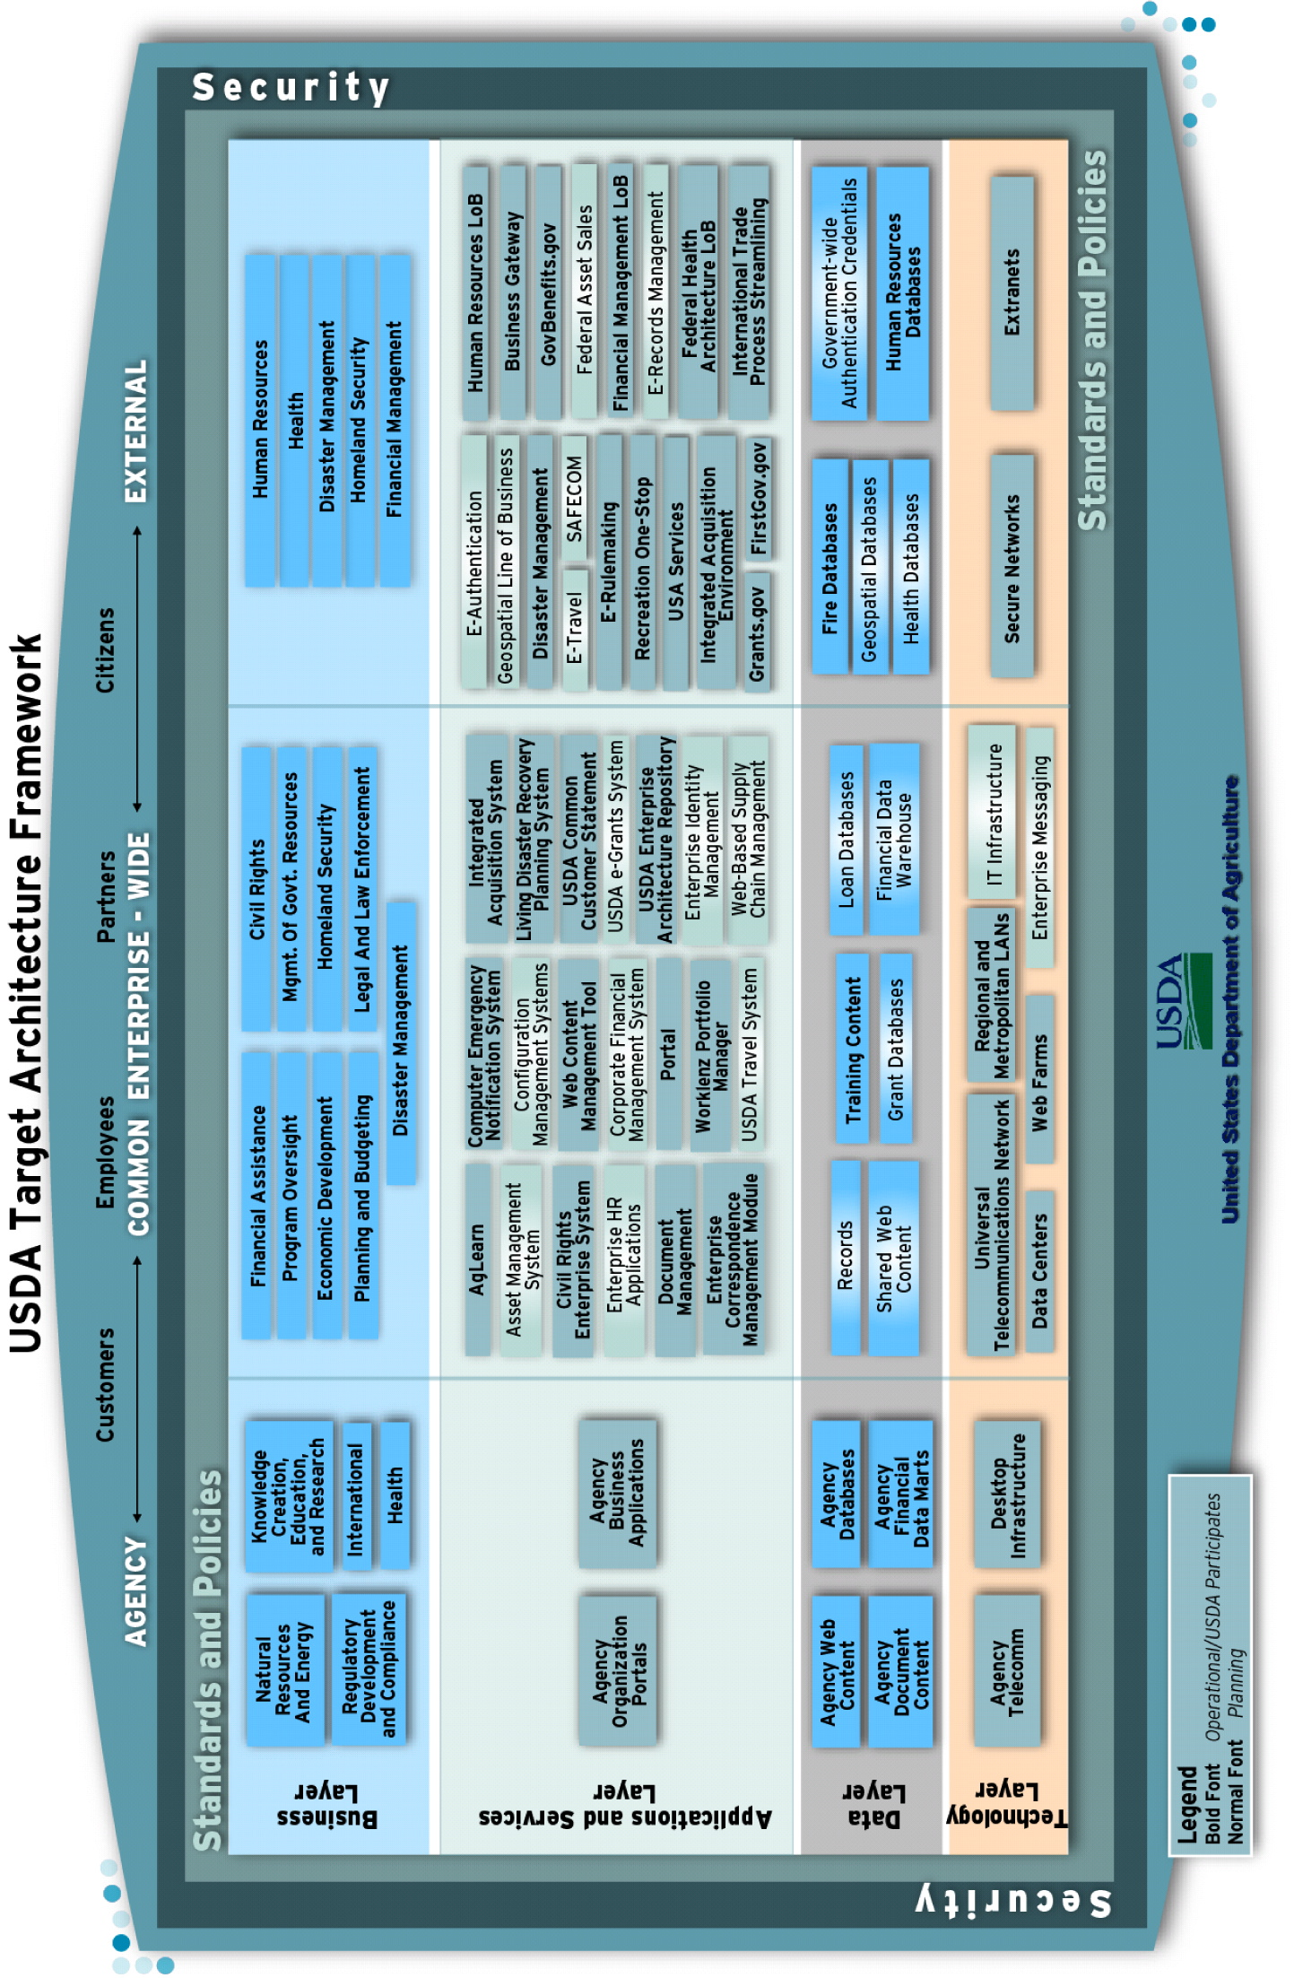
Figure 10: USDA Target Architecture Framework
As part of maturing the EA and moving towards the TA, the following common enterprise-wide components are being implemented at USDA. See Figure 11 on the next page for a better view of these components.
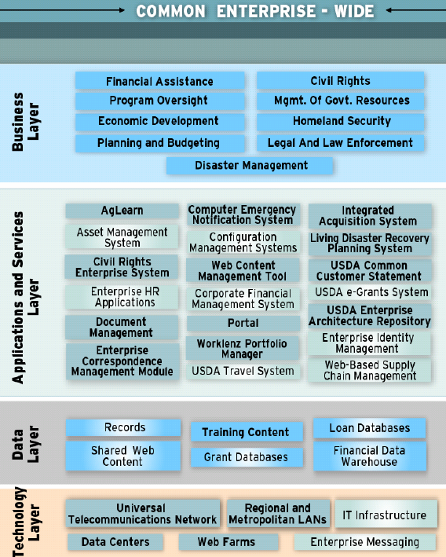
Figure 11: USDA Common Enterprise-wide Target Architecture Components

Sustain a Robust Information Security Management Program
The USDA must safeguard the data it collects and maintains. IT security includes the integrated planning framework and unified approach to developing and implementing security policies, procedures, and plans. All parties in electronic transactions must have the confidence that using electronic means to carry out private and/or sensitive transactions will be conducted in a manner that ensures information is protected. This includes transactions such as providing regulatory data, applying for a loan or grant, or requesting certification to participate in USDA programs.
The USDA Cyber Security (CS) (or Information Security) Program is defined as a unified and tightly integrated business process designed to meet USDA strategic missions with centralized management and execution. At the same time, the program is structured to provide enterprise solutions for CS so that senior leadership, resource managers, IT asset managers, and security practitioners can collectively make informed business decisions relative to CS architectural guidelines, resource allocation, and acquisition strategies
The USDA will protect and defend information and information systems by ensuring confidentiality, availability, integrity, certification and authentication, and non-repudiation.
On August 27, 2004, the President signed HSPD-12 “Policy for a Common Identification Standard for Federal Employees and Contractors” (the Directive). The Department will implement the Directive to ensure secure and reliable forms of identification for Federal employees and contractors.

Participate on Government-wide Information Technology Solutions and Initiatives which Support USDA Strategic Goals
The USDA will strive to provide an infrastructure that facilitates a seamless, secure, and reliable interface to the USDA's employees, customers, and resource partners. In addition to the infrastructure goals, the Department must continue to support the development of USDA’s customer service plans through enhanced data quality and replacement of legacy information systems with integrated web-based systems. In doing so, the USDA will develop a scalable and flexible technology foundation that will support the customer-centric E-Government systems and goals.
Beyond these infrastructure efforts, the Department will continue to meet established milestones to comply with the Expanding Presidential E-Government initiative and PMA. The OCIO and Agency CIOs will focus on key areas for effective IT management, such as EA, Federal Information Security Management Act (FISMA), and business case development, as well as on network efficiency, reliability, and capacity to ensure support of our E-Government projects.
Efforts continue internally across the Department to identify E-Government initiatives to streamline processes and improve customer service. This has necessitated the review of all initiatives so that those with cross-Department impact will be emphasized – rather than pursue stovepipe improvements – while short-term initiatives with high benefit and quick turnaround will also be prioritized.
In 2002, USDA published a Departmental e-Government Strategic Plan focused on improving the delivery of its information and services and reducing costs. The plan called for USDA to:

- Provide customers with single points of access to information and services;
- Simplify and unify business processes spanning multiple agencies;
- Establish information and service-delivery standards; and
- Consolidate redundant information technology services and systems through use of shared USDA or Government solutions.
USDA will implement numerous Presidential E-Government initiatives defined in the Departmental e-Government Strategic Plan. The full list and description of USDA Shared Services is identified in Appendix C.
To promote and implement a government-wide E-Government vision, the President’s Management Agenda identified cross-Department initiatives from various agencies. Agencies are encouraged, and in some cases mandated, to migrate from Department-specific solutions to these E-Government solutions, and in most cases, to integrate with these cross-Department solutions. The initiatives are to improve all stakeholder interactions with the government and to reduce overall government expenditures through investments in shared solutions. USDA participates in 21 of these initiatives. In addition, USDA participates in the implementation of Homeland Security Presidential Directive 12 (HSPD 12). Appendix D contains a list of Presidential E-Government Initiatives and Directives where USDA is currently participating.
USDA has embraced Internet technologies and executes many aspects of its operations in a manner consistent with the E-Government Guiding Principles. Each initiative directly supports the PMA; as well as the USDA goals and objectives.
USDA participates in eight Lines of Business (LOB) established by OMB. The goal of the LOB approach is to identify opportunities to reduce the cost of government and improve services through business performance improvements.
- IT Infrastructure Optimization

- Geospatial
- Budget Formulation and Execution
- Federal Health Architecture Line of Business
- Financial Management Line of Business
- Grants Management Line of Business
- Human Resources Line of Business
- IT Security Line of Business
Finally, USDA is also implementing Internet Protocol version 6 (IPv6) across the Government for consistency in network protocol.

Performance Measures
The following represents performance measures for Technology and Architecture Goals:
Continue to implement and finalize the USDA EA TA and move towards the next level of EA Maturity. Measurement of this effort will be determined through the implementation of common enterprise-wide components as identified in Figure 9.
Ensure that all 29 agencies are migrated to the Universal Telecommunications Network (UTN).
Establish performance standards for Infrastructure support services.
Develop a Departmental Strategy for infrastructure optimization.
Implement HSPD-12, as required by OMB.
Finalize implementation of the Enterprise Messaging System.

Conclusion

This document outlines IT goals across four interrelated IT categories:
- IT Strategy and Business Alignment;
- IT Organization and Skills;
- IT Management and Governance; and
- Technology and Architecture.
The following chart depicts how the USDA Strategic Goals and IT Strategic Goals are aligned in support of the PMA, USDA and Department-wide IT mission and vision.

Figure 12. Strategic Alignment Depiction
Once the IT goals are achieved, over the course of the next five years, the OCIO will have succeeded in providing world-class IT service in support of the Department’s mission, goals, objectives, and strategies. The OCIO will also have remained aligned with any changes in Department direction; made significant progress in maturing the EA; transformed itself into a high-performance customer-focused organization with an appropriately-skilled, highly-motivated and responsive IT workforce; evolved management and governance processes; facilitated information flow across the Department; maximized the performance of the Department’s applications and infrastructure; and strengthened IT security and privacy.
Many steps are necessary to arrive at that future. This document represents the first step of a continual process that requires collaboration and communication across the Department. It also serves as the baseline for guiding the OCIO in support of the Department and in its mission to be a center of excellence across Government.
- The immediate next steps to execute against this baseline include:
- With the enactment of the FY 2007 appropriation and submission of the FY 2008 budget, expand the Preliminary USDA IT Strategic Plan to include expanded USDA stakeholders input; develop an implementation plan with performance indicators, milestones, and key dates, and a corresponding scorecard/dashboard to report and monitor progress;
- Develop a Departmental IT Communications Strategy;
- Prioritize competing business and IT demands in a resource-constrained environment, which includes gaining agreement of priorities from key stakeholders;
- Integrate those priorities into the IT governance processes;
- Use the EA to move towards an infrastructure that can meet or exceed performance metrics at all levels of delivery (for example, from the operational level of performance to performance in supporting the Department’s mission, goals, and objectives); and
- Develop an IT Human Capital Plan that outlines target activities and milestones to acquire certain skill sets and resources, and provides clear justification for this ongoing investment.

Appendix A – Business-Driven USDA IT Strategic Planning Framework Detail
The business-driven strategic planning process entailed identifying the most comprehensive set of the Department’s planned and long-term strategies, objectives, and goals across a number of strategic planning documents. An overview of the approach is depicted in Figure 13: Business-Driven USDA IT Strategic Planning Approach.
USDA’s Strategic Plan
FY07-08 Budget
Figure 13: Business-Driven USDA IT Strategic Planning Approach
Clarifying terms became a critical step in the process, due to the number of strategic planning documents within USDA. While the USDA’s Department Strategic Plan formed the basis for the USDA IT Strategic Plan update, other documents which needed to be understood introduced unique terms. Figure 14: Definition of Terms outlines the definitions used in this document.

Figure 14: Definition of Terms
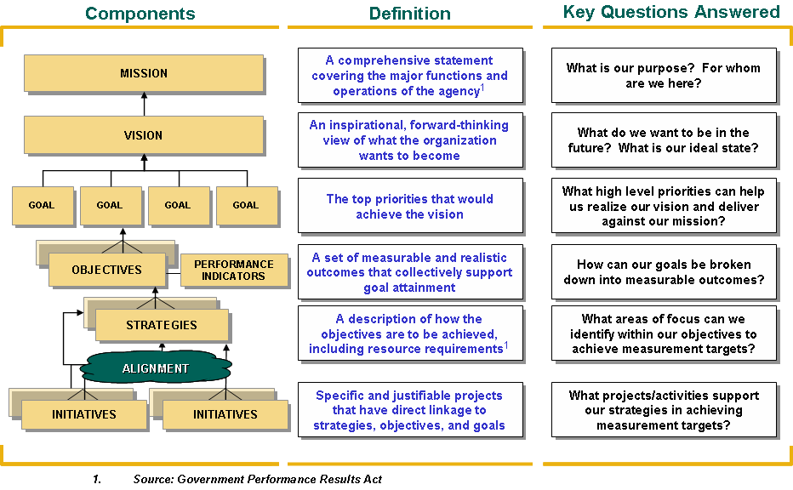
Once the Department’s mission, vision, and goals outlined in the USDA’s Department Strategic Plan were well understood, each goal was then associated with a set of Department objectives, which are measurable and linked to performance indicators. Objectives were explicitly linked to strategies. Then, specific IT Goals were screened and prioritized for their relevance to business needs.
During the process, all components were analyzed and rationalized based on current business drivers and needs and discussions with key business and support stakeholders. The result of this process formed the basis for linking the IT goals outlined in this USDA IT Strategic Plan.

Appendix B – USDA IT Strategic Planning Legislation
Over the past few years, the Congress has passed an unprecedented amount of legislation aimed at improving agency performance through implementation of more effective strategic, financial, and acquisition management policies. The Clinger-Cohen Act (CCA) of 1996, the Government Information Security Reform Act (GISRA) of 2000, the Government Performance and Results Act (GPRA) of 1993, the Chief Financial Officer’s Act (CFOA) of 1990, the Paperwork Reduction Act (PRA) of 1995 and the E-Government Act of 2002 are relevant legislation that direct agencies to improve the uses and efficiency of IT within their organizations. The table below provides a summary description of each act.

Legislation | Description
Clinger-Cohen Act, 1996 | Improves the productivity, efficiency, and effectiveness of federal programs through improved acquisition, use, and disposal of IT resources.
Government Information Security Reform Act, 2000 | Focuses on the program management, implementation, and evaluation aspects of the security of systems.
Government Performance and Results Act, 1993 | Holds federal agencies accountable for achieving program results and requires them to clarify their missions, set program goals, and measure (and report) performance related to meeting those goals.
Paperwork Reduction Act, 1995 | Ensures that operations and decisions are integrated with organization planning, budget, financial management, human resources management, and program decisions
E-Government Act of 2002 | Codifies the President’s Management Agenda (PMA) to expand E-Government initiatives, sets new OMB reporting requirements and codifies the existence of the CIO Council.
Chief Financial Officer’s Act, 1990 | Manages the strategy for developing and integrating individual agency accounting, financial information and other financial management systems to ensure adequacy, consistency, and timeliness of financial information.

President’s Management Agenda
Figure 15: Legislation Related to USDA IT Strategic Planning
The President’s Management Agenda sent to the Congress a bold strategy for improving the management and performance of the Federal Government. The PMA contains government-wide goals to improve Federal management and deliver results that matter to the American people. It reflects the Administration’s commitment to achieve immediate, concrete, and measurable results in the near term. The five government-wide goals to improve Federal management and deliver measurable results include:
- Strategic Management of Human Capital;
- Competitive Sourcing;
- Improved Financial Performance;
- Expanded Electronic Government; and
- Budget and Performance Integration.

Like all Federal agencies, USDA fully supports the PMA and has worked to ensure that its goals are incorporated into all management decisions, including IT planning and spending.

Relationship among USDA’s Corporate Planning Documents
Over the last several years, Congress and Executive Branch leadership have directed Federal agencies to improve the way government is managed. These directives emphasize the importance of performance, results, accountability, and citizen-focus over process. Specifically, legislation has directed agencies to prepare agency strategic plans, annual performance plans, annual program performance reports, and USDA IT Strategic Plans.
Strategic plans, annual performance plans, and annual program performance reports create a recurring cycle of planning, program execution, and reporting. By forging a strong link between resources and performance, these plans and reports show what is being accomplished with the funds that are being spent.

Strategic Plan
The strategic plan provides the framework for implementing all other parts of the GPRA and sets a course of action over the long term. It centers on those programs and activities that are key to carrying out an agency’s mission, and covers the major functions and operations of the agency. A strategic plan is also used to align the agency and budget structure with the mission and goals of the organization. Preparation of a strategic plan also provides an opportunity to review projects against the goals and to consider activities that can be terminated, reduced in scope, or transferred elsewhere.

Annual Performance Plan
The strategic plan’s goals and objectives set the framework for developing the annual performance plan. The annual performance plan presents a comprehensive picture of performance across the agency. It also sets out measurable goals that define what will be accomplished during a fiscal year. By identifying how much an agency will spend to achieve its performance goals, the annual performance plan forms the integral link between budget and program results. The annual performance plan also directly links to the agency’s budget. As defined by GPRA, an annual performance plan features three elements:

- A description of the operational processes, skills, and technology, and the human, capital, information, or other resources that will be needed to meet the performance goals; and
- A description of the means that will be used to verify and validate measured values.

Annual Performance Report
The annual performance report introduces greater emphasis on organizational and managerial accountability for program execution and results. It is based on the performance goals and indicators in the annual performance plan. The report covers all performance goals in the annual plan, and records the achievement of the goals and objectives in the strategic plan.
Actual performance is compared to the projected performance levels in the annual performance plan. Where target levels were not achieved, an explanation and description of the steps necessary to accomplish such goals in the future are included.

USDA IT Strategic Plan
Preparation of an USDA IT Strategic Plan includes specific ties to all of these plans and reports. The USDA IT Strategic Plan adds the elements of how IT will be used to support the business needs and priorities of an agency. This includes how IT will support the business of the agency and its strategic plan goals. Additionally, the USDA IT Strategic Planning process establishes performance goals as to how IT will support the performance of strategic plan goals and objectives set in the annual performance plan.

IT Capital Planning
The creation of an IT capital planning and investment control process is essential to the proper management of IT investments. IT capital planning is a rigorous process for planning, selecting, controlling, and evaluating IT investments. It engrains proper project management philosophies to assist project managers in staying on target with regards to cost and schedule performance. Additionally, it ensures that procedures are implemented to identify, monitor, and mitigate risks that could potentially affect project performance.
Related OMB Circulars
OMB Circular A-11 provides guidance on preparing the FY Budget submission and includes instructions on budget execution.
OMB Circular A-130 establishes policy for the management of Federal Information Resources. Agencies are required to conduct Information Management Planning in an integrated manner for managing information throughout its life cycle. Agencies will:
- Consider, at each stage of the information life cycle, the effects of decisions and actions on other stages of the life cycle, particularly those concerning information dissemination;

- Consider the effects of their actions on members of the public and ensure consultation with the public as appropriate;

- Consider the effects of their actions on State and local governments and ensure consultation with those governments as appropriate;

- Seek to satisfy new information needs through interagency or intergovernmental sharing of information, or through commercial sources, where appropriate, before creating or collecting new information;

- Integrate planning for information systems with plans for resource allocation and use, including budgeting, acquisition, and use of information technology;

- Train personnel in skills appropriate to management of information;

- Protect government information commensurate with the risk and magnitude of harm that could result from the loss, misuse, or unauthorized access to or modification of such information;

- Use voluntary standards and Federal Information Processing Standards where appropriate or required;

- Consider the effects of their actions on the privacy rights of individuals, and ensure that appropriate legal and technical safeguards are implemented;

- Record, preserve, and make accessible sufficient information to ensure the management and accountability of agency programs, and to protect the legal and financial rights of the Federal Government;

- Incorporate records management and archival functions into the design, development, and implementation of information systems; and

- Provide for access to public records where appropriate.

Appendix C – USDA Shared Services
USDA developed five enterprise-wide shared services:
- AgLearn
- eAuthentication
- Enterprise Content Management (ECM)
- Enterprise Shared Services (ESS)
- Enterprise Contingency Planning Program (ECPP)

Shared Services | Description
AgLearn | AgLearn is USDA’s implementation of the E-training Presidential E-Government Initiative. All Federal agencies are required to leverage one of the learning management systems (LMS) and services provided through contracts managed by the Office of Personnel Management (OPM) to support their human capital development. and learning management functions. The Office of the Chief Information Officer and the Office of Human Capital Management have worked together in partnership with OPM and USDA agencies to provide the best delivery of training and human capital resources needed for a department of our size and diversity. Agency shared fund of AgLearn is used for support of operating improving AgLearn, and providing courses that meet these needs. AgLearn is USDA’s official record for training data and sends the mandatory employee training data to OPM via the Enterprise Human Resources Integration (EHRI).
eAuthentication | The USDA eAuthentication initiative is a fully integrated component of the Presidential Initiative for E-Authentication. USDA partnered with agencies and private industry partners outside of the Department, including the U.S. General Services Administration (GSA) to develop a federal architecture and standard, allowing interoperability with approved electronic credential providers including USDA credentials to support single sign-on capabilities across Government. USDA is also partnering with industry leading authentication vendors, to include Verisign, Netegrity, and Entrust. The eAuthentication Program is currently working on several initiatives aimed at ensuring a sound approach to Security. We are updating our Certification and Accreditation (C&A) based on the guidelines set forth in the USDA C&A Web site. The eAuthentication team also recently completed all FY 2006 FISMA responsibilities. This included the completion of the FISMA Self Assessment and FISMA Compliance Self Assessment which resulted in our FY 2006 Plan of Action and Milestones (POAM) in the new ASSERT tool. Currently, over 180 Agency Web-based applications owned by 16 different agencies have been integrated with the USDA eAuthentication service to enable users to access all interconnected applications with a single username and password, with over 60 Web-based agency applications still awaiting integration.
Enterprise Content Management (ECM) | Content Management Services currently comprise a suite of related modules that utilize and rely upon the core components of USDA’s corporate document management infrastructure. The Enterprise Correspondence Management Module (ECMM) is designed to manage correspondence and other documents. ECMM features robust document management, flexible workflows, strong security, and easy access to information. The General Use Mobile (GUM) is similar to ECMM but focused on managing user-defined categories of documents. The Content Analysis Module (CAM) is designed to analyze and display content such as public comments regarding an issue or proposal. All of the Content Management Services modules are hosted in Enterprise Shared Services (ESS0 computing environment hosted by USDA’s National Information Technology Center (NITC) in Kansas City, MO.
Enterprise Shared Services (ESS) | Enterprise Shared Services (ESS) is a suite of development aids, platforms, and applications that facilitate USDA’s department-wide effort to deliver citizen-centric, online information and services. USDA developed ESS to leverage business, technology, and data principles to provide agencies the capability to maximize efficiencies and reduce costs while improving customer service. The business applications are hosted in a shared environment at the NITC using controlled IT hosting and operations procedures designed to support applications on the ESS infrastructure. ESS allows customers to develop and implement new or existing applications with development aids, different platforms and various application integration options. Procedures are in place to assist and improve USDA application stability, efficiency, and quality of service.
Enterprise Contingency Planning Program | Enterprise Contingency Planning Program (ECPP): IT is USDA policy to take necessary steps to maintain critical business functions in the event of an incident or disaster at any of its facilities or buildings nationwide. The purpose of contingency planning is to ensure that a set of arrangements and procedures that define interim measures to be taken will enable agencies to respond and restore major critical services or operations during an incident or disaster. The focus of contingency planning is to ensure that tested, executable plans are in place Department-wide for any type of disaster or incident. As part of this effort, USDA has implemented a suite of software tools being used to develop contingency plans. The tool developed by Strohl Systems, Inc. but is now customized for USDA use. The enterprise wide tool suite includes the following three software packages:  - ECPP is used to document contingency plans. These plans are Continuity of Operations Plans (COOP), Business Resumption Plan (BRP), Disaster Recovery Plan (DRP), Business Continuity Plan, and IT Contingency Plan.  - Business Impact Analysis Professional called BIA is used to compile business impact assessments. There are three steps: identify critical IT resources, identify disruption impacts and allowable outage times, and develop recovery priorities. A thorough, accurate BIA is the key to an effective contingency plan. BIA activities can be coordinated with the risk assessment and related activities.  - Incident Manager tool is used to manage the response to an incident or disaster.

Appendix D – USDA Participation in Presidential E-Government Initiatives
In the fall of 2001, OMB and Federal agencies identified 25 Presidential E-Government Initiatives. Operated and supported by agencies, these Initiatives are providing high-quality and well-managed solutions for tax filing, federal rulemaking and e-training among others. The 25 are divided among four key portfolios: Government to Citizen, Government to Business, Government to Government, and Internal Efficiency and Effectiveness. E-Authentication is a separate initiative that provides secure and robust authentication services to the 25 Initiatives and other major IT systems throughout government.
USDA’s current portfolio of electronic government initiatives consists of 21 Presidential E-Government Initiatives, 1 Presidential Directive, 8 Lines of Business, and 5 Enterprise-wide Shared Services (see Appendix C for shared services).
Presidential Initiatives:
- Business Gateway
- Disaster Management
- E-Authentication
- E-Clearance
- E-Government Travel
- E-Loans
- Enterprise Human Resources Integration (EHRI)
- E-Payroll
- E-Records Management
- E-Rulemaking
- E-Training
- Federal Asset Sales
- Geospatial One-Stop
- GovBenefits.gov
- Grants.gov
- Integrated Acquisition Environment
- International Trade Process Streamlining
- Recreation One-Stop
- Recruitment One-Stop
- SAFECOM
- USA Services
Presidential Directive:
1. HSPD-12
Lines of Business:
- Budget Formulation and Execution
- Federal Health Architecture
- Financial Management
- Geospatial
- Grants Management
- Human Resource
- IT Infrastructure Optimization
- IT Security

Appendix B – USDA IT Strategic Planning Legislation
DR 3600-000, USDA Information and Technology Transformation

