Lessons Learned from GSA Hallway testing

Lessons learned after 12/15/11 Hallway test of WMU
- don’t forget to print out separate task sheets for unmoderated floor
- create a page that explains FF and what we are doing for the unmoderated floor
- Unmoderated tests not worth the effort - riskier, harder to attract
- have 1 set of printed pages for each potential facilitator. Consider using both tables or testing on another floor
- Include as a UX comment “What would you expect to see / is this what you expected to see?
- buy painters tape - easy to remove
- set up printouts on both sides of the table so one ends where the other begins - that way you won’t have people talking about the same items in the same space
- consider bringing a still / video camera to document the tests. Set up a tripod on high and film
- write out path on all tasks
- label each page with a number, and then refer to those on tasks (maybe)\
- have stakeholder at 1 hour worth of tests and debrief at minimum
- check food supply before buying new items - we probably already have enough leftovers for another test
- maybe the unmoderated test would be better if we gave only one (or two) tasks - one that doesn’t require context and is easy to do independently.

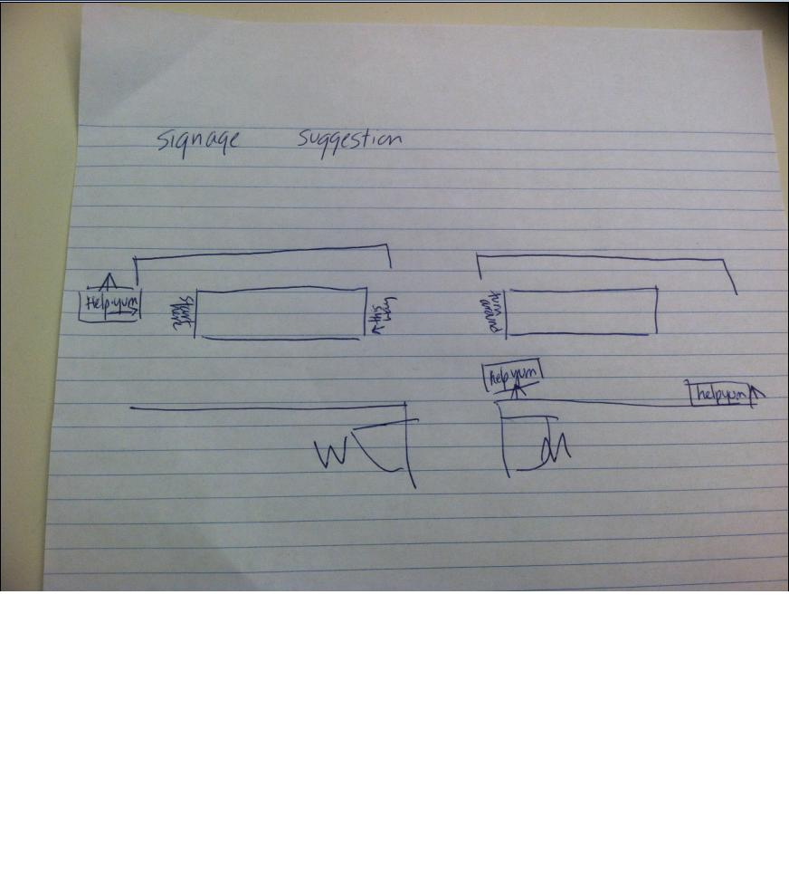

Hallway testing steps:
- Pick site / document to test
- Develop tasks (even “First Clicks are OK)
- Determine how many participants will be needed to succeed (10+ is standard, or just go for 2 hours)
- Do a timed dry run of the test
- Pick a public place to set up (or online?)
- Set up materials 30-45 min before test begins
  - signs
  - scissors
  - tape
  - 11x17 sheets
  - easels
  - camera (if needed)
  - food
  - plates
  - tasks
  - template sheets
  - clipboards / surfaces
  - “Who we are” print out for unmoderated floor
- Grab people and have them do scenarios with apples / candy as prizes. Tests will be 5-10 minutes MAX. Have 1 stakeholder there to observe as well
- Record the successes / failures for each task, and collect other feedback. Record the top 3 usability problems the users encountered
- Create solutions
- Count the total number of people tested
- Share lessons learned

Lessons Learned - Hallway Testing 10/19/2011

Test overall
- Hallways tests are great for validating changes and tweaks
- Great for finding recruits for future tests
- Possibility: If there is time feel free to test TWO sites in a session, one after the other. Or, remove the first tasks and replace them with new tasks for the 2nd half.
- hallways tests very usable at conferences or at all hands meeting
- hallway tests are helpful when launching your project + gauging initial reactions - see if people will get it
- naming - testing - sounds so complex and expensive - “user interviews” is easier, similar, open ending and scenario based
- how polished should it look? it doesn’t need to be polished - the key is someone could understand it
- idea: write forms in a coded way so the participant can’t see it and be coded, can’t let them see the word “FAIL” on the chart
- test as many as you can - 8-10 per audience. 20 is awesome for a day
- remember: location can make or break it
- choosing unmoderated vs. moderated - only depends on time and resources
- sensitive topic - moderated (medical, or private site) - use a secluded area

Setup
- To print: on PCs, right-click file, select Edit and from here you can go to page setup and 1. Select the printer 2. select 11x17 paper and 3. condense to one page.
- Set up like a two-sided buffet on the kitchen tables, if space allows
- The kitchen is a good space
- 4th and 5th floors were too quiet (CFO)
- 6th and 10th floors were busier (OGP and CIO)
- Bring a task scorecard printout and complete
- Offer fruit as well as candy. A bowl of apples / boxes of raisins would be good.
- Candy works well. Rolls of Life Savers and Breath Savers would be good too.
- make page printouts BIG - 8.5 x 11 with no margins at the minimum, or 11x17 for text heavy pages
- Taping the screen prints and tasks info to the kitchen table worked great.
- Bring tape, scissors, markers, notepads
- Posters and easels worked great
- bring a sheet that has spaces for all of the questions you are going to ask, your intro spiel and a succeed / fail chart
- Good not to include the URL on the screen prints
- Buy a couple of bowls for apples/candy
- Try and make the marketing items visually interesting - use posterboards, crayons, cutouts, bright colors, stickers, etc.
- Tear task / questions sheet in half and INCREASE THE FONT SIZE
- Put printouts in a row - don’t group them. People will be able to move from question to question and it allows more people without crowding them
- don’t list questions as 3b or 3c, just do 1, 2 3, 4
- make first question a general observation, then move into tasks
- tape down papers to avoid shuffling
- put page numbers on printouts + tasks

For unmoderated tests
- Give extra explanation to the unmanned tests - “Below are the tasks. Please write your responses
- Prime the pump - put on some sample comments to get the conversation flowing
- Avoid questions that require people to navigate between pages
- consider 3D table tents
- do test runs of it first, might not be as clear to other people, dry run first, do a test with the first person started

Testing
- Don’t ask people if they’ll do the test before the head into the bathroom!
- Dry run the task scenarios if possible
- 2-3 facilitators works great
- choose an amount of testers that you need, and then quit after that
- Call the tasks “questions”
- Get peoples full names, but feel free to only use initials on the report
- on moderated floors, no post its are needed
- recruitment hook: “Hi. Do you Have a minute to help us test a government website? I work on the 11th floor (legitimacy). It’ll just take 2 minutes, and we can give you a reward.”
- Idea: have people move through pages continuous on 1 trip for 1 purpose
- Video hallway test for marketing purposes
- put tasks sideways on the table
- arrows for unstaffed test showing people their way around the table
- not a favorite: everyone hates dum dums
- have extra copies of all the print pages and tasks

Lessons Learned - Hallway Testing at Crystal City, 12/8/2011

- Don’t let testers mark the printout (unless we have extra copies)
- Don’t use markers
- Don’t use pencil on it ourselves (one tester just started looking for pencil marks)
- Make sure the table is big enough to display the whole page (i.e. the page shouldn't flop over the side of the surface)
- Take careful notes on where users clicked (which is why I think we should have our own small copies to mark on)
- Put all the documents in order ahead of time, and label them for which task they fit with

