drm20060105.xsd

Data Dictionary

June 01, 2009

Introduction

Understanding the Diagrams and Content
This section provides a brief overview of the protocols used in this document to communicate the schema structure and content.
Elements and attributes are listed regardless of whether they are globally or locally defined. You can optionally choose to include simple types, complex types, groups, and attribute groups.
The graphics contain content model indicators, cardinality indicators, and data type information. (Since these terms may be new to those not intimate with XML a brief explanation is provided below.)
Associated with each schema item graphic are the definitions for the parent item and any associated child items. All attributes are listed first, followed by the child elements. Please note that the content model and cardinality operate together to determine if the element or attribute are required (and to what extent) in the instance document.

Content Model Indicators:
There are three possible types of content models: “sequence”, “choice”, and “all”. The particular content model in effect is shown as a branch off of the parent item. In addition to presenting information about the nature of the content these indicators show the cardinality of the content model.
- (sequence)
The sequence of the items to the right of the graphic (or below the text) is required.
- (choice)
A choice of the items to the right of the graphic (or below the text) is permitted.
- (all)
All the items to the right of the graphic are required.

Cardinality Indicators:
Cardinality refers to the number of times an item can, or must, exist in the instance document.
- Dotted line around element or attribute.
A single instance of the item can optionally exist.
- Dotted line around item with range indicated below.
Multiple instances of the item can optionally exist.
- Solid line around item.
A single instance of the item must exist.
- Solid line around item with range indicated below
At least one instance must exist; multiple instances can optionally exist.

Data Type Indication:
When a data type is assigned to an element (either a simple type or complex type the name of the data type is presented beneath the item name in the graphic.
- In some cases additional information about the item is presented (for example, the default value).
Elements can either have content that is textual/numeric in nature or content that is made up of additional elements and/or attributes. This distinction is important as is discussed below.
- When the content is textual/numeric in nature “three straight horizontal lines” will appear in the upper left-hand corner of the graphic. Pay attention to these elements because they are where you will be entering your information.
- When the content is made up of additional elements and/or attributes a “gray-box” will appear on the right-hand side of the graphic.
- If both the horizontal lines and the gray-box are shown then the contents below the element are attributes or possibly something termed "mixed-content".

Drybridge Facilitator
The Drybridge Facilitator is a product suite that dramatically simplifies the process of documenting and implementing schema solutions. The Facilitator is available as a local installation, as a hosted web service, or as a turnkey solution. The local installation is available in a demo mode, an ideal environment for you to evaluate the Facilitator's benefits. A document that contains this explanation has either been produced using the demo version or by someone who has been kind enough to help broaden the acceptance of the Drybridge Facilitator, in either case, "Thank you!”
There are several aspects to the Drybridge Facilitator:
- The Documentation Module produces powerful documentation for schemas and schema subsets. The documentation module allows you to create message oriented documentation (for a given root element) or a comprehensive data dictionary for all messages in your environment. Documentation can be produced based on the standard schema or based on modifications that you have made via the Schema Subset Module..
- The Schema Subset Module facilitates the creation of schema subsets that meet your specific business requirements. Easier to use and more powerful than typical XML redefinition, extension, and restriction approaches the subset module helps you to create and coordinate the use of schema subsets with your trading partners while retaining compliance with the underlying schema.
- The Schema Comparison Engine compares two schemas (or groups of schemas) and produces a user-friendly report of the differences.
- The Schema Generation module is used to create a valid schema based on a particular subset. This schema could be used to more tightly validate messages from a particular trading partner.
The Drybridge Facilitator simplifies the process of implementing schema solutions by allowing you to easily discuss, update, and annotate your schema and by generating annotated documentation and schema that strictly define your decisions making your development process easier. You can base your documentation on schema annotations included in the base schema and then add your own comments to the documentation.

Drybridge Consulting
Drybridge Consulting offers products and services that make it possible for companies to rapidly deploy connections between trading partners. These services allow our clients to enjoy the cost benefits of short implementation times, easy updates, and reusable code. Drybridge provides the following business integration services:
- XML message design, development, documentation, and deployment
- XML tools and stylesheet development
- Scalable, industrial-strength integration solutions
- Secure, error-free, and rapid information flow
In other words, Drybridge Consulting helps you to improve the efficiency of your business processes resulting in an improved bottom line. When you see a business process flowchart, think of Drybridge technologies. Think of the nature of the connection. Is it:
- Internal or External
- Business-to-Business or Business-to-Consumer
- Manual or Automated
- Working Correctly... or Broken
Regardless, Drybridge Consulting has the expertise to help you!

Table of Contents
Introduction 2
Understanding the Diagrams and Content 2
Drybridge Facilitator 3
Drybridge Consulting 4
Table of Contents 5
Namespace Information 10
Data Dictionary: drm20060105.xsd 11
AccessControlProtocol 11
address [attribute] 11
affiliation 11
any 11
Attribute 11
Attributes 12
AvailabilityLevel 12
beNumber [attribute] 12
category 13
city 13
classification [attribute] 13
classificationReason [attribute] 13
classifiedBy [attribute] 14
code [attribute] 14
ConfidentialityLevel 14
Consumer 14
contributor 15
contributor 18
copyright [attribute] 18
countryCode 18
coverage 18
created [attribute] 19
creator 20
creator 23
DataAsset 24
DataAssetRef 26
DataAssetRefs 26
DataAssets 26
DataContext 26
DataDescription 27
DataReferenceModel 28
DataSharing 31
DataSteward 32
DataType 32
date 32
dateOfExemptedSource [attribute] 32
dates 33
declassDate [attribute] 33
declassEvent [attribute] 33
declassException [attribute] 33
declassManualReview [attribute] 34
DepartmentName 34
derivedFrom [attribute] 34
description 34
Description 34
DigitalDataResourceRefs 35
DigitalDataResources 36
disseminationControls [attribute] 36
Document 37
Documents 38
email 38
EmployeeID 38
end 38
Endpoint 38
Entities 39
Entity 39
entityRef [attribute] 40
EntityRef 40
EntityRefs 40
EntityRelationship 41
EntityRelationships 41
ExchangeFrequency 41
ExchangePackage 42
ExchangePackages 46
extent 46
ExternalEntities 46
ExternalExchangePackages 47
ExternalTaxonomies 47
ExternalUnstructuredDataResources 47
Facility 48
facilityIdentifier 48
FGIsourceOpen [attribute] 49
FGIsourceProtected [attribute] 49
FIPS199PotentialImpactLevels 49
format 50
format 50
geoRef 50
geospatialCoverage 50
GeospatialEnabled 50
ID [attribute] 51
identifier 51
identifier 51
IDREF [attribute] 51
infoCutOff [attribute] 51
InitialDate 51
InlineEntities 52
InlineExchangePackages 52
InlineTaxonomies 52
InlineUnstructuredDataResources 52
IntegrityLevel 53
intellectualProperty [attribute] 53
keyword 53
label [attribute] 53
lang [attribute] 54
language 54
language 54
Latency 54
LocationURI 54
Media 55
medium 55
mimeType 55
MinimumEncryptionLevel 55
name [attribute] 55
name 56
nonICmarkings [attribute] 56
Organization 56
osuffix [attribute] 56
ownerProducer [attribute] 57
OwningAgency 57
PayloadDefinitionURI 57
PayloadTransport 57
Person 58
phone 58
Place 59
PointOfContact 59
pointOfContact 60
postalCode 60
posted [attribute] 61
PrimaryContact 61
privacyAct [attribute] 61
protocol [attribute] 61
province 61
publisher 62
publisher 65
qualifier [attribute] 65
qualifier [attribute] 65
QualityOfServiceInformation 65
QueryLanguage 66
QueryLanguages 66
QueryPoint 67
QueryPointRef 68
QueryPointRefs 68
QueryPoints 68
QueryPointSecurity 69
region 69
relation 69
releasableTo [attribute] 69
ReliableMessagingCapabilities 70
RepresentationFormat 70
Resource 71
rights 72
rights 73
SARIdentifier [attribute] 73
schemaHref [attribute] 73
schemaQualifier [attribute] 73
SCIcontrols [attribute] 73
security 74
SemiStructuredDataResource 77
SemiStructuredDataResourceRef 78
SemiStructuredDataResourceRefs 78
SemiStructuredDataResources 78
Service 79
source 79
source 79
start 80
state 80
Status 80
street 80
StructuredDataResource 80
StructuredDataResourceRef 81
StructuredDataResourceRefs 81
StructuredDataResources 82
subject 82
Subject 83
subjectCoverage 83
SubmissionDate 83
SubmissionInformation 84
SubmissionVersion 85
SubmittingAgency 85
subtitle 86
Supplier 89
SupplierConsumer 89
supplierType [attribute] 90
surname 90
SystemOfRecord 90
Taxonomies 90
Taxonomy 91
temporalCoverage 91
Term 91
Terms 92
TimePeriod 92
title 92
title 93
Topic 96
topicRef [attribute] 96
TopicRef 97
TopicRefs 97
TopicRelationship 97
TopicRelationships 98
Topics 98
TransactionType 98
type 99
type 99
TypeOfDataAsset 99
typeOfExemptedSource [attribute] 99
unit [attribute] 99
UnstructuredDataResource 100
UnstructuredDataResourceRef 101
UnstructuredDataResourceRefs 101
UnstructuredDataResources 102
userID 102
validTil [attribute] 102
value [attribute] 103
virtualCoverage 103
Schema Level Documentation 104
DDMS-v1_2.xsd 104
IC-ISM-v2.xsd 105
dc.xsd 105

Namespace Information
The following namespace prefixes and their associated namespaces are used by the schemas referenced in this data dictionary. To avoid confusion all references to the same namespace have been consolidated under a single namespace prefix.
- drm http://egov.gov/fea
- ism urn:us:gov:ic:ism:v2
- xml http://www.w3.org/XML/1998/namespace
- xsi http://www.w3.org/2001/XMLSchema-instance
- dc http://purl.org/dc/elements/1.1/
- ddms http://metadata.dod.mil/mdr/ns/DDMS/1.2/
- xsd http://www.w3.org/2001/XMLSchema

Data Dictionary: drm20060105.xsd

AccessControlProtocol
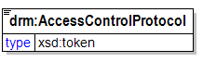
The standard and/or protocol providing access control for a Query Point.
RELATIONSHIPS: None

address [attribute]
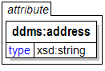

affiliation
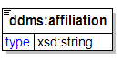
The identification of an organization or agency with which an individual or service has an affiliation.

any
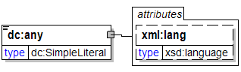
lang [attribute]

Attribute
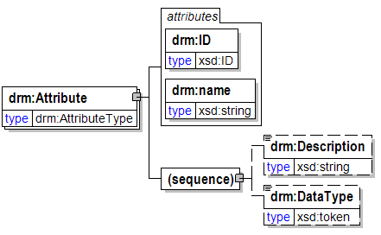
A characteristic of an Entity whose value may be used to help distinguish one instance of an Entity from other instances of the same Entity.
RELATIONSHIPS:
- An Attribute is constrained by a Data Type;
ID [attribute]
General identifier attribute used in various places.
RELATIONSHIPS: None
name [attribute]
General name attribute used in various places.
RELATIONSHIPS: None
(sequence)
Description
General description element used in various places.
RELATIONSHIPS: None
DataType
A constraint on the type of data that an instance of an Attribute may hold (e.g. "date", "string", "float" or "integer").
RELATIONSHIPS: None

Attributes
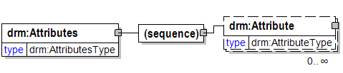
A container for Attribute elements.
RELATIONSHIPS: None
(sequence)
Attribute
A characteristic of an Entity whose value may be used to help distinguish one instance of an Entity from other instances of the same Entity.
RELATIONSHIPS:
- An Attribute is constrained by a Data Type;

AvailabilityLevel
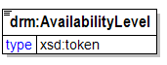
FIPS 199 "availability" impact level.
RELATIONSHIPS: None

beNumber [attribute]
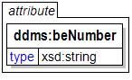
(GMI:BE_NUMBER, 1.0) Uniquely identifies the installation of the facility. The BE_NUMBER is generated based on the value input for the COORD to determine the appropriate World Area Code (WAC), the system assigned record originator and a one-up-number. Pos. 1-4, World Area Code (WAC). Pos. 5, A hyphen, '-', or an 'E', in the fifth position indicates that position-6 will contain values 0-9. Alternately, the fifth position may contain the first of a two-character system assigned record originator code, position-6 will then contain the second character of the system assigned record originator code. Pos. 6, May contain the second character of the system assigned record originator code, the one-up-number series will then begin in position seven, and range from 0001-9909. If the one-up-number series begins in postion 6, this position will contain the first of a five-position one-up-number, i.e., 00001-99999.Pos. 7-10, A one-up-number series. Depending on the content of position 5, the series may have begun in position 6 and have a range of 00001-99999. Or, have begun in position 7 and have a range from 0001-9999.

category
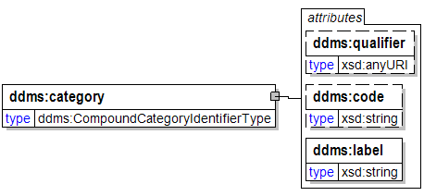
Specification of the subject matter by a qualified entry from a controlled vocabulary.
See DDMS Version 1.2 Subject @ 55.
qualifier [attribute]

code [attribute]

label [attribute]

city
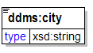

classification [attribute]
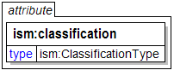

classificationReason [attribute]
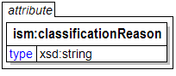
A text string containing one or more paragraph numbers, 1.4(a)
through 1.4(h), taken from E.O. 12958, as amended. Enter the
paragraph references as they should appear in a
classification/declassification block.

classifiedBy [attribute]
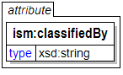
Use as specified by E.O. 12958.

code [attribute]
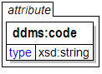

ConfidentialityLevel
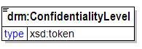
FIPS 199 "confidentiality" impact level.
RELATIONSHIPS: None

Consumer
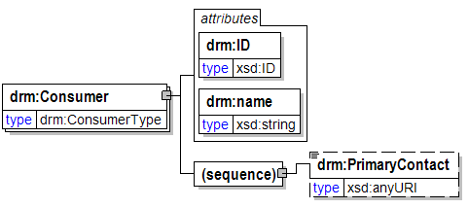
An entity (person or organization) that consumes data that is supplied by a Supplier.
RELATIONSHIPS: None
ID [attribute]
General identifier attribute used in various places.
RELATIONSHIPS: None
name [attribute]
General name attribute used in various places.
RELATIONSHIPS: None
(sequence)
PrimaryContact
A URI pointing to an electronic representation (e.g. XML document, Web page) of contact information for the primary contact for a Supplier or Consumer.
RELATIONSHIPS: None

contributor
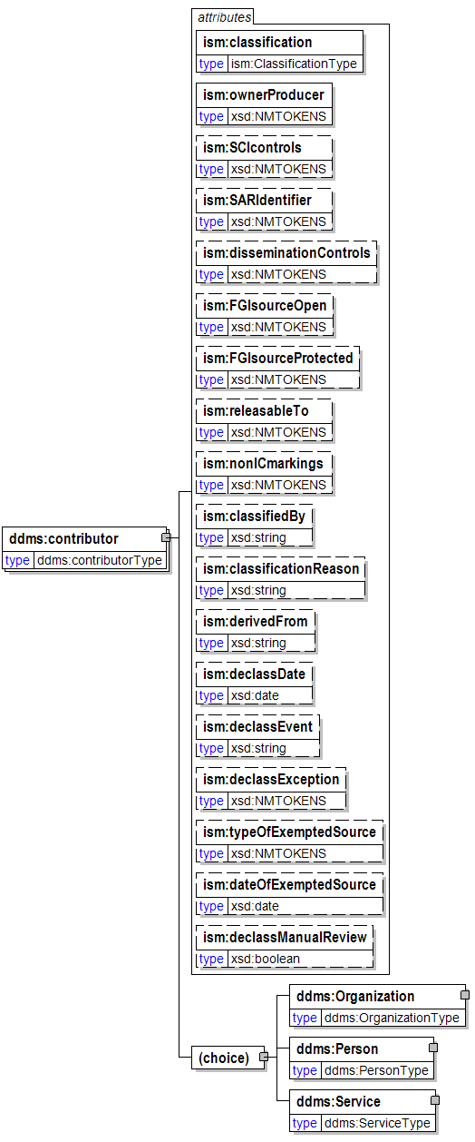
classification [attribute]

ownerProducer [attribute]
ISO 3166-1 trigraph(s) of the owner or producer country(ies) and/or
CAPCO-specified tetragraphs of international organizations.
Either (a) a single trigraph or tetragraph or (b) a space-delimited
list of trigraphs followed by tetragraphs. Trigraphs must be in
alphabetical order and tetragraphs must be in alphabetical order.
SCIcontrols [attribute]
Authorized abbreviation(s) of SCI control system(s). Either
(a) a single abbreviation or (b) a space-delimited list of
abbreviations in the order prescribed in the CAPCO Register.
SARIdentifier [attribute]
Authorized Special Access Required program digraph(s) or
trigraph(s) preceded by "SAR-". Either (a) a single digraph or
trigraph or (b) a space-delimited list of digraphs or trigraphs.
Example: "SAR-ABC SAR-DEF ..."
disseminationControls [attribute]
Authorized dissemination control portion mark abbreviation(s).
Either (a) a single abbreviation or (b) a space-delimited list
of abbreviations in the order shown in the CAPCO Register.
Exception: For the "REL" abbreviation, omit the country code
trigraph(s) and instead place the trigraph(s) in the
"releasableTo" attribute value.
FGIsourceOpen [attribute]
Non-US classification portion marking for foreign government
information in a document portion. Use this attribute to record
a source country when the intent is to post the document to a
shared space with the source identified.
FGIsourceProtected [attribute]
Non-US classification portion marking for foreign government
information in a document portion. Use this attribute to record
a source country when the intent is to filter out the identity of
the source prior to posting the document to a shared space.
releasableTo [attribute]
ISO 3166-1 trigraphic codes of countries to which the associated
content can be released. Include "USA" in all instances. Use a space-
delimited list with "USA" first, followed by the other trigraph(s)
in alphabetical order.
nonICmarkings [attribute]
Authorized non-IC portion marking abbreviation(s) from the CAPCO
Register. Either (a) a single non-IC abbreviated marking or
(b) a space-delimited list of abbreviations in the order shown
in the CAPCO Register.
classifiedBy [attribute]
Use as specified by E.O. 12958.
classificationReason [attribute]
A text string containing one or more paragraph numbers, 1.4(a)
through 1.4(h), taken from E.O. 12958, as amended. Enter the
paragraph references as they should appear in a
classification/declassification block.
derivedFrom [attribute]
A text string containing (a) the title and date of a specific source
document, or (b) the title and date of an organization classification
guide, or (c) the literal string "Multiple Sources".
declassDate [attribute]
A specific date, in the format YYYY-MM-DD, at which the applicable
information is automatically declassified.
declassEvent [attribute]
A textual description of an event that triggers declassification.
declassException [attribute]
One or more of the exceptions to 25-year declassification:
specify "25X1-human", "25X1", "25X2", ..., "25X9". If more than
one exception applies, use a space-delimited list. If "25X1-human"
applies, it should be first in a list.
typeOfExemptedSource [attribute]
One or more tokens indicating that a source that is exempted from
automatic declassification applies. Specify "OADR", "X1", "X2", ...,
"X8". If more than one applies, use a space-delimited list.
dateOfExemptedSource [attribute]
A specific date, in the format YYYY-MM-DD. Used in conjunction with
attribute "typeOfExemptedSource." If there are multiple exempted
sources, specify the date of the exempted
source that has the most recent date.
declassManualReview [attribute]
A true/false indication that manual review is required for
declassification. Use this attribute to force the appearance of
"//MR" in the header and footer marking titles. Use this attribute
ONLY when it is necessary to override the business logic applied to
classification and control markings in the document to determine
whether manual review is required.
(choice)
Organization
A named organization responsible as indicated by its encompasing element, i.e. as a creator, contributor, or publisher.
See DDMS Version 1.2 Creator @ 31.
See also DDMS Version 1.2 Publisher @ 34.
See also DDMS Version 1.2 Contributor @ 37.
Person
A person responsible as indicated by its encompasing element, i.e. as a creator, contributor, or publisher.
See DDMS Version 1.2 Creator @ 31.
See also DDMS Version 1.2 Publisher @ 34.
See also DDMS Version 1.2 Contributor @ 37.
Service
A named service responsible as indicated by its encompasing element, i.e. as a creator, contributor, or publisher.
See DDMS Version 1.2 Creator @ 31.
See also DDMS Version 1.2 Publisher @ 34.
See also DDMS Version 1.2 Contributor @ 37.

contributor
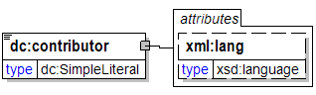
lang [attribute]

copyright [attribute]
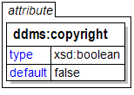
An indicator identifying products under protection against reproduction and distribution without the express written permission of the copyright owner. A yes/no value used to specify applicability of the rights. The default is “no”. {False = No}
(TBD:CopyrightIndicator, 1.0) An indicator identifying documents under protection against reproduction and distribution without the express written permission of the copyright owner This prohibition is binding on individuals and corporations, as well as the US Government. Examples of applicability: books (yes), newspaper photos (yes), US Federal Publications (no), magazine articles (yes), vendor technical information (yes).

countryCode
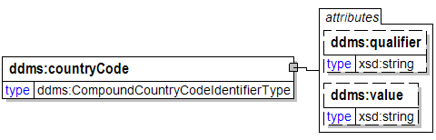
qualifier [attribute]

value [attribute]

coverage
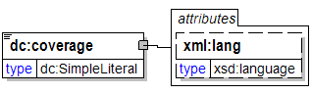
lang [attribute]

created [attribute]
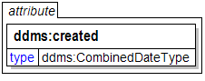
Date of creation of the resource

creator
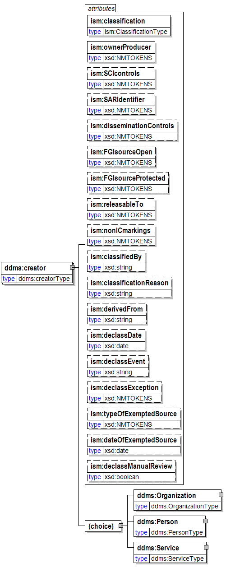
classification [attribute]

ownerProducer [attribute]
ISO 3166-1 trigraph(s) of the owner or producer country(ies) and/or
CAPCO-specified tetragraphs of international organizations.
Either (a) a single trigraph or tetragraph or (b) a space-delimited
list of trigraphs followed by tetragraphs. Trigraphs must be in
alphabetical order and tetragraphs must be in alphabetical order.
SCIcontrols [attribute]
Authorized abbreviation(s) of SCI control system(s). Either
(a) a single abbreviation or (b) a space-delimited list of
abbreviations in the order prescribed in the CAPCO Register.
SARIdentifier [attribute]
Authorized Special Access Required program digraph(s) or
trigraph(s) preceded by "SAR-". Either (a) a single digraph or
trigraph or (b) a space-delimited list of digraphs or trigraphs.
Example: "SAR-ABC SAR-DEF ..."
disseminationControls [attribute]
Authorized dissemination control portion mark abbreviation(s).
Either (a) a single abbreviation or (b) a space-delimited list
of abbreviations in the order shown in the CAPCO Register.
Exception: For the "REL" abbreviation, omit the country code
trigraph(s) and instead place the trigraph(s) in the
"releasableTo" attribute value.
FGIsourceOpen [attribute]
Non-US classification portion marking for foreign government
information in a document portion. Use this attribute to record
a source country when the intent is to post the document to a
shared space with the source identified.
FGIsourceProtected [attribute]
Non-US classification portion marking for foreign government
information in a document portion. Use this attribute to record
a source country when the intent is to filter out the identity of
the source prior to posting the document to a shared space.
releasableTo [attribute]
ISO 3166-1 trigraphic codes of countries to which the associated
content can be released. Include "USA" in all instances. Use a space-
delimited list with "USA" first, followed by the other trigraph(s)
in alphabetical order.
nonICmarkings [attribute]
Authorized non-IC portion marking abbreviation(s) from the CAPCO
Register. Either (a) a single non-IC abbreviated marking or
(b) a space-delimited list of abbreviations in the order shown
in the CAPCO Register.
classifiedBy [attribute]
Use as specified by E.O. 12958.
classificationReason [attribute]
A text string containing one or more paragraph numbers, 1.4(a)
through 1.4(h), taken from E.O. 12958, as amended. Enter the
paragraph references as they should appear in a
classification/declassification block.
derivedFrom [attribute]
A text string containing (a) the title and date of a specific source
document, or (b) the title and date of an organization classification
guide, or (c) the literal string "Multiple Sources".
declassDate [attribute]
A specific date, in the format YYYY-MM-DD, at which the applicable
information is automatically declassified.
declassEvent [attribute]
A textual description of an event that triggers declassification.
declassException [attribute]
One or more of the exceptions to 25-year declassification:
specify "25X1-human", "25X1", "25X2", ..., "25X9". If more than
one exception applies, use a space-delimited list. If "25X1-human"
applies, it should be first in a list.
typeOfExemptedSource [attribute]
One or more tokens indicating that a source that is exempted from
automatic declassification applies. Specify "OADR", "X1", "X2", ...,
"X8". If more than one applies, use a space-delimited list.
dateOfExemptedSource [attribute]
A specific date, in the format YYYY-MM-DD. Used in conjunction with
attribute "typeOfExemptedSource." If there are multiple exempted
sources, specify the date of the exempted
source that has the most recent date.
declassManualReview [attribute]
A true/false indication that manual review is required for
declassification. Use this attribute to force the appearance of
"//MR" in the header and footer marking titles. Use this attribute
ONLY when it is necessary to override the business logic applied to
classification and control markings in the document to determine
whether manual review is required.
(choice)
Organization
A named organization responsible as indicated by its encompasing element, i.e. as a creator, contributor, or publisher.
See DDMS Version 1.2 Creator @ 31.
See also DDMS Version 1.2 Publisher @ 34.
See also DDMS Version 1.2 Contributor @ 37.
Person
A person responsible as indicated by its encompasing element, i.e. as a creator, contributor, or publisher.
See DDMS Version 1.2 Creator @ 31.
See also DDMS Version 1.2 Publisher @ 34.
See also DDMS Version 1.2 Contributor @ 37.
Service
A named service responsible as indicated by its encompasing element, i.e. as a creator, contributor, or publisher.
See DDMS Version 1.2 Creator @ 31.
See also DDMS Version 1.2 Publisher @ 34.
See also DDMS Version 1.2 Contributor @ 37.

creator
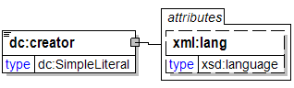
lang [attribute]

DataAsset
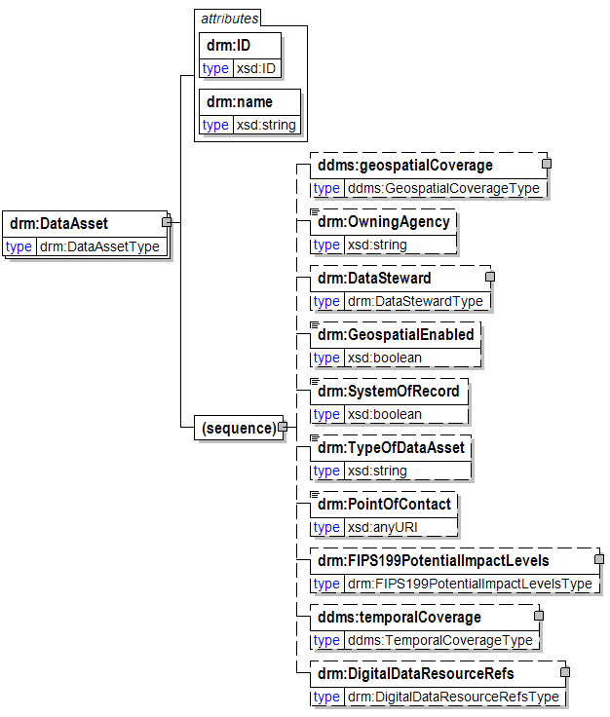
A managed container for data. Examples include a relational database, Web site, document repository, directory or data service.
RELATIONSHIPS:
- A Data Asset provides a management context for one or more Digital Data Resources;
ID [attribute]
General identifier attribute used in various places.
RELATIONSHIPS: None
name [attribute]
General name attribute used in various places.
RELATIONSHIPS: None
(sequence)
geospatialCoverage

OwningAgency
The agency providing primary stewardship for a Data Asset.
RELATIONSHIPS: None
DataSteward
A person or organization responsibile for managing a specific set of data resources.
RELATIONSHIPS:
- A Data Steward manages a Data Asset;
GeospatialEnabled
A boolean flag indicating whether or not a Data Asset supports or provides Geospatial data.
RELATIONSHIPS: None
SystemOfRecord
Denotes whether or not a data source contains Privacy Act information. This includes an individual's name, SSN, and/or personal identifier, and at least one other element of personal information about the individual (such as date of birth).
RELATIONSHIPS: None
TypeOfDataAsset
Type of Data Asset - e.g. database, Web site, registry, directory, data service, etc.
NOTE: In the future, this may be represented as an enumerated list.
RELATIONSHIPS: None
PointOfContact
A URI pointing to the person or organization to contact for more information regarding a Data Asset. This usually includes a name, phone number, email address, and other contact information. The resource/record should ideally be a structured machine-readable resource (e.g., XML document), but can be a HTML/web page providing the appropriate documentation.
RELATIONSHIPS: None
FIPS199PotentialImpactLevels
According to FIPS 199, potential impact levels on agency operations, assets, or individuals should there be a breach in security due to the loss of confidentiality, integrity, or availability.
RELATIONSHIPS: None
temporalCoverage

DigitalDataResourceRefs
A container for StructuredDataResourceRef, UnstructuredDataResourceRef, and SemiStructuredDataResourceRef elements (which are collectively considered to be Digital Data Resource references).
NOTE: This element is used for Data Assets, but not for Topics - even though the DRM 2.0 abstract model lists a relationship between a Topic and Digital Data Resources. The reason for this is that
the relationship from Data Digital Resources to Topics is represented in each of the Digital Data Resource container elements (i.e. StucturedDataResources, SemiStucturedDataResources, and
UnstucturedDataResources), in a "TopicRefs" element. This was done because it makes more sense to list Topics by which an artifact is categorized where the artifact itself is described, rather
than vice-versa.
RELATIONSHIPS: None

DataAssetRef
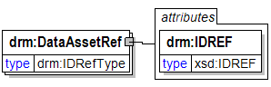
A reference to a DataAsset element contained within the same DRM instance.
RELATIONSHIPS: None
IDREF [attribute]
A reference to an identifier within the same DRM instance.
RELATIONSHIPS: None

DataAssetRefs
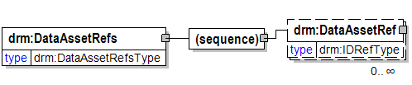
A container for DataAssetRef elements.
RELATIONSHIPS: None
(sequence)
DataAssetRef
A reference to a DataAsset element contained within the same DRM instance.
RELATIONSHIPS: None

DataAssets
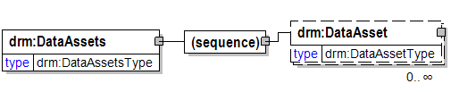
A container for DataAsset elements.
RELATIONSHIPS: None
(sequence)
DataAsset
A managed container for data. Examples include a relational database, Web site, document repository, directory or data service.
RELATIONSHIPS:
- A Data Asset provides a management context for one or more Digital Data Resources;

DataContext
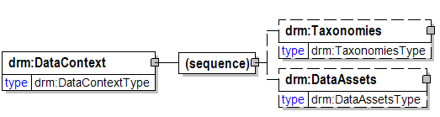
The Data Context standardization area of the DRM. The Data Context standardization area facilitates discovery of data through an approach to the categorization of data according to taxonomies, and provide linkages to the other FEA reference models.
RELATIONSHIPS: None
(sequence)
Taxonomies
A container for Taxonomy elements.
RELATIONSHIPS: None
DataAssets
A container for DataAsset elements.
RELATIONSHIPS: None

DataDescription
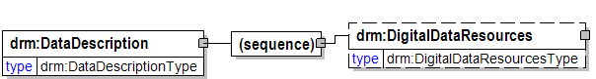
The Data Description standardization area of the DRM. The Data Description standardization area provides a means to richly describe data, thereby supporting its discovery and sharing.
RELATIONSHIPS: None
(sequence)
DigitalDataResources
A container for DigitalDataResource elements.
RELATIONSHIPS: None

DataReferenceModel
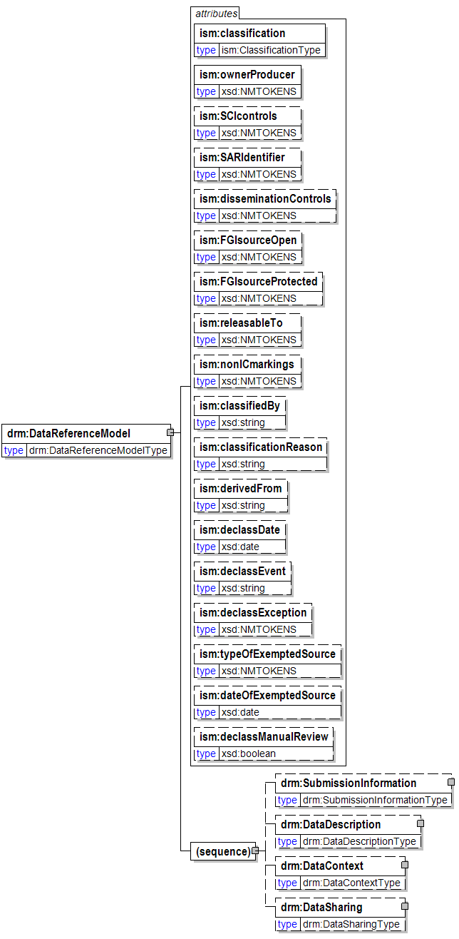
Root node of the DRM XML instance document.
RELATIONSHIPS: None
classification [attribute]

ownerProducer [attribute]
ISO 3166-1 trigraph(s) of the owner or producer country(ies) and/or
CAPCO-specified tetragraphs of international organizations.
Either (a) a single trigraph or tetragraph or (b) a space-delimited
list of trigraphs followed by tetragraphs. Trigraphs must be in
alphabetical order and tetragraphs must be in alphabetical order.
SCIcontrols [attribute]
Authorized abbreviation(s) of SCI control system(s). Either
(a) a single abbreviation or (b) a space-delimited list of
abbreviations in the order prescribed in the CAPCO Register.
SARIdentifier [attribute]
Authorized Special Access Required program digraph(s) or
trigraph(s) preceded by "SAR-". Either (a) a single digraph or
trigraph or (b) a space-delimited list of digraphs or trigraphs.
Example: "SAR-ABC SAR-DEF ..."
disseminationControls [attribute]
Authorized dissemination control portion mark abbreviation(s).
Either (a) a single abbreviation or (b) a space-delimited list
of abbreviations in the order shown in the CAPCO Register.
Exception: For the "REL" abbreviation, omit the country code
trigraph(s) and instead place the trigraph(s) in the
"releasableTo" attribute value.
FGIsourceOpen [attribute]
Non-US classification portion marking for foreign government
information in a document portion. Use this attribute to record
a source country when the intent is to post the document to a
shared space with the source identified.
FGIsourceProtected [attribute]
Non-US classification portion marking for foreign government
information in a document portion. Use this attribute to record
a source country when the intent is to filter out the identity of
the source prior to posting the document to a shared space.
releasableTo [attribute]
ISO 3166-1 trigraphic codes of countries to which the associated
content can be released. Include "USA" in all instances. Use a space-
delimited list with "USA" first, followed by the other trigraph(s)
in alphabetical order.
nonICmarkings [attribute]
Authorized non-IC portion marking abbreviation(s) from the CAPCO
Register. Either (a) a single non-IC abbreviated marking or
(b) a space-delimited list of abbreviations in the order shown
in the CAPCO Register.
classifiedBy [attribute]
Use as specified by E.O. 12958.
classificationReason [attribute]
A text string containing one or more paragraph numbers, 1.4(a)
through 1.4(h), taken from E.O. 12958, as amended. Enter the
paragraph references as they should appear in a
classification/declassification block.
derivedFrom [attribute]
A text string containing (a) the title and date of a specific source
document, or (b) the title and date of an organization classification
guide, or (c) the literal string "Multiple Sources".
declassDate [attribute]
A specific date, in the format YYYY-MM-DD, at which the applicable
information is automatically declassified.
declassEvent [attribute]
A textual description of an event that triggers declassification.
declassException [attribute]
One or more of the exceptions to 25-year declassification:
specify "25X1-human", "25X1", "25X2", ..., "25X9". If more than
one exception applies, use a space-delimited list. If "25X1-human"
applies, it should be first in a list.
typeOfExemptedSource [attribute]
One or more tokens indicating that a source that is exempted from
automatic declassification applies. Specify "OADR", "X1", "X2", ...,
"X8". If more than one applies, use a space-delimited list.
dateOfExemptedSource [attribute]
A specific date, in the format YYYY-MM-DD. Used in conjunction with
attribute "typeOfExemptedSource." If there are multiple exempted
sources, specify the date of the exempted
source that has the most recent date.
declassManualReview [attribute]
A true/false indication that manual review is required for
declassification. Use this attribute to force the appearance of
"//MR" in the header and footer marking titles. Use this attribute
ONLY when it is necessary to override the business logic applied to
classification and control markings in the document to determine
whether manual review is required.
(sequence)
SubmissionInformation
A container for all information related to a DRM submission.
RELATIONSHIPS: None
DataDescription
The Data Description standardization area of the DRM. The Data Description standardization area provides a means to richly describe data, thereby supporting its discovery and sharing.
RELATIONSHIPS: None
DataContext
The Data Context standardization area of the DRM. The Data Context standardization area facilitates discovery of data through an approach to the categorization of data according to taxonomies, and provide linkages to the other FEA reference models.
RELATIONSHIPS: None
DataSharing
The Data Sharing standardization area of the DRM. The Data Sharing standardization area describes the sharing and exchange of data, where sharing may consist of ad-hoc requests (such as a one-time query of a particular data asset), scheduled queries, and/or exchanges characterized by fixed, re-occurring transactions between parties. Data sharing is enabled by capabilities provided by both the Data Context and Data Description standardization areas.
RELATIONSHIPS: None

DataSharing
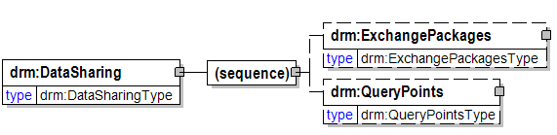
The Data Sharing standardization area of the DRM. The Data Sharing standardization area describes the sharing and exchange of data, where sharing may consist of ad-hoc requests (such as a one-time query of a particular data asset), scheduled queries, and/or exchanges characterized by fixed, re-occurring transactions between parties. Data sharing is enabled by capabilities provided by both the Data Context and Data Description standardization areas.
RELATIONSHIPS: None
(sequence)
ExchangePackages
A container for ExchangePackage elements.
RELATIONSHIPS: None
QueryPoints
A container for QueryPoint elements.
RELATIONSHIPS: None

DataSteward
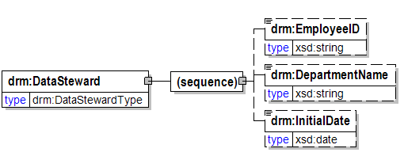
A person or organization responsibile for managing a specific set of data resources.
RELATIONSHIPS:
- A Data Steward manages a Data Asset;
(sequence)
EmployeeID
Employee ID for a Data Steward.
RELATIONSHIPS: None
DepartmentName
Name of department with which a Data Steward is associated.
RELATIONSHIPS: None
InitialDate
Date that a Data Steward became associated with a Data Asset.
RELATIONSHIPS: None

DataType
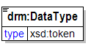
A constraint on the type of data that an instance of an Attribute may hold (e.g. "date", "string", "float" or "integer").
RELATIONSHIPS: None

date
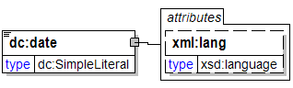
lang [attribute]

dateOfExemptedSource [attribute]
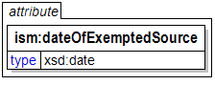
A specific date, in the format YYYY-MM-DD. Used in conjunction with
attribute "typeOfExemptedSource." If there are multiple exempted
sources, specify the date of the exempted
source that has the most recent date.

dates
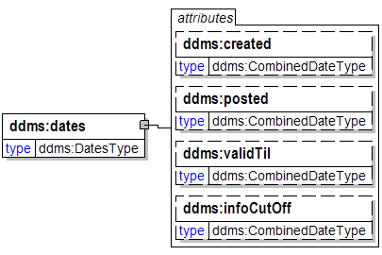
The date related properties of this resource.
See DDMS Version 1.2 Date @ 47.
created [attribute]

posted [attribute]

validTil [attribute]

infoCutOff [attribute]

declassDate [attribute]
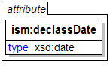
A specific date, in the format YYYY-MM-DD, at which the applicable
information is automatically declassified.

declassEvent [attribute]
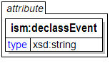
A textual description of an event that triggers declassification.

declassException [attribute]
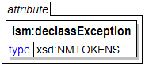
One or more of the exceptions to 25-year declassification:
specify "25X1-human", "25X1", "25X2", ..., "25X9". If more than
one exception applies, use a space-delimited list. If "25X1-human"
applies, it should be first in a list.

declassManualReview [attribute]
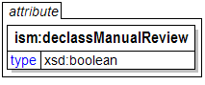
A true/false indication that manual review is required for
declassification. Use this attribute to force the appearance of
"//MR" in the header and footer marking titles. Use this attribute
ONLY when it is necessary to override the business logic applied to
classification and control markings in the document to determine
whether manual review is required.

DepartmentName
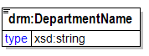
Name of department with which a Data Steward is associated.
RELATIONSHIPS: None

derivedFrom [attribute]
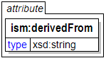
A text string containing (a) the title and date of a specific source
document, or (b) the title and date of an organization classification
guide, or (c) the literal string "Multiple Sources".

description
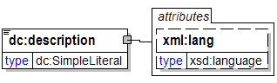
General description element used in various places.
RELATIONSHIPS: None
lang [attribute]

Description
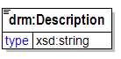
General description element used in various places.
RELATIONSHIPS: None

DigitalDataResourceRefs
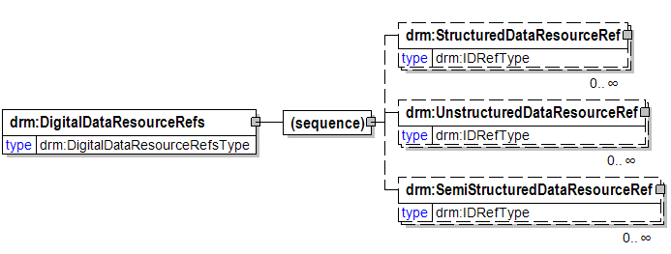
A container for StructuredDataResourceRef, UnstructuredDataResourceRef, and SemiStructuredDataResourceRef elements (which are collectively considered to be Digital Data Resource references).
NOTE: This element is used for Data Assets, but not for Topics - even though the DRM 2.0 abstract model lists a relationship between a Topic and Digital Data Resources. The reason for this is that
the relationship from Data Digital Resources to Topics is represented in each of the Digital Data Resource container elements (i.e. StucturedDataResources, SemiStucturedDataResources, and
UnstucturedDataResources), in a "TopicRefs" element. This was done because it makes more sense to list Topics by which an artifact is categorized where the artifact itself is described, rather
than vice-versa.
RELATIONSHIPS: None
(sequence)
StructuredDataResourceRef
A reference to a StructuredDataResource element contained within the same DRM instance.
RELATIONSHIPS: None
UnstructuredDataResourceRef
A reference to an UnstructuredDataResource element contained within the same DRM instance.
RELATIONSHIPS: None
SemiStructuredDataResourceRef
A reference to a SemiStructuredDataResource element contained within the same DRM instance.
RELATIONSHIPS: None

DigitalDataResources
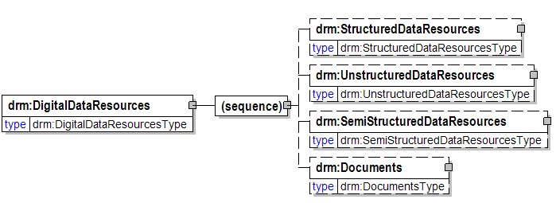
A container for DigitalDataResource elements.
RELATIONSHIPS: None
(sequence)
StructuredDataResources
A container for StructuredDataResource elements.
RELATIONSHIPS: None
UnstructuredDataResources
A container for UnstructuredDataResource elements.
RELATIONSHIPS: None
SemiStructuredDataResources
A container for SemiStructuredDataResource elements.
RELATIONSHIPS: None
Documents
A container for Document elements.
RELATIONSHIPS: None

disseminationControls [attribute]
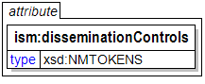
Authorized dissemination control portion mark abbreviation(s).
Either (a) a single abbreviation or (b) a space-delimited list
of abbreviations in the order shown in the CAPCO Register.
Exception: For the "REL" abbreviation, omit the country code
trigraph(s) and instead place the trigraph(s) in the
"releasableTo" attribute value.

Document
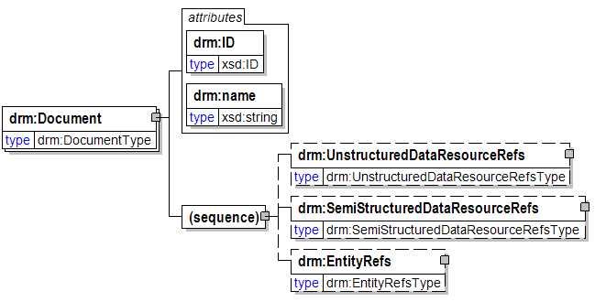
A discrete and unique electronic aggregation of data produced with the intent of conveying information. Specifically for the DRM, a Document is a file containing Unstructured and/or Semi-Structured Data Resources.
RELATIONSHIPS:
- A Document may contain one or more Unstructured Data Resources;
- A Document may contain one or more Semi-structured Data Resources;
- A Document refers to one or more Entities;
ID [attribute]
General identifier attribute used in various places.
RELATIONSHIPS: None
name [attribute]
General name attribute used in various places.
RELATIONSHIPS: None
(sequence)
UnstructuredDataResourceRefs
A container for UnstructuredDataResourceRef elements.
RELATIONSHIPS: None
SemiStructuredDataResourceRefs
A container for SemiStructuredDataResourceRef elements.
RELATIONSHIPS: None
EntityRefs
A container for EntityRef elements.
RELATIONSHIPS: None

Documents
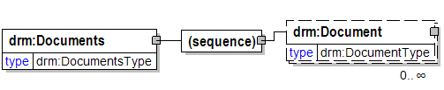
A container for Document elements.
RELATIONSHIPS: None
(sequence)
Document
A discrete and unique electronic aggregation of data produced with the intent of conveying information. Specifically for the DRM, a Document is a file containing Unstructured and/or Semi-Structured Data Resources.
RELATIONSHIPS:
- A Document may contain one or more Unstructured Data Resources;
- A Document may contain one or more Semi-structured Data Resources;
- A Document refers to one or more Entities;

email
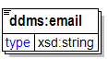
An address for electronic mail.

EmployeeID
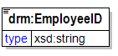
Employee ID for a Data Steward.
RELATIONSHIPS: None

end
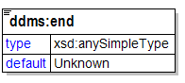

Endpoint
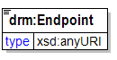
The network endpoint for a Query Point.
RELATIONSHIPS: None

Entities
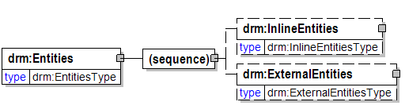
A container for Entity elements.
RELATIONSHIPS: None
(sequence)
InlineEntities
A container for "inline" Entity elements (i.e. those that appear in the DRM instance as opposed to being externally referenced).
RELATIONSHIPS: None
ExternalEntities
A container for externally referenced Entity elements.
RELATIONSHIPS: None

Entity
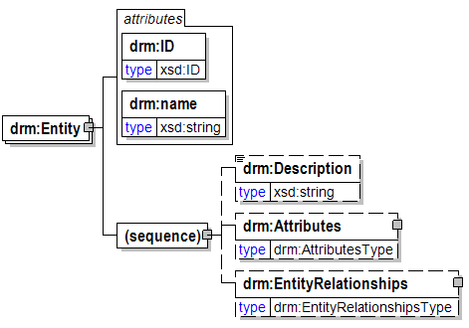
An abstraction for a person, place, object, event, or concept described (or characterized) by common Attributes.
RELATIONSHIPS:
- An Entity contains one or more Attributes (inline Entities only);
- An Entity is related to one or more other Entities;
ID [attribute]
General identifier attribute used in various places.
RELATIONSHIPS: None
name [attribute]
General name attribute used in various places.
RELATIONSHIPS: None
(sequence)
Description
General description element used in various places.
RELATIONSHIPS: None
Attributes
A container for Attribute elements.
RELATIONSHIPS: None
EntityRelationships
A container for EntityRelationship elements.
RELATIONSHIPS: None

entityRef [attribute]
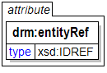
A reference to an Entity element contained within the same DRM instance.
NOTE: This attribute is used to depict relationships among Entities, while the "EntityRef" element is used to depict relationships between other concepts (e.g. Documents) and Entities. This attribute was created for reduced verbosity in depicting relationships among Entities.
RELATIONSHIPS: None

EntityRef
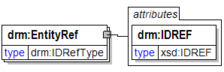
A reference to an Entity element contained within the same DRM instance.
RELATIONSHIPS: None
IDREF [attribute]
A reference to an identifier within the same DRM instance.
RELATIONSHIPS: None

EntityRefs
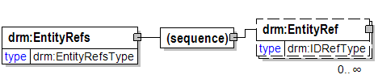
A container for EntityRef elements.
RELATIONSHIPS: None
(sequence)
EntityRef
A reference to an Entity element contained within the same DRM instance.
RELATIONSHIPS: None

EntityRelationship
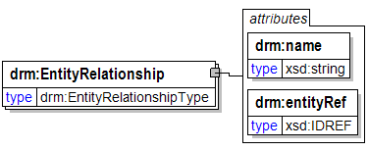
An association between two Entities.
RELATIONSHIPS: None
name [attribute]
General name attribute used in various places.
RELATIONSHIPS: None
entityRef [attribute]
A reference to an Entity element contained within the same DRM instance.
NOTE: This attribute is used to depict relationships among Entities, while the "EntityRef" element is used to depict relationships between other concepts (e.g. Documents) and Entities. This attribute was created for reduced verbosity in depicting relationships among Entities.
RELATIONSHIPS: None

EntityRelationships
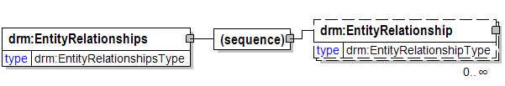
A container for EntityRelationship elements.
RELATIONSHIPS: None
(sequence)
EntityRelationship
An association between two Entities.
RELATIONSHIPS: None

ExchangeFrequency
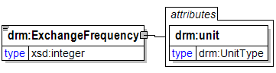
The frequency at which an exchange is estimated to occur.
RELATIONSHIPS: None
unit [attribute]
The regularity of an exchange represented by an Exchange Package (e.g. Daily, Weekly, etc.). Indicates the units that correspond to the value for the Exchange Frequency (e.g. 2 times daily, once a month, etc.).
RELATIONSHIPS: None

ExchangePackage
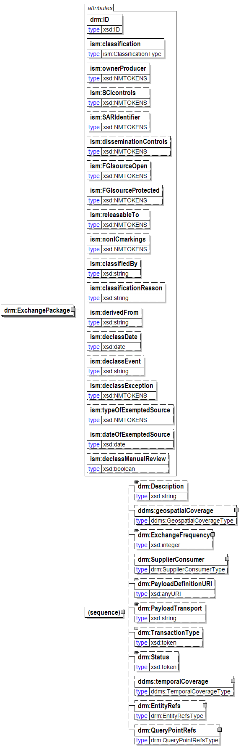
A description of a specific recurring data exchange between a Supplier and a Consumer.
RELATIONSHIPS:
- An Exchange Package refers to one or more Entities;
- An Exchange Package is disseminated to a Consumer;
- An Exchange Package queries one or more Query Points;
- An Exchange Package refers to a Payload Definition (inline Exchange Package only);
ID [attribute]
General identifier attribute used in various places.
RELATIONSHIPS: None
classification [attribute]

ownerProducer [attribute]
ISO 3166-1 trigraph(s) of the owner or producer country(ies) and/or
CAPCO-specified tetragraphs of international organizations.
Either (a) a single trigraph or tetragraph or (b) a space-delimited
list of trigraphs followed by tetragraphs. Trigraphs must be in
alphabetical order and tetragraphs must be in alphabetical order.
SCIcontrols [attribute]
Authorized abbreviation(s) of SCI control system(s). Either
(a) a single abbreviation or (b) a space-delimited list of
abbreviations in the order prescribed in the CAPCO Register.
SARIdentifier [attribute]
Authorized Special Access Required program digraph(s) or
trigraph(s) preceded by "SAR-". Either (a) a single digraph or
trigraph or (b) a space-delimited list of digraphs or trigraphs.
Example: "SAR-ABC SAR-DEF ..."
disseminationControls [attribute]
Authorized dissemination control portion mark abbreviation(s).
Either (a) a single abbreviation or (b) a space-delimited list
of abbreviations in the order shown in the CAPCO Register.
Exception: For the "REL" abbreviation, omit the country code
trigraph(s) and instead place the trigraph(s) in the
"releasableTo" attribute value.
FGIsourceOpen [attribute]
Non-US classification portion marking for foreign government
information in a document portion. Use this attribute to record
a source country when the intent is to post the document to a
shared space with the source identified.
FGIsourceProtected [attribute]
Non-US classification portion marking for foreign government
information in a document portion. Use this attribute to record
a source country when the intent is to filter out the identity of
the source prior to posting the document to a shared space.
releasableTo [attribute]
ISO 3166-1 trigraphic codes of countries to which the associated
content can be released. Include "USA" in all instances. Use a space-
delimited list with "USA" first, followed by the other trigraph(s)
in alphabetical order.
nonICmarkings [attribute]
Authorized non-IC portion marking abbreviation(s) from the CAPCO
Register. Either (a) a single non-IC abbreviated marking or
(b) a space-delimited list of abbreviations in the order shown
in the CAPCO Register.
classifiedBy [attribute]
Use as specified by E.O. 12958.
classificationReason [attribute]
A text string containing one or more paragraph numbers, 1.4(a)
through 1.4(h), taken from E.O. 12958, as amended. Enter the
paragraph references as they should appear in a
classification/declassification block.
derivedFrom [attribute]
A text string containing (a) the title and date of a specific source
document, or (b) the title and date of an organization classification
guide, or (c) the literal string "Multiple Sources".
declassDate [attribute]
A specific date, in the format YYYY-MM-DD, at which the applicable
information is automatically declassified.
declassEvent [attribute]
A textual description of an event that triggers declassification.
declassException [attribute]
One or more of the exceptions to 25-year declassification:
specify "25X1-human", "25X1", "25X2", ..., "25X9". If more than
one exception applies, use a space-delimited list. If "25X1-human"
applies, it should be first in a list.
typeOfExemptedSource [attribute]
One or more tokens indicating that a source that is exempted from
automatic declassification applies. Specify "OADR", "X1", "X2", ...,
"X8". If more than one applies, use a space-delimited list.
dateOfExemptedSource [attribute]
A specific date, in the format YYYY-MM-DD. Used in conjunction with
attribute "typeOfExemptedSource." If there are multiple exempted
sources, specify the date of the exempted
source that has the most recent date.
declassManualReview [attribute]
A true/false indication that manual review is required for
declassification. Use this attribute to force the appearance of
"//MR" in the header and footer marking titles. Use this attribute
ONLY when it is necessary to override the business logic applied to
classification and control markings in the document to determine
whether manual review is required.
(sequence)
Description
General description element used in various places.
RELATIONSHIPS: None
geospatialCoverage

ExchangeFrequency
The frequency at which an exchange is estimated to occur.
RELATIONSHIPS: None
SupplierConsumer
A container for Supplier and Consumer elements.
RELATIONSHIPS: None
PayloadDefinitionURI
The Web address of an electronic definition that defines the requirements for the payload (data) that is exchanged between a Supplier and a Consumer. Examples include XML Schema and EDI transaction sets.
RELATIONSHIPS: None
PayloadTransport
The manner by which a payload (message) is transported from sender to receiver. It is typically, but not necessarily, a computer networking protocol.
NOTE: In the future, this may be represented as an enumerated list.
RELATIONSHIPS: None
TransactionType
An indication of the message pattern that is used for transactions defined by an Exchange Package (e.g. Query/Response, Publish/Subscribe, etc.).
NOTE: Additional values for the enumerated list associated with this element may be added in the future.
RELATIONSHIPS: None
Status
The status of an Exchange Package (e.g. complete or in-progress) where "complete" indicates that the Exchange Package is set up in production, and "In-progress" indicats that the Exchange Package is not yet in production but is in the process of being prepared for production.
RELATIONSHIPS: None
temporalCoverage

EntityRefs
A container for EntityRef elements.
RELATIONSHIPS: None
QueryPointRefs
A container for QueryPointRef elements.
RELATIONSHIPS: None

ExchangePackages
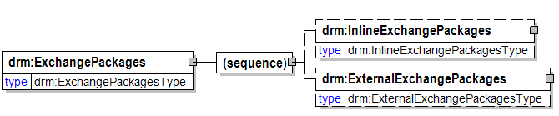
A container for ExchangePackage elements.
RELATIONSHIPS: None
(sequence)
InlineExchangePackages
A container for "inline" ExchangePackage elements (i.e. those that appear in the DRM instance as opposed to being externally referenced).
RELATIONSHIPS: None
ExternalExchangePackages
A container for externally referenced ExchangePackage elements.
RELATIONSHIPS: None

extent
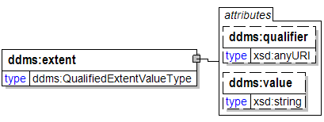
A related data size, compression rate, or pixel size (etc.) of the resource.
See also, DDMS Version 1.2 Format @ 70.
qualifier [attribute]

value [attribute]

ExternalEntities
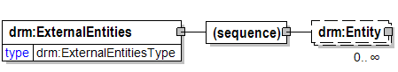
A container for externally referenced Entity elements.
RELATIONSHIPS: None
(sequence)
Entity

ExternalExchangePackages
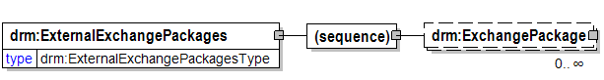
A container for externally referenced ExchangePackage elements.
RELATIONSHIPS: None
(sequence)
ExchangePackage

ExternalTaxonomies
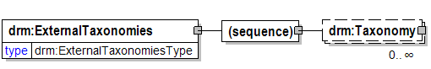
A container for externally referenced Taxonomy elements.
RELATIONSHIPS: None
(sequence)
Taxonomy

ExternalUnstructuredDataResources
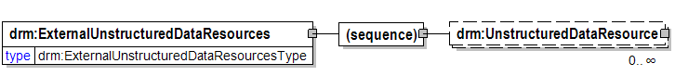
A container for externally referenced UnstructuredDataResource elements.
RELATIONSHIPS: None
(sequence)
UnstructuredDataResource

Facility
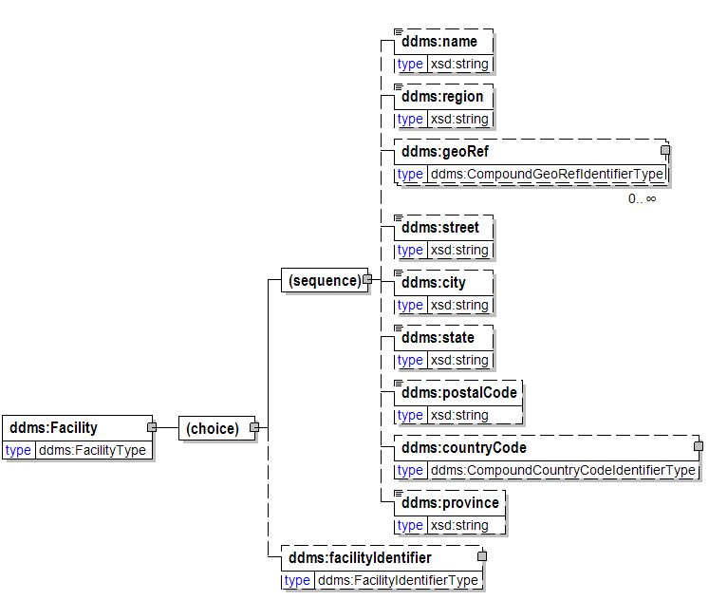
(choice)
(sequence)
name

region

geoRef

street

city

state

postalCode

countryCode

province

facilityIdentifier

facilityIdentifier
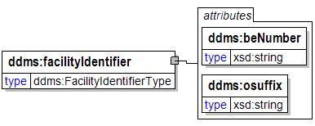
beNumber [attribute]

osuffix [attribute]

FGIsourceOpen [attribute]
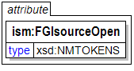
Non-US classification portion marking for foreign government
information in a document portion. Use this attribute to record
a source country when the intent is to post the document to a
shared space with the source identified.

FGIsourceProtected [attribute]
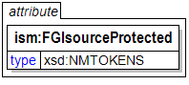
Non-US classification portion marking for foreign government
information in a document portion. Use this attribute to record
a source country when the intent is to filter out the identity of
the source prior to posting the document to a shared space.

FIPS199PotentialImpactLevels
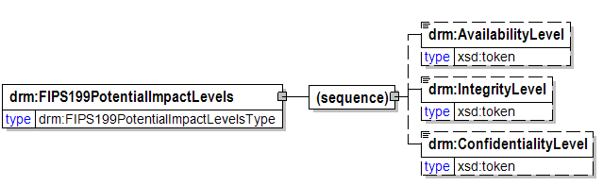
According to FIPS 199, potential impact levels on agency operations, assets, or individuals should there be a breach in security due to the loss of confidentiality, integrity, or availability.
RELATIONSHIPS: None
(sequence)
AvailabilityLevel
FIPS 199 "availability" impact level.
RELATIONSHIPS: None
IntegrityLevel
FIPS 199 "integrity" impact level.
RELATIONSHIPS: None
ConfidentialityLevel
FIPS 199 "confidentiality" impact level.
RELATIONSHIPS: None

format
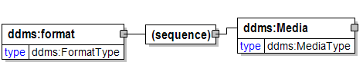
(sequence)
Media

format
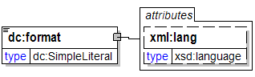
lang [attribute]

geoRef
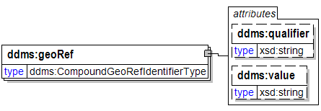
qualifier [attribute]

value [attribute]

geospatialCoverage
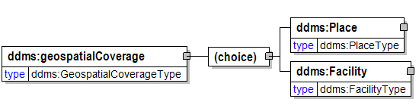
(choice)
Place

Facility

GeospatialEnabled
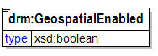
A boolean flag indicating whether or not a Data Asset supports or provides Geospatial data.
RELATIONSHIPS: None

ID [attribute]
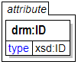
General identifier attribute used in various places.
RELATIONSHIPS: None

identifier
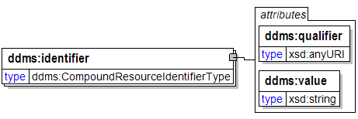
qualifier [attribute]

value [attribute]

identifier
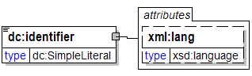
lang [attribute]

IDREF [attribute]
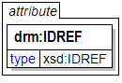
A reference to an identifier within the same DRM instance.
RELATIONSHIPS: None

infoCutOff [attribute]
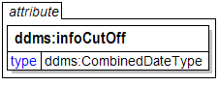
The cutoff date of information in a product. This is commonly referred to as Information Cutoff Date (ICOD). It is the date of last input.

InitialDate
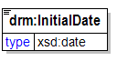
Date that a Data Steward became associated with a Data Asset.
RELATIONSHIPS: None

InlineEntities
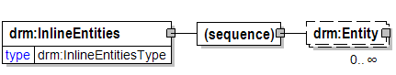
A container for "inline" Entity elements (i.e. those that appear in the DRM instance as opposed to being externally referenced).
RELATIONSHIPS: None
(sequence)
Entity

InlineExchangePackages
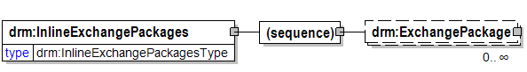
A container for "inline" ExchangePackage elements (i.e. those that appear in the DRM instance as opposed to being externally referenced).
RELATIONSHIPS: None
(sequence)
ExchangePackage

InlineTaxonomies
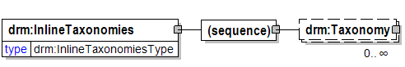
A container for "inline" Taxonomy elements (i.e. those that appear in the DRM instance as opposed to being externally referenced).
RELATIONSHIPS: None
(sequence)
Taxonomy

InlineUnstructuredDataResources
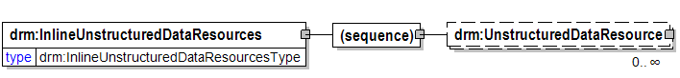
A container for "inline" UnstructuredDataResource elements (i.e. those that appear in the DRM instance as opposed to being externally referenced).
RELATIONSHIPS: None
(sequence)
UnstructuredDataResource

IntegrityLevel
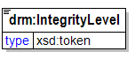
FIPS 199 "integrity" impact level.
RELATIONSHIPS: None

intellectualProperty [attribute]
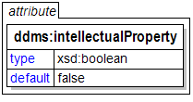
An indicator identifying products under protection against reproduction and distribution without the express written permission of the intellectual property rights owner. A yes/no value used to specify applicability of the rights. The default is “no”. {False = No}

keyword
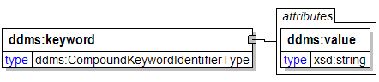
A natural language indication of the resource's subject matter.
See DDMS Version 1.2 Subject @ 55.
value [attribute]

label [attribute]
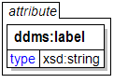

lang [attribute]
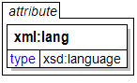

language
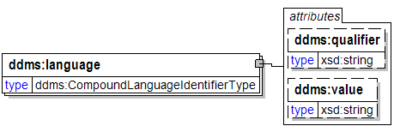
qualifier [attribute]

value [attribute]

language
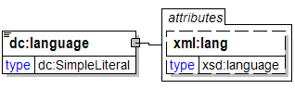
lang [attribute]

Latency
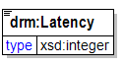
The number of seconds needed to pass a message to an access point. Usually measured from the initiation of a request to the receipt of the response.
RELATIONSHIPS: None

LocationURI
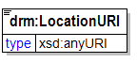
General URI element used in various places to specify the Web address of an externally referenced artifact (such as an external taxonomy).
RELATIONSHIPS: None

Media
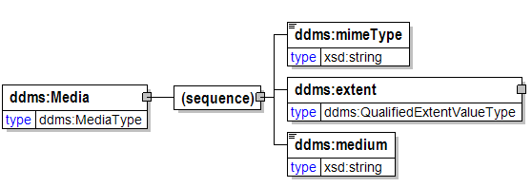
Container item for holding media info.
(sequence)
mimeType
The Internet Media Type [MIME] of the Resource.
See DDMS Version 1.2 Format @ 70.
extent
A related data size, compression rate, or pixel size (etc.) of the resource.
See also, DDMS Version 1.2 Format @ 70.
medium
The physical medium or instantiation of the resource.
See also DDMS Version 1.2 Format @ 70.

medium
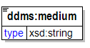
The physical medium or instantiation of the resource.
See also DDMS Version 1.2 Format @ 70.

mimeType
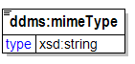
The Internet Media Type [MIME] of the Resource.
See DDMS Version 1.2 Format @ 70.

MinimumEncryptionLevel
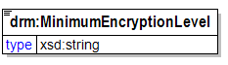
The minimal level of encryption needed to pass data to and from an access point.
RELATIONSHIPS: None

name [attribute]
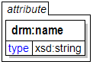
General name attribute used in various places.
RELATIONSHIPS: None

name
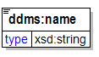

nonICmarkings [attribute]
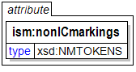
Authorized non-IC portion marking abbreviation(s) from the CAPCO
Register. Either (a) a single non-IC abbreviated marking or
(b) a space-delimited list of abbreviations in the order shown
in the CAPCO Register.

Organization
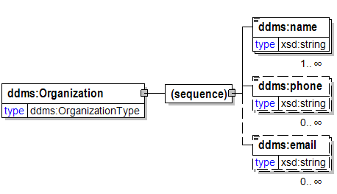
A named organization responsible as indicated by its encompasing element, i.e. as a creator, contributor, or publisher.
See DDMS Version 1.2 Creator @ 31.
See also DDMS Version 1.2 Publisher @ 34.
See also DDMS Version 1.2 Contributor @ 37.
(sequence)
name

phone

email

osuffix [attribute]
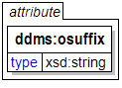
(GMI:OSUFFIX, 1.0) Uniquely identifies a facility or demographic area in conjunction with a BE_NUMBER. Pos. 1-2. SYSTEM ASSIGNED RECORD_ORIGINATOR. The organization creating the facility or demographic area. DIA installation records created prior to IDB generation of OSUFFIX contain DD.Pos. 3-5 A one-up number.

ownerProducer [attribute]
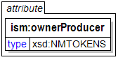
ISO 3166-1 trigraph(s) of the owner or producer country(ies) and/or
CAPCO-specified tetragraphs of international organizations.
Either (a) a single trigraph or tetragraph or (b) a space-delimited
list of trigraphs followed by tetragraphs. Trigraphs must be in
alphabetical order and tetragraphs must be in alphabetical order.

OwningAgency
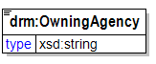
The agency providing primary stewardship for a Data Asset.
RELATIONSHIPS: None

PayloadDefinitionURI
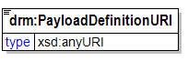
The Web address of an electronic definition that defines the requirements for the payload (data) that is exchanged between a Supplier and a Consumer. Examples include XML Schema and EDI transaction sets.
RELATIONSHIPS: None

PayloadTransport
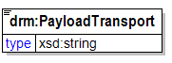
The manner by which a payload (message) is transported from sender to receiver. It is typically, but not necessarily, a computer networking protocol.
NOTE: In the future, this may be represented as an enumerated list.
RELATIONSHIPS: None

Person
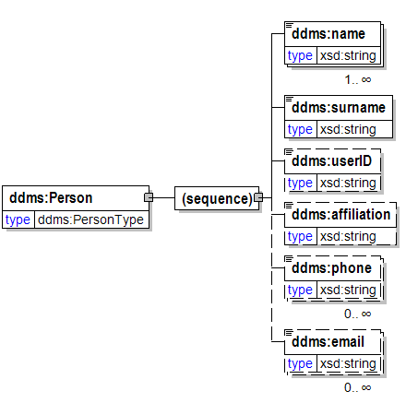
A person responsible as indicated by its encompasing element, i.e. as a creator, contributor, or publisher.
See DDMS Version 1.2 Creator @ 31.
See also DDMS Version 1.2 Publisher @ 34.
See also DDMS Version 1.2 Contributor @ 37.
(sequence)
name

surname

userID

affiliation

phone

email

phone
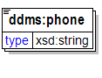
A telephone number. Optional. This value must include country code and area code, when applicable.

Place
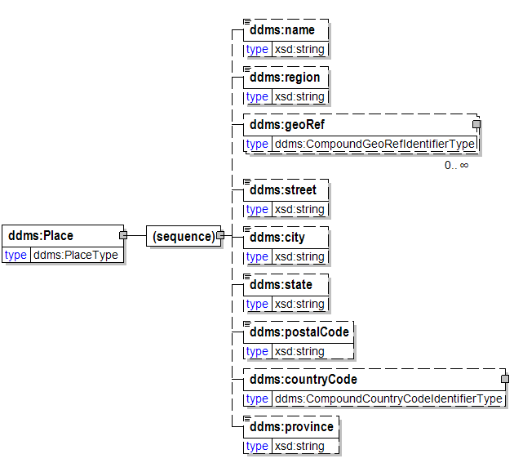
(sequence)
name

region

geoRef

street

city

state

postalCode

countryCode

province

PointOfContact
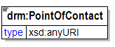
A URI pointing to the person or organization to contact for more information regarding a Data Asset. This usually includes a name, phone number, email address, and other contact information. The resource/record should ideally be a structured machine-readable resource (e.g., XML document), but can be a HTML/web page providing the appropriate documentation.
RELATIONSHIPS: None

pointOfContact
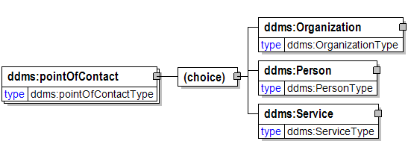
A URI pointing to the person or organization to contact for more information regarding a Data Asset. This usually includes a name, phone number, email address, and other contact information. The resource/record should ideally be a structured machine-readable resource (e.g., XML document), but can be a HTML/web page providing the appropriate documentation.
RELATIONSHIPS: None
(choice)
Organization
A named organization responsible as indicated by its encompasing element, i.e. as a creator, contributor, or publisher.
See DDMS Version 1.2 Creator @ 31.
See also DDMS Version 1.2 Publisher @ 34.
See also DDMS Version 1.2 Contributor @ 37.
Person
A person responsible as indicated by its encompasing element, i.e. as a creator, contributor, or publisher.
See DDMS Version 1.2 Creator @ 31.
See also DDMS Version 1.2 Publisher @ 34.
See also DDMS Version 1.2 Contributor @ 37.
Service
A named service responsible as indicated by its encompasing element, i.e. as a creator, contributor, or publisher.
See DDMS Version 1.2 Creator @ 31.
See also DDMS Version 1.2 Publisher @ 34.
See also DDMS Version 1.2 Contributor @ 37.

postalCode
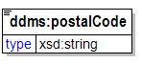

posted [attribute]
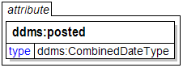
The date a product is posted to a shared network or system.

PrimaryContact
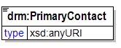
A URI pointing to an electronic representation (e.g. XML document, Web page) of contact information for the primary contact for a Supplier or Consumer.
RELATIONSHIPS: None

privacyAct [attribute]
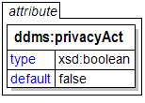
(TBD:PrivacyActIndicator, 1.0) An indicator that this product is categorized as containing personal information subject to protection by the Privacy Act. This element has no data content. Attribute "indicator", a yes/no toggle, is used to specify applicability of the Privacy Act. The default is "no". {False = No}

protocol [attribute]
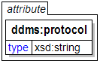

province
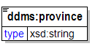

publisher
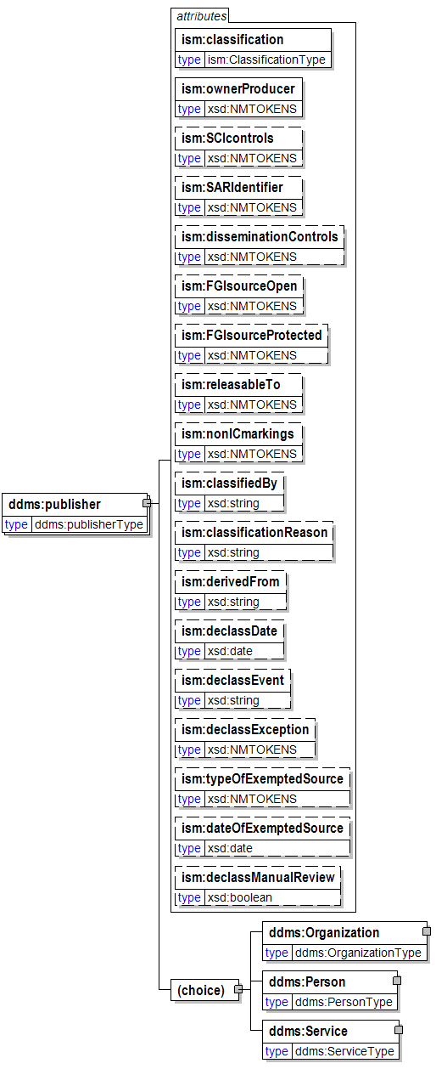
classification [attribute]

ownerProducer [attribute]
ISO 3166-1 trigraph(s) of the owner or producer country(ies) and/or
CAPCO-specified tetragraphs of international organizations.
Either (a) a single trigraph or tetragraph or (b) a space-delimited
list of trigraphs followed by tetragraphs. Trigraphs must be in
alphabetical order and tetragraphs must be in alphabetical order.
SCIcontrols [attribute]
Authorized abbreviation(s) of SCI control system(s). Either
(a) a single abbreviation or (b) a space-delimited list of
abbreviations in the order prescribed in the CAPCO Register.
SARIdentifier [attribute]
Authorized Special Access Required program digraph(s) or
trigraph(s) preceded by "SAR-". Either (a) a single digraph or
trigraph or (b) a space-delimited list of digraphs or trigraphs.
Example: "SAR-ABC SAR-DEF ..."
disseminationControls [attribute]
Authorized dissemination control portion mark abbreviation(s).
Either (a) a single abbreviation or (b) a space-delimited list
of abbreviations in the order shown in the CAPCO Register.
Exception: For the "REL" abbreviation, omit the country code
trigraph(s) and instead place the trigraph(s) in the
"releasableTo" attribute value.
FGIsourceOpen [attribute]
Non-US classification portion marking for foreign government
information in a document portion. Use this attribute to record
a source country when the intent is to post the document to a
shared space with the source identified.
FGIsourceProtected [attribute]
Non-US classification portion marking for foreign government
information in a document portion. Use this attribute to record
a source country when the intent is to filter out the identity of
the source prior to posting the document to a shared space.
releasableTo [attribute]
ISO 3166-1 trigraphic codes of countries to which the associated
content can be released. Include "USA" in all instances. Use a space-
delimited list with "USA" first, followed by the other trigraph(s)
in alphabetical order.
nonICmarkings [attribute]
Authorized non-IC portion marking abbreviation(s) from the CAPCO
Register. Either (a) a single non-IC abbreviated marking or
(b) a space-delimited list of abbreviations in the order shown
in the CAPCO Register.
classifiedBy [attribute]
Use as specified by E.O. 12958.
classificationReason [attribute]
A text string containing one or more paragraph numbers, 1.4(a)
through 1.4(h), taken from E.O. 12958, as amended. Enter the
paragraph references as they should appear in a
classification/declassification block.
derivedFrom [attribute]
A text string containing (a) the title and date of a specific source
document, or (b) the title and date of an organization classification
guide, or (c) the literal string "Multiple Sources".
declassDate [attribute]
A specific date, in the format YYYY-MM-DD, at which the applicable
information is automatically declassified.
declassEvent [attribute]
A textual description of an event that triggers declassification.
declassException [attribute]
One or more of the exceptions to 25-year declassification:
specify "25X1-human", "25X1", "25X2", ..., "25X9". If more than
one exception applies, use a space-delimited list. If "25X1-human"
applies, it should be first in a list.
typeOfExemptedSource [attribute]
One or more tokens indicating that a source that is exempted from
automatic declassification applies. Specify "OADR", "X1", "X2", ...,
"X8". If more than one applies, use a space-delimited list.
dateOfExemptedSource [attribute]
A specific date, in the format YYYY-MM-DD. Used in conjunction with
attribute "typeOfExemptedSource." If there are multiple exempted
sources, specify the date of the exempted
source that has the most recent date.
declassManualReview [attribute]
A true/false indication that manual review is required for
declassification. Use this attribute to force the appearance of
"//MR" in the header and footer marking titles. Use this attribute
ONLY when it is necessary to override the business logic applied to
classification and control markings in the document to determine
whether manual review is required.
(choice)
Organization
A named organization responsible as indicated by its encompasing element, i.e. as a creator, contributor, or publisher.
See DDMS Version 1.2 Creator @ 31.
See also DDMS Version 1.2 Publisher @ 34.
See also DDMS Version 1.2 Contributor @ 37.
Person
A person responsible as indicated by its encompasing element, i.e. as a creator, contributor, or publisher.
See DDMS Version 1.2 Creator @ 31.
See also DDMS Version 1.2 Publisher @ 34.
See also DDMS Version 1.2 Contributor @ 37.
Service
A named service responsible as indicated by its encompasing element, i.e. as a creator, contributor, or publisher.
See DDMS Version 1.2 Creator @ 31.
See also DDMS Version 1.2 Publisher @ 34.
See also DDMS Version 1.2 Contributor @ 37.

publisher
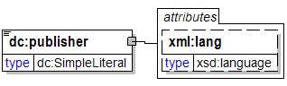
lang [attribute]

qualifier [attribute]
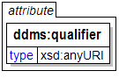

qualifier [attribute]
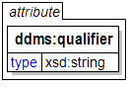

QualityOfServiceInformation
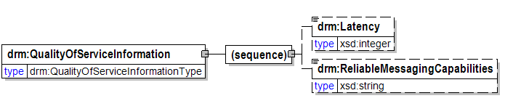
Specifies Quality of Service (QoS)-related information for a Query Point.
RELATIONSHIPS: None
(sequence)
Latency
The number of seconds needed to pass a message to an access point. Usually measured from the initiation of a request to the receipt of the response.
RELATIONSHIPS: None
ReliableMessagingCapabilities
Specifies reliable messaging-related requirements for a Query Point.
NOTE: In the future, this will may contain multiple sub-elements, each of which relates to a single capability (such as duplicate message elimination).
RELATIONSHIPS: None

QueryLanguage
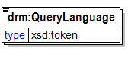
A standard query language that can be used to access the data within a Data Asset.
RELATIONSHIPS: None

QueryLanguages
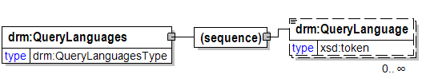
A container for QueryLanguage elements.
RELATIONSHIPS: None
(sequence)
QueryLanguage
A standard query language that can be used to access the data within a Data Asset.
RELATIONSHIPS: None

QueryPoint
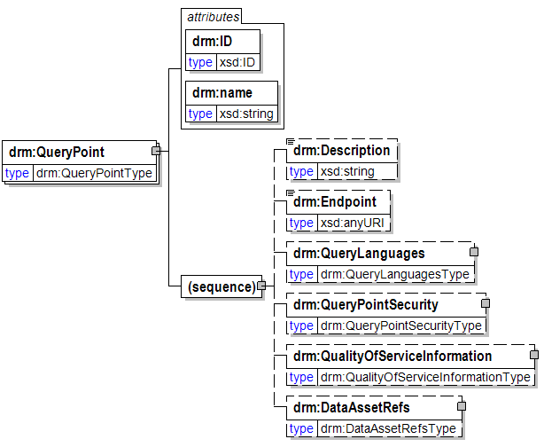
An endpoint that provides an interface for accessing and querying a Data Asset. A concrete representation of a Query Point is a specific URL at which a query Web Service may be invoked.
RELATIONSHIPS:
- A Query Point returns a result set specified in an Exchange Package;
- A Query Point accesses one or more Data Assets;
ID [attribute]
General identifier attribute used in various places.
RELATIONSHIPS: None
name [attribute]
General name attribute used in various places.
RELATIONSHIPS: None
(sequence)
Description
General description element used in various places.
RELATIONSHIPS: None
Endpoint
The network endpoint for a Query Point.
RELATIONSHIPS: None
QueryLanguages
A container for QueryLanguage elements.
RELATIONSHIPS: None
QueryPointSecurity
Specifies security-related information for a Query Point.
RELATIONSHIPS: None
QualityOfServiceInformation
Specifies Quality of Service (QoS)-related information for a Query Point.
RELATIONSHIPS: None
DataAssetRefs
A container for DataAssetRef elements.
RELATIONSHIPS: None

QueryPointRef
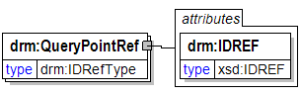
A reference to a QueryPoint element contained within the same DRM instance.
RELATIONSHIPS: None
IDREF [attribute]
A reference to an identifier within the same DRM instance.
RELATIONSHIPS: None

QueryPointRefs
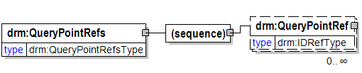
A container for QueryPointRef elements.
RELATIONSHIPS: None
(sequence)
QueryPointRef
A reference to a QueryPoint element contained within the same DRM instance.
RELATIONSHIPS: None

QueryPoints
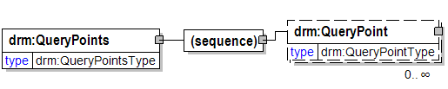
A container for QueryPoint elements.
RELATIONSHIPS: None
(sequence)
QueryPoint
An endpoint that provides an interface for accessing and querying a Data Asset. A concrete representation of a Query Point is a specific URL at which a query Web Service may be invoked.
RELATIONSHIPS:
- A Query Point returns a result set specified in an Exchange Package;
- A Query Point accesses one or more Data Assets;

QueryPointSecurity
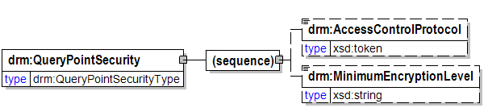
Specifies security-related information for a Query Point.
RELATIONSHIPS: None
(sequence)
AccessControlProtocol
The standard and/or protocol providing access control for a Query Point.
RELATIONSHIPS: None
MinimumEncryptionLevel
The minimal level of encryption needed to pass data to and from an access point.
RELATIONSHIPS: None

region
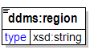

relation
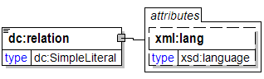
lang [attribute]

releasableTo [attribute]
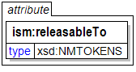
ISO 3166-1 trigraphic codes of countries to which the associated
content can be released. Include "USA" in all instances. Use a space-
delimited list with "USA" first, followed by the other trigraph(s)
in alphabetical order.

ReliableMessagingCapabilities
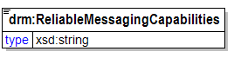
Specifies reliable messaging-related requirements for a Query Point.
NOTE: In the future, this will may contain multiple sub-elements, each of which relates to a single capability (such as duplicate message elimination).
RELATIONSHIPS: None

RepresentationFormat
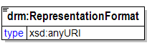
A URI indicating a data standard to which an externally referenced artifact (such as a Taxonomy) complies.
RELATIONSHIPS: None

Resource
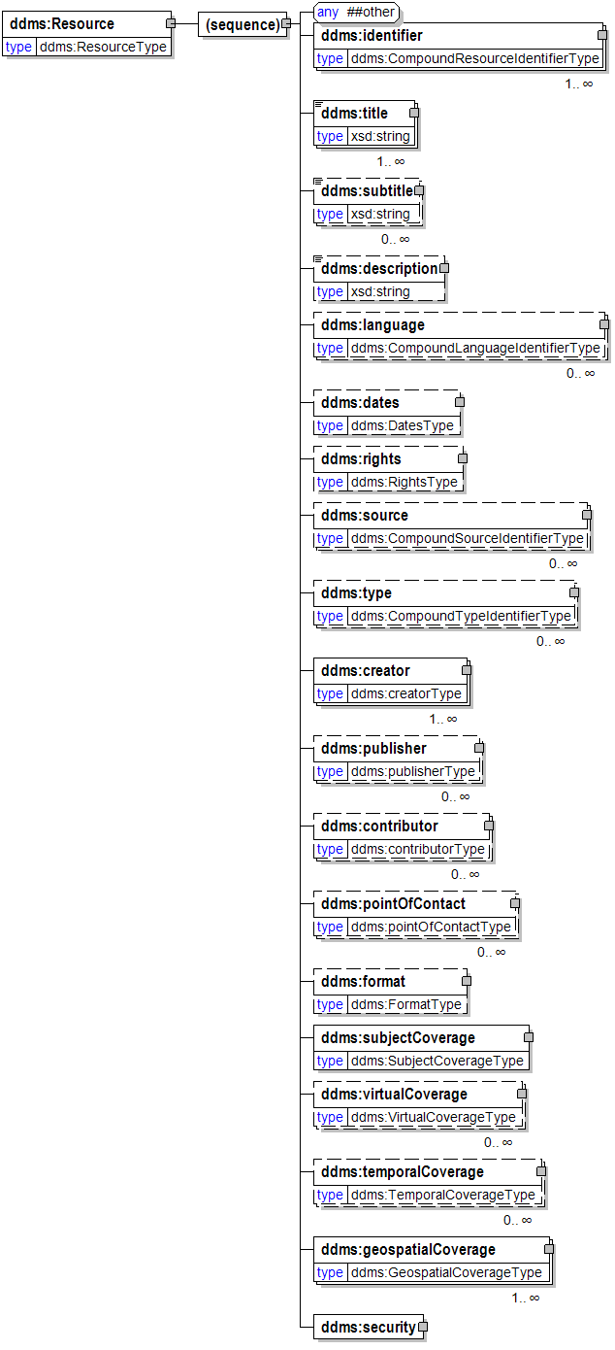
(sequence)
identifier

title

subtitle
A subtitle may be any form of the title used as a substitute, or it may be an alternative to the formal title of the resource.
See also, DDMS Version 1.2 Title @ 28.
description
General description element used in various places.
RELATIONSHIPS: None
language

dates
The date related properties of this resource.
See DDMS Version 1.2 Date @ 47.
rights

source

type

creator

publisher

contributor

pointOfContact
A URI pointing to the person or organization to contact for more information regarding a Data Asset. This usually includes a name, phone number, email address, and other contact information. The resource/record should ideally be a structured machine-readable resource (e.g., XML document), but can be a HTML/web page providing the appropriate documentation.
RELATIONSHIPS: None
format

subjectCoverage
The range of concepts that characterize the subject matter of the resource.
See DDMS Version 1.2 Subject @ 48.
virtualCoverage
The subject-matter coverage of a publication in terms of one ore more virtual addresses. Must identify the protocol being used and the virtual address of the resource.
See DDMS Version 1.2 Virtual Coverage @ 66.
temporalCoverage

geospatialCoverage

security

[Any Type]
Any type of content is permitted at this point.

rights
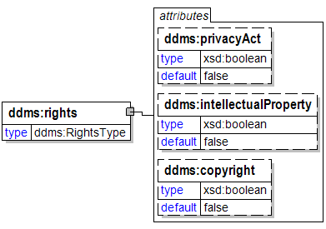
privacyAct [attribute]

intellectualProperty [attribute]

copyright [attribute]

rights
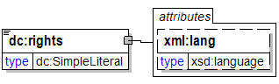
lang [attribute]

SARIdentifier [attribute]
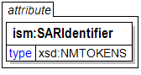
Authorized Special Access Required program digraph(s) or
trigraph(s) preceded by "SAR-". Either (a) a single digraph or
trigraph or (b) a space-delimited list of digraphs or trigraphs.
Example: "SAR-ABC SAR-DEF ..."

schemaHref [attribute]
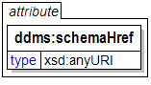

schemaQualifier [attribute]
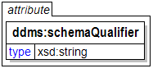

SCIcontrols [attribute]
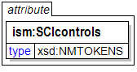
Authorized abbreviation(s) of SCI control system(s). Either
(a) a single abbreviation or (b) a space-delimited list of
abbreviations in the order prescribed in the CAPCO Register.

security
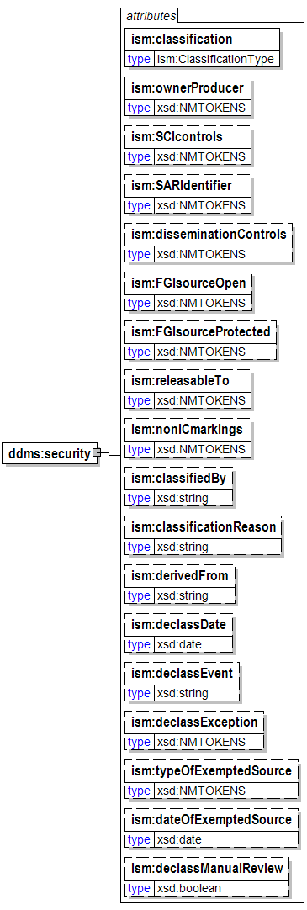
classification [attribute]

ownerProducer [attribute]
ISO 3166-1 trigraph(s) of the owner or producer country(ies) and/or
CAPCO-specified tetragraphs of international organizations.
Either (a) a single trigraph or tetragraph or (b) a space-delimited
list of trigraphs followed by tetragraphs. Trigraphs must be in
alphabetical order and tetragraphs must be in alphabetical order.
SCIcontrols [attribute]
Authorized abbreviation(s) of SCI control system(s). Either
(a) a single abbreviation or (b) a space-delimited list of
abbreviations in the order prescribed in the CAPCO Register.
SARIdentifier [attribute]
Authorized Special Access Required program digraph(s) or
trigraph(s) preceded by "SAR-". Either (a) a single digraph or
trigraph or (b) a space-delimited list of digraphs or trigraphs.
Example: "SAR-ABC SAR-DEF ..."
disseminationControls [attribute]
Authorized dissemination control portion mark abbreviation(s).
Either (a) a single abbreviation or (b) a space-delimited list
of abbreviations in the order shown in the CAPCO Register.
Exception: For the "REL" abbreviation, omit the country code
trigraph(s) and instead place the trigraph(s) in the
"releasableTo" attribute value.
FGIsourceOpen [attribute]
Non-US classification portion marking for foreign government
information in a document portion. Use this attribute to record
a source country when the intent is to post the document to a
shared space with the source identified.
FGIsourceProtected [attribute]
Non-US classification portion marking for foreign government
information in a document portion. Use this attribute to record
a source country when the intent is to filter out the identity of
the source prior to posting the document to a shared space.
releasableTo [attribute]
ISO 3166-1 trigraphic codes of countries to which the associated
content can be released. Include "USA" in all instances. Use a space-
delimited list with "USA" first, followed by the other trigraph(s)
in alphabetical order.
nonICmarkings [attribute]
Authorized non-IC portion marking abbreviation(s) from the CAPCO
Register. Either (a) a single non-IC abbreviated marking or
(b) a space-delimited list of abbreviations in the order shown
in the CAPCO Register.
classifiedBy [attribute]
Use as specified by E.O. 12958.
classificationReason [attribute]
A text string containing one or more paragraph numbers, 1.4(a)
through 1.4(h), taken from E.O. 12958, as amended. Enter the
paragraph references as they should appear in a
classification/declassification block.
derivedFrom [attribute]
A text string containing (a) the title and date of a specific source
document, or (b) the title and date of an organization classification
guide, or (c) the literal string "Multiple Sources".
declassDate [attribute]
A specific date, in the format YYYY-MM-DD, at which the applicable
information is automatically declassified.
declassEvent [attribute]
A textual description of an event that triggers declassification.
declassException [attribute]
One or more of the exceptions to 25-year declassification:
specify "25X1-human", "25X1", "25X2", ..., "25X9". If more than
one exception applies, use a space-delimited list. If "25X1-human"
applies, it should be first in a list.
typeOfExemptedSource [attribute]
One or more tokens indicating that a source that is exempted from
automatic declassification applies. Specify "OADR", "X1", "X2", ...,
"X8". If more than one applies, use a space-delimited list.
dateOfExemptedSource [attribute]
A specific date, in the format YYYY-MM-DD. Used in conjunction with
attribute "typeOfExemptedSource." If there are multiple exempted
sources, specify the date of the exempted
source that has the most recent date.
declassManualReview [attribute]
A true/false indication that manual review is required for
declassification. Use this attribute to force the appearance of
"//MR" in the header and footer marking titles. Use this attribute
ONLY when it is necessary to override the business logic applied to
classification and control markings in the document to determine
whether manual review is required.

SemiStructuredDataResource
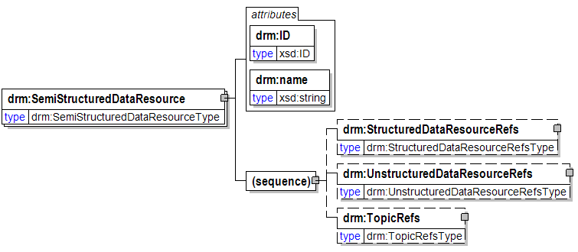
An electronic resource containing data that has characteristics of both structured and unstructured data, such as an e-mail (with structured data such as sender and subject, and unstructured text).
RELATIONSHIPS:
- A Semi-Structured Data Resource is a type of Digital Data Resource;
- A Semi-Structured Data Resource (because it is a Digital Data Resource) is categorized by one or more Topics;
ID [attribute]
General identifier attribute used in various places.
RELATIONSHIPS: None
name [attribute]
General name attribute used in various places.
RELATIONSHIPS: None
(sequence)
StructuredDataResourceRefs
A container for StructuredDataResourceRef elements.
RELATIONSHIPS: None
UnstructuredDataResourceRefs
A container for UnstructuredDataResourceRef elements.
RELATIONSHIPS: None
TopicRefs
A container for TopicRef elements.
RELATIONSHIPS: None

SemiStructuredDataResourceRef
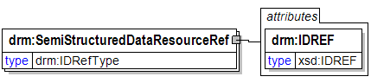
A reference to a SemiStructuredDataResource element contained within the same DRM instance.
RELATIONSHIPS: None
IDREF [attribute]
A reference to an identifier within the same DRM instance.
RELATIONSHIPS: None

SemiStructuredDataResourceRefs
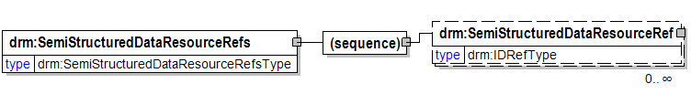
A container for SemiStructuredDataResourceRef elements.
RELATIONSHIPS: None
(sequence)
SemiStructuredDataResourceRef
A reference to a SemiStructuredDataResource element contained within the same DRM instance.
RELATIONSHIPS: None

SemiStructuredDataResources
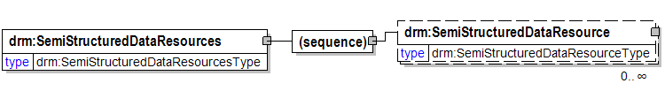
A container for SemiStructuredDataResource elements.
RELATIONSHIPS: None
(sequence)
SemiStructuredDataResource
An electronic resource containing data that has characteristics of both structured and unstructured data, such as an e-mail (with structured data such as sender and subject, and unstructured text).
RELATIONSHIPS:
- A Semi-Structured Data Resource is a type of Digital Data Resource;
- A Semi-Structured Data Resource (because it is a Digital Data Resource) is categorized by one or more Topics;

Service
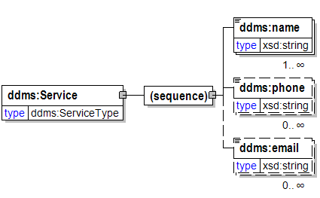
A named service responsible as indicated by its encompasing element, i.e. as a creator, contributor, or publisher.
See DDMS Version 1.2 Creator @ 31.
See also DDMS Version 1.2 Publisher @ 34.
See also DDMS Version 1.2 Contributor @ 37.
(sequence)
name

phone

email

source
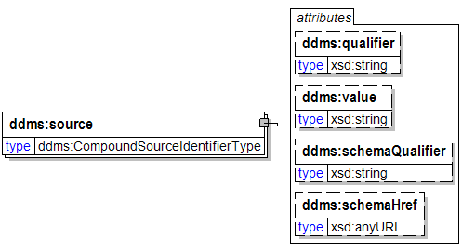
qualifier [attribute]

value [attribute]

schemaQualifier [attribute]

schemaHref [attribute]

source
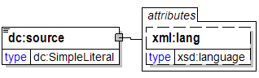
lang [attribute]

start
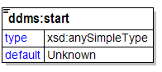

state
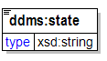

Status
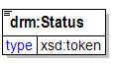
The status of an Exchange Package (e.g. complete or in-progress) where "complete" indicates that the Exchange Package is set up in production, and "In-progress" indicats that the Exchange Package is not yet in production but is in the process of being prepared for production.
RELATIONSHIPS: None

street
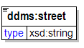

StructuredDataResource
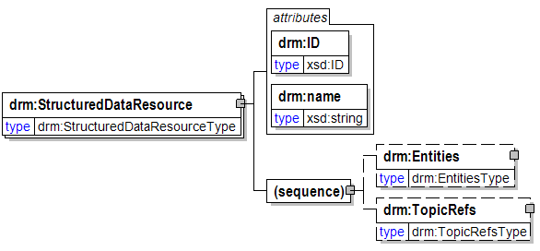
An electronic resource containing data that is described via the E-R (Entity-Relationship) or class model, such as logical data models and XML documents. Structured data is organized in well-defined semantic "chunks" called entities.
RELATIONSHIPS:
- A Structured Data Resource is a type of Digital Data Resource;
- A Structured Data Resource (because it is a Digital Data Resource) is categorized by one or more Topics;
ID [attribute]
General identifier attribute used in various places.
RELATIONSHIPS: None
name [attribute]
General name attribute used in various places.
RELATIONSHIPS: None
(sequence)
Entities
A container for Entity elements.
RELATIONSHIPS: None
TopicRefs
A container for TopicRef elements.
RELATIONSHIPS: None

StructuredDataResourceRef
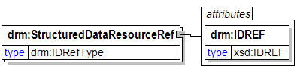
A reference to a StructuredDataResource element contained within the same DRM instance.
RELATIONSHIPS: None
IDREF [attribute]
A reference to an identifier within the same DRM instance.
RELATIONSHIPS: None

StructuredDataResourceRefs
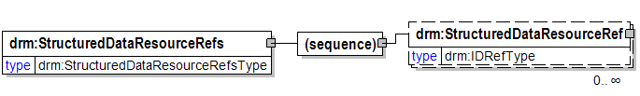
A container for StructuredDataResourceRef elements.
RELATIONSHIPS: None
(sequence)
StructuredDataResourceRef
A reference to a StructuredDataResource element contained within the same DRM instance.
RELATIONSHIPS: None

StructuredDataResources
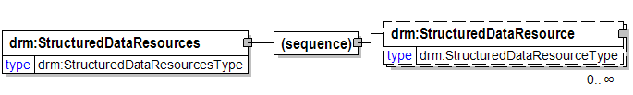
A container for StructuredDataResource elements.
RELATIONSHIPS: None
(sequence)
StructuredDataResource
An electronic resource containing data that is described via the E-R (Entity-Relationship) or class model, such as logical data models and XML documents. Structured data is organized in well-defined semantic "chunks" called entities.
RELATIONSHIPS:
- A Structured Data Resource is a type of Digital Data Resource;
- A Structured Data Resource (because it is a Digital Data Resource) is categorized by one or more Topics;

subject
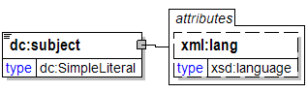
lang [attribute]

Subject
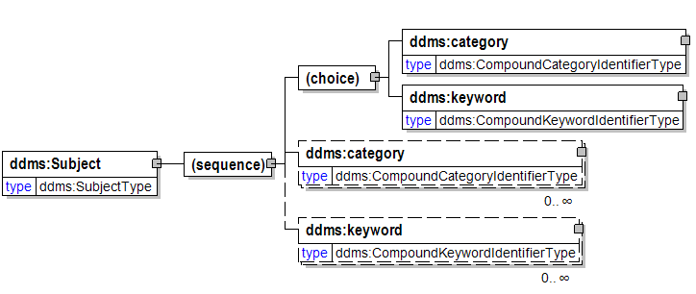
(sequence)
(choice)
category
Specification of the subject matter by a qualified entry from a controlled vocabulary.
See DDMS Version 1.2 Subject @ 55.
keyword
A natural language indication of the resource's subject matter.
See DDMS Version 1.2 Subject @ 55.
category
Specification of the subject matter by a qualified entry from a controlled vocabulary.
See DDMS Version 1.2 Subject @ 55.
keyword
A natural language indication of the resource's subject matter.
See DDMS Version 1.2 Subject @ 55.

subjectCoverage
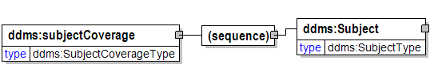
The range of concepts that characterize the subject matter of the resource.
See DDMS Version 1.2 Subject @ 48.
(sequence)
Subject

SubmissionDate
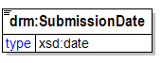
The date that a DRM instance was submitted. May include time as well.
RELATIONSHIPS: None

SubmissionInformation
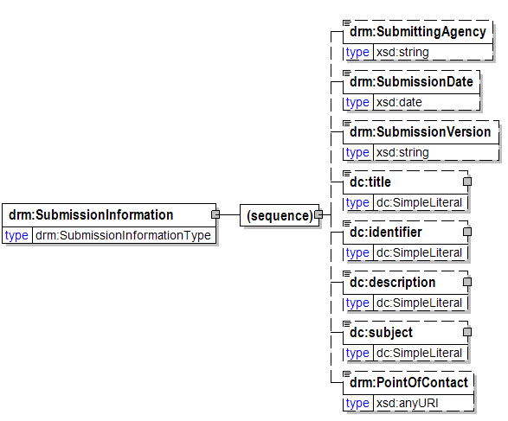
A container for all information related to a DRM submission.
RELATIONSHIPS: None
(sequence)
SubmittingAgency
The Government agency, bureau, office, or department that submits a DRM instance.
RELATIONSHIPS: None
SubmissionDate
The date that a DRM instance was submitted. May include time as well.
RELATIONSHIPS: None
SubmissionVersion
Any submitter-determined string that uniquely (according to the submitter) differentiates a DRM submission from previous DRM submissions by the submitter.
RELATIONSHIPS: None
title

identifier

description
General description element used in various places.
RELATIONSHIPS: None
subject

PointOfContact
A URI pointing to the person or organization to contact for more information regarding a Data Asset. This usually includes a name, phone number, email address, and other contact information. The resource/record should ideally be a structured machine-readable resource (e.g., XML document), but can be a HTML/web page providing the appropriate documentation.
RELATIONSHIPS: None

SubmissionVersion
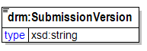
Any submitter-determined string that uniquely (according to the submitter) differentiates a DRM submission from previous DRM submissions by the submitter.
RELATIONSHIPS: None

SubmittingAgency
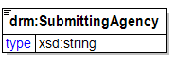
The Government agency, bureau, office, or department that submits a DRM instance.
RELATIONSHIPS: None

subtitle
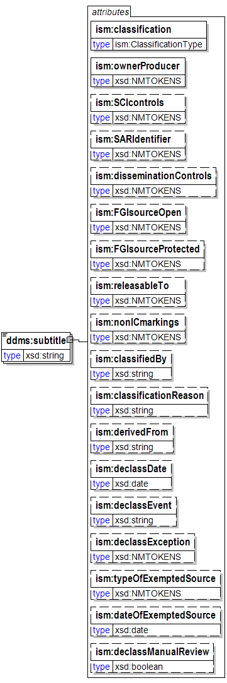
A subtitle may be any form of the title used as a substitute, or it may be an alternative to the formal title of the resource.
See also, DDMS Version 1.2 Title @ 28.
classification [attribute]

ownerProducer [attribute]
ISO 3166-1 trigraph(s) of the owner or producer country(ies) and/or
CAPCO-specified tetragraphs of international organizations.
Either (a) a single trigraph or tetragraph or (b) a space-delimited
list of trigraphs followed by tetragraphs. Trigraphs must be in
alphabetical order and tetragraphs must be in alphabetical order.
SCIcontrols [attribute]
Authorized abbreviation(s) of SCI control system(s). Either
(a) a single abbreviation or (b) a space-delimited list of
abbreviations in the order prescribed in the CAPCO Register.
SARIdentifier [attribute]
Authorized Special Access Required program digraph(s) or
trigraph(s) preceded by "SAR-". Either (a) a single digraph or
trigraph or (b) a space-delimited list of digraphs or trigraphs.
Example: "SAR-ABC SAR-DEF ..."
disseminationControls [attribute]
Authorized dissemination control portion mark abbreviation(s).
Either (a) a single abbreviation or (b) a space-delimited list
of abbreviations in the order shown in the CAPCO Register.
Exception: For the "REL" abbreviation, omit the country code
trigraph(s) and instead place the trigraph(s) in the
"releasableTo" attribute value.
FGIsourceOpen [attribute]
Non-US classification portion marking for foreign government
information in a document portion. Use this attribute to record
a source country when the intent is to post the document to a
shared space with the source identified.
FGIsourceProtected [attribute]
Non-US classification portion marking for foreign government
information in a document portion. Use this attribute to record
a source country when the intent is to filter out the identity of
the source prior to posting the document to a shared space.
releasableTo [attribute]
ISO 3166-1 trigraphic codes of countries to which the associated
content can be released. Include "USA" in all instances. Use a space-
delimited list with "USA" first, followed by the other trigraph(s)
in alphabetical order.
nonICmarkings [attribute]
Authorized non-IC portion marking abbreviation(s) from the CAPCO
Register. Either (a) a single non-IC abbreviated marking or
(b) a space-delimited list of abbreviations in the order shown
in the CAPCO Register.
classifiedBy [attribute]
Use as specified by E.O. 12958.
classificationReason [attribute]
A text string containing one or more paragraph numbers, 1.4(a)
through 1.4(h), taken from E.O. 12958, as amended. Enter the
paragraph references as they should appear in a
classification/declassification block.
derivedFrom [attribute]
A text string containing (a) the title and date of a specific source
document, or (b) the title and date of an organization classification
guide, or (c) the literal string "Multiple Sources".
declassDate [attribute]
A specific date, in the format YYYY-MM-DD, at which the applicable
information is automatically declassified.
declassEvent [attribute]
A textual description of an event that triggers declassification.
declassException [attribute]
One or more of the exceptions to 25-year declassification:
specify "25X1-human", "25X1", "25X2", ..., "25X9". If more than
one exception applies, use a space-delimited list. If "25X1-human"
applies, it should be first in a list.
typeOfExemptedSource [attribute]
One or more tokens indicating that a source that is exempted from
automatic declassification applies. Specify "OADR", "X1", "X2", ...,
"X8". If more than one applies, use a space-delimited list.
dateOfExemptedSource [attribute]
A specific date, in the format YYYY-MM-DD. Used in conjunction with
attribute "typeOfExemptedSource." If there are multiple exempted
sources, specify the date of the exempted
source that has the most recent date.
declassManualReview [attribute]
A true/false indication that manual review is required for
declassification. Use this attribute to force the appearance of
"//MR" in the header and footer marking titles. Use this attribute
ONLY when it is necessary to override the business logic applied to
classification and control markings in the document to determine
whether manual review is required.

Supplier
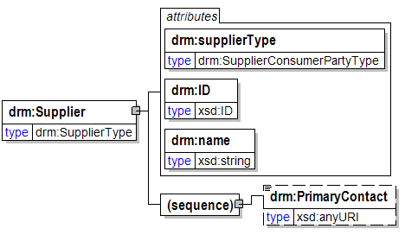
An entity (person or organization) that supplies data to a Consumer. Note that a Supplier may or may not be the original producer of the data. For this reason, the name "Producer" was not used.
RELATIONSHIPS:
- A Supplier produces an Exchange Package;
supplierType [attribute]
The type of entity that the Supplier represents (e.g. Agency, system, individual, etc.).
RELATIONSHIPS: None
ID [attribute]
General identifier attribute used in various places.
RELATIONSHIPS: None
name [attribute]
General name attribute used in various places.
RELATIONSHIPS: None
(sequence)
PrimaryContact
A URI pointing to an electronic representation (e.g. XML document, Web page) of contact information for the primary contact for a Supplier or Consumer.
RELATIONSHIPS: None

SupplierConsumer
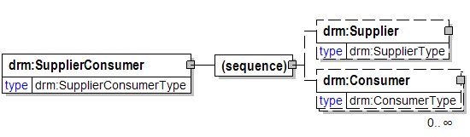
A container for Supplier and Consumer elements.
RELATIONSHIPS: None
(sequence)
Supplier
An entity (person or organization) that supplies data to a Consumer. Note that a Supplier may or may not be the original producer of the data. For this reason, the name "Producer" was not used.
RELATIONSHIPS:
- A Supplier produces an Exchange Package;
Consumer
An entity (person or organization) that consumes data that is supplied by a Supplier.
RELATIONSHIPS: None

supplierType [attribute]
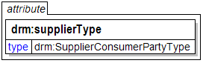
The type of entity that the Supplier represents (e.g. Agency, system, individual, etc.).
RELATIONSHIPS: None

surname
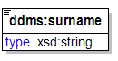
A name shared in common to identify members of a family; also called “last name”

SystemOfRecord
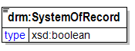
Denotes whether or not a data source contains Privacy Act information. This includes an individual's name, SSN, and/or personal identifier, and at least one other element of personal information about the individual (such as date of birth).
RELATIONSHIPS: None

Taxonomies
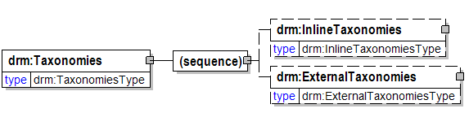
A container for Taxonomy elements.
RELATIONSHIPS: None
(sequence)
InlineTaxonomies
A container for "inline" Taxonomy elements (i.e. those that appear in the DRM instance as opposed to being externally referenced).
RELATIONSHIPS: None
ExternalTaxonomies
A container for externally referenced Taxonomy elements.
RELATIONSHIPS: None

Taxonomy
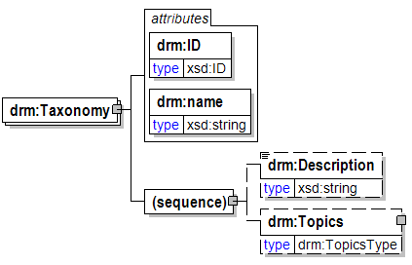
A collection of controlled vocabulary terms (Topics) organized into a hierarchical structure.
RELATIONSHIPS:
- A Taxonomy contains one or more Topics (inline Taxonomies only);
ID [attribute]
General identifier attribute used in various places.
RELATIONSHIPS: None
name [attribute]
General name attribute used in various places.
RELATIONSHIPS: None
(sequence)
Description
General description element used in various places.
RELATIONSHIPS: None
Topics
A container for Topic elements.
RELATIONSHIPS: None

temporalCoverage
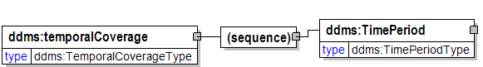
(sequence)
TimePeriod

Term
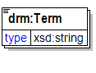
A keyword and/or keyphrase associated with a taxonomy Topic.
RELATIONSHIPS: None

Terms
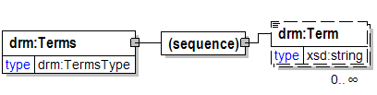
A container for Term elements.
RELATIONSHIPS: None
(sequence)
Term
A keyword and/or keyphrase associated with a taxonomy Topic.
RELATIONSHIPS: None

TimePeriod
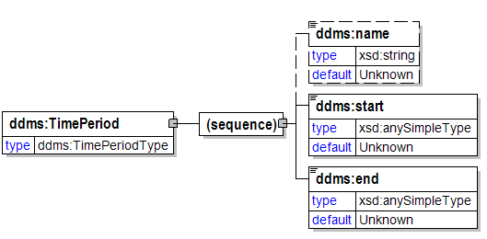
(sequence)
name

start

end

title
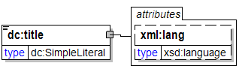
lang [attribute]

title
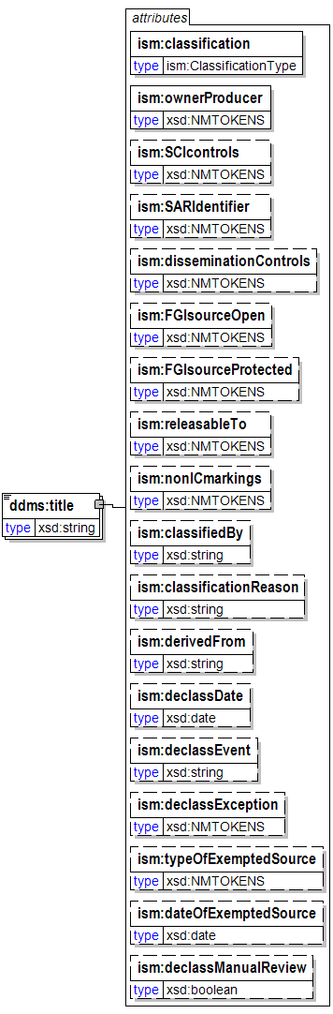
classification [attribute]

ownerProducer [attribute]
ISO 3166-1 trigraph(s) of the owner or producer country(ies) and/or
CAPCO-specified tetragraphs of international organizations.
Either (a) a single trigraph or tetragraph or (b) a space-delimited
list of trigraphs followed by tetragraphs. Trigraphs must be in
alphabetical order and tetragraphs must be in alphabetical order.
SCIcontrols [attribute]
Authorized abbreviation(s) of SCI control system(s). Either
(a) a single abbreviation or (b) a space-delimited list of
abbreviations in the order prescribed in the CAPCO Register.
SARIdentifier [attribute]
Authorized Special Access Required program digraph(s) or
trigraph(s) preceded by "SAR-". Either (a) a single digraph or
trigraph or (b) a space-delimited list of digraphs or trigraphs.
Example: "SAR-ABC SAR-DEF ..."
disseminationControls [attribute]
Authorized dissemination control portion mark abbreviation(s).
Either (a) a single abbreviation or (b) a space-delimited list
of abbreviations in the order shown in the CAPCO Register.
Exception: For the "REL" abbreviation, omit the country code
trigraph(s) and instead place the trigraph(s) in the
"releasableTo" attribute value.
FGIsourceOpen [attribute]
Non-US classification portion marking for foreign government
information in a document portion. Use this attribute to record
a source country when the intent is to post the document to a
shared space with the source identified.
FGIsourceProtected [attribute]
Non-US classification portion marking for foreign government
information in a document portion. Use this attribute to record
a source country when the intent is to filter out the identity of
the source prior to posting the document to a shared space.
releasableTo [attribute]
ISO 3166-1 trigraphic codes of countries to which the associated
content can be released. Include "USA" in all instances. Use a space-
delimited list with "USA" first, followed by the other trigraph(s)
in alphabetical order.
nonICmarkings [attribute]
Authorized non-IC portion marking abbreviation(s) from the CAPCO
Register. Either (a) a single non-IC abbreviated marking or
(b) a space-delimited list of abbreviations in the order shown
in the CAPCO Register.
classifiedBy [attribute]
Use as specified by E.O. 12958.
classificationReason [attribute]
A text string containing one or more paragraph numbers, 1.4(a)
through 1.4(h), taken from E.O. 12958, as amended. Enter the
paragraph references as they should appear in a
classification/declassification block.
derivedFrom [attribute]
A text string containing (a) the title and date of a specific source
document, or (b) the title and date of an organization classification
guide, or (c) the literal string "Multiple Sources".
declassDate [attribute]
A specific date, in the format YYYY-MM-DD, at which the applicable
information is automatically declassified.
declassEvent [attribute]
A textual description of an event that triggers declassification.
declassException [attribute]
One or more of the exceptions to 25-year declassification:
specify "25X1-human", "25X1", "25X2", ..., "25X9". If more than
one exception applies, use a space-delimited list. If "25X1-human"
applies, it should be first in a list.
typeOfExemptedSource [attribute]
One or more tokens indicating that a source that is exempted from
automatic declassification applies. Specify "OADR", "X1", "X2", ...,
"X8". If more than one applies, use a space-delimited list.
dateOfExemptedSource [attribute]
A specific date, in the format YYYY-MM-DD. Used in conjunction with
attribute "typeOfExemptedSource." If there are multiple exempted
sources, specify the date of the exempted
source that has the most recent date.
declassManualReview [attribute]
A true/false indication that manual review is required for
declassification. Use this attribute to force the appearance of
"//MR" in the header and footer marking titles. Use this attribute
ONLY when it is necessary to override the business logic applied to
classification and control markings in the document to determine
whether manual review is required.

Topic
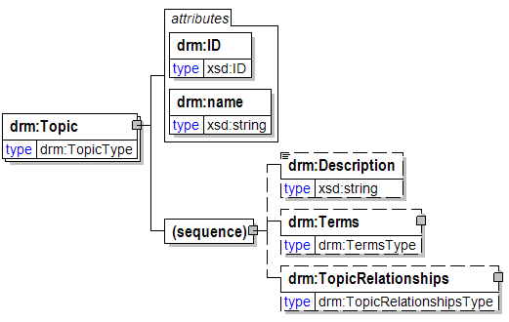
A category within a Taxonomy; often synonymous with "node". A Topic is the central concept for applying context to data.
RELATIONSHIPS:
- A Topic is related to one or more other Topics (inline Taxonomies only);
- A Topic categorizes one or more Digital Data Resources;
ID [attribute]
General identifier attribute used in various places.
RELATIONSHIPS: None
name [attribute]
General name attribute used in various places.
RELATIONSHIPS: None
(sequence)
Description
General description element used in various places.
RELATIONSHIPS: None
Terms
A container for Term elements.
RELATIONSHIPS: None
TopicRelationships
A container for TopicRelationship elements.
RELATIONSHIPS: None

topicRef [attribute]
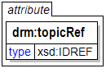
A reference to a Topic element contained within the same DRM instance.
NOTE: This attribute is used to depict relationships among Topics while the "TopicRef" element is used to depict relationships between other concepts (e.g. Entities) and Topics. This attribute was created for reduced verbosity in depicting relationships among Topics.
RELATIONSHIPS: None

TopicRef
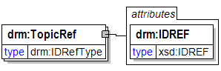
A reference to a Topic element contained within the same DRM instance.
RELATIONSHIPS: None
IDREF [attribute]
A reference to an identifier within the same DRM instance.
RELATIONSHIPS: None

TopicRefs
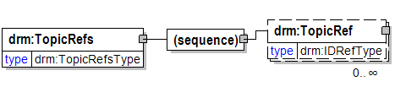
A container for TopicRef elements.
RELATIONSHIPS: None
(sequence)
TopicRef
A reference to a Topic element contained within the same DRM instance.
RELATIONSHIPS: None

TopicRelationship
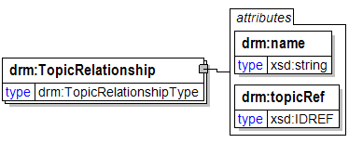
An association between two Topics.
RELATIONSHIPS: None
name [attribute]
General name attribute used in various places.
RELATIONSHIPS: None
topicRef [attribute]
A reference to a Topic element contained within the same DRM instance.
NOTE: This attribute is used to depict relationships among Topics while the "TopicRef" element is used to depict relationships between other concepts (e.g. Entities) and Topics. This attribute was created for reduced verbosity in depicting relationships among Topics.
RELATIONSHIPS: None

TopicRelationships
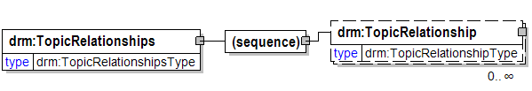
A container for TopicRelationship elements.
RELATIONSHIPS: None
(sequence)
TopicRelationship
An association between two Topics.
RELATIONSHIPS: None

Topics
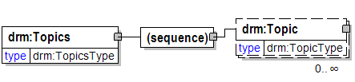
A container for Topic elements.
RELATIONSHIPS: None
(sequence)
Topic
A category within a Taxonomy; often synonymous with "node". A Topic is the central concept for applying context to data.
RELATIONSHIPS:
- A Topic is related to one or more other Topics (inline Taxonomies only);
- A Topic categorizes one or more Digital Data Resources;

TransactionType
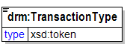
An indication of the message pattern that is used for transactions defined by an Exchange Package (e.g. Query/Response, Publish/Subscribe, etc.).
NOTE: Additional values for the enumerated list associated with this element may be added in the future.
RELATIONSHIPS: None

type
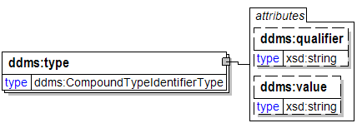
qualifier [attribute]

value [attribute]

type
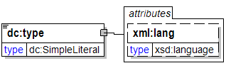
lang [attribute]

TypeOfDataAsset
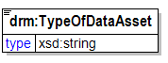
Type of Data Asset - e.g. database, Web site, registry, directory, data service, etc.
NOTE: In the future, this may be represented as an enumerated list.
RELATIONSHIPS: None

typeOfExemptedSource [attribute]
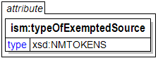
One or more tokens indicating that a source that is exempted from
automatic declassification applies. Specify "OADR", "X1", "X2", ...,
"X8". If more than one applies, use a space-delimited list.

unit [attribute]
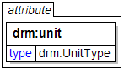
The regularity of an exchange represented by an Exchange Package (e.g. Daily, Weekly, etc.). Indicates the units that correspond to the value for the Exchange Frequency (e.g. 2 times daily, once a month, etc.).
RELATIONSHIPS: None

UnstructuredDataResource
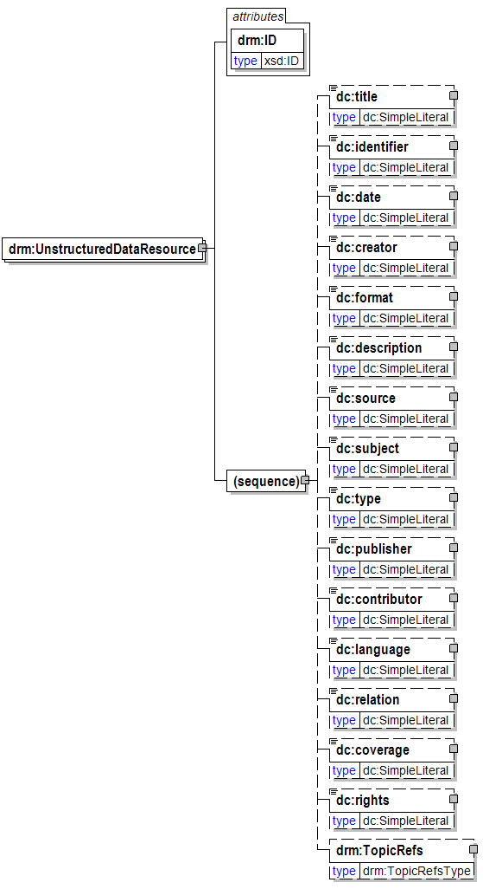
An electronic resource containing data that is of a more free-form format, such as multimedia files, images, sound files, or unstructured text. Unstructured data does not necessarily follow any format or hierarchal sequence, nor does it follow any relational rules.
RELATIONSHIPS:
- An Unstructured Data Resource is a type of Digital Data Resource;
- An Unstructured Data Resource (because it is a Digital Data Resource) is categorized by one or more Topics;
ID [attribute]
General identifier attribute used in various places.
RELATIONSHIPS: None
(sequence)
title

identifier

date

creator

format

description
General description element used in various places.
RELATIONSHIPS: None
source

subject

type

publisher

contributor

language

relation

coverage

rights

TopicRefs
A container for TopicRef elements.
RELATIONSHIPS: None

UnstructuredDataResourceRef
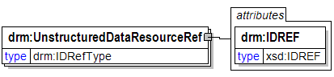
A reference to an UnstructuredDataResource element contained within the same DRM instance.
RELATIONSHIPS: None
IDREF [attribute]
A reference to an identifier within the same DRM instance.
RELATIONSHIPS: None

UnstructuredDataResourceRefs
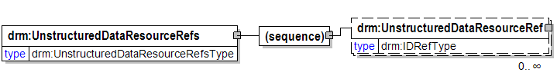
A container for UnstructuredDataResourceRef elements.
RELATIONSHIPS: None
(sequence)
UnstructuredDataResourceRef
A reference to an UnstructuredDataResource element contained within the same DRM instance.
RELATIONSHIPS: None

UnstructuredDataResources
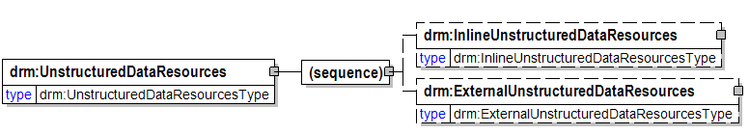
A container for UnstructuredDataResource elements.
RELATIONSHIPS: None
(sequence)
InlineUnstructuredDataResources
A container for "inline" UnstructuredDataResource elements (i.e. those that appear in the DRM instance as opposed to being externally referenced).
RELATIONSHIPS: None
ExternalUnstructuredDataResources
A container for externally referenced UnstructuredDataResource elements.
RELATIONSHIPS: None

userID
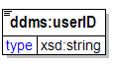
Unique identifier applied by an agency to an author, coauthor, POC, tasking requester or addressee.

validTil [attribute]
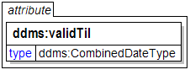
The date that a product should be removed from a registry, index, or catalog.

value [attribute]
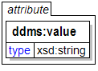

virtualCoverage
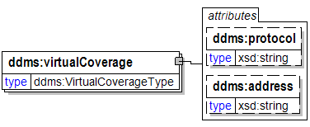
The subject-matter coverage of a publication in terms of one ore more virtual addresses. Must identify the protocol being used and the virtual address of the resource.
See DDMS Version 1.2 Virtual Coverage @ 66.
protocol [attribute]

address [attribute]

Schema Level Documentation

DDMS-v1_2.xsd
This schema is an implmementation of the Department of Defense Discovery Metadata Specification version 1.2.
By the DDMS Focus Group:
Robert Allegar - Booz Allen Hamilton
Arsic Antoinette - Mitre Corp.
Wil Bailey - DLA
Daniel Barclay - FGM, Inc.
Brian Brotsos - SAIC
Clive Carpi - SAIC
Mike Daconta - McDonald Bradley
Stan Davis - DISA
Michael Fontaine - OSD/NII
Glenda Hayes - Mitre Corp.
Kirk Maskalenko - FGM, Inc.
Mary Ann Melosh - SAIC
Eric Peterson - McDonald Bradley
Jim Pipher - DISA
Joseph J. Pantella, FGM, Inc.
Glenn Pruitt - FGM, Inc.
Tony Reggio - Pennsylvania State University
Kyle Rice - McDonald Bradley
Clay Robinson - OSD/NII
Rebecca Smith - DIA
Brian Sullivan - NGA (NIMA)
Eric Yuan - Booz Allen Hamilton
JJP
Change Log:
07/13/2004 (J. Pantella) -- Added a global classification attribute per CR #1 of July 1, 2004 DDMS modification.
07/13/2004 (J. Pantella) -- Modified title and subtitle elements to use the classification attribute per CR #1 of July 1, 2004 DDMS modification.
07/13/2004 (J. Pantella) -- Modified SubjectType category and keywords per CR #2 of July 1, 2004 DDMS modification. NOTE: At least one of either Keyword or Category must appear, after one instance of either appears, additional categories must appear before additional keywords.
07/13/2004 (J. Pantella) -- Modified CompoundSourceIdentifierType to support the schema qualifier and schema HREF attributes on the source element per CR#4 of July 1, 2004 DDMS modification.
07/14/2004 (J. Pantella) -- Fixed bug that prevented street address information from being included in the Place and Facility elements.
07/26/2004 (J. Pantella) -- Modified the qualifier attribute of the CompoundCategoryIdentifierType used in the category element to be of type xs:anyURI.
08/04/2004 (J. Pantella) -- Modified Place and Facility to support the state element.
08/04/2004 (J. Pantella) -- Removed AddressType because it was not used.
08/06/2004 (J. Pantella) -- Required xs:any element to have a minoccurs of 0.
08/11/2004 (J. Pantella) -- Modified contributor, producer, creator and pointOfContact to be of respective types. Eliminated the substitution group solution previously employed.
08/16/2004 (J. Pantella) -- Modified CompoundResourceIdentifierType and QualifiedExtentValueType qualifier attributes to be of xs:anyURI per Tiger Team.
08/17/2004 (J. Pantella) -- Modified the target namespace to reflect the needs identified in the Registry meetings (G. Hayes in attendance).
08/23/2004 (J. Pantella) -- Added comments to annotate changes made by the Tiger Team.
11/23/2004 (J. Pantella) -- Modified title, subtitle, description, publisher, contributor, creator and security elements to reuse the ICISM:SecurityAttributesGroup.
11/23/2004 (J. Pantella) -- Removed prior implementation of security and classification attributes.
11/23/2004 (J. Pantella) -- Modified the temporalCoverage sub-elements to provide mechanism to specify Unknown or Not Applicable value defaulting to Unknown persuant to the approval of CR#11.
12/12/2004 (J. Pantella) -- Modified subjectType to eliminate redundancy causing tool issues.
12/16/2004 (J. Pantella) -- Commented out all residual elements and types related to the previous, substitution group based, modeling of the creator, publisher, and contributor.
1/2/2005 (J. Pantella) -- Modified namespace and comments to remove anticipated name change.
1/19/2005 (J. Pantella) -- Modified title and subtitle to support mulitple appearances.

IC-ISM-v2.xsd
W3C XML Schema for the Intelligence Community Metadata Standard for
Information Security Marking (IC-ISM), which is part of the IC
standards for Information Assurance.

dc.xsd
DCMES 1.1 XML Schema
XML Schema for http://purl.org/dc/elements/1.1/ namespace
Created 2003-04-02
Created by
Tim Cole (t-cole3@uiuc.edu)
Tom Habing (thabing@uiuc.edu)
Jane Hunter (jane@dstc.edu.au)
Pete Johnston (p.johnston@ukoln.ac.uk),
Carl Lagoze (lagoze@cs.cornell.edu)
This schema declares XML elements for the 15 DC elements from the
http://purl.org/dc/elements/1.1/ namespace.
It defines a complexType SimpleLiteral which permits mixed content
and makes the xml:lang attribute available. It disallows child elements by
use of minOcccurs/maxOccurs.
However, this complexType does permit the derivation of other complexTypes
which would permit child elements.
All elements are declared as substitutable for the abstract element any,
which means that the default type for all elements is dc:SimpleLiteral.

