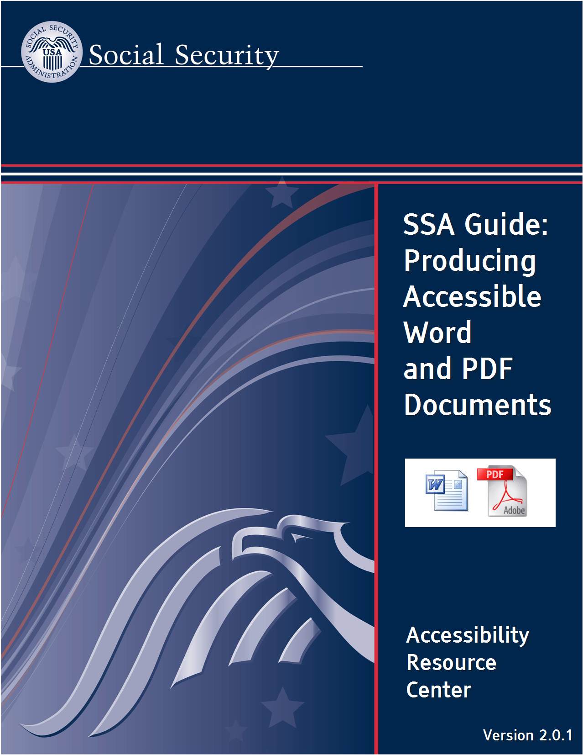
CONTENTS
0. Introduction 1
0.0. About this guide 1
Version information 1
Required Software 1
Conventions used in this guide 1
Not in this guide… 1
Introduction to accessibility and Section 508 2
0.1. Reading technologies, and implications for document design 3
The (alternate) user interface 3
Visual versus programmatic formatting 4
Implications for the design of documents 8
1. Producing Accessible Word Documents 11
1.0. Preparation 11
Views and panes 11
Showing formatting characters and marks on the document 16
Avoid automatic formatting 17
1.1. Formatting 19
1.1.1. Use Styles for formatting 19
1.1.2. Format paragraph line spacing with styles 26
1.1.3. Use list formatting 27
1.1.4. Use Column formatting 29
1.1.5. Do Not Use Hyphenation 31
1.2. Navigation 32
1.2.1. Place document titles in the main document; not the 'Header' area 32
1.2.2. Use Heading Levels in style formatting 34
1.2.3. Use automation if creating a Table of Contents 36
1.3. Language 39
1.3.1. Set the language properties 39
1.4. Fonts 41
1.4.1. Use System Fonts 41
1.5. Graphics / images 43
1.5.1. Add Alternate Text to graphics / images 43
1.5.2. Group Complex Objects 47
1.5.3. Place graphics / images 'in line' 49
1.6. Artifacts 52
1.6.1. Convert text boxes to regular paragraphs 52
1.7. Tables 56
1.7.1. Remove table formatting applied to non-tabular information 56
1.7.2. Set the header row as 'repeating' 57
1.7.3. Remove text wrapping around tables 59
1.8. Links 61
1.8.1. Assign link names that make sense when spoken in isolation 61
1.8.2. Where possible, do not allow links to span two lines of text 62
1.9. Color 63
1.9.1. Use text colors that contrast with their backgrounds 63
1.9.2. Use automatic color settings for black text and white text 64
1.9.3. Provide redundancy for information presented in color 65
1.10. Document properties 67
1.10.1. Set the document title in document properties 67
2. Converting from Word to PDF 69
2.0. Essential concepts 69
Easy ways and hard ways to make an accessible PDF 69
Conversion is one-way, with no going back 71
2.1. Conversion from Word to PDF 74
2.1.1. Configure Conversion Preferences 74
2.1.2. Convert the document with the 'PDF Maker' application in Word 78
3. Checking and fixing accessibility issues in PDF documents 79
3.0. Preparation 79
The 'Accessibility Full Check' 79
Other guidance and Help 83
Limited 'Undo' capabilities in Acrobat Pro during accessibility remediation 84
3.1. Reading order 85
3.1.1. The initial view is set properly? 85
3.1.2. The reading order is correct? 87
3.1.3. Lists have the correct tag structure? 89
3.1.4. The tab order of pages is set? 91
3.2. Navigation 92
3.2.1. Bookmarks are set correctly? 92
3.2.2. Headings are set correctly? 92
3.2.3. Dynamic tables of contents are working? 94
3.3. Language 95
3.3.1. The Language(s) have been defined? 95
3.4. Fonts 97
3.4.1. Character Mappings have worked properly? 97
3.5. Graphics / images 98
3.5.1. Alternate Text is added to Information-Type images? 98
3.6. Artifacts 99
3.6.1. Artifacts are correctly placed outside of the reading order? 99
3.7. Tables 100
3.7.1. Table Tags are set? 100
3.8. Links 103
3.8.1. Links make sense when spoken in isolation? 103
3.8.2. Links (where possible) are on only one line of text? 103
3.9. Color 105
3.9.1. High-Contrast color combinations are used? 105
3.9.2. Color is only used redundantly? 106
3.10. Document properties 107
3.10.1. Document properties are properly set? 107
4. Checklists 109
Word Document Accessibility Checklist 111
PDF Document Accessibility Checklist 113

Introduction

About this guide

Version information
SSA Guide: Producing Accessible Word and PDF documents Version 2.0.1, March 2010.
This guide is produced by the Social Security Administration Accessible Solutions Branch (ASB) / Accessibility Resource Center (ARC).

Required Software
For producing accessible Word documents:
- Windows XP or Vista
- Office 2007 (including Word 2007)
For converting Word Documents to accessible PDF (Portable Document Format) Files:
- Adobe Reader
- Acrobat Pro 8.1
Important: version 8.1 is a minimum requirement. Version 8.0 will not work properly.
- CommonLook Plug-In for Acrobat Pro

Conventions used in this guide
Menu commands are in bold, and underlined text.
Keystrokes have an outline, e.g.: CTRL+ALT+Delete.

Not in this guide…
- This is not a guide to using Word and/or Adobe Acrobat Pro: This guide provides information on how to use certain features in MS Word and Adobe Acrobat Pro in order to make documents more accessible for people with disabilities. This guide is not intended as a replacement for general training on how to use these applications.
- This is not a guide for producing Braille or Large Print documents: This guide addresses accessibility-related features of documents for reading on a computer.
- PDF Forms are not covered in this guide.

Introduction to accessibility and Section 508
For a general introduction to accessibility and requirements of Section 508 of the Rehabilitation Act, see the resources and training materials at:
The GSA Section 508 website: http://www.section508.gov/

Reading technologies, and implications for document design

The (alternate) user interface
Documents can be printed out or read on a computer. Accessibility considerations are important for both print and electronic document formats, but in this guide we are mostly interested in reading documents on computers.
The User Interface is the means by which inputs (controls) are relayed to the computer so that the desired output (display) of information (in this case, document content) is presented to the user.
In regular operation, users can use their eyes, ears, voice and hands to provide inputs and perceive outputs. Typically, the computer screen, audio speakers, keyboard, and mouse are used.
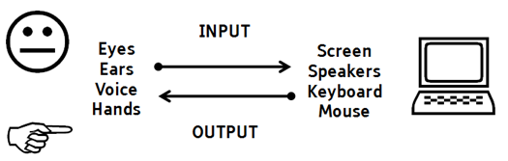
When someone who has a sensory or a physical disability is reading a document on a computer, one or more of the regular input / output capabilities can be diminished or unavailable. For example:
- Someone who is totally blind cannot use their eyes, so they cannot see the screen and they cannot use the mouse (the mouse requires eye-hand coordination). Instead, they can use talking software, called a Screen Reader to hear the information that is ordinarily shown on screen, and they use the keyboard to control the Screen Reader software.
- Someone who has low vision has a diminished ability to use the screen. They can compensate by using Screen Magnification software. Depending on their preferences, they may use a combination of Screen Magnification and Screen Reader software.
- Someone who has no ability to use hands may use Speech Recognition software to control the computer. They cannot use the keyboard or mouse, so all commands are spoken (e.g., "Page Up... Page Up... Move to Top...").
The key point is that people with disabilities (PWDs) can use an alternative mode of input and/or output when the ordinary method is unavailable. The words and meaning of the document remain the same, it is only the information delivery and user control mechanisms that differ.
It is important to know that in order for these alternate interface mechanisms to work, the documents need to be designed to be accessible. Attention must be paid to certain design details (covered in this guide) in order to make it possible for technologies such as Screen Readers, Screen Magnifiers, and Speech Recognition Software to be able to work with individual documents. Without attending to these design details, many PWDs will find it difficult or impossible to read your documents.

Visual versus programmatic formatting
To a sighted reader of a document, a 'heading' looks like a heading when it is visually formatted differently to other text. Things like centering, bold, underlining and capitalization can all be used to differentiate a chunk of text to look like a 'heading'. Formatting of this kind (bold, underline, etc.) can also be used within paragraphs, to emphasize certain words. The problem for Screen Reader software is that because this type of formatting can be applied in either a heading or a paragraph of text, there is no way for the software to detect which one it is—is it a heading or a regular paragraph?
With a page of text that is laid out with headings differentiated only by visual formatting (bold, underline etc.), the way the Screen Reader software interprets the page is analogous to single, continuous block of text:
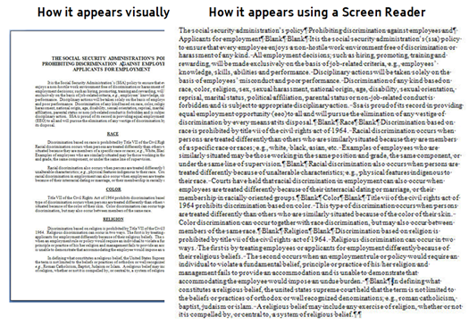
It is clear that for a sighted reader, removing the visual formatting of headings makes the page much more difficult to read. But for a non-sighted user, the text is spoken only one word at a time, with no way to skip over sections to the next heading. In fact, when only visual formatting is applied to the text, the Screen Reader can employ only very limited reading commands such as:
- read previous/next word,
- read previous/next paragraph,
- go to the beginning/end of the document.
What is missing is a programmatic identification of headings in the document. This can be applied easily by use of styles in MS Word. The heading can still look the same way as it did before (bold, underline etc.), but some non-visible code gets added to the piece of text that says, (essentially) 'this is a heading'.
In MS Word and in PDFs, heading styles can be applied programmatically. The heading styles can have associated levels, just as with visual differentiation (i.e., level 1, level 2, level 3 etc.) to give a hierarchical structure to a document's content. When heading styles are applied, the Screen Reader software can, at the command of the user, jump to the next heading in the document:
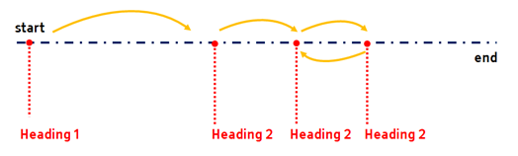
Now, with heading styles applied, the list of commands available to the Screen Reader expands to include:
- Jump to next/previous heading,
- Jump to next/previous heading of level n.,
- Display a list of all the headings in this document.
- Sort the list of headings alphabetically or in the order they appear in the document.
By adding this programmatic formatting, the Screen Reader user can now navigate the document much more easily. In addition to headings, we can enable a large number of Screen Reader controls to work. We can provide comparable access to a document by applying programmatic formatting on other parts of the text, such as:
- Images (graphics)
- Tables
- Bulleted Lists
- Numbered Lists
- Hyperlinks
- etc.
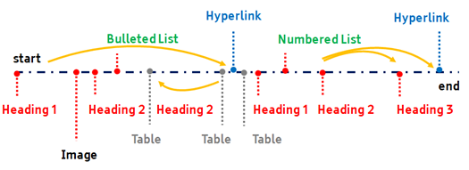
Even the most complex documents can be made easily navigable with a screen reader if the correct styles and formatting are applied. By applying this type of formatting, people who are blind or who have low vision may be able to access and read documents as quickly and as efficiently as their colleagues who have good vision.

Implications for the design of documents
In terms of design, we can sum up the situation as follows:
- Certain physical and/or sensory capabilities of the users will be reduced or unavailable;
- Therefore, we cannot rely on one or more of the regular computer controls and/or displays (inputs/outputs) being available;
- Therefore, we need to change the formatting (programming) in the document so that it works with the technologies that PWDs typically use to interact with computers.
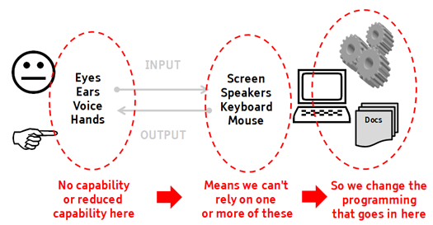
To make documents accessible, the focus of document developers must be on formatting the document so that it works with things like Screen Readers, Screen Magnifiers, and Speech Recognition software. Taking this approach—focusing design attention on the elements in the document itself—has several benefits for you, the document developer:
- You do not need to make a 'special' document for any one group of users. The document will be readable for everyone;
- The content of the documents does not need to change. All that changes is the formatting aspects applied to various pieces of text;
- You do not need to change the visual layout of the document to make it accessible;
- You do not need to learn how to use technologies that PWDs typically use (if you format the document appropriately, there is a very high probability that it will work for PWDs);
- You do not need to be a programmer. Although the additional formatting is programmatically applied to text using the MS Word and Acrobat Pro applications as non-visual code, it is not the same sort of task as software programming. All of the tools necessary to add the formatting are included in the MS Word and Acrobat Pro software; and
- By using formatting of the kind necessary for accessibility, authoring and editing documents becomes a much more rapid process. The reason is that this type of formatting makes moving and changing text easier for any developer. If you want to change the size of the font for every heading in a 200 page document, for example you can do this with a couple of commands. If you want to change the spacing between every paragraph in a long document, you can you can do this in a matter of seconds if you are using styles (programmatic formatting).

Producing Accessible Word Documents

Preparation
The following items are MS Word tools that are useful to know about as preparation for accessibility development tasks.

Views and panes

Document Views
There are five different ways to view a document in MS Word. The different views are accessed by Ribbon… View Tab. The five document views are:
- Print Layout
- Full Screen Reading
- Web Layout
- Outline
- Draft
The text that will be (can be) read by a Screen Reader is best represented by the Draft view. If an element such as an image or a text box shows on the screen in Print Layout view, but it does not show in Draft view, then it is highly probable that the element will not be read aloud for the user.
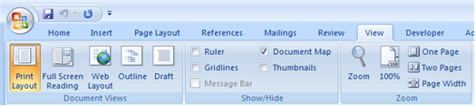

Helpful Panes
MS Word has a number of different window 'panes' that can be helpful to use while developing a document. These panes do not need to be shown at all times—they can be displayed as and when needed. The panes and the means to show the panes are described below:
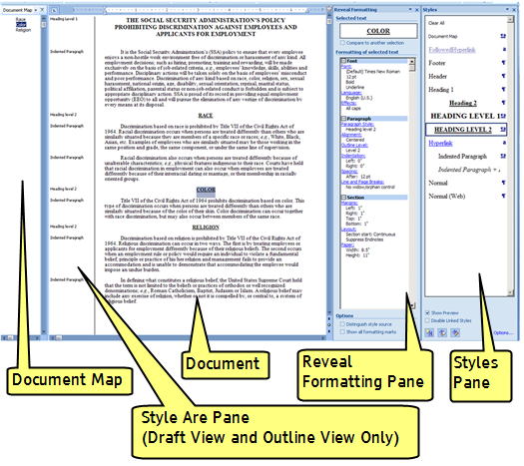

Document Map
This is a 'map' of the structure in terms of the headings that have been applied in the document. When the document is formatted correctly, anything that looks like a heading will show up in this map. The map provides a quick means of navigating to different headings within large documents.
- To view the document map: Ribbon... View Tab... Show/Hide Area... Document Map.

Style Area Pane
This pane shows the name of the style that is used for each paragraph in the document.
For example, if a heading is properly used, the style area will show 'Heading #' in this pane. If you open the Style Area Pane and every style says 'Normal' even though there are headings and bullet lists in the document, the document will not be accessible to Screen Reader users.
To show the Style Area Pane (in Draft View and Outline View only):
- Open the Word Options dialog box (Office Button > Word Options);
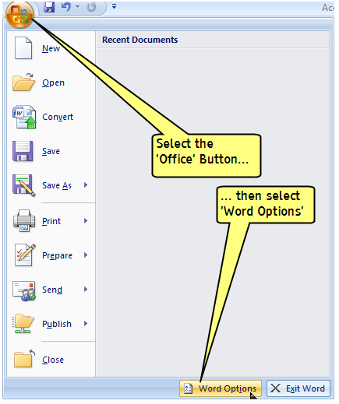
- Go to Advanced, then scroll down to Display, and then add a value (e.g., 2") to Style area pane width in draft and outline views.
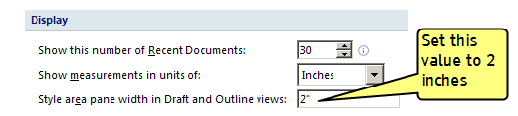
- View the document in Draft View: Ribbon… View Tab… Document Views Area > Draft.

Styles Pane
The Styles Pane is useful for seeing what styles have been applied to text, picking styles to apply to text, and managing styles. Style-formatting is a necessary part of making documents accessible.
To view the Styles Pane:
- Go to the Styles Area of the Ribbon (Ribbon... Home Tab... Styles Area):
- Click the small icon in the bottom right corner of the styles area.
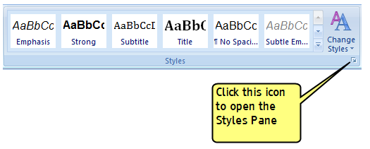
Note: At first, the Pane may appear as a floating window. To make the position of the pane 'fixed', try clicking and holding the menu bar of the pane, and drag it to the right hand side of the screen.

Reveal Formatting Pane
This pane is useful for examining the characteristics that have been applied to a piece of text. This includes fonts, styles, language settings, bullet and numbering styles and so on. To open the Reveal Formatting Pane:
- Have the Styles Pane open (see above).
- Select the Style Inspector button at the bottom of the Styles Pane. The Style Inspector pops up.
- Select the Reveal Formatting button at the bottom of the Style Inspector. The Reveal Formatting Pane opens.
Note: Make sure that 'Distinguish style source' is checked at the bottom of the Reveal Formatting Pane.
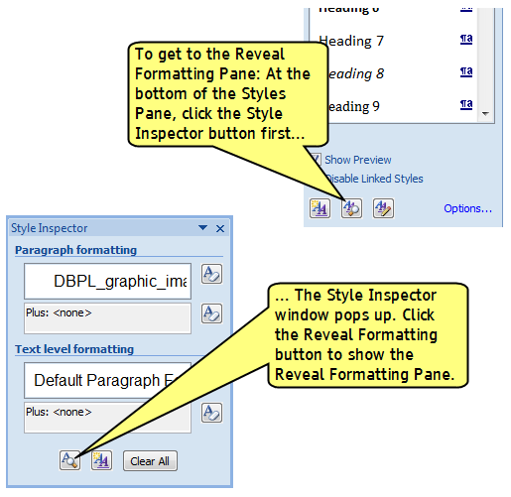

Showing formatting characters and marks on the document
There are a number of non-printing 'characters' and marks that MS Word uses. While these do not show up on the printed page, it can be useful to make them visible while editing a document. The non-printing formatting marks include:
- Spaces,
- Tab characters,
- Paragraph ('carriage return') characters,
- Object anchors.
To show and hide the non-printing formatting marks on screen: Ribbon… Home Tab… Paragraph Area > Show/Hide Button.
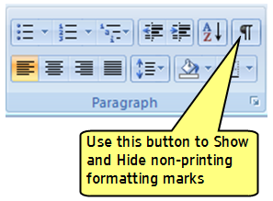
Note: It is advised that Tab characters be avoided where possible for formatting. For example, to make a paragraph start off with an indent, it is better to set up a paragraph style that has an indented first line than it is to insert a Tab character at the start of each paragraph. In this way, text can be more easily managed in the editing process.

Avoid automatic formatting

Turning off 'AutoCorrect' functions
By default, MS Word tries to 'AutoCorrect' your typing. For example, if you start typing numbers in front of items, the MS Word software 'assumes' you are typing a list of numbers, and so changes the formatting automatically to a numbered list, with accompanying indentation, tab stops, tab characters and so forth.
While this may be a useful feature for novice users of MS Word, it is much better to manage styles yourself, applying your desired settings for indents, tab stops etc.
Furthermore, when you are trying to manage a document and apply the styles that are necessary to provide accessibility, 'AutoCorrect' features are more like to automatically break your efforts.
Therefore, while learning to make documents accessible, it is highly recommended that you turn off all of the AutoCorrect functions in Word. This will mean that it is you who have sole control over how the text looks and behaves.
To turn off AutoCorrect features:
- Go to the Word Options dialog box. (Ribbon… Office Button > Word Options)
- Go to Proofing and click the AutoCorrect Options button.
- Uncheck every item in every tab of the dialog box.
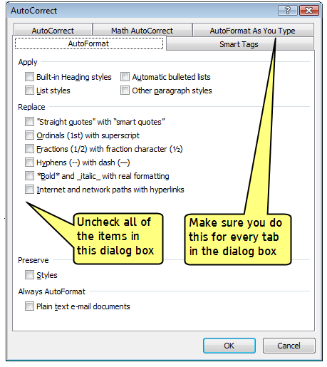

Formatting

Use Styles for formatting

A) Rationale
A style is a set of formatting characteristics applied to paragraphs, tables, characters, or lists. In a document, styles are used to quickly and consistently change the appearance of the content. Styles can also impose a relational structure (hierarchy) on a document by assigning outline levels to headings.
Using styles means that information about the organization and hierarchy of the document's content is available to Screen Readers. This information can be used to navigate to the structural elements. It also allows screen reader user to skim through a document (reading only the headings, for example).

B) Development Methods
- Always use styles to format paragraphs, headings, table text, and lists (bullets and numbered lists).
- Where necessary, use styles to format characters (e.g., words that always appear in bold or italic).
- Start in the Styles Area (Ribbon... Home Tab... Styles Area):
  - To modify any previewed style, right click it.
  - To preview more styles, click the drop-down icon.
  - Open the Styles Pane for managing and controlling all available styles. To open the Styles Pane, click the icon in the bottom right corner of the styles area (shortcut is CTRL+ALT+SHIFT+S)
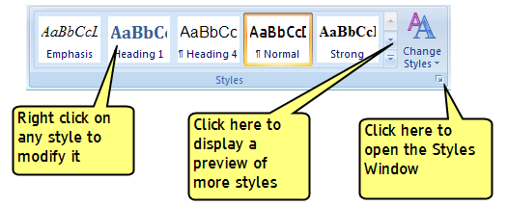
- Use the Styles Pane for managing and controlling multiple styles.
  - To apply a style, select text in the main document and click on a style name;
  - To modify an existing style, right click the style name and then click the drop-down icon;
  - To make new styles, and inspect and manage existing styles, use the controls in the bottom left corner of the Styles Pane;
  - To set your preferences for how styles are displayed in this window, click the Options... button.
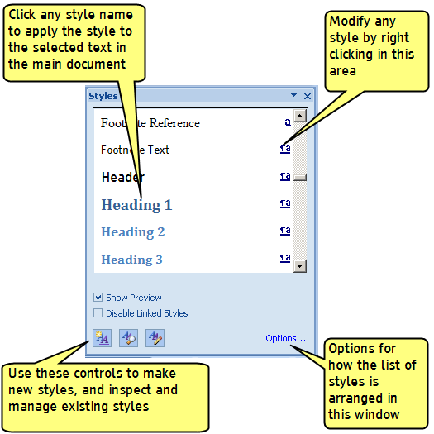
- To make a new style or modify an existing style, right click on it in the Styles Area or in the Styles Pane. The Style Dialog Box appears. For each style:
  - Give the style a name
  - Select the type of style (Paragraph, Table text, Character or Link)
  - A hierarchy structure of styles enables you to have changes in one style affect another. To make this style a 'child' of 'parent' style in the hierarchy, name the style that it is based on.
  - For simple formatting (font name and size, color, paragraph alignment etc.), use the controls in this dialog box.
  - For more detailed formatting of fonts, paragraphs, tabs, borders, language and numbering, use the Format drop-down menu.
Note: 'frame' formatting should be avoided in this menu.
  - To manage how the style is stored (e.g., just in the document or in the global template), use the various controls at the bottom of the dialog box.
Note: You should always make sure that the 'Automatically Update' checkbox is unchecked in the Style Dialog Box. Automatic updating of styles makes them very difficult to manage (see also 1.0 Preparation).
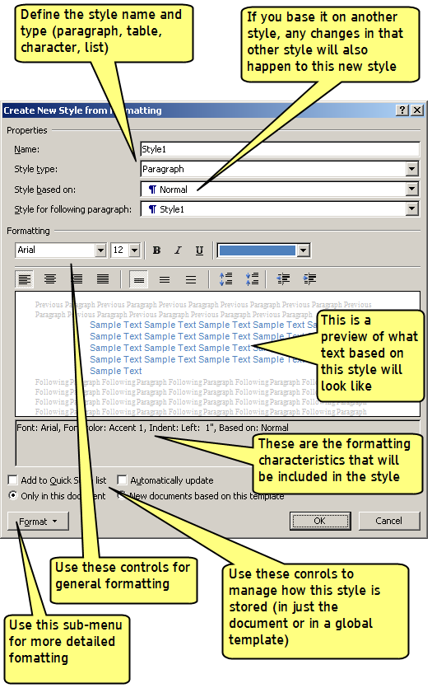

C) Testing Methods
There are various methods for inspecting a document to determine whether styles have been used. These methods can be used separately or together:

Look at the Document Map:
- View the Document Map (Ribbon... View Tab... Show/Hide Area... Document Map).
- TEST: Does the heading structure and hierarchy in the Document Map match the structure shown visually in the main document? If it does not match, then the document is NOT properly formatted with styles.

Make the formatting marks visible in the document:
- View the formatting marks in the document. (Ribbon... Home Tab... Paragraph Area... Show/Hide (¶) button).
- TEST: If there are TAB (→) characters used to provide indentation; if there are multiple Paragraph 'Return' (¶) characters used to provide spacing between paragraphs; if there are multiple SPACE (…) characters used to align text, Then the document is NOT properly formatted with styles.
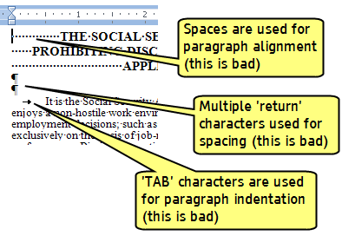

View the Style area pane in the Draft View:
- Set up a Style area pane. (Word Options > Advanced > Display... Style area pane width). Set the width at 2 inches;
- Go to Draft View. (Ribbon... View Tab... Document Views Area... Draft);
- TEST: If the same style name is always applied to every paragraph, even though the document has a look that has different types of paragraph and heading styles, then the document is NOT properly formatted with styles.
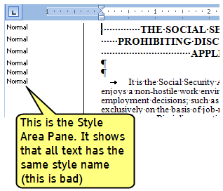

Use the Style inspector and Reveal formatting pane to see what formatting has been applied to each paragraph:
- Open the Style Pane and click on the Inspect Styles button.
- In the Inspect Styles Window, click on the Reveal Formatting button.
- In the Reveal Formatting Pane, examine the paragraph formatting.
- TEST: If things like heading (outline) levels, style names and alignment settings are not applied, then the document is NOT properly formatted with styles.
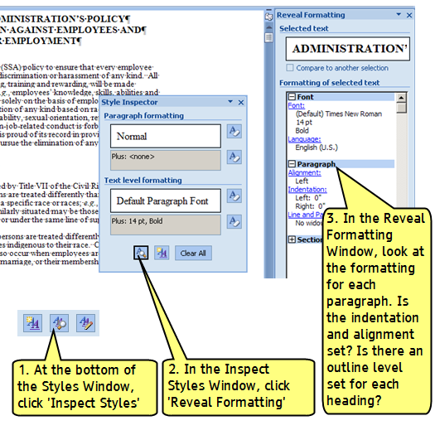

Format paragraph line spacing with styles

A) Rationale
When paragraphs are formatted with styles, it is (a) easier for screen reader users to navigate, and (b) they have less keys to press. When paragraph line spacing is done incorrectly with multiple 'carriage return' (¶) characters, screen readers hear "Blank... Blank... Blank..." for each line.
Using style formatting for paragraph spacing also makes it easier to move blocks of text around during the document editing process. Using this method, spacing is automatically maintained, so there is no need to go back over the document and manually add 'carriage return' characters for spacing.

B) Development Methods

Set paragraph spacing
- Open the Paragraph Dialog Box (Ribbon... Home Tab... Styles Area > Right Click style > Modify> Format > Paragraph)
- Set the amount of points that should be before and after the current paragraph. For example, if the font is 12 points high, add 12 points of spacing after to get the effect of a blank line between paragraphs.
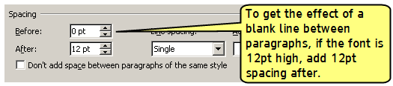

C) Testing Methods
Use the same testing methods for Use Styles for formatting (1.1.1).

Use list formatting

A) Rationale
When bulleted list and numbered list formatting is used, Screen Readers will properly announce the text as being part of a list, and provide a means for the user to quickly navigate between items as well as move in and out of lists.
When bullets and numbers are made with incorrect formatting, Screen Readers will treat the lists as regular text, meaning that the list reading controls are inoperative.

B) Development Methods
There are two main ways to set lists in MS Word:
- Define the list format in the style: In the Style dialog box, Select Format > Numbering and then in the Numbering and Bullets dialog box set the type of list you want.
- Use direct paragraph formatting for lists: Go to Ribbon… Home Tab… Paragraph Area and use the list controls.
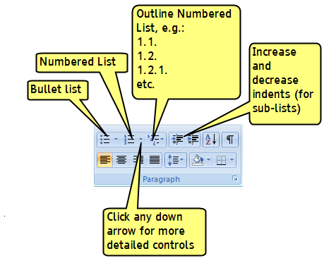
Note: Even with automatic formatting turned off in MS Word (see 1.0 Preparation), some automation effects may persist in the lists, especially if the direct formatting is used. It may be necessary to right click on the list number (or bullet) and use the controls on the pop-up menu to set the numbering values correctly:
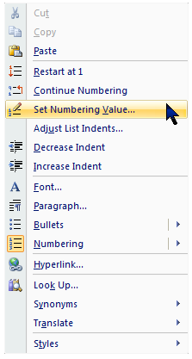

C) Testing Methods
Use the Reveal Formatting Pane (see 1.0 Preparation) to examine text to see if the text is defined as being part of a bullet list or number list.

Use Column formatting

A) Rationale
When column formatting is used, screen readers will read in the correct order (i.e., first go down one column and then move to the top of the next column).
When column formatting is not used (e.g., TAB characters are used to visually separate text to make it look like columns), the reading order is garbled for screen reader users (the screen reader reads [row 1, column 1; row 1, column 2; row 2, column 1; row 2, column 2 etc.]).

B) Development Methods

Format the columns
- Go to the Print Layout View: (Ribbon... View Tab... Document Views... Print Layout)
- Open the Columns dialog box (Ribbon... Page Layout Tab... Page Setup Area > Columns > More Columns)
- Set the number of columns, spacing between columns, and whether this formatting should apply to a section or the whole document.
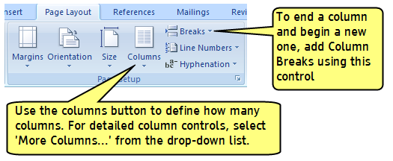

To end one column and begin the next, use column breaks
If, for example, the text in one column is short and does not fill the whole length of the column, then add a column break to start a new column (rather than 'carriage return' [¶] paragraph marks).

C) Testing Methods
Use the same testing methods for Use Styles for formatting (1.1.1).
You can also do a quick manual test in Print Layout View: (Ribbon... View Tab... Document Views... Print Layout):
- TEST: Place your cursor anywhere in the column. Press the right arrow key and watch the cursor movement. The cursor should follow the text column by column.

Do Not Use Hyphenation

A) Rationale
Screen readers split up hyphenated words instead of speaking them properly as single words. Hyphenation can make reading very confusing for Screen Reader users.

B) Development Methods

Avoid using manual hyphenation techniques
Do not insert hard hyphens (using the dash/hyphen key) and/or line breaks to force end-of-line hyphenation.
- Delete instances of hard hyphens.

Remove automatic hyphenation
- Open the Page Setup Area. (Ribbon... Page Layout... Page Setup Area).
- Click the drop-down menu under Hyphenation and ensure that 'None' is the setting.
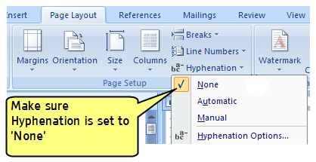

C) Testing Methods
- Use the same method as in Development Methods (above) to check the Automatic Hyphenation setting.
- Look through the document manually to find instances of manual hyphenation.

Navigation

Place document titles in the main document; not the 'Header' area

A) Rationale
A Word Document page is normally divided into three areas: 1) The Header area; 2) the Main Document area; and 3) The Footer area. Screen readers normally read only what is in the middle—the Main Document Area.
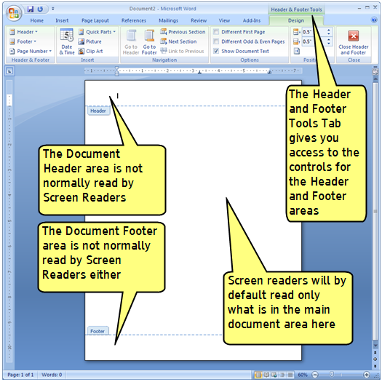
While it may seem logical to place a 'document heading' in the 'Header' area, this is not what the header area is intended for. The Header Area is the place to put running headers like a book or report name, author names and so forth. Similarly, the Footer area is for things like page numbers, copyright messages and the like. Important information that should be read by Screen Readers, like document titles and page headings, as well as signatures at the end of memos, all need to be placed in the Main Document Area.
Note: while Screen Reader users are able to access the text in the Header Area and Footer Area, this is not a normal method of reading (it is awkward and difficult for Screen Reader users to keep track of text in these areas).
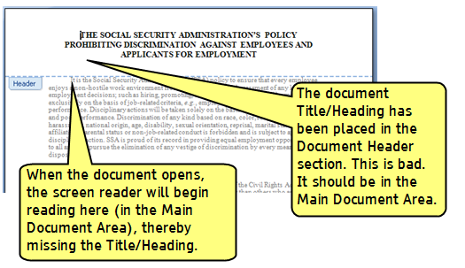

B) Development Methods

Move all text that needs to be read into the Main Document Area
- Open the Header or the Footer Areas (Ribbon... Insert Tab... Header & Footer area > Header > Edit Header).
- Cut information that has been erroneously placed in the Header or Footer.
- Close the Header and Footer
- Paste the information into the Main Document Area.

C) Testing Methods
Use the same method as in Development Methods (above) to check content in the Header and Footer Areas.
You can also do a quick manual test in Print Layout View: (Ribbon... View Tab... Document Views... Print Layout):
- TEST: Place your cursor anywhere at the top of the document (Press CTRL+Page Up). The cursor should be at the top of the content that needs to be read by the Screen Reader (i.e., the natural starting point for the document).

Use Heading Levels in style formatting

A) Rationale
Headings are used to divide documents up into meaningful chunks of information. When headings are defined using Word's built-in heading styles, Screen Reader users can quickly navigate through the document. They can jump to the next heading, or to the next heading at a certain level (e.g., moving forward and backwards through the document at only the top level headings).
When headings are incorrectly marked up, using character formatting only (e.g., applying BOLD format, and/or using ALL CAPITAL LETTERS), there is no programmatic way for the Screen Reader to know where the headings are. Therefore, they (a) cannot easily navigate through a document, and (b) when a heading is reached there is no notification that what is being said is in fact a heading.
Tip: Using the built-in styles for word means that the Heading styles can be easily used to build a linked Table of Contents (1.2.3) for the document, which also aids navigation.

B) Development Methods

Use the built-in Heading styles
Note: See Use Styles for formatting (1.1.1) for an introduction to working with styles.
- Open the Styles Window. (shortcut is CTRL+ALT+SHIFT+S).
- If Headings 1 through 9 are not shown, click the Options... button at the bottom of the Styles Window, and make sure that 'All Styles' are visible in the list.
- Apply the headings to the text in the main document.
- If you need to modify the heading styles, right click the style name.
TIP: By default, heading 9 is based on heading 8, heading 8 is based on heading 7, and so on all the way up to heading 1. This means that if you start with the formatting for heading 1, all the changes will affect the lower headings. This is a useful way to manage the look and behavior of all the headings in the document.
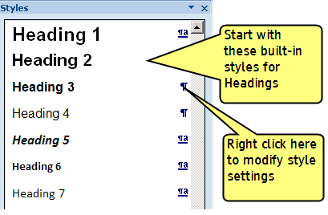

Ensure that Outline Level for a heading matches the visual look of headings
If you are working on a document that did not use the built in Heading styles, and used custom style names for headings, it will be necessary to set the 'Outline Level' of each custom heading style.
- Open the Styles Window. (shortcut is CTRL+ALT+SHIFT+S).
- Right click the custom heading style.
- In the style dialog box, go to Format > Paragraph > Indents and Spacing TAB.
- Set the Outline level to match the visual look of the document headings. (e.g., the main title should be Outline Level 1, the next level down is Level 2, etc.).
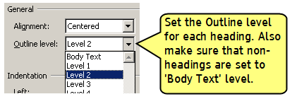

C) Testing Methods
Use the same methods used Development Methods (above) to check the Outline Level of each style.

Use automation if creating a Table of Contents

A) Rationale
A Table of Contents (TOC) is a quick and effective means to examine the content of a document. A linked TOC is an even more effective means to examine and navigate a document. Providing a linked TOC therefore aids Screen Reader users to both understand the structure of a documents, and to navigate within it.

B) Development Methods

Create a linked Table of Contents
- Place the cursor where you want the TOC to appear in the document.
- Open the TOC dialog box (Ribbon... References Tab... Table of Contents Area > Table of Contents > Insert Table of Contents...).
- Make sure 'Use Hyperlinks instead of page numbers' is checked.
- Select the various desired options for the TOC
  - Add page numbers, Tab Leaders etc.
  - Use the Options... button to select the paragraph styles that will be used to form the TOC (the default includes all of the 'Heading' styles).
  - If you need to modify how the TOC looks on the page, use the Modify... button.
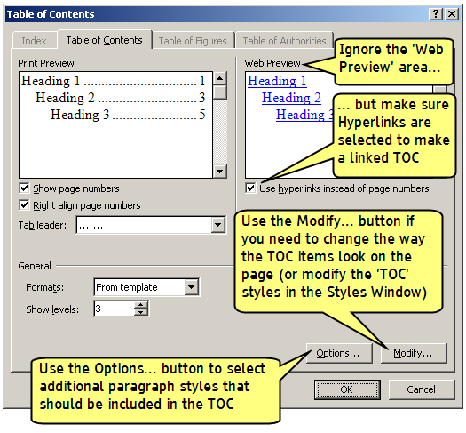
Note: Once a TOC is introduced to the documents, styles named TOC 1, TOC 2, etc. should appear in the Styles Window. These TOC styles can be modified just like any other.
Note: Make sure you update the TOC when you complete editing the document.
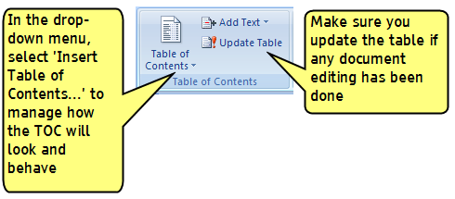

C) Testing Methods
If the Table of Contents has been made properly using hyperlinks, it will be clickable. Make sure that the links in the TOC take you to the right destination heading. Also make sure that the TOC has been updated properly (i.e., the page numbers in the TOC match those in the Main Document).

Language

Set the language properties

A) Rationale
A Screen Reader converts text to speech, and it pronounces things according to the language specified in the style format settings.
Problems occur when the language has not been set at all, or it has been set to the wrong language. For example, if text is in Spanish but it has been set in the style format as English, then the Screen Reader software will speak the words as they are written, but with an English accent. To a Spanish speaking blind screen reader user, the speech will sound comical at best, and incomprehensible at worst.

B) Development Methods
Language can be set for the entire document, or, if there are multiple languages used in the document, language can be set at the character or paragraph level with styles.
Note: See Use Styles for formatting (1.1.1) for an introduction to working with styles.

Set the language for the document if only one language is used
- Select all of the text in the document (CTRL+A)
- Open the Set Language dialog box (Ribbon... Review Tab... Proofing Area > Set Language).
- If the document is in English or Spanish then set the language to either
  - English (U.S.)
  - Spanish (International sort)

Set the language for the individual styles if multiple languages are used
Note: this requirement applies even if the documents contains only a few words or phrases in a different language.
- Open the Styles Window. (shortcut is CTRL+ALT+SHIFT+S).
- Right click on each style used in the document and Modify it.
  - In the 'Style Properties' dialog box, select Format > Language... and set the language for this style.
Tip: if you have made styles with a hierarchical structure, you may only need to fix one or two styles instead of each style in the documents. For example, set the Normal style to 'English (U.S.)' and then every style based on he Normal style will be set properly. Then set up a style called 'Spanish text' and set the properties for this style. This strategy only works well if there is a hierarchy used to create the styles used in the documents.

C) Testing Methods
You can use the same methods for Use Styles for formatting (1.1.1).
- Check that the language setting is correct in the Reveal Formatting Window.

Fonts

Use System Fonts

A) Rationale
An easy to ready font can make reading possible for people who have low vision, and much more enjoyable for people who have regular vision. While it may be tempting to be creative in your font choices, employing a 'fancy' or non-standard font can add frustration for many readers.
Non-standard system fonts can include non-standard characters. For example, the 'symbol' and 'Windings' font sets contain iconographic characters that are not going to be read by Screen Reader software. If non-standard characters are used, an alternative description of the meaning of those characters is required for Screen Reader Users.
In addition, if you choose a font that is non-standard, there is no guarantee that the user of the document will have that font loaded on their computer. Their system will then do a font substitution, but this can negatively impact the layout and overall look/readability of the document.

B) Development Methods
Use standard/system fonts in your document. Good choices are fonts like
- Arial
- Courier
- Times New Roman
- Verdana
Poor choices are things like comic fonts and script/cursive fonts.
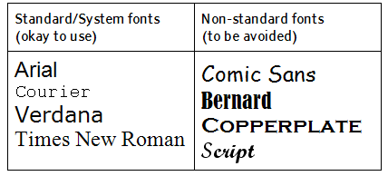

C) Testing Methods
You can use the same methods for Use Styles for formatting (1.1.1).
- Check that the font is appropriate in the Reveal Formatting Window.
- Manually check that non-standard characters have not been used.

Graphics / images

Add Alternate Text to graphics / images

A) Rationale
Screen Reader software converts text to speech, but it cannot convert graphics/images to text. To overcome this, text can be programmatically attached to a graphic. The Screen Reader software then reads this "Alternate text" when a graphic is shown.
The amount and type of description that is put into the alternate text (commonly abbreviated to "Alt-Text") depends on the type/purpose of the graphic. There are three main types of graphic:

Information-Type Graphics
Information-Type graphics convey important information not contained in the adjacent text:
- Alternate text should succinctly convey in words the same information that is communicated by the graphic. It should represent the meaning, function, or purpose of the image, not just describe its appearance.
- Information-Type graphics definitely need Alt-Text.
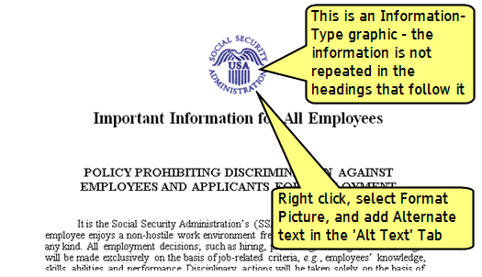

Redundant-Type Graphics
Redundant-Type Graphics contain information that is repeated / duplicated in adjacent text or added as a caption associated with the image:
- Redundant-Type Graphics require a judgment to be made about what is the appropriate Alt-Text to provide. It may be okay to not provide any Alt-Text in this case, or it may warrant some short Alt-Text, for example "This graphic shows the dialog box controls as described in the main text".
Note: Most of the graphics in this guide are of the Redundant-Type, with this short Alt-Text applied: "Graphic illustrating the information and/or steps in the surrounding text".

Decorative-Type Graphics
Decorative-Type Graphics contain no information necessary for the comprehension of the document's content:
- Decorative-Type Graphics definitely do not need Alt-Text.
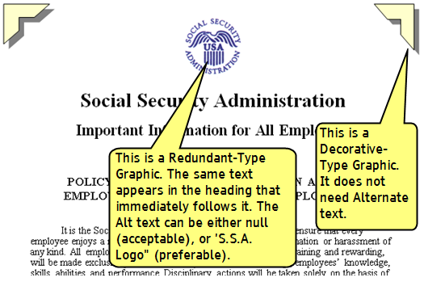

B) Development Methods
- Determine the type of graphic/image in order to prepare the appropriate Alt-text wording (see Rationale, above).
- Right click the graphic and select Format Picture. Open the Alt Text Tab and type in the appropriate Alt-text.
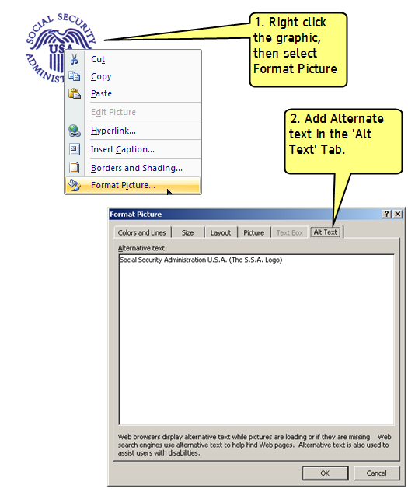
Note: If you are working on a new (unsaved) document, there might not be an Alt-text Tab when you try to format the picture. This is a result of Word 2007 using a new XML-based formatting system. If this is the case, do the following procedure:
- Save the document. This should convert the document to the older Word 2003 (non-XML) format. The document extension should be ".doc"; not ".docx"
- Re-open the document. It should now be in the older format and the above procedure should now work.
Note: if you are working on a document that needs to be saved in the Word 2007 (XML) format, then the following procedure will need to be followed for adding Alt-text to graphics:
- Left click the graphic. A Picture Tools menu appears at the top of the Ribbon.
- Select the Picture Tools menu.
- Click the small icon in the bottom right corner of the Size area. This brings up the Format Picture dialog which will have an Alt-Text Tab.
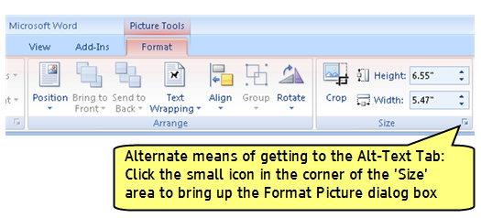

C) Testing Methods
- Determine the type of graphic (Information-Type, Redundant-Type, or Decorative-Type). See Rationale, above for an explanation of graphic types.
- Use the same method as in Development Methods, above to check that the Alt-text is appropriate for the type of graphic.

Group Complex Objects

A) Rationale
If you use the drawing tools in Word that are found in Ribbon... Insert Tab... Illustrations Area (e.g., Clip Art, Shapes, Smart Art, Charts), then each object that you use to create a larger visual picture is treated as a separate object in Word. The problem for Screen Readers is that there is no logical place to add the Alt-text necessary to convey the meaning of the larger visual picture.
The solution for this problem is to group the objects into one picture, and then Add Alternate Text to graphics / images (1.5.1) to the group.
Note: If a graphic/image is imported into a Word document from another program, it will normally be a single object within Word. Alt-text can then easily be applied to the single object.

B) Development Methods
- Select the objects that are to be grouped:
  - Corral the objects by clicking and dragging a box around the objects; or
  - Hold down the CTRL key continuously while you left click on each object to be grouped.
- Group the objects:
  - Right click on one of the objects and select Grouping > Group; or
  - Go to Ribbon... Picture Tools Tab... Arrange area > Group.
- When the object is grouped, be sure to then add the appropriate Alternate Text (1.5.1).
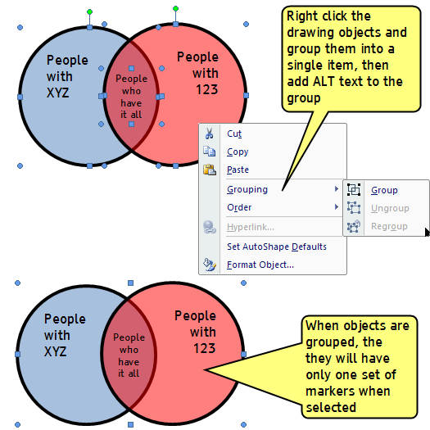

C) Testing Methods
- Click on the graphics/images in the document. They should have only one set of markers applied to them (see Development Methods, above).

Place graphics / images 'in line'

A) Rationale
Graphics/images can be 'placed' in a Word document as 'in line' with the text, or they can be placed as 'floating' and 'anchored' near the text. Screen Reader software can only detect and properly read the Alt-text (1.5.1) associated with a graphics when it is placed 'in line'.

B) Development Methods
- Right click the image and select Format Picture.
- In the Format Picture dialog box, select the Layout Tab, and select 'Inline with text'.
- The graphic may appear to move in the document from where it is intended to be placed. If necessary, move the graphic to the correct location.
Note: Inline graphics can be treated like regular text, in that they can be placed on the left, right, or centered on the page. To make editing easier, a style can be created to help manage how graphics are laid out throughout the document—see Use Styles for formatting (1.1.1)..
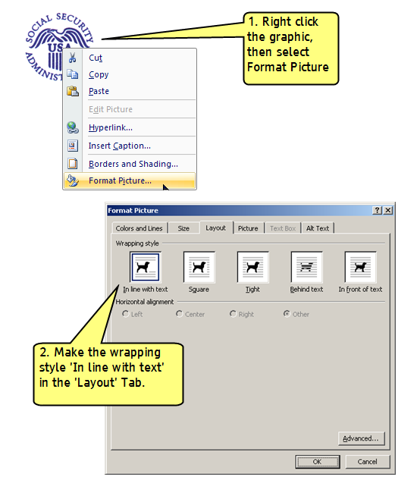

C) Testing Methods
Check that the image is inline:
- Make formatting marks visible with the Show/Hide () button (Ribbon... Home Tab... Paragraph > Show/Hide button);
- Make sure the anchor symbol () DOES NOT APPEAR next to any graphic/image. (If the images are properly inline there will be no anchor symbols).

Artifacts

Convert text boxes to regular paragraphs

A) Rationale
Text-boxes provide a means to add text to a document, and locate it anywhere on the page. Unfortunately, text boxes work more like images than text. Because of this, text boxes only show up in the 'print layout' view, and Screen Reading software is unable to access the information in a text box.
Instead of using text boxes, style formatting (1.1.1) can be used to locate the text in the desired place on the page. Style (paragraph-level) formatting may take a few more steps to achieve than using text-boxes, but style formatting is much more accessible for Screen Readers.

B) Development Methods

Development
During development, do not use the text box tool (Ribbon... Insert Tab... Shapes > Text Box); Instead, Use Styles for formatting (1.1.1).
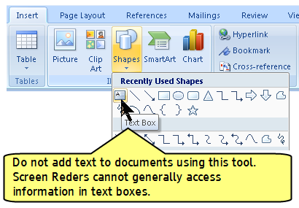

Remediation
If text boxes have been used in a document (see Testing Methods, below):
- Copy the text in the text box,
- Delete the text box
- Paste the text into the main document
- Format the pasted text using Style formatting (1.1.1)

C) Testing Methods
There are two ways to check if text boxes have been used:
- View the document in Page Layout view and in Draft View (Ribbon... View Tab... Document View).
Note: To do this you can either:
  - switch between the views; or
  - open two versions of the same document and use a different view in each; or
  - print the document and then compare it to on-screen Draft view.
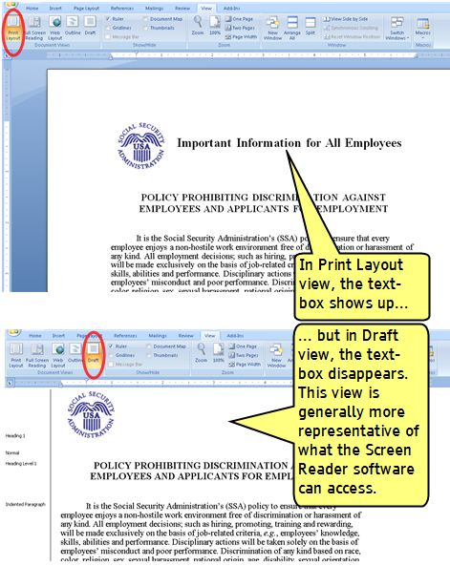
- In Page Layout View (Ribbon... View Tab... Document View > Page Layout), right click on any text that might be a text box. If placeholder marks appear and the text can be dragged and repositioned, it is a text box.
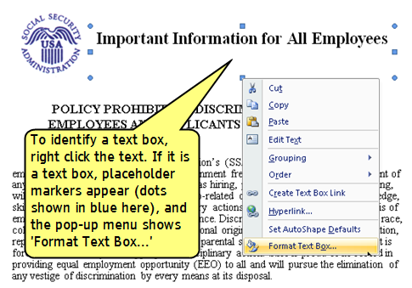

Tables

Remove table formatting applied to non-tabular information

A) Rationale
It is possible to use tables as a means of applying a desired visual layout. For example, text that is supposed to show in four columns can be placed in a table with one row and four columns. Visually, there are four columns of text. This is problematic for Screen Reader users. Tables are meant to be used for tabular information (data).
Screen Reader users can easily navigate to and examine data in tables. There are specific keyboard controls for reading tables that differ to the controls for reading regular text. When non-tabular text is rendered with tables, the reading controls are incorrect. This can make it confusing and difficult to read the document with a Screen Reader.

B) Development Methods
For any non-tabular text, visual formatting can be achieved without the use of tables. For guidance, see 1.1.1 Use Styles for formatting, and 1.1.3 Use list formatting.

C) Testing Methods
There are two ways to determine whether tables have been used for visual formatting of non-tabular information:
- Right click on any text that you suspect is formatted as a table. If the Table Tools part of the Ribbon shows up, table formatting has been used.
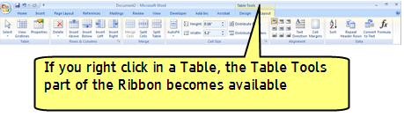
- Make table gridlines visible for all tables in the document: (Ribbon… Home Tab… Paragraph Area > Borders > View Gridlines). If gridlines show up around non-tabular information, tables have been used.
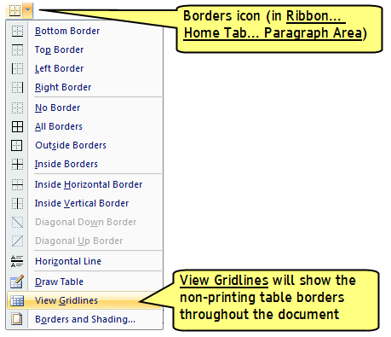

Set the header row as 'repeating'

A) Rationale
It is possible to programmatically assign a table row as being the 'header row'. This enables the Screen Reader software to be able to tell the user for each cell what the header for that column is.
Without the header row being properly identified, the Screen Reader can only say (using the example in the image below) 'Column 3' instead of 'Column 3, dessert'. This is not as great an issue in a simple table of only a few rows and columns, but in a data table of 20 rows and 15 columns, being able to identify the heading is extremely useful.

B) Development Methods
- Place the cursor anywhere in the first row of the table. Right click and select Table Properties from the pop-up menu.
- Select the Row Tab in the Table Properties Dialog Box.
- Check 'Repeat as header row at the top of each page'
Note: Do this even if the table does not go over multiple pages.
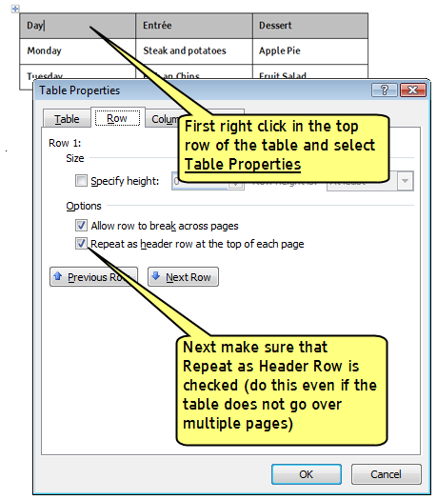

C) Testing Methods
Use the same methods as Development methods (above) to check to see if the header row setting has been checked for the first row of each data table.

Remove text wrapping around tables

A) Rationale
Screen Readers software works well when it is reading across the page in either Table Reading Mode, or in Text Reading Mode.
When text is wrapped around a data table (so that it appears to wrap around the left or the right side of the table), there is an increased likelihood of reading errors. The Screen Reader Software may have a difficult time switching between Table Reading and Text Reading Modes, and deciding which thing to read first (the text or the table).
To remedy this problem, tables should be presented in their own lines of the page, without any wrapped text to the left or the right.

B) Development Methods
- Place the cursor anywhere in the table. Right click and select Table Properties from the pop-up menu.
- Select the Table Tab in the Table Properties Dialog Box.
- Select 'Text Wrapping None'
Note: After this is done, it may be necessary to move the text that was originally wrapped around the table (i.e., it might move to after the table, but logically it should be placed before the table).
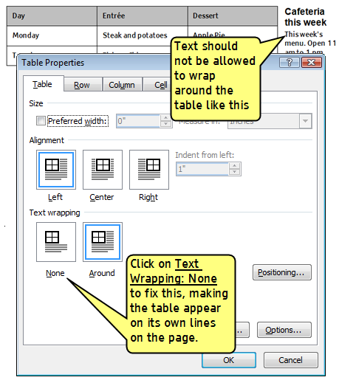

C) Testing Methods
Visually inspect and or right click in any table as per Development methods (above) to see if text is wrapped around data tables.

Links

Assign link names that make sense when spoken in isolation

A) Rationale
When a Screen Reader is reading text and there is a link, the software will insert the word "Link" in front of the text to alert the user that this is a selectable hyperlink.
Another way that Screen Readers can access the links that are in a document is for them to call up a list of links. This list will display only the text that has been marked as a link.
It is important that the list of links makes sense to the user when it is read out of context. That is, the name of each link should make sense in the list when it is read in isolation.
Consider the following four examples of the same text and same link rendered using different methods:
- Please read The SSA Online Accessibility Policy. Click Here
- Please read The SSA Online Accessibility Policy. http://www.ssa.gov/webcontent/accessibility.htm
- Please visit The SSA Online Accessibility Policy.
- Please visit The SSA Online Accessibility Policy: http://www.ssa.gov/webcontent/accessibility.htm
If every link in the document was rendered using method #1, the list of links would read like this:
- Click Here
- Click Here
- Click Here
- Click Here
It is easy to see that individual links are not possible to read out of context.
If every link was rendered using method #2, the list would read like this:
- http://www.ssa.gov/webcontent/accessibility.htm
- http://ssa.gov/pgm/links_disability.htm
- http://www.section508.gov/
This list also makes no sense in context. While we might be comfortable in normal conversation saying "go to s s a dot gov" we generally do not say to people "go to s s a dot gov slash p g m slash links underscore disability dot h t m". It is too long and it is too difficult to understand. However, when the list of links is presented this way, this is exactly how the Screen Reader will say each link.
If every link was rendered with method #3, the list would be read like this:
- The SSA Online Accessibility Policy
- SSA Disability Benefits
- GSA's Section 508 website
Using this method, all of the links make sense when spoken out of context. This is the best method to use.
Where it is important to have the URL displayed on the printed page, Method #4 is the same as method #3, but with the URL also spoken in the list. This method is perfectly acceptable, so long as the name comes first and the URL comes last in each link.

B) Development Methods
- Right click any hyperlink in the document.
- Make sure that in the Hyperlink dialog box the 'Text to display' field has a link name that makes sense when spoken in isolation.
Note: See Rationale, above for an explanation of how links are spoken by Screen Readers.

C) Testing Methods
Examine the document for instances of links that have names like 'Click Here', and/or links that are just URLs, like http://ssahost.ba.ssa.gov/arc/. These links need to be remediated according to Development Methods, above.

Where possible, do not allow links to span two lines of text

A) Rationale
When a document gets converted to a PDF, links that span two lines of text will be read by a Screen Reader as two links instead of one.

B) Development Methods
Where possible, format the text so that links so that they remain on one line of text.

C) Testing Methods
Open the document in Print Layout view (Ribbon… View Tab… Document Views… Print Layout). Look to see if links span two lines, and fix as necessary.

Color

Use text colors that contrast with their backgrounds

A) Rationale
Color contrast in documents is the difference between the brightness of the text compared with its background.
In the table below, the background of the text is shown in increasing shades of gray. The shades of gray are numbered in Word's color picker as increasing percentages.
As the gray percentage increases the contrast decreases. Black text on a black background has a contrast of zero (as does white text on a white background).
shading | 10% | 20% | 30% | 40% | 50% | 60% | 70% | 80% | 90% | 100%
text | text | text | text | text | text | text | text | text | text | text
contrast | 90% | 80% | 70% | 60% | 50% | 40% | 30% | 20% | 10% | 0%

Zero contrast text is impossible to read by everyone. 10 per cent contrast text is readable by people who have very good eyesight. In general, as we age, our contrast sensitivity goes down. Also, some younger people can have low contrast sensitivity.
While we may be able to read 10% contrast text ourselves, we must remember that not everyone can.
Good contrast is not limited to shades of gray. It applies to every color. Certain color combinations provide low levels of contrast, as the examples in the table below show.
shading | blue | green | yellow | black
text | red | blue | orange | brown

Certain color combinations provide high levels of contrast, as the examples in the table below show.
shading | blue | green | yellow | black
text | yellow | yellow | red | white

B) Development Methods
Choose combinations of foreground colors and background colors that provide good levels of contrast.

C) Testing Methods
Although it is difficult to replicate having low contrast sensitivity with your own eyes, there are several means to look at how well the text contrasts with its background:
- Print the text on a color printer and a black and white printer. Does it look as readable?
- Print the text and try reading it in a dimly lit room. Is it readable?
- Adjust the color and brightness settings on your monitor. Is the text still readable?

Use automatic color settings for black text and white text

A) Rationale
People with certain types of vision impairment prefer to use their computer in either High Contrast Mode, where the differences between the text and backgrounds are made greater; or in High Contrast Reverse Mode, in which the white backgrounds are changed to black, and black text is changed to white. These changes take place in the operating system, and can be set in the Control Panel:
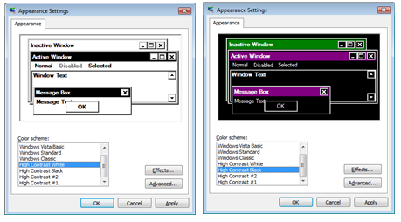
In MS Word, text can be rendered as any color, or as 'Automatic'. When one of these high contrast modes is chosen by the user, the following will happen:
- Text that is assigned the color 'White' will not show up in High Contrast Mode.
- Text that is assigned the color 'Black' will not show up in High Contrast Reverse Mode.
- That that is assigned the color 'Automatic' will show up in either of the high contract modes.
By using the 'Automatic' color setting for black and white text, the text will be visible for people who rely on these high contrast modes for accessing their computer.
For other colors, the automatic setting might not work as well, but so long as efforts are made to provide high contrast (see 1.9.1) the text should be readable by most readers with low vision.

B) Development Methods
When setting up styles for text that is intended to be shown as black or as white, set the font color to 'automatic'.

C) Testing Methods
Use the Reveal Formatting Pane to examine text to see if black text and white text is assigned color automatically (see 1.0 Preparation).
Using the high contrast settings in the accessibility control panel of your computer is also a good means to check to see how the document looks in high contrast modes.

Provide redundancy for information presented in color

A) Rationale
Some people have color vision problems where they cannot distinguish between certain colors, certain shades of the same color, or see any color at all.
Using color to emphasize or call attention to certain elements may help make documents easier to read for many people. However, when color is used as the only way to convey information, the meaning can be lost to those with color vision problems.
For example, if completed items in a table are indicated by a green X and incomplete items shown as a red X, they may look identical to someone who is color blind (and they will sound the same to someone using a Screen Reader):
Task | Due Date | Completed
Task 1 | January 3, 2010 | X
Task 2 | February 9, 2010 | X
Task 3 | March 4, 2010 | X

To remedy this, provide another (redundant) means of giving the information (size, shape, or character, for example):
Task | Due Date | Completed
Task 1 | January 3, 2010 | Y
Task 2 | February 9, 2010 | N
Task 3 | March 4, 2010 | Y

B) Development Methods
Only use color as an enhancement, not as the sole means of conveying information.

C) Testing Methods
- Print the text on a black and white printer. Is the information still conveyed properly?
- Adjust the color settings on your monitor. Is the information still conveyed properly?

Document properties

Set the document title in document properties

A) Rationale
A document can have 'properties' assigned to it, such as a title, the name of the author, the name of the company that produced it. Some of these properties might initially be blank, or filled in automatically by MS Word. All of the properties can be manually set by the document author.
When a Screen Reader opens up a document, it will first try to say the title assigned in the properties. If that is blank, it will say the filename. For the same reason that links are better if they are spoken with real names rather than URLs (see 1.8.1), the properties are better if they are spoken as real names (e.g., "Application for Benefits") rather than file names (e.g., ("appl_ben_version4.pdf").
Note: There are a number of other benefits to setting the document properties:
- Most search engines use the title of a document to describe the document in their search results list. If a file does not have a title, the file name appears in the results list instead;
- Setting other document properties, such as subject, category, and keywords, is also useful for returning high-quality search results; and
- Setting the author of the document is extremely helpful in tracking down the originator of the document. This may be necessary when it is time to update the document, or for dealing with document issues, such as security settings, certifications, and signatures.

B) Development Methods
Set the document title (and other desired properties):
- Select the Office Button.
- Select Prepare > Properties.
- Set the properties in the pop-up fields.
Note: More document properties can be set in the Advanced Document Properties dialog box, which can be found in the information section at the top of the properties pop-up fields.

C) Testing Methods
Use the same methods as above in Development Methods to check that the title of the document in the properties is the same as the title in the main document.

Converting from Word to PDF

Essential concepts
Notes:
- Make sure you have version Acrobat Pro 8.1 and the CommonLook plug-in installed (See About this guide, Section 0.0).
- This guide does not include information of producing accessible PDF forms. See About this guide (0.0).

Easy ways and hard ways to make an accessible PDF
There are several methods for making a PDF document, including:
- In MS Word with Adobe Acrobat Pro 8.1 installed, converting a Word document to PDF with the PDF Maker application;
- In other Adobe applications (e.g., InDesign, LiveCycle), outputting a document as a PDF file;
- In MS Word and other MS Office applications, saving a file as a PDF;
- Scanning images of documents, and putting those page images in sequence into a PDF.
Method #1 in the above list is the easiest and most efficient method for most document authors to create an accessible PDF.
For document authors using method #2 (producing a PDF from other Adobe applications), some of the settings information in this guide for conversion may be helpful to know, but this guide is not intended to cover this method.
Although the standard application of MS Word is capable of saving a file as PDF (method #3), it is not recommended because this method does not properly format the PDF to work with Screen Readers and other technologies typically used by people with disabilities (PWDs). Using method #3, the following problems can occur:
- Graphics do not get identified properly;
- Headings do not work properly;
- Tables do not get formatted in a way that works well with Screen Reader table reading controls.
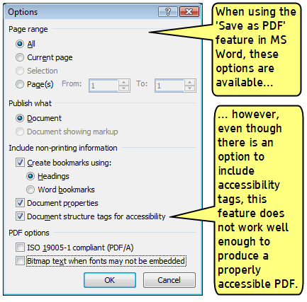
The final method, using scanned images (#4 in the above list), means that you are starting out with images of text rather than text that can be read by a Screen Reader. If you wanted to make this type of document accessible, you would first have to run Optical Character Recognition software (which can be unreliable depending on the quality of the images) to convert the images to readable text. Next you would have to replicate the structure (headings, lists, links etc.) in the converted text. This is a very difficult way to create an accessible PDF.
This section of the guide therefore concerns method #1 in the above list, converting to PDF using the PDF Maker application.

Conversion is one-way, with no going back
You can convert a Word Document to a PDF with the PDF Maker application; but there is no equivalent conversion process for turning a PDF back into a Word Document.
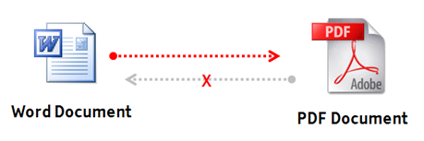
This means that if you start with a Word Document, convert it to PDF, and then start making changes to the PDF, those changes are not reflected in the Word Document. If you need to make any edits or fixes to the Word Document, you will need to convert it to a PDF again, losing any work you did on the earlier version of the PDF file. This is important to know, because the rule of thumb is that:
- The more you can do to make your Word Document accessible…
- The less work you will have to do to make your PDF version of the document accessible; and
- The less work you will have to do to convert documents if and when their contents get revised in at a future date.
If you start with a Word document that has poor accessibility, you are almost certain to have an inaccessible PDF document. If you have a Word document that has good accessibility, the conversion should go smoothly, and you are likely to have a mostly accessible PDF. There will still be some things to check, even if you start off with a Word document that has good accessibility.
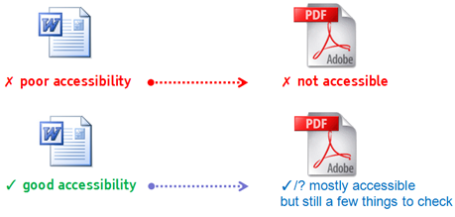
Generally speaking, the more you can do to fix accessibility issues in the Word Document, the better your conversion will be. See the section of this guide on Producing Accessible Word Documents (Section 1).

What if I don't have the source file in Word format?

I have a PDF file with selectable text:
There are two main options if you have a PDF that needs to be made accessible, but you do not have an original Word file to convert to PDF:
- Manually identify and fix all of the problems in the PDF: This requires doing all of the steps in the next section of this guide (Checking and fixing accessibility issues in PDF documents option, Section 3);
- Saving the text in the PDF in an MS Word file, and then reformatting it from scratch: This option can be achieved by either:
  - Going into the PDF and copying all of the text and then pasting it into a blank word document. Some of the formatting may be kept, but it may not be correctly formatted for accessibility;
  - Using a third-party application to convert PDFs to other formats including Word. This option may produce some better formatting, depending on the quality of the application's conversion process, but it still may not be correctly formatted for accessibility;
  - Going into the PDF and copying all of the text and then pasting it as unformatted text into a blank word document (Ribbon… Home Tab… Paste… Paste Special > Unformatted Text). None the formatting will be kept, but it may be easier to then apply the correct formatting in Word. Note: Page numbers and running headers that show on the PDF will probably be picked up in the copied and pasted text, and will need to be manually removed from the pasted text in the Word file.

I have a PDF file that has non-selectable text (all pages are images):
As stated earlier, this is a very difficult way to create an accessible PDF. The following steps are necessary:
- Run Optical Character Recognition on the text. This feature is available in the Acrobat Pro application.
- Check the quality of the conversion manually (depending on the quality of the source image, some characters, word, or even whole sections might be incorrectly recognized by the OCR software);
- Go to the procedures listed above for 'I have a PDF file with selectable text'.

Conversion from Word to PDF
Notes:
- Make sure you have version 8.1 and the CommonLook plug-in installed (See About this guide, Section 0.0).
- Use the 'PDF Maker' application that gets installed in MS Word as a part of Acrobat Pro. Do not use the 'Save As PDF' feature in Word.

Configure Conversion Preferences
- In MS Word, go to Ribbon… Acrobat Tab… Create Adobe PDF Area > Preferences.
Note: If you do not have the Acrobat Tab showing, you might not have Acrobat Pro set up correctly, or you might have version 8.0 of Acrobat Pro on your system. Version 8.1 or higher is necessary.
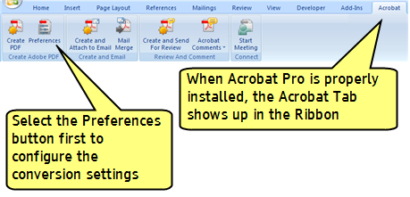
- Settings Tab—the following settings should be used:
- Conversion Settings: Standard
- View Adobe PDF result: checked
- Prompt for Adobe PDF file name: checked
- Convert Document Information: checked
- Attach source file to Adobe PDF: unchecked
- Add bookmarks to Adobe PDF: checked
- Add links to Adobe PDF: checked
- Enable accessible and reflow with Tagged PDF: checked
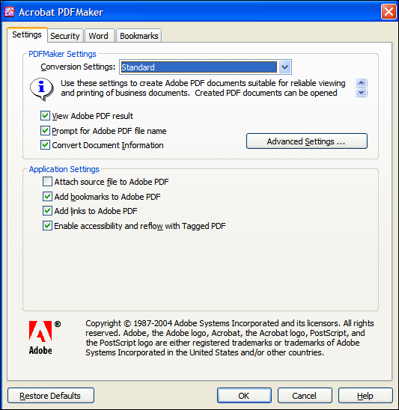
- Security Tab—the following settings should be used:
- Require a password to open the document: unchecked
- Use a password to restrict printing and editing of the document and its security settings: unchecked
Note: If security settings have to be used, ensure that "Enable text access for screen reader devices for the visually impaired" is checked.
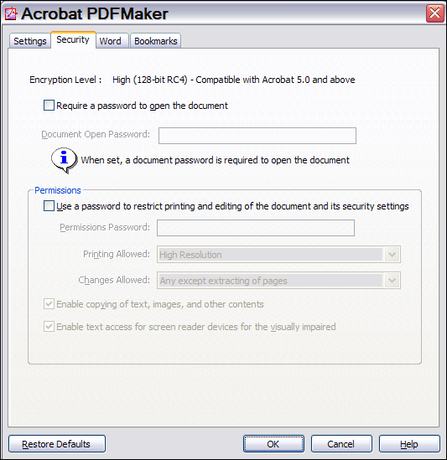
- Word Tab—the following settings should be used:
- Convert displayed comments to notes in PDF: unchecked
- Convert cross-references and table of contents to links: checked
- Convert footnote and endnote links: checked
- Enable advanced tagging: checked
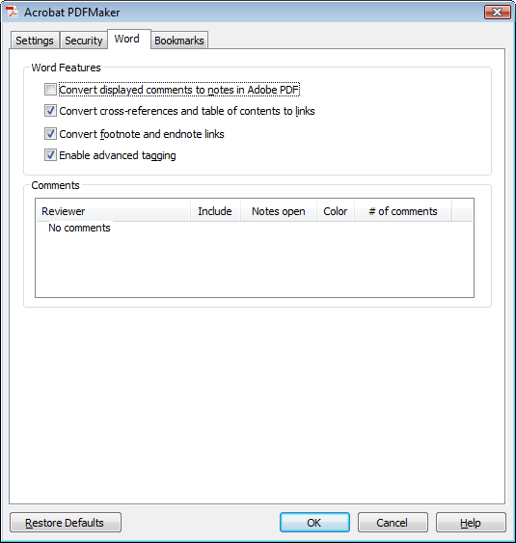
- Bookmarks Tab—the following settings should be used:
- Convert Word Headings to Bookmarks: checked
Note: it is possible, using the list in this dialog box, to set the levels of headings that you want to appear as bookmarks in the PDF.
- Convert Word Styles to Bookmarks: unchecked
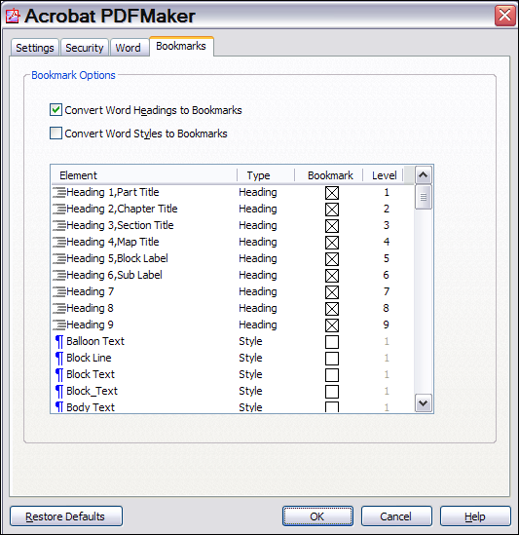

Convert the document with the 'PDF Maker' application in Word
- In MS Word, go to Ribbon… Acrobat Tab… Create Adobe PDF Area > Create PDF.
- Make sure that the Fully Functional PDF radio button is selected.
- Select the Save button.

Checking and fixing accessibility issues in PDF documents
Notes:
- Make sure you have version Acrobat Pro 8.1 and the CommonLook plug-in installed (See About this guide, Section 0.0).
- Before starting this guide, it is highly recommended that you be familiar with Section 0.1, Reading technologies, and implications for document design.

Preparation

The 'Accessibility Full Check'
The 'accessibility full check' is a tool within Acrobat Pro, used to provide an overview (but not necessarily a complete list) of accessibility problems that may need to be remediated (fixed). Although this check is not absolutely necessary to do, it does offer a useful place to start with any newly created PDF to get an overview of the type and number of problems.

Running the Accessibility Full Check
- Have the PDF open in Acrobat Pro.
- Choose Advanced > Accessibility > Full Check.
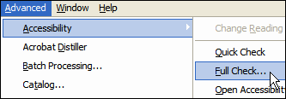
- Select Create Accessibility Report, and then select the Browse button to save a copy to the desired location.
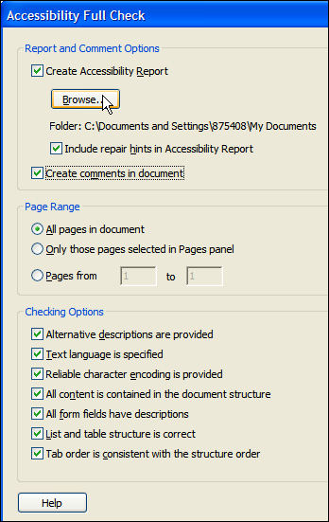
- Specify the pages to be included in the accessibility check (normally 'All').
- To view the report as comments in the PDF document, select Create Comments In Document.
- Select all of the checkboxes for the desired Checking Options.
Note: With the CommonLook plug-in installed, it is also possible to check the document for compliance with Section 508 standards (a drop down list is seen in the middle of this dialog box).
- Click Start Checking.
- A dialog opens reporting the problems found in the document.
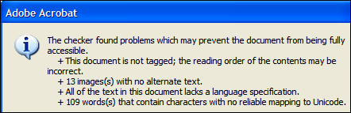
- Note the problems found and dismiss the dialog by selecting OK.
- A report opens in a side window with a list of problems and links to specific areas of the document. Comments and highlights within the document indicate potential problems.
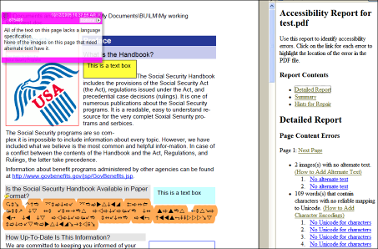
- To view and highlight problem individually, open the Comments tab (Comments > Show Comments List) and select individual comments within the Comments pane. The corresponding element in the document will be highlighted.
Note: After addressing each problem noted by a comment, delete the comment (otherwise it will appear as an untagged element the next time the Full Check is run).
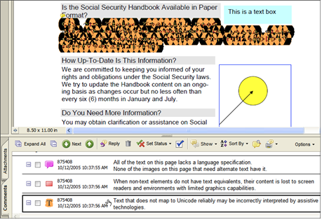

Remediating accessibility problems found in the check
It will be necessary to address the problems reported in the accessibility full check. Refer to the table of contents at the start of this guide and/or the Checklists at the back of this guide to locate the section(s) containing guidance on how to remediate the problems found.
Note: The 'full check' does not cover all of the elements in this guide that need to be checked. To be sure that all necessary checks are made, fill out a checklist (see Checklists, section 4) for each document being tested.

Other guidance and Help
Note: The more you have formatted your original Word document with accessibility in mind (see Producing Accessible Word Documents, section 1), the less likely it is that you will need to consult the following additional sources of guidance and help.

Help in Acrobat Pro for accessibility
For some tasks requiring advanced editing of PDFs, there may be a need to consult the Acrobat Pro help (Help… Complete Adobe Acrobat Professional Help… Accessibility, tags, and reflow).
Note: The Acrobat Pro help window can take a very long time to load.
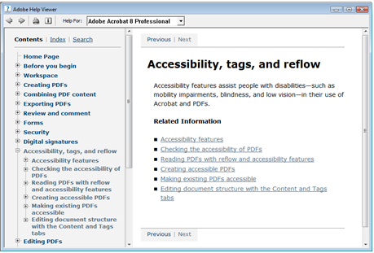

CommonLook accessibility verification
The CommonLook plug-in for Acrobat Pro includes a step-by-step verification process for checking the accessibility of PDFs. The Plug-in also has a tool for remediating tables. For more guidance, see the CommonLook manual.

Limited 'Undo' capabilities in Acrobat Pro during accessibility remediation
The is no 'undo' command available for many of the tools used to fix accessibility issues with Acrobat Pro.
For example, in setting the reading order (3.1.2) and modifying table tags (3.7.1), there is no way to go back if you make a mistake.
For this reason, it is highly recommended that you save your work (save the PDF file) every few minutes, and/or before making a substantial change to the document.

Reading order

The initial view is set properly?

A) Checking
The 'initial view' settings dictate how the document looks when it is opened by the end-user.
The initial view settings allow you to set:
- Whether the navigation tab should show up (it should show up as 'Bookmarks Panel and Page' because the Bookmarks Panel is a useful means of navigation for Screen Reader users);
- Whether single or multiple pages should show ('single page' is preferred for Screen Reader and Screen Magnification users);
- The Magnification—either actual size, fitting to the width of the window, a certain percentage etc. (unless there is a strong reason to override the user's preferences, the Default setting is best for Screen Magnification users… as this setting brings up the document in the user's preferred size on the screen);
- The starting page (ordinarily this should be page 1).
To get to the initial settings, open File… Properties to bring up the Document Properties dialog box. Then select the Initial View Tab.

B) Remediating
- Navigation tab / Show: 'Bookmarks Panel and Page';
- Page Layout: 'single page';
- Magnification: 'Default';
- Open to Page: 'Page 1' (or Last viewed page if that is an option).
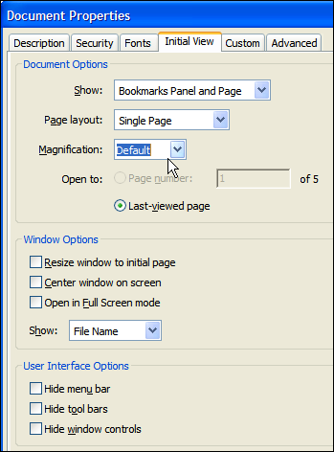
Note: when done, open the PDF in Adobe Reader to double check that the initial view is set properly.

The reading order is correct?

A) Checking
The reading order is the order in which the Screen Reader will speak the information presented on each page.
- View the reading order for each page: Advanced… Accessibility… Touch up reading order. The numbered gray boxes show the order in which the Screen Reader will speak the information on the page.
- For any item that is not in the reading order, determine whether it should or should not be spoken. For example, running headers and footers should not be spoken. Information-Type graphics should be spoken. If there are any elements on the page that are out of sequence, or otherwise mis-assigned in the reading order, see Remediating, below.
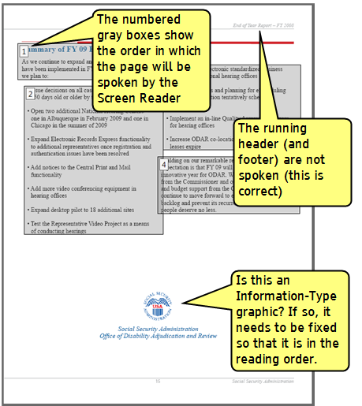

B) Remediating
- Draw a box around any content that needs to be fixed.
- Select the type of item it should be in the TouchUp Reading Order box.
Note: There are useful buttons at the bottom of this box, including Clear Page Structure (for when the order is so off that starting over is better) and Show Order Panel (to show a list of pages and the order of the content for each page).
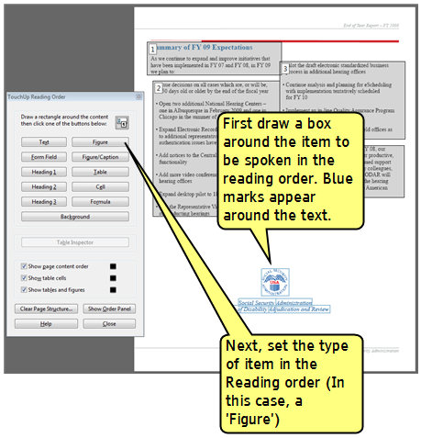

Lists have the correct tag structure?

A) Checking
Lists should have a tag structure in the code that is embedded in the PDF. To check the tag structure for lists:
- Go to View… Navigation Panels… Tags.
- Open and close elements of the tag tree using by clicking the plus and minus icons.
Tip: To see a corresponding highlight in the main document for any item selected in the tag tree, right click any item in the list and check Highlight Content in the pop-up menu.
- Check that there is a list structure for each numbered or bulleted list item. The structure should include the following:
  - A list tag <L> at the start of each list, and for each item:
  - A list item tag <LI>
  - A label tag <Lbl>
  - A content tag <Lbody>
  - The content (the text to display in the main document)
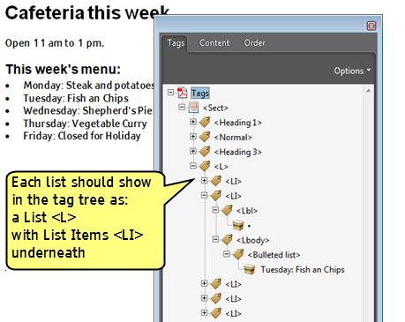

B) Remediating
If the tag structure is not properly following the content in the main document, it is likely that Screen Reader software will not read the list items properly.
- The easiest way to fix this is to go back to the original word file and Use list formatting (Section 1.1.3).
- If the original file is not available, the tag tree will have to be fixed manually. Refer to additional sources of help and guidance for instructions (See Section 3.0).

The tab order of pages is set?

A) Checking & B) Remediating
- Open the Pages tab: View… Navigation Tabs…Pages.
- In the Pages tab, select all pages (to do this, scroll up to the first page and select it, then scroll down to the last page and while holding SHIFT, select it. A blue outline should appear around all of the pages.
- Select Options > Page Properties > Tab Order tab.
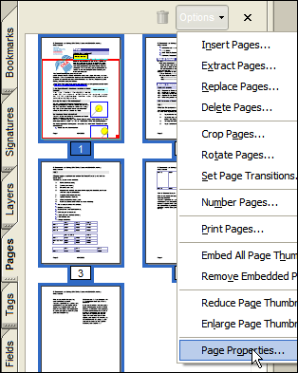
- Select the radio button Use Document Structure.
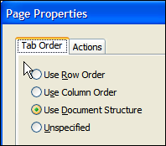

Navigation

Bookmarks are set correctly?

A) Checking
- Open the Bookmarks tab by selecting View… Navigation Panels… Bookmarks.
- Review the bookmarks and determine if the bookmarks:
  - link to the appropriate destination,
  - are nested properly, and
  - are labeled correctly.
Note: If Word's heading styles (Section 1.2.2) were used properly and the settings for the PDF conversion were correct (Section 2.1.1) then the PDF bookmarks should be correct.

B) Remediating
If the bookmarks are incorrect, they can either be corrected in Word, or modified in the Bookmarks tab within Acrobat.
If bookmarks are modified in the Bookmarks tab within Acrobat, those same modifications will need to be re-applied every time the document is converted from Word. It is therefore recommended that bookmarks be corrected in Word.
To modify bookmarks in Acrobat:
- Open the Bookmarks tab by selecting View… Navigation Panels… Bookmarks.
- Click and drag bookmarks up and down in the list of bookmarks to where they logically belong.
- Use right clicking of bookmarks and the Options button in the Bookmarks tab to create and delete bookmarks, and change the destination of bookmarks.

Headings are set correctly?

A) Checking
Headings should have a tag structure in the code that is embedded in the PDF. To check the tag structure for headings:
- Go to View… Navigation Panels… Tags.
- Open and close elements of the tag tree using by clicking the plus and minus icons.
Tip: To see a corresponding highlight in the main document for any item selected in the tag tree, right click any item in the list and check Highlight Content in the pop-up menu.
- Check that there is a Heading tag with the correct level <Heading #> for each heading in the main document.
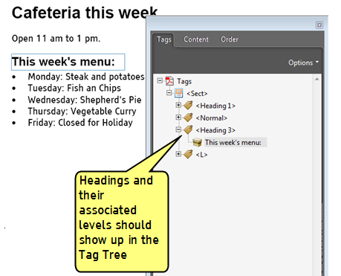

B) Remediating
If the tag structure is not properly following the content in the main document, it is likely that Screen Reader software will not read the headings properly.
- The easiest way to fix this is to go back to the original word file and Use Heading Levels in style formatting (Section 1.2.2).
- If the original file is not available, the tag tree will have to be fixed manually. Refer to additional sources of help and guidance for instructions (See Section 3.0).

Dynamic tables of contents are working?

A) Checking
If automation was used in MS Word to create a linked tale of contents (Section 1.2.3), the links should work in the PDF after conversion.
To check if the links are working properly:
- In Acrobat Reader go to the TOC and select the links. They should take you to the correct destination.
- Check that the go back command (ALT+left arrow) returns you to the TOC.

B) Remediating
If the TOC is not working properly:
- The easiest way to fix this is to go back to the original word file and Use automation if creating a Table of Contents (Section 1.2.3).
- If the original file is not available, the links and the tag tree will have to be fixed manually. Refer to additional sources of help and guidance for instructions (See Section 3.0).

Language

The Language(s) have been defined?
Note: For more information on language switching, see Language (Section 1.3).

A) Checking and B) Remediating

Set the default document language.
- Select File… Properties > Advanced Tab > Reading Options > Language.
- Select English US from the dropdown list (or other primary language as necessary).
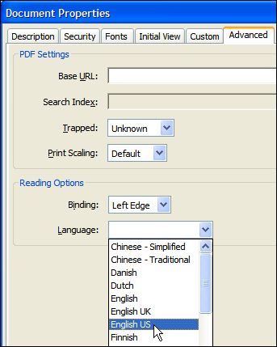

Set the language for portions of the text that use a different language from the document's default language.
- Open the Tags tab: View… Navigation Tabs > Tags.
- In the Tags tab, expand the tag tree as needed to see the elements.
- Right click the appropriate text element, and choose Properties from the pop-up menu.
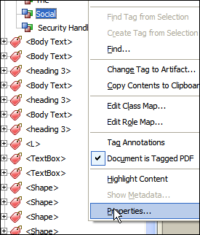
- In the TouchUp Properties dialog box, select the Tag tab.
- Select a language from the Language dropdown list menu.
Note: The language specified for an element also applies to all elements nested under it in the logical structure tree.
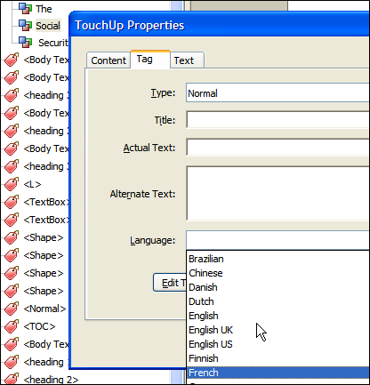

Fonts

Character Mappings have worked properly?

A) Checking and B) Remediating
If non-standard fonts and/or symbol characters have been used (e.g., for novel-looking bullets), then a character mapping error may come up in the Accessibility Full Check (Section 3.0).
Non-standard characters may not display correctly on a user's screen (or printout) if they do not have the specific non-standard fonts installed. The best way to avoid this is to Use System Fonts (See 1.4.1).
If non-standard characters and fonts are used, either:
- Return to the original Word document and swap out the spurious non-standard characters with characters from a standard font (See 1.4.1); or
- Treat these elements as images and add alternate text (See 3.5.1);, or if the character is decorative (such as a bullet), change it to an artifact (See 3.6.1).

Graphics / images

Alternate Text is added to Information-Type images?

A) Checking and B) Remediating
- Right click on any Information-Type graphic and select Edit Alternate Text from the pop-up menu.
- Check that the Alternate Text explains the purpose and meaning of the graphic.
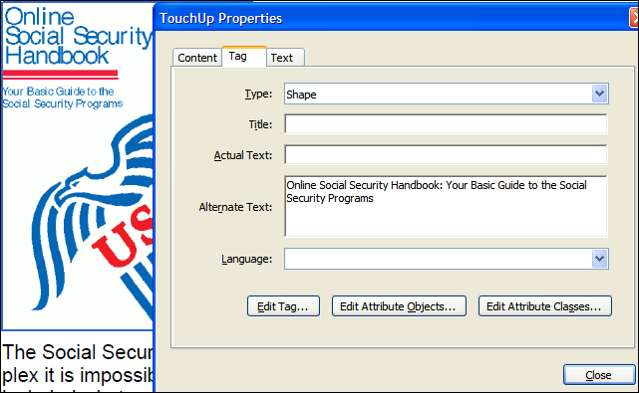
Notes:
- For an explanation of the different types of graphic (information, redundant and decorative), and how to add alt-text in the original MS Word document, see Graphics / images(Section 1.5).
- If graphic objects were not grouped properly before the conversion to PDF (Section 1.5.2), then either return to the source and group the objects before conversion, or use the TouchUp Reading Order tool to corral objects as single images in the reading order (See Section 3.1.2).

Artifacts

Artifacts are correctly placed outside of the reading order?

A) Checking and B) Remediating
Artifacts are things that should be outside of the Reading order (See Section 3.1.2). This includes decorative-type images, lines, running headers and footers etc.
Note: If the TouchUp Reading order reveals a large number of spurious elements, or elements that always get mistakenly 'corralled' into text that needs to be in the reading order, an element can be marked as an artifact in the Tag tree:
- Open the Tag Tree (View… Navigation Panels… Tags).
- In the Tags tab, expand the sections to identify the element that needs to be changed (if necessary, right click an element in the tag tree and select Highlight Content to see where the elements are in the main document).
- Select the element and right click it.
- Choose Change Tag to Artifact from the pop-up menu.
- If an empty container tag is left behind, delete it.
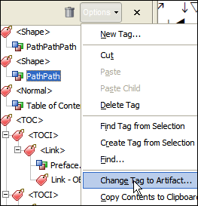
Note: In MS Word documents, text boxes are artifacts that need to be changed to regular text with style formatting. This needs to be done prior to converting to a PDF. For details, see Artifacts (section 1.6).
For documents with many artifact problems, see other sources of help and guidance (section 3.0).

Tables

Table Tags are set?

A) Checking
There are a number of table tags that are used in the code within PDF documents. The main ones are:
- <Table>: Table element—A two-dimensional arrangement of data or text cells that contains table row elements as child elements and may have a caption element as its first or last child element.
- <TR>: Table Row element—One row of headings or data in a table; may contain table header cell elements and table data cell elements.
- <TD>: Table Data cell element—Table cell that contains non-header data.
- <TH>: Table Header cell element—A table cell that contains header text or data describing one or more rows or columns of a table.
To check table elements, do the following:
- Open the Tag Tree (View… Navigation Panels… Tags).
- Expand the tags to view a table tag.
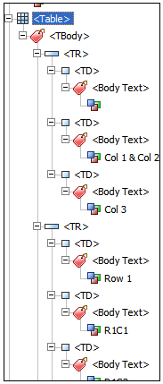
- Review the table tags to determine whether columns, rows, and cells have been correctly identified. Select the table tag <Table> and verify that it contains one of the following elements:
  - Table Rows, each of which contains Table Header <TH> or Table Data <TD> cells.
  - <THead>, <TBody>, and <TFoot> sections, each of which contains Table Rows <TR>. (The Table Rows <TR> contain <TH> cells, <TD> cells, or both.)

B) Remediating
Note: Tables that lack well-defined borders or contain adjacent page elements are often tagged incorrectly (see section 1.7.3).
Poorly tagged tables can be corrected by selecting and redefining them or by splitting combined cells by creating a tag for each cell. It may be necessary to return to the original MS Word document, remove split cells and (if necessary) add well defined borders (see section 1.7 for more information).
Note: Tables may include merged cells to create a column or row heading that straddles or 'spans' two or more associated columns or rows. In these cases, attributes for Tags may include {ColSpan} and {RowSpan}. If these attributes are not set properly, the way the table is read by Screen Reader software may be incorrect. The CommonLook plug-in for Acrobat Pro has a tool for remediating complex tables. Refer to Help in Acrobat Pro and the CommonLook manual (See Other guidance and help, Section 3.0).

Links

Links make sense when spoken in isolation?

A) Checking & B) Remediating
See the Rationale and Testing Methods in Assign link names that make sense when spoken in isolation (Section 1.8.1).

Links (where possible) are on only one line of text?

A) Checking
Links that span two lines of text on the page will be (mistakenly) read twice by Screen Reader software (see section 1.8.2).
Review the links on the pages to determine whether links are spanning two lines of text.

B) Remediating
If possible, fix this problems in the original MS Word document before converting to PDF. If not possible, use the following procedure to make the link speak as a single link:
- Open the Advanced Editing toolbar. (View…Toolbars… Advanced Editing).
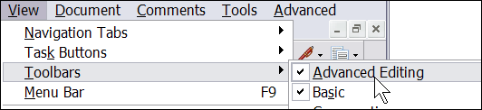
- Select the link tool:
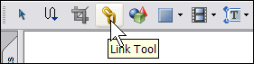
- Links are highlighted:
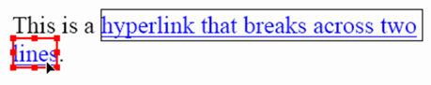
- Select the link box of the second part of the link and delete it.
- Open the Content tab, find the second part of the desired link text, and move the text so that it is below the first part of the link text within the same container.
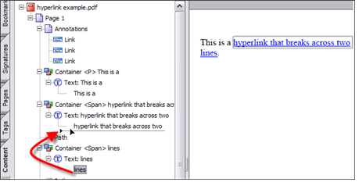
- Delete the empty container element left behind.
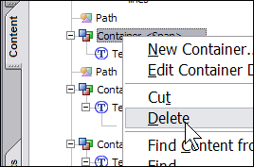

Color

High-Contrast color combinations are used?

A) Checking

Use Windows Operating system high contrast and high contrast reverse modes
- See Section 1.9.2 for details.

View the document using Acrobat's various high contrast modes
- Go to Edit… Preferences…Accessibility.
- Select various High-contrast color combinations and review the document.
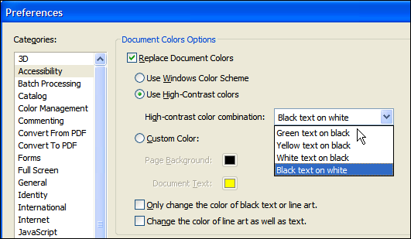
- Determine if all text is still readable when the document is viewed using each of Acrobat's 4 high contrast color combinations.

B) Remediating
If any problems are found with the colors used in the PDF, it will be necessary to return to the original MS Word document and fix the problems there (See Color, Section 1.9).

Color is only used redundantly?

A) Checking
See the Rationale and Testing Methods in Provide redundancy for information presented in color (Section 1.9.3).

B) Remediating
If any problems are found with the colors used in the PDF, it will be necessary to return to the original MS Word document and fix the problems there (See Color, Section 1.9).

Document properties

Document properties are properly set?

A) Checking & B) Remediating
Open the Document properties dialog box (File… Properties… Description Tab).
At a minimum, the Title of the document field should be set. Information added to other fields will aid in online the search-ability of the document (see section 1.10).

Checklists
On the next two pages are checklists for:
- Word Document Accessibility
- PDF Document Accessibility (including conversion from a Word file)
Photocopy a new checklist for each document to be tested.

Word Document Accessibility Checklist
1.1.1 Use Styles for formatting (page 19) [_]
1.1.2 Format paragraph line spacing with styles (page 26) [_]
1.1.3 Use list formatting (page 27) [_]
1.1.4 Use Column formatting (page 29) [_]
1.1.5 Do Not Use Hyphenation (page 31) [_]
1.2.1 Place document titles in the main document; not the 'Header' area (p.32) [_]
1.2.2 Use Heading Levels in style formatting (page 34) [_]
1.2.3 Use automation if creating a Table of Contents (page 36) [_]
1.3.1 Set the language properties (page 39) [_]
1.4.1 Use System Fonts (page 41) [_]
1.5.1 Add Alternate Text to graphics / images (page 43) [_]
1.5.2 Group Complex Objects (page 47) [_]
1.5.3 Place graphics / images 'in line' (page 49) [_]
1.6.1 Convert text boxes to regular paragraphs (page 52) [_]
1.7.1 Remove table formatting applied to non-tabular information (page 56) [_]
1.7.2 Set the header row as 'repeating' (page 57) [_]
1.7.3 Remove text wrapping around tables (page 59) [_]
1.8.1 Assign link names that make sense when spoken in isolation (page 61) [_]
1.8.2 Where possible, do not allow links to span two lines of text (page 62) [_]
1.9.1 Use text colors that contrast with their backgrounds (page 63) [_]
1.9.2 Use automatic color settings for black text and white text (page 64) [_]
1.9.3 Provide redundancy for information presented in color (page 65) [_]
1.10.1 Set the document title in document properties (page 67) [_]

PDF Document Accessibility Checklist
2.1.1 Configure Conversion Preferences (page 74) [_]
2.1.2 Convert the document with the 'PDF Maker' application in Word (page 78) [_]
3.1.1 The initial view is set properly? (page 85) [_]
3.1.2 The reading order is correct? (page 87) [_]
3.1.3 Lists have the correct tag structure? (page 89) [_]
3.1.4 The tab order of pages is set? (page 91) [_]
3.2.1 Bookmarks are set correctly? (page 92) [_]
3.2.2 Headings are set correctly? (page 92) [_]
3.2.3 Dynamic tables of contents are working? (page 94) [_]
3.3.1 The Language(s) have been defined? (page 95) [_]
3.4.1 Character Mappings have worked properly? (page 97) [_]
3.5.1 Alternate Text is added to Information-Type images? (page 98) [_]
3.6.1 Artifacts are correctly placed outside of the reading order? (page 99) [_]
3.7.1 Table Tags are set? (page 100) [_]
3.8.1 Links make sense when spoken in isolation? (page 103) [_]
3.8.2 Links (where possible) are on only one line of text? (page 103) [_]
3.9.1 High-Contrast color combinations are used? (page 105) [_]
3.9.2 Color is only used redundantly? (page 106) [_]
3.10.1 Document properties are properly set? (page 107) [_]

