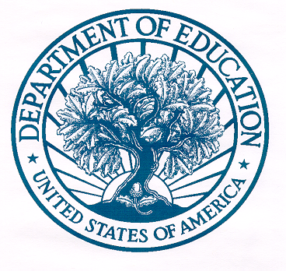
UNITED STATES DEPARTMENT OF EDUCATION
OFFICE OF THE CHIEF FINANCIAL OFFICER

May 24, 2010

Mr. Danny Werfel
Controller
Office of Federal Financial Management
Office of Management and Budget
725 17th Street, NW
Washington, DC 20503

Dear Mr. Werfel:

The purpose of this letter is to comply with the reporting requirements identified in the November 20, 2009 Executive Order (EO) 13520, Section 3 (f) relative to improper payments. The U.S. Department of Education (Department) is committed to ensuring the integrity of its programs and is focused on identifying and managing the risk of improper payments and mitigating the risk with adequate control activities.

Section 3 (f) of the EO requires the agency head to submit a report on any identified high-dollar improper payments to the Department’s Office of the Inspector General (OIG) and the Council of Inspectors General on Integrity and Efficiency (CIGIE), and make the report available to the public.

During the period of November 20, 2009 through March 31, 2010, the Department had no high-dollar overpayments as defined by the Office of Management and Budget (OMB) implementing guidance M-10-13 dated March 22, 2010.

The Department will work closely with the OIG and OMB to explore additional opportunities for identifying and reducing potential improper payments.

If you have any questions, please contact Hugh Hurwitz at (202) 245-6555.

Sincerely,

/s/

Thomas P. Skelly
Delegated to Perform Functions
of the Chief Financial Officer

cc: Ms. Kathleen Tighe
U.S. Department of Education

Ms. Phyllis Fong, Chair
Council of the Inspectors General
on Integrity and Efficiency

