Puerto Rico

http://www.de.gobierno.pr

Districts and schools

Number of districts (CCD) | 1993-94 | 2003-04
 | 1 | 1

Number of public schools (CCD) | 1993-94 | 2003-04
Elementary | 962 | 833
Middle | 216 | 203
High | 160 | 171
Combined | 189 | 258
Other | 43 | 43
Total | 1,570 | 1,508

Number of charter schools (CCD) | 2003-04
 | 120

Finances

Total current expenditures  (CCD, in thousands of dollars, adjusted for inflation to 2002-03) | 1993-94 | 2002-03
Instructional | $1,239,563 | $1,676,315
Noninstructional | 234,313 | 303,868
Support | 336,228 | 561,201
Total | 1,810,104 | 2,541,384

Per-pupil expenditures  (CCD, adjusted for inflation to 2002-03) | 1993-94 | 2002-03
 | $2,867 | $4,260

Sources of Funding
(CCD, 2002-03)

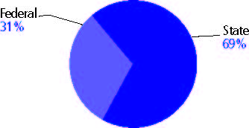

Title I allocation 2002-03 (ED; Includes Title I, Part A) | $402,231,713

Students

Public school enrollment (CCD) | 1993-94 | 2003-04
Pre-K | 281 | 232
K-8 | 455,072 | 405,348
9-12 | 163,511 | 160,077
Total (K-12) | 618,583 | 565,425

Race/ethnicity (CCD) | 1993-94 | 2003-04
American Indian/Alaskan Native | 0 | 0
Asian/Pacific Islander | 0 | 0
Black, non-Hispanic | 0 | 0
Hispanic | 100% | 100%
White, non-Hispanic | 0 | 0

Students with disabilities (OSEP) | 1993-94 | 2003-04
 | n/a | n/a

Students with limited  English proficiency (NCELA) | 1993-94 | 2003-04
 | 24% | 98%

Migrant students (OME) | 1993-94 | 2003-04
 | 3% | 3%

Eighth-grade students enrolled in Algebra I for high school credit (NAEP) | 1996 | 2003
 | - | 31%

Students eligible to participate in the Free or Reduced-Price Lunch Program, 2003-04 (CCD) | 467,033

All schools by percent of students eligible to participate in the Free or Reduced-Price Lunch Program, 2003-04† (CCD)
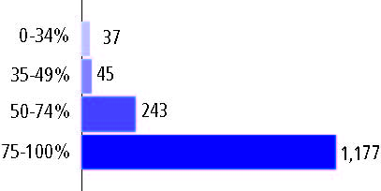

† 6 schools did not report

Staff

Number of FTE teachers (CCD) | 1993-94 | 2003-04
Elementary | 19,125 | 19,133
Middle | 6,697 | 6,419
High | 6,181 | 6,854
Combined | 6,634 | 8,947
Other | 718 | 726
Total | 39,355 | 42,079

Number of FTE non-teacher staff (CCD) | 1993-94 | 2003-04
Instructional aides | - | 237
Instructional coordinators | 672 | 312
Administrators | 1,595 | 3,123
Other | 25,922 | 28,581
Total | 28,189 | 32,253

Percentage of teachers with a major in the main subject taught, grades 7-12 (SASS) | 1994 | 2000
English | n/a | n/a
Mathematics | n/a | n/a
Science | n/a | n/a
Social Studies | n/a | n/a

Percentage of core courses taught by highly qualified teachers, 2003-04 (As defined and reported by states, collected by ED)

Outcomes

 | 1993-94 | 2000-01
High school dropout rate (NCES) | n/a | 1%
Avg. freshman graduation rate (NCES) | 89% | 66
College-going rate (IPEDS/NCES) | n/a | n/a

NAEP state results
Reading, Grade 4 | 1994 | 2005
Proficient level or above | - | -
Basic level or above | - | -
Math, Grade 8 | 1996 | 2005
Proficient level or above | - | -
Basic level or above | - | -

Statewide Accountability Information:

State Accountability Website: www.de.gobierno.pr

State assessment for NCLB accountability: Pruebas Puertorriqueñas de Aprovechamiento Académico

State student achievement levels: Basic, Proficient, Advanced

 |  | 2001-02  Annual measurable  objective starting point | Target  2003-04
Grade 3 | Reading | 32.7% | 32.7%
 | Mathematics | 38.7 | 38.7
Grade 8 | Reading | 32.7 | 32.7
 | Mathematics | 38.7 | 38.7
High school | Reading | 32.7 | 32.7
 | Mathematics | 38.7 | 38.7

2003-04 NCLB accountability results, applied to 2004-05 school year
AYP outcomes and consequences* | Title I schools |  | All schools |  | All districts
Made AYP | 707 | 47% | 707 | 46% | n/a | n/a
Identified for improvement:
Year 1 | 466 | 31% | 466 | 30% | n/a | n/a
Year 2 | 80 | 5% | 80 | 5% | n/a | n/a
Corrective action | 21 | 1% | 21 | 1% | n/a | n/a
Restructuring | 13 | 1% | 13 | 1% | n/a | n/a
Exited improvement status (made AYP twice after missing twice or more, includes total “made” above) | 5 | * | 5 | * | n/a | n/a
*AYP outcomes for this state are not available due to issues with data collection, measurement, or other reasons. For more information, please visit the state’s Web site, above.

Other indicator, 2003-04 | State target | State outcome
Elementary Indicator: English language proficiency | 34% | Met
Middle Indicator: English language proficiency | 34% | Met
High School Indicator: Graduation rate | 80% | Met

NCLB choice participation | Number of Title I students | Percent of eligible students
Title I school choice: | - | -
Supplemental educational services: | 4,698 | 20%

Student Achievement 2003-04

Pruebas Puertorriqueñas de Aprovechamiento Académico, used for NCLB accountability
Grade 3

Reading
Proficient Level or above for:
All students | 50%
Economically disadvantaged students | 49
Migrant students | 46
Students with disabilities | 41
Students with limited English proficiency | 46
Black, non-Hispanic students | #
Hispanic students | 41
White, non-Hispanic students | 63

Student achievement trend: Reading percent proficient level or above

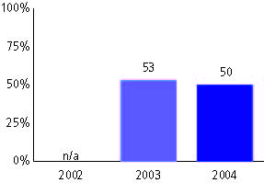

Pruebas Puertorriqueñas de Aprovechamiento Académico, used for NCLB accountability
Grade 3

Mathematics
Proficient Level or above for:
All students | 60%
Economically disadvantaged students | 60
Migrant students | 56
Students with disabilities | 53
Students with limited English proficiency | 58
Black, non-Hispanic students | #
Hispanic students | 53
White, non-Hispanic students | 82

Student achievement trend: Mathematics percent proficient level or above

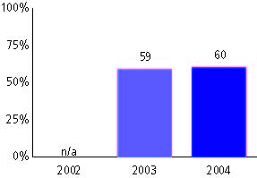

Pruebas Puertorriqueñas de Aprovechamiento Académico, used for NCLB accountability
Grade 4

Reading
Proficient Level or above for:
All students | 53%
Economically disadvantaged students | 51
Migrant students | 50
Students with disabilities | 39
Students with limited English proficiency | 49
Black, non-Hispanic students | #
Hispanic students | 47
White, non-Hispanic students | 60

Student achievement trend: Reading percent proficient level or above

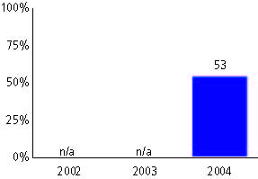

Pruebas Puertorriqueñas de Aprovechamiento Académico, used for NCLB accountability
Grade 4

Mathematics
Proficient Level or above for:
All students | 56%
Economically disadvantaged students | 55
Migrant students | 54
Students with disabilities | 43
Students with limited English proficiency | 57
Black, non-Hispanic students | #
Hispanic students | 49
White, non-Hispanic students | 60

Student achievement trend: Mathematics percent proficient level or above

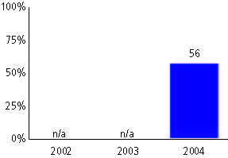

Pruebas Puertorriqueñas de Aprovechamiento Académico, used for NCLB accountability
Grade 5

Reading
Proficient Level or above for:
All students | 54%
Economically disadvantaged students | 53
Migrant students | 51
Students with disabilities | 39
Students with limited English proficiency | 49
Black, non-Hispanic students | #
Hispanic students | 53
White, non-Hispanic students | 29

Student achievement trend: Reading percent proficient level or above

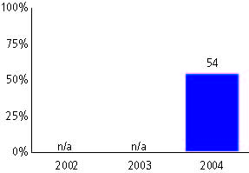

Pruebas Puertorriqueñas de Aprovechamiento Académico, used for NCLB accountability
Grade 5

Mathematics
Proficient Level or above for:
All students | 34%
Economically disadvantaged students | 33
Migrant students | 32
Students with disabilities | 26
Students with limited English proficiency | 32
Black, non-Hispanic students | #
Hispanic students | 35
White, non-Hispanic students | 38

Student achievement trend: Mathematics percent proficient level or above

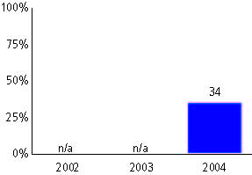

Pruebas Puertorriqueñas de Aprovechamiento Académico, used for NCLB accountability
Grade 6

Reading
Proficient Level or above for:
All students | 45%
Economically disadvantaged students | 42
Migrant students | 42
Students with disabilities | 24
Students with limited English proficiency | 39
Black, non-Hispanic students | #
Hispanic students | 45
White, non-Hispanic students | 48

Student achievement trend: Reading percent proficient level or above

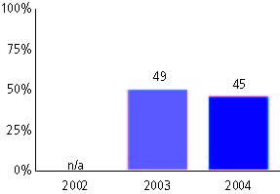

Pruebas Puertorriqueñas de Aprovechamiento Académico, used for NCLB accountability
Grade 6

Mathematics
Proficient Level or above for:
All students | 53%
Economically disadvantaged students | 51
Migrant students | 54
Students with disabilities | 37
Students with limited English proficiency | 50
Black, non-Hispanic students | #
Hispanic students | 51
White, non-Hispanic students | 63

Student achievement trend: Mathematics percent proficient level or above

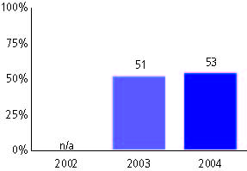

Pruebas Puertorriqueñas de Aprovechamiento Académico, used for NCLB accountability
Grade 7

Reading
Proficient Level or above for:
All students | 31%
Economically disadvantaged students | 28
Migrant students | 32
Students with disabilities | 15
Students with limited English proficiency | 25
Black, non-Hispanic students | #
Hispanic students | 31
White, non-Hispanic students | 28

Student achievement trend: Reading percent proficient level or above

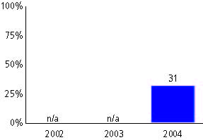

Pruebas Puertorriqueñas de Aprovechamiento Académico, used for NCLB accountability
Grade 7

Mathematics
Proficient Level or above for:
All students | 39%
Economically disadvantaged students | 38
Migrant students | 40
Students with disabilities | 28
Students with limited English proficiency | 37
Black, non-Hispanic students | #
Hispanic students | 39
White, non-Hispanic students | 33

Student achievement trend: Mathematics percent proficient level or above

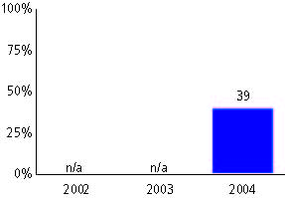

Pruebas Puertorriqueñas de Aprovechamiento Académico, used for NCLB accountability
Grade 8

Reading
Proficient Level or above for:
All students | 30%
Economically disadvantaged students | 27
Migrant students | 26
Students with disabilities | 11
Students with limited English proficiency | 27
Black, non-Hispanic students | #
Hispanic students | 30
White, non-Hispanic students | 39

Student achievement trend: Reading percent proficient level or above

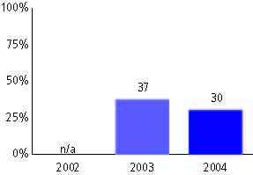

Pruebas Puertorriqueñas de Aprovechamiento Académico, used for NCLB accountability
Grade 8

Mathematics
Proficient Level or above for:
All students | 35%
Economically disadvantaged students | 33
Migrant students | 31
Students with disabilities | 16
Students with limited English proficiency | 32
Black, non-Hispanic students | #
Hispanic students | 36
White, non-Hispanic students | 59

Student achievement trend: Mathematics percent proficient level or above

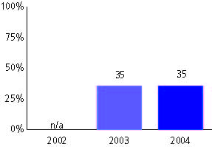

Pruebas Puertorriqueñas de Aprovechamiento Académico, used for NCLB accountability
High school

Reading
Proficient Level or above for:
All students | 43%
Economically disadvantaged students | 40
Migrant students | 38
Students with disabilities | 13
Students with limited English proficiency | 37
Black, non-Hispanic students | #
Hispanic students | 47
White, non-Hispanic students | 37

Student achievement trend: Reading percent proficient level or above

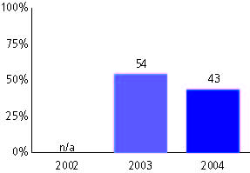

Pruebas Puertorriqueñas de Aprovechamiento Académico, used for NCLB accountability
High school

Mathematics
Proficient Level or above for:
All students | 33%
Economically disadvantaged students | 30
Migrant students | 34
Students with disabilities | 15
Students with limited English proficiency | 35
Black, non-Hispanic students | #
Hispanic students | 31
White, non-Hispanic students | 35

Student achievement trend: Mathematics percent proficient level or above

