Pennsylvania

http://www.pde.state.pa.us

Districts and schools

Number of districts (CCD) | 1993-94 | 2003-04
 | 501 | 501

Number of public schools (CCD) | 1993-94 | 2003-04
Elementary | 1,969 | 1,917
Middle | 515 | 572
High | 589 | 619
Combined | 20 | 55
Other | 27 | 26
Total | 3,120 | 3,189

Number of charter schools (CCD) | 2003-04
 | 102

Finances

Total current expenditures  (CCD, in thousands of dollars, adjusted for inflation to 2002-03) | 1993-94 | 2002-03
Instructional | $9,103,826 | $10,095,432
Noninstructional | 543,969 | 639,074
Support | 4,669,648 | 5,609,932
Total | 14,317,443 | 16,344,438

Per-pupil expenditures  (CCD, adjusted for inflation to 2002-03) | 1993-94 | 2002-03
 | $8,210 | $8,997

Sources of Funding
(CCD, 2002-03)

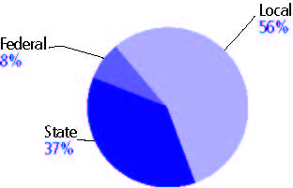

Title I allocation 2002-03 (ED; Includes Title I, Part A) | $438,337,029

Students

Public school enrollment (CCD) | 1993-94 | 2003-04
Pre-K | 4,181 | 2,588
K-8 | 1,211,113 | 1,229,976
9-12 | 496,382 | 582,624
Total (K-12) | 1,707,495 | 1,812,600

Race/ethnicity (CCD) | 1993-94 | 2003-04
American Indian/Alaskan Native | * | *
Asian/Pacific Islander | 2% | 2%
Black, non-Hispanic | 14 | 16
Hispanic | 3 | 6
White, non-Hispanic | 81 | 76

Students with disabilities (OSEP) | 1993-94 | 2003-04
 | 9% | 12%

Students with limited  English proficiency (NCELA) | 1993-94 | 2003-04
 | - | 2%

Migrant students (OME) | 1993-94 | 2003-04
 | * | 2%

Eighth-grade students enrolled in Algebra I for high school credit (NAEP) | 1996 | 2003
 | - | 31%

Students eligible to participate in the Free or Reduced-Price Lunch Program, 2003-04 (CCD) | 511,940

All schools by percent of students eligible to participate in the Free or Reduced-Price Lunch Program, 2003-04† (CCD)

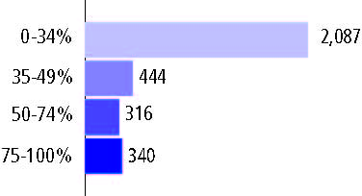
† 2 schools did not report

Staff

Number of FTE teachers (CCD) | 1993-94 | 2003-04
Elementary | 42,794 | 50,037
Middle | 19,111 | 24,731
High | 30,178 | 35,839
Combined | 676 | 1,562
Other | 814 | 923
Total | 93,573 | 113,092

Number of FTE non-teacher staff (CCD) | 1993-94 | 2003-04
Instructional aides | 12,676 | 24,987
Instructional coordinators | 1,576 | 1,424
Administrators | 5,133 | 6,297
Other | 70,198 | 80,762
Total | 89,583 | 113,470

Percentage of teachers with a major in the main subject taught, grades 7-12 (SASS) | 1994 | 2000
English | 74% | 67%
Mathematics | 98 | 81
Science | 85 | 79
Social Studies | 74 | 73

Percentage of core courses taught by highly qualified teachers, 2003-04 (As defined and reported by states, collected by ED)

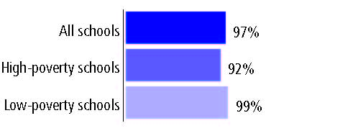

Outcomes

 | 1993-94 | 2000-01
High school dropout rate (NCES) | 4% | 4%
Avg. freshman graduation rate (NCES) | 81 | 79
College-going rate (IPEDS/NCES) | 57 | 61

NAEP state results
Reading, Grade 4 | 1994 | 2005
Proficient level or above | 30% | 36%
Basic level or above | 61 | 69
Math, Grade 8 | 1996 | 2005
Proficient level or above | - | 31%
Basic level or above | - | 72

Statewide Accountability Information:

State Accountability Website: http://www.pde.state.pa.us/pas/cwp/view.asp?a=3&Q=95497&pasNav=|6150|&pasNav=|

State assessment for NCLB accountability: Pennsylvania System of School Assessment (PSSA)

State student achievement levels: Below Basic, Basic, Proficient, Advanced

 |  | 2001-02  Annual measurable  objective starting point | Target  2003-04
Grade 5 | Reading | 45% | 45%
 | Mathematics | 35 | 35
Grade 8 | Reading | 45 | 45
 | Mathematics | 35 | 35
High school | Reading | 45 | 45
 | Mathematics | 35 | 35

2003-04 NCLB accountability results, applied to 2004-05 school year
AYP outcomes and consequences | Title I schools |  | All schools |  | All districts
Made AYP | 1,552 | 88% | 2,604 | 81% | 168 | 57%
Identified for improvement:
Year 1 | 42 | 2% | 191 | 6% | 208 | 41%
Year 2 | 60 | 3% | 62 | 2% | 1 | *
Corrective action | 1 | * | 1 | * | 0 | 0
Restructuring | 75 | 4% | 75 | 2% | 4 | 1%
Exited improvement status (made AYP twice after missing twice or more, includes total “made” above) | 19 | 1% | 19 | 1% | 0 | 0

Other indicator, 2003-04 | State target | State outcome
Elementary Indicator: Attendance | Meet or progress toward 90% | Met
Middle Indicator: Attendance | Meet or progress toward 90% | Met
High School Indicator: Graduation rate | Meet or progress toward 80% | Met

NCLB choice participation | Number of Title I students | Percent of eligible students
Title I school choice: | 1,126 | 1%
Supplemental educational services: | - | -

Student Achievement 2003-04

Pennsylvania System of School Assessment, used for NCLB accountability
Grade 3

Reading
Proficient Level or above for:
All students | n/a
Economically disadvantaged students | n/a
Migrant students | n/a
Students with disabilities | n/a
Students with limited English proficiency | n/a
Black, non-Hispanic students | n/a
Hispanic students | n/a
White, non-Hispanic students | n/a

Trend Data Not Available

Pennsylvania System of School Assessment, used for NCLB accountability
Grade 3

Mathematics
Proficient Level or above for:
All students | n/a
Economically disadvantaged students | n/a
Migrant students | n/a
Students with disabilities | n/a
Students with limited English proficiency | n/a
Black, non-Hispanic students | n/a
Hispanic students | n/a
White, non-Hispanic students | n/a

Trend Data Not Available

Pennsylvania System of School Assessment, used for NCLB accountability
Grade 4

Reading
Proficient Level or above for:
All students | n/a
Economically disadvantaged students | n/a
Migrant students | n/a
Students with disabilities | n/a
Students with limited English proficiency | n/a
Black, non-Hispanic students | n/a
Hispanic students | n/a
White, non-Hispanic students | n/a

Trend Data Not Available

Pennsylvania System of School Assessment, used for NCLB accountability
Grade 4

Mathematics
Proficient Level or above for:
All students | n/a
Economically disadvantaged students | n/a
Migrant students | n/a
Students with disabilities | n/a
Students with limited English proficiency | n/a
Black, non-Hispanic students | n/a
Hispanic students | n/a
White, non-Hispanic students | n/a

Trend Data Not Available

Pennsylvania System of School Assessment, used for NCLB accountability
Grade 5

Reading
Proficient Level or above for:
All students | 63%
Economically disadvantaged students | 42
Migrant students | 29
Students with disabilities | 23
Students with limited English proficiency | 25
Black, non-Hispanic students | 35
Hispanic students | 35
White, non-Hispanic students | 71

Student achievement trend: Reading percent proficient level or above

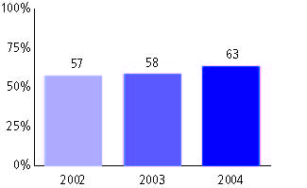

Pennsylvania System of School Assessment, used for NCLB accountability
Grade 5

Mathematics
Proficient Level or above for:
All students | 62%
Economically disadvantaged students | 42
Migrant students | 36
Students with disabilities | 27
Students with limited English proficiency | 34
Black, non-Hispanic students | 30
Hispanic students | 38
White, non-Hispanic students | 70

Student achievement trend: Mathematics percent proficient level or above

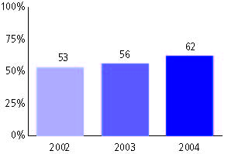

Pennsylvania System of School Assessment, used for NCLB accountability
Grade 6

Reading
Proficient Level or above for:
All students | n/a
Economically disadvantaged students | n/a
Migrant students | n/a
Students with disabilities | n/a
Students with limited English proficiency | n/a
Black, non-Hispanic students | n/a
Hispanic students | n/a
White, non-Hispanic students | n/a

Trend Data Not Available

Pennsylvania System of School Assessment, used for NCLB accountability
Grade 6

Mathematics
Proficient Level or above for:
All students | n/a
Economically disadvantaged students | n/a
Migrant students | n/a
Students with disabilities | n/a
Students with limited English proficiency | n/a
Black, non-Hispanic students | n/a
Hispanic students | n/a
White, non-Hispanic students | n/a

Trend Data Not Available

Pennsylvania System of School Assessment, used for NCLB accountability
Grade 7

Reading
Proficient Level or above for:
All students | n/a
Economically disadvantaged students | n/a
Migrant students | n/a
Students with disabilities | n/a
Students with limited English proficiency | n/a
Black, non-Hispanic students | n/a
Hispanic students | n/a
White, non-Hispanic students | n/a

Trend Data Not Available

Pennsylvania System of School Assessment, used for NCLB accountability
Grade 7

Mathematics
Proficient Level or above for:
All students | n/a
Economically disadvantaged students | n/a
Migrant students | n/a
Students with disabilities | n/a
Students with limited English proficiency | n/a
Black, non-Hispanic students | n/a
Hispanic students | n/a
White, non-Hispanic students | n/a

Trend Data Not Available

Pennsylvania System of School Assessment, used for NCLB accountability
Grade 8

Reading
Proficient Level or above for:
All students | 69%
Economically disadvantaged students | 47
Migrant students | 29
Students with disabilities | 23
Students with limited English proficiency | 20
Black, non-Hispanic students | 42
Hispanic students | 40
White, non-Hispanic students | 76

Student achievement trend: Reading percent proficient level or above

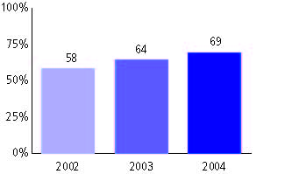

Pennsylvania System of School Assessment, used for NCLB accountability
Grade 8

Mathematics
Proficient Level or above for:
All students | 58%
Economically disadvantaged students | 35
Migrant students | 26
Students with disabilities | 16
Students with limited English proficiency | 28
Black, non-Hispanic students | 26
Hispanic students | 31
White, non-Hispanic students | 65

Student achievement trend: Mathematics percent proficient level or above

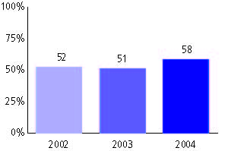

Pennsylvania System of School Assessment, used for NCLB accountability
Grade 11

Reading
Proficient Level or above for:
All students | 61%
Economically disadvantaged students | 34
Migrant students | 22
Students with disabilities | 15
Students with limited English proficiency | 14
Black, non-Hispanic students | 28
Hispanic students | 29
White, non-Hispanic students | 67

Student achievement trend: Reading percent proficient level or above

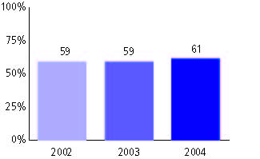

Pennsylvania System of School Assessment, used for NCLB accountability
Grade 11

Mathematics
Proficient Level or above for:
All students | 49%
Economically disadvantaged students | 24
Migrant students | 25
Students with disabilities | 9
Students with limited English proficiency | 28
Black, non-Hispanic students | 17
Hispanic students | 19
White, non-Hispanic students | 55

Student achievement trend: Mathematics percent proficient level or above

