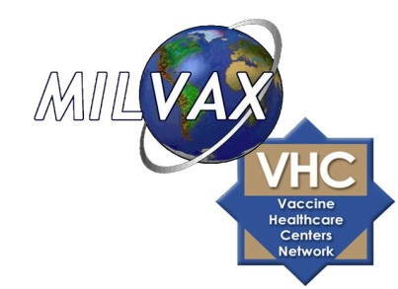

MILITARY VACCINE (MILVAX) AGENCY

IMMUNIZATION LEADERS COURSE

Club Alliance/Building 1495

Fleet Activities Yokosuka Japan
11 December 2012

Course Description:
The MILVAX Immunization Basic Course (IBC) is a one day, eight hour course designed to train personnel in the essential elements of a safe and effective immunization program using DoD regulations, Advisory Committee on Immunization Practices (ACIP) guidelines and Centers for Disease Control and Prevention (CDC) recommendations for immunization practice.
Mission and Objectives:
The mission of the Immunization Basic Course is to train personnel in the essential components of a safe and effective immunization program, and to establish quality standards for vaccine administration.
Who should attend:
Participants should be medical personnel involved in immunization clinic management or the administration of vaccines, including Physician Assistants, Nurses, LPNs, medics, healthcare specialists, immunization technicians and corpsman.
Course Training Objectives

- Identify the eight military immunization standards of practice and illustrate their use in daily clinic operations
- Differentiate the various DoD immunization program requirements
- Demonstrate immunization administration techniques
- Discuss staff training and competency improvement plans
Continuing Education Credits
Upon completion of the Immunization Basic Course you may qualify for Continuing Nursing Education (CNE) credits as well Continuing Education Units for Emergency Medical Technicians. Detailed information is available on the ImzU Continuing Education Credits page.

Mr. Michael Sutton Mr. Doug Phelps
Phone: (703) 681-5684 Phone: (81) 611-722-7865
DSN: 761-5684 DSN: 315-622-7865
michael.sutton1@amedd.army.mil douglas.s.phelps@usmc.mil

Program sponsored by the Military Vaccine (MILVAX) Agency
7700 Arlington, BLVD STE 5143
Falls Church, VA 22042-5143
www.vaccines.mil
877-GET-VACC
vaccines@amedd.army.mil

