Idaho

http://www.sde.state.id.us

Districts and schools

Number of districts (CCD) | 1993-94 | 2002-03
 | 113 | 114

Number of public schools (CCD) | 1993-94 | 2002-03
Elementary | 329 | 350
Middle | 100 | 106
High | 142 | 172
Combined | 15 | 28
Other | 13 | 4
Total | 599 | 660

Number of charter schools (CCD) | 2002-03
 | 13

Finances

Total current expenditures  (CCD, in thousands of dollars, adjusted for inflation to 2001-02) | 1993-94 | 2001-02
Instructional | $695,625 | $905,333
Noninstructional | 53,749 | 63,933
Support | 350,421 | 512,538
Total | 1,099,794 | 1,481,804

Per-pupil expenditures  (CCD, adjusted for inflation to 2001-02) | 1993-94 | 2001-02
 | $4,645 | $6,011

Sources of funding
(CCD, 2001-02)

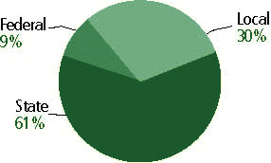

Title I allocation 2001-02 (ED; Includes Title I, Part A) | $32,795,334

Students

Public school enrollment (CCD) | 1993-94 | 2002-03
Pre-K | 1,389 | 2,517
K-8 | 164,828 | 170,608
9-12 | 69,287 | 75,241
Total (K-12) | 234,115 | 245,849

Race/ethnicity (CCD) | 1993-94 | 2002-03
American Indian/Alaskan Native | 1% | 1%
Asian/Pacific Islander | 1 | 1
Black, non-Hispanic | 1 | 1
Hispanic | 7 | 11
White, non-Hispanic | 90 | 86

Students with disabilities (OSEP) | 1993-94 | 2002-03
 | 8% | 10%

Students with limited  English proficiency (NCELA) | 1993-94 | 2002-03
 | 3% | 8%

Migrant Students (OME) | 1993-94 | 2002-03
 | 5% | 6%

Eighth-grade students enrolled in Algebra I for high school credit (NAEP) | 1996 | 2003
 | n/a | 28%

Students eligible to participate in the Free or Reduced-Price Lunch Program, 2002-03 (CCD) | 90,447

All schools by percent of students eligible to participate in the Free or Reduced-Price Lunch Program, 2002-03† (CCD)
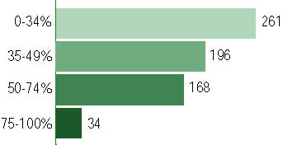
† 1 school did not report
Staff

Number of FTE teachers (CCD) | 1993-94 | 2002-03
Elementary | 5,713 | 6,379
Middle | 2,635 | 2,924
High | 3,205 | 4,081
Combined | 155 | 365
Other | 300 | 147
Total | 12,007 | 13,896

Number of FTE non-teacher staff (CCD) | 1993-94 | 2002-03
Instructional aides | 1,709 | 2,641
Instructional coordinators | 185 | 274
Administrators | 709 | 847
Other | 5,373 | 7,293
Total | 7,976 | 11,001

Percentage of teachers with a major in the main subject taught, grades 7-12 (SASS) | 1994 | 2000
English | 69% | 57%
Mathematics | 46 | 49
Science | 77 | 75
Social Studies | 73 | 66

Percentage of core courses taught by highly qualified teachers, 2002-03 (As defined and reported by states, collected by ED)

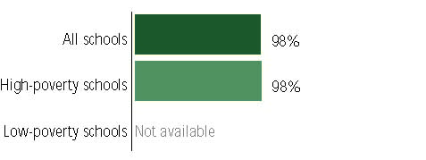

Outcomes

 | 1993-94 | 2000-01
High school dropout rate (NCES) | 9% | 6%
Averaged freshman graduation rate (NCES) | 80 | 80
College-going rate (IPEDS/NCES) | 48 | 45

NAEP state results
Reading, Grade 4 | 1994 | 2003
Proficient level or above | n/a | 30%
Basic level or above | n/a | 64
Math, 2003, Grade 8 | 1996 | 2003
Proficient level or above | n/a | 28%
Basic level or above | n/a | 72

Statewide Accountability Information:

State Accountability Website: http://www.sde.state.id.us/ipd/reportcard/SchoolReportCard0304.asp

State assessment for NCLB accountability: Idaho State Achievement Test

State student achievement levels: Basic, Proficient, Advanced

 |  | 2001-02  Annual measurable  objective starting point | Target  2002-03
Grade 4 | Reading | 66% | 66%
 | Mathematics | 51 | 62
Grade 8 | Reading | 66 | 66
 | Mathematics | 51 | 51
High School | Reading | 66 | 66
 | Mathematics | 51 | 51

AYP outcomes and consequences* | Title I schools |  | All schools |  | All districts
Made AYP | n/a | n/a | n/a | n/a | n/a | n/a
Identified for improvement:
Year 1 | - | - | - | - | - | -
Year 2 | - | - | - | - | - | -
Corrective action | - | - | - | - | - | -
Restructuring | - | - | - | - | - | -
Exited improvement status (made AYP twice after missing twice or more, includes total “made” above) | - | - | - | - | - | -
*AYP outcomes for this state are not available due to issues with data collection, measurement, or other reasons. For more information, please visit the state’s Web site, above.

Other indicator, 2002-03 | State target | State outcome
Elementary indicator: Language Arts ISAT or student growth | Meet or progress toward standard set by board | Met
Middle indicator: Language Arts ISAT or student growth | Meet or progress toward standard set by board | Met
High school indicator: Graduation rate | Meet or progress toward standard set by board | Met

NCLB choice participation | Number of Title I students | Percent of Eligible Students
Title I school choice | 0 | -
Supplemental educational services | 0 | -

Student Achievement 2002-03

Idaho Standards Achievement Test, for NCLB accountability
Grade 3

Reading
Proficient Level or above for:
All students | n/a
Economically disadvantaged students | n/a
Migrant students | n/a
Students with disabilities | n/a
Students with limited English proficiency | n/a
Black, non-Hispanic students | n/a
Hispanic students | n/a
White, non-Hispanic students | n/a

Trend Data Not Available

Idaho Standards Achievement Test, for NCLB accountability
Grade 3

Mathematics
Proficient Level or above for:
All students | n/a
Economically disadvantaged students | n/a
Migrant students | n/a
Students with disabilities | n/a
Students with limited English proficiency | n/a
Black, non-Hispanic students | n/a
Hispanic students | n/a
White, non-Hispanic students | n/a

Trend Data Not Available

Idaho Standards Achievement Test, for NCLB accountability
Grade 4

Reading
Proficient Level or above for:
All students | 75%
Economically disadvantaged students | 65
Migrant students | 39
Students with disabilities | 36
Students with limited English proficiency | 39
Black, non-Hispanic students | 75
Hispanic students | 50
White, non-Hispanic students | 79

Student achievement trend: Reading percent proficient level or above

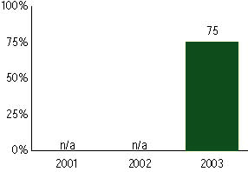

Idaho Standards Achievement Test, for NCLB accountability
Grade 4

Mathematics
Proficient Level or above for:
All students | 77%
Economically disadvantaged students | 68
Migrant students | 51
Students with disabilities | 45
Students with limited English proficiency | 49
Black, non-Hispanic students | 67
Hispanic students | 58
White, non-Hispanic students | 81

Student achievement trend: Mathematics percent proficient level or above

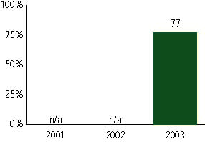

Idaho Standards Achievement Test, for NCLB accountability
Grade 5

Reading
Proficient Level or above for:
All students | n/a
Economically disadvantaged students | n/a
Migrant students | n/a
Students with disabilities | n/a
Students with limited English proficiency | n/a
Black, non-Hispanic students | n/a
Hispanic students | n/a
White, non-Hispanic students | n/a

Trend Data Not Available

Idaho Standards Achievement Test, for NCLB accountability
Grade 5

Mathematics
Proficient Level or above for:
All students | n/a
Economically disadvantaged students | n/a
Migrant students | n/a
Students with disabilities | n/a
Students with limited English proficiency | n/a
Black, non-Hispanic students | n/a
Hispanic students | n/a
White, non-Hispanic students | n/a

Trend Data Not Available

Idaho Standards Achievement Test, for NCLB accountability
Grade 6

Reading
Proficient Level or above for:
All students | n/a
Economically disadvantaged students | n/a
Migrant students | n/a
Students with disabilities | n/a
Students with limited English proficiency | n/a
Black, non-Hispanic students | n/a
Hispanic students | n/a
White, non-Hispanic students | n/a

Trend Data Not Available

Idaho Standards Achievement Test, for NCLB accountability
Grade 6

Mathematics
Proficient Level or above for:
All students | n/a
Economically disadvantaged students | n/a
Migrant students | n/a
Students with disabilities | n/a
Students with limited English proficiency | n/a
Black, non-Hispanic students | n/a
Hispanic students | n/a
White, non-Hispanic students | n/a

Trend Data Not Available

Idaho Standards Achievement Test, for NCLB accountability
Grade 7

Reading
Proficient Level or above for:
All students | n/a
Economically disadvantaged students | n/a
Migrant students | n/a
Students with disabilities | n/a
Students with limited English proficiency | n/a
Black, non-Hispanic students | n/a
Hispanic students | n/a
White, non-Hispanic students | n/a

Trend Data Not Available

Idaho Standards Achievement Test, for NCLB accountability
Grade 7

Mathematics
Proficient Level or above for:
All students | n/a
Economically disadvantaged students | n/a
Migrant students | n/a
Students with disabilities | n/a
Students with limited English proficiency | n/a
Black, non-Hispanic students | n/a
Hispanic students | n/a
White, non-Hispanic students | n/a

Trend Data Not Available

Idaho Standards Achievement Test, for NCLB accountability
Grade 8

Reading
Proficient Level or above for:
All students | 74%
Economically disadvantaged students | 61
Migrant students | 33
Students with disabilities | 28
Students with limited English proficiency | 36
Black, non-Hispanic students | 65
Hispanic students | 44
White, non-Hispanic students | 78

Student achievement trend: Reading percent proficient level or above

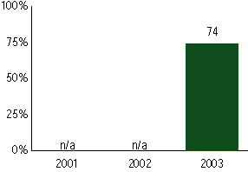

Idaho Standards Achievement Test, for NCLB accountability
Grade 8

Mathematics
Proficient Level or above for:
All students | 53%
Economically disadvantaged students | 36
Migrant students | 17
Students with disabilities | 12
Students with limited English proficiency | 21
Black, non-Hispanic students | 37
Hispanic students | 25
White, non-Hispanic students | 57

Student achievement trend: Mathematics percent proficient level or above

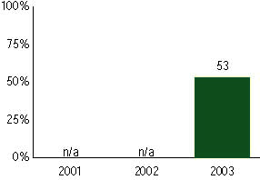

Idaho Standards Achievement Test, for NCLB accountability
High school

Reading
Proficient Level or above for:
All students | 75%
Economically disadvantaged students | 61
Migrant students | 32
Students with disabilities | 27
Students with limited English proficiency | 29
Black, non-Hispanic students | 63
Hispanic students | 40
White, non-Hispanic students | 79

Student achievement trend: Reading percent proficient level or above

Idaho Standards Achievement Test, for NCLB accountability
High School

Mathematics
Proficient Level or above for:
All students | 71%
Economically disadvantaged students | 57
Migrant students | 38
Students with disabilities | 22
Students with limited English proficiency | 35
Black, non-Hispanic students | 51
Hispanic students | 43
White, non-Hispanic students | 74

Student achievement trend: Mathematics percent proficient level or above

