
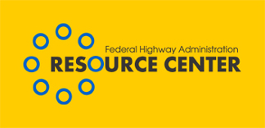

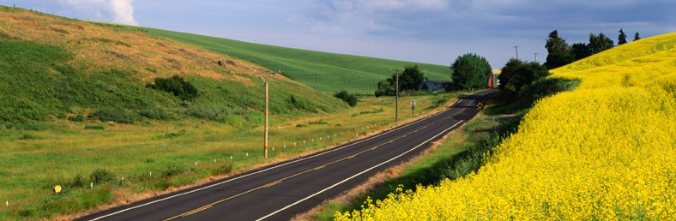

Volume 2, Issue 1 January 2006

A new Approach – Public Involvement in Wyoming

LETTER FROM THE EDITOR

Dear Environmental Colleague,

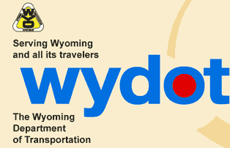
We are looking forward to bringing you a lot of good information this year – with that in mind be sure to check out Bonnie Harper Lore’s article on page 4 with an eye toward SAFTEA-LU’s invasive plant requirements. Please feel free to share this issue with those you believe would find it interesting or helpful. As always, if you have comments about a story or story ideas, please let us know.
The Wyoming Department of Transportation (WYDOT) is now incorporating the use of Public Involvement Coordinators (PIC) in each highway district across the state. These specialists are actively involved in addressing the public’s concerns on highway projects throughout Wyoming and offer a more personal single point of contact. They are active participants at public meetings and meet in person with landowners and homeowners. The use of these coordinators has benefited the Wyoming DOT by having a much more proactive public involvement process.

Where did Wyoming get the idea? The idea originated with Tim Stark, WYDOT Environmental Services Manager, who prepared a white paper assessing WYDOT’s weaknesses with public involvement activities. The Director of WYDOT agreed with the assessment and a task force was assembled. What was discovered was the need for decentralizing the public involvement responsibilities and to hire qualified professionals (Public Involvement Coordinators) to lead this task.

Did any particular problem lead to this arrangement? WYDOT had a credibility problem. Good customer service is founded on good communication. Good communication requires skilled professionals with adequate time and resources. WYDOT didn’t have enough of any of these and they were limited to holding one public meeting per project. But one public meeting during a project’s development process was not enough. People impacted by a transportation project normally have more questions than one public meeting will allow.

Coupled with the credibility problem was the location and centralized nature of WYDOT. All public involvement activities were conducted by highway engineers from the Cheyenne headquarters office. Wyoming, the 9th largest state in the union, has its capital city of Cheyenne located in the far southeast corner of the state – a mere 10 miles from Colorado and only 40 miles from Nebraska. People in communities like Cody and Jackson, which are over 400 miles from Cheyenne, would seriously doubt WYDOT’s ability to understand their issues.

Who are these Public Involvement Coordinators--background, training, experience? Each Public Involvement Coordinator (PIC) was hired for their public involvement background and communication skills. Most of them have either journalism, communications or public relations degrees. Some have worked for local newspapers. Some have worked for the local media. One even had experience with NASA doing the same thing. All have excellent people skills.

What do they cost and what do they save? Beginning PICs start out around $2500 per month, depending on experience. They save time and a lot of frustration. By getting the word about projects out early, people are made aware of what's going on before final decisions have been made. The District Engineering staff, responsible for the time consuming task of handling complaints, saw complaints drop off considerably. Although it is hard to measure the savings, the new approach has allowed some projects to move very quickly. One EA, for example, which might have taken as long as 3 years was completed in only 4 months. The increased efficiency is believed to be a direct result of the trust the community now has in WYDOT’s customer service.

How do the communities in which they work respond to working with one person? The PIC provides a single point of contact for the public and relieves the WYDOT District Engineers from having to deal with a lot of concerns from the land owners. The number of hours spent with complaints has gone from significant level to nearly non-existent. One of the Public Involvement Coordinators has recently moved on to a position as Director of a Chamber of Commerce in one of the local communities. Communities have gone from complaining about WYDOT to respecting their work. They see these new Public Involvement Coordinators as valuable assets for their communities.

Do they work with the planning phase as well as project development, design, construction, maintenance, enhancement projects? Yes, the Coordinators work with all phases and types of projects in the districts.

To whom do they report? The Public Involvement Coordinators report to the District Engineers but are coordinated through the WYDOT Public Affairs Office at their headquarters.
Is there any central office oversight or does each district operate independently? Although there is no central office oversight, they do get together on a regular basis and compare notes and coordinate with the WYDOT Public Affairs Office. Each district is different with different issues so they do operate independently, yet they all operate under the same basis/foundation.

For more information, contact Rodney Vaughn at
307-772-2004, ext. 148, Rodney.Vaughn@fhwa.dot.gov or WYDOT’s Tim Stark at
307-777-4379, Timothy.Stark@dot.state.wy.us.

-- Rodney Vaughn, Environmental/ Special Program Engineer
FHWA WY Division Office

Sincerely, Don Cote
Environment Technical Service Team (TST) Leader &
Editor–in-Chief
Phone: (720) 963-3210
E-mail: Don.Cote@fhwa.dot.gov

Editorial Board Members:
David Grachen, Brian Smith, and David Sullivan
FHWA Resource Center
Aung Gye, Office of Project Development & Environmental Review, FHWA HQ
INSIDE
- FHWA Environmental Conference preparations…p. 3
- GA Hosts NEPA peer-to-peer workshop…p. 3
- The Silent Invaders…p. 4
- Environmental Competency Program… p. 7
- Environmental Calendar…p. 8

“Influence of Transportation Infrastructure on Land Use” Report Available
The Office of Planning, Environment and Realty contracted with the Urban Land Institute to convene a panel of experts on land use, transportation and development to produce the report entitled “Influence of Transportation Infrastructure on Land Use.”

In addition, a limited number of hard copies of the report are available. They can be requested from Fred Ducca at 202-366-5843 or Fred.Ducca@fhwa.dot.gov. Fred can also answer any questions you may have about the report.

In November 2005, the FHWA Georgia Division and Georgia Department of Transportation (GDOT) hosted a Peer-to-Peer Workshop intended to enhance the internal environmental and planning processes as they relate to transportation project development and delivery in Georgia. The Peer-to-Peer Workshop was jointly sponsored by the FHWA and FTA, through the Transportation Planning Capacity Building Program.

The workshop consisted of eight presentations given by a panel of visiting environmental and transportation managers from across the United States. Following each of the presentations, the peer panel led an in-depth roundtable discussion of the issue. Presentation topics, and subsequent roundtable discussions, included: learning from the results of a previous peer exchange in Tennessee; the impacts of the Safe, Accountable, Flexible, Efficient Transportation Equity Act: A Legacy for Users (SAFETEA-LU); environmental streamlining; environmental performance measures; enhancing interagency coordination; improving environmental documentation; and improving the linkage between planning and NEPA.
Panel members and participants included
transportation and environmental professionals from FHWA Headquarters, FHWA Resource Center, FHWA Georgia Division, FHWA Indiana Division, Federal Transit Administration, GDOT, Tennessee Department of Transportation, Texas Department of Transportation, Utah Department of Transportation, and Washington State Department of Transportation.

The Peer-to-Peer Workshop built upon the action plan developed by the FHWA Georgia Division and GDOT as a result of the June 2004 Linking Planning and NEPA Workshop. Information provided by the peer States gave GDOT insight into what practices have, and have not, worked in the other States. The GDOT plans to use the information gathered during the workshop to continue to strive to improve project delivery while advancing environmental stewardship and streamlining opportunities.

- David Grachen, FHWA Resource Center, David.Grachen@fhwa.dot.gov .
Georgia Hosts NEPA Peer to Peer Workshop

In November 2005, the FHWA Georgia Division and Georgia Department of Transportation (GDOT) hosted a Peer-to-Peer Workshop intended to enhance the internal environmental and planning processes as they relate to transportation project development and delivery in Georgia. The Peer-to-Peer Workshop was jointly sponsored by the FHWA and FTA, through the Transportation Planning Capacity Building Program.

The workshop consisted of eight presentations given by a panel of visiting environmental and transportation managers from across the United States. Following each of the presentations, the peer panel led an in-depth roundtable discussion of the issue. Presentation topics, and subsequent roundtable discussions, included: learning from the results of a previous peer exchange in Tennessee; the impacts of the Safe, Accountable, Flexible, Efficient Transportation Equity Act: A Legacy for Users (SAFETEA-LU); environmental streamlining; environmental performance measures; enhancing interagency coordination; improving environmental documentation; and improving the linkage between planning and NEPA.

Panel members and participants included transportation and environmental professionals from FHWA Headquarters,

Environmental Conference UPDATE!
Save the Date ! June 27- 29, 2006
HEP, HCC, a number of Division Offices, the Resource Center, and Federal Lands Offices have been working together through a planning team to organize the next FHWA Environmental Conference. The 2.5 day conference, which is only open to FHWA staff and invited presenters, will be held on Tuesday, June 27 through mid-day on Thursday, June 29, 2006 at the Hilton Crystal City, in Arlington, VA. The hotel is located close to Reagan National Airport and is accessible to Metro.
The planning team is developing a wide range of agenda topics which should be of interest to both environmental and planning staff. The 2004 Environmental Conference was attended by FHWA staff representing a wide range of disciplines within the organization, and we believe that this diversity added to the success of the conference. Please forward this message to your staff and encourage them to save these dates and prepare to join us in Crystal City in June 2006.
We expect to have an agenda and a conference website available by late January 2006. If you have any questions about the conference, please contact Carol Adkins at Carol.Adkins@fhwa.dot.gov .

Continued on p. 4

The Silent Invaders

Like all invasive plants, they blend into a world of green vegetation which the ordinary passerby considers “a good thing”. The most silent of the invasive plants in this scene are the exotic grasses. The grasses spreading quietly across the landscape often are unnoticed because all grasses look alike at first glimpse, until they flower. Grasses are simply difficult to identify, flowering or not. You have already heard of weedy Cheat grass, Johnson Grass, Medusahead rye and Smooth brome. Here are ten other grasses, you should get to know. Some have infiltrated the West and some have blended into the East; but all are spreading across the nation. Some State Departments of Transportation are planting one or two of these, but most are trying to eradicate them. Here are ten grasses to learn about and watch for!!!

Chinese Silver Grass, Miscanthus sinensi. This grass originates in eastern Asia and has become a popular ornamental grass. It has escaped easily into highway corridors, woodland borders and wetland edges. This 4-8’ perennial spreads by rhizomes and is on a number of “watch” lists. IT is easily recognized in lathe autumn by its silvery plume-like panicles. It has been observed as far West as Minnesota.

Reed Canary Grass, Phalaris arundinacea. This 3-7’ perennial came from Europe and Asia. It was introduced for its forage value and later planted for erosions control and naturalized. It grows in dense mats and spreads vegetatively and tolerates dry to wet soils. Unfortunately, it is said that a native species exists and the distinction between it and the exotic is complex. Because the Eurasian species crowds out native habitats, it is best not to plant the available commercial seed. This invasive wetland grass is abundant from coast to coast.

Giant Phragmites or Common Reed, Phragmites australis. You cannot miss this 10-15’ perennial. It spreads by seed and by rhizomatous runners and can reach 10 or more feet in a single season. It threatens wetland communities, changes hydrology, alters wildlife habitat and increases fire potential. This grass is often confused with a native, shorter Phragmites that is a natural component of many undisturbed tidal and freshwater marshes. The robust Phragmites found in ditches and disturbed wetlands is likely the invasive. This grass was introduced on the Atlantic Coast in the 1900’s.

Giant Reed, Arundo donax. Known as giant reed because it can top 20’, this perennial has creeping rootstocks and deep fibrous roots. This grass prefers moist places and tolerates saline soils as well as heavy clays and sands. It is thought to have been introduced from India in California in the early 1800’s. it was widely planted as an ornamental and for erosion control. Historically this grass was used for basketry, woodwind instruments, fishing rods, etc. Primarily, it spreads vegetatively.

Fountain Grass, Pennisetum setaceum comes from northern Africa. It is a small (2-3’) perennial grass which grows in clumps. Its bristly, purplish inflorescences are attractive. This grass is a poor pasture grass and a serious weed in dry habitats. This grass not only tolerates droughty conditions, but a wide elevational range. In Hawaii it establishes on rangelands to bare lava flows. It is a wind-dispersed seeder and seeds remain viable six years or longer. Not only is this grass aggressive in natural communities, but it also raises fuel loads increasing the spread of
wildfires.

Cogongrass, Imperata cylindrical. Cogongrass came from Southeast Asia. This perennial is rhizomatous and grows from 2-4’ in height. The leaves are an inch wide with a prominent white midrib, ending in a sharp point. Cogongrass can invade and overtake disturbed ecosystems. Recent hurricanes in the South could speed up their spread. The grass is a threat to habitat and endangered species. It is tolerant of shade, salinity, and drought. It was accidentally introduced in Mobile, Alabama via packing materials. It was also introduced as forage grass and erosion control and is still sold as an ornamental grass. It is considered one of the world’s worst weeds and is on the Federal Noxious Weed List.

Buffelgrass, Pennisetum ciliaris. Buffelgrass is one of the most common invited species turned invasive. The grass increases grass cover and the possibility of man-made fires. It is an perennial African bunch grass. It was introduced in the ‘30’s for erosion control and forage. From there it was sold to ranchers in Sonora, Mexico. Only salinity, clay, and poor drainage limit it. This grass now threatens the entire Sonoran Desert Bioregion on both sides of the border. For more information, read “Drought-Tolerant Exotic guffel-Grass and Desertification” by Alejandro E. Castellanos-V, et. al. in the 2002 Weeds Across Borders proceedings.

Japanese stiltgrass, Microstegium vimineum. Originally from Asia, this is an annual grass that averages 3’ in height. It grows in a branching, sprawling, mat-like manner. Its pale green leaves are alternate along a branched stalk,stalk, resembling a small, delicate bamboo. A easy characteristic to catch is a pale, silvery stripe of hairs along the midrib of the upper leaf surface. The flower spikes appear in September and go to seed by early October. The grass tolerated shady and moist environments. Typical habitats invaded by stiltgrass include forested wetlands, moist forests, old fields, rights-of-way, and river corridors. It is now found in most Eastern States.

Pampas Grass, Cortaderia selloana is a perennial clump grass from South America. Pampas grass has light violet to silvery white plumes. Its cousin, Jubata grass, Cortaderia jubata has brownish or purplish plumes that are taller. Jubata flowers in late summer, long after Pampas grass. It has been used both as erosion control and as an ornamental. Because it establishes rapidly on bare soils, it is no longer recommended for highway plantings. Both Cortaderias were purposefully introduced. Both threaten native ecosystems.

Tall Fescue, Lolium arundinaceum. This grass is native to Europe and North Africa. It is a cool season, perennial bunchgrass. Tall fescue invades native grasslands, savannas and woodlands. It was spread in misguided conservation plantings and pasture forage. Many ground-nesting birds like Bobwhite quail cannot use this grass for food and shelter. At this time this grass is scattered in States like, Arkansas, Georgia, Kansas, Idaho, Iowa, Louisiana, Missouri, Nebraska, New Jersey, Oklahoma, Oregon, Tennessee, Washington, and Wisconsin. It is found in grasslands and disturbed sites and is thought to be allelopathic as well as poisonous to cattle and other herbivores.

Bibliography:
These grasses were described with the help of the following references:
-Randall, John M. and Janet Marinelli, Editors, 1996. Invasive Plants, Weeds of the Global Garden.
Brooklyn Botanic Garden, Inc., New York
-Czarapata, Elizabeth J., 2005. Invasive Plants of the Upper Midwest. The University of Wisconsin Press, Madison.
Swearingen, Jil, Ongoing. Weeds Gone Wild. The Plant Conservation Alliance, Washington D.C. l

[Note: This article also appears in the current issue of Greener Roadsides.]

About the author:
Bonnie Harper-Lore, from the FHWA Office of Office of Planning, Environment, and Realty (HEP), is an expert on highway vegetation issues. She has traveled all over the world representing FHWA and helping other countries with their vegetation programs. She considers her key work, however, to be with State DOT’s, which she visits and find answers for through conferences, research, funding, and policy changes.
She also produces the Greener Roadsides newsletter for HEP.
We are delighted to have Bonnie’s contribution to this issue. You may send comments or questions to her at Bonnie.Harper-Lore@fhwa.dot.gov.
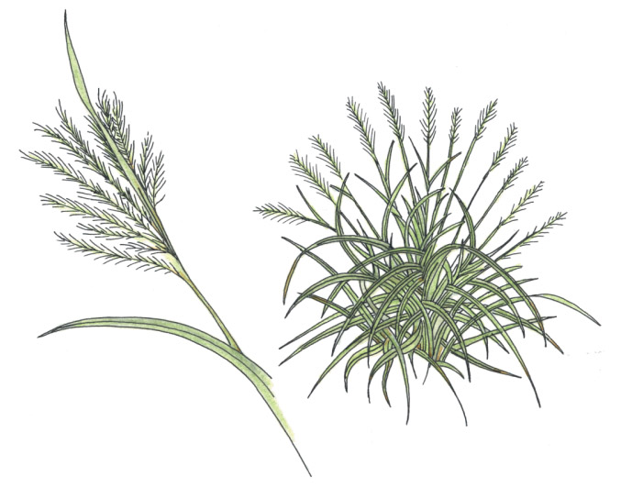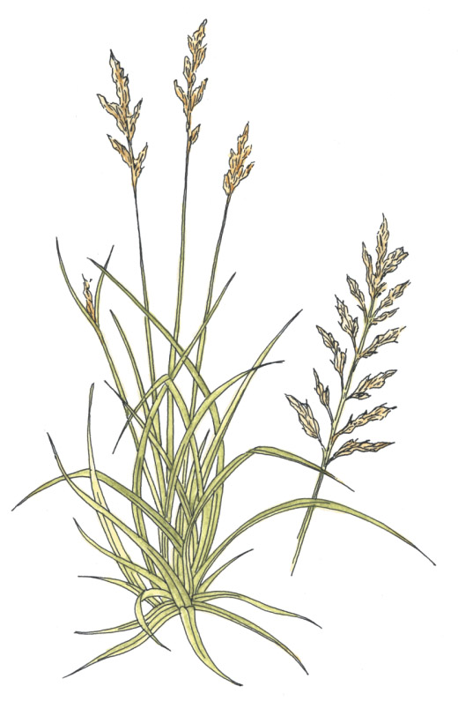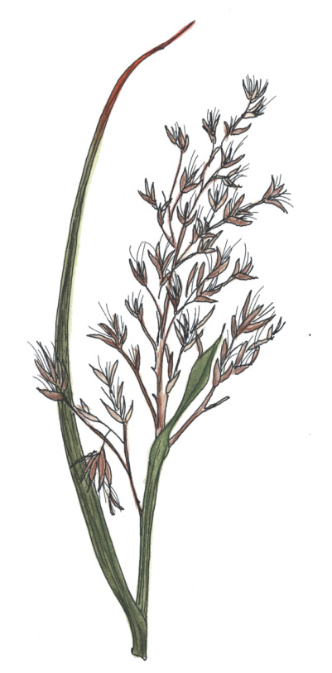
Chinese Silver Grass Reed Canary Grass Giant Phragmites or
Miscanthus sinensi Phalaris arundinacea Common Reed
Phragmites australis

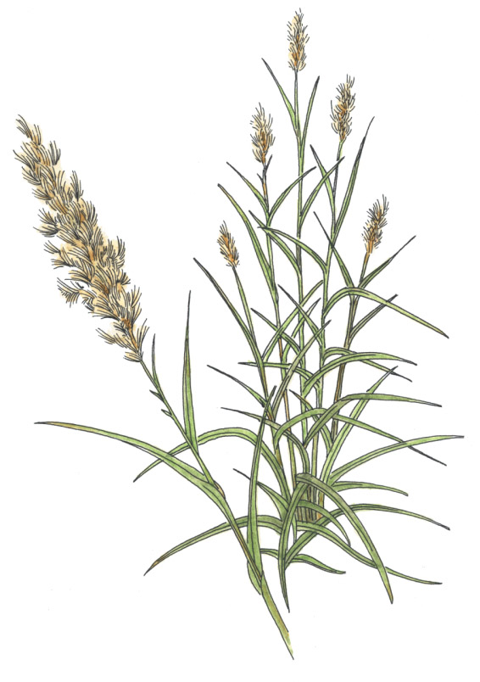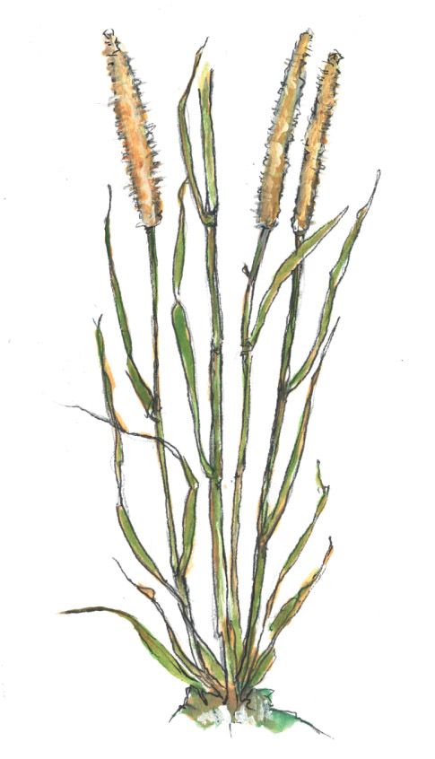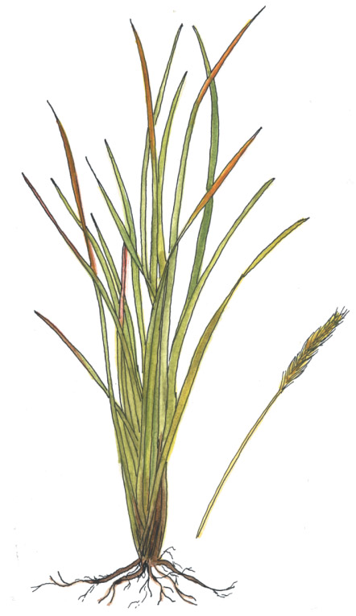
Giant Reed Fountain Grass Cogongrass
Arundo donax Pennisetum setaceum Imperata cylindrical

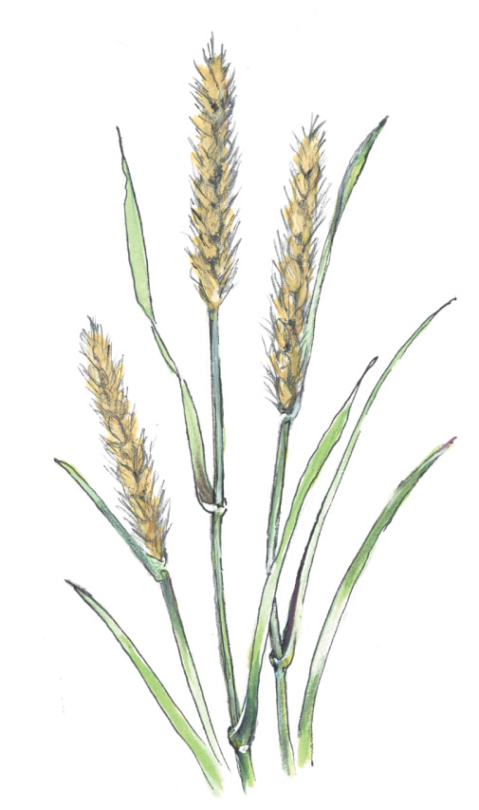
Buffelgrass
Pennisetum ciliaris

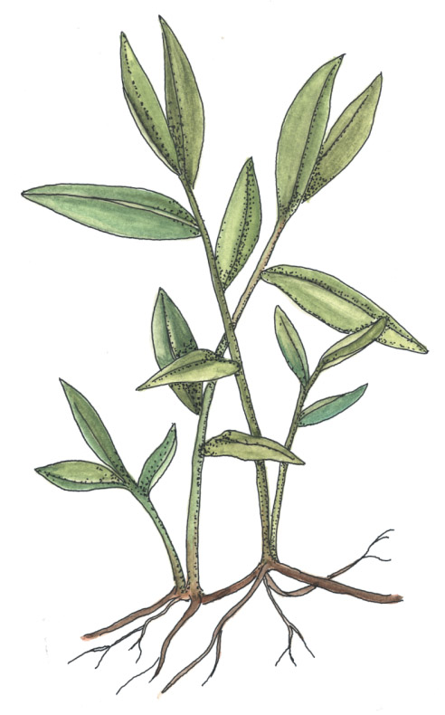
Japanese stiltgrass
Microstegium vimineum

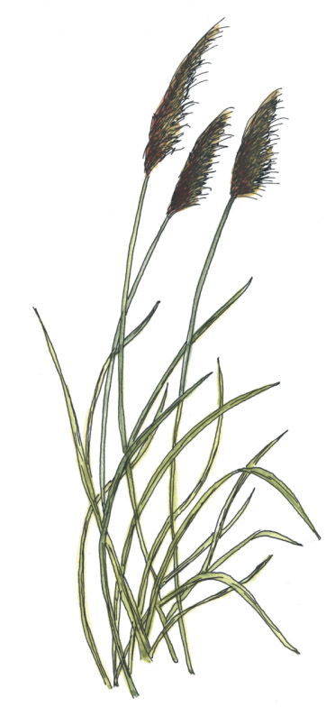
Pampas Grass
Cortaderia selloana

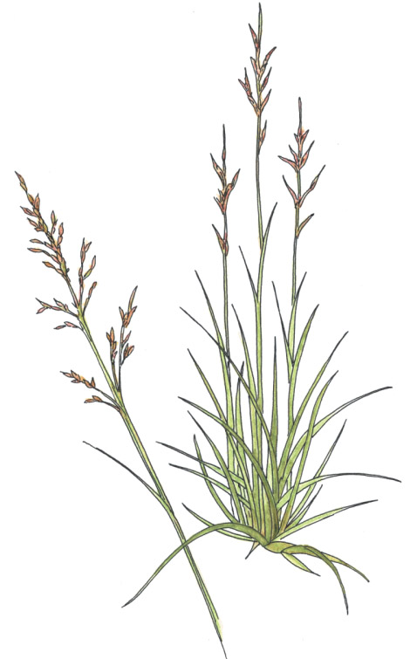
Tall Fescue
Lolium arundinaceum

It is that time again!
Grants for noxious weed/invasive plant partnerships are available. The National Fish and Wildlife Foundation is currently accepting applications for grant dollars. These grants are also known as “the Pulling Together Initiative grants”.
Most federal agencies contribute funds to a pool used for these grants.

The current application cycle is for funding from May of 2006 to September of 2007. The money is aimed at local weed management area partnerships. This funding could help you try out or continue private-public sector or interagency partnerships to get the work done on the ground.

Please visit the National Fish and Wildlife website for more information.

Pennsylvania DOT Discovers: How Deep Is Deep Enough??

The Pennsylvania Division office recently requested guidance from the staff of the Advisory Council on Historic Preservation (Council) regarding the level of effort necessary to undertake identification, evaluation and mitigation for Areas of Potential Effect (APE) with deeply buried intact soils. Of concern were those APE’s with deeply buried intact soils that could contain significant archaeological resources, or those that contain deeply buried known significant archaeological sites. The following questions were posed to the Council;

1) How do we reasonably identify the vertical APE for a project in situations with deeply buried intact soils or where known sites will be encapsulated with fill as part of the project? 2) How should the Criteria of Effect be applied to the encapsulation of intact soils, potential sites or known sites where the APE does not vertically extend to the depth of the soils or site? 3) Does the Section 106 Effect of a Federal undertaking on a site, rest on the access archaeologists have to it?

In brief, the response provided by the Council notes the latitude within the existing regulations for identification and recognizes that effort should be commensurate with the magnitude and scope of an undertaking, respecting the regulatory roles of Federally Recognized Tribes, THPO’s, SHPO’s, transportation agencies, other consulting parties and the FHWA as the lead Federal Agency. The Council recognizes that given a consultative process and certain physical circumstances, the placement of fill over a known National Register eligible or listed archaeological site or an APE that is likely to contain a National Register eligible site might not constitute an Adverse Effect.

Please contact Deborah Suciu Smith of the Pennsylvania Division office at 717-221-3785 or Deborah.Suciu.smith@fhwa.dot.gov for details or to obtain an electronic copy of Council staff guidance. The Council response is staff guidance and direction, not formal policy; however, the Council’s Archaeological Task Force is presently working on the development of formal policy regarding reasonable and good faith effort.

Expand Your Knowledge through the New Environmental Competency Building
Program
Transportation and environmental professionals face a number of challenges during the transportation project development process. The new Environmental Competency Building (ECB) Program is designed to focus on these challenges and the current and future multidisciplinary professional development needs of transportation and environmental professionals. ECB is an effort to assemble existing environmental resources and expertise, inform others of these resources, and explore ways to enhance the skills of transportation professionals involved in the project development and environmental review processes. The ECB program is formed through a collaborative effort with the Federal Highway Administration, the American Association of State Highway and Transportation Officials Center for Environmental Excellence, State Departments of Transportation, the Environmental Protection Agency, and the private consulting industry.
Check out the new Environmental Competency Building website to learn more about ECB resources. The website is a forum to find trainings, conferences, reference materials, and best practices in environmentally friendly transportation project development. For more information, contact Lamar Smith at Lamar.Smith@fhwa.dot.gov.

Earth Day, Environmental Brochures Available
The FHWA Resource Center office in Baltimore has several boxes of COMMON ROADSIDE INVASIVES, A Roadside Field Guide to Showy Herbaceous Weeds and COMMON ROADSIDE WILDFLOWERS (prepared by our FHWA Vegetation Specialist--Bonnie Harper-Lore) brochures. These beautiful brochures are wonderful handouts for any type of environmental meeting or as educational materials for schools, scout groups, etc. They are especially appropriate for Earth Day (April 22) activities. Upon your request, we will be happy to ship a number of them to you for engineering, environmental or interagency meetings, or direct distribution to the public. You may request them from Deborah.Vocke@fhwa.dot.gov, Marie.Roybal@fhwa.dot.gov or Susie.Taylor@fhwa.dot.gov.

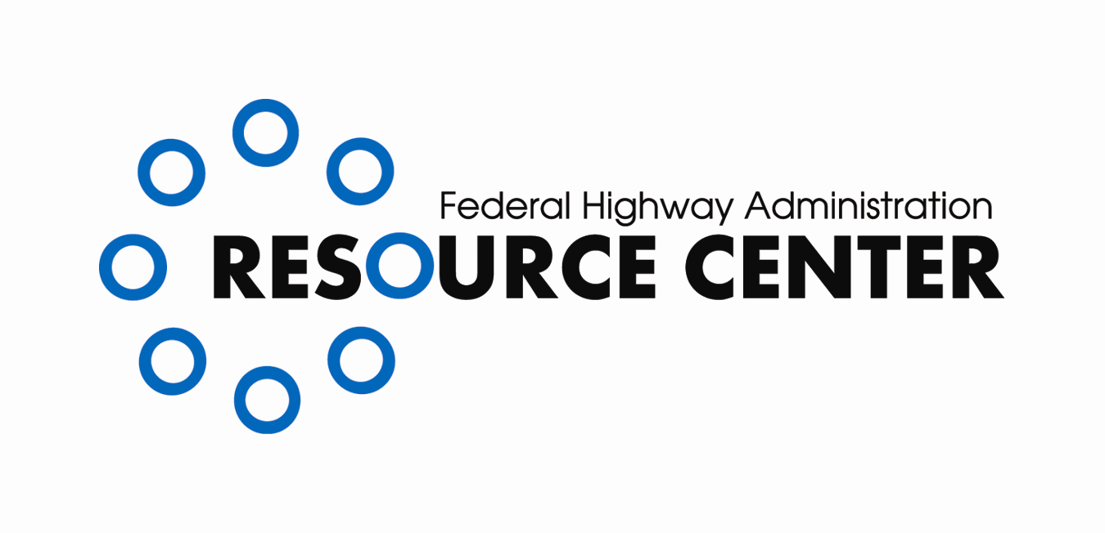
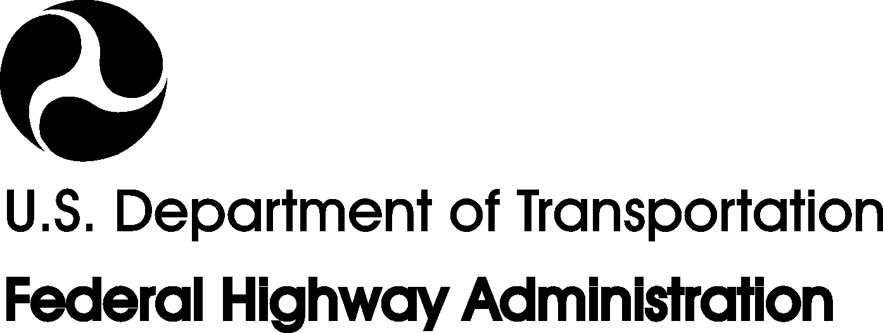
CONTACT INFORMATION:

Editor–in-Chief
Don Cote
Environment Technical Service Team (TST)
Team Leader
Phone: (720) 963-3210
Don.Cote@fhwa.dot.gov

Editorial Board Members:
David Grachen, Brian Smith, and David Sullivan
FHWA Resource Center
Aung Gye
Office of Project Development &
Environmental Review, FHWA HQ

Managing Editor:
Marie C. Roybal,
FHWA Resource Center
(720) 963-3241
Marie.Roybal@fhwa.dot.gov

Due to Quarterly publication schedule, all article submissions for future issues are due to the Editor-In-Chief by the 15th of March, June, September, and/or December

*If you would like to receive this newsletter electronically, please send your email address to:
Marie.Roybal@fhwa.dot.gov
Here are a few of the upcoming events of interest to the environmental community:

January 2006
January 22-26
TRB 84th Annual Meeting
Washington D.C.

April 2006
April 22
Earth Day

April 23-26
National Association of Environmental Professionals (NAEP) 31st Annual Conference Albuquerque, NM

April 27-30
Preserving Historic Road Conference
Boston, MA

May 2006
May 25-27
Weeds Across Borders
Conference held biennially to connect Agricultural, Environmental, and DOTs on both sides of the Canadian and Mexican borders so that they can work together and share information as weeds continue to spread.
Hermosillo, Mexico
All border States are invited to attend.

June 2006
June 27-29
FHWA Environmental Conference
Arlington VA
Contact: Carol Adkins, Carol.Adkins@fhwa.dot.gov

March 2007
Mar 17 - Mar 18
National OHV Program Managers Workshop
Ontario, CA
Co-sponsored by: National Off-Highway Vehicle Conservation Council and FHWA's Recreational Trails Program Contact: Bob Walker (406) 444-4584
Contact: Donna Carter, conference@naep.org

May 2007
May 13 - May 17
Coastal Sediments 2007
New Orleans, LA

