United States Marshals Service
FY 2009 Performance Budget

Justice Prisoner and Alien Transportation System
Revolving Fund



February 2008

Table of Contents

I. Overview of the Justice Prisoner and Alien Transportation System 3
II. Summary of Program Changes 8
III. Appropriation Language and Analysis of Appropriations Language (N/A) 8
IV. Decision Unit Justification 9
A. Justice Prisoner and Alien Transportation System 9
1. Program Description 9
2. Performance Tables 10
3. Performance, Resources, and Strategies 14
a. Performance Plan and Report for Outcomes 14
b. Strategies to Accomplish Outcomes 14
c. Results of Program Assessment Rating Tool (PART) Reviews 14
V. E-Gov Initiatives (N/A) 16
VI. Exhibits 16

A. Organizational Chart
B. Summary of Requirements
C. Program Increases by Decision Unit (N/A)
D. Resources by DOJ Strategic Goal/Objective
E. Justification for Base Adjustments (N/A)
F. Crosswalk of 2007 Availability
G. Crosswalk of 2008 Availability (N/A)
H. Summary of Reimbursable Resources
I. Detail of Permanent Positions by Category
J. Financial Analysis of Program Increases/Offsets (N/A)
K. Summary of Requirements by Grade
L. Summary of Requirements by Object Class
M. Status of Congressionally Requested Studies, Reports, and Evaluations (N/A)
N. Schedule of Aircraft

I. Overview of the Justice Prisoner and Alien Transportation System (JPATS)

A. Introduction

JPATS was created on October 1, 1995, by merging the USMS National Prisoner Transportation System and Immigration and Naturalization Service (INS) Air Transport Branch. This merger was based on an August 15, 1994 memorandum in which the Attorney General directed the consolidation [by FY 1996] of the prisoner and detainee air transportation functions that were being performed by the USMS and INS into a single entity to be managed by the USMS. The JPATS mission is to transport federal detainees and prisoners, including pretrial, sentenced, and deportable aliens, whether in the custody of the USMS, Bureau of Prisons (BOP), and Immigration and Customs Enforcement (ICE). JPATS also provides prisoner transportation for the Department of Defense (DOD), state, and local law enforcement agencies on a reimbursable, space-available basis. JPATS transports prisoners and detainees in a cost-effective manner without sacrificing the safety of the public, federal employees, or those in custody.

In 1997, Coopers & Lybrand prepared a JPATS 5-Year Strategic Plan that included a recommendation that JPATS be funded through a revolving fund to allow flexibility in its financial planning, operational decision-making, and the delivery of services. On October 1, 1998, JPATS began operating as a revolving fund activity with the goal of having all operating costs reimbursed by customer agencies. The benefits of the JPATS revolving fund are: 1) it is a no-year account with a consistent funding stream from the customer agencies, thus not subject to Continuing Resolution restrictions; 2) it operates under the concept of full-cost recovery; 3) it provides for multi-year funding/leasing authority for capital acquisitions; and 4) it has authority to retain proceeds from the disposal of JPATS aircraft and parts. The JPATS Revolving Fund provides stability in costs to the customer agencies since the fund can absorb, on a short-time basis, cost fluctuations for operating expenses such as fuel and major aircraft maintenance. It also simplifies the task of replacing aircraft and obtaining major aircraft parts by enabling managers to extend the cost of equipment purchases or equipment leases over several years, and to plan the procurement of equipment, or equipment lease agreements when needed, rather than waiting for available, appropriated funding.

JPATS receives compulsory guidance from the General Services Administration (GSA), which is charged with monitoring the effective use of all government aircraft in accordance with Office of Management and Budget (OMB) requirements. JPATS follows GSA directives with assistance from Justice Management Division’s (JMD) Facilities and Administrative Services Staff (FASS), a member of GSA’s Interagency Committee for Aviation Policy (ICAP). FASS serves as an effective intermediary between JPATS and GSA, passing along technical and operational advice from GSA-ICAP to JPATS, while transmitting JPATS data to GSA through the Federal Aviation Interactive Reporting System (FAIRS). ICAP provides direct assistance to JPATS through programs like the ICAP Aviation Resources Management (ARMS), which engages professional aviators from other government programs in safety reviews of JPATS operations. The ARMS program offers a comprehensive survey, on request, of an agency's flight program (management/administration, operations, maintenance, safety, and training). GSA puts together a team of aviation experts, which generally spends about two weeks on-site with the requesting agency's aviation program. JPATS completed an ARMS review in December 2007 with no significant findings.
JPATS adheres to all of the Federal Aviation Administration (FAA) public sector aviation rules and regulations regarding aviation safety, operations, and maintenance. JPATS is an organizational component within the USMS with the Assistant Director for JPATS reporting to the Deputy Director of the USMS. USMS was both management and customer for JPATS since its inception in FY 1996 until FY 2006. In FY 2007, USMS Salaries and Expenses funding for prisoner transportation was transferred to the Office of the Federal Detention Trustee (OFDT). OFDT’s control of funds for both detention and transportation is expected to result in greater cost efficiencies. The JPATS Revolving Fund budget reflects the anticipated revenue and expenditures that are related to the movement of detainees and prisoners. Program funding requirements are identified in the budget submission of each customer agency.

JPATS was evaluated via the OMB PART process in the spring of FY 2006, resulting in a program rating of “moderately effective.” The follow up actions and their status are described in detail in Section II.

B. Issues, Outcomes, and Strategies

JPATS coordinates with the OFDT, USMS, ICE, and BOP to ensure that:

- Detainees, prisoners, and deportable aliens are transported and detained in a cost effective manner, utilizing procedures that safeguard USMS personnel and the public.
- Persons in custody reach their destinations in a timely manner.

JPATS is currently utilizing a leasing strategy that provides increased aircraft reliability, fuel efficiency, and prisoner capacity in the large aircraft leased for all JPATS operations. These leased aircraft are operating at the following locations: three at Mesa, Arizona; three at Alexandria, Louisiana; and two at Oklahoma City, Oklahoma. JPATS is currently working with the Justice Management Division (JMD) procurement division to develop a long-term aircraft leasing program to serve JPATS requirements in future years. In the interim, JPATS’ current short-term (3-year) large aircraft leases are being replaced with GSA Blanket Purchase Agreement (BPA) orders as they expire.

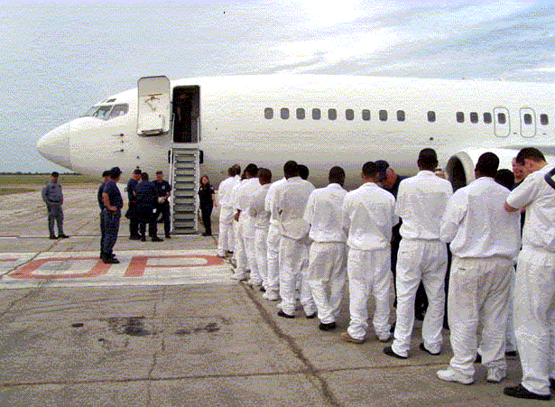

The Oklahoma City hangar has four years remaining on its lease. The annual lease payment is approximately $1 million. Since OMB Circular A-11 requires agencies to reserve sufficient budgetary authority equal to the net present value of the Government’s total estimated legal obligations over the life of a lease, JPATS obligated $4 million from retained earnings in
FY 2007 to cover the remaining years of the lease. This action corrected a non-compliance issue identified in the financial audit.

The following is a brief summary of the Department’s Strategic Goal and Objective supported by JPATS.

DOJ Strategic Goal III: Ensure the Fair and Efficient Operation of the Federal Justice System

- Protect judges, witnesses, and other participants in federal proceedings, and ensure the appearance of criminal defendants for judicial proceedings or confinement (Goal III, Objective 3.1)

JPATS supports the DOJ Strategic Plan by moving prisoners and aliens as quickly, safely, and as cost effectively as possible. The following chart shows the actual and projected levels of air transportation movements and flight hours for all JPATS customer agencies from FY 2003 to
FY 2009:

Fiscal Year | Air Movements | Flight Hours
2003 | 175,207 | 11,635
2004 | 176,522 | 11,746
2005 | 181,951 | 10,512
2006 | 213,140 | 11,674
2007 | 244,136 | 14,069
2008 (Est.) | 267,000 | 16,275
2009 (Est.) | 343,380 | 22,275

In May 2006, JPATS acquired a 56 passenger turbo-prop aircraft to facilitate USMS, BOP, and ICE air operations between the eastern seaboard of the United States and Puerto Rico, St. Thomas, and St. Croix. This new aircraft increased the actual movements in FY 2007 and is projected to increase JPATS air movements in FY 2008. ICE large movements and hours are expected to increase throughout FY 2008 and FY 2009 due to their programmatic requirements. An additional 19 passenger turbo-prop aircraft will be procured in FY 2008 and delivered in
FY 2009 to support USMS operations in Alaska.

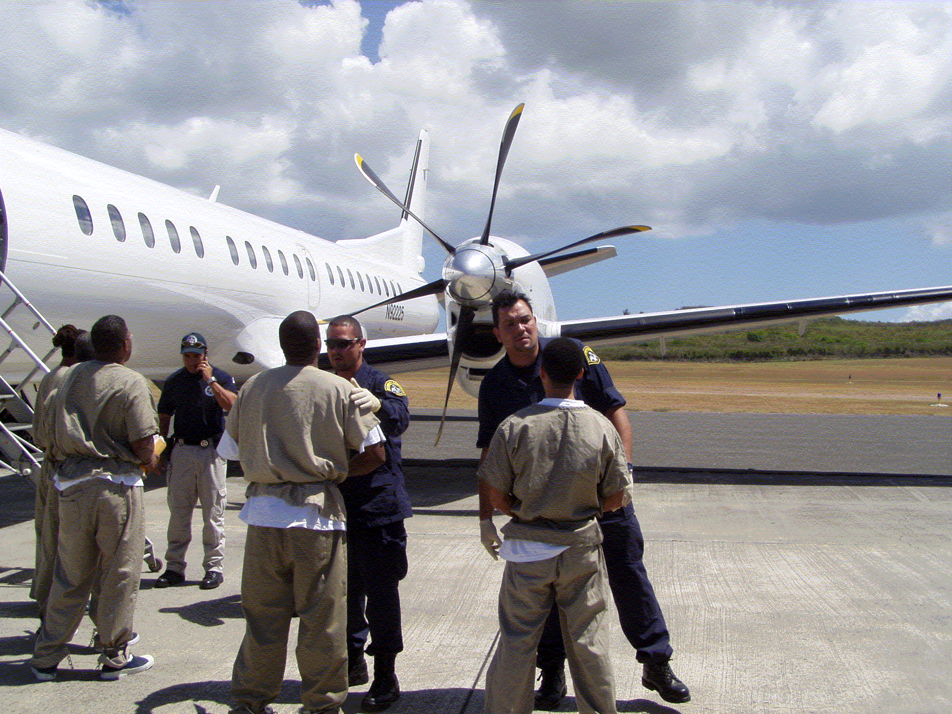

C. Full Program Costs

On October 1, 1998, JPATS began operating as a revolving fund activity with total operating costs being reimbursed by customer agencies. A price-per-flying-hour methodology was developed by the JPATS Business Office in conjunction with financial and operational staff members from the Justice Management Division (JMD), BOP, ICE, and the USMS. This methodology was implemented in 2002, and replaced the price-per-movement methodology that was used during the first 3 years of JPATS operation. The goal was to develop an accurate, fair, and equitable pricing methodology for all agencies with full cost recovery. This was accomplished by following OMB Circular A-126 guidelines that identify fixed and variable cost categories and by establishing specific prices-per-flying-hour for JPATS customers. Fixed and variable costs were identified by large and small aircraft. JPATS budget projections have incorporated an additional tool known as “activity based costing” to further refine the accuracy of customer pricing initiatives begun in FY 2002. In FY 2006, the methodology was further refined to a price-per-flight-hour-per-seat basis. Customers are billed based on the number of flight hours and the number of seats they actually utilize to move their prisoners/detainees. Aircraft usage requirement projections are provided by the customer agencies prior to the beginning of the budget cycle.

D. Performance Challenges

JPATS faces a variety of challenges in accomplishing its mission. These challenges fall into two broad categories:

External Challenges

The JPATS aviation program is subject to a variety of influences and regulations external to the Department of Justice. The JPATS increasing workload is generated by other federal agencies, particularly DHS due to immigration related prisoner movements, and the federal Judiciary. JPATS determines the schedule to move prisoners based on the appearance dates specified in court orders.

JPATS must continually anticipate customer needs in the future. During FY 2008 and 2009, JPATS FTE is projected to increase from 196 to 249, a net increase of 53 FTE, to accommodate ICE’s planned increases in alien deportation flights and the USMS operations in Alaska. These increased resource costs will be funded on a reimbursable basis by the customer utilizing the assets.

Internal Challenges

The greatest internal challenge is ensuring the safety of the aircraft, staff, and prisoners/detainees. A Safety Officer and a formal safety program are in place to meet this challenge. The Safety Officer provides constant monitoring of the aviation program and conducts numerous training sessions each year to help JPATS continue to meet its high standards of aviation safety.

A second significant internal challenge is ensuring that JPATS has access to an adequate number of aircraft to meet customer demands. When a leased aircraft requires maintenance, the aircraft leasing company must locate a replacement aircraft for the scheduled mission. If a replacement aircraft cannot be immediately located, or if a JPATS-owned aircraft requires unscheduled maintenance, JPATS either locates another leased aircraft or reschedules the mission. The acquisition strategy of leasing newer, more reliable aircraft will increase the operational readiness of the air fleet, reducing unscheduled downtime and enabling JPATS to meet customer missions.

A third internal challenge is appropriately staffing each scheduled flight with flight personnel/security officers to secure the prisoners/detainees being transported and with a Public Health Service (PHS) nurse to attend to any urgent health issues. JPATS now provides ground security at all airlift stops for the loading and transferring of prisoners/detainees, historically provided by USMS, BOP, and ICE personnel. Through a standardized training program and the use of standardized weapons, these specialized security personnel strengthen the safety of prisoner movements. Meeting these challenges will ensure that the JPATS missions will fly as scheduled in the safest manner possible.

II. Summary of Program Changes

Item Name | Description |  |  |  | Page
Item Name |  | Pos. | FTE | Dollars ($000) | Page
Alaska Operations | Annualize Alaska Operating Level | 9 | 9 | $1,453 | 6
Southwest Operations | Southwest Flight Operations Requirements | 44 | 44 | 3,589 | 9
Total |  | 53 | 53 | $5,042

III. Appropriation Language and Analysis of Appropriations Language (N/A)

Not applicable because the JPATS Revolving Fund is not an appropriated account.
IV. Decision Unit Justification

A. Justice Prisoner and Alien Transportation System

Justice Prisoner and Alien Transportation System - TOTAL | Perm. Pos. | FTE | Amount ($000)
2007 Operating Level | 170 | 170 | $119,789
2008 Operating Level | 196 | 196 | 154,380
2009 Current Services | 196 | 196 | 154,380
2009 Operating Level Changes | 53 | 53 | 5,042
2009 Operating Level | 249 | 249 | 159,422
Total Change 2008-2009 | 53 | 53 | $5,042

1. Program Description

JPATS moves federal prisoners and detainees by air, including sentenced, pretrial and deportable aliens, whether in the custody of the U.S. Marshals Service (USMS), Bureau of Prisons (BOP), or Bureau of Immigration and Customs Enforcement (ICE). JPATS also transports Department of Defense and state and local prisoners on a reimbursable, space-available basis. The JPATS goal is to move prisoners and deportable aliens safely and securely, in the most cost efficient manner possible.

Customer agencies provide projected aircraft utilization requirements. JPATS estimates non-federal requirements based on historical data. Due to increased program requirements, ICE large movements and hours are expected to increase throughout FY 2008 and FY 2009. JPATS is planning a new hub in the southwest to support repatriations in this area. This location will be established in FY 2009 after completion of the approval process. JPATS plans to procure an additional turbo-prop aircraft in FY 2008, delivered in FY 2009, to support USMS operations in Alaska.

JPATS is committed to ensuring that each scheduled flight is staffed with qualified flight personnel to safely operate each aircraft, that adequate security officers are present to ensure the safety of the detainees/prisoners being transported, and that at least one Public Health Service (PHS) nurse is present for any medical emergency. In response to current and projected external influences and to safely and efficiently satisfy the increasing service demands, JPATS must correspondingly increase service personnel FTE. During FY 2008 and 2009, JPATS FTE is projected to increase from 196 to 249, a net increase of 53 FTE. The chart below shows the projected personnel requirements by location in FY 2009:

Proposed Personnel Requirements by Location
 | Alexandria, LA | Kansas City, MO | Oklahoma City, OK | Phoenix, AZ | Puerto Rico | Anchorage, AK | Southwest | Totals
JPATS Total | 38 | 50 | 60 | 41 | 13 | 9 | 38 | 249

2. Performance Tables
A. Definition of Terms or explanations for Indicators.

Workload:
1. JPATS receives requests to move prisoners and determines the appropriate mode of transportation (i.e., ground and/or air movement). JPATS uses the Automated Prisoner Scheduling System (APSS), a module within the Justice Detainee Information System (JDIS), to schedule and track movements electronically.

Performance Measures:
1. The number of air movements accomplished using JPATS owned or leased aircraft.
2. Represents the number of flight hours accomplished. Customer agencies provide estimated flight hours for budget development.
3. Represents the average cost-per-hour for large (75-140 passengers) aircraft. Individual prices for cost-per-hour were developed for each customer. Prior to setting outyear targets, JPATS requests customer projection of services required (how many flight hours needed). Further, the analysis performed to project future costs includes the inflationary factors for employee pay raises and the escalating costs for non-labor categories such as aircraft leases, space rental, the market price for fuel, and other supplies.
4. Represents the average cost-per-hour for small (8-50 passengers) aircraft. Individual prices for cost-per-hour were developed for each location utilizing activity based costing methodology. Prior to setting outyear targets, JPATS requests customer projection of services required (how many flight hours needed). Further, the analysis performed to project future costs includes the escalating costs mentioned above in #3.
5. Depicts the average age of owned aircraft in the JPATS fleet. Aircraft that are beyond economical repair and sold are excluded from the fleet’s average age. As the aircraft age, the cost to maintain increases and availability decreases due to increased maintenance required.
6. Unscheduled maintenance causes decreased ability to meet mission goals along with increased operating costs.
7 and 8. Incident reports are filled out and tracked whenever a critical event occurs, such as a prisoner escape or flight accident.
B. Factors Affecting FY 2007 Program Performance.
JPATS did not meet its target for percent of time JPATS owned aircraft not available to fly due to unscheduled maintenance due to aging wiring relays internal to two of the four owned aircraft (tail numbers N2032 and N2033). Both Hawker aircraft had extensive time in unscheduled maintenance to replace cracked wiring, ensuring the safety of the aircraft. These problems could not be seen during normal maintenance checks, but rendered the aircraft unsafe for flight.

JPATS did not meet its target of zero for incidents on JPATS movements. On May 3, 2007, during a cross-bleed engine start, the aircraft jet blast damaged an aluminum “roll-up” door on a loading dock at the Oakland International Airport with no aircraft damage and no injuries were reported. There was minor property damage to the roll-up aluminum door.

In FY 2007, increased ICE program level requirements resulted in increases of prisoner and detainee air movements and flight hours.

C. Factors Affecting FY 2008 and FY 2009 Plans.

At the end of FY 2008, JPATS will begin new operations to and within Alaska. USMS detainees will be flown throughout the state because the constantly varying weather conditions, lack of highway and railroad infrastructure, and large geographic distances preclude conventional ground transportation. As part of this operation, JPATS will purchase a 19-seat, twin engine, turbo-prop aircraft in
FY 2008 to be delivered in FY 2009.

A new location proposed for the southwest is expected to be established in FY 2009 to accommodate increased alien movements for ICE.

A new long-term aircraft lease program for large aircraft is undergoing procurement action for future years.

3. Performance, Resources, and Strategies

a. Performance Plan and Report for Outcomes

JPATS now provides ground security at all airlift stops for the loading and transferring of prisoners/detainees, historically provided by USMS, BOP, and ICE personnel. Through a standardized training program and the use of standardized weapons, these specialized security personnel strengthen the safety of prisoner movements. The designated Safety Officer provides constant monitoring of the aviation program and conducts numerous training sessions each year to help JPATS continue to meet its high standards of aviation safety. Also, the acquisition strategy of leasing newer, more reliable aircraft will increase the operational readiness of the air fleet, reducing unscheduled downtime and enabling JPATS to meet customer missions.

b. Strategies to Accomplish Outcomes

JPATS did not meet its target for “percent of time JPATS owned aircraft not available to fly” due to unscheduled maintenance caused by aging wiring relays internal to two of the four owned aircraft (tail numbers N2032 and N2033). Both Hawker aircraft had extensive time in unscheduled maintenance to replace cracked wiring, essential for ensuring the safety of the aircraft. These problems could not be seen during normal maintenance checks, but rendered the aircraft unsafe for flight. Repair issues will continue to be found in aging aircraft, however, percent of time JPATS owned aircraft not available to fly due to unscheduled maintenance is projected to decrease.

In FY 2007, increased ICE program level requirements resulted in increases of prisoner and detainee air movements and flight hours. To more accurately reflect current trends, FY 2008 and FY 2009 targets for the following measured items have been adjusted upward based on FY 2007 actual data:

- Number of prisoner and detainee air movements accomplished;
- Number of hours to accomplish air movements;
- Average cost per hour for large aircraft, and;
- Average cost per hour for small aircraft.

c. Results of Program Assessment Rating Tool (PART) Reviews

JPATS was evaluated via OMB’s Program Assessment Rating Tool (PART) in FY 2006 and received a rating of “Moderately Effective.” As a result of this evaluation, two recommendations were suggested. First, JPATS should pursue a Bi-Annual Aviation Resource Management Survey (ARMS) review. To date, the JPATS' Aviation Safety Officer coordinated with the Interagency Committee for Aviation Policy (ICAP) committee in charge of the ARMS program to initiate the review. JPATS underwent an ARMS review in late September of 2007 from the ICAP committee. The official ARMS review report was completed in December 2007 with no significant findings.

Second, JPATS should review and analyze current baseline metrics. To accomplish this, JPATS began a monthly performance metric review in February 2006. This review was revised in third quarter FY 2007 to become a formal quarterly management review covering operations, finance, and administration. The FY 2007 year end metrics established the baseline for all quarterly internal management metric reporting which has continued into FY 2008.

V. E-Gov Initiatives (N/A)

VI. Exhibits

