U.S. Department of Justice

Environment & Natural Resources Division

(ENRD)

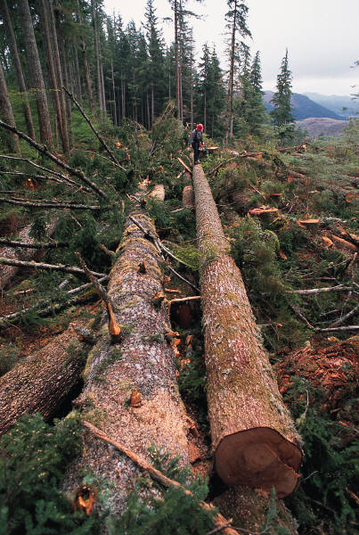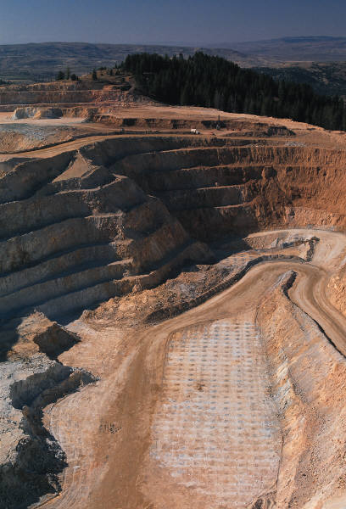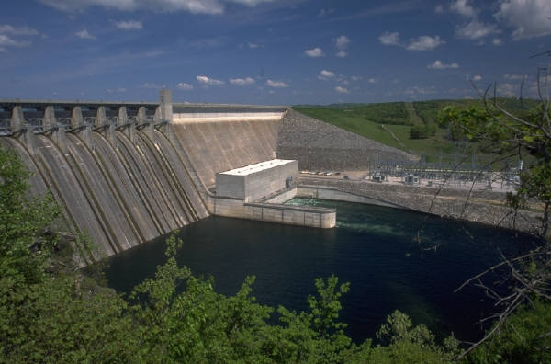

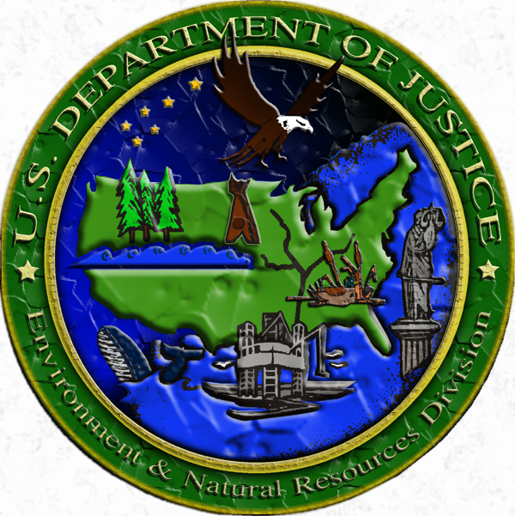

F Y 2 0 0 9

PERFORMANCE BUDGET

CONGRESSIONAL SUBMISSION

Table of Contents

Page No.

I. Overview 1

II Summary of Program Changes N/A

III. Appropriations Language and Analysis of Appropriations Language N/A

IV. Decision Unit Justification

A. Environment and Natural Resources Division 5
1. Program Description 5
2. Performance Tables 17
3. Performance, Resources, and Strategies 20

V. E-Gov Initiatives 30

VI. Exhibits

- Organizational Chart
B. Summary of Requirements
C. Program Increases by Decision Unit N/A
- Resources by DOJ Strategic Goal/Objective
- Justification for Base Adjustments
- Crosswalk of 2007 Availability
- Crosswalk of 2008 Availability
- Summary of Reimbursable Resources
- Detail of Permanent Positions by Category
- Financial Analysis of Program Increases/Offsets N/A
- Summary of Requirements by Grade
- Summary of Requirements by Object Class
- Status of Congressionally Requested Studies, Reports, and Evaluations N/A

I. Overview of the Environment & Natural Resources Division

A. Introduction:

Environment and Natural Resources Division (ENRD) Mission: ENRD’s mandate is to enforce civil and criminal environmental laws and programs protecting the health and environment of the United States and to defend suits challenging those laws and programs. To accomplish this mission in FY 2009, the Division is requesting a total of $103,093,000, including 445 General Legal Activities (GLA) funded positions, and 499 Full-Time Equivalents (FTE).

Electronic copies of the Department of Justice’s Congressional Budget Justifications and Capital Asset Plan and Business Case exhibits can be viewed or downloaded from the Internet using the Internet address: https://www.usdoj.gov/jmd/2009justification/.

B. Issues, Outcomes, and Strategies:

As the Nation's chief environmental litigator, ENRD supports the Justice Department’s Strategic Goal Two: Enforce Federal Laws and Represent the Rights and Interests of the American People, and Strategic Objective 2.7: Vigorously enforce and represent the interests of the United States in all matters over which the Department has jurisdiction.

The Division initiates and pursues legal action to enforce federal pollution abatement laws and obtain compliance with environmental protection and conservation statutes. ENRD also represents the United States in all matters concerning protection, use, and development of the nation's natural resources and public lands. The Division defends suits challenging all of the foregoing laws, and fulfills the federal government’s responsibility to litigate on behalf of Indian tribes and individual Indians. ENRD’s legal successes protect the federal fisc, reduce harmful discharges into the air, water, and land, enable clean-up of contaminated waste sites, and ensure proper disposal of solid and hazardous waste.

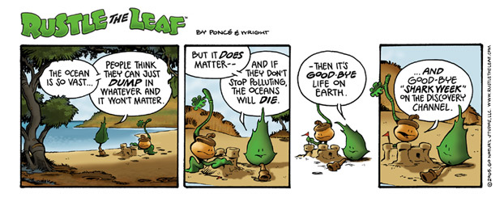

In affirmative litigation, ENRD obtains redress for past violations harming the environment, ensures that violators of criminal statutes are appropriately punished, establishes credible deterrents against future violations of these laws, recoups federal funds spent to abate environmental contamination, and obtains money to restore or replace natural resources damaged by oil spills or the release of other hazardous substances into the environment. ENRD also ensures that the federal government receives appropriate royalties and income from activities on public lands and waters.

By vigorously prosecuting environmental criminals, ENRD spurs improvements in industry practice and greater environmental compliance. Additionally, the Division obtains civil penalties and fines against violators, thereby removing the economic benefits of non-compliance and leveling the playing field so that companies complying with environmental laws do not suffer competitive disadvantages.

In defensive litigation, ENRD represents the United States in challenges to federal environmental and conservation programs and all matters concerning the protection, use, and development of the nation's public lands and natural resources. ENRD faces a growing workload in a wide variety of natural resource areas, including litigation over water quality and watersheds, the management of public lands and natural resources, endangered species and sensitive habitats, and land acquisition and exchanges. The Division is increasingly called upon to defend Department of Defense training and operations necessary to military readiness and national defense.

Additionally, ENRD continues to defend the federal government in lawsuits alleging the United States has breached its trust responsibilities to Indian Tribes by failing to provide “full and complete” historical accountings of tribal trust funds and non-monetary trust resources, failing to administer properly tribal accounts that receive revenues from economic activity on Tribal lands, and failing to manage properly tribal non-monetary trust resources. As a result of a statute of limitations which expired December 31, 2006, ENRD received a number of new case filings in this area. Approximately 86 of the 104 currently filed cases were filed after November 2005 (some 72 cases were filed in November and December 2006 alone). Two of the cases feature requests to certify classes of over 250 Tribal plaintiffs. If such requests are granted, the United States will have been sued by more than 300 Tribes. To date, we have settled two Tribal Trust cases. ENRD is engaged in formal alternative dispute resolution (ADR) processes or informal settlement discussions with the Tribes in 13 other cases. ENRD is actively litigating approximately twenty of the Tribal Trust cases; and we are only beginning to review the claims and understand the issues involved in the 72 additional cases which were filed in the first quarter of FY 2007. For these Tribal Trust cases, regardless of litigation posture, the Division is obligated to identify, locate, review, scan, manage, and produce over 400 million pages of documents relevant to Tribal Trust fund accounts, resources, and assets. Consequently, we expect the Tribal Trust litigation to continue in full force for the foreseeable future.

C. Full Program Costs:

The Division is one single Decision Unit. Its operations include both criminal and civil litigating activities directly related to the strategic goals and objectives of the Department of Justice. The methodology used to allocate expenses is based on the percentage of hours worked on criminal and civil cases. These percentages are then used to allocate the expenses of the Division into the two areas of criminal and civil litigating activities. These two areas of execution correlate directly to Strategic Objective 2.7 under the Departmental Strategic Goal Two: Vigorously enforce and represent the interests of the United States in all matters over which the Department has jurisdiction.

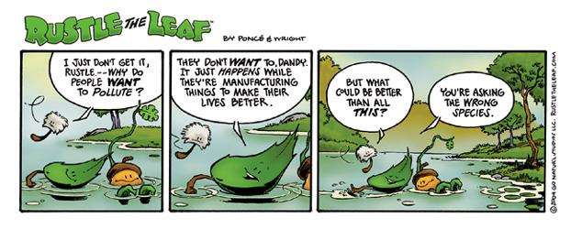

D. Performance Challenges:

External Challenges

The Division has limited control over the filing of defensive cases, which make up the majority of our workload. Court schedules and deadlines drive the pace of work and attorney time devoted to these cases. ENRD’s defensive caseload is expected to increase in FY 2009 as a result of numerous factors.
- The 76 newly filed Tribal Trust cases in the first quarter of FY 2007 will have a profound impact on ENRD’s caseload in FY 2009, as these cases mature and enter the discovery and trial phases of litigation.
- ENRD expects a number of challenges to the simplified energy development and permitting provisions of the 2005 Energy Policy Act. Based on ENRD’s past experience – in the 1970s and 1980s, the Interior Department conducted offshore oil and gas lease sales in nearly all coastal regions of the continental U.S. and in Alaska – we realize that sizeable, energized leasing programs result in sizeable increases in case work.
- Hurricane Katrina-related inverse condemnation (Fifth Amendment takings) lawsuits have the potential to inundate ENRD’s workforce. These non-discretionary cases (which have a 6-year limitation on filing [i.e., until August 2011], rather than 2-year limitation period for tort claims under the FTCA), largely claim that the construction of defective levees, the failure to erect a levee system capable of withstanding a Category 5 hurricane, or other actions/projects undertaken by the Army Corps of Engineers resulted in a “taking” of real property under the Fifth Amendment.
- Additionally, beginning in late FY 2008, Indian and other federal water rights adjudications currently stayed for settlement negotiations are expected to resume.

The Division also will be responsible for handling cases that arise from the Administration’s focus in other environment arenas, such as white collar environmental crimes. Prosecution of white collar crimes and corporate fraud is one of the Attorney General’s six stated priorities; and casework involving the prosecution of corporations and corporate executives may impose a greater-than-expected workload demand on the Environment Division in FY 2009 and beyond. ENRD realized a number of legal victories in the area of white collar environmental crimes in FY 2007 (described in the Accomplishments section of this Performance Budget), and we foresee more investigative and litigative activity in the immediate future. Although we expect an increased workload in the area of white collar criminal litigation, we are not seeking a program enhancement in this area for FY 2009 because we believe offsetting resource demands will allow us to accommodate prospective needs from our base.

Internal Challenges

ENRD’s overwhelming internal challenge is to ensure sufficient attorney FTEs and dollars to carry out the increasing demands of our defensive workload. ENRD will continue to face other internal challenges related to the effort of balancing available personnel and resources against workload demands.

Another challenge involves maintaining adequate information technology resources for our workforce. Like other litigating components, ENRD must provide computer resources for our attorneys that meet the changing, increasingly technological demands of the legal industry. With the introduction of new technologies and new requirements – such as e-filing, on-line document repositories, electronic trials, extranet docketing systems, etc. – we need to continually provide our workforce with the necessary hardware and systems to accommodate these business process challenges.

The most significant information technology system challenge which will confront ENRD in FY 2009 is expected to be the Department’s Litigation Case Management System (LCMS). LCMS is a shared case management system for the Executive Office of United States Attorneys, the 94 United States Attorneys Offices, the Civil Division, the Civil Rights Division, the Environment and Natural Resources Division, the Criminal Division, the Tax Division, and the Antitrust Division. This new, unified system is intended to provide accurate, timely, and useful data for all end users and managers across the seven Department of Justice litigating divisions. Implementation of LCMS is expected to be an expensive and time-consuming initiative in FY 2009. Based on information provided by DOJ’s Office of the Chief Information Officer (LCMS PMO), ENRD will be required to contribute significant sums of money and personnel resources in FY 2009 and subsequent years in order to implement and administer this required system. The required expenditures will pay for software license fees and ENRD's share of the costs of the Justice Data Center (JDC), LCMS PMO, and contractor support services. We expect to incur significant additional costs in FY 2009 in the conversion and testing of data and reports from our old case management system to the new case management system.

The Division will complete its business process assessment and common data model planning for LCMS in early FY 2008. Throughout the rest of FY 2008, we will begin mapping data, prioritizing reports, building conversion tools, migrating data, and cleaning up conversion/migration discrepancies. And in FY 2009, we will engage in testing, full implementation, and final roll-out of the system. This sizeable endeavor will require the effort and attention of existing government employees as well as the specialized expertise and supplemental labor of industry consultants and/or contractor resources.

To access the Exhibit 300 submission for ENRD and other DOJ components, please go to: http://www.usdoj.gov/jmd/2009justification/exhibit300/.

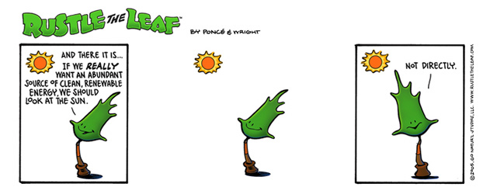

IV. Decision Unit Justification

A. Environment and Natural Resources Division

FY 2009 Request Summary | Perm. Pos. | FTE | Amount ($000)
2007 Enacted with Rescissions | 436 | 490 | $ 95,093
2007 Enacted with Rescissions and Supplementals | 436 | 490 | 95,093
2008 Enacted | 445 | 495 | 99,365
Adjustments to Base and Technical Adjustments | - | 4 | 3,728
2009 Current Services | 445 | 499 | 103,093
2009 Program Increases | - | - | -
2009 Request | 445 | 499 | 103,093
Total Change 2008-2009 | - | 4 | $ 3,728

1. Program Description

As stated in the Department of Justice Strategic Plan, ENRD works to:

- Investigate and prosecute environmental crimes, including both wildlife and pollution violations;

- Pursue cases against those who violate laws that protect public health, the environment, and natural resources;

- Defend U.S. interests against suits challenging statutes and agency actions;

- Develop constructive partnerships with other federal agencies, state and local governments, and interested parties to maximize environmental compliance and stewardship of natural resources;

- Act in accordance with United States trust responsibilities to Indian tribes and individual Indians in litigation involving the interests of Indians.

The Division focuses on both civil and criminal litigation regarding the defense and enforcement of environmental laws and regulations. The Division serves as the nation’s environmental litigator and represents many federal agencies in environmental litigation (e.g., the Environmental Protection Agency, Department of Agriculture, Department of the Interior, Department of Defense, and Department of Homeland Security.)

As the nation’s chief environmental litigator, ENRD strives to obtain compliance with environmental and conservation statutes. To this end, we seek to obtain redress of past violations that harmed the environment, establish credible deterrence against future violations of these laws, recoup federal funds spent to abate environmental contamination, and obtain money to restore or replace natural resources damaged through oil spills or the release of other hazardous substances. The Division ensures illegal emissions are eliminated, leaks and hazardous wastes are cleaned up, and drinking water is safe. Our actions, in conjunction with the work of our client agencies, enhance the quality of the environment in the United States and the health and safety of its citizens.

Civil litigating activities include cases where ENRD defends the United States in a broad range of environmental litigation and enforces the nation’s environmental laws. The majority of the Division’s cases are defensive or non-discretionary in nature. They include claims alleging noncompliance with federal, state and local pollution control and natural resource laws. Civil litigating activities also involve the defense and enforcement of environmental statutes such as the Comprehensive Environmental Response, Compensation, and Liability Act (CERCLA), the Clean Air Act (CAA), the Clean Water Act (CWA), the National Environmental Policy Act (NEPA), and the Endangered Species Act (ESA).

The Division defends Fifth Amendment taking claims brought against the United States alleging that federal actions have resulted in the taking of private property without payment of just compensation, thereby requiring the United States to strike a balance between the interests of property owners, the needs of society, and the public fisc. ENRD also prosecutes eminent domain cases to acquire land for congressionally authorized purposes ranging from national defense to conservation and preservation. Furthermore, the Division assists in fulfillment of United States trust responsibilities to Indian Tribes. ENRD is heavily involved in defending lawsuits alleging the United States has breached trust responsibilities to Tribes by mismanaging Tribal natural resources and failing to properly administer accounts that receive revenues from economic activity on Tribal lands. The effectiveness of our defensive litigation is measured by percent of cases successfully resolved and savings to the federal fisc. These results can be seen in the Performance and Resources Table contained in this submission.
Criminal litigating activities focus on identifying and prosecuting violators of laws protecting wildlife, the environment, and public health. These cases involve issues such as fraud in the environmental testing industry, smuggling of protected species, exploitation and abuse of marine resources through illegal commercial fishing, and related criminal activity. ENRD enforces criminal statutes designed to punish those who pollute the nation’s air and water; illegally store, transport and dispose of hazardous wastes; illegally transport hazardous materials; unlawfully deal in ozone-depleting substances; and lie to officials to cover up illegal conduct. The effectiveness of criminal litigation is measured by the percentage of cases successfully resolved. These results can also be seen in the Performance and Resources Table contained in this submission.

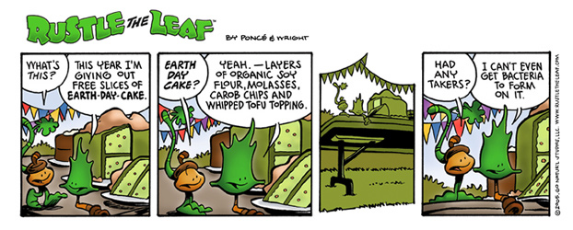

ACCOMPLISHMENTS

In FY 2007, ENRD successfully litigated 881 cases while working on a total of 5,459 cases and matters. The estimated value of federal injunctive relief (i.e., clean-up work and pollution prevention actions by private parties) as a result of cases litigated by ENRD in FY 2007 was $6.7 billion. In addition, as a result of ENRD’s affirmative civil and criminal enforcement efforts, the Division imposed $480 million in civil penalties, cost recoveries, criminal fines, restitutions and criminal supplemental sentences in FY 2007. ENRD achieved a favorable outcome in 96 percent of cases resolved. Below are notable successes from the Division’s civil and criminal litigation dockets.

Civil Cases

- Tribal Trust Cases

The extraordinarily complex and multifaceted Tribal Trust Cases continue to command a large portion of ENRD’s time and resources. Over the past several months, the Division has engaged in a number of activities, including ADR and settlement, to defend the government’s interests against 104 filed claims of trust mismanagement. In response to a December 31, 2006 deadline for the filing of certain claims, 72 of the current 104 cases were filed in the first quarter of FY 2007. This “filing frenzy” has required an immense amount of coordination, research, communication, and motions practice over the past several months. The substantial activity in the Tribal Trust cases has also required the identification, acquisition, and propagation of volumes of discovery and related litigation documents. Through the end of FY 2007, ENRD has acquired, processed, and produced over 28 million pages of tribal records relevant to the 104 Tribal Trust cases.

- Cobell/Tribal Trust Settlement Legislation

ENRD has been actively involved in developing the Administration’s proposal to settle the Cobell and Tribal Trust litigation and to improve management of Indian trust assets. There have been numerous activities on this front during FY 2007, including (1) preparation and transmission of a letter from Attorney General Gonzales and Secretary Kempthorne to key Congressional leaders on the settlement proposal, and (2) a hearing at which the Associate AG testified in support of the proposal. We expect to continue to be involved in these matters in FY 2009. Personnel from various ENRD litigating sections have come together to help shoulder some of the burden of newly-filed Tribal Trust cases; one Law & Policy Section (LPS) attorney has taken on some tribal trust work, and another will be taking on a Natural Resources Section (NRS) case to enable NRS to reallocate its assignments to accommodate the newly-filed tribal trust cases.

- Helping to Ensure National Security

In FY 2007, the Division filed new cases for such diverse military installations as the Navy’s Air Facility, El Centro; the Harvey Point Defense Testing Facility; the Naval Computer and Telecommunications Area Master Station; the Army’s Gowen Field Training Area in Idaho; and the Air Force’s Seymour Johnson Air Force Base and Travis Air Force Base. In addition, ENRD continued its litigation efforts in existing cases such as that involving property at Eielson Air Force Base in Alaska, a case which concerns complex lease issues arising from the military’s “section 801 housing” project, pursuant to which the military leased land on installations to private developers who constructed military housing that was leased back to the military.

- Resolving Historic Indian Claims Commission Litigation

The Environment Division resolved the final remaining action by a tribe filed with the Indian Claims Commission (ICC), which was constituted in 1946 and retired in 1978, in the case of Pueblo de San Ildefonso v. United States. The “Pueblo de San Ildefonso Claims Settlement Act of 2005," which was necessary to implement our negotiated settlement, became law in September 2006. The final hearing before the Court of Federal Claims occurred in the first quarter of FY 2007, at which time Pueblo representatives and the United States executed stipulations and the court entered final judgment. The settlement resolves the last of 615 petitions for compensation for historic wrongs filed by tribes with the Indian Claims Commission. Also, in Pueblo of Isleta v. United States, the Division completed a favorable settlement in an action brought under a Special Jurisdictional Act for a Pueblo that failed to file an action with the Indian Claims Commission. The court entered judgment in FY 2007, ending what appears to be the last of the historic Indian claims docket at the Court of Federal Claims.

- Clean Air Act Enforcement

During the past year, ENRD continued to successfully litigate Clean Air Act (CAA) claims against operators of coal-fired electric power generating plants. The violations arose from companies engaging in major life extension projects on aging facilities without installing required state of the art pollution controls, resulting in tens of millions of tons of excess air pollution that has adversely affected the health of the elderly, the young, and asthma sufferers, degraded forests, damaged waterways, and contaminated reservoirs. This year, the Division achieved a notable Supreme Court victory upholding the Environmental Protection Agency (EPA) interpretation of the CAA that underlies many of these enforcement efforts. In Environmental Defense v. Duke Energy Corp., the Supreme Court, in a 9-0 decision, agreed with the United States that the lower courts had impermissibly reviewed the validity of EPA’s Prevention of Significant Deterioration (PSD) regulations, which they lacked authority to do under the CAA.

In United States v. East Kentucky Power Cooperative, ENRD obtained a consent decree that resolved claims under the CAA’s New Source Review (NSR)/PSD provisions, under which EKPC agreed to system-wide tonnage limits on its emissions of SO² and NOx reducing annual emissions by approximately 50,000 tons per year. In United States v. Wisconsin Electric Power Company, the district court entered an amended consent decree, nearly four years after its lodging. This system-wide power plants settlement requires WEPCO to install pollution control equipment at an estimated cost of $620 million and pay a $3.1 million civil penalty. The Division also obtained the first consent decree with an electric utility, Nevada Power Co., for violations at a gas-fired plant. Pursuant to the consent decree, Nevada Power will install approximately $60 million in pollution controls to secure significant reductions of NOx from four of its operating units. The settlements achieved thus far will, when fully implemented, remove almost two million tons of pollutants from the air each year.

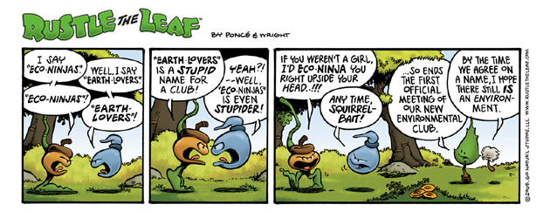

- Addressing Air Pollution From Oil Refineries

The Division also made progress in its national initiative to combat CAA violations within the petroleum refining industry by obtaining consent decrees with three more refiners: Total Petrochemical USA Inc., Valero Energy Corporation, and Hunt Refining Co. Total agreed to pay a $2.9 million penalty and upgrade pollution controls to resolve claims under the CAA. The changes to its facility, estimated to cost $37 million, will significantly reduce the facility’s emissions of air pollutants, ultimately reducing annual emissions of NOx, SO₂, and carbon monoxide by more than 180, 800, and 120 tons, respectively. Valero agreed to pay a $4.25 million penalty and install $232 million worth of new and upgraded pollution controls at refineries in three states. The controls will eventually reduce annual emissions of NOx and SO₂ by more than 1,870 and 1,810 tons per year, respectively, and will result in additional reductions of carbon monoxide, volatile organic compounds, and particulate matter from each of the refineries. Valero will also spend $1.6 million on mitigation projects. Hunt agreed to pay a $400,000 civil penalty and spend more than $48.5 million for new and upgraded pollution controls at three refineries to resolve claims under the CAA. The work is expected to reduce more than 1,250 tons of harmful emissions annually from the company’s refineries. The States of Alabama and Mississippi joined in the settlements.

With these settlements, ENRD’s petroleum refinery enforcement initiative will have addressed more than 92 individual refineries – comprising approximately 85% of the nation’s refining capacity – and will reduce air pollutants by more than 325,000 tons a year.

- Enforcement of the Clean Water Act Through Publicly Owned Sewer Cases

Through its aggressive national enforcement program, ENRD continued to protect the nation’s waterways by ensuring the integrity of municipal wastewater treatment systems. The Division lodged a consent decree with the City of Indianapolis, resolving claims relating to discharges from the City’s sanitary sewers and overflows (SSOs) from the portions of its sewer system where storm water and sanitary sewage are combined (CSOs). The City will implement a long-term control plan at an estimated cost of $1.86 billion, perform a pollution reduction SEP valued at $2 million, and pay a civil penalty of $1.17 million. In a landmark settlement with federal, state, and county authorities, the defendant in United States v. Allegheny County Sanitary Authority agreed to a comprehensive plan to greatly reduce the annual discharge of billions of gallons of untreated sewage into local waterways. ALCOSAN has agreed to a multi-year strategy to upgrade the sewage systems serving Pittsburgh and 82 surrounding municipalities at a cost in excess of $1 billion. The settlement also requires ALCOSAN to pay a $1.2 million penalty for past CWA violations, and to undertake $3 million in environmental projects.

- Enforcement Under Comprehensive Environmental Response, Compensation and Liability Act (“CERCLA” or “the Superfund Act”)

The Environment and Natural Resources Division secured the commitment of responsible parties to clean up additional hazardous waste sites, at costs estimated in excess of $270 million, and recovered approximately $200 million for the Superfund to help finance future cleanups. Examples of some of the major Superfund cases resolved by the Division this year include: United States v. Kennecott Utah Copper Corporation (defendant to spend approximately $15 million to remedy groundwater contamination caused by past mining operations at the Bingham Canyon mine in Utah); United States v. MidAmerican Energy Company (defendants to pay $4.6 million in past costs and assist EPA’s response actions at the LeMars Coal Gas Superfund site in Iowa); United States v. Frazer Exton Development Corp. (defendant to perform $22 million remedial action and pay 50% of EPA’s unreimbursed costs at the Foote Mineral Superfund site in Chester, PA); United States v. Exxon Mobil Corporation (101 defendants to ensure a site-wide $48 million cleanup of the Beede Waste Oil site in Plaistow, NH, pay more than $9 million for future federal and state oversight costs, and $17 million in past federal and state response costs); United States v. EPEC Polymers, Inc. (defendant to remediate two of the three remaining known contaminated areas of the Turtle Bayou site in Liberty County, TX, at an estimated cost of $13.4 million; reimburse the United States for $6.9 million of past costs and interim costs estimated at $1 million; and pay the United States’ future response costs, estimated at $2.1 million).

- Defending the Constitutionality of the Superfund Law

In addition to its enforcement actions to secure the cleanup of hazardous waste sites, the Division has also successfully defended lawsuits aimed at interfering with cleanup actions by EPA and other federal agencies. For example, in United States v. Capital Tax Corp., a Superfund cost recovery and penalty action involving the National Lacquer and Paint site in Chicago, the defendant brought counterclaims alleging an EPA pattern and practice of unconstitutional implementation of its administrative order authority under section 106 of CERCLA. The Division prevailed on a motion to dismiss. The court found that the company lacked standing and, in the alternative, that there is no due process violation because the unilateral administrative order recipient gets a pre-deprivation hearing, thus upholding the constitutionality of key enforcement.

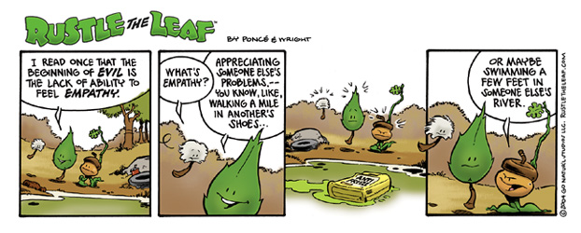

- Defending Fish and Wildlife Service’s Endangered Species Act Listing/Critical Habitat Program

The Endangered Species Act (ESA) requires either the Fish and Wildlife Service (FWS) or the National Marine Fisheries Service (NMFS), depending on the species, to determine whether a species should be listed as endangered or threatened under a set of five criteria and to designate critical habitat for listed species. In FY 2007, we had notable success defending such determinations. In Alabama-Tombigbee Rivers Coalition v. Kempthorne, the Eleventh Circuit rejected an industry trade group’s challenges to the FWS’s listing of the Alabama Sturgeon under the ESA as an endangered species. The court found that there was substantial evidence in the record that the Alabama sturgeon was not the same fish as the shovelnose sturgeon, a much more plentiful species. In American Wildlands et al. v. Norton et al., the court upheld a FWS listing determination for the westslope cutthroat trout on the basis that the Service’s use of morphological data, as well as genetic data, to identify the species was reasonable. In National Association of Homebuilders v. Kempthorne, the court agreed with the Division’s argument that the FWS’s decision not to list the pygmy owl was reasonable, where the population in the United States was peripheral to a large pygmy-owl population in northern Mexico. In Home Builders of N. Cal. v. FWS, the court upheld FWS’s designation of critical habitat for 15 vernal pool species, where certain California lands had been excluded because they already had adequate management plans. In Alsea Valley Alliance v. Lautenbacher, the Division prevailed against a challenge to the NMFS’s decision to list 16 “Evolutionarily Significant Units” of salmon.

- Protecting the Nation’s Wetlands

In June 2006, the Supreme Court issued a splintered opinion in Rapanos v. United States on the extent of federal jurisdiction under the Clean Water Act (CWA) to regulate wetlands and upstream tributaries of navigable waters. In numerous cases in district and appellate courts during FY 2007, the Division has litigated the meaning of the Rapanos decision and the extent of federal regulatory jurisdiction. After Rapanos, the Sixth Circuit Court of Appeals remanded United States v. Cundiff, a civil enforcement action for the illegal filling of wetlands, to the district court, which ruled that the United States had established jurisdiction over the defendants’ wetlands based on both the test enunciated by the plurality and the test put forth in Justice Kennedy’s concurring opinion in Rapanos. The court ordered defendants to perform the government’s proposed restoration plan.

United States v. Fabian is a CWA civil enforcement action in connection with the unauthorized filling of wetlands located along the Little Calumet River in Indiana. The Division obtained a favorable decision on summary judgment in this case. The court found that the United States had demonstrated that defendant’s property contained wetlands that were within federal jurisdiction under the CWA and that defendant had added pollutants to the wetlands. In United States v. Bailey, the Division worked with the U.S. Attorney’s Office to obtain a favorable ruling in a civil enforcement action for violations of the CWA in wetlands adjacent to Lake of the Woods in Minnesota. The defendant constructed a one-quarter mile long road in wetlands abutting the lake. In granting summary judgment for the government, the court held that the United States can establish regulatory jurisdiction under either Justice Scalia’s plurality opinion, or Justice Kennedy’s concurring opinion in Rapanos.

- Successfully Defending the U.S. Army Corps of Engineers’ Clean Water Act Permits

ENRD successfully defended permitting decisions by the Corps under Section 404 of the CWA in a number of cases. In Natural Resources Defense Council v. Army Corps of Engineers, plaintiffs challenged a regional general permit issued by the Corps regulating discharges of dredged and fill material into waters of the United States in a 48,000-acre area in the Florida Panhandle. The Division prevailed on summary judgment. Bering Strait Citizens v. Army Corps of Engineers was a challenge to a CWA permit issued in connection with the construction and operation of the Rock Creek Mine/Mill Complex and the Big Hurrah Mine, near Nome, Alaska. The Division successfully defended the permit. In Friends of Magurrewock v. Army Corps of Engineers, the Division defeated a motion for preliminary injunction seeking to enjoin a Corps permit issued to the Maine Department of Transportation to fill 6.8 acres of wetlands and riverbed in connection with the construction of an international border crossing between Calais, Maine, and St. Stephen, New Brunswick. The district court found that the Corps had reasonably assessed practicable locations for the international border crossing and reasonably concluded that impacts of the bridge on a nearby wildlife refuge were speculative.

- Protecting the Federal Fisc – Royalties Due to the United States

In BP America Production Co. v. Burton, oil and gas companies that hold federal oil and gas leases on which they owe production royalties to the federal government argued that the Interior Department’s Minerals Management Service (MMS) could not enforce orders to the companies to reaudit past payments for inadequacies for more than the six-year period in the general statute of limitations in 28 U.S.C. 2415(a). The Supreme Court disagreed, holding that the limitations period pertained only to damage actions founded on contracts brought by the United States, not to an agency’s issuance of administrative orders. This holding will require the oil companies involved in the law suit to reaudit their accounts for the years 1989-1996 and could potentially result in tens of millions of dollars of royalty payments owed to the federal government.

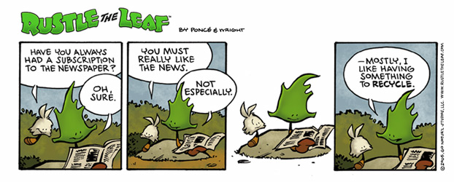

Criminal Cases

- Vessel Pollution Cases

The Vessel Pollution Initiative is an ongoing, concentrated effort to detect, deter, and prosecute those who illegally discharge pollutants from ships into the oceans, coastal waters and inland waterways. The Division continues to have great success prosecuting deliberate violations. In United States v. Overseas Shipholding Group, the defendant pled guilty to and was sentenced on charges that it engaged in conspiracy, obstructed justice, made false statements, and violated the Act to Prevent Pollution from Ships (APPS) and the Clean Water Act, as amended by the Oil Pollution Act of 1990. The offenses – involving twelve OSG oil tankers – involved intentional falsification of oil record books to conceal the discharge of sludge and oil contaminated waste, as well as bypassing required pollution prevention equipment. OSG was sentenced to pay a total of $37 million in penalties, the largest-ever penalty involving deliberate vessel pollution, to serve a three-year term of probation, and to implement a stringent environmental compliance plan.

In United States v. Pacific Gulf Marine, Inc., the defendant, an American shipping company, pled guilty to four APPS violations involving the illegal discharge of hundreds of thousands of gallons of oil-contaminated bilge waste from four of its ships. PGM was sentenced to pay a $1 million fine, to pay $500,000 to fund environmental projects on the Chesapeake Bay and provide environmental education, to complete a three-year term of probation, and to implement an environmental compliance plan. In United States v. Ionia Management S.A., et al., the defendant company, a Greek operator, was convicted by a jury on 18 counts, including falsifying records and presenting false oil record books to the Coast Guard, for overboard dumping of waste oil into international waters. In United States v. Petraia Maritime Ltd., et al., the defendant, a Swedish owner and operator of the M/V Kent Navigator, was convicted on three APPS violations for failure to maintain an accurate oil record book. Coast Guard investigators discovered evidence of illegal bilge waste discharges and concealment of the discharges.

In United States v. Chian Spirit Maritime Enterprises, Inc., et al. al., the named defendant and its Greek owner/operator each pled guilty to one APPS violation, and each was sentenced to pay $1.25 million for misleading Coast Guard investigators during an inspection of the M/V Irene E.M. In United States v. Kassian Maritime Navigation Agency Ltd., et al., the corporate defendant pled guilty to one APPS violation for maintaining a false oil record book and was sentenced to pay a $1 million fine, to serve 30 months probation, and to pay $300,000 to fund community service projects. In United States v. Nicanor Jumalon et al., the defendant, captain of the M/V Sportsqueen, pled guilty to obstruction of justice and was sentenced to serve eight months in prison for illegally dumping oil-contaminated ballast water from the ship. The India-based shipping company, Accord Ship Management Inc., pled guilty and was sentenced to pay a $1.75 million fine and serve a three-year term of probation for conspiracy, an APPS violation, and two counts of obstruction for dumping sludge, bilge wastes, and oil contaminated ballast water from the ship. The Chief Engineer also pled guilty to two obstruction violations and was sentenced to serve five months incarceration.

- Enforcing the Laws Protecting Wildlife

In United States v. James Miller, et al., the defendant and his son each pled guilty for their roles in running a big-game hunting guide operation in Alaska between 1999 and 2001. Miller pled guilty to one felony Lacey Act charge and one felony false statement charge and was sentenced to serve 18 months’ incarceration followed by a three-year term of probation. He also will forfeit his Super Cub aircraft, a hunting rifle, and several hunting trophies. His son was previously sentenced. In United States v. Antonio Vidal Pego, et al., Pego and Vadilur S.A., a Uruguayan corporation, each pled guilty to and was sentenced on charges involving the illegal importation of Patagonian and Antarctic toothfish (also known as Chilean Sea Bass). The government seized more than 53,000 pounds of toothfish, valued at $314,397. Pego pled guilty to obstruction of justice and was sentenced to serve a four-year term of probation and pay a $400,000 fine. Vadilur pled guilty to false labeling, importation of illegally possessed fish, and attempted sale of those fish. The company was sentenced to a four-year term of probation and ordered to pay a $100,000 fine, cease all corporate activities, and dissolve as a business.

In United States v. Jan Swart, d/b/a Trophy Hunting Safaris, et al. al., Swart, a South African big-game outfitter, pled guilty to one felony smuggling violation, and was sentenced to serve 18 months’ incarceration followed by a three-year term of probation. The charge stems from his involvement in a scheme to import five hides and three skulls of leopards illegally killed in South Africa and smuggled to Zimbabwe, before being imported through Denver. In United States v. Jeffrey Diaz, the defendant pled guilty on November 28, 2006, to two felony smuggling counts and two felony false statement counts for smuggling 12 Australian Eagle Owl eggs, and lying about it on customs forms. He was sentenced to serve 21 months’ incarceration, followed by a three-year term of probation, and pay a $5,000 fine. The smuggling of the fertile eggs into the United States from Australia without the required quarantine period posed a tangible threat of disease transmission to humans, including bird flu, as well as a threat to the commercial poultry industry in the form of Newcastles Disease.

In United States v. Panhandle Trading Inc., et al., two corporate and one individual defendant pled guilty to conspiracy to violate the Lacey Act and conspiracy to commit money laundering, for their roles in an illegal catfish importation scheme. The individual was sentenced to serve 51 months’ incarceration followed by a three-year term of supervised release. Both companies will complete five-year terms of probation, and all three defendants will be held jointly and severally liable for $1,139,275 in restitution to the Department of Homeland Security.

- Prosecuting Clean Water Act Violations

In United States v. Moses, the defendant, an Idaho real estate developer used a bulldozer and other heavy equipment to channelize and reroute Teton Creek in an attempt to prevent periodic flooding of an adjacent subdivision that he had developed. When he continued these actions despite repeated orders to stop from state and federal officials, he was indicted for multiple violations of the Clean Water Act (CWA). He was convicted and sentenced to 18 months in prison and fined $9,000. In United States v. Sinclair Tulsa Refining Company, et al., the defendant, a subsidiary of Sinclair Oil, pled guilty to two felony CWA violations. Two company managers each pled guilty to one felony CWA count for manipulating the sampling and discharges of wastewater into the Arkansas River in violation of Sinclair’s NPDES permit. Sinclair was sentenced to pay a $5 million fine, pay $500,000 to fund a community service project on the Arkansas River, and serve a two-year term of probation. In United States v. Acquity Specialty Products, et al., the defendant pled guilty to one CWA violation and was sentenced to pay a $3.8 million fine and complete a three-year term of probation. Acquity admitted that from September 1998 until November 2002, while inspectors conducted sampling, employees altered the wastewater flow in order to distort the sampling results. The Director of Environmental Compliance pled guilty to conspiracy to violate the CWA and was sentenced to pay a $5,000 fine and serve a five-year term of probation.

- Prosecuting Hazardous Waste and Clean Air Act Violations

In United States v. Dennis Rodriguez, the defendant, president and chief operator of North American Waste Assistance, pled guilty to three Resource Conservation and Recovery Act (RCRA) violations, and was sentenced to five months incarceration, followed by five months of house arrest, and a two-year term of probation. Rodriguez generated a manifest that stated 84 drums contained “Non RCRA, Non-regulated hazardous waste” when the drums actually contained an expired petroleum-based compound which was an ignitable hazardous waste. Using the false manifest, he delivered the waste to non-RCRA landfills. In United States v. Dylan Starnes, et al., the defendant, who had been convicted in 2005 on 15 counts, including Clean Air Act (CAA) and false statement violations, was sentenced to serve 33 months’ incarceration, followed by a three-year term of probation. Starnes and his co-defendant did not follow asbestos work practice regulations, and filed false air monitoring reports related to a remediation project in a HUD-funded housing project. In United States v. Citgo Petroleum Corporation, et al., Citgo Petroleum and Citgo Refining and Chemical Company were convicted on two CAA violations. Between 1994 and 2003, the defendants operated tanks that contained oil without installing the proper emission controls. Citgo Refining and Chemical Company was also convicted on three misdemeanor violations of the Migratory Bird Treaty Act. The tanks attracted migratory birds, several of which (including cormorants, pelicans, and several species of ducks) were killed after they landed in the open tanks and became trapped in the oil.

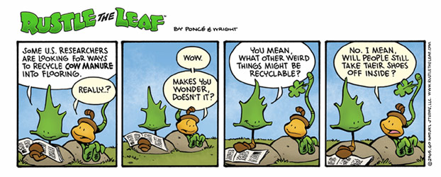

- Performance and Resources Table

Performance and Resources Table (Cont.)

Performance Measure Table

3. Performance, Resources, and Strategies

The Environment and Natural Resources Division contributes to the Justice Department’s Strategic Goal Two: Prevent Crime, Enforce Federal Laws, and Represent the Rights and Interests of the American People; and, more specifically, Strategic Objective 2.7: Vigorously enforce and represent the interests of the United States in all matters over which the Department has jurisdiction. The Division focuses on both civil and criminal litigation within this strategic objective. An explanation by litigating activity follows.

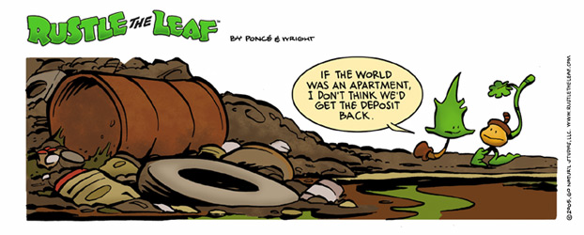

Criminal Litigating Activities
Data Collection and Storage: A majority of the performance data submitted by ENRD are generated from the Division’s Case Management System (CMS). Similarly, EOUSA data are extracted from their CMS.

Data Validation and Verification: The Division has instituted a formal data quality assurance program to ensure a quarterly review of the Division’s docket. The case systems data are monitored by the Division to maintain accuracy.

Data Limitations: Timeliness of notification by the courts.

A. Performance Plan and Report for Outcomes

Vigorous prosecution remains the cornerstone of the Department’s integrated approach to ensuring broad-based environmental compliance. It is the goal of investigators and prosecutors to discover and prosecute criminals before they have done substantial damage to the environment (including protected species), seriously affected public health, or inflicted economic damage on consumers or law-abiding competitors. The Department’s environmental protection efforts depend on a strong and credible criminal program to prosecute and deter future wrongdoing. Highly publicized prosecutions and tougher sentencing for environmental criminals are spurring improvements in industry practice and greater environmental compliance. Working together with federal, state and local law enforcement, the Department is meeting the challenges of increased referrals and more complex criminal cases through training of agents, officers and prosecutors, outreach programs, and domestic and international cooperation.

Performance Results

I. Performance Measure - Percent of Criminal Environmental Cases Successfully Resolved [ENRD Only]

- FY 2007 Target: 85%

- FY 2007 Actual: 94%

- FY 2007 ENRD Resources Expended: $9.95 million

Discussion: FY 2007 proved to be a very strong year for criminal enforcement in ENRD’s Environmental Crimes Section (ECS). Through the end of the fiscal year, the Environmental Crimes Section successfully prosecuted 110 defendants, achieving a 94% success rate, and imposing criminal fines and penalties totaling over $203 million. Successes include one of several vessel pollution cases successfully litigated by ENRD in which the company agreed to pay $37 million in penalties, the largest-ever penalty involving deliberate vessel pollution. The company responsible, Overseas Shipholding Group, was also required to serve a three-year term of probation and required to implement a stringent environmental compliance plan.

The Division also logged a number of successes involving criminal prosecution of federal wildlife laws. In one case of note, United States v. Antonio Vidal Pego, et al., Pego and Vadilur S.A., a Uruguayan corporation, each pled guilty to and was sentenced on charges involving the illegal importation of Patagonian and Antarctic toothfish (also known as Chilean Sea Bass). The government seized more than 53,000 pounds of toothfish, valued at $314,397. Pego pled guilty to obstruction of justice and was sentenced to serve a four-year term of probation and pay a $400,000 fine. Vadilur pled guilty to false labeling, importation of illegally possessed fish, and attempted sale of those fish. The company was sentenced to a four-year term of probation and ordered to pay a $100,000 fine, cease all corporate activities, and dissolve as a business.

FY 2007 Performance Plan Evaluation: Based on the end-of-the-fiscal-year performance data, we exceeded our original goal by 9 percent for FY 2007.

FY 2008/2009 Performance Plan: Considering our past performance, we have increased our targets to 90 percent of cases successfully litigated in FY 2008 and FY 2009. ENRD targets are set lower than the actual performance so that there is no incentive to ramp up prosecutions or lawsuits against insignificant targets for “easy” wins solely to meet higher targets. Such an approach would do a disservice to the public by steering litigation away from more complicated problems facing the country’s environment and natural resources. The past eight years of data demonstrates that our targets, set at achievable levels, have not deterred high performance as shown in the actual successes.

Public Benefit: The Division continues to produce successful criminal prosecutions relating to environmental statutes. These successes ensure compliance with the law and lead to specific improvements in the quality of the environment of the United States, and the health and safety of its citizens. Additionally, ENRD has had numerous successes in prosecuting vessels for illegally disposing of hazardous materials into United States waterways. These successes have improved the quality of our waterways and promoted compliance with proper disposition of hazardous materials. Also, the Division has successfully prosecuted numerous companies for violations of environmental laws which endangered their workers. Our successes lead to safer workplaces and fewer lives lost to hazardous conditions.

II. Performance Measure - $ Awarded in Criminal Environmental Cases [ENRD Only]

- FY 2007 Target: In accordance with Department guidance, targeted levels of performance are not projected for this indicator.

- FY 2007 Actual: $203.3 million

Discussion: Successes in FY 2007 include a number of Vessel Pollution cases, wildlife prosecutions, and criminal violations of both the Clean Air Act (CAA) and Clean Water Act (CWA). Both the depth and breadth of successes in the area of criminal monetary impositions in FY 2007 was particularly impressive. In the Vessel Pollution cases alone, ENRD cases were responsible for over $40 million in federal criminal penalties. In plea agreements announced in October 2007, British Petroleum agreed to pay $50 million in criminal fines for Clean Air Act violations relating to a catastrophic explosion that killed 15 employees and injured at least 170 others, as well as $12 million in criminal fines, $4 million in community service payments, and $4 million in restitution to the state for Clean Water Act violations relating to pipeline leaks onto the tundra and into a frozen lake in Alaska. In one significant Clean Water Act case, United States v. Acquity Specialty Products, et al., the defendant pled guilty to one CWA violation and was sentenced to pay a $3.8 million fine and complete a three-year term of probation. Acquity admitted that from September 1998 until November 2002, while inspectors conducted sampling, employees altered the wastewater flow in order to distort the sampling results. The Director of Environmental Compliance pled guilty to conspiracy to violate the CWA and was sentenced to pay a $5,000 fine and serve a five-year term of probation.

FY 2008/2009 Performance Plan: Not Applicable. In accordance with Department guidance, levels of performance for FY 2008 and FY 2009 are not projected for this indicator. Many factors affect our overall performance, such as proposed legislation, judicial calendars, etc. The performance of the Division also tends to realize spikes and valleys when large cases are decided. Therefore, we do not project annually, but our goal is to improve overall performance over a 5-year span.

Public Benefit: The Division continues to obtain criminal fines from violators, thereby removing economic benefits of non-compliance and leveling the playing field for companies that comply with environmental laws. Additionally, our prosecution efforts deter others from committing crimes and promote adherence to environmental and natural resource laws and regulations. These efforts result in the reduction of hazardous materials and wildlife violations thereby improving the quality of the United States’ waterways, airways, land, and wildlife resulting in improved public health and safety.

B. Strategies to Accomplish Outcomes

The Division will continue efforts to obtain convictions and to deter environmental crimes through initiatives focused on vessel pollution, illegal timber harvesting, laboratory fraud, chlorofluorocarbon (CFC) smuggling, wildlife smuggling, transportation of hazardous materials and worker safety. ENRD will also continue to prosecute international trafficking of protected species of fish, wildlife, and plants with a host of international treaty partners.

International trade in wildlife is second in size only to the illegal drug trade, and our criminal prosecutors work directly on these cases, as well as assist United States Attorneys Offices and share ENRD expertise nationwide with state and federal prosecutors and investigators. We will focus on both interstate trafficking and poaching cases on federal lands, and seek to ensure that wildlife conservation laws are applied uniformly and enforced across the country, seeking consistency in the United States’ position in these criminal prosecutions and a vigorous enforcement program that serves as an international role model.

The Division will also focus on illegal timber cutting and trafficking in FY 2009. This is an issue which has commanded the Administration’s increasing attention. For example, the President’s Initiative Against Illegal Logging has resulted in increasing efforts by the United States to assist other nations in the prevention of timber theft. Surprisingly there appears to be no one federal agency tracking theft of timber within the United States border. Timber theft has for the most part been handled by federal and state authorities on an ad hoc basis; and while most states with large tracts of public land would indicate timber theft is a problem no one authority has taken a lead in coordinating the investigation and prosecution of timber theft. ENRD is prepared to take the lead on this important issue.

ENRD has partnered with other federal agencies, such as EPA, to pursue litigation against criminal violators of our nation’s environmental policies. Egregious offenders are being brought to justice daily. The Division has worked collaboratively to identify violators who pose a significant threat to public health. By prosecuting criminal violations of regulations, ENRD is forcing compliance and discouraging continued disregard for public health.

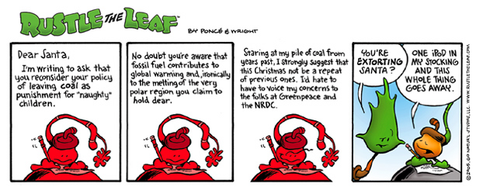

Civil Litigating Activities

Data Collection and Storage: A majority of the performance data submitted by ENRD is generated from the Division’s Case Management System (CMS).

Data Validation and Verification: The Division has instituted a formal data quality assurance program to ensure a quarterly review of the Division’s docket. The systems data is constantly being monitored by the Division to maintain accuracy.

Data Limitations: Timeliness of notification by the courts
A. Performance Plan and Report for Outcomes

The Department enforces environmental laws to protect the health and environment of the United States and its citizens, defends environmental challenges to government programs and activities, and represents the United States in all matters concerning the protection, use, and development of the nation's natural resources and public lands, wildlife protection, Indian rights and claims, and the acquisition of federal property.

Performance Results

I. Performance Measure - Percent of Civil Environmental Cases Successfully Resolved [ENRD Only]

- FY 2007 Target:
85% Affirmative; 75% Defensive

- FY 2007 Actual:
97% Affirmative; 92% Defensive

- FY 2007 ENRD Resources Expended: $85.1 million

Discussion: In FY 2007, the Division obtained nearly $6.7 billion in injunctive relief, through litigation or judicially approved consent decrees, that will ensure that harmful sediments are removed from rivers, state of the art pollution control devices are added to factories to provide cleaner air, sewage discharges are eliminated, and damaged land and water aquifers are restored. This extraordinary result made this the second best year in the Division’s history. In addition, the Division successfully resolved one of the largest enforcement cases of all time, the massive case against American Electric Power for alleged Clean Air Act violations, by consent decree lodged on October 9, 2007. Working jointly with eight states and thirteen environmental groups, the Division led the effort to bring the company into compliance with the law and obtain extraordinary pollution reduction. In the wake of the Supreme Court’s recent – and unanimous – decision in which the Division vindicated the Environmental Protection Agency’s position on a key liability issue in these cases, the Division reached a settlement that will require American Electric Power to undertake remedial actions to reduce its emissions of pollutants at an estimated cost of $4.6 billion, the highest value of injunctive relief obtained in any environmental settlement. The environmental impact is enormous. The settlement secures at least 183,000 tons per year of air pollution reductions and is one of the largest percentage decreases achieved in any settlement with a coal-fired electric utility.

The Division also secured a record civil penalty under the Clean Air Act’s acid rain program in a settlement with the East Kentucky Power Cooperative. The Division continued to protect the nation’s air quality by successfully pursuing Clean Air Act claims against oil refineries, automobile manufacturers, and diverse industrial facilities.

ENRD also worked successfully to ensure the integrity of municipal wastewater treatment systems. Each year, hundreds of billions of gallons of untreated sewage are discharged into the nation’s waters from municipal wastewater treatment systems that are overwhelmed by weather conditions they are not adequate to handle. This year, the Division reached settlements with several cities – including two of the largest settlements ever reached, encompassing Indianapolis and the Pittsburgh region – that will collectively provide for more than $4 billion in expenditures to bring these systems into compliance with the Clean Water Act. These settlements will ultimately reduce the volume of untreated sewage discharges by tens of billions of gallons. The Division also protected the nation’s waters and wetlands from illegal fill through favorable settlements of Clean Water Act enforcement actions.

Further, the Division successfully settled the first court action ever brought under the Pipeline Safety Act this year. The settlement of this case – which arose out of a tragic explosion of an El Paso Natural Gas Company pipeline which killed twelve people – will require the defendant to pay a $15.5 million civil penalty and to spend at least $86 million on comprehensive upgrades of its pipeline system.

FY 2007 Performance Plan: Based on end of year performance data, we exceeded our Affirmative and Defensive goals by 12 percent and 17 percent, respectively.

FY 2008/2009 Performance Plan: Considering our past performance, we aim to reach 85 percent Affirmative and 75 percent Defensive (average of 80%) as our rates of cases successfully litigated for FY 2008 and FY 2009. ENRD’s targets are set lower than the actual performance so that there is no incentive to ramp up prosecutions or lawsuits against easy targets solely to meet an “ambitious” goal. This sort of easy approach would do a disservice to the public by steering litigation away from more difficult problems facing the country’s environment and natural resources. The past eight years of data demonstrates that our targets, set at achievable levels, have not deterred the high performance as shown in the actual successes.

The successes delineated in the “Accomplishments” section of this document demonstrate the Division’s effectiveness at defending the nation’s environmental laws. By receiving full base funding in FY 2009, ENRD hopes to maintain our success rates while effectively defending the United States. If ENRD cannot offer a strong defense, the Executive Branch’s ability to enforce regulatory compliance or defend policy challenges may be seriously impaired. For example, the Division’s efforts in the realm of Indian Tribal Trust litigation have been successful to date. However, if ENRD is forced to fully litigate these cases with limited resources, the resulting impact would be delays in resolution and unnecessary expense against the federal coffers.

Public Benefit: The success of the Department ensures the correction of pollution control deficiencies, reduction of harmful discharges into the air, water, and land, clean-up of chemical releases, abandoned waste, and proper disposal of solid and hazardous waste. In addition, the Department’s enforcement efforts help ensure military preparedness, safeguard the quality of the environment in the United States, and protect the health and safety of its citizens.

II. Performance Measure - Costs Avoided and $ Awarded in Civil Environmental Cases [ENRD Only]

- FY 2007 Target: In accordance with Department guidance, targeted levels of performance are not projected for this indicator.

- FY 2007 Actual: $1.482 billion avoided; $274 million awarded

Discussion: The Division enjoyed unprecedented civil litigation successes, concerning cases seeking civil penalties and other monetary recoveries, during FY 2007. During the past fiscal year, the Division continued to successfully litigate Clean Air Act (CAA) claims against operators of coal fired electric power generating plants. These types of violations, litigated out of ENRD’s Environmental Enforcement Section (EES), arise from companies engaging major life extension projects on their facilities without installing required state of the art pollution controls. The resulting tens of millions of tons of excess air pollution has adversely affected human health, degraded forests, damaged waterways, and contaminated reservoirs.

During the past year, the Division continued to successfully litigate Clean Air Act (CAA) claims against operators of coal-fired electric power generating plants. The violations arose from companies engaging in major life extension projects on aging facilities without installing required state of the art pollution controls, resulting in tens of millions of tons of excess air pollution that has adversely affected the health of the elderly, the young, and asthma sufferers, degraded forests, damaged waterways, and contaminated reservoirs. In United States v. East Kentucky Power Cooperative, the Division obtained a consent decree that resolved claims under the CAA’s New Source Review (NSR)/PSD provisions, under which EKPC agreed to system-wide tonnage limits on its emissions of SO₂ and NOx reducing annual emissions by approximately 50,000 tons per year. The reductions will be achieved by the installation of controls estimated to cost $650 million. The decree also requires EKPC to pay a civil penalty of $750,000, and to conduct an environmental mitigation project at a cost of at least $5 million. In a separate landmark settlement, EKPC also agreed to settle claims under the CAA’s acid rain program and pay the largest civil penalty to date under that program – $11.4 million – as well as take steps to reduce approximately 400 tons of harmful emissions annually and offset another approximately 20,000 tons of emissions released from its facility located in Clark County, Ky.
In United States v. Wisconsin Electric Power Company, the district court entered an amended consent decree, nearly four years after its lodging. This system-wide power plants settlement requires WEPCO to install pollution control equipment at an estimated cost of $620 million and pay a $3.1 million civil penalty. In addition, the Division secured an amendment of a 2002 consent decree stemming from the failures of certain coal-fired power plants owned by Public Service Electric Gas in New Jersey to meet emissions reduction requirements in the 2002 consent decree. The newly achieved air pollution reductions are equal or in certain respects superior to those that would have been achieved under the 2002 consent decree. PSEG will also pay a civil penalty of $6 million and perform environmental mitigation measures valued at $3.25 million to reduce particulate matter from diesel engines in New Jersey.

The Division also made progress in its national initiative to combat CAA violations within the petroleum refining industry by obtaining consent decrees with three more refiners, Total Petrochemical USA Inc., Valero Energy Corporation, and Hunt Refining Co. Total agreed to pay a $2.9 million penalty and upgrade pollution controls to resolve claims under the CAA. The changes to its facility, estimated to cost $37 million, will significantly reduce the facility’s emissions of air pollutants, ultimately reducing annual emissions of NOx, SO₂, and carbon monoxide by more than 180, 800, and 120 tons, respectively. Valero agreed to pay a $4.25 million penalty and install $232 million worth of new and upgraded pollution controls at refineries in three states. The controls will eventually reduce annual emissions of NOx and SO₂ by more than 1,870 and 1,810 tons per year, respectively, and will result in additional reductions of carbon monoxide, volatile organic compounds, and particulate matter from each of the refineries. Hunt agreed to pay a $400,000 civil penalty and spend more than $48.5 million for new and upgraded pollution controls at three refineries to resolve claims under the CAA.

The Division furthermore obtained a consent decree in United States v. Mercedes-Benz USA and DaimlerChrysler, AG, resolving claims that the defendants failed to promptly notify EPA of eight separate emission-related defects in a number of different Mercedes vehicles. The CAA requires such prompt notification by auto manufacturers so that the government can consider whether a recall is necessary. In response to the investigation, Mercedes began voluntary recalls for two of the defects at issue and notified owners that it would extend the warranty coverage to address a third defect, at an estimated cost of about $59 million. Under the consent decree, Mercedes agreed to pay a penalty of $1.2 million and to improve its investigation and reporting system to ensure future compliance, at an estimated cost of about $5.4 million.

FY 2008/2009 Performance Plan: Not Applicable. In accordance with Department guidance, levels of performance for FY’s 2008 through 2009 are not projected for this indicator. There are many factors that affect our overall performance, including proposed legislation, judicial calendars, etc. The performance of the Division tends to realize spikes and valleys when large cases are decided. Therefore, we do not project annually, but our goal is to improve overall performance in a 5-year span.

III. Efficiency Measures

1) Total Dollar Value Awarded per $1 Expenditures
[Affirmative / ENRD Only]

2) Total Dollars Saved the Government per $1 Expenditures [Defensive / ENRD Only]

- FY 2007 Target: $76 awarded; $17 saved

- FY 2007 Actual: $117 awarded; $25 saved

Discussion: The Division had a commendable FY 2007 in its efforts to secure commitments by polluters to take action to remedy their violations of the nation's environmental laws. Actions taken by the Division in Federal courts resulted in over $6.79 billion in settlements and court ordered injunctive relief. Additionally, the Division saved the government more than $1.482 billion in defensive litigation. These successes and the Division’s enforcement work have produced significant gains for the public fisc, public health, and the environment. The Division routinely saves the American taxpayer hundreds of millions of dollars – many times the Division’s annual budget.

Accordingly, in FY 2007, ENRD exceeded its ambitious performance goals of (a) total dollar value awarded per $1 expenditure and (b) total dollars saved the government per $1 expenditures.

FY 2008/2009 Performance Plan: Considering the exemplary record in protecting the environment, Indian rights, and the nation’s natural resources, wildlife, and public lands, the Division has continued to establish ambitious targets through FY 2009. The out-year performance goals were set at approximate target levels. Thus, the Division will monitor future year performance levels and make the necessary adjustments to reflect actual performance levels. The Division anticipates continued successes through vigorous enforcement which generally will produce settlements and significant gains for the public and the public fisc.

Public Benefit: The Division’s efforts to defend federal programs, ensure compliance with environmental and natural resource statutes, win civil penalties, recoup federal funds spent to abate environmental contamination, ensure military preparedness, and ensure the safety and security of our water supply, demonstrate that the United States’ environmental laws and regulations are being vigorously enforced. Polluters who violate these laws are not allowed to gain an unfair economic advantage over law-abiding companies. The deterrent effect of the Division’s work encourages voluntary compliance with the environmental and natural resource laws, thereby improving the environment, the quality of our natural resources, and the safety and health of United States citizens.

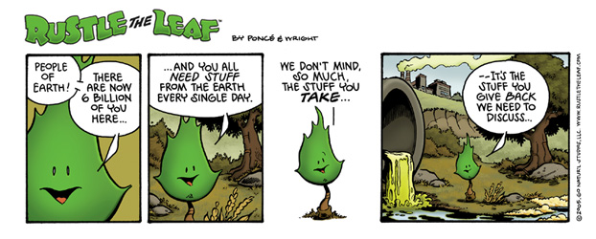

B. Strategies to Accomplish Outcomes

As our environment changes, so do the actions we take to preserve the health and life of those residing within the borders of the United States. Environmental groups and other interested parties challenge Administration policies every year. ENRD is responsible for defending federal agencies carrying out Administration policies every day. The Division has realized some remarkable successes to date. In an effort to continue our successful record of litigation, the Division has sought new and creative ways to utilize our limited resources. ENRD has adopted a policy of “porosity” whereby specialized attorneys are provided an opportunity to work on cases outside of their expertise to gain perspective and depth. This policy has resulted in more flexibility to shift workloads between attorneys when they become overburdened. Although cross-training staff grows our workforce’s skills and abilities, it does not address long-term caseload issues.

The Division works collaboratively with client agencies towards adjudications and settlements. These alternative methods of resolution are less contentious and save the government expenses associated with full-blown litigation. Water rights adjudications, reclamations, and inverse takings cases are typically handled in settlement mode versus litigation mode. Settlements have the best outcome, and reach the largest number of people. In order to continue achieving successful settlements, ENRD must remain committed to collaborative negotiations with all interested parties. If a policy shift occurs, ENRD will be forced to take a more aggressive litigation stance, which would be costly without demonstrating added value for the Federal Government.

The Division’s Environmental Enforcement Section (EES) is turning its attention to toxic air pollutants, mineral processing plant violations of RCRA, and industry practices that result in toxic emissions in violation of the Clean Air Act. EPA has been performing inspections of industries previously protected under the Bevel Amendments, but no longer exempt from the statutory requirements. To date, EPA has found 100 percent non-compliance in these inspections. Numerous resulting case referrals are expected, with ENRD prosecuting as many as our resources will allow.

C. Results of Program Assessment Rating Tool (PART)

During FY 2005, the Division was assessed through the Office of Management and Budget’s (OMB) Program Assessment Rating Tool (PART) along with five other litigating components (Antitrust, Civil Division, Criminal Division, Civil Rights Division, and Tax Division), collectively named the General Legal Activities (GLA) Program. At the end of the assessment, the GLA Program received the highest rating of “Effective.” Other findings showed that:

- The Program effectively achieves its goal of resolving cases in favor of the government. Favorable resolutions, in turn, punish and deter violations of the law; ensure the integrity of federal laws and programs; and prevent the government from losing money through unfavorable settlements or judgments.

- The Program collaborates effectively with its partners, notably the U.S. Attorneys Offices. The two programs work closely to share expertise, make referrals, and designate cases for prosecution, while minimizing any overlap of responsibilities.

- The Program exhibits good management practices. This includes strong financial management, collecting and using performance information to make decisions, and holding managers accountable for program performance.

Additionally, to exhibit continual improvement of business practices, the Program will perform these follow-up actions:

- Seek regular, independent evaluations of the Program's effectiveness at resolving cases in favor of the government;

- Establish a leadership training and mentoring program to continue improving the quality of the program's management; and

- Work with the Department's Chief Information Officer to evaluate and purchase litigation software that will improve productivity and efficiency.

The recent actions initiated in FY 2007, but not completed are as follows:

- After an unsuccessful attempt to get onto the OIG's docket for FY07, the Department is reaching out to the Federal Consulting Group at the Department of Treasury. The FCG assists federal agencies in building an organization's program evaluation and performance measurement capacity.

- Each of the litigating components has developed a leadership training and/or mentoring program, or is in the process of developing one. Over the course of this fiscal year, the litigating components trained 1,817 attorneys and 623 non-attorneys after conducting 682 training sessions. Additionally, 117 new employees are enrolled in a mentoring program.

- Development of LCMS continues towards deployment. Stage 1 completed the JAD sessions bringing users & designers together to review proposed designs. Stage 1 is on track to deploy to 4 USAOs in mid 2008. Stage 2 WG met bi-weekly thru 2007 with Stage 3 components in attendance. Contractors worked w/Stage 2 Divisions (ENRD, CIV and CRT) to complete a requirements tool to project resources & time for implementing LCMS. Requirements planning begins in Spring 2008 with deployment targeted for 2009.

V. E-Gov Initiatives

The Justice Department is fully committed to the President’s Management Agenda (PMA) and the E-Government initiatives that are integral to achieving the objectives of the PMA. The E-Government initiatives serve citizens, business, and federal employees by delivering high quality services more efficiently at a lower price. The Department is in varying stages of implementing E-Government solutions and services including initiatives focused on integrating government wide transactions, processes, standards adoption, and consolidation of administrative systems that are necessary tools for agency administration, but are not core to DOJ’s mission. To ensure that DOJ obtains value from the various initiatives, the Department actively participates in the governance bodies that direct the initiatives and we communicate regularly with the other federal agencies that are serving as the “Managing Partners” to ensure that the initiatives meet the needs of the Department and its customers. The Department believes that working with other agencies to implement common or consolidated solutions will help DOJ to reduce the funding requirements for administrative and public-facing systems, thereby allowing DOJ to focus more of its scarce resources on higher priority, mission related needs. DOJ’s modest contributions to the Administration’s E-Government projects will facilitate achievement of this objective.

A. Funding and Costs

The Department of Justice participates in the following E-Government initiatives and Lines of Business:

Business Gateway | E-Travel | Integrated Acquisition Environment | Case Management LoB
Disaster Assistance Improvement Plan | Federal Asset Sales | IAE - Loans & Grants - Dunn & Bradstreet | Geospatial LoB
Disaster Assist. Improvement Plan - Capacity Surge | Geospatial One-Stop | Financial Mgmt. Consolidated LoB | Budget Formulation and Execution LoB
E-Authentication | GovBenefits.gov | Human Resources LoB | IT Infrastructure LoB
E-Rulemaking | Grants.gov | Grants Management LoB

The Department of Justice E-Government expenses – i.e. DOJ’s share of e-Gov initiatives managed by other federal agencies – are paid for from the Department’s Working Capital Fund. These costs, along with other internal E-Government related expenses (oversight and administrative expenses such as salaries, rent, etc.) are reimbursed by the components to the WCF. The Environment and Natural Resources Division (ENRD) reimbursement amount is based on the anticipated or realized benefits from an e-Government initiative. The table below identifies ENRD’s actual or planned reimbursement to the Department’s Working Capital Fund. As such, ENRD E-Government reimbursement to the WCF is $139,000 for FY 2008. The anticipated ENRD e-Government reimbursement to the WCF is $82,000 for FY 2009.

B. Benefits
ENRD established baseline cost estimates for each IT investment being (or planned to be) modified, replaced, or retired due to the Department’s use of an E-Government or Line of Business initiative. ENRD is measuring actual costs of these investments on an ongoing basis. As ENRD completes migrations to common solutions provided by an E-Government or Line of Business initiative, ENRD expects to realize cost savings or avoidance through retirement or replacement of legacy systems and/or decreased operational costs. The table below represents only those E-Government initiatives and Lines of Businesses where ENRD expects to realize benefits in FY 2008 and FY 2009.

E-Gov Initiative | FY 2008 Benefits ($000) | FY 2009 Anticipated Benefits ($000) | Comments
Enterprise Human Resource Integration | 126 | 126
E-Authentication | 43 | 43
Financial Mgmt. Consolidated LoB | 2,698 | 2698
Human Resource LoB | 201 | 201
Case Management LoB | 1,060 | 1,103

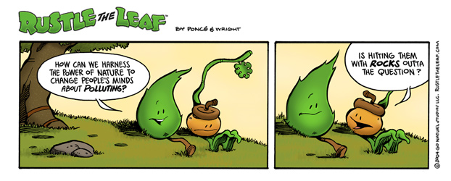

VI. Exhibits
A. Organizational Chart
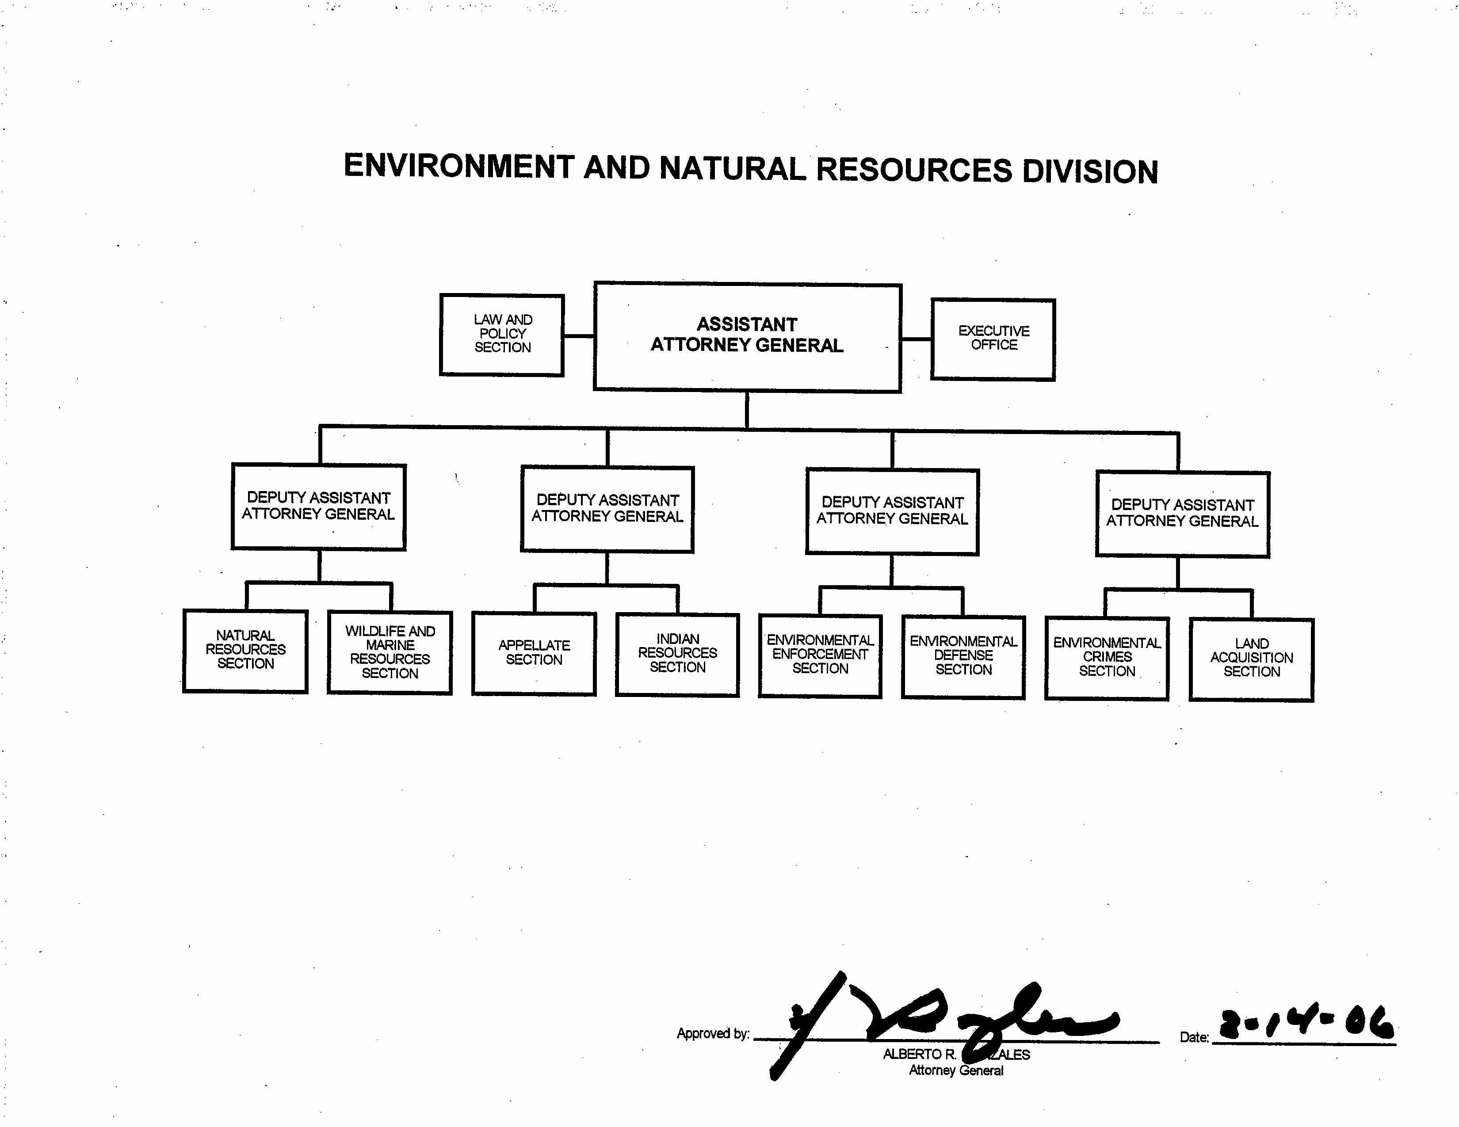

Exhibit A
B. Summary of Requirements

Exhibit B
B. Summary of Requirements (Cont.)

Exhibit B
D. Resources by Department of Justice Strategic Goal and Objective

Exhibit D
E. Justification for Base Adjustments

Exhibit E
E. Justification for Base Adjustments (Cont.)

Exhibit E
F. Crosswalk of 2007 Availability

Exhibit F
G. Crosswalk of 2008 Availability

Exhibit G
H. Summary of Reimbursable Resources

Exhibit H
- Detail of Permanent Positions by Category

Exhibit I
K. Summary of Requirements by Grade

Exhibit K
L. Summary of Requirements by Object Class

Exhibit L

