U.S. Department  of Transportation  Federal Aviation  Administration | Advisory Circular
Subject: DESIGN OF AIRCRAFT DEICING FACILITIES | Date: 2/5/2008  Initiated by: AAS-100 | AC No: 150/5300-14B  Change:

1. PURPOSE. This advisory circular (AC) provides standards, specifications, and guidance for designing aircraft deicing facilities.

2. APPLICATION. The FAA recommends the guidelines and standards in this AC for aircraft deicing facilities. This AC does not constitute a regulation and in general is not mandatory. However, use of these guidelines is mandatory for aircraft deicing facilities funded under the Airport Improvement Program (AIP) and Passenger Facility Charge (PFC) Program. Mandatory terms such as “must” used herein apply only to those who establish aircraft deicing facilities using AIP or PFC funds.

3. CANCELLATION. This AC cancels AC 150/5300-14A, Design of Aircraft Deicing Facilities, dated September 18, 2007.

4. PRINCIPAL CHANGES.

a. Paragraph 3-2, Separation Standards for Off-gate Aircraft Deicing Pads, includes revised text related to a new table 3-1. The revision seeks to reduce accident/incident rates associated with ground deicing/anti-icing operations at deicing pads. The design of permanent deicing facilities calls for the inclusion of vehicle safety zones and vehicle maneuvering areas for deicing pads. The 10-foot (3 m) dimension for the width of the vehicle safety zone is the industry consensus and is recommended by the SAE G-12, Aircraft Ground Deicing/Anti-icing Committee, Subcommittee for Design and Operations of Aircraft Ground Deicing Facilities. In addition, National Transportation Safety Board (NTSB) “Factual Reports” support the need for this revision. Examples include NYCC06LA074 [February 25, 2006], DEN06IA034 [January 19, 2006], and DEN06IA008
[October 10, 2005]. These reports are available from the NTSB Accident Database (http://www.ntsb.gov/ntsb/).

b. New Table 3-1.

(1) Combines and updates former tables 3-1 and 3-2 to offer airport operators the option to locate off-gate deicing facilities in the movement area or non-movement areas (columns #4 and 5). Column #4, off-gate deicing facilities with vehicle safety zones, was added to allocate sufficient separation between deicing pads where the deicing facility will eventually be converted into a permanent off-gate deicing facility. Column #5, off-gate deicing facilities without vehicle safety zones, continues to reflect the practice by airport operators to designate on a temporary basis the use of apron areas, near a departure runway or adjacent to terminal gates, for deicing/anti-icing airplanes. Temporary off-gate deicing facilities may have vehicle safety zones, but they generally lack the on-site infrastructure that is associated with permanent off-gate deicing facilities, such as a snow control center, crew shelter, overhead lighting, or electronic message boards.

(2) Resolves insufficient space between vehicle maneuvering areas, vehicle safety zones, and parked airplanes that may exist for several airplane design groups when applying only taxilane criteria from AC 150/5300-13, Airport Design.

(3) Provides five equations, one per each of the five scenarios in the new table 3-1, that may be used for the justification of a modification of standard that provides an acceptable level of safety to the recommended separation standard. The use of an equation incurs an operational limitation on permitted wingspan for a given deicing pad.

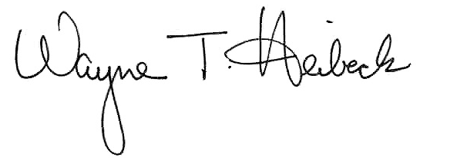

Wayne T. Heibeck
Acting Director of Airport Safety and Standards

This page intentionally blank.

CONTENTS

CHAPTER 1. INTRODUCTION

Paragraph Page

1-1. Overview 1
1-2. Definitions 1
1-3. Project Input 2
1-4. Related Reading Material 2

CHAPTER 2. SIZING AND SITING DEICING FACILITIES

2-1. General 3
2-2. FAA Clearance and Separation Standards Affecting Deicing Facilities 3
2-3. Capacity of Deicing Facilities 4
2-4. Factors Affecting Number of Aircraft Deicing Pads and Deicing Facilities 4
2-5. Factors Affecting Facility Location and Size 5
2-6. Fluid Handling Requirements at Deicing Facilities 6
2-7. Nighttime Lighting 6
2-8. Bypass Taxiing Capability 6
2-9. Multiple Deicing Queues 6
2-10 Topography 6
2-11 Utilities 7
2-12. The Airport Layout Plan (ALP) and Sizing and Siting Facilities 7

CHAPTER 3. DESIGN OF AIRCRAFT DEICING PADS

3-1. Aircraft Deicing Pads 9
3-2. Separation Standards for Off-gate Aircraft Deicing Pads 9
3-3. Fixed Fluid Applicators 9
3-4. Pavement Markings for Off-gate Deicing Facilities 9
3-5. Deicing Pad Layouts 11
3-6. Electronic Message Boards for Off-gate Deicing Facilities 15
3-7 Apron Designs for Off-gate Deicing Facilities 15

CHAPTER 4. AIRCRAFT ACCESS AND VEHICLE SERVICE ROADS

4-1. Aircraft Access Routes 19
4-2. Vehicle Service Roads 19

CHAPTER 5. DESIGN OF INFRA-RED AIRCRAFT DEICING FACILITIES

5-1. Overview 21
5-2. Design Airplane 21
5-3. Infra-red Deicing Facilities (IDFs) 21

Paragraph Page

5-4. Siting of Infra-red Deicing Facilities 21
5-5. Entrance Taxiway 22
5-6. Infra-red Deicing Structure 22
5-7. Nighttime Lighting 23
5-8. Sizing Infra-red Deicing Structures 23
5-9. Optional Equipment – Ice Detection Cameras 24
5-10. Facility Operations Shelter 25
5-11. Computer-Controlled Gas-Powered Infra-red EU Systems 25
5-12. Installation of Infra-red EU Systems 27
5-13. Infra-red EU System Configuration 27
5-14. Computer Hardware/Performance 27
5-15. Anti-icing Capability 28
5-16. Exit Taxiway 28
5-17. Bypass Taxiing Capability 28
5-18. Runoff Mitigation 28

CHAPTER 6. WATER QUALITY MITIGATION

6-1. Runoff Mitigation Structures 29
6-2. Mitigation Alternatives 29
6-3. Publicly Owned Treatment Works (POTWs) 29
6-4. Detention Basins 30
6-5. Underground Storage Tanks (USTs) 30
6-6. Recycling Glycol Fluids 30
6-7. Anaerobic Bioremediation Systems 31

FIGURES

Figure 1-1. Aircraft deicing pad with vehicle maneuvering area 2
Figure 2-1. Separate taxiing entrance to an aircraft deicing facility 7
Figure 3-1(a). Facility taxiway/taxiway holding position marking 12
Figure 3-1(b). Deicing pad identification (“B5”) surface marking at entrance point 12
Figure 3-1(c). Vehicle safety zone surface marking standards 13
Figure 3-2. Example of a common deicing pad layout 14
Figure 3-3. Example of a composite deicing pad layout 14
Figure 3-4. Deicing pad centerlines oriented 45 degrees with the connecting taxiway 14
Figure 3-5(a). Electronic message board instructing the pilot to continue forward to the stop point of the deicing pad 16
Figure 3-5(b). Electronic message board informing the pilot the aircraft has reached the stop point of the deicing pad 16
Figure 3-5(c). An electronic message board alternating information to the aircraft receiving deicing/anti-icing treatment 17
Figure 5-1. FAA Boeing 727-100 taxiing into an infra-red deicing facility 22

TABLES

Table 3-1. Separation criteria for off-gate aircraft deicing pads having parallel taxiways 10
Table 5-1. Protective cover lengths 24
Table 5-2. Horizontal clearances 24
Table 5-3. Acceptance criteria for contamination removal by infra-red EU systems 27

CHAPTER 1. INTRODUCTION

1-1. OVERVIEW. Safe and efficient aircraft operations are of primary importance in the development of any aircraft deicing facility. This AC discusses sizing, siting, environmental runoff mitigation, and operational needs of a deicing facility and how to maximize deicing capacity while maintaining maximum safety and efficiency. Airport managers can construct, within FAA standards, deicing facilities at terminals, on apron areas, taxiways or near departure runways. Furthermore, there are a number of operations issues associated with off-gate deicing facilities that should be evaluated. The Society of Automotive Engineers (SAE) Aerospace Division publication Aerospace Recommended Practice (ARP) 4902, Design and Operation of Aircraft Deicing Facilities, provides a list of operational issues that SAE recommends addressing. It is preferable that the facility’s service provider follow, if possible, one agreed-upon deicing/anti-icing procedure for all users of the facility. One common procedure must minimize the confusion that can occur when several users prescribe a wide range of requirements. The airport operator should address such issues prior to the design of the facility to ensure the facility’s safety benefits can be achieved in an operationally efficient and cost-effective manner.

a. Role of Deicing Facility. The design of deicing facilities should, to the extent practicable, meet the needs of air carriers, as outlined in FAA-approved aircraft ground deicing/anti-icing programs, and all other aviation community users. A key element in this effort is designing a facility that is efficient and offers users operational flexibility. Coordination of an airport authority’s Snow and Ice Control Plan and user’s ground deicing/anti-icing programs, with input from the FAA, will ensure icing conditions affecting the safety of flight are better met.

b. Design Flexibility. This AC identifies aircraft deicing facilities as being either centralized or remote (see paragraphs 1-2(b) and 1-2(c)).

(1) Centralized Deicing Facilities. Centralized deicing facilities, where aircraft receive deicing/anti-icing treatment, can be constructed at numerous sites with increasing constraints toward departure runways. A terminal, for example, is a centralized deicing facility; the gates serve as aircraft deicing pads for deicing/anti-icing operations. Gate areas that cannot meet storm water permitting regulations but can adequately handle deicing/anti-icing demands of users and allow acceptable taxiing times to the departure runway under varying weather conditions should, if practicable, be upgraded environmentally.

(2) Remote Deicing Facilities. Remote deicing facilities allow aircraft to receive deicing/anti-icing treatment. Siting remote facilities near departure runways minimizes the taxiing time between treatment and takeoff. Such facilities also compensate for changing weather conditions when icing conditions or blowing snow are expected to occur along the taxi route taken by aircraft to the departure runway.

1-2. DEFINITIONS.

a. Aircraft Deicing Facility. An aircraft deicing facility is a facility where—

(1) frost, ice, slush, or snow is removed (deicing) from the aircraft in order to provide clean surfaces, and/or

(2) clean surfaces of the aircraft receive protection (anti-icing) against the formation of frost or ice and accumulation of snow or slush for a limited period of time (referred to as the “holdover time”).

b. Centralized Deicing Facility. A centralized deicing facility is an aircraft deicing facility located at the terminal gates/aprons or along taxiways serving departure runways.

c. Remote Deicing Facility. A remote deicing facility is an aircraft deicing facility located along taxiways serving departure runways or near the departure end of runways.

d. Aircraft Deicing Pad. An aircraft deicing pad consists of two areas (see figure 1-1):

(1) inner area for the parking of aircraft to receive deicing/anti-icing treatment, and

(2) outer area for maneuvering two or more mobile deicing vehicles.

e. Holdover Time. Holdover time is the estimated time the application of anti-icing fluid will prevent the formation of frozen contamination on the protected surfaces of an aircraft. With a one-step deicing/anti-icing operation, the holdover begins at the start of the operation; with a two-step operation, at the start of the final anti-icing application. Holdover time will have effectively run out when frozen deposits start to form/accumulate on the treated aircraft surfaces. For departure planning purposes, holdover time guidelines for various anti-icers—such as Types I, II, and IV—are published. Guidelines for holdover times can be found in
SAE ARP 4737, Aircraft Deicing/Anti-icing Methods with
Fluids. The Association of European Airlines (AEA)
notes, “Due to the many variables that can influence
holdover times, these times should not be considered minimum or maximum as the actual time of protection may be reduced or extended, depending upon particular conditions existing at the time.”

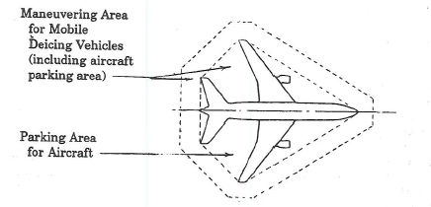
Figure 1-1. Aircraft deicing pad with vehicle maneuvering area

1-3. PROJECT INPUT. Because each airport is unique, deicing/anti-icing needs of users are better addressed when affected parties help identify the requirements for deicing facilities.

a. Affected Parties. Airport management should solicit input from the following parties:

(1) FAA Air Traffic Control, Airports Division, Technical Operations, and Flight Standards Offices,

(2) airport operations chief, environmental manager, and the aircraft rescue and fire fighting chief,

(3) station/operations managers of tenant air carrier and regional or commuter air carriers,

(4) pilot organizations or representatives, air taxis, and general aviation users,

(5) ground deicing managers of air carrier, regional or commuter air carriers, and/or the fixed base operator contracted with the responsibility,

(6) engineering contractor, and

(7) other parties at the discretion of airport management.

b. Other. The FAA recommends that airports involve or inform Federal, state, and local environmental authorities having jurisdiction early in the facility development process to ensure compliance with storm water permitting requirements. Review of deicing facility plans by environmental authorities is a significant step toward compliance with U.S. Environmental Protection Agency National Pollutant Discharge Elimination System (NPDES) storm water permitting requirements.

1-4. RELATED READING MATERIAL. Publications referenced in this AC are available from the following organizations:

a. FAA ACs, www.faa.gov.
b. Society of Automotive Engineers (SAE), 400 Commonwealth Drive, Warrendale, PA 15096-0001, or www.sae.org.

c. The International Organization for Standardization, Case Postal 56, Rue de Varembe, CH-1211 Geneva 20, Switzerland, or www.iso.org.

d. National Fire Protection Association (NFPA), 1 Batterymarch Park, Quincy, MA 02169-7471, or www.nfpa.org.

e. American Society for Testing and Materials (ASTM) International, 100 Barr Harbor Drive, PO Box C700, West Conshohocken, PA, 19428-2959, or www.astm.org.

f. Association of European Airlines, www.aea.be.

CHAPTER 2. SIZING AND SITING DEICING FACILITIES

2-1. GENERAL. Aircraft deicing facilities are recommended at airports where icing conditions are expected. This includes airports that serve aircraft that can develop frost or ice on critical surfaces even though the airport itself does not experience ground icing conditions.

a. Centralized Deicing Facilities at Terminals. For some airports, centralized deicing facilities at or adjacent to terminals can adequately meet the deicing/anti-icing demands of users and still allow acceptable taxiing times to the departure runways under varying weather conditions. Improvements to or expansion of these facilities at terminal gates should, if practicable, include apron drainage areas that collect glycol runoff for proper disposal or recycling.

b. Centralized Deicing Facilities Off the Terminal. Centralized deicing facilities off the terminal are recommended when terminal deicing facilities (including apron facilities) experience excessive gate delays or taxiing times or suffer from severe weather conditions conducive to aircraft ground icing conditions. When the construction cost for runoff mitigation is not cost-effective, terminals with deicing gates that lack permanent environmental runoff structures are candidates for off-terminal deicing facilities.

Centralized deicing facilities have the following basic components:

(1) aircraft deicing pad(s) for maneuvering aircraft and mobile deicing vehicles,

(2) bypass taxiing capability,

(3) environmental runoff mitigation measure,

(4) permanent or portable nighttime lighting system, and, but not necessarily,

(5) deicing crew shelter with kitchen and toilet facilities,

(6) co-located support facilities that may include one or more of the following:

(i) storage tank(s), transfer system(s) for aircraft deicing/anti-icing fluid(s),

- fixed-fluid applicator.
c. Remote Deicing Facilities. Remote deicing facilities located near departure runway ends or along taxiways are recommended when taxiing times from terminals or other centralized deicing facilities frequently exceed holdover times. Under changing weather conditions, they can compensate for icing conditions or blowing snow expected to occur along the taxi route taken by aircraft to the departure runway. These facilities can improve flow control by permitting retreatment of aircraft without having the aircraft return to a more distant treatment site. Remote deicing facilities have the following components:

(1) aircraft deicing pad(s) for the maneuvering of aircraft and mobile deicing vehicles,

(2) bypass taxiing capability,

(3) environmental runoff mitigation measure, and

(4) portable nighttime lighting system.

2-2. FAA CLEARANCE AND SEPARATION STANDARDS AFFECTING DEICING FACILITIES. To ensure aircraft safety, the location and operation of deicing facilities must follow the clearance and separation standards specified in AC 150/5300-13, Airport Design. These standards involve airspace, aircraft separations, FAA Technical Operations facilities critical areas, and Airport Traffic Control Tower (ATCT) line-of-sight criteria.

a. Object Clearance Criteria. Deicing facilities must be sited in accordance with object clearing criteria described in paragraph 211, Object Clearing Criteria, in AC 150/5300-13. When constructing deicing facilities with limited physical space, airports can site the facility in a non-movement area, i.e., areas not under direct ATCT control. Such siting reduces wing tip clearance criteria, thereby allowing closer aircraft separations, i.e., taxilane criteria versus taxiway criteria. In such cases, the airport operator should contact the ATCT to redefine a portion of a movement area as non-movement.

b. FAA Technical Operations. Deicing facilities must be located so as not to cause signal interference or signal degradation to existing FAA radar, navigational aids (NAVAIDs), airport lighting, weather facilities, communications, etc. This includes interference or degradation caused by deicing facilities with fluid storage tanks, crew shelters, and permanent nighttime lighting structures. If any FAA radar, navigational aid improvements are planned, sufficient obstacle clearances, as required by new facilities, must be protected. Some airports may require additional FAA communications equipment to meet the operational needs of the deicing facility. Additional communications equipment installations may result from increased ground control frequencies necessary for the ATCT to provide safe flow of airport ground traffic and to enable ground deicing personnel to conduct safe deicing operations. In all cases, the installation of communications equipment and assignment of frequencies need to be coordinated with FAA Technical Operations prior to the construction of deicing facilities. To further protect FAA installations, sites must be evaluated to assess the impact of jet blast velocities and exhaust deposits.

c. ATCT Line-of-Sight. The deicing facility and its supporting structures must minimize reductions to the ATCT’s visual contact with the movement area. To maintain the ATCT’s visual contact, aircraft being deiced/anti-iced should not obstruct the line-of-sight to active runway ends and their entrance taxiways. To minimize shadows, aircraft with the largest surfaces to be treated should be evaluated. Visual contact of movement areas from planned ATCT cab positions should also be evaluated.

2-3. CAPACITY OF DEICING FACILITIES. Airports should have deicing facilities with a deicing/anti-icing capacity that approximates the airport’s peak hour departure rate that the ATCT can manage during icing conditions. This departure rate helps determine the number of aircraft deicing pads required at a facility or facilities to balance the departure rate and the holdover times of applied deicing/anti-icing fluids so that, to the extent practicable, holdover times are in effect when the pilot receives takeoff clearance. To meet the needs of future aircraft, the FAA recommends an evaluation of aircraft development for a planning period of at least 10 years. This information is available from air carriers (e.g., anticipated airline service and aircraft on order) and airframe manufacturers.

  - FACTORS AFFECTING NUMBER OF AIRCRAFT DEICING PADS AND DEICING FACILITIES.

a. Number of Deicing Pads. Evaluating the impact of the following factors provides a better estimate of the number of deicing pads needed at a facility.

(1) Procedures and Methods of Users. Facility users will perform either one-step or two-step deicing/anti-icing procedures. The latter procedure, routinely used during periods of precipitation, results in longer occupancy times at deicing pads. To provide users with procedural flexibility, the number of deicing pads should be based on the two-step approach. Furthermore, increases to this occupancy time may be needed to reflect differences in the methods used to treat aircraft and perform preflight inspections. It is not unusual for users to supplement preflight inspection items recommended by aircraft manufacturers with additional items for aircraft having special operational considerations.

(2) Variations in Meteorological Conditions. Variations in meteorological conditions, e.g., type of precipitation, increase the extent (and frequency) of the deicing/anti-icing treatment. Airports that commonly experience heavy wet snows or freezing rain should increase the number of deicing pads to maintain departure flow rates at levels that avoid unacceptable delays for subsequent aircraft awaiting treatment. If revised flow control procedures fail to prevent meteorological conditions from frequently degrading the holdover time used for the initial treatment, the airport should consider a facility closer to the active runway. To the extent practicable, there should be a balance between the number of deicing facilities and their location to offset severe meteorological conditions so holdover times are in effect at takeoff.

(3) Type of Aircraft Receiving Treatment. The processing time to deice/anti-ice aircraft for the same weather conditions and fluids varies by aircraft types. Narrow-body aircraft are processed quicker than wide-body aircraft, and aircraft with center fuselage mounted engines, such as DC-10s and Boeing 727s, require additional processing time. Airports with a high percentage of narrow-body aircraft and a low percentage of wide-body aircraft may need additional deicing pads to adequately maintain this particular fleet’s departure demand. A balanced fleet mix may provide a means of increasing a facility’s deicing capacity by relating flow rates of common-sized aircraft to specific deicing pads.

(4) Heating Performance and Volume Capacity of Mobile Deicing Vehicles. Additional deicing pads may be needed if users operate mobile deicing vehicles with small tank capacities or vehicles that require extended periods of time to heat fluids after refilling (that is, times approaching 20 minutes). Nearby refilling points can help offset such increases.

(5) Remote Deicing Facilities. Depending on the airport, construction of a remote deicing facility may counter some of the above factors.

b. Number of Deicing Facilities. The estimated number of deicing pads plus other structural and operational needs of a deicing facility determine the approximate physical space requirement for siting the facility. Once the facility’s overall physical size requirement is known, the search for suitable sites follows within the framework of safety and operational siting factors cited in this AC.

(1) Multiple Deicing Facilities. When the estimated number of deicing pads cannot be physically sited or operationally managed (such as under usual poor weather conditions) at a single site, the airport should consider additional facilities.

(2) Type of Facility User. Airports serving a wide variety of scheduled service by regional or commuter air carriers and nonscheduled service by air taxi, general aviation aircraft, and airline charters may better meet their deicing/anti-icing needs by constructing a separate deicing facility for the group. If a single facility is identified for all airport users, additional physical space may be necessary to meet the specific needs for one of the groups, e.g., for facilities that store fluids, adequate space for storing appropriate deicing/anti-icing fluids for smaller aircraft.

2-5. FACTORS AFFECTING FACILITY LOCATION AND SIZE. The primary factor for siting deicing facilities is the taxiing time that begins with the start of the last step of the deicing/anti-icing treatment and ends with takeoff clearance, such that the holdover times of fluids are still in effect. The analysis should use slower taxiing speeds experienced under winter-contaminated conditions as well as other time-contributing factors specific to the airport. SAE ARP 4737 and ISO 11076, Aircraft – Ground-based Deicing/Anti-Icing Methods with Fluids, provide departure planning holdover time charts for various anti-icers, such as Type I and Type IV, which assist in balancing holdover times and winter taxiing times from the facility to takeoff. Other factors involved in locating facilities follow.

a. Restrictions on Deicing/Anti-icing Fluids. Restrictions on deicing fluid usage can impact the siting of facilities. Though used for the same weather conditions, non-Newtonian fluids, such as Type II and Type IV, provide longer holdover times than Type I, a Newtonian fluid, but they are restricted to aircraft with higher takeoff rotational speeds (e.g., 100 knots or as approved by airframe manufacturers). This restriction may necessitate siting a facility closer to the departure runway in order to serve restricted aircraft or to have separate facilities for the two groups. Also, facility siting may have to take into account airports that are located in very cold climates since Type II fluids have a lower temperature application limit, i.e., -13° F (-25 °C).

b. Effects of Fluid Applicators.

(1) Mobile Deicing Vehicles. Normally, the use of mobile deicing vehicles as compared to fixed-fluid applicators increases the number of suitable sites for facilities by permitting closer construction to active runways. However, for certain airports, a close site may require construction of new service roads and/or staging areas to allow such vehicles to serve the facility.

(2) Fixed-Fluid Applicators. Use of fixed-fluid applicators, such as a gantry, telescopic booms, etc., will limit the number of suitable sites due to height restrictions (see AC 150/5300-13, Object Clearing Criteria). However, this type of applicator may allow airports to reduce vehicle traffic and escorting demands or compensate for the lack of service roads and staging areas. If fixed-fluid applicators are installed, each deicing pad still must have sufficient outer maneuvering area for two mobile deicing vehicles.

c. Fleet Mix. The physical space required by deicing facilities depends to some degree on the fleet mix being served. For instance, airports serving a large variety of aircraft types and sizes may require facilities more flexible and complex than those airports serving predominantly one class of aircraft.

d. Existing Taxiing Routes. Before siting deicing facilities away from the terminal areas, an airport should first evaluate the use of existing taxiways that minimize the taxiing time to the facility and, more important, the subsequent taxiing time remaining between treatment and takeoff.

e. Environmental Runoff Alternative. The cost-effective environmental alternatives available to the airport to control deicer runoff may reduce the number of sites suitable for a deicing facility. For example, land-locked airports near large bodies of water may have to site a facility closer to existing sanitary sewers than to departure runways. It is noted that acceptable alternatives to mitigate deicer runoff will vary according to city, county, and state environmental runoff regulations imposed on each airport site.

f. Integrating Airport Safety Programs. When identifying deicing/anti-icing requirements, the airport should look for ways of integrating current airport safety programs with the operation of the deicing facility, thereby continuing airport safety initiatives. For instance, the runway incursion program at busy airports may be maintained by widening service roads for bi-directional traffic or by designating additional staging areas instead of constructing separate roads. Other potentially affected safety programs include the airport’s Surface Movement Guidance and Control System (SMGCS), Emergency Plan and the Snow and Ice Control Plan. More than likely, there will be changes to the last plan. For instance, the airport may need to reclassify previously non-cleared service roads to departure runways that will be needed by deicing vehicles or authorized personnel for post-treatment exterior checks to priority 1 snow clearing status.

2-6. FLUID HANDLING REQUIREMENTS AT DEICING FACILITIES.

a. Storage Tank and Fluid Transfer System Designs. Overheating, excessive mechanical shearing, or contamination, e.g., from corroded tanks, may degrade the holdover characteristics of non-Newtonian fluids. Non-Newtonian fluids are Type II, Type III, and Type IV. Newtonian fluids are Type I (see SAE ARP 4737, for fluid classifications). To protect the performance characteristics of these fluids from degradation, storage tanks and fluid transfer systems installed at deicing facilities must be designed in accordance with the fluid manufacturer’s recommendations. Fluid transfer systems must be dedicated to the specific fluid being handled to prevent the inadvertent mixing of fluids of different types or different manufactures. Fluid manufacturers should provide the airport manager recommendations about compatible pumps, control valves, piping, and compatible storage tanks. Additionally, SAE ARP 4737 provides industry recommended practices for storage tank and transfer systems.

b. Separate Storage Tank Capacity. Deicing facilities using various types of deicing/anti-icing fluids will require more physical space to permit separate storage of fluids. Fluid manufacturers should always be consulted for storage tank requirements, maintenance, and precautions for currently used fluids and new products entering the market.

c. Tanks, Fill Ports, and Discharge Points Labeling. To avoid cross-contamination of deicing fluids at a deicing facility, all tanks, fill ports, and discharge points must be conspicuously labeled for the type of fluid handled, e.g., SAE TYPE I AIRCRAFT DEICING FLUID, ISO TYPE II AIRCRAFT DEICING FLUID.

2-7. NIGHTTIME LIGHTING. All facilities will provide permanent nighttime lighting structures or have portable nighttime lighting systems available so ground crews have the necessary illumination for deicing/anti-icing operations and pre-takeoff inspections during night or low-visibility conditions. One portable alternative is mobile deicing vehicles with modified lights that provide sufficient illumination for deicing/anti-icing treatments and pre-takeoff inspections during night or low visibility. AC 150/5360-13, Planning and Design Guidelines for Airport Terminal Facilities, table 4-1, provides general lighting requirements for apron-related functions. The height of lighting poles must be in accordance with AC 150/5300-13 Object Clearing Criteria. Permanent nighttime lights should be aimed and shielded to avoid glare to pilots and the ATCT’s line-of-sight without reducing the illumination of critical areas.

2-8. BYPASS TAXIING CAPABILITY. To further maximize departure flows for all departing aircraft, potential sites should have enough physical space to allow bypass taxiing capability for aircraft not needing treatment. This feature permits the facility to receive aircraft that require treatment, while allowing other aircraft to continue unimpeded for departure. Figure 2-1 provides an example.

2-9. MULTIPLE DEICING QUEUES. Gains in deicing capacity at off-gate facilities are possible when deicing pads have individual entrance and exit queuing capabilities (for example, see figures 3-2, 3-3, and 3-4). These features give the ATCT greater flexibility to issue departure clearances without subjecting aircraft to a “first-in/first-out” queuing situation. Such design features are recommended, if practicable, for off-gate facilities that experience extended periods of operation under continuous poor weather conditions.

2-10. TOPOGRAPHY. Topography is a key cost factor in constructing a deicing facility.

a. Final Grades. To reduce construction costs, facilities should be sited on relatively flat land where the natural terrain features conform to the final grades for the ultimate design of the deicing facility.

b. Drainage Areas. Sites with high water tables that require costly subdrainage and a runoff mitigation alternative should be avoided. The final site should readily lend itself to facility runoff mitigation at reasonable cost. AC 150/5320-5, Surface Drainage Design, provides design standards for airfield drainage systems.

2-11. UTILITIES. Although utility considerations are subordinate to other siting factors, the airport manager should evaluate whether to extend electric power, telephone service and sanitary or storm sewers to support an off-gate facility. For some situations, independent service installations or a separate runoff mitigation alternative at the site may be more cost-effective.

2-12. THE AIRPORT LAYOUT PLAN (ALP) AND SITING AND SIZING FACILITIES. Review of the airport’s ALP provides information that should simplify the siting and sizing process. Some ALPs delineate planned land acquisition areas adjacent to airport property for airport development. Consequently, a revision can show areas identified for a deicing facility. Any changes to the ALP should be considered carefully and all changes documented and submitted to the FAA for approval.

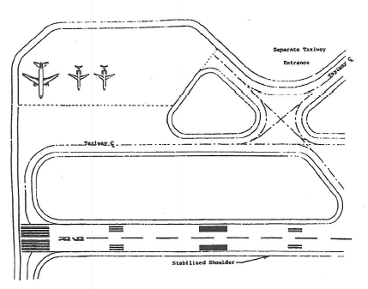

Figure 2-1. Separate taxiing entrance to an aircraft deicing facility

This page intentionally blank.

CHAPTER 3. DESIGN OF AIRCRAFT DEICING PADS

3-1. AIRCRAFT DEICING PADS. The size of an aircraft deicing pad is determined by the aircraft parking area and the maneuvering area for mobile deicing vehicles as shown in figure 1-1.

a. Aircraft Parking Area. This area is the inner area used for parking aircraft to receive deicing/anti-icing treatment.

(1) Width. The width of the parking area equals the upper wingspan of the most demanding airplane design group (ADG) using the deicing pad.

(2) Length. The length of the parking area equals the fuselage length of the most demanding aircraft using the deicing pad.

b. Maneuvering Area for Mobile Deicing Vehicles. This outer area provides the “vehicle lane width” necessary for two or more mobile deicing vehicles to satisfactorily perform simultaneous and complete left- and right-side uniform fluid distribution techniques for removing deposits of frost, ice, slush, and snow from aircraft surfaces and for anti-icing operations. The vehicle lane width must be 12.5 feet (3.8 m) and be mutually exclusive of any adjacent deicing pad. As noted by SAE ARP 4737, “Dual vehicle fluid applications help in eliminating potential aerodynamic problems resulting from fluid applications by a single mobile deicing vehicle.”

3-2. SEPARATION STANDARDS FOR OFF-GATE AIRCRAFT DEICING PADS. Aircraft deicing pads for off-gate facilities will have parallel taxiway centerlines. Separation criteria provided in table 3-1 takes into account the need for individual deicing pads to provide sufficient maneuvering area around the aircraft to allow simultaneous treatment by two or more mobile deicing vehicles (see paragraph 1-2(d)(2) and figure 1-1) and, with the exception of column #5 of table 3-1, sufficient non-overlapping space for a vehicle safety zone (VSZ) between adjacent deicing pads (see paragraph 3-4(d)) and for outer deicing pads. Thus a permanent deicing facility with three deicing pads will have six vehicles maneuvering areas (VMAs) and four VSZs. Table 3-1 observes taxiway centerline to fixed or movable object criteria because VSZs house fixed and movable objects. Furthermore, table 3-1 entries and footnotes ensure that sufficient separation exists between taxi centerlines and VSZs for VMAs. Table 3-1 offers airport operators the option to locate permanent off-gate deicing facilities in the movement or non-movement areas. Column #5, off-gate deicing facilities without vehicle safety zones, reflects the practice by airport operators to designate on a temporary basis the use of suitable apron areas, near a departure runway or adjacent to terminal gates, for deicing/anti-icing airplanes. Temporary off-gate deicing facilities may have vehicle safety zones, but they generally lack the infrastructure that is associated with permanent off-gate deicing facilities, such as a snow control center with a crew shelter, overhead lighting, and possibly electronic message boards.

3-3. FIXED-FLUID APPLICATORS. Fixed-fluid applicators should satisfactorily perform simultaneous and complete left- and right-side uniform fluid distribution techniques for removing deposits of frost, ice, slush, and snow from aircraft surfaces and for anti-icing operations. Fixed-fluid applicators, such as gantries or telescopic booms, can have the advantage of reducing vehicle traffic and lowering the quantities of fluid used. Though fixed-fluid applicators may be the primary deicing applicators for a deicing pad, the pad must have enough maneuvering area for mobile deicing vehicles to provide secondary backup capabilities in case of primary equipment failures.

3-4. PAVEMENT SURFACE MARKINGS FOR OFF-GATE DEICING FACILITIES.

a. Taxiway Centerline Surface Markings. Off-gate deicing facilities will have taxiway centerline surface markings for entering a deicing pad, moving through the deicing pad, and exiting the facility. The surface marking must be in accordance with AC 150/5340-1, Standards for Airport Markings. At airports operating below 1,200 feet runway visual range (RVR), deicing facilities located on a designated SMGCS low-visibility taxi route (see AC 120-57, Surface Movement Guidance and Control System (SMGCS)) may require additional taxiing route surface marking, lighting, and sign systems necessary to support SMGCS operations.

b. Facility Boundary Surface Marking. Off-gate deicing facilities must have a taxiway/taxiway holding position surface marking to indicate the entrance and exit boundary of the facility (figure 2-1). The surface marking, which serves two functions, must be in accordance with paragraph 3-4(b)(1) and (b)(2). This marking reduces incursions by deicing crews and aircraft into the object free area of the connecting taxiway during nighttime or low-visibility conditions. Also, it identifies the ground control transfer points between the ATCT and facility control. Lighted signage may be used instead of surface markings only at the facility entrance. If lighted signs are used, they must be in accordance with AC 150/5340-18, Standards for Airport Sign Systems.
(1) Surface Marking. The taxiway/taxiway holding position surface marking (perimeter of the facility) must be marked in accordance with AC 150/5340-1 (see figure 3-1(a)).

Airplane  Design  Group²  (ADG) | Off-Gate Aircraft Deicing Facilities
Airplane  Design  Group²  (ADG) | Non-Movement Area¹ |  | Movement Area¹
Airplane  Design  Group²  (ADG) | Column #1³  Outer Deicing Pad  Taxi Centerline (CL) to Edge of Vehicle Safety Zone (VSZ) | Column #2³  Interior Deicing Pads  Taxi CL to  Taxi CL | Column #3³  Outer Deicing Pad  Taxi CL to  Edge of VSZ | Column #4³  Interior Deicing Pads  Taxi CL to  Taxi CL | Column #5 ⁴  Temporary Deicing Pads  Taxi CL to  Taxi CL
Airplane  Design  Group²  (ADG) | Includes  1 Vehicle Maneuvering Area (VMA) | Includes  2 VMAs + 1 VSZ | Includes  1 VMA | Includes  2 VMAs + 1 VSZ | Includes  VMAs and no VSZ
ADG VI | 167 ft  (51 m) | 344 ft  (105 m) | 193 ft  (59 m) | 396 ft  (120.5 m) | 324 ft  (99 m)
ADG V | 138 ft  (42 m) | 286 ft  (87 m) | 160 ft  (48.5 m) | 330 ft  (100.5) | 267 ft  (81 m)
ADG IV | 112.5 ft  (34 m) | 235 ft  (71.5 m) | 129.5 ft  (39.5 m) | 269 ft  (82 m) | 215 ft  (65.5 m)
ADG III | 81 ft  (24.5 m) | 172 ft  (52.5 m) | 93 ft  (28.5 m) | 196 ft  (59.5 m) | 152 ft  (46.5 m)
ADG II | 57.5 ft  (17.5 m) | 125 ft  (38 m) | 65.5 ft  (20 m) | 141 ft  (43 m) | 105 ft  (32 m)
ADG I | 39.5 ft  (12 m) | 89 ft  (27 m) | 44.5 ft  (13.5 m) | 99 ft  (30 m) | 74 ft  (22.5 m)
The values obtained from the following equations may be used to show that a modification of standard will provide an acceptable level of safety. Refer to paragraph 6 of AC 150/5300-13 for guidance on modification of standard requirements.

Column No. 1: Taxilane CL to fixed or movable object equals 0.6 times airplane wingspan (WS) plus 10 feet - [(0.6)(WS) + 10] for all ADGs.
Column No. 2: Taxilane CL to parallel taxilane CL with fixed or movable object equals [(1.2)(WS) + 30] for all ADGs, plus with ADG I, wingspans less than 25 feet require sufficient separation for two VMAs and one VSZ.
Column No. 3: Taxiway CL to fixed or movable object equals [(0.7)(WS) + 10] for all ADGs.
Column No. 4: Taxiway CL to parallel taxiway CL with fixed or movable object equals [(1.4)(WS) + 30] for all ADGs, plus with ADG I, wingspans less than 15 feet require sufficient separation for two VMAs and one VSZ.
Column No. 5: Taxiway CL to parallel taxiway CL equals [(1.2)(WS) + 10] for ADGs III – VI. Apply the same equation for ADGs I and II, but wingspans less than 75 feet require sufficient separation for two VMAs and no VSZ.
Note 1: Facilities built in non-movement areas are not under direct ATCT control. Facilities built in movement areas are under direct ATCT control.
Note 2: ADGs are defined in AC 150/5300-13, paragraph 2. Table 3-1 values assume largest airplane wingspan within each ADG.
Note 3: Columns #1 – 4 have a 12.5-foot (3.8-m) wide VMAs and a 10-foot (3-m) wide VSZ.
Note 4: Column #5 has 12.5-foot (3.8-m) wide VMA and no VSZ.

Table 3-1. Separation criteria for off-gate aircraft deicing pads having parallel taxiways

(2) Location. The taxiway/ taxiway holding position marking will be located outside all taxiway/taxilane object free areas (OFAs), runway safety areas, runway obstacle free zones (OFZs), and FAA Technical Operations facility critical areas, e.g., navigation aids (NAVAIDS).

c. Deicing Pad Identification Surface Marking. Off-gate deicing facilities must have the entrance of each deicing pad marked with a deicing pad identification surface marking to assist pilots in identifying the assigned deicing pad. The surface marking is rectangular in shape with alphanumeric inscriptions in accordance with paragraph 28, Surface Painted Taxiway Location Signs, of AC 150/5340-1, with the exception that the rectangle will be symmetrically located on the facility’s entrance taxiway centerline as shown in figure 3-1(b). The location should also facilitate the pilot’s line-of-sight from both directions.

(1) Dual-Sided Operations. Facilities that operate with aircraft entering from either end of the facility must provide a deicing pad identification surface marking at each entrance to the deicing pad with the identifiers facing the pilot.

(2) Composite Deicing Pad Surface Markings. If a single deicing pad will serve as a composite deicing pad (or “grouping”) such as pad #5 in figure 3-3, which incorporates pads #4 and #6, then a single entrance taxiway centerline surface marking will be used for the grouping. After a given distance, the single entrance centerline will separate into individual taxiway centerlines for the incorporated deicing pads. Each individual taxiway centerline entrance within the grouping will be marked with its own deicing pad identifier. Since these pads are used as a grouping, the deicing pad identifiers will use the same alpha character followed by a different numeric character. For example, the pad grouping #4, #5, and #6 would be identified as D2, D1, and D3, respectively, with the main entrance taxiway centerline serving pad #5 designated as D1.

d. Vehicle Safety Zone Surface Markings. Each deicing pad at off-gate deicing facilities must have a vehicle safety zone (VSZ) surface marking on each side of its taxiway centerline in accordance with figure 3-1(c). The VSZ functions as a safety zone for personnel and parked deicing vehicles and other equipment before and after deicing/anti-icing operations. For a composite deicing pad (grouping), such as pads #4, #5, #6 in figure 3-3, two VSZs are provided for the grouping, one VSZ to the left of pad #4 and the other VSZ to the right of pad #6.
(1) Width of VSZs. The minimum width for the VSZ is 10 feet (3.0 m), which restricts vehicle parking to “face-to-face” instead of “side-by-side”.

(2) Overall Length of VSZs. The overall continuous length of the VSZ should offer “trouble-free” parking of the vehicle fleet required to perform the deicing/anti-icing operations. In all cases, the overall continuous length will be such that neither end of the VSZ violates the taxiway/taxilane object free area of taxiways or taxilanes located outside the boundary of the deicing facility. Depending on the jet blast profiles of certain aircraft, the length of the VSZ toward the exit side of the facility may need to be reduced to minimize severe jet blast impacts onto parked vehicles and personnel when the aircraft exits and turns onto the connecting taxiway.

(3) Location of VSZs. Case 1 – Placement of VSZs between adjacent deicing pads will be in accordance with paragraph 3-2 of this AC. Case 2 – Placement of the VSZ on the outermost deicing pad will be in accordance with fixed/movable criteria specified in table 2-3 in AC 150/5300-13.

3-5. DEICING PAD LAYOUTS. Layouts for deicing pads should maximize the flexibility of deicing operations and reduce ATCT workloads. The following layouts provide alternatives for varying weather conditions.

a. Layouts.

(1) Common Deicing Pad Layout. A common deicing pad layout has a single centerline through the deicing pad to guide all sized aircraft. For facilities serving a fleet mix with numerous wide-body aircraft, separating deicing pads for wide-body aircraft from other aircraft may increase deicing capacity (see pad #1 in figure 3-2).

(2) Composite Deicing Pad Layout. A composite deicing pad layout has more than one centerline through the deicing pad to guide different sized aircraft. For facilities serving a balanced mix of different sized aircraft, correlating the percentages of aircraft types to their departure rates may increase deicing capacity (see figure 3-3). When two aircraft use a common centerline, additional parking space between aircraft may be needed to account for exiting jet blast degradation of Type II protective coatings and velocities on personnel/equipment (see paragraph 3-5c(1)).

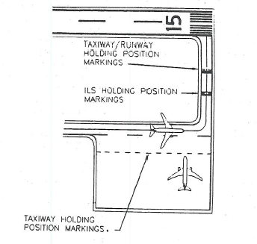
Figure 3-1(a). Facility taxiway/taxiway holding position marking

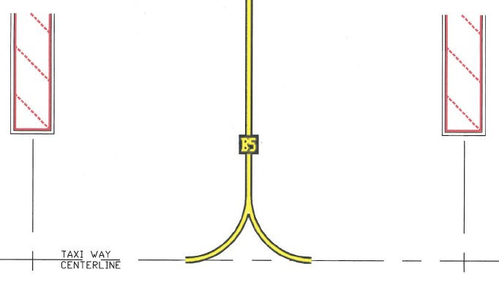

Figure 3-1(b). Deicing pad identification (“B5”) surface marking at entrance point

b. Centerline Orientation.

(1) Frequent High Wind Velocities. Airports that experience frequent high wind velocities should, to the extent practicable, orient the centerlines of deicing pads with the prevailing wind. This allows heated fluids to be applied closer to the surface of the aircraft skin, thereby minimizing heat loss and fluid usage, and takes advantage of the full hydraulic force of the fluid spray. The AEA notes under deicing application procedures, “For maximum effect, fluids shall be applied close to the aircraft surfaces to minimize heat loss.”

(2) Low Visibility. From a winter operational standpoint, low visibility, etc., maintaining the cockpit over centerline reduces the possibility of
excursions from the facility’s taxiways compared to judgmental oversteering. AC 150/5300-13 provides the criteria for ample curve and fillet radii necessary for cockpit-over-centerline taxiing.

(3) Minimizing Facility Depths. Additional suitable sites for airports may be possible by orienting the centerlines of deicing pads so they are non-perpendicular to the connecting taxiway. Figure 3-4 illustrates centerlines oriented 45 degrees to the connecting taxiway. In this case, the facility’s depths serving MD-80s (L=147.8 ft (45.0 m)) and Boeing 737-400s (L=119.6 ft (36.5 m)) would be reduced approximately 43 feet (13 m) and 35 feet (10.6 m), respectively a 30-percent depth reduction. (L is the fuselage length.)

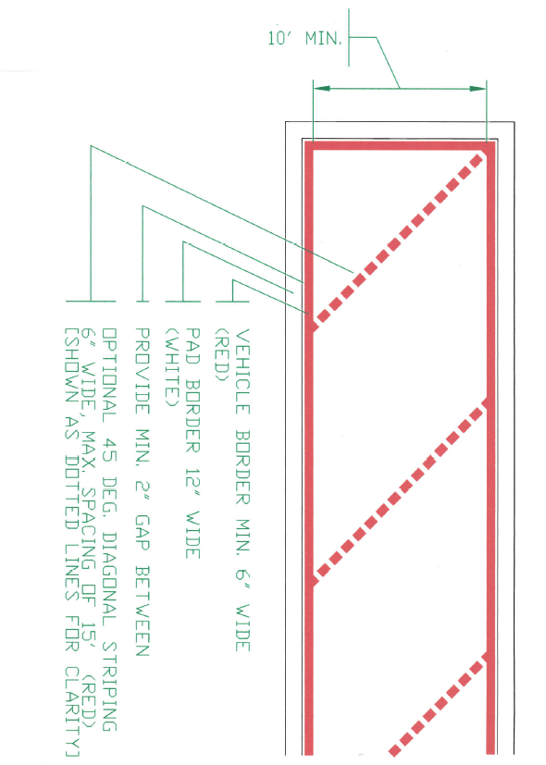

Figure 3-1(c). Vehicle safety zone surface marking standards

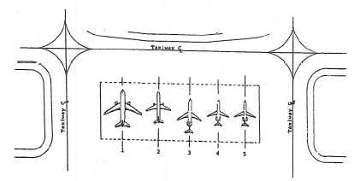

Figure 3-2. Example of a common deicing pad layout

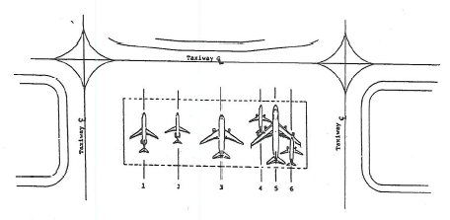
Figure 3-3. Example of a composite deicing pad layout

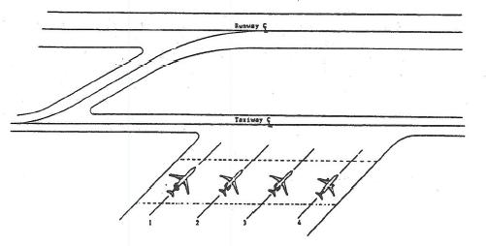
Figure 3-4. Deicing pad centerlines oriented 45 degrees to the connecting taxiway

c. Exiting Jet Blast.

(1) Exiting Aircraft. The deicing pad layout should account for jet blast effects caused by exiting aircraft on other aircraft that are receiving or have completed deicing/anti-icing treatment and on personnel and equipment performing duties. Jet blast velocities on neighboring aircraft can cause a degradation of the protective film coating of Type II fluids, leading to reduced holdover times. Reduced holdover protection also results when taxiing aircraft recirculate snow onto following aircraft when trailing separations are short. As AEA states, “Sufficient distance from the preceding aircraft must be maintained as blowing snow or jet blasts can degrade the anti-icing protection of the aircraft”. AC 20-117, Hazards Following Ground Deicing and Ground Operations Conducive to Aircraft Icing, further warns that in addition to the degradation effects of anti-icing protection, “Be aware that operations in close proximity to other aircraft can induce snow, other ice particles, or moisture to be blown onto critical aircraft components, or allow dry snow to melt and refreeze”. Aircraft manufacturers are the primary source for jet blast pressures and velocity curves.

(2) Mitigation Measures. Mitigation measures may be necessary at deicing facilities to ensure jet blast does not damage parked ground service equipment required at the facility, personnel shelter, and FAA navigational facilities. AC 150/5300-13 describes means of minimizing the effects of jet blast.

3-6. ELECTRONIC MESSAGE BOARDS FOR OFF-GATE DEICING FACILITIES. The use of electronic message boards (EMBs) at off-gate deicing facilities by the service provider (not ATCT) have increased the overall efficiency of deicing/anti-icing aircraft and, additionally, improved the transfer of information between flight crews and service providers. In general, the primary purpose for installing EMBs is to (1) reduce verbal communication between all involved parties; [caution – radio communication is still necessary to inform flight crews when to exit the deicing pad]; (2) provide flight crews with clear, concise information; (3) improve deicing pad operational safety and efficiency; and (4) reduce ground congestion by removing personnel and equipment from the deicing pad area after completing deicing/anti-icing operations. If EMBs are installed, they should be installed in accordance with SAE AS 5635, Message Boards (Deicing Facilities). The SAE aerospace standard defines the minimum content and appearance of the electronic display, functional capabilities, design requirements, and inspection and testing requirements for EMBs. One acceptable location for EMBs is within the vehicle safety zones discussed in paragraph 3-4(d). Figures 3-5(a) through (c) illustrate the types of information exhibited by EMBs at Toronto Pearson International Airport, Toronto, Canada, and Montreal Pierre Elliot Trudeau International Airport, Montreal, Canada.

3-7. APRON DESIGNS FOR OFF-GATE DEICING FACILITIES. Aprons for deicing facilities must have a pavement design that supports the anticipated aircraft loads and directs deicing fluid for collection.

a. Pavement Designs. The pavement must be either a rigid (concrete) or flexible (asphalt) pavement and designed in accordance with AC 150/5320-6, Airport Pavement Design and Evaluation, and AC 150/5320-12, Measurement, Construction, and Maintenance of Skid Resistant Airport Pavement Surfaces. Deicing pads should be grooved to assist in channeling deicing fluids for collection and providing aircraft and personnel better traction.

b. Apron Grades and Surface Gradients. Apron grades and adjacent surface gradients must be in accordance with AC 150/5300-13. Apron areas should direct flows away from deicing pad centerlines, fixed-fluid applicators, vehicle safety zones, and crew shelter. If interior covered drains are used, they must not create a hazard to aircraft and personnel. AC 150/5320-5 provides guidance on high-strength covers.

c. Limit of Apron Perimeter. The perimeter of the facility’s apron must extend such that no aircraft surface being deiced/anti-iced extends beyond it, and it will have a means for collecting or redirecting deicing fluid runoff. One alternative is a trench drainage system. Regardless of the collection alternative, it must not in itself become a hazard to taxiing aircraft or personnel.

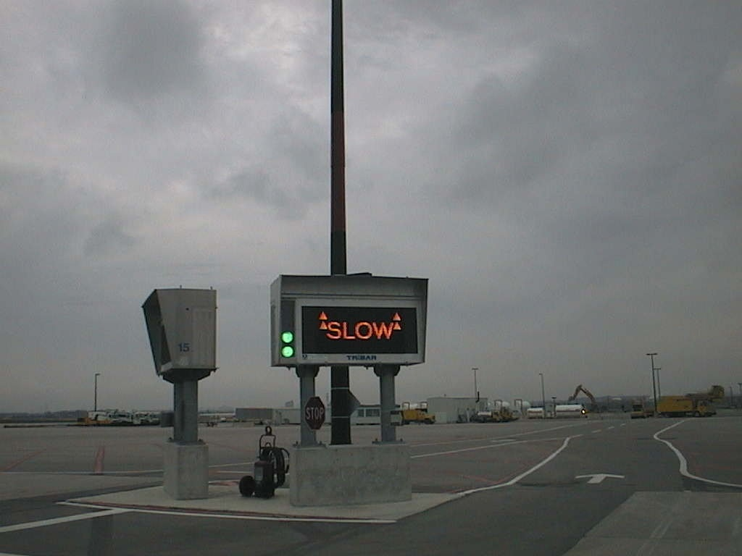

Figure 3-5(a). Electronic message board instructing the pilot to continue forward to the stop point of the deicing pad

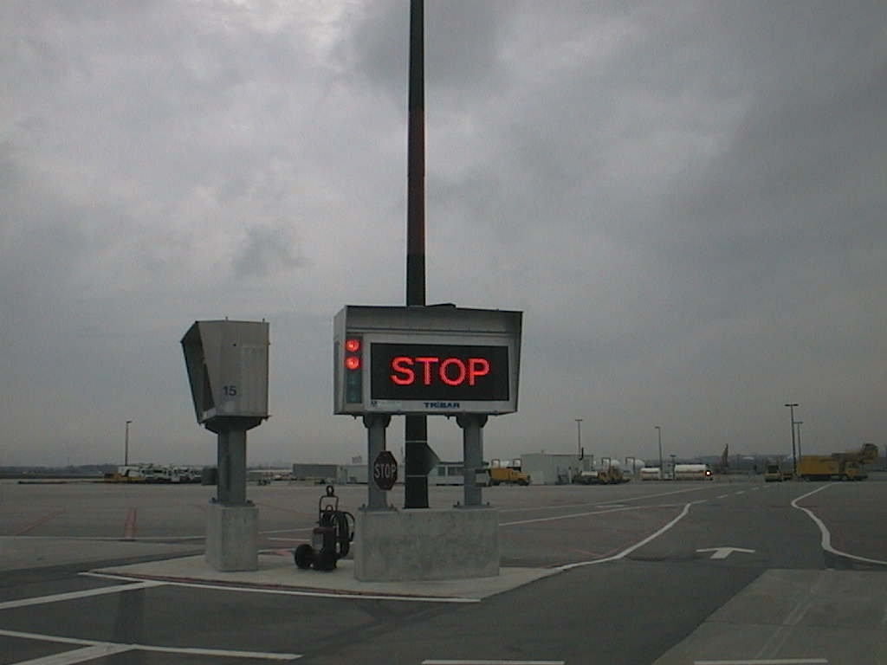

Figure 3-5(b). Electronic message board informing the pilot the aircraft has reached the stop point of the deicing pad

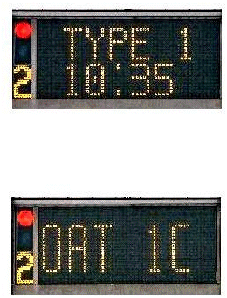

Left-side – Information Display (both images): Red ‘Stop’, Pad Identification

Right-side – Information Display: Fluid Type, Time (Start of Deicing) (top image);
repeat for Anti-icing, if required; alternating with Outside Ambient Temperature (bottom image)

Figure 3-5(c). An electronic message board alternating information to the aircraft receiving deicing/anti-icing treatment

This page intentionally blank.

CHAPTER 4. AIRCRAFT ACCESS AND VEHICLE SERVICE ROADS

4-1. AIRCRAFT ACCESS ROUTES. Deicing facilities will have some form of bypass taxiing capability to accept aircraft requiring treatment without restricting other aircraft access to active runways. Besides supporting departure demand for the anticipated weather conditions, this feature may offer an aircraft a return route for re-deicing when it exceeds its holdover time. The merging of taxiing routes serving the facility with other taxiing routes should allow the ATCT easy directional control to direct aircraft for deicing or clear the aircraft for departure.

a. Holding Bays. Some airports do not have enough physical space for facilities to have a separate taxiway for bypass taxiing capability. One alternative to reducing potential bottlenecks is to expand or construct a holding bay. The size of the holding bay should allow aircraft the maneuverability to be deiced/anti-iced while permitting subsequent aircraft bypass taxiing capability.

b. Design of Taxiing Access Routes for Facilities. Access taxiing routes for facilities will be designed in accordance with AC 150/5300-13, AC 150/5320-6, and AC 150/5320-12. Additionally, taxiing routes should—

(1) have a minimum of turns, taxiway intersections, and runway crossings,

(2) avoid areas that require repeated ATCT clearances, and

(3) not create potential bottlenecks nor operational problems for landing aircraft.

4-2. VEHICLE SERVICE ROADS. Deicing facilities may require vehicle service roads or staging areas to operate more efficiently, to reduce the likelihood of runway incursions by deicing vehicles and ground service vehicles, or to operate the environmental alternative for managing deicing fluid runoff. So as not to compromise the emergency response times of aircraft rescue and fire fighting (ARFF) vehicles when deicing vehicle traffic is heavy on a service road, pullover shoulders should be constructed or similar provisions should be made.

a. Operational Dependency. Usually, centralized facilities depend less on service roads than remote facilities because of their closer proximity to the terminal apron areas. One possible means of lessening the need for service roads at a centralized facility is to install deicing fluid storage tanks and transfer systems or fixed-fluid applicators. Remote deicing facilities are recommended to have a service road when no other means, such as a nonactive taxiway, is available for mobile deicing vehicles and service vehicles to reach the site. This service road will provide authorized personnel the access necessary to conduct outside-the-aircraft and pre-takeoff contamination checks and to perform deicing/anti-icing treatment.

b. Safety Dependency. Reducing potential runway/taxiway incursions by deicing vehicles and ground service equipment is a safety objective. A service road is recommended when no other means is available to separate deicing vehicles and aircraft traffic from sharing a common taxiway route. For some airports, an extension to an existing service road or perimeter road is sufficient. Depending on the airport’s safety programs, physical constraints, etc., service vehicles without the benefit of a vehicle service road may still need to be escorted on taxiway/runways.

c. Environmental Dependency. The environmental mitigation alternative needed to manage deicing fluid runoff may require a service road. For instance, a deicing facility with a detention basin may require an extension of a perimeter road to allow airport vehicles to reach the basin for monitoring and metering out permitted discharges. A deicing facility with an underground storage tank or a concrete vault that requires a hauling truck to siphon contaminants for proper disposal may also need a service road.

d. Service Road Design. Service roads should accommodate deicing vehicle widths and turning radii requirements. Vehicle dimensions and other characteristics related to service road design are described in SAE ARP 4806, Aircraft Deicing/Anti-icing Self Propelled Vehicle, Functional Requirements; SAE ARP 1971, Aircraft Deicing Vehicle – Self-Propelled Large and Small Capacity; and ISO 11077, Aerospace – Self-Propelled De-icing/Anti-icing Vehicles –Functional Requirements. If vehicles use remote staging areas, service roads should be located, to the extent practicable, to minimize runway crossings, repeated ATCT clearances, or airport escorting. Additionally, service roads should—

(1) have the handling capacity to permit the necessary number of deicing vehicles to transport a quantity of fluid that equals the facility’s peak deicing fluid demand.

(2) have clearly defined circulation routes with the minimum of taxiway and runway crossings to reduce potential incursions. Service roads for airports operating under a SMGCS Plan may require vehicle stop signs, stop bars, and other signs and marking to be installed where they intersect an aircraft movement area operating under the plan.

(3) be located so as not to create an aircraft hazard or impede emergency response times of ARFF vehicles.

(4) be bidirectional where vehicle traffic is heavy.

(5) avoid conflicts with future airport development.

(6) not create additional congestion and inconveniences to other users.

CHAPTER 5. DESIGN OF INFRA-RED AIRCRAFT DEICING FACILITIES

5-1. OVERVIEW. The predominant method for deicing airplanes relies on the application of aqueous solutions of freezing point depressant (FPD) fluids. For deicing operations, other methods have been employed, such as the mechanical removal of certain types of contamination from airplane surfaces or the placement of airplanes within a heated hangar to melt or loosen contamination. For anti-icing airplanes, the only acceptable method continues to rely solely on the application of an appropriate anti-icing FPD. Today, all available FPDs are glycol-based products.

Recent developments in the ability of infra-red energy to deliver sufficient, targeted energy to contaminated airplane surfaces, as prescribed in paragraph 5-11, makes infra-red technology, in conjunction with an FAA-approved airplane ground deicing/anti-icing program, an alternative deicing method. This alternative method offers airport authorities an environmental benefit because it is supplemented with little or no FPD during the deicing process. However, since infra-red energy can support only the deicing process, airplanes requiring anti-icing protection must still require an application of an appropriate anti-icing FPD.

This chapter provides design standards and recommendations for building infra-red aircraft deicing facility (IDFs) using a new class of infra-red devices intended for deicing operations; these differ from devices used in the heating industry. Figure 5-1 illustrates an IDF with an entrance taxiway and an infra-red deicing structure; an anti-icing pad is just out of view.

5-2. DESIGN AIRPLANE. The design airplane used to design an IDF will be, in many applications, a composite of several airplanes. A composite allows the designer to take into account the most demanding airplanes’ physical characteristics in terms of size and shape. For example, the composite takes into account maximum tail heights plus their shapes, such as the T- shaped tail section of DeHavilland Dash-8s; vertical heights of wings fitted with winglets, such as the Airbus 320; and variations in fuselage lengths within an airplane family, such as the Boeing 737 family.
5-3. INFRA-RED DEICING FACILITIES (IDFs). IDFs have the following basic components:

a. Entrance taxiway,

b. Infra-red deicing structure,

c. Nighttime lighting,

d. Computerized gas-powered infra-red energy unit (EU) system,

e. Facility operations shelter,

f. Anti-icing capability,

g. Exit taxiway,

h. Bypass taxing capability, and

i. Runoff mitigation measure.

As optional equipment, IDF may have ice detection cameras, as described in paragraph 5-9.

5-4. SITING OF INFRA-RED DEICING FACILITIES. IDFs must be sited in accordance with paragraph 2-2, FAA Clearance and Separation Standards Affecting Deicing Facilities. For air traffic control towers to initiate control and release of aircraft, the perimeter of the facility must be marked in accordance with paragraph 3-4, Pavement Surface Markings for Off-gate Deicing Facilities. With the improved holdover times of current anti-icers, terminal or cargo ramp areas present promising locations for siting IDFs. For some airports, however, acceptable sites along a taxiway may better complement the type of operation in use during the winter season. Regardless of the chosen site, the ground surrounding an IDF needs to be properly graded and prepared to support ARFF vehicles. The requirement for grading provides responding ARFF crews with access to any section of the IDF.

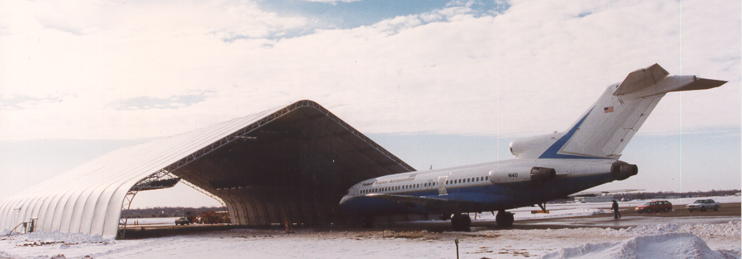

Figure 5-1. FAA Boeing 727-100 taxiing into an infra-red deicing structure

5-5. ENTRANCE TAXIWAY. IDFs will have an entrance taxiway designed, marked, and lighted in accordance with AC 150/5300-13, Airport Design; AC 150/5340-1, Standards for Airport Markings; and AC 150/5345-46, Specification for Runway and Taxiway Light Fixtures. The section of the entrance taxiway leading into the infra-red deicing structure must be straight and long enough to permit the longest airplane to align its entire fuselage with the taxiway centerline prior to entering the structure.

5-6. INFRA-RED DEICING STRUCTURE. IDFs must have an infra-red deicing structure where airplanes are deiced by an infra-red EU system.

a. Modular Truss Design. The structure must be designed in accordance with the building code requirements for the jurisdiction having authority. The structure must be of a modular truss design that offers the owner the flexibility to (1) accommodate changes in airplane physical characteristics and (2) relocate the above-ground portion of the structure on a seasonal basis. The structural components must be of an interchangeable type that offers a range of sizes from the same basic structural components in terms of expandable widths, lengths, and heights, each being independent of the other.

b. Modular Truss Construction and Framing Materials. Modular truss components used for framing must be made of an aluminum alloy or steel. Steel structures must be galvanized in accordance with ASTM A 123, Standard Specification for Zinc (Hot-Dip Galvanized) Coatings on Iron and Steel Products, to resist corrosion. Each supporting column must be designed and anchored—in accordance with the building code requirements for the jurisdiction having authority—to resist imposed static and dynamic forces, such as wind loads and snow loads. All components, including cross members, fasteners, and bolts, must be positively secured to protect against loosening and the possibility of foreign object damage to airplane turbine engines and propellers.

c. Fabric Cover. IDFs must be covered by a fabric material (walls and roof) that is flame-resistant in accordance with the large-scale test in National Fire Protection Association (NFPA) 701, Standard Method of Fire Tests for Flame Propagation of Textiles and Films. Furthermore, the fabric cover must be easy to repair when damaged and of a PVC-coated fabric, as opposed to laminated, to improve durability and to protect the base fabric from ultraviolet light degradation.

d. Lightning Protection. The structure must be fitted with lightning protection in accordance with NFPA 780, Standards for the Installation of Lightning Protection Systems.

e. Structure and Installation Design Codes. The structure must be designed in accordance with the building code requirements for the jurisdiction having authority.

f. Fire Safety Codes. The structure must be designed in accordance with fire code requirements for the jurisdiction having authority.

g. Electrical Code. Electric service for the structure must be designed in accordance with the electric code requirements for the jurisdiction having authority. At a minimum, electrical service must be installed in accordance with the provisions for aircraft hangars contained in Article 513, Aircraft Hangars, of NFPA 70, National Electrical Code®. Furthermore, all wiring not enclosed in conduits/raceways must be adequately supported, laced, or banded to reduce wear and damage as the result of jet blast or prop wash.

5-7. NIGHTTIME LIGHTING. The IDF must provide nighttime lighting within the infra-red deicing structure and, if constructed, for the exterior anti-icing pad. Nighttime lighting helps ground personnel perform deicing/anti-icing processes and airplane inspections more effectively. Interior lighting must be restricted to electric. Lighting for the exterior anti-icing pad must be in accordance with paragraph 2-7, Nighttime Lighting.

5-8. SIZING INFRA-RED DEICING STRUCTURES. The size of infra-red deicing structures must be determined by clearance requirements that separate the structure framing/infra-red EUs from the design airplane.

a. Length of Structure. The length of the structure must equal the length of the design airplane fuselage plus a length for an overhead protective cover (PC). The PC, which is equally divided front and back of the fuselage, serves to reduce or eliminate the amount of falling precipitation onto airplane surfaces. The PC length will be in accordance with table 5-1. Sites customarily experiencing large horizontal dispersion of falling snow and/or frozen precipitation, as can result from strong winds, can minimize such dispersions by orienting the facility centerline perpendicular to such winds.

b. Height of Structure. The height of the structure must be such that the closest point of the infra-red EUs and structural framing clears the most demanding airplane tail section by 10 feet (3.0 m). Care in selecting this dimension is necessary since the vertical heights of airplanes vary according to tire pressures and taxiing weights, e.g. operating design empty weight versus maximum design taxiing weight. Therefore, the designer must take into account the maximum height of all tail sections and their shape as provided by the airplane manufacturer(s).

c. Roof Size. The roof of the structure must be arched to maximize the delivered radiant energy by the infra-red EU system and thereby reduce deicing times. Furthermore, the arched-roof must be designed with open ends and be free of ceiling pockets to eliminate the accumulation of engine exhaust and other vapors. In accordance with NFPA 409, Standard on Aircraft Hangars, a 10-foot (3.0 m) clearance must be provided between the arched framing/infra-red EUs and the most demanding airplane wing configuration, i.e., height of wingtips and winglets. The designer needs to take into account height variations of wingtips, especially for airplanes with winglets, when airplanes are not fully loaded with fuel. For example, Boeing publication D6-58326-1, 747-400 Airplane Characteristics for Airport Planning, shows that winglets on the Boeing 747-400 range from approximately 22 feet (6.7 m) to almost 31 feet (9.3 m) above the ground. The designer must use the highest ground clearances provided by airplane manufacturers.

d. Width of Structure. The width of the structure must provide the clearance measured horizontally between wingtips/winglets and the structural framing/infra-red EUs in accordance with table 5-2.

e. Wall Egress. Each wall must have one egress between two adjacent columns to provide an additional evacuation route for passengers during an emergency. The number of openings must be in accordance with the jurisdiction having authority, but each opening must not be less than 4 feet (1.2 m) by 8 feet (2.5m). The egress must be located behind the wing section and prominently labeled and lighted. If the jurisdiction having authority requires the use of doors, then the doors must be of a non-locking type that open outwards.

f. Floor Design. The floor must be designed to carry the maximum anticipated taxiing weight of the design airplane in accordance with paragraph 3-7(a), Pavement Designs. The floor must be sloped to allow for drainage. If an infra-red deicing structure is placed over an existing taxiway, the taxiway width must be expanded up to the supporting structural columns of the structure. In this case, the transverse grade of the taxiway will be continued for the full-expanded width. The portions of floor that are wider than the existing taxiway must have a load-bearing capacity for the expected vehicle traffic within the structure. The edges of the floor in all cases must be free of any type of continuous curbing.

g. Drainage Design. The floor must be designed to prohibit meltoff and other runoff from ponding within the structure and direct runoff for proper treatment. Any interior drains should be located near the perimeter of the floor to minimize their exposure to aircraft and vehicular traffic. When used, high-strength drainage boxes and covers must be designed in accordance with AC 150/5320-5. Additionally, the design of the drainage system must take into account the ability of the ARFF service to respond unimpeded to emergencies and passengers to evacuate the structure safely. For example, the drainage system leading away from the structure must not be of an open ditch design.

h. Floor Markings. The floor must have two types of markings. First, the floor must be marked with a taxiway centerline in accordance with AC 150/5340-1. Second, the floor must be marked with a nose wheel stop mark to indicate the proper placement of airplanes under the infra-red EU system. The facility operator should determine the shape and color of the stop mark. Since the infra-red EU system offers the operator the flexibility for zonal application of energies—that is, energizing only portions of the system—more than one stop mark may be needed to process smaller airplanes.

5-9. OPTIONAL EQUIPMENT – ICE DETECTION CAMERAS. Infra-red deicing structures may have as optional equipment ice detection cameras that allow facility operators to scan airplane surfaces for the presence of frozen contamination before and after airplanes are exposed to infra-red energy. The cameras must meet the requirements of SAE AS 5116, Minimum Operational Performance Specification for Ground Ice Detection Systems. Cameras may be either a hand-held system or fixed system with color monitors that show degrees of frozen contamination. The color monitor for hand-held cameras are built into the camera itself, while for a fixed system, the color monitor is a separate piece of equipment. If a fixed system is used, the cameras should be placed in a manner that maximizes the surface viewing areas of airplanes.

Airplane Design Group (ADG) | Protective Cover Length¹
ADG II and Smaller | 20 feet (6.1 m)
ADG III and Larger | 30 feet (9.1 m)
Note: 1. PC is equally divided front and back of the fuselage.

Table 5-1. Protective cover lengths

Airplane Design Group (ADG) | Clearance Distance
ADG II and Smaller | 10 feet (3.0 m)
ADG III | 15 feet (4.6 m)
ADG IV and Larger | 20 feet (6.1 m)

Table 5-2. Horizontal clearances

5-10. FACILITY OPERATIONS SHELTER. The infra-red deicing structure must have an enclosed, temperature-controlled shelter for facility personnel, with a separate operations room to house the computer system that controls the infra-red EU system, a printer, color monitor(s) for the fixed infra-red ice detection camera(s), telephones, and other equipment necessary to the operation. The separate operations room is intended to eliminate inadvertent distraction to system operator(s). The operations room must have a window(s) that allows personnel running the infra-red EU system a full view of the operation. The shelter must be located in accordance with the clearances specified in table 5-2. A suitable portable fire extinguisher(s) must be provided in accordance with NFPA 10, Standard for Portable Fire Extinguishers.

5-11. COMPUTER-CONTROLLED GAS-POWERED INFRA-RED EU SYSTEMS. Gas-powered infra-red EU systems must deliver sufficient radiant energy at appropriate wavelengths that target specific types of contamination without damaging airplanes. Furthermore, systems must be computer-controlled to ensure greater operational control and improved efficiency to remove contaminates. Computer control allows specific infra-red EU systems to vary their energy levels and exposure times independently for zonal applications. Thus, operators can tailor the deicing process to tackle differences in airplane types and sizes and variations in the types and thickness of contamination adhering to the airplane. Therefore, systems must deliver infra-red energy in accordance with the two-part test criteria from the following paragraphs.

An independent lab must evaluate the manufacturer’s system to be installed at the airport and analyze the actual energy levels that airplanes will be subjected to. The testing parameters will allow the flexibility for conducting system evaluations either outdoors (preferable due to the separation requirements of the test and limit the size of infra-red EU systems) or in a very large cold chamber. The FAA reserves the right to retest all manufacturer’s infra-red EU systems at its discretion.

a. Purpose of Contamination Removal and Heated Panel Tests. Acceptable infra-red EU systems pass two interrelated tests. Test procedure (TP) #1, Contamination Removal, evaluates the system’s capacity to deliver sufficient focused infra-red energy to remove artificially produced ice layers of specified thicknesses from test panels within specified time frames. Test procedure (TP) #2, Heated Panel, evaluates the system’s performance settings used in TP #1 to evaluate the potential for the system to overheat uncontaminated (cleaned) test panels beyond a prescribed maximum surface temperature. System evaluations must be conducted in accordance with the test methods outlined in paragraph 5-11(d). Although the evaluation tests are based on a 10-foot (3.05 m) separation between the panels and infra-red EU system, the majority of the infra-red EUs within a system in field applications will operate at much greater distances. Infra-red EU systems are intended to work effectively at greater distances, such as 20 to 30 feet (6 to 9 m) or more from some aircraft sections. For example, some infra-red EUs aimed at the midwing sections and the upper fuselage will be placed much more than 10 feet away (3 m).

b. Test Locations and Conditions. Independent labs must conduct evaluations either in a large cold chamber or, preferably, outdoors under the following conditions: cold chamber or ambient outdoor temperature at or below 28 °F ± 2 °F (–2.5 °C ± 1.0 °C) with winds not exceeding 10 mph (16 km/hr.)

c. Independent Testing Lab Report. The independent testing lab report must contain—

(1) for TP #1, the actual observed times necessary to remove completely the contamination thicknesses for each tested panel,

(2) for TP #2, a temperature rise over time profile graph that notes the highest recorded temperature for each tested panel,

(3) photographs showing the system’s setup over the inclined supporting structure that holds the test panels,

(4) separation distances from the infra-red EUs to the test panels,

(5) ambient outdoor or cold chamber temperature and wind conditions at the start and conclusion of the evaluations, and

(6) statement of success or failure for the candidate system. Specific failure(s) of a testing requirement(s) will be noted.

For pass/fail determinations, complete ice removal is defined as the absence of ice, which has undergone a physical change to water or vapor, from the entire upper surface of a test panel, excluding water droplets from the drip edge. Also, since the testing panels are inclined, portions of ice sheets that disbond and slide off the testing panels due to the effect of gravity are considered to be “completely removed”, i.e., meeting the intent of TP #1.

d. Testing Methods and Materials for Contamination Removal and Heated Panel Tests.

Testing Materials:

(1) Test panels, six in all, will be 3-foot square by ⅛⁻inch thick flat sheets of aluminum alloy SAE Aerospace Material Specification (AMS) 4037 in accordance with AMS 1428, Fluid, Aircraft Deicing/Anti-icing, Non-Newtonian (Pseudo plastic), SAE Types II, II and IV, latest edition.

(2) Artificial ice will be produced by freezing ASTM D 1193, Standard Specification for Reagent Water, Type IV water.

(3) Set up an inclined supporting stand (ISS) to secure and support three separated test panels simultaneously in an inclined position. The ISS must be able to secure test panels so the lower drip edge of the test panels are 3 feet ± 1 inch (91.5 cm ± 2.5 cm) above the floor and provide a +10 degree ± 1.0 degree incline from the horizontal. The ISS must have a means to eliminate sagging of the test panel, which in turn may cause breakage of the artificial ice layer (for example, ISSs should have a center structural member to eliminate sagging). Furthermore, ISSs should be on wheels/casters to allow them, once test panels are secured, to be rolled into position beneath the candidate infra-red EU system.

Test Procedure: TP #1
Contamination Removal

Step 1: Setup of Overhead Infra-red EU System. Position the candidate infra-red EU system directly above the ISS with three clean test panels (see 5-11(d)(3) for height requirements) such that the lowest part of the system (EU housing) is at a distance of 10 feet ± 1 inch (3.05 m ± 2.5 cm) above the top of the three test panels. Regardless of the system’s arrangement, all EUs must be at least 10 feet (3.05 m) away from the test panels. Mark the location of the ISS on the floor. Floor markings will later be used to reposition the ISS with secured test panels for actual test runs.

Step 2: Artificial Ice. Prepare six test panels, individually numbered with an artificially produced ice layer. Test panels will have temporary walls attached to their edges to create a ½-inch (1.27 cm) high dam effect. (The dam effect can be obtained by using paraffin wax, silicon, or caulking compound to hold water.) Pour Type IV water into the six test panels to obtain three test panels with a depth of ⅛ inch ± ¹/₁₆ inch (0.32 cm ± 0.16 cm) and three test panels with a depth of ¼ inch ± ¹/₁₆ inch (0.64 cm ± 0.16 cm). To help measure the water depth, five small rubber washers having the prescribed depths can be used. The five rubber washers will be placed in a “T pattern” (not an “X pattern”) one centered and four placed approximately 6 inches (15.25 cm) from the edges. Cold store test panels with washers at 25 to 28 °F (-4.0 to -2.5 °C) for at least 8 hours to allow the Type IV water to freeze completely. All temporary walls are to be removed carefully prior to exposing test panels with infra-red energy.

Step 3: Inclined Test Panels. Carefully place three test panels with ¼-inch ice thickness, separated horizontally by 1 foot (30.5 cm), onto the ISS. Make sure the lower edge of the test panels are slightly below the ISS, approximately ½ inch (1.25 cm), to allow ice melt to flow freely off the inclined test panels. Precaution: Panels need to be secured in a “flat as possible” manner to eliminate ice breakage due to sagging or bending of the test panels.

Step 4: Time Recording. After the infra-red EU system achieves equilibrium (expected settings in actual field operations), roll the ISS with secured test panels underneath the system and reposition the ISS using the step #1 floor markings. Commence time recording immediately. The clock is stopped for each test panel once all observable ice contamination is removed from the entire upper surface. Record the time required for all three test panels. Test panels can have water droplets on the drip edges, and panels need not be completely dried. The longest time duration recorded for this ice thickness will be used to determine acceptance in accordance with table 5-3. Repeat steps #3 and #4 with the ⅛-inch contaminated test panels.

Test Procedure: TP #2
Heated Panel

Step 1: Setup of Overhead Infra-red EU System. Evaluate the identical infra-red EU system and ISS setup used for TP #1, step 1.

Step 2: Acclimated Test Panels. Cold store six clean, uncontaminated test panels at 25 to 28 °F (-4.0 to –2.5 °C) for 3 hours.

Step 3: Inclined Test Panels. Secure three clean, uncontaminated test panels in the same position as described in TP #1, step 3.

Step 4: Thermocouple Placement. Attach two thermocouples down the middle of each test panel so they record the surface temperature of the test panel. Place the first thermocouple 1 foot (30.5 cm) from the top of the test panel. Place the second thermocouple 1 foot (30.5 cm) below the first thermocouple. Cover the housing of the thermocouple in such a manner as to minimize a temperature rise in the thermocouple itself as a result of infra-red energy exposure. Thermocouples used must have an operating temperature reading range from at least +10 to +250 °F (-12 to +121 °C) with a tolerance of 1 ° F (0.5 °C).

Step 5: Time Recording. Energize the infra-red EU system to the same power settings used to remove the ¼-inch ice contamination in TP #1, step 4. Once the system is in equilibrium, reposition the ISS and commence time and temperature recording. Record the continuous surface temperature rise of each test panel for a total exposure time of 10 minutes. Repeat TP #2, steps 3, 4, and 5, for the ⅛-inch power settings. Acceptable systems are those where the maximum temperature rise as measured in step 5 of TP #2 for all six test panels remains below 150 °F (65.5 °C).

Contamination Type and Thickness | Maximum Removal  Time Permitted  (minutes)
⅛-inch Ice | 8
¼-inch Ice | 15

Table 5-3. Acceptance criteria for contamination removal by infra-red EU systems

5-12. INSTALLATION OF INFRA-RED EU SYSTEMS. Installed infra-red EU systems must be gas-fueled. Individual infra-red EUs that comprise the system will be at least 10 feet (3.0 m) away from airplane surfaces for the airplanes expected to use the facility. Gas-fueled infra-red EU systems, which include the gas supply and, if present, storage vessels, must be installed in accordance with NFPA 54, National Fuel Gas Code. The main gas supply system(s) will be equipped with manually operated control valves and emergency safety shutoff valve(s). The manually operated valves must be located at strategic points inside and immediately outside the structure so the main gas supply can be shut down quickly in the event of an emergency. A placard must indicate the location of all red-coded control and emergency safety shutoff valve(s).

5-13. INFRA-RED EU SYSTEM CONFIGURATION.
a. Infra-red Energy Zones. The entire infra-red EU system must be placed in an overhead configuration that provides effective infra-red energy to the design airplane. Additionally, the configuration must consist of independently operated energy zones that allow the operator to use all energy zones in the system or pre-selected energy zones. For example, the operator could use only those energy zones that are better suited for small airplane applications.
b. Maintenance. Infra-red EU systems must be located in areas that do not subject them to damage by aircraft or ground equipment. Provisions must be made to ensure accessibility to individual infra-red EUs for scheduled maintenance purposes.

5-14. COMPUTER HARDWARE/PERFORMANCE.

a. Hardware. Infra-red EU systems must employ computer hardware consisting of a processing unit, color monitor, and printer. The computer must have the operating capability to perform software routines with sufficient speed and memory for data evaluation/records.

b. Software Routines. Software routines may be initiated by keyboard and/or by a touch screen monitor. The software must have a routine that automatically self-imposes a system shutdown when the system itself acknowledges a problem. Furthermore, the software must have routines that allow the operator to—

(1) pre-warm the structure,

(2) regulate the amount of focused infra-red energy through variable power settings to remove the various types of contamination and various airplane configurations,

(3) regulate the duration of infra-red energy application for each power setting,

(4) energize specific infra-red EUs and at different infra-red energies for zonal applications,

(5) shutdown the entire system with a single command button,

(6) print records detailing airplane designation, time of entry to structure, energy settings used and their duration, and time of completion, and

(7) receive warning(s) as required by the authority having jurisdiction to indicate a problem has occurred with the infra-red EU system.

5-15. ANTI-ICING CAPABILITY. IDFs will provide the facility operator with the capability to anti-ice airplanes in one of two ways.

a. Interior Anti-icing Operations. The clearance criteria for sizing infra-red deicing structures is such that sufficient clearance is afforded for deicing trucks to perform anti-icing operations within the structure. Depending on where the infra-red deicing structure is placed, a paved vehicle staging area may be necessary. That is, deicing trucks will have a staging area(s) that allows untreated and treated airplanes to enter and exit the structure safely.
b. Exterior Anti-icing Pad. If a determination is made to perform exterior anti-icing operations, then a dedicated uncovered anti-icing pad will be required. Generally, the anti-icing pad will be located directly in line with the infra-red deicing structure. It is recommended that the anti-icing pad, which consists of the aircraft parking area and the vehicle maneuvering area, be at least 20 feet (6 m) from the opening of the infra-red structure. The anti-icing pad must be marked with a taxiway centerline and lighted in accordance with AC 150/5340-1 and AC 150/5345-46. The length of the anti-icing pad must be in accordance with paragraph 3-1, Aircraft Deicing Pads. The anti-icing pad must be 10 feet (3 m) wider than specified in paragraph 3-1. The 10-foot (3 m) increase is used to provide a 10-foot (3 m) vehicle safety zone for parking and staging mobile deicing trucks.

5-16. EXIT TAXIWAY. IDFs must have an exit taxiway designed, marked, and lighted in accordance with AC 150/5300-13, AC 150/5340-1, and AC 150/5345-46. The section of the exit taxiway leading out of the infra-red deicing structure must be straight and long enough to permit the longest exiting airplane to completely clear the structure before initiating a turn.

5-17. BYPASS TAXIING CAPABILITY. IDFs will provide a taxiway route to by-pass the IDF in accordance with paragraph 2-8, Bypass Taxiing Capability.

5-18. RUNOFF MITIGATION. IDFs must have a runoff mitigation structure(s) that permits proper disposal of glycol-based products in accordance with Chapter 6, Water Quality Mitigation.

CHAPTER 6. WATER QUALITY MITIGATION

6-1. RUNOFF MITIGATION STRUCTURES. Since deicing/anti-icing fluids are chemical products that have environmental consequences that affect the water quality of receiving waters and the aquatic communities that use those waters, deicing facilities must have runoff mitigation structures. The recommended structures are those that compose a mitigating alternative that collects and retains runoff for proper disposal or recycling. In terms of structural best management practices, this approach to “control the source” offers airport managers an effective and economical means of complying with storm water permitting requirements. AC 150/5320-15, Management of Airport Industrial Waste, provides additional best management practices for mitigating various types of pollutants from entering storm water runoff conveyances.

a. Treatment Advantages. The approach to “control the source” offers two treatment advantages. First, it lessens the difficulty of dealing with the facility’s deicer runoff by isolating it from airfield storm sewers or from terminal areas that do not divert seasonal flows of glycols. Second, deicing facilities enhance the feasibility and economic benefits of recycling glycols by collecting higher glycol concentrations, as compared to drainage systems where glycols are further diluted with other runoff and precipitation.

b. Treatment Parameters. Biochemical oxygen demand (BOD) and toxicity are the primary runoff effects the alternative needs to mitigate. The additives in fluids may have an effect on the overall biodegradability. Depending on the type of discharge permit, the alternative would need to monitor specific items, generally based on BOD₅, chemical oxygen demand (COD), total organic carbon (TOC), total suspended solids (TSS), oil/grease, pH, and flow rate limits.

6-2. MITIGATION ALTERNATIVES. The mitigation alternative should allow users of the deicing facility continued use of deicing fluids within the framework of Federal, state, and local storm water runoff regulations (discharge permits). The FAA strongly recommends the Federal, state, or local environmental authority having jurisdiction review the proposed alternative to verify its effectiveness in meeting water quality permit requirements (see paragraph 1-3, Project Input). Prior to final selection, all alternatives should be evaluated on a lifecycle cost basis to avoid an accepted long-term alternative with a short useful life; for an example, see paragraph 6-3, Publicly Owned Treatment Works (POTWs). Additionally, it should reflect the best alternative afforded by the facility’s site and integration with the airport master drainage plan. A few alternatives are an—

a. off-airport biochemical treatment of facility runoff at POTWs by way of a sanitary sewer. See paragraph 6-3, Publicly Owned Treatment Works, for additional guidance.

b. on-airport detention basin with a pump station for discharging metered runoff to receiving waters by an airport storm sewer. See paragraph 6-4, Detention Basins, for additional guidance.

c. on-airport anaerobic biochemical reactor for pre-treatment of runoff prior to discharge to POTWs or a detention basin. See paragraph 6-7, Anaerobic Bioremediation Systems.

d. on-airport underground storage tanks (USTs) or concrete vaults for detention of runoff that hauling tankers can pump out for proper disposal. Airports lacking the physical space for detention ponds can consider placing USTs near the deicing facility. See paragraph 6-5, Underground Storage Tanks (USTs), for additional guidance.

e. on-airport recycling system. See paragraph 6-6, Recycling Glycol Fluids, for additional guidance.

f. diversion boxes for diverting seasonal glycol runoff to a specific location, such as a detention basin. Depending on the site and storm water permitting requirements, one of the above alternatives and/or other technologies working in tandem should provide the airport manager with an effective alternative acceptable to Federal, state, and local environmental authorities.

6-3. PUBLICLY OWNED TREATMENT WORKS (POTWs). Off-airport biochemical treatment of facility runoff at POTWs is a proven mitigation alternative. This alternative normally requires the airport manager to monitor flow volumes and pretreat glycol-contaminated storm water to protect the receiving POTW facility; for an example, see paragraph 6-7, Anaerobic Bioremediation Systems. Areas of probable pretreatment are high BOD_{5,} COD, TOC, TSS, pH, and oil/grease. Of these, treatment of glycol BOD loads is of primary concern since some data show an impact load of approximately 3,000 times that of raw human sewage. To protect POTWs, the U.S. Environmental Protection Agency (USEPA) developed a national pretreatment strategy (1977) under the Clean Water Act. The regulations were published as Title 40 Code of Federal Regulations (CFR), Part 403, General Pretreatment Regulations for Existing and New Sources of Pollution. Regardless of the size of the surrounding community, airport authorities considering this alternative should not only evaluate the POTW’s current capacity, but whether it can accept both future load demands from the airport and a growing community.

6-4. DETENTION BASINS. For airports with available physical space, an economical alternative to treating “first flush” runoff from deicing facilities is with a single or series of detention basins. The state or local authority having jurisdiction generally sets construction and design standards. Impermeable liners to protect the groundwater and/or monitoring wells to detect breached liners will likely be required.

a. Sizing. The biodegradability rate, which varies by glycol types, is a primary factor for determining basin capacity. Basin capacity can be reduced by taking into account the slower microbial activity during the winter season and the greater concentration of available oxygen in colder water. Dissolved oxygen is normally expressed in parts per million or other concentrations. Detention of ethylene glycol, which degrades quicker than propylene glycol, permits earlier metered discharges and, thus, reduced basin capacity.

b. Mechanical Aeration. The quick consumption of available oxygen levels within basins by glycol can lead to anaerobic conditions (lack of oxygen). This condition leads to undesirable odors due to the adverse impacts to bacterial generation necessary for glycol degradation. A recommended corrective action is to install a mechanical aeration system to replenish oxygen levels. This supplemental acceleration of biodegradation, and earlier discharging of glycols, further reduces a basin’s capacity. The installed system should maintain dissolved oxygen levels at the level that places the alternative in environmental compliance. For some basins, pump stations and force mains may be required if the discharge cannot reach the desired outfall locations.

c. Wildlife Management. AC 150/5320-15 and AC 150/5200-33, Hazardous Wildlife Attractants On or Near Airports, provide recommended configurations and site location for detention basins to minimize potential wildlife issues. Non-enclosed detention basins must not be situated under or adjacent to runway approaches.

d. Other Features. Additional design features may be necessary if runway deicers containing urea or other effluents are collected within a basin that contains nutrients for plant growth. For instance, the growth of algae blooms under the right conditions may be considered suspended solids by some environmental authorities. Their inclusion in the TSS discharge limit may cause this alternative to exceed permitted levels.

6-5. UNDERGROUND STORAGE TANKS (USTs). UST systems that collect ethylene glycol deicing fluids are regulated under the USEPA UST regulations, i.e., 40 CFR, Part 280, Technical Standards and Corrective Action Requirements for Owners and Operators of Underground Storage Tanks (UST), and Part 281, Approval of State Underground Storage Tank Programs. Though other types of glycols are available that may not be regulated and thus not require USTs, UST systems have the potential to collect a regulated substance such as aviation fuel. Because of this potential and future use of ethylene glycol-based fluids by tenants, the FAA recommends this alternative be designed in accordance with applicable USEPA and state UST regulations. For facilities used on a yearly basis, this alternative may collect regulated substances when the deicing pads are used for washing the exterior of aircraft. If a UST is the final collection point, a rigid pad with catch basin may be required for hauling tankers.

6-6. RECYCLING GLYCOL FLUIDS. Depending on the nature of the runoff and economics, it may be possible to use improved technologies that recycle spent glycol fluids collected at concentrations of 5 percent and, under certain conditions, even lower percentages. The recycling of fluid types that offer longer holdover times compared to Type I fluids is normally more demanding because of special polymers. This problem, however, is resolved by adding an extra processing step, thus making recycling an economical alternative. Recycling provides airport management with two valued resources: recycled glycol and water. In addition to recouping some of the chemical cost for glycol and the utility cost for water, other recycling benefits may be reduced sludge disposal costs incurred by other mitigation alternatives and less physical space needed for equipment.

a. Recycled Glycol Fluids. Recycling glycol may lower disposal cost of effluent through the resale of recovered product to fluid manufacturers or to other secondary markets. Prior to using recycled glycols as the primary aircraft deicer/anti-icer fluid, recertification in accordance with established industry standards is necessary, e.g., SAE, ISO. Also, recycled glycol fluids may be reused on the airfield pavements if they meet the appropriate glycol-based runway fluid specifications in AC 150/5200-30, Airport Winter Safety and Operations.

b. Recycled Water. The limited availability and high cost of water for some airports may make recycling a cost-effective runoff mitigation alternative. Airport management can commit recovered water, if permitted, to irrigate airport landscapes, wash airport/aircraft equipment, or use for other non-potable water purposes.

6-7. ANAEROBIC BIOREMEDIATION SYSTEMS. Anaerobic bioremediation systems in conjunction with POTWs or detention basins can be an effective means of disposing of glycol-contaminated storm water. The bioremediation system generally consists of a glycol contaminated storm water collection and storage system, a bioreactor treatment system, and a gas/heat recovery system. Today, many POTWs will only accept limited quantities of glycol-contaminated storm water. Anaerobic systems, depending on the airport’s discharge permit, can reduce BOD₅ concentration levels sufficiently to permit unrestricted disposal to a POTW. For example, one airport-tested system reduced the
oxygen demand of incoming glycol-contaminated runoff by over 98 percent. For those cases where POTWs continue to impose discharge restrictions, the lowered BOD₅ concentration level may allow an increase to the permitted discharge rate. Regarding detention basins, the presence of high glycol concentrations usually makes complete treatment more difficult. Treatment under such conditions normally requires considerably more energy for aeration systems and produce large amounts of excess biomass, which, in turn, needs proper disposal. Anaerobic systems not only reduce high BOD₅ concentration levels but produce significantly less biomass. When biomass is a problem, anaerobic systems can use activated carbon as the media for attaching the biomass. Furthermore, these systems have demonstrated an additional ability to remove or lower to non-detectable levels “additive packages” that are necessary in deicer products from collected runoff. An economic benefit of the anaerobic process is that it converts glycol in runoff to methane gas that can be used for heating.

