Practical Steps to Improving Retention and Graduation Rates
by
The Florida State University Student Success Team

Retention and graduation should be a key concern for our country and our universities. The advantages of a college degree are critical in three ways: first is the well-known employment and salary structure associated with different levels of education, shown in Figure 1; second is the less well known relationship between parents’ educational status and the chances that their children will graduate (Figure 2); and third is the enormous intellectual gain experienced by college graduates who then go on to contribute to the economic and civic growth of our country.

Yet for all of these advantages graduation remains low. At public four year institutions, only 52.4% graduate within six years at the institution where they began as First-Time-in-College (FTIC) students.

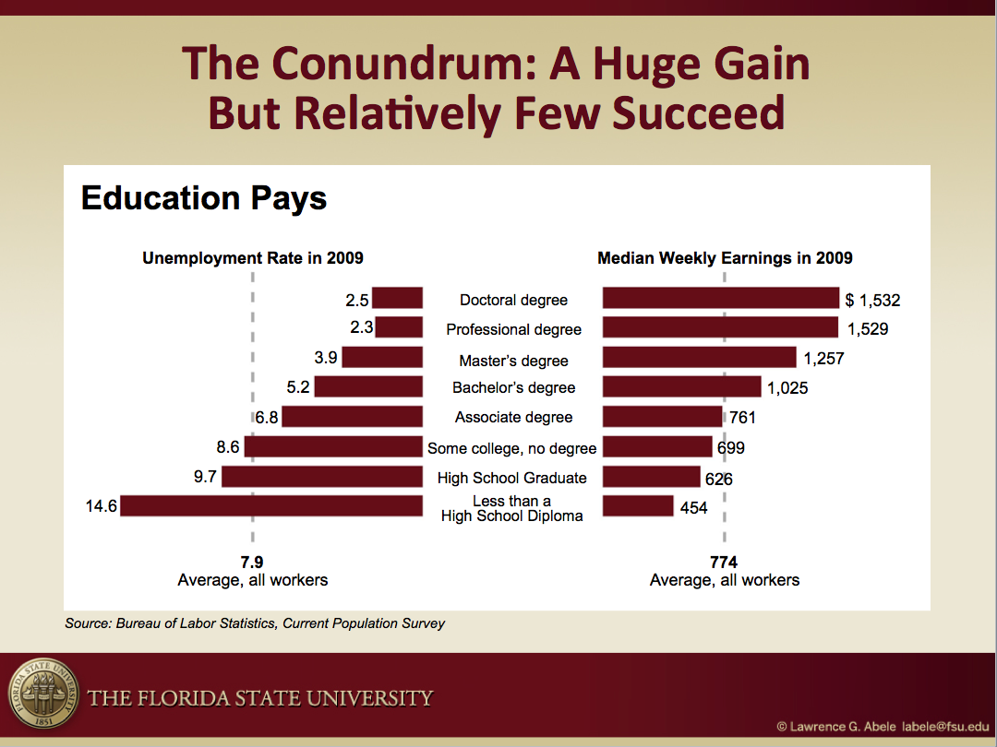
Figure 1 – The relationship between educational attainment, salary and unemployment

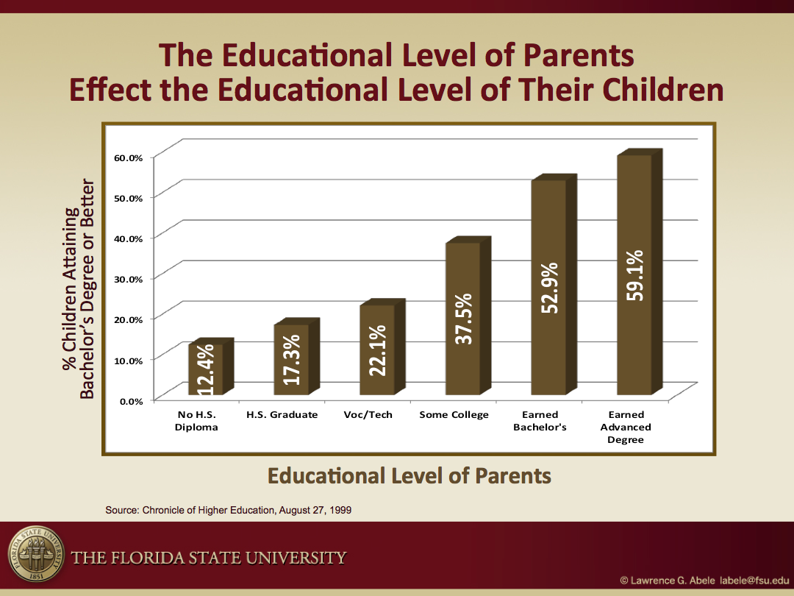

Figure 2 – Relationship between Parental Education Level and the Educational Attainment of their Children

Averages can hide a great deal of information and it is worth taking a closer look at graduation rates. Figure 3 plots the first year retention rate against graduation rate for 512 public colleges and universities. The good news is that there is considerable variation among institutions, which strongly suggests that there is an institutional effect.
For example, there are several institutions with 70% retention rates, but one will graduate 55% of their students and the other only 25%. In fact, while institutions may not focus on retention explicitly, they can and do have a huge effect on graduation rate.
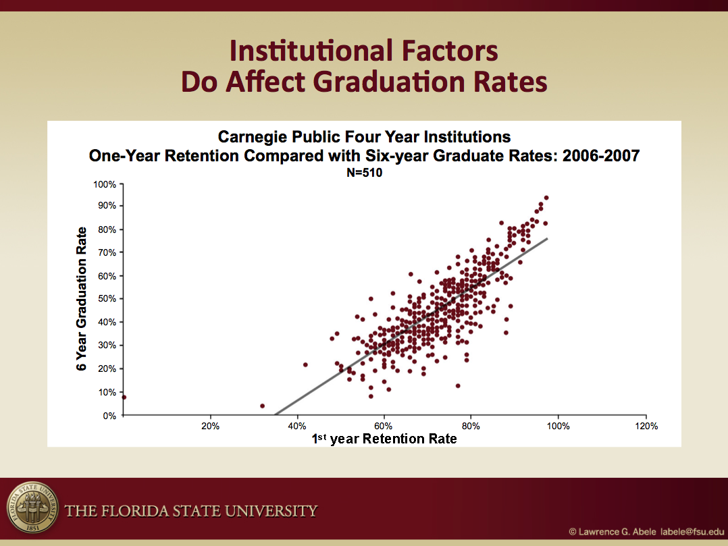

Figure 3 – Relationship Between an Institution’s First-Year Retention Rate (X) and Its Graduation Rate (Y)

The action steps needed to improve graduation rates are relatively simple but can be difficult to implement. Success requires a focused commitment from the top leadership of the institution for at least five years. The high turnover of presidents and provosts adds to the difficulty of implementation. In this discussion, we will outline a process and action steps that can be taken to improve graduation rates for all students.

There are three critical elements to a successful retention/graduation program:
1. An individual, by status or personality, must drive the process.
2. A process based on detailed data must be developed, measured and monitored closely for at least five years.
3. There must be a team of individuals from across campus who are committed to student success and who meet weekly to assess progress.

In this sketch we would like to outline some low cost and some higher cost actions that have been shown to be effective in improving student success and graduation rates. Some are quite simple though often overlooked. A recent web survey indicates that very few institutions have implemented systematic changes to improve graduation rates (although the California State System is a notable exception). This suggests there are very real prospects for institutions to register meaningful gains in performance.

Before implementing any changes, one predicate must be acknowledged. It is important that everyone involved in improving graduation rates understands that it is a slow process and that actions taken today may not have a measurable effect for 18 months or more. Institutional leadership must commit for the long haul. That is the fundamental tenet of change management in this area. Failure to attend to this one principle may be the primary reason why the issue has not received the attention it deserves and results have generally been so anemic.

With this one principle in place, we offer 10 elements important to a sustained approach to retention/graduation:
1. Develop a “map” of course schedules by term for every major with the critical courses highlighted. If a student does not successfully complete a critical course in the term recommended, place a registration hold. Require the student to meet with an advisor to find out what happened and take appropriate action to ensure the student understands how to proceed. For example, if an accounting major has not completed calculus by the end of the first year, it is unlikely that the student can complete the degree in a reasonable amount of time. Part of the conversation with the advisor may well involve looking for an alternate major that might better suit the student’s strengths and provide a viable alternative for reaching the student’s career goals.
2. Establish an automated contact system (email, Twitter, Facebook or other social media) to reach every student and let each one know that the institution is monitoring his or her progress. Send a congratulatory note to students who do well or improve and a note asking if everything is OK to any student who drops as little as 0.25 in their grade point average. Additional intervention is necessary for any student who falls below a 2.0, but that is a higher cost action that will be addressed later.
3. Move academic advisors to the students and develop a structure that fosters professionalism and accountability among advisors. A log of student contacts by time of day and day of week will reveal that few students seek out advisors between 8:00 AM and 11:00 AM. Drop-in advising should be made easy by having advisors with afternoon and evening hours available in the library, student union and other sites where students congregate.
4. Establish Freshman Interest Groups (known by several different names) allowing small groups of students with similar interests to take several classes together along with a small weekly seminar in the topic. With appropriate supervision, high-achieving senior students can lead the seminar and provide inspiring role models for the new students.
5. Pay attention to where students live. Research shows that students who live on campus for the first year earn higher grades and are retained at higher levels than those who live off campus. Living-Learning Communities offer an even better opportunity to a smaller segment of the on-campus population. Students in these special programs live in the same residence hall and participate in courses and programs that have a common theme. Teaching at least one of the courses in a classroom in the residence hall will further enrich these programs. The result is an even higher level of academic success and retention.
6. Look at course grades. The courses with high percentages of Ds and Fs particularly those with high enrollment, should be studied. There are national programs to assist with this effort. Encouraging faculty to take attendance is a good idea for all courses but is particularly important in courses with high percentages of Ds and Fs. This is getting easier with so many electronic options available to assist faculty teaching courses with high enrollments.
7. Survey students who choose to leave the university prior to graduation and take note of their academic performance. Retention can be an issue for high-achieving as well as low-performing students and different strategies will be necessary to engage and better meet the needs of all student groups.
8. Do not neglect the full range of academic support services available to help engage and retain students. A great deal can be learned and accomplished by working with student groups, especially student government, since this group often has more resources than the average academic department.
9. Be willing to intervene early. Data shows that without intervention more than half of the students who fall below a 2.0 early in their college experience will drop out. Yet, a relatively low cost mandatory course focusing on study habits, time management, note taking, etc. will significantly reduce attrition.
10. Be willing to deploy new approaches. Coaching has become part of our American culture. Health providers often offer coaching to patients to encourage adherence to a health improvement program. Some professional groups offer coaching to new senior administrators in the field. And there are plenty of ads in the media for life coaches, so it is not surprising that coaching has entered higher education.

The ten actions listed above should be implemented for all students. Here are a few examples of specific ways that these strategies have been implemented at Florida State University.

- Expanded academic advising services. We place centrally selected and trained advisors in academic departments across the campus as well as in specialized advising centers for students who are still choosing a major or need help in changing majors. With expertise on university policies, resources and opportunities as well as extensive training in effective guidance, these professional advisors promote students’ progress and growth throughout their academic careers. Advisors work to empower students to take personal responsibility and ownership of their educational endeavors.
- A structured program to work with undecided (and also re-deciding) students. These students are typically at risk for non-retention and often have academic difficulties due to their lack of focus on a clear program of study. Our Center for Exploratory Students offers students a step-by-step process, filled with mandatory one-on-one meetings, programming events and action items, aimed at helping students declare their majors with confidence. Since implementing our program for Exploratory students, their retention rates have consistently gone up and are now more in line with the retention rates of the general student population.
3. Success Coaching. In randomized trials of 400 and 1,000 students, biweekly meetings with trained academic coaches yielded a significant improvement in retention as well as student satisfaction and engagement with their college experience. We have since expanded this program to provide coaching for several targeted groups of students who are at high risk for non-retention. The improvement in retention has yielded additional tuition revenue that not only paid for the cost of coaching but generated significant new tuition revenue in only three years. Few institutions are likely to be able to coach every student, but we have found this to be a cost-effective solution to assisting targeted groups of students.
4. Expanded tutoring services. Two forms of tutoring for all students were added based on student input and with support from student government. Drop-in peer tutoring in selected courses offers short interactions of 15 minutes. Tutoring by appointment offers up to one hour of focused assistance. Drop-in tutoring operates out of the library and runs until 1:00 AM while tutoring by appointment operates out of a new Learning Studio open until 10:00 PM. Both facilities offer study rooms and technology that can be reserved for student use, promoting collaboration and active engagement in the learning process.
5. Special programming for First generation and Pell grant recipient students. Research shows that first generation students and economically disadvantaged students often face additional challenges in making the transition to college. Students who are selected to participate in Florida State University’s Summer Bridge Program arrive on campus a week before summer classes formally start and engage in activities that introduce them to the geography and culture of the campus. A number of programs are mandatory for all Summer Bridge participants, including daily study and tutorial hours, academic survival skills programs, and cultural events. Dedicated advisors and senior students from the same program serve as mentors and tutors. All students live on campus during the summer term, and follow-up tutoring, advising, and other support services continue throughout the students’ time at the university. The cohort of 350 students is large enough to ensure that these students see each other and are a visible presence on campus, and many of these students go on to be campus leaders.
6. Expanded opportunities for high-achieving students. Our retention analysis indicates that approximately one third of the students leaving the university before graduation were doing very well academically. While personal and family issues often play a large part, we enhanced our efforts to keep these students engaged and motivated to complete their degrees at Florida State through expanding undergraduate research opportunities, providing greater variety in the offerings and activities for Honors students, and establishing an Office of National Fellowships to help raise awareness of nationally competitive scholarship opportunities and encourage students’ personal growth through participation in the fellowship application process. We also established two lower division honor societies named for outstanding African American and Hispanic leaders. Open to all academically qualified students, these groups provide inspiring role models for students in underrepresented groups while recognizing and fostering academic achievement.

Florida State University has implemented these and other strategies with success. The improved retention rates achieved over a 15-year period are shown in Figure 4.

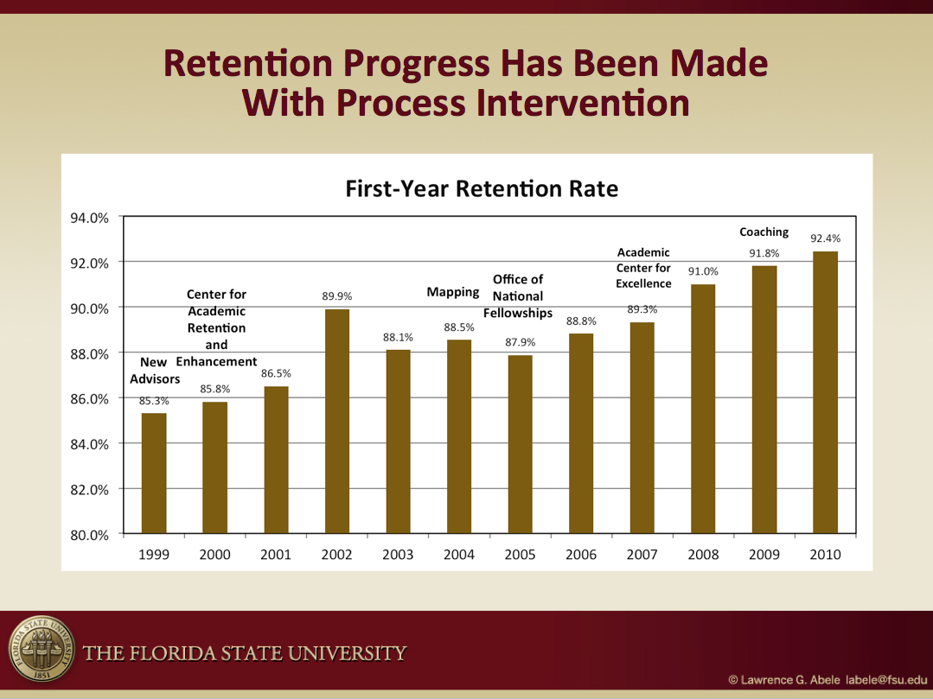

Figure 4 – Retention Rates of First-Time-In-College Students Have Steadily Increased

As one would expect, the graduation rate increases as the retention rate increases as shown in Figure 5 below. It is clear that institutional attention to the challenge of improving graduation rates will result in improvements. What is also clear is that a great deal can be accomplished without adding burdens to an already over-worked faculty.

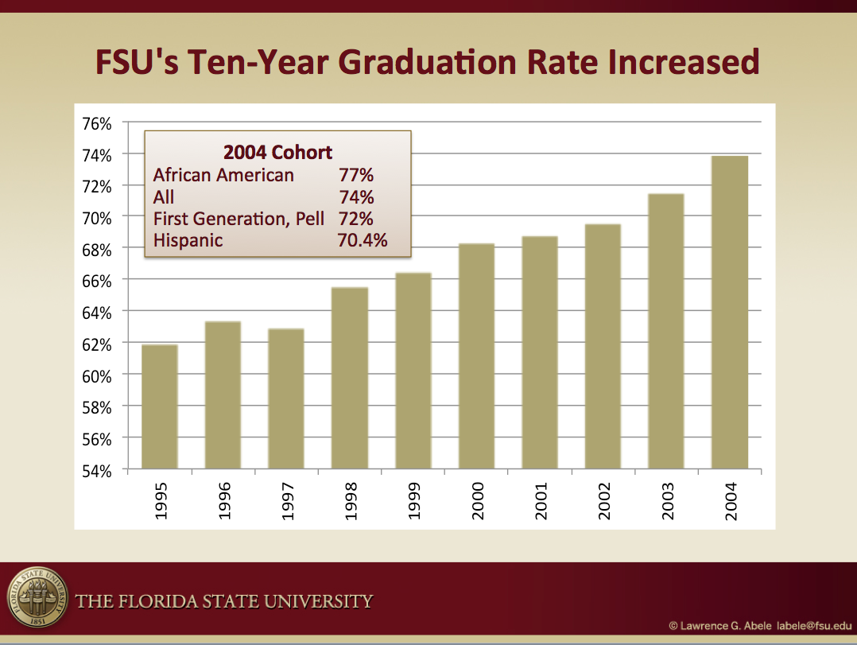
Figure 5 – FSU’s Ten-Year Graduation Trend

