

RBI
Reimbursable Report (External)
Job Aid
Effective MM DD 2012

TABLE OF CONTENTS

Introduction 3
Navigating DLA Enterprise External Business Portal 4
I. Navigate to Reimbursable Report 4
Executing Reimbursable Report 5
I. Executing Reimbursable Report 5
II. Viewing Report Results 5

Introduction

External customers use the Reimbursable Report to understand if the item they turned in is reimbursable, and if so, what amount is reimbursable from their turn in. This report provides insight into the determination of whether an item is reimbursable and if so, the amount to be reimbursed when or if that item is sold. This determination is generated by logic resident within EBS when an initial receipt for an item is passed from DSS to EBS. The determination is stored along with the reimbursable amount so that once the item is sold, that generator is credited the reimbursement amount. Disposition Services retains a portion of the reimbursement amount paid to the generator to cover the costs associated with selling the item. This report also conveys the status of that reimbursement.

The Purpose of this job aid is to provide users with information on how to:
  - Navigate the DLA Enterprise External Business Portal to the Reimbursable Report
  - Properly execute Reimbursable Report

The Audience for this job aid includes:
  - External Customers

Navigating DLA Enterprise External Business Portal

Users will need to navigate through the DLA Enterprise External Business Portal to access the Reimbursable Report.

Navigate to Reimbursable Report
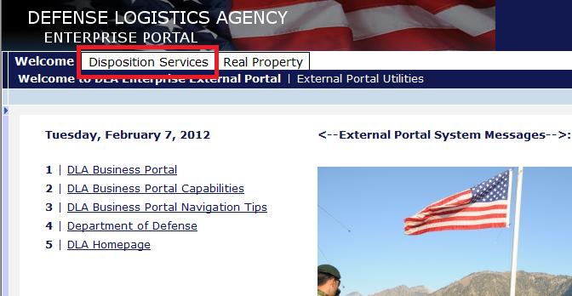
  - Once in the portal, click on "Disposition Services" tab
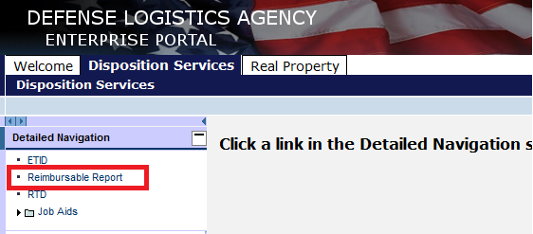
  - Click on Reimbursable Report

Executing Reimbursable Report

After the user has opened the report, they will need to add selection criteria to their prompt.

Executing Reimbursable Report

  - Open Reimbursable Report
  - In the “RBI Reimbursable Input” box, it is mandatory that we provide either a 6-digit DODAAC or a Fund Citation Code. The Fund Citation Codes consists of the Treasury Symbol (Department Code), the Fiscal Year, the Basic symbol, the subhead (Allotment) and the Fiscal Accounting Station number (FASN)
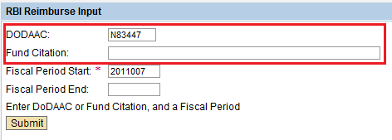
  - It is mandatory to enter a Fiscal Period Start date. A user may also provide a Fiscal Period End date to create a Fiscal Period Range. Fiscal Period must be in YYYYMMM format (Ex: 2007003)
  - Click to execute the report using the provided selection criteria

Viewing Report Results

  - Execute the Reimbursable Report
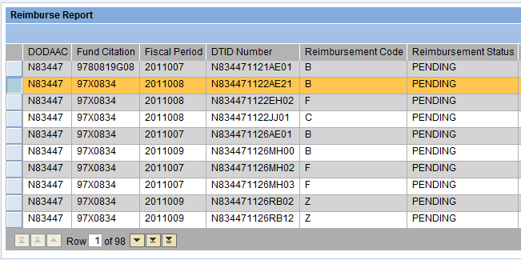
  - Report results are displayed
  - Use the arrows to scroll or page through the results. To jump to a specific section of the results, type desired row number into the Row box.

