Congressman Ed Royce Presents:


Combat Fraud Forum

Information on Identity Theft, Mortgage Loans and Lending, Investment Scams, Charity Fraud, And Medicare fraud

Where: CYpress COmmunity Center
5700 Orange Avenue
Cypress, CA 90630

When: Friday, May 7, 2010
1 to 3 PM IN THE GRAND BALLROOM

Presented In Partnership With:

-Federal Trade Commission

-Internal REvenue Service

40th District

-United STates Citizenship and immigration services

-Federal Bureau of investigation
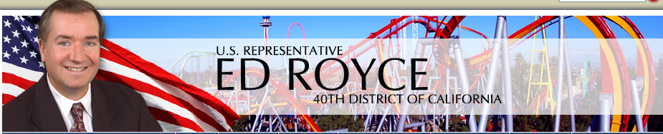
This event is free of charge. For more information, please contact Congressman Royce's office at (714) 744-4130.

