Tropical Cyclone Report
Tropical Storm Laura
(AL122008)
29 September-1 October 2008

Richard J. Pasch
National Hurricane Center
4 February 2009

Short-lived Laura remained well out at sea over the North Atlantic.

- Synoptic History

Laura originated from a non-tropical source. On 26 September, a low pressure system formed along a quasi-stationary front a few hundred miles west of the Azores. During the ensuing day or so, the cyclone intensified, apparently due to baroclinic energy sources, and acquired hurricane force (70 kt) winds on 27 September. Over the next couple of days the extratropical cyclone moved westward while the associated frontal features gradually dissipated, and rather unorganized deep convection developed within the system’s circulation. The cyclone’s maximum winds had decreased to near 50 kt by 28 September. By early on 29 September, a prominent band of deep convection formed over the southeastern semicircle of the cyclone; however, deep cloudiness was not concentrated near or over the center, and the system was essentially collocated with an upper-tropospheric low pressure area. It is estimated that the system had transformed into a 50-kt subtropical storm by 0600 UTC 29 September, centered about 650 n mi south-southeast of Cape Race, Newfoundland.

The “best track” chart of the cyclone’s path is given in Fig. 1, with the wind and pressure histories shown in Figs. 2 and 3, respectively. The best track positions and intensities are listed in Table 1. Laura turned from a west-northwestward to a north-northwestward heading as it moved between an area of high pressure to the north of the Azores and an extratropical cyclone (the remnants of Hurricane Kyle) over the Canadian Maritimes. By early on 30 September Laura was moving northward while maintaining an intensity of near 50 kt. Although the system had acquired some warm-core structure, it had minimal deep convection and was still too coincident with the upper-tropospheric low to be considered a tropical cyclone. A little later on 30 September, the upper-level low became stretched and offset from the center of Laura, the radius of maximum winds contracted somewhat to near 60 n mi, and moderately deep convection became more organized and concentrated near the center of circulation. Based on these events, it is estimated that the system became a tropical storm around 1200 UTC 30 September. Maximum winds remained near 50 kt as Laura traversed marginal sea surface temperatures of around 26ºC. By early on 1 October, the system began a gradual weakening trend as it moved over cooler waters. Laura weakened to 40 kt by 1200 UTC 1 October, and its deep convection had diminished to the point that it could no longer be designated a tropical cyclone. There was little evidence of frontal structure within the system at that time, indicating that Laura had become a remnant low. The low accelerated northward, and surface analyses suggest that the system became embedded within a front by 0600 UTC 2 October, marking a transformation into an extratropical cyclone. Around 0600 UTC 3 October, the cyclone turned eastward and slowed its forward motion while intensifying again to hurricane force. The system then accelerated eastward while gradually weakening, and finally became absorbed within a larger extratropical low pressure system several hundred n mi west of the British Isles on 4 October.

- Meteorological Statistics

Observations in Laura (Figs. 2 and 3) include satellite-based Dvorak and Hebert-Poteat technique intensity estimates from the Tropical Analysis and Forecast Branch (TAFB) and the Satellite Analysis Branch (SAB) as well as surface ship and fixed platform observations over the North Atlantic. Data and imagery from NOAA polar-orbiting satellites, the NASA Tropical Rainfall Measuring Mission (TRMM), the NASA QuikSCAT, and Defense Meteorological Satellite Program (DMSP) satellites, among others, were also useful in tracking Laura. The estimated peak intensity of Laura, 50 kt, is based on both satellite classifications and QuikSCAT measurements.

Ship and stationary platform reports of winds of tropical storm force associated with Laura are given in Table 2.

- Casualty and Damage Statistics

There were no reports of damage or casualties associated with Laura.

- Forecast and Warning Critique

The first mention in the Tropical Weather Outlook (TWO) of the extratropical cyclone that would eventually become Laura was made 36 h prior to subtropical cyclogenesis. At that time, the TWO indicated the potential for the system to slowly acquire subtropical or tropical characteristics, and the experimental genesis probability was set in the “low” category (less than 20%). The genesis probabilities increased to the “medium” category (20% to 50%) within 24 h of genesis, but were not in the “high” category (greater than 50%) until 6 h before the formation of the subtropical cyclone.

A verification of official and guidance model track forecasts is given in Table 3. Average official track errors for Laura were 19, 30, 33 and 48 n mi for the 12, 24, 36, and 48 h forecasts, respectively. There were no official forecasts to verify at 72 h or longer forecast intervals. The number of forecasts ranged from 8 at 12 h to just 2 at 48 h. These errors are fairly low in comparison to the average 5-yr official track errors (also shown in Table 3), but for such a small sample of forecasts, the comparisons are not very meaningful.

A verification of official and guidance model intensity forecasts is given in Table 4. Average official intensity errors were 3, 8, 10, and 13 kt for the 12, 24, 36, and 48 h forecasts, respectively. For comparison, the average 5-yr official intensity errors are 7, 10, 12, and 14 kt, respectively. The mean official intensity forecasts had a positive bias that ranged from 3 kt at 12 h to 13 kt at 48 h; every official forecast had a positive bias.

Watches and/or warnings were not required for Laura.
Table 1. Best track for Tropical Storm Laura, 29 September-1 October 2008.

Date/Time  (UTC) | Latitude  (°N) | Longitude  (°W) | Pressure  (mb) | Wind Speed  (kt) | Stage
26 / 0000 | 39.0 | 35.0 | 1011 | 40 | extratropical
26 / 0600 | 37.9 | 35.0 | 1010 | 45 | "
26 / 1200 | 37.0 | 35.5 | 1009 | 50 | "
26 / 1800 | 36.5 | 36.0 | 1007 | 55 | "
27 / 0000 | 37.0 | 36.5 | 1004 | 60 | "
27 / 0600 | 37.4 | 37.2 | 998 | 65 | "
27 / 1200 | 37.5 | 38.0 | 992 | 70 | "
27 / 1800 | 37.4 | 39.0 | 992 | 70 | "
28 / 0000 | 37.3 | 40.0 | 994 | 60 | "
28 / 0600 | 37.2 | 41.2 | 994 | 55 | "
28 / 1200 | 37.0 | 42.5 | 995 | 50 | "
28 / 1800 | 36.8 | 44.1 | 995 | 50 | "
29 / 0000 | 36.7 | 45.7 | 995 | 50 | "
29 / 0600 | 37.0 | 47.0 | 995 | 50 | subtropical storm
29 / 1200 | 37.2 | 47.7 | 995 | 50 | "
29 / 1800 | 37.8 | 48.2 | 995 | 50 | "
30 / 0000 | 38.6 | 48.5 | 996 | 50 | "
30 / 0600 | 39.6 | 48.8 | 996 | 50 | "
30 / 1200 | 40.6 | 48.9 | 996 | 50 | tropical storm
30 / 1800 | 41.7 | 48.8 | 994 | 50 | "
01 / 0000 | 42.9 | 48.3 | 995 | 45 | "
01 / 0600 | 44.2 | 47.7 | 995 | 45 | "
01 / 1200 | 45.7 | 46.9 | 995 | 40 | low
01 / 1800 | 47.5 | 46.3 | 995 | 40 | "
02 / 0000 | 49.5 | 46.0 | 997 | 35 | "
02 / 0600 | 51.5 | 46.0 | 996 | 35 | extratropical
02 / 1200 | 53.5 | 46.0 | 992 | 40 | "
02 / 1800 | 55.6 | 45.5 | 992 | 40 | "
03 / 0000 | 56.9 | 44.0 | 991 | 50 | "
03 / 0600 | 57.0 | 42.0 | 990 | 65 | "
03 / 1200 | 57.0 | 40.0 | 992 | 60 | "
03 / 1800 | 57.0 | 37.0 | 994 | 55 | "
04 / 0000 | 56.5 | 31.4 | 996 | 45 | "
04 / 0600 | 56.0 | 26.0 | 997 | 40 | "
04 / 1200 |  |  |  |  | merged with extratropical low
30 / 1800 | 41.7 | 48.8 | 994 | 50 | minimum pressure (as a tropical or subtropical cyclone)

Table 2. Selected ship and fixed platform reports with winds of at least 34 kt for Tropical Storm Laura, 29 September-1 October 2008.

Date/Time (UTC) | Ship call sign | Latitude  (°N) | Longitude  (°W) | Wind  dir/speed (kt) | Pressure  (mb)
29 / 1800 | C6QK | 36.8 | 44.3 | 160 / 35 | 1008.9
29 / 2100 | C6QK | 36.4 | 44.6 | 160 / 35 | 1008.8
30 / 0000 | C6QK | 36.0 | 45.1 | 180 / 37 | 1009.6
01 / 0000 | VEP717 | 46.7 | 48.7 | 080 / 36 | 1008.7
01 / 0300 | S6TS | 40.9 | 47.9 | 250 / 35 | 1006.5
01 / 0300 | VCXF | 46.4 | 48.4 | 090 / 36 | 1005.3
01 / 0300 | VEP717 | 46.7 | 48.7 | 070 / 47 | 1004.6
01 / 0300 | YJUF7 | 46.7 | 48.0 | 100 / 39 | 1005.8
01 / 0600 | V2OH3 | 46.1 | 44.4 | 090 / 40 | 1006.2
01 / 0600 | VEP717 | 46.7 | 48.7 | 110 / 45 | 1002.1
01 / 0600 | YJUF7 | 46.7 | 48.0 | 110 / 41 | 1002.8

Table 3. Track forecast evaluation (heterogeneous sample) for Tropical Storm Laura, 29 September-1 October 2008. Forecast errors (n mi) are followed by the number of forecasts in parentheses. Errors smaller than the NHC official forecast are shown in boldface type.

Forecast Technique | Forecast Period (h)
Forecast Technique | 12 | 24 | 36 | 48 | 72 | 96 | 120
CLP5 | 38 ( 8) | 99 ( 6) | 217 ( 4) | 350 ( 2)
GFNI | 27 ( 5) | 42 ( 3) | 53 ( 1)
GFDI | 27 ( 8) | 45 ( 6) | 26 ( 4) | 35 ( 2)
HWFI | 26 ( 8) | 60 ( 6) | 101 ( 4) | 129 ( 2)
GFSI | 20 ( 8) | 45 ( 6) | 55 ( 4) | 72 ( 2)
AEMI | 27 ( 8) | 56 ( 6) | 68 ( 4) | 121 ( 2)
NGPI | 24 ( 6) | 45 ( 4) | 63 ( 2)
UKMI | 20 ( 6) | 18 ( 4) | 21 ( 2)
EGRI | 20 ( 6) | 18 ( 4) | 38 ( 2)
EMXI | 17 ( 6) | 22 ( 4) | 63 ( 2)
BAMD | 39 ( 8) | 70 ( 6) | 99 ( 4) | 177 ( 2)
BAMM | 32 ( 8) | 43 ( 6) | 63 ( 4) | 123 ( 2)
BAMS | 37 ( 7) | 66 ( 5) | 99 ( 3) | 80 ( 1)
LBAR | 31 ( 7) | 69 ( 5) | 154 ( 3) | 366 ( 1)
TVCN | 20 ( 8) | 33 ( 6) | 40 ( 4) | 72 ( 2)
GUNA | 16 ( 6) | 30 ( 4) | 21 ( 2)
FSSE | 17 ( 7) | 34 ( 5) | 34 ( 3) | 47 ( 1)
OFCL | 19 ( 8) | 30 ( 6) | 33 ( 4) | 48 ( 2)
NHC Official  (2003-2007 mean) | 34.0 (1742) | 58.2 (1574) | 82.2 (1407) | 106.2 (1254) | 154.2 (996) | 207.5 (787) | 272.5 (627)

Table 4. Intensity forecast evaluation (heterogeneous sample) for Tropical Storm Laura, 29 September-1 October 2008. Forecast errors (kt) are followed by the number of forecasts in parentheses. Errors smaller than the NHC official forecast are shown in boldface type.

Forecast Technique | Forecast Period (h)
Forecast Technique | 12 | 24 | 36 | 48 | 72 | 96 | 120
OCD5 | 2.9 ( 8) | 5.0 ( 6) | 11.5 ( 4) | 18.0 ( 2)
GHMI | 3.0 ( 8) | 7.8 ( 6) | 7.8 ( 4) | 6.0 ( 2)
HWFI | 4.8 ( 8) | 5.5 ( 6) | 4.3 ( 4) | 9.5 ( 2)
LGEM | 3.4 ( 8) | 7.5 ( 6) | 12.3 ( 4) | 15.5 ( 2)
DSHP | 3.5 ( 8) | 8.3 ( 6) | 14.3 ( 4) | 20.5 ( 2)
FSSE | 2.4 ( 7) | 2.4 ( 5) | 7.3 ( 3) | 13.0 ( 1)
ICON | 1.9 ( 8) | 1.2 ( 6) | 3.8 ( 4) | 7.5 ( 2)
OFCL | 3.1 ( 8) | 7.5 ( 6) | 10.0 ( 4) | 12.5 ( 2)
NHC Official  (2003-2007 mean) | 6.7 (1742) | 10.0 (1574) | 12.3 (1407) | 14.3 (1254) | 18.2 (996) | 19.7 (787) | 21.8 (627)

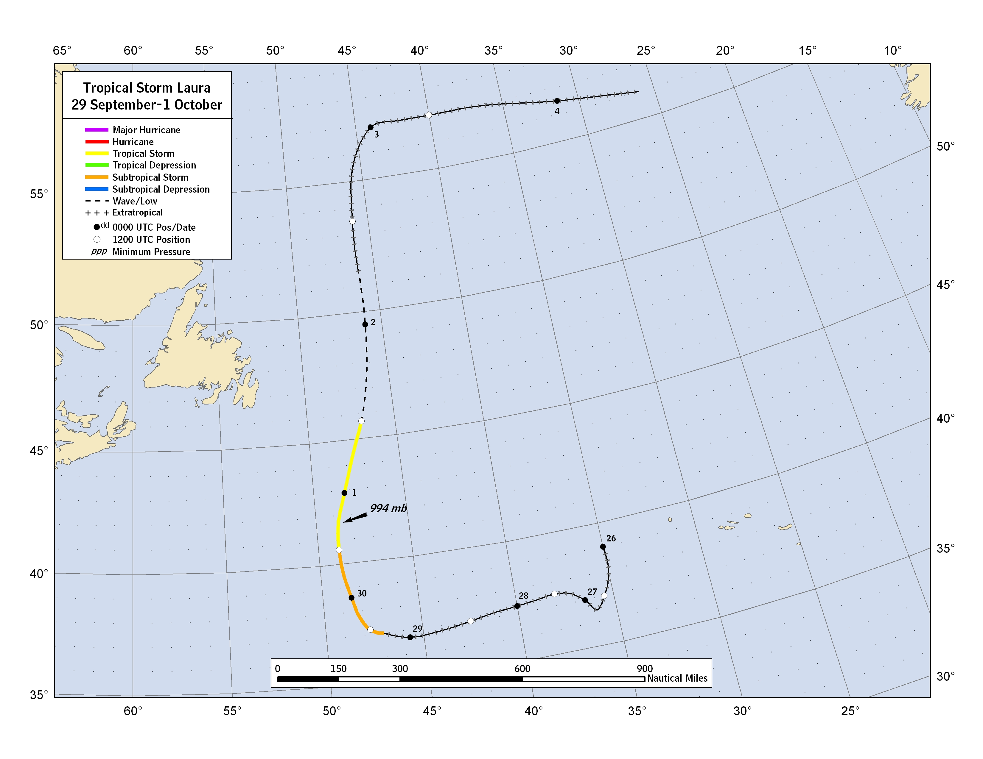
Figure 1. Best track positions for Tropical Storm Laura, 29 September-1 October 2008. Track during the extratropical stage is based partially on analyses from the NOAA Ocean Prediction Center.
Figure 2. Selected wind observations and best track maximum sustained surface wind speed curve for Tropical Storm Laura, 29 September-1 October 2008. Estimates during the extratropical stage are based partially on analyses from the NOAA Ocean Prediction Center. Dashed vertical lines correspond to 0000 UTC.

Figure 3. Selected pressure observations and best track minimum central pressure curve for Tropical Storm Laura, 29 September-1 October 2008. Estimates during the extratropical stage are based partially on analyses from the NOAA Ocean Prediction Center. Dashed vertical lines correspond to 0000 UTC.

A digital record of the complete best track, including wind radii, can be found on line at ftp://ftp.nhc.noaa.gov/atcf. Data for the current year’s storms are located in the btk directory, while previous years’ data are located in the archive directory.

