UMLS Step-by-Step

Validate the UMLS Release Files

In this tutorial you will:
- Use MetamorphoSys
- Ensure that all UMLS files are present and complete
 Note: You must have the UMLS Release Files available either via download or DVD to complete this process.
- Start MetamorphoSys, the UMLS customization program
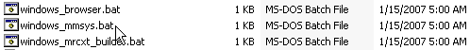
- Select File from the Welcome Screen
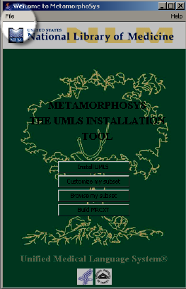

- Select Validate Distribution from the Welcome Screen
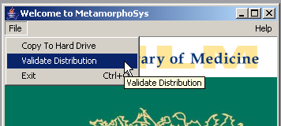

- Ensure that the directory that contains the UMLS files is displayed. If using a DVD the directory displayed should be the DVD drive.
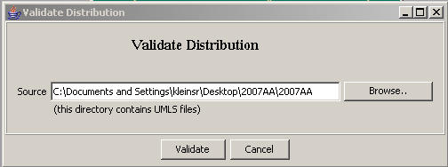

- Click Validate
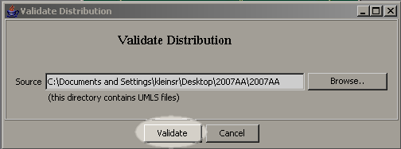

- The validation process can take as long as twenty minutes. Validating the files on a UMLS DVD will take longer than validating files that have been copied to your hard drive.
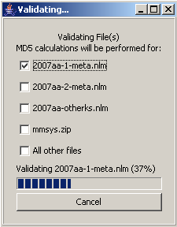

- Read the notification box. If validation fails, you will need to download the Release Files again or request a new DVD.
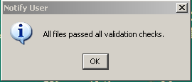

- Click OK.
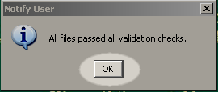

 Note: When validating files that have been copied to your hard drive (or other writable location) the file "validation.log" will be written. This text file contains any errors that were encountered or a note of success.

