AP4. APPENDIX 4
INSTRUCTIONS FOR PREPARATION OF STANDARD FORM 364
AP4.1. ORIGINAL REPORT. A hard copy Supply Discrepancy Reports (SDR) shall only be used by exception under Chapter 17 guidance. When reported manually via hard copy, the following instructions for use of the SF 364, Report of Discrepancy, apply.
AP4.1.1. Indicate whether shipping discrepancy or packaging discrepancy by placing an "X" in appropriate boxes at the top of the form.
Item 1 Date of Preparation. Use month, day, and four-position year format for the date the reporting activity prepares the SDR (e.g., January 10, 2012).
Item 2 Report Number. Provide the locally assigned report number. For Security Assistance shipments, this consists of one alpha character to identify the initiating office in-country, four numeric characters for number control, two alpha characters for the foreign customer country and three to six alphanumeric characters for the master and line item case designator, i.e., A0010-JA-KBD/001. For any unnumbered reports received, the International Logistics Control Office (ILCO) shall assign number x9000 to x9999 and so advise the foreign country customer on the receipted copy. Suffix code R added to the report number indicates the purchaser has asked for reconsideration of the report disposition. Suffix code C added to the report number indicates that the purchaser has contested the U.S. Government's decision on a request for reconsideration.
Item 3 To. In-the-clear name, address, ZIP code and DoD Activity Address Code (DoDAAC) and/or Routing Identifier Code (RIC) (if assigned), and attention symbol/code of action activity. The action activity is based upon the origin of the shipment. If forwarding to the ICP, the RIC of the ICP is located in positions 67-69 of the DD Form 1348-1A. If forwarding to the Defense Distribution Depot, the RIC of the shipping depot is located in positions 4-6 of the DD Form 1348-1A.
Item 4 From. DoDAAC, name, address and ZIP code of the reporting activity or Security Assistance customer (consignee). The in-the-clear address shall be entered.
Item 5a Shipper's Name. Enter name, DoDAAC and/or RIC (for DoD activities) or commercial and government entity (CAGE) code (if available, for commercial contractor facilities), and address of shipper (consignor) when different from Item 3. If applicable, the RIC of the shipping depot is located in positions 4-6 of the DD Form 1348-1A.
Item 5b Number and Date of Invoice. Applicable to Security Assistance billing discrepancies. Enter number and date of vendor's invoice or shipper's bill number. Attach copy of invoice to SF 364.
Item 6 Transportation Document. Enter the type of transportation document, Transportation Control Number (TCN), Government Bill of Lading (GBL), Commercial Bill of Lading (CBL), manifest, waybill, insured/certified U.S. Postal Service, or transportation control and movement document (TCMD) and the identifying number assigned to such document. This is a mandatory entry when shipment received was made via traceable means, (e.g., GBL, CBL). Further for U.S. SDRs, for discrepancies involving shortages, include following statement in Item 12--"Shortage has been verified as not being transportation related."
Item 7a Shipper's Number. Enter shipment number (when more than one shipment is made under a contract or requisition) and contract/contract line item number/document number (e.g., contract, purchase order). For Security Assistance, also include the shipment date to distinguish multiple shipments from a contractor source.
Item 7b Office Administering Contract. Name, address, and ZIP code of the Contract Administration Office (CAO) activity that directed/arranged shipment.
Item 8 Requisitioner's Number. Enter the requisitioning activity's number, (e.g., requisition, purchase request, and suffix code), if applicable. Entry of the applicable requisition document number is mandatory in all instances, even though a contract/purchase order is involved. Only one document number will be included on each SF 364. For U.S. SDRs only, when the original requisition number cannot be identified for discrepancies in sealed vendor packs, the reporting activity must include a constructed document number. When using a constructed document number in an SDR, use block 13 to cite the fund code and bill-to/credit-to DoDAAC, if different from that in the document number.
Item 9a NSN/Part Number and Nomenclature. If item received is different from item shown on shipping documents, or different from item ordered, show each item on a separate line. For serial numbered principal items, sets, kits and outfits, list the item individual serial number first, followed by the discrepancies applicable to that serial number. (Sets, kits and outfits showing an assembly order number, the assembly order number should also be listed.)
Item 9b Unit of Issue. Enter unit of issue as billed or indicated on shipping document for each item listed in Item 9a.
Item 9c Quantity Shipped/Billed. Enter quantity of item shipped or billed. When code C1 is applicable, enter the quantity and the supply condition code of the item when shipped, (e.g., 980A as shown on shipping document).
Item 9d Quantity Received. Enter the quantity of item received.
Item 10a Discrepancy Quantity. Enter the discrepant quantity. If code C1 is applicable, enter the quantity and the supply condition code of the item received. If total quantity received is classified under more than one condition code, enter separately each partial quantity so classified, followed by the applicable condition code, (e.g., 960A, 20F).
Item 10b Discrepancy Unit Price. Enter the unit price as billed or shown on shipping document.
Item 10c Discrepancy Total Cost. For shipping discrepancies, enter the total value of materiel (10a x 10b). For U.S. SDR packaging deficiencies, enter total cost for corrective packaging of all discrepant items. For SDRs reporting both a packaging and a shipping discrepancy on the same item, enter on separate lines both the total value of the materiel and the total cost for corrective packaging.
Item 10d Discrepancy Code. Nature of the discrepancy using the applicable discrepancy code. See Appendix 3 for discrepancy codes that supplements those listed on the face of the form. If a condition exists that is not listed, use code Z1 and describe discrepancy in Item 12, Remarks. Use up to three discrepancy codes. When Discrepancy Code Q1, Product Quality Deficiency, or C2, Expired Shelf Life, is applicable, enter the following information under Item 12, Remarks:
1. Manufacturer's name and commercial and government entity (CAGE) code (if available).
2. Contract/purchase order number if not shown in Item 7a.
3. Date manufactured, date cured, date assembled, date packed (apply one as appropriate), and expiration date for Type I (nonextendible) shelf-life items and inspection or test date for Type II (extendible) shelf-life items. Include the date overhauled/rebuilt if pertinent.
4. Lot/batch number.
5. Location of materiel.
6. Name, address, and telephone number of point of contact.
7. Nature of complaint stating in detail why materiel is unsatisfactory.
Item 11 Action Code. Nature of the action requested identified by action code. See Appendix 3 for action codes that supplements those listed on the face of the form.
Item 12 Remarks.
General Conditions. Use for any supplemental information when the combination of discrepancy codes and action codes needs clarification; when discrepancies need explanation; and when a breakdown of cost to report, in terms of labor man-hours and materials, is required. Specific data such as appearance, lot/batch number, manufacture/packaging date, inspector number and inspection date, probable cause of improper packaging, and suggested corrective action should be entered here. Provide photos where it would assist in determining the cause/validity of the discrepancy/deficiency.
Information Contact. Include name and communication numbers, (e.g., DSN and commercial telephone numbers, facsimile number, and e-mail address) of the person to be contacted for additional information if different from that entered in Item 14a.
Discrepancies in Sealed Vendor Packs. Enter, if available, the contract number and lot number from the item package and the words "concealed discrepancy found upon opening sealed vendor pack," or cite the appropriate discrepancy code.
Special conditions. For shortages or nonreceipt of GSA items shipped via U.S. Postal Service--cite whether all packages shown as shipped in Item 5 of GSA or DD Form 1348-1A were received. For medical materiel requiring refrigeration or frozen storage--cite the information requested on the special instruction sheet, which is included with shipments of such materiel. For classified materiel--cite whether indications of container tampering were or were not evident; indicate whether a security deviation inquiry may be necessary at the origin.
Security Assistance SDRs. Cite the specific violation of specification, regulation, packaging instruction, or contract.
Item 13 Funding and Accounting Data. (Not applicable to Security Assistance SDRs.)
For packaging discrepancies, the accounting/appropriation fund cite may be entered in this block by the SDR initiator if reimbursement funds/credits are expected for costs incurred to correct reported deficiencies. Use only when a billing document such as the SF 1080, Voucher for Transfer Between Appropriation and/or Funds, will not be prepared.
When using a constructed document number under authorized SDR procedures and prior coordination with the applicable Component finance office (Code U in the first position of the constructed document number serial number (DLMS Utilization Code U) per MILSBILLS procedures), include fund code and credit-to/bill-to DoDAAC, to ensure that credit/billing is appropriate.
Item 14a Typed or Printed Name, Title, and Phone Number of Preparing Official. Self-explanatory. Include both full commercial, DSN, and facsimile communication numbers and e-mail address, if available.
Item 14b Signature. Self-explanatory.
Item 15 Distribution Addressees for Copies. Enter other addressees receiving copies of the report. Not applicable to Security Assistance SDRs.
AP4.2 SUPPLY DISCREPANCY REPORT REPLY. The reverse of SF 364 shall be completed by the action activity as required by this publication.
Item 16 From. The name, DoDAAC and/or RIC, and address of the activity preparing the reply.
Item 17 Distribution Addressees for Copies. Enter addressees (including DoDAAC and/or RIC (if assigned)) receiving copies of the reply in addition to addressee listed in Item 18.
Item 18 To. Enter address (including DoDAAC and/or RIC (if assigned)) of the activity indicated in Item 4 on face of the form. For Security Assistance, use the address for the appropriate ILCO.
Item 19 Enter action taken by responsible action office by placing an "X" in appropriate box(es). Do NOT check box 19f(2) for U.S. SDRs; the regulation(s) citation(s) applies only for shipments to Security Assistance customers. Also, see instructions for Item 23.
Item 20 Enter disposition instructions by placing an "X" in appropriate box(es). Also, see instructions for Item 23.
Item 21 Enter an "X" to indicate to the reporting activity that a new requisition is required if the materiel is still needed. Also, see instructions for Item 23.
Item 22 Enter an "X" to indicate a replacement shipment will be made and the approximate shipment date. Also, see instructions for Item 23.
Item 23 Remarks
General Conditions. Enter any clarification or information necessary for a complete reply. Enter corrective action taken to preclude future packaging discrepancies and/or record the SDR reply code (Appendix 3). This code and applicable narrative may be used rather than marking equivalent boxes for Items 19, 20, and 21.
Item 24a Typed or Printed Name and Phone Number of Preparing Official. This is the individual authorized to provide an SDR response. Include both DSN and full commercial telephone numbers.
Item 24b Signature. Self-explanatory.
Item 24c Date. Use month, day, and four-position year (e.g., January 10, 2012).
AP4.3. SUPPLY DISCREPANCY REPORT FOLLOW-UPS, CORRECTIONS, AND CANCELLATIONS
AP4.3.1. At the top of the original report annotate the appropriate word ("FOLLOW-UP," "CORRECTION," or "CANCELLATION") and the date the follow-up, correction, or cancellation was prepared and forward to the same distribution addresses as the initial report.
AP4.3.2. Where there is any change to the point of contact information provided in block 14a of the original SF 364, enter the new point of contact name and telephone number(s) and e-mail address.
AP4.3.3. For corrected or cancelled SDRs, the initiator shall explain the clarifying data in detail in the "Remarks" block. Include the signature, date, DSN number, complete commercial telephone number, and e-mail address, if available, of the person preparing the revised report.

SF364, Supply Discrepancy Report Form (Front)

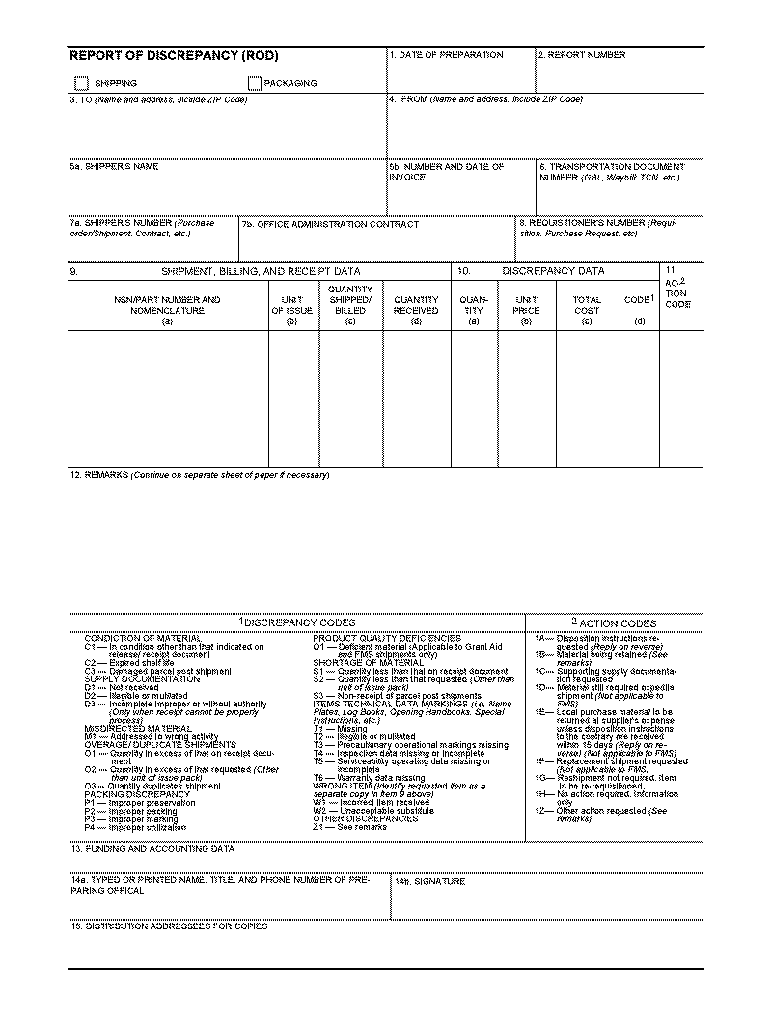

SF364, Supply Discrepancy Report Form (Reverse Side)
