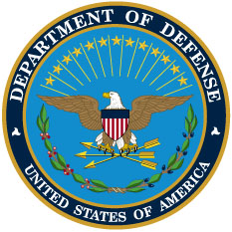

DEFENSE LOGISTICS MANAGEMENT SYSTEM
VOLUME 1
CONCEPTS
AND
PROCEDURES

June 5, 2012
DEPUTY ASSISTANT SECRETARY OF DEFENSE
(SUPPLY CHAIN INTEGRATION)

