**AP1.6. APPENDIX 1.6**

**DD FORM 1348-6  
DOD SINGLE LINE ITEM REQUISITION SYSTEM DOCUMENT (MANUAL-LONG FORM)**

**SAMPLE**

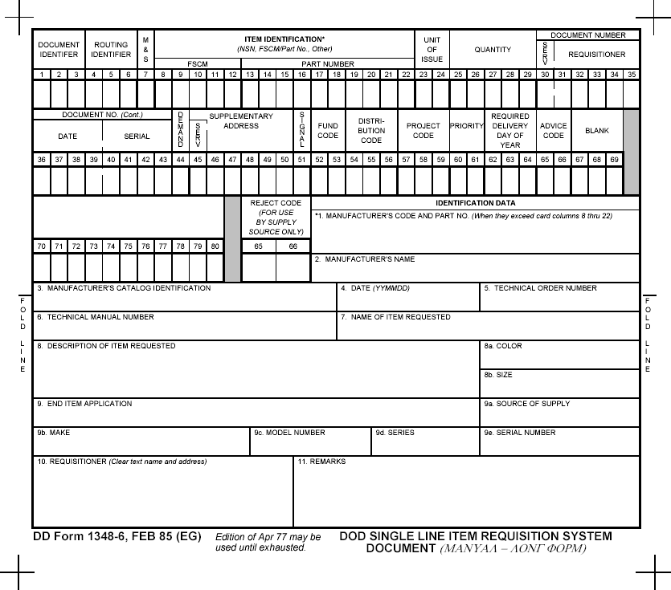

INSTRUCTIONS FOR IDENTIFICATION OF DATA BLOCKS

| FIELD LEGEND | BLOCK NUMBER | ENTRY AND INSTRUCTIONS |
| --- | --- | --- |
| Manufacturer’s Code and Part Number | 1 | Enter the item contractor and Government entity (CAGE) code when available, first, followed by the complete part number when the part number exceeds 10 digits. |
| Manufacturer’s Name | 2 | Enter the manufacturer’s name and address (including Zip Code, if known) when the CAGE is not available. |
| Manufacturer’s Catalog Identification | 3 | Enter the manufacturer’s catalog identification number when available. |
| Date | 4 | Enter the date of the publication in calendar date format (YYMMDD). |
| Technical Order Number | 5 | Enter the applicable order number in which the requested item may be defined. |
| Technical Manual Number | 6 | Enter the applicable technical manual number in which the requested item may be defined. |
| Name of Item Requested | 7 | Enter the appropriate name of item requested. |
| Description of Item Requested | 8 | Enter the description of item requested and, if necessary, attach exhibits or pictures. |
| Color | 8a | Enter the color of item requested, if applicable. |
| Size | 8b | Enter the size of item requested, if applicable. |
| End Item Applicable | 9 | Enter the name of the applicable end item for which the requested item applies. Entry should cite NSN and/or nomenclature. If application is unknown, enter unknown. |
| Supply Source | 9a | Enter the supply source of the applicable end item, if known. |
| Make | 9b | Enter the manufacturer’s make of the applicable end item, if known. |
| Model Number | 9c | Enter the manufacturer’s model number of the applicable end item, if known. |
| Series | 9d | Enter the manufacturer’s series number of the applicable end item, if known. |
| Serial Number | 9e | Enter the manufacturer’s serial number of the end item, if known. |
| Requisitioner | 10 | Enter the requisitioner’s clear-text name, commercial or DSN number, and address including ZIP code. |
| Remarks | 11 | Enter any additional information which will assist the supply source to obtain the correct item. |