AP1.2. APPENDIX 1.2
DD FORM 1348, DOD SINGLE LINE ITEM REQUISITION SYSTEM DOCUMENT (MANUAL)

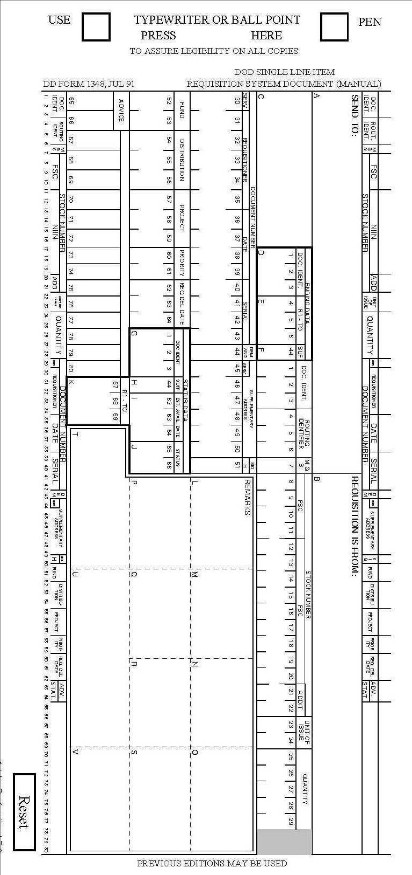
SAMPLE

