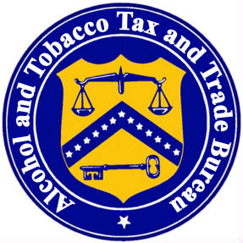

Federal Compliance Training for the Brewery Industry
Presented by the Alcohol and Tobacco Tax and Trade Bureau
Northwest Field Office
9:oo A.M. − 3:00 P.M.

Portland, Oregon – April 26
Holiday Inn Hotel, Airport

Seattle, Washington − April 28
Red Lion Hotel, Airport

Phoenix, Arizona − May 3
Crowne Plaza Hotel, Phoenix Airport

Topics

Pay.Gov, Flavored Malt Beverages, Record keeping and Reports, Changes after Qualification, Statement of Process, Bonds, Taxes, Labeling, Exports, and Suspension of SOT

Free Admission ***Register Early *** Limited Space

Registration : Phone: (360) 696-7900 Fax: (360) 696-7901

Please provide the following information:
Brewery Name__________________________ BRE #____________
Phone _____________________ email____________________________
Attending Portland ( ) Seattle ( ) Phoenix ( )
Name of Attendee(s)______________________________________________________
Please call if you require any special accommodations

Food and beverage will not be provided

