WILDFIRE PREPAREDNESS TIPS

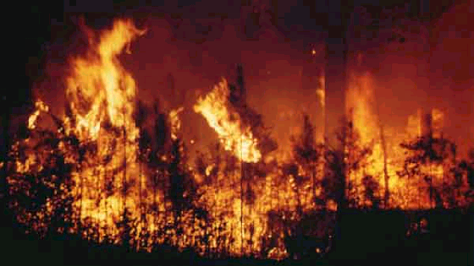

- Clear a 30 to 50 foot wide safety zone around your home or business. Keep trees and shrubs pruned so vegetation is away from buildings. Remove dead vegetation and dispose of rubbish and debris.

- Mow your grass regularly.

- Make sure fire trucks can get to your house and outbuildings in an emergency.

- Keep your chimney in good condition, and ensure that it has a spark screen.

- Have enough garden hose to reach all the structures on your property.

- Keep fire tools (shovels, buckets, rakes, and saws) handy.

- Have a ladder that can reach your roof.

- Observe burning bans announced by local government. Don't burn debris outdoors when it is windy and never leave a fire unattended.

- Soak grill or fireplace ashes in water for a day before disposing of them.

- Stack firewood well away from your home and, if possible, uphill of it.

- As vehicle exhaust systems are often hot enough to ignite a fire, don't drive or park on high grass that is dry.

