RESEARCH AND OVERSIGHT
COUNCIL
ON WORKERS' COMPENSATION

ANNUAL FINANCIAL REPORT

For The Year Ended August 31, 2003



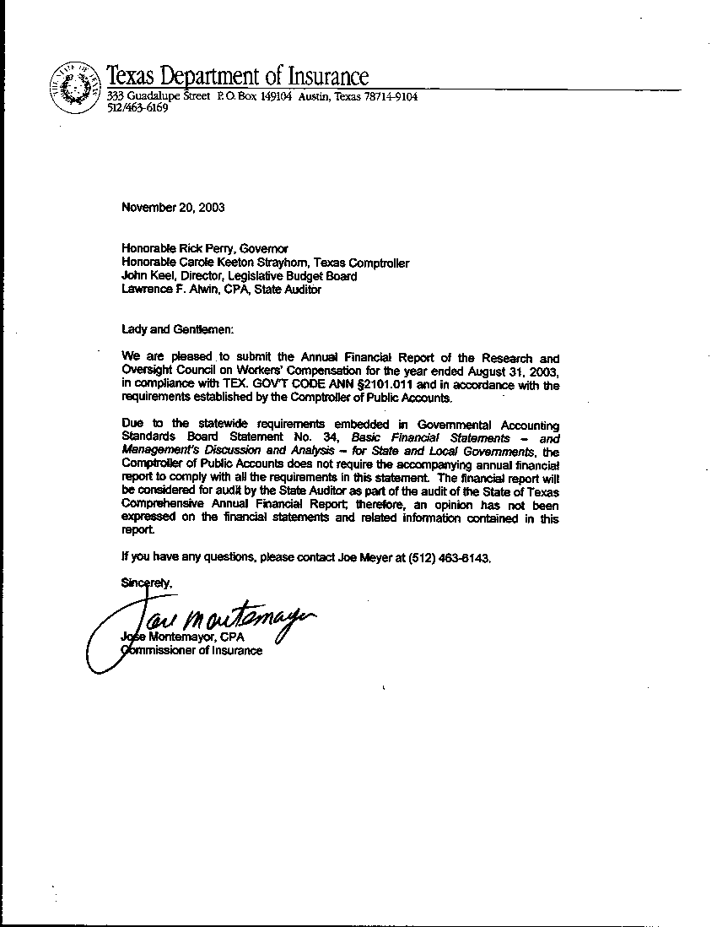

RESEARCH AND OVERSIGHT COUNCIL ON WORKERS’ COMPENSATION

TABLE OF CONTENTS

GENERAL PURPOSE FINANCIAL STATEMENTS – EXHIBITS:

- Combined Balance Sheet /Statement of Net Assets-Governmental Funds………..1
II. Combined Statement of Revenues, Expenditures and Changes in Fund Balance/
Statement of Activities-Governmental Funds………………………………...2

NOTES TO THE FINANCIAL STATEMENTS:

1. Summary of Significant Accounting Policies……………………………………. 3
2. Fixed Assets………………………………………………………………………. 6
3. Deposits, Investments & Repurchase Agreements……………………………….. 6
4. Summary of Long Term Liabilities……………………………………………….. 6
5. Capital Leases………………………………………………………………………6
6. Operating Lease Obligations………………………………………………..…….. 7
7. Interfund Balances/Activities………………………………………………..……. 7
8. Contingent Liabilities…………………………………………………… ………. 7
9. Continuance Subject to Review………………………………………………….. 7
10. Risk Financing and Related Insurance…………………………………………… 7
11. Segment Information………………………………………………………..……. .8
12. Bonded Indebtedness……………………………………………………………... .8
13. Subsequent Events……………………………………………………………….. .8
14. Related Parties………………………………………………………………….… .8
15. Stewardship, Compliance and Accountability…………………………………… .8
16. The Financial Reporting Entity………………...………………………………… .8
17. Restatement of Fund Balances and Net Assets…………………………………….8
18. Employees’ Retirement Plans………………………………………………….…. 8
19. Deferred Compensation……………………………………………………………8
- Donor-Restricted Endowments…………………………………………………….8
- Management Discussion and Analysis (Material Changes to AFR)………………9
- Post Employment Health Care and Life Insurance Benefits………………………9

EXHIBITS

A-1. Combining Statement of Balance Sheet - All General and Consolidated Funds….10
A-2. Combining Statement of Revenues, Expenditures and Changes in Fund Balances -
All General and Consolidated Funds…………………………………….11

SCHEDULES

1-A. Schedule of Expenditures of Federal Awards ……………………………………..12
1-B. Schedule of State Grant Pass-Through From/To State Agencies………………….12
2-A. Miscellaneous Bond Information………………………………………………….12
2-B. Changes in Bonded Indebtedness………….………………………………………12
2-C. Debt Service Requirements………….…………………………………………….12
2-D. Analysis of Funds Available for Debt Service…………………………………….12
2-E. Defeased Bonds Outstanding………………………………………………………12

RESEARCH AND OVERSIGHT
COUNCIL ON WORKERS’

COMPENSATION

Combined
Financial
Statements:
Exhibits

For the fiscal year ended August 31, 2003

RESEARCH AND OVERSIGHT
COUNCIL ON WORKERS’

COMPENSATION

Notes
to the
Financial
Statements

For the fiscal year ended August 31, 2003

NOTES TO THE FINANCIAL STATEMENTS

NOTE 1: SUMMARY OF SIGNIFICANT ACCOUNTING POLICIES

A. ENTITY

The Research and Oversight Council on Workers' Compensation (ROC) is an agency of the State of Texas and its financial records comply with state statutes and regulations. This includes compliance with the Texas Comptroller of Public Accounts Reporting Requirements of State Agencies.

The ROC operates under the authority of the Texas Workers' Compensation Act, Texas Labor Code Annotated, Chapter 404, as amended by H. B. 1091, 74th Leg. Session (1995). The purpose of the agency is to conduct objective research and monitor the Texas workers' compensation system. The ROC is a component unit of the statewide reporting entity which will be audited.

The State of Texas General Appropriations bill for the 2004-2005 biennium as signed into law did not contain an appropriation to fund the operations of the ROC. As a result, the agency ceased its operations on August 31, 2003. On August 31, 2003, the ROC and the Texas Department of Insurance (TDI) signed a Memorandum of Understanding (MOU), which transfers and contracts the entirety of the professional studies and research functions previously performed by the ROC to the TDI effective September 1, 2003. This contract terminates on August 31, 2005.

Due to the significant changes related to Governmental Accounting Standards Board Statement No. 34, Basic Financial Statements – and Management’s Discussion and Analysis – for State and Local Governments, the Comptroller of Public Accounts does not require the accompanying annual financial report to be in compliance with generally accepted accounting principles (GAAP). The financial report will be considered for audit by the State Auditor as part of the audit of the State of Texas Comprehensive Annual Financial Report; therefore, an opinion has not been expressed on the financial statements and related information contained in this report.

The agency has determined there is no component unit as defined by GASB No. 14 – The Financial Reporting Entity.

NOTE 1: (continued)

B. FUND STRUCTURE

The accompanying financial statements are presented on the basis of funds, each of which is considered a separate accounting entity.

H. B. 3050 passed by the 74th Legislature resulted in the creation of a new dedicated revenue fund number 5016 for the ROC effective September 1, 1995.

GOVERNMENTAL FUND TYPES & GOVERNMENT-WIDE ADJUSTMENT FUND TYPES

General Fund
The General Fund is the principal operating fund used to account for most of the state’s general activities. It accounts for all financial resources except those accounted for in other funds.

Capital Asset Adjustment Fund Type
Capital Asset Adjustment fund type will be used to convert governmental fund types’ capital
Assets from modified accrual to full accrual.

Long-Term Liabilities Adjustment Fund Type
Long-Term Liabilities Adjustment fund type will be used to convert governmental fund types’
debt from modified accrual to full accrual.

Other Adjustment Fund Type
Other Adjustments fund type will be used to convert all other governmental fund types activity
from modified accrual to full accrual.

C. BASIS OF ACCOUNTING

The basis of accounting determines when revenues and expenditures or expenses are recognized in the accounts reported in the financial statements. The accounting and financial reporting treatment applied to a fund is determined by its measurement focus.

Governmental fund types that build the fund financial statements are accounted for using the

NOTE 1: (continued)

modified accrual method basis of accounting. Under the modified accrual, revenues are recognized in the period in which they become both measurable and available to finance operations of the fiscal year or liquidate liabilities existing at fiscal year end. The State of Texas considers receivables collected within sixty days after year-end to be available and recognizes them as revenues of the current year for Fund Financial Statements prepared on the modified basis of accrual. Expenditures and other uses of financial resources are recognized when the related liability is incurred.

Governmental adjustment fund types that will build the government-wide financial statements are accounted for using the full accrual method of accounting. This includes capital assets, accumulated depreciation and unpaid Employee Compensable leave. The activity will be recognized in these fund types.

D. BUDGETS AND BUDGETARY ACCOUNTING

The budget is prepared biennially and represents appropriations authorized by the legislature and approved by the Governor (the General Appropriations Act).

Unencumbered appropriations are generally subject to lapse 60 days after the end of the fiscal year for which they were appropriated.

E. ASSETS, LIABILITIES AND FUND BALANCES/NET ASSETS

ASSETS

Cash in State Treasury
This represents the amount of all cash on deposit with the State Treasury to be used for agency operations.

Consumable Inventories
Consumable inventory is valued at cost, generally utilizing the last-in, first-out method. The consumption method of accounting is used to account for inventories that appear in the governmental fund types. The cost of these items is expensed when the items are consumed.

Capital Assets
Assets with an initial, individual cost of more than $5,000 and an estimated useful life in excess of one year should be capitalized. These assets are capitalized at cost or, if not purchased, at appraised fair value as of the date of acquisition. Purchases of assets by governmental funds are reported as expenditures. Depreciation is reported on all “exhaustible” assets. “Inexhaustible” assets such as works of art and historical treasures

NOTE 1: (continued)

are not depreciated. Assets are depreciated over the estimated useful life of the asset using the straight-line method.

LIABILITIES

Accounts Payable
Accounts Payable represents the liabilities for the value of assets or services received at the balance sheet date for which payment is pending.

Payroll Payable
Payroll Payable is the accrual at year-end of payroll related items.

Employees' Compensable Leave Balances
Employees' Compensable Leave balances represent the liability that becomes “due” upon the occurrence of relevant events such as resignations, retirements and uses of leave balances by covered employees. Liabilities are reported separately as either current or noncurrent in the statement of net assets.

FUND BALANCE/NET ASSETS

The difference between fund assets and liabilities is ‘Net Assets’ on the government-wide, proprietary and fiduciary fund statements, and the ‘Fund Balance’ is the difference between fund assets and liabilities on the governmental fund statements.

Reservations of Fund Balance
Fund balances for governmental funds are classified as either reserved or unreserved in the fund financial statements. Reservations are legally restricted to a specific future use or not available for expenditure.

Reserved for consumable Inventories
This represents the amount of postage to be used in the next fiscal year.

Unreserved/Undesignated:
This represents any remaining fund balance after reservations.

Invested in Capital Assets, Net of Related Debt
Invested in capital assets, net of related debt consists of capital assets, net of accumulated depreciation and reduced by outstanding balances for bond, notes, and other debt that are attributed to the acquisition, construction, or improvement of those assets.

NOTE 1: (continued)

Unrestricted Net Assets

Unrestricted Net Assets consist of net assets which do not have constraints placed on their use that are externally imposed or imposed by law. Unrestricted net assets often have constraints on resources, which are imposed by management, but can be removed or modified.

INTERFUND TRANSACTIONS AND BALANCES

The agency has numerous transactions between and within fund types. Quasi-external transactions are charges for services rendered by one fund to another. They are accounted for as revenues, expenditures, or expenses. All other interfund transactions are reported as transfers.

NOTE 2: CAPITAL ASSETS

A summary of changes in Capital Assets for the year ended August 31, 2003 is presented below:

Governmental Activities | Balance  09/01/02 | Adjustments | Reclass | Additions | Deletions | Balance  08/31/03
Depreciable Assets:
Furniture and Equipment | $40,127.96 |  | (10,495.12) | 5,195.00 |  | $34,827.84
Total Assets at Historical Costs | $40,127.96 |  | (10,495.12) | 5,195.00 |  | $34,827.84
Less Accumulated Depreciation:
Furniture and Equipment | $(30,571.25) |  | 6,559.20 | (5,815.01) |  | $(29,827.06)
Total Accumulated Depreciation
Governmental Activities  Net Capital Assets | $9,556.71 | $0.00 | $(3,935.92) | $(620.01) | $0.00 | $5,000.78

NOTE 3: DEPOSITS, INVESTMENTS & REPURCHASE AGREEMENTS

NOT APPLICABLE

NOTE 4: SUMMARY OF LONG-TERM LIABILITIES

Changes in Long Term Debt
Governmental Activities | Balance  09-01-02 | Additions | Reductions | Balance  08-31-03 | Amounts Due  Within One  Year
Compensable Leave | 51,732.17 | 56,091.45 | (72,627.83) | 35,195.79 | 24,080.70
During the year ended August 31, 2003 the following changes occurred in liabilities.

Employees' Compensable Leave
A state employee is entitled to be paid for all unused vacation time accrued, in the event of the employee's resignation, dismissal, or separation from State employment, provided the employee has had continuous employment with the State for six months. Expenditures for accumulated leave balances are recognized in the period paid or taken in governmental fund types. For these fund types, the liability for unpaid benefits is recorded in the Statement of Net Assets. No liability is recorded for non-vesting accumulating rights to receive sick pay benefits.

The Agency's monetary liabilities for compensable future absences as of August 31, 2003 were as follows:
 | Annual Leave | $34,920.33
 | FLSA & State Comp Time | 275.46
 | Total Compensable Leave | $35,195.79

Note: FLSA hours accumulated are one and one half times hours worked.

NOTE 5: CAPITAL LEASES

NOT APPLICABLE

NOTE 6: OPERATING LEASE OBLIGATIONS

Included in the expenditures reported in the financial statements is the following operating amount of rent paid or due under an operating lease (for office space).
Fund Type
General Fund $63,282.60

There are no operating lease obligations beyond August 31, 2003 due to the unavailability of
funds. ROC notified the Texas Building and Procurement Commission in July 2003 that it

would be canceling its operating lease as of August 31, 2003 as a result of the line-item veto of the ROC’s funding in the State of Texas General Appropriations bill for the biennium 2004-2005 as signed into law.

NOTE 7: INTERFUND BALANCES/ACTIVITIES

As explained in Note 1 on Interfund Activities and Balances, there are numerous transactions between funds and agencies. At year-end, amounts to be received or paid are reported as:
- Transfers In or Transfers Out
The agency experienced routine transfers with other state agencies, which were consistent with the activities of the fund making the transfer.

Individual balances and activity at August 31, 2003 follows:

 | TRANSFERS IN | TRANSFERS OUT
GENERAL REVENUE (01)
Appd Fund 5016, D23 Fund 5016
(Agency 902, D23 Fund 0001) | $1,816,903.93 | $1,799.00
Total Legislative Transfers (Exh II) | $1,816,903.93 $167,625.00 | $1,799.00 $546,626.37

NOTE 8: CONTINGENT LIABILITIES

NOT APPLICABLE

NOTE 9: CONTINUANCE SUBJECT TO REVIEW

The Texas Sunset Act (Chapter 325, Government Code) applies to the ROC. Unless continued in existence as provided by that chapter, the ROC is abolished on September 1, 2007.

The State of Texas General Appropriations bill for the 2004-2005 biennium as signed into law did not contain an appropriation to fund the operations of the ROC. On August 31, 2003, the ROC and the Texas Department of Insurance (TDI) signed a Memorandum of Understanding (MOU), which transfers and contracts the entirety of the professional studies and research functions to the TDI effective September 1, 2003. This contract terminates on August 31, 2005.

NOTE 10: RISK FINANCING AND RELATED INSURANCE

The Texas Research and Oversight Council on Workers' Compensation assumes substantially

all risks associated with tort claims and liability claims due to the performance of its duties. Currently there is no purchase of commercial insurance, nor is the agency involved in any risk pools with other government entities.

NOTE 11: SEGMENT INFORMATION

NOT APPLICABLE

NOTE 12: BONDED INDEBTEDNESS

NOT APPLICABLE

NOTE 13: SUBSEQUENT EVENTS

The State of Texas General Appropriations bill for the 2004-2005 biennium as signed into law did not contain an appropriation to fund the operations of the ROC. On August 31, 2003, the ROC and the Texas Department of Insurance (TDI) signed a Memorandum of Understanding (MOU), which transfers and contracts the entirety of the professional studies and research functions to the TDI effective September 1, 2003. The MOU provides for the transfer of all state records, assets, and other property of the ROC to the TDI. This contract terminates on August 31, 2005.

NOTE 14: RELATED PARTIES

NOT APPLICABLE

NOTE 15: STEWARDSHIP, COMPLIANCE AND ACCOUNTABILITY

NOT APPLICABLE

NOTE 16: THE FINANCIAL REPORTING ENTITY AND JOINT VENTURES

NOT APPLICABLE

NOTE 17: RESTATEMENT OF FUND BALANCES/RETAINED EARNINGS

NOT APPLICABLE

NOTE 18: EMPLOYEES RETIREMENT PLANS

NOT APPLICABLE

NOTE 19: DEFERRED COMPENSATION

NOT APPLICABLE

NOTE 20: DONOR-RESTRICTED ENDOWMENTS

NOT APPLICABLE

NOTE 21: MANAGEMENT DISCUSSION AND ANALYSIS (MATERIAL CHANGES TO AFR)

NOT APPLICABLE

NOTE 22: POST EMPLOYMENT HEALTH CARE AND LIFE INSURANCE BENEFITS

NOT APPLICABLE

RESEARCH AND OVERSIGHT
COUNCIL ON WORKERS’

COMPENSATION

Combining
Financial
Statements:
Exhibits

For the fiscal year ended August 31, 2003

RESEARCH AND OVERSIGHT
COUNCIL ON WORKERS’

COMPENSATION

Schedules

For the fiscal year ended August 31, 2003

END OF REPORT

