Golden and Hagins Serve as Keynote Speakers at NAACP Conference
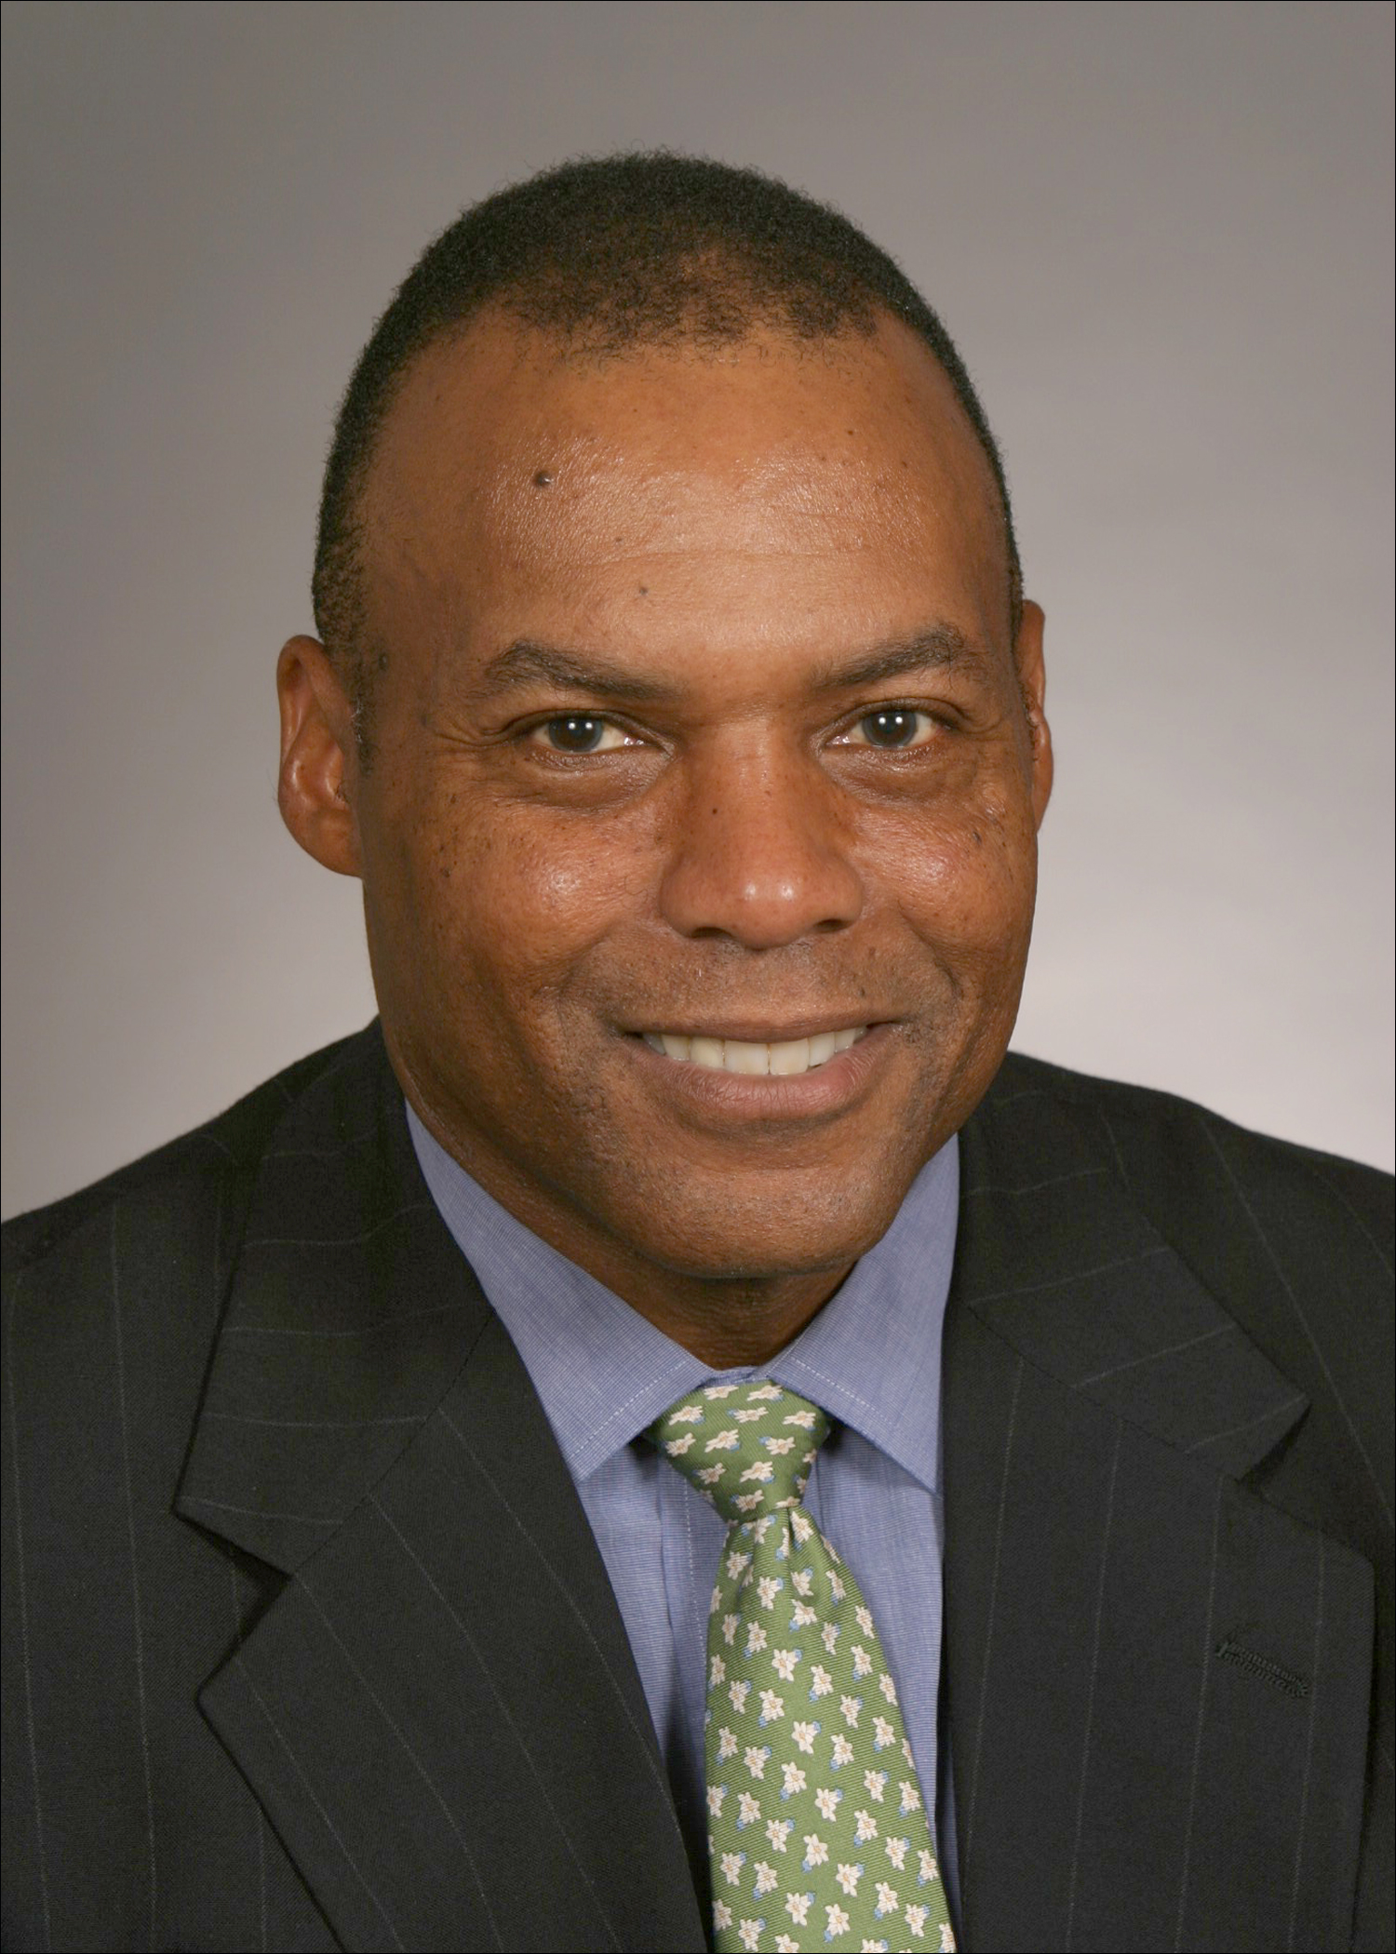

Ombudsman Sam Golden and Director of Compliance Policy Calvin Hagins served as keynote speakers at the NAACP Western Region I Conference, on Saturday, May 5. During the conference’s economic empowerment session, Mr. Golden provided an overview on CAG, and Mr. Hagins discussed issues such as CRA, consumer lending regulations, and consumer deposit regulations. This outreach effort, organized by OCC’s External Outreach and Minority Affairs unit, marked the first time OCC representatives have served as presenters at an NAACP event.
Sam Golden
Ombudsman
Calvin Hagins
Director of Compliance Policy
Founded in 1909, the NAACP is the nation’s oldest civil rights organization. Today the organization is engaged in a number of economic empowerment efforts, such as the Financial Empowerment Initiative (FEI) that is designed to help minority communities gain increased access to credit, capital, and financial services.

