Transition to Teaching Program Evaluation: An
Interim Report on the FY 2002 Grantees
U.S. Department of Education
Office of Planning, Evaluation and Policy Development
Policy and Program Studies Service
Prepared by:
Meredith Ludwig
Amy Bacevich
Andrew Wayne
Maggie Hale
Kazuaki Uekawa
American Institutes for Research
Washington, D.C.

2007

This report was prepared for the U.S. Department of Education under Contract Number ED01CO0026/0021 with the American Institutes for Research. Margery Yeager served as the contracting officer’s representative. The views expressed herein do not necessarily represent the positions or policies of the Department of Education. No official endorsement by the U.S. Department of Education is intended or should be inferred.
U.S. Department of Education
Margaret Spellings
Secretary
Office of Planning, Evaluation and Policy Development
Doug Mesecar
Acting Assistant Secretary
Policy and Program Studies Service
Alan Ginsburg
Director
Program and Analytic Studies Division
David Goodwin
Director
May 2007

This report is in the public domain. Authorization to reproduce it in whole or in part is granted. While permission to reprint this publication is not necessary, the suggested citation is: Transition to Teaching Program Evaluation: An Interim Report on the FY 2002 Grantees, U.S. Department of Education; Office of Planning, Evaluation and Policy Development; Policy and Program Studies Service, Washington, D.C., 2007.

Copies of this report may be ordered in the following ways:

Mail. Write to:

ED Pubs
Education Publications Center
U. S. Department of Education
P. O. Box 1398
Jessup, MD 20794-1398

Fax. Dial 301-470-1244.

Telephone (toll-free). Dial 877-433-7827 (877-4-ED-PUBS). If 877 service is not yet available in your area, call 800-872-5327 (800-USA-LEARN). Those who use a telecommunications device for the deaf (TDD) or a teletypewriter (TTY) should call 1-877-576-7734.

Electronic mail. Send your request to: edpubs@inet.ed.gov.

Online. Order a copy of the report at: www.edpubs.org. This report may also be downloaded from the Department’s Web site at www.ed.gov/about/offices/list/opepd/ppss/reports.html#title.

Alternate formats. Upon request, this publication is available in alternate formats such as Braille, large print, or computer diskette. For more information, please contact the Department’s Alternate Format Center at 202-260-0852 or 202-260-0818.

This report contains Web site addresses for information created and maintained by private organizations. This information is provided for the reader’s convenience. The U.S. Department of Education is not responsible for controlling or guaranteeing the accuracy, relevance, timeliness, or completeness of this outside information. Further, the inclusion of information or a Web site address does not reflect the importance of the organization, nor is it intended to endorse any views expressed, or products or services offered.
Contents
LIST OF EXHIBITS v

executive summary 1
Chapter I: OVERVIEW OF TTT GRANTEES, PARTICIPANTS and Teachers 13
Highlights 13
Purpose of the TTT Grant Program 13
The TTT Project and Its Components 15
Type of Grant Recipient 17
Participating LEAs 19
Project Budget Resources 22
Project Objectives: Progress and Challenges Over Three Years 25
TTT Teachers 30
Chapter II: Recruitment and Selection of TTT PARTICIPANTS 37
Highlights 37
Recruitment 37
Recruitment Strategies in TTT Projects 38
Recruitment Challenges Identified 41
Recruitment Results 47
Selection Processes 48
Chapter III: Preparation and Certification 53
Highlights 53
Preparation in TTT Projects 53
Program Delivery Approaches and Challenges 59
Certification 61
Chapter IV: Hiring and Placement Of New Teachers 65
Highlights 65
Hiring and Placement 65
Chapter V: Mentoring and Other Supports for Newly Hired Teachers 73
Highlights 73
TTT Project Support for TTT Participants 73
Mentoring in TTT Projects 76
Implementing Mentoring Approaches and Challenges 78
Retention Outcomes 79
Chapter VI: Teacher Satisfaction and Future Plans 85
Highlights 85
Interest in Teaching and Perspective on Preparedness 86
Future Plans 90
Chapter VII: CONCLUSION 93
The TTT Project: A Complex System 93
Areas for Further Investigation 96
Recommendations 97
References R-1
APPENDIX A: DEFINITIONS A-1
APPENDIX B: Participant Sample B-1
APPENDIX C: Snapshots of the Eight TTT Sites Visited C-1
APPENDIX D: EVALUATION METHODOLOGY D-1

EXHIBITS
Exhibit 1. Percentage of Grantees Reporting Target Groups and Percentage of Year 3 Participants from Each Target Group 4
Exhibit 2. Number of Participants Targeted, Total Applications Received, and Total Applicants Determined as Eligible as Reported by FY 2002 TTT Grantees for the Third Project Year, by Target Group 4
Exhibit 3. TTT Teachers’ Choice of Preparation Pathway Without TTT 6
Exhibit 4. Number of TTT Participants Who Were New Teachers of Record in High-Need Schools in High-Need LEAs, by Grade Level and Year and Subject Area in 2002, 2003 and 2004 7
Exhibit 5. Percentage of Participants Who Became Teachers of Record in 2002 and 2003 and Their Retention Status, by Year Entering the TTT Project (2002 and 2003) 8
Exhibit 6. Grantee Component Framework: Addressing Participant Needs 15
Exhibit 7. Percentage of FY 2002 TTT Grantees, by Grant Recipient 17
Exhibit 8. Percentage of FY 2002 TTT Grantees, by Scope 18
Exhibit 9. Percentage of FY 2002 TTT Grantees Reporting Number of Participating LEAs 20
Exhibit 10. Percentage of Participating LEAs by Type of LEA 21
Exhibit 11. Percentage of Participating Organizations with TTT Responsibilities 21
Exhibit 12. Percentage of FY 2002 TTT Grantees Reporting Third Year Budgets, by Size of Budget 23
Exhibit 13. Status of Unexpended Funds 24
Exhibit 14. Plans for Use of Unexpended Funds 24
Exhibit 15. Progress in Meeting Project-Established Objectives in Year 3 25
Exhibit 16. Issues and Changes Made to Meet Project-Established Objectives 26
Exhibit 17. Approaches to Resolving Difficulties or Barriers 28
Exhibit 18. Percentage of TTT Teachers, by Ethnicity and Race 31
Exhibit 19. Percentage of TTT Teachers Who Are Hispanic, by Target Group 31
Exhibit 20. Percentage of TTT Teachers, by Target Group 32
Exhibit 21. Percentage of 2004–05 Participants by Occupation Prior to TTT 33
Exhibit 22. Percentage of FY 2002 TTT Grantees Who Ranked Each Recruitment Method as One of Their Top Three Recruitment Methods 39
Exhibit 23. Percentage of TTT Teachers Reporting the Importance of Sources for Learning About TTT 40
Exhibit 24. Percentage of FY 2002 TTT Grantees Reporting Incentives Offered to Participants 43
Exhibit 25. Percentage of Grantees Offering Incentive, Average Amount of Incentive Provided and Number of Participants Receiving Incentive, as Reported by FY 2002 TTT Grantees for the Third Project Year, by Type of Incentive 43
Exhibit 26. Average Out-of-Pocket Expenses for TTT Participants in Their First Year 44
Exhibit 27. Average Out-of-Pocket Expenses Reported by TTT Grantees for a Typical Participation Year, by Grantee Recipient Type 45
Exhibit 28. Percentage of FY 2002 TTT Grantees Indicating Each Element Was One of the Top Three Most Attractive Elements to Participants 46
Exhibit 29. Percentage of TTT Teachers Reporting Influences on Decision to Participate in TTT 47
Exhibit 30. Number of Participants Targeted, Total Applications Received, and Total Applicants Determined as Eligible as Reported by FY 2002 TTT Grantees for the Third Project Year, by Target Group 48
Exhibit 31. Percentage of Grantees Reporting Target Groups and Percentage of Year 3 Participants From Each Target Group 48
Exhibit 32. Percentage of FY2002 Grantees Indicating the Importance of Various Factors in Selecting Applicants for Admission 51
Exhibit 33. Number of FY2002 TTT Grantees Using Multiple Selection Factors 52
Exhibit 34. Percentage of FY 2002 TTT Grantees Requiring Components of Teacher Preparation, by Component 54
Exhibit 35. Percentage of FY 2002 TTT Grantees Who Reported Requiring Course Credit or Professional Development Hours, by Topic 55
Exhibit 36. Percentage of TTT Teachers Reporting Activities and Areas of Study NOT Part of Their Program 56
Exhibit 37. Percentage of TTT Teachers Reporting Their Program Included a Student Teaching Experience 57
Exhibit 38. Percentage of TTT Teachers Reporting Utility of Areas of Study 58
Exhibit 39. Percentage of FY 2002 TTT Grantees Reporting Required Program Elements Before and After Attaining Teacher of Record (TOR) Status, by Target Group and Program Element 59
Exhibit 40. Most Commonly Used Practices of FY 2002 TTT Grantees for Determining Eligibility for Certification Status, by Target Group 62
Exhibit 41. Percentage of TTT Teachers with Certification Matching Their Main Teaching Assignment, by Target Group 63
Exhibit 42. Percentage of FY 2002 TTT Grantees Reporting Various Assignment Areas as Being Identified as High-Need in Participating LEAs, by Grade Level and Subject Area 66
Exhibit 43. Number of TTT Participants Who Were New Teachers of Record in High-Need Schools in High-Need LEAs, by Grade Level and Year and Subject Area in 2002, 2003 and 2004 67
Exhibit 44. Percentage of TTT Teachers Reporting Main Teaching Level 68
Exhibit 45. Percentage of TTT Teachers by Subject Area Assignment 70
Exhibit 46. Percentage of TTT Teachers Reporting Main Teaching Assignment Field, by Target Group 71
Exhibit 47. Percentage of TTT Teachers Reporting Teaching Assignments Outside of Main Teaching Field, by Target Groups 71
Exhibit 48. Percentage of TTT Teachers Who Teach a Subject Outside of Their Primary Assignment Subject, by Primary Teaching Subject 72
Exhibit 49. Percentage of FY 2002 TTT Grantees Reporting Frequency and Type of Support Offered 74
Exhibit 50. Percentage of FY 2002 TTT Grantees Offering Support, by Number of Years 74
Exhibit 51. Percentage of TTT Teachers Reporting Types of Support Experienced During TTT Participation, by Target Group 75
Exhibit 52. Percentage of Teachers Reporting Having a Mentor This Year* 76
Exhibit 53. Percentage of TTT Teachers Reporting Entities Providing Mentoring 77
Exhibit 54. Percentage of TTT Teachers Reporting Frequency of Mentor Meetings 78
Exhibit 55. Percentage of Participants Who Became Teachers of Record in 2002 and 2003 and Their Retention Status, by Year Entering the TTT Project (2002 and 2003) 80
Exhibit 56. Percentage of Teachers Who Became Teachers of Record in 2002 and Were Still Teaching in 2004 by the Duration of Site-Based Mentoring Offered by FY 2002 TTT Grantees 80
Exhibit 57. Percentage of FY 2002 TTT Grantees Ranking Retention Methods Among Top Three Used 81
Exhibit 58. Frequency with which Grantees Reported Various Top Three Reasons for Not Completing Their Teaching Assignments and Leaving the Project 82
Exhibit 59. Percentage of FY 2002 TTT Grantees Reporting Range of Participants Who Left the Project After 1 Year (2003–04) 83
Exhibit 60. TTT Teachers’ Choice of Preparation Pathway Without TTT 86
Exhibit 61. Percentage of TTT Teachers Reporting the Extent to Which Specific Reasons Influenced Their Becoming a Teacher 87
Exhibit 62. TTT Teachers’ Perceived Level of Preparation to Face Challenges in Their First Year of Teaching 88
Exhibit 63. Percentage of TTT Teachers Reporting Their Feelings of Preparedness for Teaching Their Subject, by Type of Grant Recipient 89
Exhibit 64. Percentage of TTT Teachers Reporting Extent of Challenges in the First Three Months of Teaching 89
Exhibit 65. Percentage of TTT Teachers Reporting Extent to Which Factors Would Cause Them to Leave Teaching 90
Exhibit 66. Percentage of TTT Teachers Reporting the Amount of Time They Plan to Remain in Teaching, in Comparison With SASS Data on Alternative Route Teachers and Traditional Route Teachers 91
Exhibit 67. Grantee Component Framework: Addressing Participant Needs 93

executive summary
Congress established the Transition to Teaching (TTT) program to serve high-need schools in high-need districts (local education agencies or LEAs). The program is authorized under Title II, Part C, Subpart 1, Chapter B of the Elementary and Secondary Education Act of 1965, as amended by the No Child Left Behind Act of 2001 (NCLB) (Pub. L. No. 107-110). The purposes of TTT are “(a) to recruit and retain highly qualified mid-career professionals (including highly qualified paraprofessionals), and recent graduates of an institution of higher education, as teachers in high-need schools, including recruiting teachers through alternative routes to certification; and (b) to encourage the development and expansion of alternative routes to certification under State-approved programs that enable individuals to be eligible for teacher certification within a reduced period of time, relying on the experience, expertise, and academic qualifications of an individual, or other factors in lieu of traditional course work in the field of education.”
This report presents the findings of the TTT interim evaluation—an effort to gather data to describe to Congress the progress at the three-year interim point of five-year grants awarded in FY 2002.
Four primary data sources were used as the basis for the report:
- An online Annual Performance Report (APR) to document project-level characteristics and outcomes was developed and administered in 2004–2005, covering the third year of project activities;
- Eight case studies of FY 2002 projects were conducted in 2004–2005;
- A survey of participants from the first three project years who were hired as teachers of record during that time period was conducted in 2005–2006; and
- Interim reports submitted by grantees in the FY 2002 cohort in 2005 were the basis for a review of objectives, progress made, and challenges in the first three years.
Data from the 2003–2004 Schools and Staffing Survey (SASS) were also used to compare the characteristics, teaching assignments, perceptions and future plans of TTT teachers and teachers in the workforce with less than three years of experience.
The resulting report brings together data from all of these sources to describe the overall implementation picture of the FY 2002 grantees, describing each component of the TTT projects: recruitment and selection, preparation, certification, placement, support while teaching, and retention.
TTT grantees are a microcosm of the alternate routes implemented in approximately 600 program sites in 48 states and the District of Columbia (Feistritzer, 2006). Of the 92 FY 2002 TTT grantees whose progress at the third year of project activity were analyzed in this evaluation, fully half were institutions of higher education (IHEs), 25 percent were LEAs, 17 percent were state departments of education (SEAs), and 7 percent were nonprofit organizations. Nearly two-thirds of FY 2002 grantees (60 percent) had a local (rather than statewide or regional or national) focus. All TTT grantees focus on serving the needs of high-need schools in high-need LEAs, as defined in the legislation (see footnote 1). A relatively small proportion of all LEAs working with FY 2002 TTT grantees were urban (26 percent); 69 percent were described as rural by the TTT projects.
TTT projects recruit from one or more target groups, as spelled out in the authorizing legislation, addressing the needs of school districts and schools that have met the “high-need” designation. In most TTT projects, participants become teachers simultaneously with their “enrollment” in the project; however, some projects require course completion and even a lengthy internship prior to becoming a teacher of record.
TTT projects offer flexibility to participants as they complete state teacher certification requirements. The approaches used by various projects are structured to meet the NCLB standards for approved alternate route projects; thus, TTT teachers are considered highly qualified teachers, according to NCLB guidelines. Projects seek applicants who meet the content knowledge provisions outlined for all teachers in NCLB. In the FY 2002 projects that focus on paraprofessionals, some individuals are matriculating to earn their first bachelor’s degree, but nearly all other participants already have an earned bachelor’s.
Preparation for teaching is a primary concern, once participants are selected. Some participants enroll in academic courses through local IHEs; others participate in seminars and professional development activities where they demonstrate competencies. Online courses and online mentoring components are incorporated in a number of TTT projects. While much of the content is similar to what a typical teacher studies in preparation for her role, in some TTT projects, the emphasis at the beginning of preparation is on the craft of teaching and on classroom management. Many TTT projects require a student teaching experience during the summer prior to teaching or for an entire year. About 40 percent of teachers participating in TTT projects (FY 2002) reported they had a student teaching experience.
Once hired and teaching, participants in TTT projects find an array of supports available to them. Some TTT projects create and implement mentoring and other induction programs; in others, participants gain access to induction programs currently in place and supported by the state or district.
Interim Report Findings
The findings from this interim report underscore the ways in which the TTT grantees (and the program) have addressed three key NCLB policy issues related to this federal grant program. Based on one project year’s performance report and interim evaluations of varying depth and detail, this report stops short of a comprehensive program evaluation, because grantees continue to make improvements and changes to their projects and many expected to have a no-cost extension year.
Increasing the pool of highly qualified teachers by recruiting nontraditional candidates into teaching
Each TTT grantee specifies the target population it plans to recruit and sets recruitment targets for the grant overall and for each project year: most projects target more than one applicant group. Recruitment strategies and information dissemination about the project are key, because the populations being targeted may be uncertain about how to become a teacher and may not be aware that there are (within their state) many alternative routes to meeting state teacher certification requirements. Also, with its focus on high-need schools in high-need LEAs, TTT projects face more of a challenge to identify unfilled positions and recruit and place individuals with the appropriate credentials for these positions.
TTT grantees reported they learned that the most powerful way to reach people is by “word of mouth,” that is, informal and formal presentations by project administrators and presentations by TTT participants in schools and IHEs. TTT teachers, in turn, agreed that the approach through which they gained the most information was by “word of mouth.” Targeted recruitment efforts for specific populations were highly recommended by TTT grantees; however, more costly measures, such as TV advertising, were not as productive because, while the level of interest received was high, many of those expressing interest were not qualified. Web site content was found to be very valuable to prospective participants. Disseminating full information about the project and the expected commitment proved effective, according to participants, as was establishing a reputation as a strong project.
As a cohort, the TTT FY 2002 grantees were highly successful in attracting a large number of applicants for targeted positions in the third project year: TTT grantees set targets to hire nearly 4,000 teachers and they reported receiving applications from 14,000 prospective candidates. One unique aspect of a TTT project is that it may have more than one recruiting period in a calendar year and be serving two or more cohorts of participants in one year.
TTT projects also report generally succeeding in finding placements in high-need schools in high-need districts for eligible participants, however, they reported many challenges associated with this process, including budget shifts that reduced positions, changing state requirements, competition from other routes to teaching, some negative views toward alternate routes, and a lack of LEAs in their areas that meet the program standard for high-need. As a result, in their three-year interim evaluations, many grantees recalled that the challenge of meeting recruiting and placement goals for those specific districts was felt each year.
Overall, in the first three years of the grant, the FY 2002 grantees have facilitated the hiring of an estimated 7,000 new teachers. Projects gradually ramped up in terms of the number hired, with a fairly large jump from year 1 to year 2.
The following tables describe the level of recruitment for the grantee cohort of FY 2002 as a whole, highlighting three findings: TTT grantees tend to recruit more than one type of participant; midcareer professionals make up the largest portion of teachers recruited and hired through the TTT grantee projects; and TTT recruitment efforts yield many more applicants than are eligible to become highly qualified teachers (see Exhibits 1 and 2).
- Percentage of Grantees Reporting Target Groups and
Percentage of Year 3 Participants from Each Target Group
Target Group of Grantees | Percentage of Grantees Targeting This Group | Percentage of Total  Year 3 Participants From Each Target Group
Midcareer professionals | 87 | 59
Paraprofessionals | 52 | 14
Recent college graduates | 79 | 27
Exhibit reads: Eighty-seven percent of FY 2002 grantees targeted midcareer professionals, and fifty-nine percent of participants were midcareer professionals. Not shown in this exhibit is the small percentage that target one of the three groups alone; 4 percent of TTT FY 2002 projects target paraprofessionals exclusively.
Source: Transition to Teaching Annual Performance Report, 2004–05.

- Number of Participants Targeted, Total Applications Received, and Total Applicants Determined as Eligible as Reported by FY 2002 TTT Grantees for the Third Project Year, by Target Group
Target Group of Grantees | Goal (Number of Participants to Recruit) | Number of Applications Received | Number of Applicants Determined as Eligible | Percentage of Applicants Determined as Eligible | Ratio of Eligible Applications per Slot
Midcareer professionals | 2,022 | 8,513 | 5,467 | 64 | 2.7 to 1
Paraprofessionals | 781 | 1,642 | 1,068 | 65 | 1.4 to 1
Recent college graduates | 893 | 4,075 | 3,062 | 75 | 3.4 to 1
Exhibit reads: Across all FY 2002 grantees, the total number of individuals from the midcareer target group sought was 2,022; 8,513 applications were received; 5,467 applicants (64 percent of the total applications received) were determined to be eligible through the selection and screening process. The ratio of eligible applications per slot was 2.7 to 1 in the third project year.
Source: Transition to Teaching Annual Performance Report, 2004–05.
Bringing increased flexibility to the teacher preparation system by encouraging the creation and expansion of alternative routes or pathways to teacher certification and lowering barriers of time and cost of preparation, while raising standards and program rigor
At the time of the awarding of these grants, nearly three-quarters of states had already at least one approved alternate route. The rest were expected to follow suit, stimulated by the NCLB expectation that states eliminate all emergency or provisional certificate and waiver programs (Feistritzer, personal communication, 2006). Approximately one-third of the TTT FY 2002 awards were provided to entities seeking to build on existing programs (under state-approved alternate routes) and approximately two-thirds of the awards went to entities initiating new programs. As a federal grant program, TTT has enhanced and sustained the approved alternate routes in states, and, in some states and districts, it has been the source of the first alternate route option for those entering teaching and the first program.
Participants in TTT projects report that financial incentives offered, an employment guarantee, and support while obtaining certification are the three most attractive features of TTT projects. Through the TTT grant, projects were able to offer financial incentives, which could include scholarship or tuition reimbursement of up to $5,000 for the grant period for those committing to teach in high-need schools in approved high-need school districts for at least three years. This assistance is compelling for many individuals who do not have the resources to return to school and want to remain continuously employed while preparing to be certified.
TTT teachers who became teachers of record during the first three years of the FY 2002 grant primarily reported they made the decision to become a teacher because of their desire to work with young people (64 percent). TTT teachers also reported they perceived the project to add value through its requirements for study, and more than two-thirds said they felt well prepared to teach their subject area. TTT teachers reported that their projects followed through on their commitments. Still, these teachers experienced challenges in their first few months of teaching, noting that the administrative, classroom management, and time demands of teaching were very challenging. These challenges, it should be noted, are similar to the ones experienced by many new teachers.
Like teachers in the workforce today, about half of the TTT teachers who have been teaching in the first three years of these grants reported they planned to stay in teaching for as long as they were able. These teachers also suggested that, while working conditions and administrative-related issues could be a factor in a decision to leave teaching, they were anticipating the level of these challenges would be moderate with respect to their long-term teaching plans.
Twenty percent of TTT teachers indicated they would not have entered teaching, if the TTT option were not available in their area. Among targeted groups, paraprofessionals were least likely to say they would not have taught without the TTT alternative (14 percent) compared to recent college graduates (22 percent) and midcareer professionals (24 percent). Teachers who were born in the 1980s were much more likely to say they would have simply not taught if TTT were not available. Incentives were the top-ranked influence on a participant’s decision to participate in TTT; for those who placed this as the top influence, if TTT was not available, they indicated they would have chosen a traditional program. Finally, teachers of social studies and foreign languages were least likely to have expected to find another alternate route and most likely to have simply not taught. No pattern was discernible for mathematics or science teachers (see Exhibit 3).
- TTT Teachers’ Choice of Preparation Pathway
Without TTT
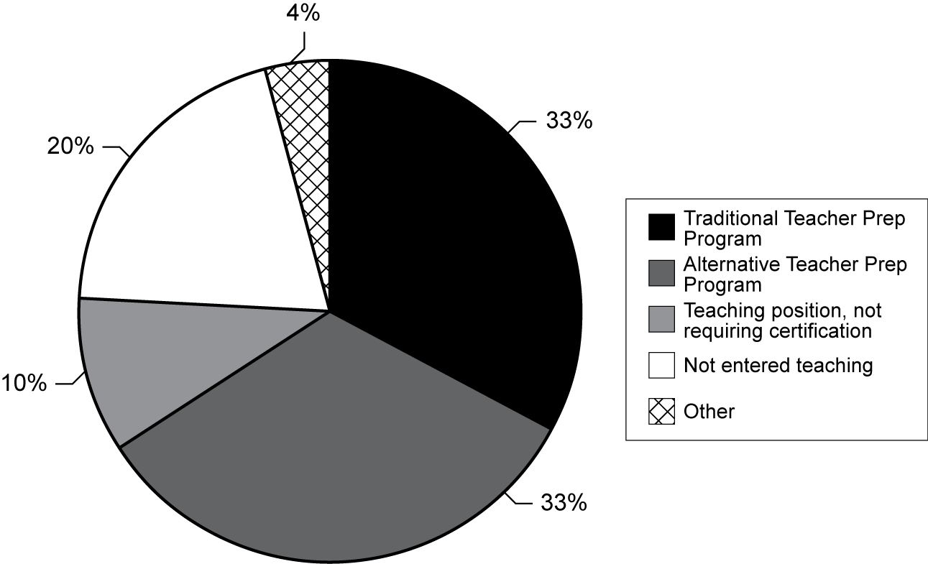
Exhibit reads: Thirty-three percent of TTT teachers reported they would have participated in a traditional teacher education program if the TTT project had not been available.
Source: Transition to Teaching TTT teacher survey, 2005–06.
Improving the retention rate of new teachers by supporting strong mentoring programs and induction and including a three-year teaching commitment in high-need schools in high-need districts as part of the program requirements
Over the first three years of the FY 2002 grants included in this evaluation, an estimated 7,000 participants were hired to teach and were working in areas designated by school districts of greatest need: middle and high school and in the subject areas of science, mathematics and special education. TTT projects have been generally able to increase the number of participants recruited and hired in each project year (see Exhibit 4). The largest percentage of TTT teachers were hired to teach mathematics (21 percent) and special education (21 percent).
- Number of TTT Participants Who Were New Teachers
of Record in High-Need Schools in High-Need LEAs,
by Grade Level and Year and Subject Area in 2002,
2003 and 2004
Exhibit reads: In 2004, 1,125 new teachers of record were hired in participating LEAs for high school placements.
Source: Transition to Teaching Annual Performance Report, 2004–05.
TTT teachers have been generally assigned to teach in the field in which they are seeking certification but at least 20 percent overall reported they have also been assigned to teach subjects outside of their main teaching area. Eighty percent or more of TTT teachers in the first three years reported their certification matched their main teaching assignment.
Calculating a three-year retention rate for TTT teachers was not possible for this interim evaluation, because the data were not available at the time of the grantee reports. However, data for the first two groups of teachers hired in 2002 and 2003 were available and show that the retention rate is relatively high, even with some attrition in a single year or over two years. Seventy-four percent of those who entered the project in 2002 were still teaching in 2004 (see Exhibit 5). As a comparison to this retention rate, the most recent national estimates (from SASS data in 1999–2000) indicate 29 percent of first-time teachers either changed schools at the end of the year (15 percent) or left teaching (14 percent) (Smith and Ingersoll, 2004). These analyses also found that beginning teachers comparable to the TTT teachers in high-poverty schools were “less likely than their counterparts in medium-poverty schools to move after a year but were more likely to leave teaching (16 percent as opposed to 9 percent)” (Smith and Ingersoll, 2004). Additional research on mobility was recently released which complements these findings (Marvel et al., 2006).
The importance of TTT support and mentoring to new teachers was explored, especially in light of research that shows a combination of supports can be significant in reducing teacher turnover (Smith and Ingersoll, 2004). Retention rates were not found to be associated with the number of years over which TTT projects provided mentoring assistance. The percentage of TTT teachers reporting they had a mentor (63 percent in the surveyed year) was slightly lower than that reported by other new teachers in the workforce (approximately 70 percent) (SASS, 2003–04). This was likely due to two factors. First, all TTT projects did not provide the same kind of support to new teachers, thus mentoring was not a universal component. Second, in many TTT projects mentoring support was the responsibility of the district and was not provided for all years. Thus in any given year, some TTT teachers were participating in a mentoring program, while others were not. This variability may have affected the perception of some TTT teachers who reported some dissatisfaction with the quality and quantity of mentoring and this feeling was reinforced by the reports of project directors who found it difficult to ensure a high quality of this and other supports when they were depending upon existing induction programs administered by districts in their states.
- Percentage of Participants Who Became Teachers
of Record in 2002 and 2003 and Their Retention Status,
by Year Entering the TTT Project (2002 and 2003)
Note: TTT projects may enroll more than one cohort of participants in a given project year.
Exhibit reads: Ninety-four percent of participants who entered the TTT project in 2002 and became teachers of record in 2002 were reported to still be teaching in 2003.
Source: Transition to Teaching Annual Performance Report, 2004–05.
Challenges and Lessons Learned
In their approaches to facilitating recruitment, selection, preparation, hiring, placement, certification, and support while teaching, TTT grantees have developed approaches that might differ with respect to recruitment strategies, involvement of school principals and district administrators, number and background of participants, and the nature and extent of support. Still, TTT grantees report that they share certain challenges in starting up and sustaining these components in alternate routes to certification.
Recruitment. The most critical challenge identified by grantees was that of recruitment, which was cited by almost one-third of the grantees. This category encompasses attracting qualified participants to teaching and to committing to a placement in high-need LEAs for three years. Recruitment was complicated by external factors, such as changes in state or district certification policies that affected alternate route participants, isolation of rural school districts, labor market conditions in some cities, competitive programs in the region, and the expense of living and working in urban districts. TTT projects attract many applicants with their focused recruitment efforts, but applicants are not all eligible and there is some attrition over time.
Selection. Some grantees reported receiving applications from individuals who were not adequately qualified and found it necessary to refine the participant selection process. A few projects instituted candidate screeners. Others established extensive selection and placement processes through which district administrators and IHE faculty were involved. By taking steps to be more selective and setting higher standards for entry, the grantees were also establishing a reputation as a selective program, which, it was believed, would eventually facilitate both recruitment and hiring.
Retention. A number of participants were unhappy with the working conditions in high-need schools, and still others who were eligible, would not commit to the project because they wanted to select the location where they would work and did not find the needs of specific types of LEAs compelling. Still others signed up originally, but then left because of difficulty in maintaining their performance, balancing work and course commitments, and financial considerations. Projects reported that participants felt LEAs in rural locations were simply harder to access, and they were not able to recruit as well for these districts or attract mentors, so instead focused on preparing training components that could be conveniently delivered.
Definition of High-Need LEAs Provided in the Authorizing Legislation. One quarter of the grantees cited problems with meeting the TTT program constraints regarding the definition of high-need LEA and high-need schools in terms of the level of poverty and the highly qualified teacher requirement. In their applications, TTT projects identified the districts that would meet the requirements and then worked with the program office if any changes were requested (e.g., adding an LEA to the list). Besides finding the districts and schools within the definition, some TTT projects found that their participants wanted to teach in other schools and districts that did not meet the definition, resulting in some attrition. Other projects reported that some high-need LEAs dropped out of their arrangement or had fewer openings than anticipated. As a result, projects maintained an ongoing discourse with the TTT program office about the LEA definition.
Grantees responded to the challenges they faced in meeting their objectives in many different ways; three key methods were mentioned in 60 percent of grantee responses: (a) networking and collaborating with LEAs, agencies, projects and schools; (b) providing more or improving professional development and support; and (c) increasing recruitment efforts, including more targeted efforts to reach individuals who were eligible.
Conclusion and Recommendations
The Transition to Teaching grant program supports a wide variety of alternate route approaches which exist within the broader population of state-, district- and university-provided options for those wishing to become teachers. As the data on the third project year activities were being collected through the APRs, the case studies, and the interim reports, it became clear that changes were being made to improve on the approaches. In conjunction with project monitors and through participation in grantee meetings, project management received support, particularly in the areas of recruitment and evaluation. Still, some lessons learned and challenges faced in the first three years of operations indicate the potential for some changes and new directions for the TTT program as a whole. Some of these are more appropriately addressed to the Congress as it plans for reauthorization of NCLB and considers options to strengthen the TTT program within the Office of Innovation and Improvement (OII).
1. In deliberations leading to reauthorization, consider giving the program office (OII) the authority to award shorter planning grants to prospective entities. Awarding one-year planning grants to entities planning to create new alternate routes would allow them the time to develop a business plan, pilot effective recruitment approaches, and obtain formal commitments from participating LEAs. Many FY 2002 projects indicated that the first year was a start-up and planning year, in terms of operations. Recruitment takes time and substantial resources and the yield is small each year considering the effort made. During this planning year, TTT projects could be asked to establish more of a “business plan” and finalize the targeted number of participants based on numbers of teachers needed. This planning year could also include project mentoring by program staff to establish the groundwork for evidence-based evaluations. There is some precedent for this option. For example, in the PT3 grant program, initial catalyst grants were awarded. Many of the IHE programs awarded these used the period to build strong models planning the integration of technology in teacher preparation programs and courses.
2. Use discretionary funds now available to OII and TTT to invest in the documentation and dissemination of effective practices for alternate route projects. Just as the FY 2002 grants were awarded, ED also produced a book of promising practices for alternate routes and established a national clearinghouse to gather annual data and provide access to policy and research reports. These information dissemination activities have proved valuable to many in this field. Four years later, and with the accumulated experience of the more than 100 grantees being documented, it makes sense to consider establishing a clearinghouse function within the program’s Web site or within the ED’s labs and centers that focuses on effective components of alternate routes. Through such a resource, alternate route project directors and evaluators would be able to find, for example, research studies on induction (including the latest data from the Institute of Education Sciences [IES] study on induction programs) and descriptions of effective induction activities in TTT projects, along with evidence about their success.
3. Encourage OII and TTT grantees to collaborate at the state and district level about policies regarding alternate routes. In their interim evaluations and in narrative APR responses about promising practices and challenges, project directors indicated the importance of working through policy differences that could affect their program options, their targeted recruitment, and their success in producing certified teachers. For example, a number of projects raised the concern that they might not be able to continue special education options due to changes in certification requirements in their states. In addition, a recent Government Accountability Office (GAO) report on Troops-to-Teachers indicated that additional collaboration among alternate routes that share recruiting populations might enhance recruitment success. Finally, in the case studies conducted for this interim report, we learned that such collaboration might ameliorate the confusing situation that sometimes faces applicants to teaching when there are competing routes, for example, regarding requirements to become highly qualified, costs, and mentoring. Project directors indicated that when they try to take advantage of existing mentoring and induction components in their states and districts, they face challenges in providing a high-quality program that is most closely related to the needs of their own project participants and does not include duplicative components.
4. Use discretionary funds now available to OII to conduct a small-scale investigation of the importance of the level of incentives to project participation. While the incentives provided by TTT are helpful, they do not ameliorate the high and rising cost of tuition at public and private colleges where most participants complete their academic requirements. The program could be enhanced by more information on what level of incentive is most appealing to participants and what makes sense given the cost of recruiting and supporting participants through to certification. Through this study, ED could explore some options, for example, removing the cap of $5,000 to allow flexibility to projects recruiting from different populations with varying financial needs; investigating the relationship between different levels of funding and participation; and exploring whether professional development-type online programs are less expensive to operate and to participate in.
5. In deliberations preceding reauthorization, reexamine the definition of high-need LEAs and high-need schools. Project grantees reported several challenges in this regard, most notably, they were able in some cases to identify many districts and schools that needed teachers, but all of them did not meet the narrow definition. Projects reported many more applications than expected, but some participants did not want to teach in designated high-need schools, so they earned certification through the TTT route, but did not make a commitment as to the school in which they would be teaching. ED could examine the impact of the current definition on total number of participants hired and retained and work with a group of experienced project directors to recommend additional criteria to assist grantees and participants. There should be a way to develop an approach so that unfilled teaching positions do not remain so and participants who wish to become highly qualified through alternate routes are not turned away, without penalizing the neediest schools.
Organization of the Report
This report begins with an overview chapter, and each subsequent chapter addresses a key component of grantee activity.
Chapter I: Overview of TTT Grantees, Participants and Teachers. This chapter provides an overview of TTT grantees and participants as they become teachers. Drawing on the APR for the third project year and reporting on progress toward objectives and challenges from the interim reports, project-level data are provided which illustrate the variation in grantee type, scope, participating organizations, and budget.
Chapter II: Recruitment and Selection of TTT Participants. This chapter focuses on the strategies and approaches that TTT projects implemented to recruit targeted participants, review their qualifications, and the results of these efforts for the third project year, addressing the first policy goal of the program: increasing the pool of highly qualified teachers by recruiting nontraditional candidates into teaching.
Chapter III: Preparation and Certification. This chapter outlines the activities of TTT projects as they prepare and support participants who are either serving as interns or as teachers of record while attending classes and professional development seminars. This chapter addresses the second policy goal related to breaking down barriers to teaching.
Chapter IV: Hiring and Placement of New Teachers. This chapter highlights the accomplishments of TTT grantees regarding hiring and placement in high-need schools in high-need LEAs and reviews the subject area assignments of these new teachers.
Chapter V: Mentoring and Other Supports for Newly Hired Teachers. The variety of supports provided to teachers in TTT projects are described in this chapter, addressing the policy goal of improving the retention rates of new teachers. In addition, the retention rates of TTT teachers in the early years of the FY 2002 grantees are reported in this chapter.
Chapter VI: Teacher Satisfaction and Future Plans. In this chapter we report TTT teacher data regarding their perception of TTT project preparation and support, along with the challenges faced and their future plans regarding teaching.
Chapter VII: Conclusion. This chapter draws together the evaluation findings and identifies potential refinements for the TTT program as well as questions for further investigation.

OVERVIEW OF TTT GRANTEES, PARTICIPANTS and Teachers

Highlights
- The FY 2002 cohort of TTT grantees was the largest in number in the history of the program thus far. Half of the 92 grantees were IHEs, 25 percent were local education agencies (LEAs), 17 percent were state departments of education (SEAs), and 7 percent were nonprofit organizations.
- In total, grantees reported 939 LEAs hired TTT participants in their third project year. A relatively small proportion of all LEAs working with FY 2002 TTT grantees were urban (26 percent); 69 percent were described as rural. Nationally, 51 percent of districts are rural, 41 percent are suburban, and 8 percent are urban. Some grantees served single large urban districts and others, multiple small rural districts.
- As a group, TTT teachers hired in the last three years confirmed the grantee reports that their participants were racially and ethnically more diverse than teachers in the current teaching workforce with three or fewer years of experience; for example, 30 percent of TTT teachers reported they were black, compared with 19 percent of teachers in the general workforce certified through alternate routes and 9 percent of teachers in the workforce trained in traditional routes (SASS, 2003–04).

Purpose of the TTT Grant Program
To serve high-need schools in high-need districts, Congress established the Transition to Teaching (TTT) program, which is authorized under Title II, Part C, Subpart 1, Chapter B of the Elementary and Secondary Education Act of 1965, as amended by the No Child Left Behind Act of 2001 (NCLB) (Pub. L. No. 107-110).
The program provides five-year grants to a range of eligible applicants, including a high-need local education agency (LEA), a state education agency (SEA), institutions of higher education (IHE) or for-profit and nonprofit organizations in partnership with high-need LEAs or an SEA, a regional consortium of SEAs, or a consortium of high-need LEAs. The program’s stated purposes are “(a) to recruit and retain highly qualified midcareer professionals (including highly qualified paraprofessionals) and recent graduates of an institution of higher education, as teachers in high-need schools, including recruiting teachers through alternative routes to certification; and (b) to encourage the development and expansion of alternative routes to certification under State-approved programs that enable individuals to be eligible for teacher certification within a reduced period of time, relying on the experience, expertise, and academic qualifications of an individual, or other factors in lieu of traditional course work in the field of education.” All participants in TTT projects are considered highly qualified since they meet ED’s requirements for alternate routes as specified in NCLB.
Specifically, the TTT grant program was designed to address three policy issues:
1. Increasing the pool of qualified candidates by recruiting nontraditional candidates into teaching;
2. Bringing flexibility into the teacher preparation system by encouraging the creation and expansion of alternative routes or pathways to teacher certification and lowering barriers of time and cost of preparation, while raising standards and program rigor; and
3. Improving the retention rate of new teachers by supporting strong mentoring programs and induction and including a three-year commitment to teach in high-need schools in high-need LEAs as part of the program requirements.
As of February 2006, a total of 120 TTT grantees, located in 37 states, were participating in the federal program. (An additional four states were served by current regional grants.) This group included 89 grantees who had received continuation grants and 32 grantees who had received new grant awards in fiscal year FY 2004 (one of these was terminated in year 1). Of these 120 grants, 62 were administered by IHEs, 33 by local school districts, 16 by SEAs and nine by nonprofit organizations. In FY 2006, a new competition produced 31 new awards. The FY 2002 cohort that is the subject of this evaluation report began with 95 awards and was financed with $35 million. Ninety-four of these awards were continued in FY 2003, and 92 grantees within this cohort are the focus of this evaluation.
This chapter provides an overview of FY 2002 TTT grantees, using descriptive data to illustrate the ways grantees varied by type of recipient, scope, participating LEAs and other partners, and budget, which parallels the variation found in alternate routes more broadly (Feistritzer, 2006). This discussion situates TTT in the overall landscape of alternate routes for teacher preparation, providing a basis to examine participant experiences, project features and outcomes in later chapters. The chapter draws upon four resources: the Annual Performance Report (APR) for the third project year administered online, interim evaluations submitted by FY 2002 grantees in 2005, the TTT Teacher Survey, and descriptions from eight case studies conducted in 2004–05.

The TTT Project and Its Components
TTT grants are awarded to a range of entities (as specified in the authorizing legislation above). Brief descriptions of the ways in which a few of the FY 2002 grantees work illustrate the partnering arrangements they have initiated and their focused objectives: (1) an IHE seeks a coordinated effort among three western states, developing an online preparation program aligned with state standards and recruiting broadly for openings in high-need LEAs; (2) an urban school district reaches out to paraprofessionals within its staff, facilitating their degree completion and hiring them as teachers of record; (3) a state department of education working with an IHE develops tutorial modules, assisting individuals as they assemble portfolios for review by an alternative licensing board.
TTT project objectives speak to the hiring needs of their schools and districts and to the preparation needs of their participants seeking certification as teachers, as shown in this graphic (see Exhibit 6). All TTT projects recruit and select participants. The activity in these other components differs across projects, depending on the individuals and their education and backgrounds: these characteristics influence what participants need from the program. Each component is described briefly below.
- Grantee Component Framework: Addressing Participant Needs

TTT Project Components

1. Recruitment and Selection of Participants
Participant Characteristics
2. Preparation and Certification*
3. Hiring, Placement and Support for Retention
4. New Teacher Satisfaction

*Certification component: timing to certification may vary according to state requirements and individual candidate’s fulfillment of requirements.
Framework reads: TTT project activities begin with recruitment and selection of participants from a wide range of applicants. Some projects provide training and support for certification prior to hiring, while others support participants as soon as they are hired and placed in schools at levels and subjects corresponding to their specialization. Projects support teachers of record and participants through orientation, field experience, internships, and focused course work. Some projects provide mentoring and others facilitate it through existing sources. If a project achieves its goals for participants, satisfaction is expressed through retention for three years, certification, and recommendations by “word of mouth” to other prospective applicants.
The TTT projects begin by designating a target population (midcareer professionals, recent college graduates, or paraprofessionals) and setting goals for their recruitment. Many projects recruit from more than one of these populations, sometimes expanding their recruitment goals over the first few years to include multiple groups, changing scope with ED approval. Some projects have multiple cohorts participating each project year, but many recruit in the spring so participants can begin preparation in the summer, and begin teaching in the fall.
TTT projects have selection processes articulated with district and school policies. In some projects, individuals became participants when they have been officially hired by a school district and they begin teaching immediately; while in others, participating organizations collaborate on the selection, participants take part in orientation and other classes, and hiring takes place at a later time, after preparation is completed or partially completed. Another unique aspect of the TTT projects is that in a given year, there may be one or more cohorts of participants being recruited and hired. Thus the number of TTT participants is fluid over a project year.
The training or preparation of TTT participants is one area in which flexibility and innovative practices are frequently demonstrated. Some TTT grantees provide the preparation through courses or seminars; in others, participants enroll in a partnering IHE where they fulfill academic requirements for certification. In still other grantees, for example, some state-administered grantees, a system of preparation modules has been devised for all participants or participants compile a portfolio which is reviewed for the acquisition of competencies required.
Every TTT participant who is teaching is seeking certification. Some participants achieve certification in their field earlier because of their qualifications or specialization. Because many participants begin teaching immediately after joining a TTT project, they may have a provisional certificate until they have completed further requirements. TTT projects offer a variety of types of assistance to participants as they progress through the certification process.
When individuals “enroll” in a TTT project, many already have a contract to teach. In other TTT projects, individuals are placed as interns with the expectation that schools will hire them. Still others do not guarantee a position, but facilitate hiring through participating LEAs.
Many TTT projects focus on developing mentoring and other support opportunities for their participants to help them succeed in teaching. It is also frequently the case that TTT participants, once hired in a district, qualify for a district- or statewide mandated mentoring program and take advantage of this source of support.
TTT projects are able to offer monetary incentives up to $5,000 for participants who commit to teach for three years in high-need schools in high-need LEAs (all are asked to commit to teaching for three years). This incentive, combined with training, support, and certification assistance is a unique feature of the federal program compared to many other alternate route options available throughout the country.
TTT projects attract many more applicants than are found eligible and sometimes they are unable to place every one of their participants. Still few participants leave on an annual basis. TTT teachers express their satisfaction by recommending the project to others and by completing the project requirements successfully. While some participants leave due to personal reasons and others due to dissatisfaction with project components or school conditions, generally speaking, TTT one-and two-year retention rates have been within the retention ranges reported nationally.
The rest of this chapter highlights the variation within the FY 2002 TTT cohort in terms of their objectives, grant type, scope, size, budget, and participating organizations. Later chapters will focus in on the distinctive project components and elaborate on the challenges projects have faced.
Unique characteristics and goals of the TTT cohort participating in this evaluation are further illustrated in Appendix C by snapshots of the eight sites visited. These snapshots were taken during the third year of the FY 2002 grant periods to correspond roughly with the data being collected for the APRs. Because projects are making key adjustments in line with the TTT program requirements and the needs of their school and district constituencies, some features presented in the appendix may have since changed.

Type of Grant Recipient
The FY 2002 cohort of TTT grantees was the largest in number in the history of the program thus far. This cohort is a microcosm of the larger population of alternate approaches to teacher certification across the country: grantee types range from universities to a regional education center (nonprofit); scope from local school districts to a regional and even national recruitment, and size from small annual cohorts (60 or less) to large cohorts (500 or more over five years).
The grant recipient is the entity with overall project responsibility and fiscal control: the recipient is held accountable for several aspects of TTT, including progress reports to the U.S. Department of Education, managing financial matters, ensuring that participants meet program obligations and maintaining productive relationships with and among program partners.
Half of the 92 grantees in FY 2002 were IHEs, 25 percent were LEAs, 17 percent were SEAs, 7 percent were nonprofit organizations. These percentages parallel the sponsorship of other alternate routes across the United States; about half of all alternate routes were administered by colleges and universities (IHEs), about 20 percent by school districts and smaller numbers by community colleges, regional service centers, State departments of education, partnerships and other organizations (Feistritzer, 2006). Exhibit 7 depicts the FY 2002 TTT grantees by recipient type.
- Percentage of FY 2002 TTT Grantees,
by Grant Recipient
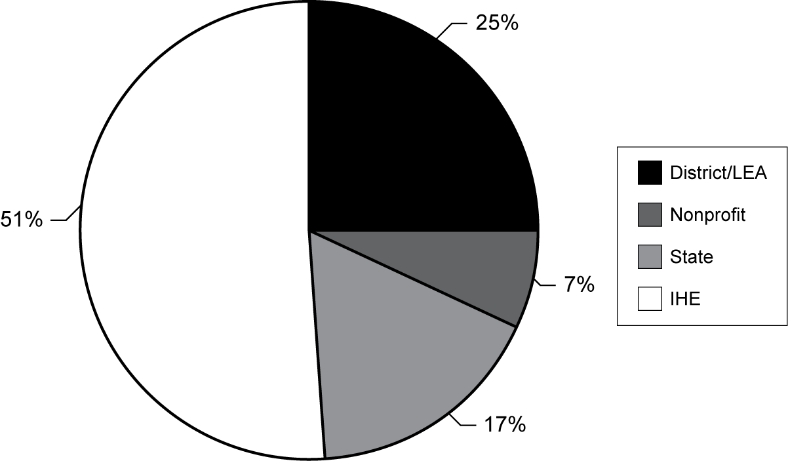
Exhibit reads: Twenty-five percent of FY 2002 TTT grantees are LEAs.
Source: Transition to Teaching Annual Performance Report, 2004–05.
The 92 grantees whose data were reported in the 2004–05 online APR were located in 37 states and the District of Columbia. While they represent numerous states, their geographic scope, in terms of the schools and districts served, ranged from a single district to multiple states. Most grantees (60 percent) had a local scope. Thirty percent had a state-level scope and 10 percent had a regional or national scope (see Exhibit 8).
- Percentage of FY 2002 TTT Grantees,
by Scope
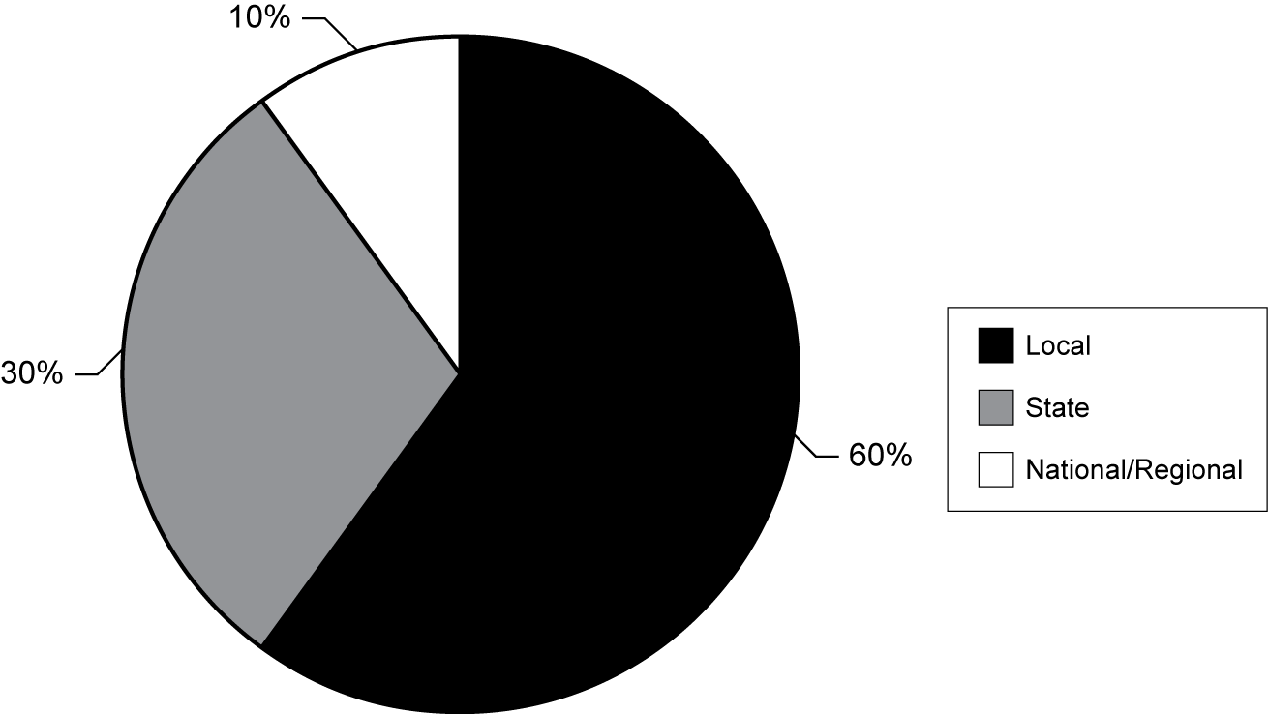
Exhibit reads: Sixty percent of the FY 2002 TTT grantees described themselves as local in scope.
Source: Transition to Teaching Annual Performance Report, 2004–05.
IHEs were the grant recipients of 53 percent of TTT projects with a local scope, while LEA grantees administered 38 percent of these locally oriented projects. This relationship makes sense considering the tradition of the IHE and LEA partnership around placement of interns and hiring of new teachers from traditional programs. Similarly, some of the earliest alternate route programs were begun in districts, where local hiring needs were the primary focus.
As Mayer et al. have reported (2003), in the universe of alternative certification programs, multiple approaches to sponsorship are typical. Unfortunately, the literature on alternative certification programs provides no guidance on which type of sponsorship is most effective, nor does it identify the problems associated with each. In the TTT evaluation, site visits to grantees of various types highlighted that different perspectives are taken according to sponsorship; however, the interim evaluations and APR responses did not indicate strong differences in outcomes according to sponsorship. Still, the existence of some differences indicates additional exploration of this relationship might be worthwhile.
As grantees, SEAs tend to have a broad view; they have the authority to bring overall flexibility to the certification eligibility process, within the context of state standards for teachers. State-based alternate routes may also have the kind of leverage to both tap the provider interests of IHEs and to use state mentoring programs in support of alternative certification participants. They can set the standards for course content, training requirements, and license eligibility.
Two examples of state grantees are South Carolina’s Program of Alternative Certification for Educators (PACE) and the TTT grant managed by the Maryland State Department of Education, the Maryland Alternative Routes to Certification Options (MARCO). These two also highlight the diversity among SEA grantees: PACE recruits and trains statewide; MARCO is focused on one large school district. The location of PACE in the SCSDE permits the preparation and certification of candidates to be centrally administered. The SCSDE draws on the expertise of national board teachers throughout the state to develop and deliver a single body of content through modules at university and school sites in the state. MARCO builds on an existing alternative certification program: the Resident Teacher Certificate program. The new TTT grant is designed to infuse more resources into the recruitment process and create the type of links within a centralized system that permit the coordination of the additional professional development and certification processes that teachers need.
School district-sponsored projects—such as Orange County (Florida) Public Schools (OCPS), Baldwin Park (California) Unified School District (BPUSD), and Newport News (Virginia) Public Schools (NNPS)—tend to have a local reach. These district-initiated projects focus specifically on (a) midcareer or recent college graduates, helping them become credentialed teachers who will remain in the district and (b) paraprofessionals, who already work in its schools, and need support to move into credentialed status.
Some IHE-based projects (such as Montana State University) and nonprofit entities that work with universities (including Green River Regional Education Cooperative with Western Kentucky University [GRREC-WKU] and the Intercultural Development Research Association [IDRA]) focus on regional needs and draw on the experience of IHEs’ traditional programs.
Montana’s Northern Plains Transition to Teaching (NPTT) project developed an online program to facilitate a regional partnership among Montana, Wyoming, and South Dakota and brought each state department of education together around a common goal.
GRREC, a regional service center for school districts, involves a collaborative and longstanding relationship with WKU. WKU’s model of teacher preparation serves as the source for preparing all GRREC’s TTT participants.
IDRA, which administers the Texas-Teacher Excellence for All Students (T-TExAS) and administered Project BECA (Bilingual Education Collaborating Alliance) from 2001 to 2004, is a nonprofit organization with a record of experience preparing teachers for bilingual education and English as a Second Language (ESL). While serving as the primary fiscal agent that provides general leadership and program oversight, IDRA relies on school districts to place candidates and on individual IHEs to prepare participants with the course delivery system of their choice.

Participating LEAs
The primary goal of TTT projects is to realize the hiring and placement and certification of participants as teachers of record in high-need schools in approved high-need LEAs that have agreed to work with TTT grantees. Because they are in approved alternate route projects, TTT participants are considered highly qualified under NCLB, thus assisting high-need schools in high-need LEAs to meet the federal goal for placing a highly qualified teacher in every classroom.
In their grant applications, prospective projects indicate those high-need LEAs with which they will partner or, if an LEA, show how they qualify. In total, grantees reported the involvement of 939 LEAs that hired TTT participants in their third project year. While the number of LEAs involved with a single project varied, 74 percent of grantees reported placements of participants in 10 or fewer LEAs and involvement with just one LEA was reported by 27 percent of grantees. Fifty-nine percent of all grantees reported five or fewer LEA partners and another 15 percent of grantees worked with between six and 10 LEAs (see Exhibit 9). Some grantees were working with one large urban district; others were addressing the needs of multiple, small rural districts.
- Percentage of FY 2002 TTT Grantees Reporting
Number of Participating LEAs
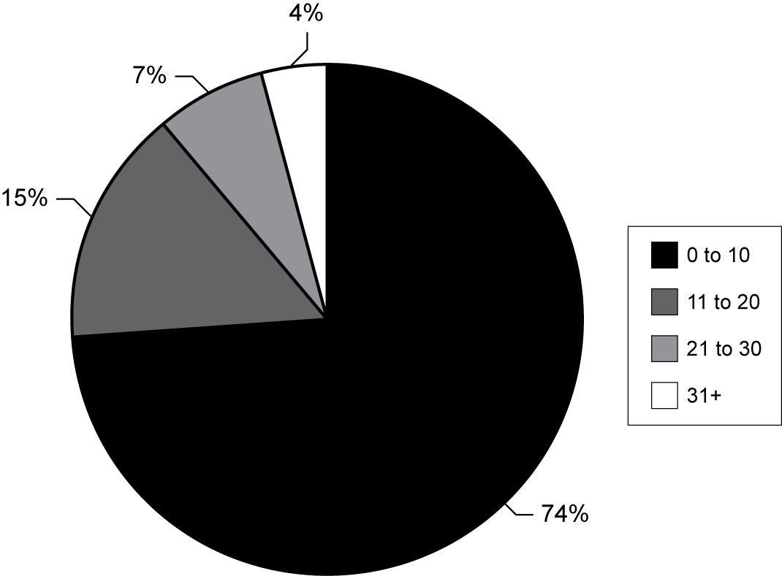
Note: Some grantees are LEAs.
Exhibit reads: Seventy-four percent of FY 2002 TTT grantees reported working with between 0 and 10 participating LEAs.
Source: Transition to Teaching Annual Performance Report, 2004–05.
A relatively small proportion of all LEAs working with FY 2002 TTT grantees were urban (26 percent); 69 percent were described as rural (see Exhibit 10). Nationally, about 50 percent of districts are rural. This represented a concerted effort by grantees to address what has been noted as a concern in states with rural districts: the relative lack of teacher applicants who are highly qualified in all academic subjects they teach.
- Percentage of Participating LEAs by Type of LEA
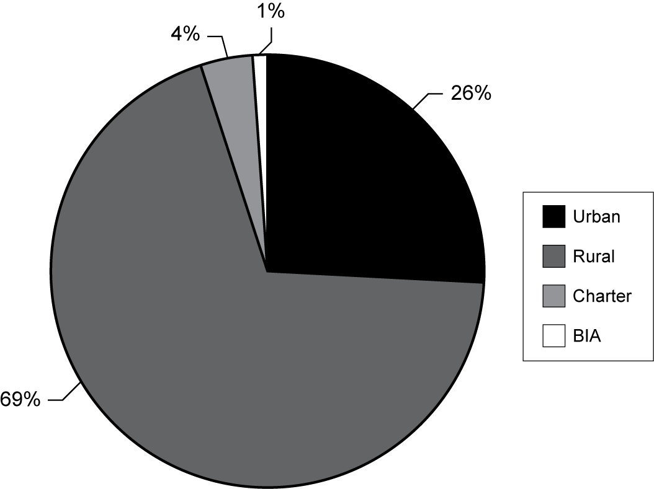
Exhibit reads: Twenty-six percent of LEAs working with FY 2002 TTT grantees were identified as urban by grantees.
Source: Transition to Teaching Annual Performance Report, 2004–05.
Meeting the recruiting and hiring goals of partner districts, according to TTT projects, required substantial resources and key participating organizations that played important and often multiple roles. Projects reported that almost three-quarters (71 percent) of participating organizations assisted with recruitment, and nearly as many provided assistance with training and course work (64 percent) and advice and governance through service on an advisory board (50 percent). About half of the organizations were reported to be supporting the retention goals of the grantee (52 percent) and mentoring and induction (50 percent), and 42 percent were occupied with candidate placement; 23 percent were reported to assist with a range of other responsibilities (see Exhibit 11).
- Percentage of Participating Organizations with TTT Responsibilities
Note: Advisory/governance refers to participation on advisory boards created by the grantees.
Exhibit reads: Seventy-one percent of participating organizations assisted the TTT project with recruitment activities.
Source: Transition to Teaching Annual Performance Report, 2004–05.
Project directors reported that grantees benefited most when participating organizations contributed community knowledge, skill and experience, and the wisdom required to negotiate state and district regulations. In addition, TTT projects reported that the accomplishments that could be made by their relatively small staffs were augmented when these organizations shouldered their commitment and assigned staff to fulfill these commitments.
Examples of Assistance Provided by Participating Organizations for FY 2002 Grantees
- Assistance in meeting recruitment objectives: A grantee in Washington, D.C., working with American University stated, “The relationship with these partners has brought in top quality candidates to the program who are dedicated to continuing work in the D.C. Public Schools.” At another project with many partners the project director commented on how the multiple organizations were able to work together and strategize to cover the most ground for recruiting, “Central Missouri State University (CMSU) and Northwest Missouri State University (NWMSU) collaborated to recruit and place candidates in the joint TTT initiative. CMSU catered more to candidates in the south and east parts of the Kansas City while NWMSU catered more to candidates in the north and west parts of Kansas City. This helped cut candidates’ travel time and make class locations more easily accessible. NWMSU utilized the services of the Northwest Regional Professional Development Center for providing materials and training for candidates.”
- Contributions to retention in high-need LEAs: Organizations sometimes also had an advantage of having participated in similar programs which meant that they not only had experience in that area, but they also had relevant contacts there. “Wayne State University’s experience with designing and delivering educational programs in the urban setting has allowed Detroit Public Schools to recruit from a pool of program participants who have a higher probability of teaching in urban settings,” wrote a project director in his APR submission.
- Assistance with licensure requirements: The Ohio Department of Education was reported to have supplied staffing support for a TTT project and provided more information, including direct linkages, to licensure requirements and state standards for curriculum. Sometimes grantees were able to seek help from the department in more specific areas, for example, the Office of Bilingual Pupil Services at the New York City Department of Education helped to find and recruit participants for their programs.
- Assistance with placement and hiring: TeachOregon has developed an online program that matches teachers seeking employment with school districts with open positions and has added a new search feature focusing on high-need schools (incorporating schools that are eligible as high-need through the Transition to Teaching program as well as a Title II Teacher Quality program). This system is intended to match highly qualified newly licensed teachers with high-need schools in high-need LEAs that have open positions.
- Contribution to mentoring component: Texas A&M Universities as a partner developed an e-mentoring program that was available at all nine campuses. In Oregon, Western Oregon University “ran a highly successful” Teacher Mentor Institute summer 2004 with 47 experienced teachers learning how to better mentor new teachers.
- Assistance with knowledge of the community: A TTT grantee in California explained how its partnership helped train participants: “We work closely with a community-based organization called Hope Community Services, Inc. We place our project participants there in their afterschool and summer school programs. Our project participants develop their teaching skills and experience working with students from low income, diverse cultural and language backgrounds.” According to the grantee, community members know their communities better than anyone else, and an experience such as this provides a valuable introduction to contacts in the community and helps teachers know what to expect as they plan to teach in that community.

Project Budget Resources
TTT project annual budgets over the five years range from just under $100,000 to nearly $800,000 (two grantees reported larger budgets for specific project years of between $1 million and $2 million). In the third project year, the FY 2002 cohort budgets ranged from a relatively small contribution or no new funds for the year (due to unexpended funds from the previous year) to a maximum grant of $724,300. As illustrated by Exhibit 12, the majority of TTT grantee budgets (63 percent) approved for the third project year might be characterized as “medium-sized” (relative to all 2002 grants) within the range of $250,000–$499,999. In addition, the budgets for 23 percent of grantees were less than $249,999 and 14 percent were $500,000 or more. The total investment in grant awards in 2002 was $35 million.
- Percentage of FY 2002 TTT Grantees Reporting
Third Year Budgets, by Size of Budget
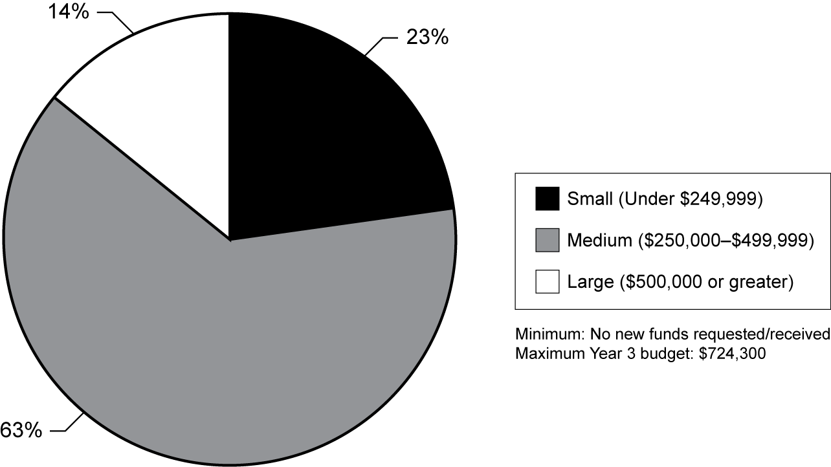
Exhibit reads: Twenty-three percent of FY 2002 TTT grantees received approved allocations for the third project year under $249,999.
Source: Transition to Teaching Annual Performance Report and Interim Evaluations, 2004–05.
Forty-two percent of grantees who provided responses in the APR survey indicated they were not finished expending their funds for the current year (see Exhibit 13). The program office can approve a roll-over of unexpended funds, which is common for multiyear grantees. Some of the reasons for unexpended funds highlighted the challenges of operating alternate routes.
Unexpended funds resulted when projects overestimated the costs of the program (20 percent), or had fewer than expected qualified participants applying for the grant (29 percent). Nearly 17 percent had carryover funds because their project started behind schedule. One project director explained why the project had purposely reserved money from previous years, “Purposefully, we have rolled over funds from project years 1 and 2 in order to be able to support the tuition scholarships introduced during project year 2 and afforded to cohorts 2, 3, 4 and 5 and mentoring costs (due to increased numbers) during projects years 3–5.” Only one grantee responded to the survey stating that he did not have any unexpended funds.
- Status of Unexpended Funds
Comment | Percentage of grantees who gave category response
Not finished expending budget* | 42
Fewer than expected enrolled participants** | 29
General costs were lower than expected | 20
Project started behind schedule/after funding started | 17
Other | 12
N/A | 6
Fewer than expected LEAs applying for grant | 2
Did not have unexpended funds | 1
Budget period changed | 1
*Still using the funding—fiscal budget year did not correspond with school year. Contracts, invoices, scholarships etc. still to be paid. Will expend or nearly expend all funds.
**Either fewer participants were recruited or hired, or they dropped out. This also affected the budget by decreasing the number of stipends and scholarships that were provided.
Exhibit reads: Nearly 42 percent of grantees who responded to the question about unexpended funds reported they had not finished expending their budget for that year.
Source: Transition to Teaching Annual Performance Report, 2004–05.
More than a third (39 percent) of grantees wrote that they would spend unexpended funds on general project activities, administrative purposes, and working toward the project objectives. More specific plans included recruitment (24 percent), improving the mentoring program (19 percent), professional development (20 percent), supplies and materials for participants (10 percent), more staff hires and raises (15 percent), and more scholarships and incentives to participants (23 percent). These activities are all approved within the scope of the TTT program. Three grantees (4 percent) wrote that they were anticipating more participants the following year and they were planning on using the money to accommodate and support them (see Exhibit 14).
- Plans for Use of Unexpended Funds
Plan to use the unexpended funds over the next year
Comment | Percentage of grantees who gave category response
Other general project activities/working towards goal/administration and operation of grant | 39
Recruitment | 24
Provide more scholarships/incentives | 23
Professional development | 20
Mentoring program | 19
Staff raises/hires | 15
Supplies/materials for participants | 10
Continue paying this year’s costs | 9
Anticipate more participants next year | 4
Exhibit reads: Of those grantees who reported unexpended funds, 39 percent indicated plans to use unexpended funds for general project activities.
Source: Transition to Teaching Annual Performance Report, 2004–05.

Project Objectives: Progress and Challenges Over Three Years
At the end of Year 3, grantees submitted both the year 3 APRs and interim evaluations in which they described progress over three years toward the objectives set forth in their grant applications. TTT grantees proposed objectives that were integral to (1) the needs of their participating school districts (or their own needs if the grantee was a school district) and (2) met the overall TTT program goals.
In both of these progress reports, TTT grantees reported undertaking refinements for recruitment and selection processes, for training approaches and content, and for mentoring activities. Changes were made only with the approval of the ED project officer and in keeping with the scope and objectives of the original application. In many projects, changes were informed by outside evaluations and were evidence of a process of continuous assessment.
In their APR year 3 reports, 39 percent of the grantees reported success in meeting their objectives for the third project year; 2 percent stated that they had not met their objectives. Remaining responses encompassed a range of goal achievement, including grantees that exceeded their goals (6 percent), completed most of their goals (13 percent), completed some of their goals (7 percent) and did not meet most of their goals (1 percent) (see Exhibit 15).
Some of the grantees (6 percent) responded that it was too early to be definitive, but they expected to meet their goals by the end of the reporting year (see Exhibit 15).
- Progress in Meeting
Project-Established Objectives in Year 3
To what extent has your project met its objectives this reporting year?
Category | Percentage of grantees who gave category response
Met goal(s) | 39
Response focuses progress made, but does not refer to the actual project goals (unable to tell if they are fulfilled) | 14
Met most of goals | 13
Met some goals | 7
Exceeded goal(s) | 6
Projected that they will meet goals by end of year | 6
Goals are partially met | 3
Only mentioned one goal (met) | 3
Only mentioned one goal (partially met) | 3
Did not meet goal(s) | 2
Did not specify goals | 2
Most goals not met | 1
Only mentioned one goal (exceeded) | 1
Other | 1
Exhibit reads: Thirty-nine percent of grantees indicated that project goals were met.
Source: Transition to Teaching Annual Performance Report, 2004–05.
In their interim evaluations, also, grantees elaborated on issues and changes that had occurred within the project as well as the external factors that had influenced these. The most frequently reported issues were related to the sites and positions into which participants were placed (indicated by 42 percent) and the applicant or candidate pool (indicated by 41 percent). In addition, 34 percent reported issues with recruitment methods, 30 percent with the organization or structure of the project, and 29 percent with project personnel. The nature of the issues and changes for these four categories are detailed in the table below (see Exhibit 16).
- Issues and Changes Made to Meet
Project-Established Objectives
Type of issue or change | Nature of issue or change
Sites/positions | Positions expanded by:  - Adding new LEAs  - Working with LEAs to identify vacancies sooner  Positions limited by:  - Failure to meet LEA qualifying definition  - Budget cuts  - Decreased student enrollment  - Location or organization  - Low demand for participants’ areas of certification  - Participants seeking out positions in non-qualifying LEAs
Applicant or candidate pool | Pool expanded by:  - Seeking other target groups  - Using online recruitment and application methods  - Offering additional grade levels or subject areas  Pool limited by:  - Military deployment  - Few paraprofessionals meeting prerequisites  - Few candidates meeting prerequisites  - Uncertainty about LEAs (see sites and positions, above)  - Competition with other alternate routes or districts
Recruitment methods | Effective recruitment methods include:  - Web-based tools (e.g., enhanced Web sites, online applications, advertisements)  - Face-to-face interaction (e.g., job fairs, informational sessions)  Recruitment challenged by:  - Project organization (e.g., small staff, relocation)  - Uncertainty about LEAs (see sites and positions, above)
Organization/structure | Changes to improve organization by:  - New partners (LEAs, IHEs)  - Development of committees to evaluate and advise  - New/expanded project location  Changes to improve structure by:  - New grade level or subject area focus
Personnel | New or proposed personnel as:  - Coordinators for recruitment, certification, and mentoring  - Project directors  - Support staff  - Academic advisers  Loss of personnel through:  - Resignation by individuals  - Eliminated positions
Note: The number of instances was based on 90 interim evaluations with details on issues and changes.
Source: Grantee Interim Evaluations, 2005.
Grantees responded to the challenges they faced in meeting their objectives in many different ways; however, three key methods mentioned in 60 percent of grantee responses to this survey question on the APR were confirmed in the interim reports: (1) networking and collaborating with LEA partners, education and community agencies, other alternate route projects and schools; (2) providing more or improving professional development; and (3) increasing recruitment efforts.
About 39 percent of grantees reported that they had worked on networking and collaborating with LEAs, SEAs, partnering agencies and other projects, schools, and teachers. These efforts increased communication and understanding; personal contacts proved to be invaluable resources for problem solving and were especially helpful in hiring and recruitment.
Some grantees reported receiving assistance with more specific problems from persons who were not participating in day-to-day decisions about the project. For example, after the most recent restructuring of one public school district, a grantee there contacted school principals to make sure that paraprofessionals in the TTT project would be able to keep their jobs while they worked toward certification.
Grantees worked to make the program experience more successful for participants by improving professional development opportunities and offering more support. To accommodate the inflexible nature of teachers’ schedules and participants living and working in rural areas, grantees adapted courses for accessibility. Many of these projects offered options such as online courses, night classes, summer courses, and internships. Grantees also worked to improve their mentoring component by spending more time and money on recruiting and training mentors for the project. One grantee reflected, “Our most effective strategy has been to increase the mentorship provided through the use of mentor consultants. These mentors coach, model, observe, and provide feedback [to participants] on a consistent, ongoing basis.” This improvement in training helped provide the support participants needed to stay with the project and become successful.
Grantees addressed the issue of participant dropout in part by clarifying and reiterating the program’s requirements and financial obligations: “The TTT participants have been involved in trainings throughout the year. Participants now have a more comprehensive understanding of their responsibilities for meeting the guidelines of the grant requirements,” said one project director. By maintaining an understanding of what is involved in completing the project requirements and being more aware of what was involved in financial planning for their expenses during their TTT involvement, grantees found that participants were more likely to remain and were more prepared for the demands of training and the career ahead of them.
Overall, grantees reported in their APRs that they experienced varying degrees of success with addressing challenges: three stated outright that their efforts had not been effective, some reported continuing efforts to confront issues, and a few acknowledged that they did not know how to tackle the problems that confronted them (see Exhibit 17).
- Approaches to Resolving Difficulties or Barriers
How are these difficulties or barriers being addressed?
Category | Percentage of grantees who gave category response
Networked/collaborated with other/current LEAs, agencies, projects, schools, teachers, etc. | 39
Increased professional development and opportunities* | 36
Increased recruitment efforts** | 25
Other | 16
Improved communication | 11
Reduced program cost, provided incentives and/or stipends | 9
Made staff adjustments | 8
Clarified requirements | 7
Incorporated more high-need districts as LEA partners | 7
Refined selection process | 5
Expanded capacity to include more candidates | 2
Situation has changed so the initial challenge is no longer an issue | 1
*Including recruiting and training mentors and improving the mentor program, providing more flexible courses for participants (e.g., summer or Internet-based)
**Such as interest sessions, encouraging current participants to recruit, developing the Web site, expanding geographical location, attempting to reach more types of participants not originally targeted (e.g., nonmilitary participants)
Exhibit reads: Thirty-nine percent of grantees indicated they relied on networking or collaborating with LEAs and other entities to resolve difficulties or barriers.
Source: Transition to Teaching Annual Performance Report, 2004–05.
Seeking Broader Outcomes
Reach to Teach in Georgia
2002 Transition to Teaching Project
Georgia Professional Standards Commission
A number of TTT grantees were developed at the state level and, according to their project directors, have developed approaches that have had broader implications for state certification or workforce policy. The following example is provided by the Reach to Teach grantee in Georgia.
- Results of Reducing Barriers: More Candidates
Alternative route teachers accounted for 19.2 percent of all new Georgia teacher hires in 2005. (This is slightly higher than national statistics reported in 2005, which show that 35,000 plus individuals completed alternate routes compared to about 300,000 certified through traditional routes.) This percentage has increased from 7.1 percent since 2000 and is predicted to rise annually. Recent changes in Georgia certification policies have significantly reduced or eliminated barriers to enable schools to attract, prepare and certify teachers from alternative routes into both high-need and all other schools. Since winter 2002, the Reach to Teach in Georgia Program (RTT) at the Georgia Professional Standards Commission has recruited and supported over 550 qualifying alternative route teachers of record in eligible high-need schools. These teachers have achieved or are candidates for full certification through the Georgia Teacher Alternative Preparation Program (GATAPP) and other state-approved alternative programs. The RTT participants are in 23 high-need LEAs and 472 schools selected from over 70 qualifying Georgia LEAs. Some participating LEAs hired more than 70 percent of new hires and 40 percent of the teacher workforce from RTT targeted candidates. Retention among RTT participants exceeds the state retention average of all traditional and alternative route teachers in the first three years of employment. Project participation for LEAs and teachers is restricted only by eligibility criteria, program and staff capacities, and by funding resources.
- Maximizing Outreach
From inception the RTT planning group recognized the need to maximize outreach and impact, and to ensure that successes are sustained and perpetuated beyond federal funding. Project staff and participants work with a Transition to Teaching Committee of the Statewide School Human Resources Task Force to implement an ongoing plan and coordinate allowable funding and resource allocations to disseminate information about the Transition to Teaching purpose, programs, strategies, pitfalls and successes. The result is increasing capacity among Georgia superintendents, human resource officers, principals and peer teachers to effectively staff and retain highly qualified teachers from a variety of alternative sources into high-need schools and to raise student achievement by improving teacher performance in the classroom. The RTT program joins with Georgia’s Troops and Spouses to Teachers Programs, Title IIA and Georgia Department of Education teacher quality initiatives, the GATAPP and other approved alternative preparation programs, the state’s TeachGeorgia recruitment program, and with TeachGeorgia.org official electronic application and educator job placement Web site, etc., to sponsor and conduct Best Practices Institutes in recruiting, preparing, retaining and assessing the performance of alternative route teachers.
- Mixed Model of Delivery
An RTT Academy Faculty comprised of selected National Board Certified Teachers in critical content fields has developed and facilitates a mixed model face-to-face, virtual support and training network and delivery through Livetext. The faculty trains teacher participants in content knowledge and skills, classroom management development, classroom culture and diversity, lesson planning, and conducts regular content dialogue groups with RTT cohort members across Georgia. The RTT staff has completed educator workforce analysis and planning [Strengths Weaknesses Opportunities Threats (SWOT)] sessions in project LEAs and communities. Participants are replicating the SWOT process by training non-project LEAs to conduct workforce analysis and planning activities. Evolving evidence of the project’s infusion into Georgia school staffing priorities and State level participation is seen in project years three and four. Representatives from the Human Recourses Task Force, RTT and other LEAs, the business community and higher education are currently engaged in a Statewide Effective Schools Staffing Task Force to devise and recommend to the governor and legislature, a Georgia Effective Staffing Plan: Recruiting to Retain the Highest Quality Educators in Georgia Public Schools, 2007–2010; and to approve a common recruitment, employment and retention definition of the ‘Hard-to-Staff’ Georgia School. The workgroup emphasizes effective educator staffing in high-need schools as priority among recruiting and retaining high quality teacher performance in all schools.

TTT Teachers
This evaluation gathered information about TTT participants who became new teachers from two sources: the APR submitted by grantees described the participants in the third project year and a few questions sought data on new teachers of record, for example, the number hired each year; the TTT teacher surveys were administered to teachers who had been hired since 2002 and up to 2004. In this survey, teachers reported on their own backgrounds and experiences. This section provides data from both sources regarding the participants who became teachers.
The literature provides some support for the premise that alternate routes tend to attract greater percentages of minority candidates (Allen, 2003; Clewell and Villegas, 2001; Lutz and Hutton, 1989; Shen, 1997). Further, for 2005, the National Center for Education Information (NCEI) reported 32 percent of new teachers from alternate routes as non-white, compared to just 11 percent of the total teacher workforce in that year. However, Humphrey and Wechsler (2005) suggest that in terms of race and ethnicity, participants in alternate route programs generally reflect the demographic composition of the local labor markets.
Grantees reported about half of participants in the third project year were white and half represented other categories: 27 percent black, 13 percent Hispanic and 9 percent in several other categories. Little difference was reported when these data were broken down by target group for midcareer professionals and recent college graduates. In both groups, more than half of the participants were white and close to 30 percent were black. The race and ethnicity reports for paraprofessionals, however, indicate that more paraprofessionals were Hispanic than among other participant groups. This was likely due to the concentration of paraprofessionals in TTT projects located in districts with a large proportion of Hispanic residents.
As a group, TTT teachers hired between 2002 and 2004 confirmed the grantee reports that they were racially and ethnically more diverse than teachers in the workforce with three or fewer years of experience; for example, 30 percent of TTT teachers reported they were black, compared with 19 percent of teachers in the general workforce coming through alternate routes and 9 percent of teachers in the workforce trained in traditional routes (SASS, 2003–04). In addition, 62 percent of TTT teachers described themselves as white (compared with 77 percent of teachers who came through alternate routes generally and 89 percent of teachers trained in traditional routes); 12 percent reported that they are Hispanic compared to 6 percent of teachers in the workforce trained in traditional programs (see Exhibit 18).
- Percentage of TTT Teachers, by Ethnicity and Race
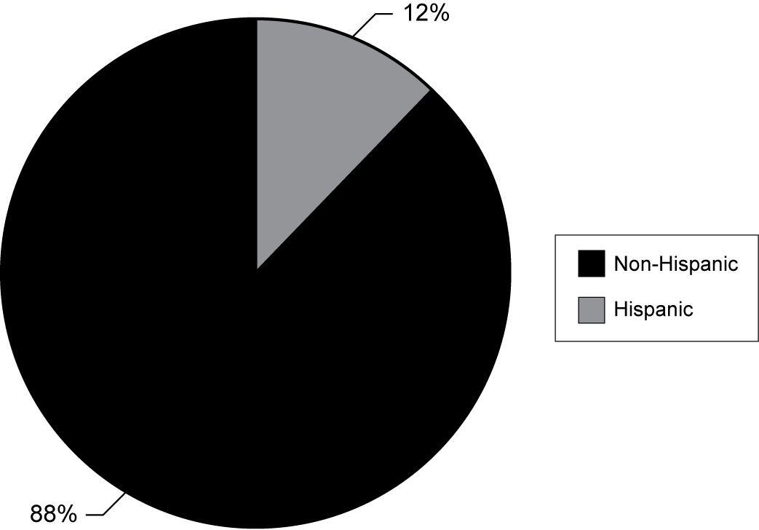 | 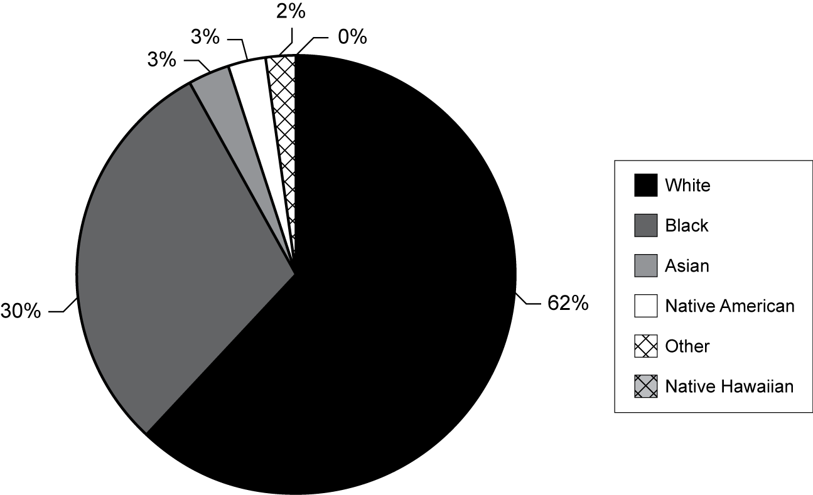
Exhibit reads: Twelve percent of TTT teachers are Hispanic.  Source: Transition to Teaching TTT teacher survey, 2005–06. | Exhibit reads: Sixty-two percent of TTT teachers are white.  Source: Transition to Teaching TTT teacher survey,  2005–06.
TTT teachers differed notably as to their ethnicity when examined by target group: 18 percent of paraprofessionals reported their ethnicity as Hispanic, compared to 12 percent of the total participant sample (see Exhibit 19).
- Percentage of TTT Teachers Who Are Hispanic,
by Target Group
Exhibit reads: Eighteen percent of TTT teachers who were paraprofessionals described their ethnicity as Hispanic.
Source: Transition to Teaching TTT teacher survey, 2005–06.
When TTT teachers identified themselves according to target group for the TTT teacher survey, the smallest percentage reported they were paraprofessionals (13 percent) and the largest percentage reported they were midcareer professionals (50 percent) (see Exhibit 20).
- Percentage of TTT Teachers, by Target Group
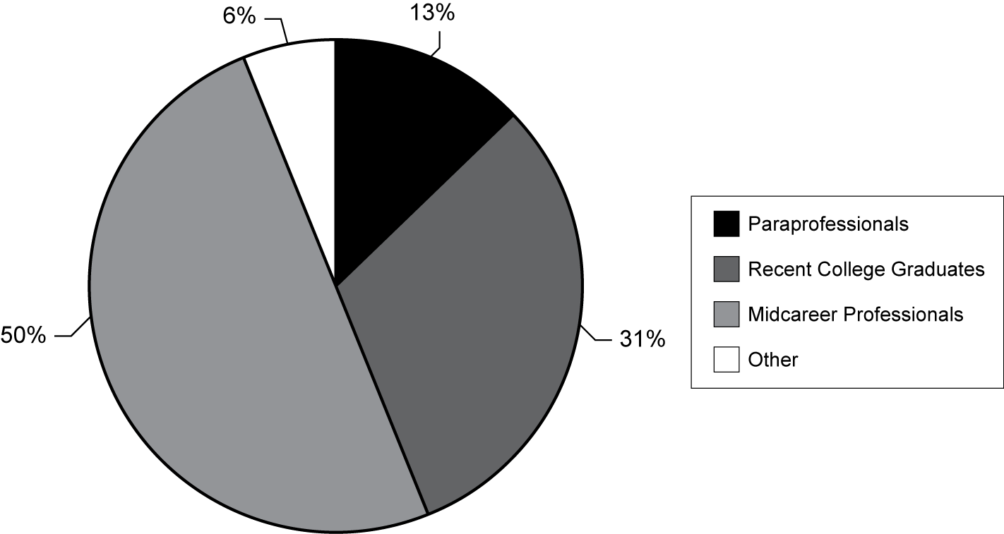
Exhibit reads: Thirteen percent of TTT teachers in FY 2002 grantees described themselves as paraprofessionals.
Source: Transition to Teaching TTT teacher survey, 2005–06.
Although some alternate routes focus on recruiting individuals from specific occupations related to educational backgrounds in mathematics, science, and technology, studies of alternate routes have found relatively limited occupational diversity among participants as a whole. These studies indicate that many participants have backgrounds as students or other school-related areas, or in other fields, rather than the anticipated professional backgrounds (Humphrey and Wechsler, 2005; Shen, 1997; Zientek, Capraro, and Capraro, 2006). Among the participants in the third project year of the FY 2002 grantees, prior occupations ranged from professional to service: 29 percent of participants worked in professional occupations, 22 percent worked as K–12 school staff (including paraprofessionals) (see Exhibit 21).

- Percentage of 2004–05
Participants by Occupation Prior to TTT
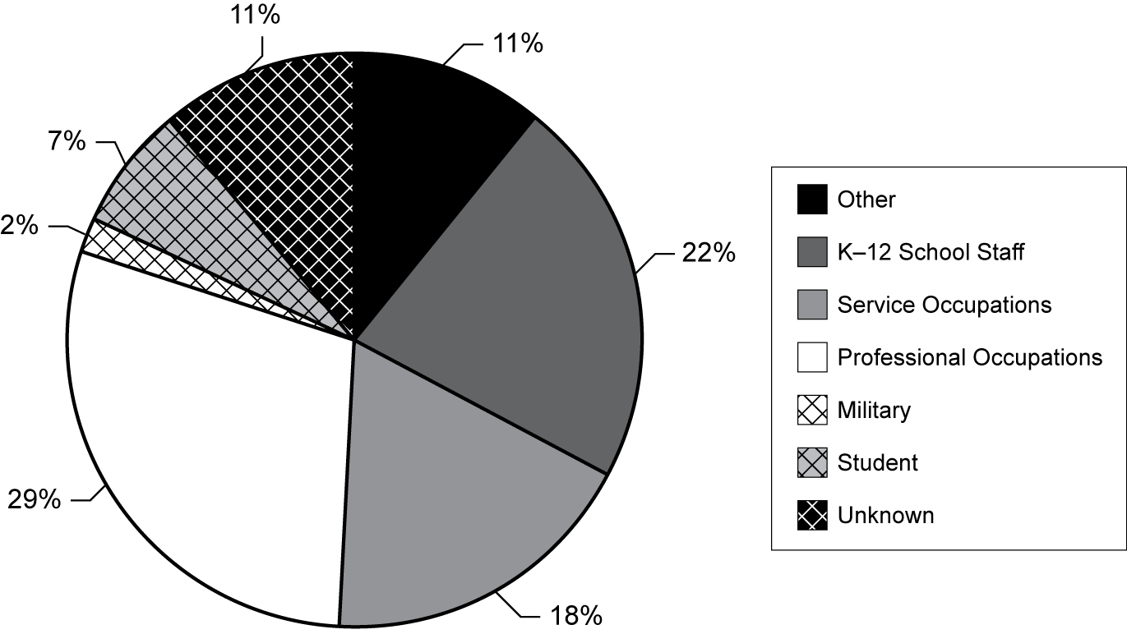
Exhibit reads: The prior occupation of 11 percent of participants in the third project year of FY 2002 grantees was reported as “other.” See footnote below for details of category development.
Source: Transition to Teaching Annual Performance Report, 2004–05.

Who are paraprofessionals, and what are their experiences in TTT?
- Recruitment
The smallest group of TTT participants, paraprofessionals were targeted for recruitment into TTT by 52 percent of grantees. Grantees reported receiving 1,642 applications from paraprofessionals, of which 1,068 proved eligible for entry into TTT teacher preparation. TTT participants in the paraprofessionals group have at least two years of experience in K–12 classrooms (as a teacher’s aide, for example) and a minimum of four semesters of postsecondary education or demonstrated competence in an academic subject.
- Demographics
Paraprofessional participants proved a more diverse group than their counterparts in the midcareer and recent college graduate groups. Grantees reported the highest percentage of paraprofessional participants as Hispanic (32 percent), with 28 percent white, 22 percent black, and 13 percent in “multiracial” or other categories. Half of paraprofessionals held bachelors’ degrees as their highest degrees, 23 percent held no degree, and 20 percent held two-year degrees.
- Attraction of TTT
In deciding to participate in TTT, 61 percent of paraprofessional participants indicated that they were influenced by the incentives offered, 31 percent by the location of the project, 27 percent by the method of delivery (such as online or on weekends), and 36 percent by the guarantee of employment.
- TTT Preparation and Outcomes
Because many paraprofessionals have no bachelors’ degrees, it makes sense that 61 percent of grantees reported requiring that paraprofessionals take courses for credit toward one. More paraprofessional participants reported receiving support in the form of common planning time (66 percent) and extra classroom assistance (34 percent) than their midcareer and recent college graduate counterparts, and 42 percent engaged in student teaching. Eighty-eight percent of paraprofessional participants reported holding full-time positions as teachers of record. Among former paraprofessionals who were working as teachers of record, the largest groups worked in special education (30 percent) and general K–5 (20 percent) positions, with 12 percent in mathematics positions and 10 percent in science. Twelve percent of paraprofessional participants working as teachers of record indicated that they were teaching in subjects outside of their main field, but 86 percent reported that their main teaching assignment matched their certification area.
Who are recent college graduates, and what are their experiences in TTT?
- Recruitment
Seventy-nine percent of grantees reported targeting recent college graduates as they recruited applicants to their TTT projects. Grantees reported receiving 4,075 applications from recent college graduates, and 75 percent of these were deemed eligible for teacher preparation. Recent college graduates include individuals who graduated from a college or university within three years of their application to a TTT project. These participants hold at least a bachelor’s degree in a field other than education.
- Demographics
More than half (55 percent) of recent college graduate participants are white, 27 percent are black, and 10 percent are Hispanic. As might be expected given their status as recent college graduates, 87 percent were reported as holding a bachelor’s degree as the highest degree earned, while 5 percent held a master’s degree and 8 percent had some other degree as the highest earned. Twenty-one percent of recent college graduates reported being students as their prior occupation, 18 percent held professional occupations, 17 percent were K–12 school staff, and 15 percent were in service occupations.

- Attraction of TTT
In making the decision to pursue teacher certification through TTT, 47 percent of recent college graduates indicated that they were influenced by the incentives offered by TTT projects, while 45 percent noted the promise of support while teaching and 34 percent the location of the TTT project were influential factors.
- TTT Preparation and Outcomes
Thirty-seven percent of recent college graduate participants engaged in student teaching as part of their preparation, and 99 percent reported finding full-time (rather than part-time, itinerant, or substitute) positions as teachers of record. Among teachers of record in this recent college graduate group, 25 percent reported positions in mathematics, 15 percent in special education, 13 percent in science, and 13 percent in general K–5 positions. Ninety-one percent of these teachers of record reported holding certification that matched their main teaching assignment; however, 26 percent also indicated that they taught classes outside of their main teaching field.
Who are midcareer professionals, and what are their experiences in TTT?
- Recruitment
Eighty-seven percent of grantees reported targeting this group in their recruitment efforts, aiming for a total of 2,022 midcareer professional participants. However, 8,513 midcareer professionals submitted applications and 64 percent of these (5,467) were deemed eligible for acceptance into TTT. Midcareer professionals, or those who transitioned to teaching from a career outside of education, form the largest group of TTT participants.
- Demographics
The midcareer professional group was reported as 54 percent white, 29 percent black, and 10 percent Hispanic. Seventy-four percent of these participants held bachelors’ degrees as their highest degree, and 15 percent held masters’ degrees. Forty-five percent of midcareer professionals held professional occupations prior to their participation in TTT; 26 percent were in service occupations, and 26 percent worked in other or unknown occupations.
- Attraction of TTT
More than their paraprofessional and recent college graduate counterparts, midcareer participants were influenced to participate in TTT by the guarantee of employment (43 percent). In addition, 46 percent were influenced by the offer of incentives, 46 percent by the support provided by the project as they worked toward certification, and 37 percent by the support provided during teaching.
- TTT Preparation and Outcomes
Thirty-nine percent of midcareer participants reported they took part in student teaching as part of the TTT program, and 95 percent reported holding full-time positions as teachers of record. Among teachers of record in the midcareer group, 25 percent reported teaching positions in mathematics, 23 percent were in special education, 12 percent in science, and 9 percent in general K–5 classrooms. Eighty-eight percent of these teachers of record indicated that their certification is appropriate to their main teaching assignment; however, 20 percent reported that they teach subjects outside of their main teaching field.

Source: Transition to Teaching Evaluation, Transition to Teaching Annual Performance Report, 2004–05 and TTT Teacher Survey, 2005–06

Recruitment and Selection of TTT PARTICIPANTS

Highlights
- Recruitment is a particularly important component of TTT projects because the targeted groups are nontraditional entrants into teaching, including individuals who may have had some teaching experience but had not considered seeking certification. Experience reported by grantees over their first three years indicated that “word of mouth” dissemination about TTT projects leads to the recruitment of more eligible candidates. In turn, participants in current TTT projects confirm that this is, by far, the most effective and informative strategy that was used in their particular case.
- In the third project year, TTT grantees set targets to recruit and train 3,696 new teachers. The applications for these positions far exceeded the slots: for recent college graduates, the ratio of eligible applicants to slots was 3.4 to 1. Between 64 and 75 percent of applicants were determined, through the selection process, to be eligible, according to their category (midcareer professionals, paraprofessionals, and recent college graduates). TTT projects tend to target more than one group of participants.
- TTT projects have instituted entry standards for the selection of participants, with particular emphasis on their subject area background. Few projects report using standards for entry that are different or more selective than those of traditional programs. This cohort of projects has, however, provided some lessons about how to work collaboratively with school districts in the screening process. Some TTT projects require participants to be hired officially by a high-need school district before being enrolled in their TTT project.

Recruitment
Recruitment refers to the ways by which TTT grantees represent and provide information about the teacher preparation route for the purpose of attracting applicants who have an interest in teaching in high-need schools in high-need LEAs. The data reported in this section elaborate on the recruitment strategies used by grantees and the value of those strategies to participants.
To understand why recruitment is such a critical aspect of a TTT project it is important to consider the place of alternate routes within the larger community of teacher preparation programs. With more than 1,300 traditional teacher preparation programs existing across the country in IHEs, most individuals who wish to enter the teaching profession are likely to find an IHE-based program in their city or region, reasonably close by. It is conventional wisdom that those preparing to be teachers select an IHE within 50 miles of their home because they are expecting to begin their teaching career in the area where they grew up or where they wish to live. TTT grantees confirmed that this was also the preference of their applicants, many of whom were established in their communities. Individuals who choose the traditional route, through an undergraduate degree, to qualify for teaching, whether or not they seek a teaching job immediately following school, know where to look for a program: they have confidence that within their IHE they will find the information needed to pursue their career goal and that the program will guide them to fulfill certification requirements.
However, many IHE graduates who prepared for teaching or considered teaching while in undergraduate school do not work in the area of their undergraduate major right after completing their studies. Longitudinal analyses of data on the outcomes of the college graduating class of
1992–93 indicate that 36 percent of this class had applied for a teaching job, become certified to teach, or considered teaching within four years of receiving a bachelor’s degree (Loeb and Reininger, 2004). In addition, analyses of career trajectories of graduates of undergraduate teacher preparation programs point to a large drop-off of individuals who are trained as teachers at the undergraduate level once they have graduated and that less than 60 percent actually become teachers (Hull, 2004).
There are also many in the workforce who decide, after 5, 10, 15 or more years to change their careers. One appeal of developing multiple alternate routes is to provide these individuals with options, especially if they have been turned off by the “traditional approach” because of regulations and requirements, confusing information, lack of funds to pursue extended study, or other reasons.

Recruitment Strategies in TTT Projects
Marketing and recruitment strategies are critical to the success of an alternate route. TTT projects begin with an assessment of the teacher need (the knowledge that there are shortages in specific fields within the neediest districts), then gather information about the potential market for participants. With this information, projects undertake marketing activities and shape a program of study and support that will facilitate entry into the profession and retention.
In their proposals, grantees indicated one or more of three specific target groups—midcareer professionals, recent college graduates, or paraprofessionals—that they planned to recruit to teach in high-need schools in high-need LEAs. In fact, most TTT projects targeted multiple groups. Of the 92 FY 2002 grantees, 80 targeted multiple groups, seven targeted midcareer professionals only, one targeted recent college graduates only, and four targeted paraprofessionals only.
In their various data reports submitted in 2005, grantees provided lessons learned about the strategies they used. In general, they commented on things such as the creation of a Web site, which was deemed important because of its flexibility: content could be changed and updated; full details could be provided; and links could be made to sites of origin directly related to participants, that is, where they would be most likely to begin their job search. Recognizing participants needed a great deal of information “before committing to this life change” one grantee reported developing a CD-ROM with information about the panoply of alternate route programs available in their area, including interviews with project directors. Use of other media for announcements and advertising received split reviews: many grantees said that advertising was the most costly alternative and that sometimes newspaper articles attracted unqualified candidates. Others reported that radio and public announcements were effective because they brought in candidates who were not involved in schools. Project administrators presented information at job fairs and career fairs, which they considered two different approaches for traditional and nontraditional candidates. Community college fairs were recommended to attract individuals who were going back to school for specific training.
Accomplishing recruitment goals requires using multiple strategies and making effective use of community resources and resources of participating organizations. Assessing the needs of participating high-need districts was an essential first step in identifying a target group, however, projects experienced varying degrees of success in the hiring of recruited participants due to changes in staffing needs in partner schools; occasionally they were faced with a system in which hiring preferences led to choosing individuals from other preparation programs. Having a pool of individuals with strong incentives to take advantage of the TTT project was advantageous to projects in meeting these goals. Some projects with a wide reach had to work harder with their recruitment efforts to call attention to unique preparation approaches or to recruit individuals in specific subject areas or because they were recruiting for schools in high-need school districts.
Grantees suggested that targeting specific groups of candidates was essential, especially to attract minority students (use of ethnic news media). Thus the TTT projects reported crafting specific types of advertising materials and using specific media for each group: midcareer, recent college graduates, and paraprofessionals.
Identifying the top three (successful) methods by which they recruited TTT participants, 70 percent of grantees named “word of mouth.” Other often-used methods included developing Web sites (56 percent), advertising at local schools (47 percent) and advertising at IHEs (31 percent). The use of media—either as purchased advertising or by news coverage—ranked at the lower end of use by grantees, as did cooperation with a state employment office and use of e-mail or mail distribution lists (see Exhibit 22).
Confirming the importance of disseminating information by word of mouth, TTT teachers reported about the ways they learned about the TTT projects in their area and they overwhelmingly (90 percent) reported word of mouth as their most important source for learning about TTT, while 42 percent referred to Web sites and 29 percent learned about TTT through advertising at local schools (see Exhibit 23).
- Percentage of FY 2002 TTT Grantees Who Ranked Each Recruitment Method as One of Their Top Three Recruitment Methods

Exhibit reads: Seventy percent of FY 2002 grantees ranked “word of mouth” as one of their top three recruitment methods.
Source: Transition to Teaching Annual Performance Report, 2004–05.

- Percentage of TTT Teachers
Reporting the Importance of Sources for Learning About TTT
Exhibit reads: Ninety percent of TTT teachers reported that “word of mouth” was an important source for learning about TTT.
Source: Transition to Teaching TTT teacher survey, 2005–06.
Promising Practices in Recruitment: Recruitment by Word of Mouth
As has been noted, 70 percent of TTT grantees reported word of mouth as a top recruitment method. Project administrators made formal presentations, such as those at conferences and job fairs, and held informal conversations throughout their districts about the TTT opportunity. They also encouraged participants to spread the news about their experiences in the project. On the formal side, one grantee described presentations given at local community or service organizations, employment centers, and career fairs, indicating, “Successful experiences by participants are shared with others interested in pursuing teacher licensure and the opportunity to work with students in high-need schools within our region’s high-need LEAs.” Less formally, one grantee explained, “Several of the current teachers in the program have informed other prospective teacher candidates. Individuals that have read or heard about the grant project have also passed along information to family and friends.”
Grantees reported mixed issues with a reliance on word of mouth as a strategy for recruiting qualified TTT candidates. Certainly, grantees reported, inquiries received about TTT could be traced to use of a word of mouth strategy. One grantee explained, “By far the most effective recruiting is done by word of mouth from student to student. That is, students already in the program recommend it to their fellow students.” Another indicated, “We have received many inquiries about the TTT program from persons who say that they heard about the program from school administrators and also from someone already in the program.” Effectiveness of this strategy, however, seems to depend on the project’s reputation as high quality and relatively problem-free; as one grantee explained, “If your program is run well, the participants will talk about it. Of course, if it is run poorly, they will talk about that as well.” Another noted, “If you have a good program, then word of mouth will eventually be your best recruiting tool.” In addition, the word of mouth strategy may have a very local reach. One grantee explained that through word of mouth, “we get a large number of applications from friends and family of school system staff and current [participants].” Another noted, “In our small, very rural area, posting flyers or brochures plus word of mouth are all extremely effective.”

Recruitment Challenges Identified
Recruitment was identified by the grantees as being the most critical challenge they faced as a project, but when they reported on recruitment they were including the requirements of TTT, the issue of identifying high-need school districts, and the eligibility of applicants. As one grantee explained, “The eligibility requirements for our TTT program [refers to the project itself not the federal TTT program] limit the pool of applicants. We had difficulty finding individuals with at least five years of work experience, a math or science background, and a desire to become an urban teacher. This was compounded by a constrained recruiting budget and an improved economy in the local area meaning more options with greater pay for those with the background necessary for our program.” Competing employment opportunities were mentioned, as were decreasing employment opportunities in the schools due to decreased school budgets. Many grantees mentioned the difficulty in attracting participants to teach in the high-need LEAs.
Other recruitment challenges were reported to be related to a range of external factors at the state or district level. For example, some grantees targeting individuals in the military found that a large proportion of the military in their area was being deployed to serve overseas. Natural disasters also changed priorities. Some southern states affected by the 2005 destructive hurricanes had difficulty recruiting because community members were too busy trying to reclaim their lives and possessions to consider transitioning into a new career. One project in a popular tourist destination found that the tourist industry presented significant competition, making it difficult to persuade people to consider switching to a career in education.
One quarter of the grantees cited problems meeting the TTT program constraints regarding the definition of high-need LEA and requirement to teach in high-need LEAs for three years to benefit from incentive funds. Another problem often noted by project directors was identifying which LEAs were certified as “high-need” under the federal grant specifications. One grantee commented, “The primary barrier is the delayed U.S. Census data available to determine designated high-need LEAs.” Some grantees complained that specific LEAs needed teachers, but were not eligible under the grant or had missed the cutoff for qualifying as high-need by less than 1 percent. Those schools needed teachers and the TTT projects needed teaching jobs, but the grantees could not place participants in them under the stipulations of the TTT grant. When recruitment was successful, project directors reported that they were able to place many more participants but could not count them in the APR data because they were in unqualified LEAs. A number of grantees reported that otherwise eligible participants were unhappy with the working conditions in high-need schools, and still others lost their interest in a commitment to the TTT project when they understood the working conditions. TTT projects worked with many rural school districts and some of their prospective participants reported that these LEAs were simply harder to access, while project directors also reported difficulty providing support in rural LEAs. Still other grantees indicated prospective participants expressed the desire to work in districts closer to home.
Grantees employed several methods to increase recruitment yield, including offering more information sessions, conducting career fairs, recruiting more participant types (for example, a project targeting members of the military expanded to recruit nonmilitary participants), improving Web sites and other outreach approaches, and encouraging current participants to spread the word about the program. This strategy for success was shared by one of the grantees:
To address these [recruitment] barriers, we came back after our winter break with a new recruitment campaign, which included holding an information session at the community college one evening and presenting at the principals’ meeting. Both of these were quite effective. Attendance was good at the session (about 50 attended), and the principals asked questions and made positive comments about the program.
In recognition of the recruiting challenges faced, grantees took steps toward improving incentives, working conditions, and opportunities for their participants, such as (a) providing more stipend and grant opportunities; (b) acquiring more technology, to enhance dissemination such as computers and video equipment; (c) engaging more high-need LEAs; (d) making staff adjustments, such as hiring a recruitment manager; and (e) adjusting the budget. They also extolled close working relationships with their LEAs. Two grantees commented that the TTT grant had expanded to include candidates teaching different subjects at different grade levels, which allowed them to recruit more participants. As one grantee wrote:
We have learned that recruitment and marketing is never done—candidates and schools may have access to information, but until they are in a position to need the information it will likely not be retained. Because of the LEA restrictions [in the TTT program requirements] we have found our best strategy is to be in close communication with the schools.
Grantee Snapshot: Recruitment at Northern Plains Transition to Teaching
(Montana State University)
For Northern Plains Transition to Teaching (NPTT)—a project that prepares teachers for shortage areas in Montana, South Dakota and Wyoming—successful recruitment has been the result of both hard work and serendipity. NPTT engaged in an aggressive marketing and recruitment campaign at the local, regional, and national levels during the first year of the program’s operation. These efforts were largely media focused: News stories appeared in regional and national newspapers (including The Washington Post, The Seattle Times, San Francisco Chronicle and Los Angeles Times) and on the Associated Press wire service. Local, regional, and tribal newspapers in the three partnering states carried NPTT advertisements, and promotional information was sent to local network television affiliates. According to project administrators, the most successful promotional activity was NPTT’s story on CNN’s Education Web site. The story was reportedly the second most frequently visited page on the Web site for two weeks in February 2003.
Additionally, NPTT representatives have promoted the program at numerous local, state, regional, and national professional conferences and meetings, and the NPTT Web site serves as a primary source of information about the program. The program’s marketing efforts were reportedly responsible for approximately 5,000 telephone and e-mail inquiries. The project director, however, credits face-to-face visits as the program’s most effective method of recruitment. The director explained, “I’d say that me going to visit face-to-face with people has been a very effective tool. No other method puts a face behind the program, which is key.” The director also described making an additional effort to meet with district and state administrators as well as university representatives: “I try to see them as often as I can. The goal is to generate interest and applicants, indirectly, and school districts willing to take candidates.”

One of the attractive recruitment features TTT projects have to offer is the availability of monetary incentives to participants making a commitment to teach in high-need schools in high-need LEAs for three years: the limit is $5,000 per participant for the entire grant. For many grantees, recruitment efforts included the offer of various incentives—such as scholarships, stipends, or bonuses—to draw applicants to the project. In the third project year nearly half of grantees provided one incentive to participants, and 34 percent offered two incentives. Interestingly, 9 percent of grantees reported offering no incentives to participants (see Exhibit 24). One of these projects explained that by keeping the cost of participation very low (no charge for tuition or fees) they did not need to offer an incentive.
- Percentage of FY 2002 TTT Grantees Reporting
Incentives Offered to Participants
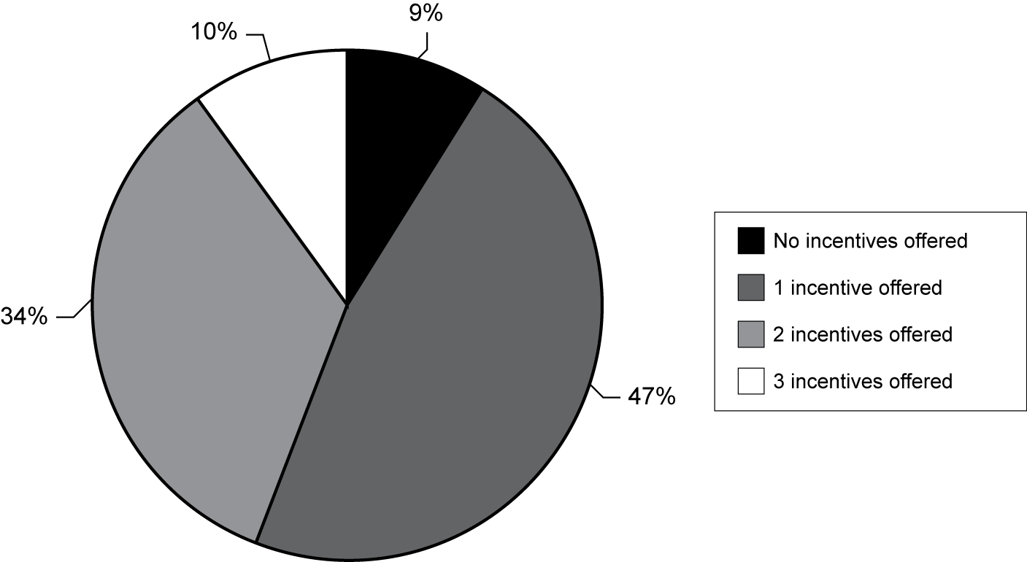
Note: The number of incentives may vary per year due to project features and participants’ requests.
Exhibit reads: Nine percent of FY 2002 grantees reported offering no incentives.
Source: Transition to Teaching Annual Performance Report, 2004–05.
Tuition scholarships were given as an incentive by more grantees than any other incentive (70 percent). This is reasonable, considering the approved use of funds for individuals teaching in high-need schools in high-need LEAs. Grantees also reported offering stipends (34 percent) and other types of incentives (36 percent), and a few offered loan repayment or bonuses. The total dollar amount spent on tuition scholarships was nearly five times the amount that was spent on stipends; grantees reported that 3,285 participants received these scholarships, more than the combined totals of those receiving stipends and other incentives (see Exhibit 25).
- Percentage of Grantees Offering Incentive, Average Amount of Incentive Provided and Number of Participants Receiving Incentive, as Reported by FY 2002 TTT Grantees for the Third Project Year,
by Type of Incentive
Type of Incentive | Percentage of Grantees Offering Incentive | Number of Participants Receiving Incentive | Average Amount of Incentive Provided in Third Project Year
Tuition scholarships | 70 | 3,285 | $1,716.61
Stipends | 34 | 1,091 | $1,467.42
Other | 36 | 1,189 | $824.20
Loan repayment | 3.3 | 160 | $199.92
Bonus | 0.02 | 98 | $71.94
Exhibit reads: Seventy percent of grantees reported offering tuition scholarships; the number of participants receiving this incentive was reported to be 3,285; the average amount provided in the third project year was $1,716.61. The average amount per participant is dependent on when reimbursement is requested per year.
Source: Transition to Teaching Annual Performance Report, 2004–05.
Many TTT participants enroll in their project and begin their teaching assignment simultaneously; therefore, they are being paid a salary, although some are being paid at a reduced level set by their district. Even with the $5,000 tuition reimbursement they may earn by their school placement, they still incur costs for their project participation and academic or professional development requirements. If the project duration extends past a year, the $5,000 amount is unlikely to meet the financial needs of many participants. The typical one-year cost of participation in a TTT project varied according to the type of grantee and partners providing the preparation component. Individual participants’ qualifications varied as did their needs in terms of academic course work. Participation could also be more expensive if a participant chose to attend higher-cost IHEs to complete their academic requirements. At the same time, some TTT projects offered online courses and modules, which decreased the per-course cost to each participant.
The APR data provide an average out-of-pocket cost for participants after receiving incentives, across all types of grantees. The average costs to first-year TTT participants for miscellaneous expenses was $345, for books $403, and for tuition $3,775, with an average total cost of $4,495, as shown in Exhibit 26.
- Average Out-of-Pocket Expenses for
TTT Participants in Their First Year
Exhibit reads: The average cost of miscellaneous expenses for a typical first-year TTT participant across all types of grantees was reported to be $345, after receiving the typical incentive.
Source: Transition to Teaching Annual Performance Report, 2004–05.
The average out-of-pocket cost to participate in TTT projects differed by type of grant recipient, with state-administered projects reporting the lowest ($1,957). The average total cost to participants in IHE-based grantees ($5,275) and in those administered by nonprofit entities ($6,705) were reported to be the highest. The difference is likely explained by the fact that in IHE and nonprofit grantees, participants were matriculating in public and private universities and facing increased tuition and fees. In some of the state grantees, costs were kept at a minimum because participants were engaged in seminars or professional development seminars for which they paid little if anything. Exhibit 27 summarizes the cost to participants by grantee type.
- Average Out-of-Pocket Expenses Reported by
TTT Grantees for a Typical Participation Year,
by Grantee Recipient Type
Exhibit reads: The total average out-of-pocket cost to TTT participants in their initial year in a TTT project administered by nonprofit entities was reported to be $6,705 by FY 2002 TTT grantees.
Source: Transition to Teaching Annual Performance Report, 2004–05.
These recruitment incentives, together with other project features, served to attract TTT participants during the recruitment and application stage. Of all features that attracted prospective participants, incentives were identified by the largest percentage of grantees (77 percent) as being among the top three most attractive, still, grantees reported that total costs for some participants far exceeded the benefit of the tuition reimbursement allowed by the TTT federal grant ($5,000).
The provision of certain supports while teaching was reported as an attractive element by 43 percent of grantees, and 41 percent indicated that methods of providing preparation—for example, through online courses, evening classes or summer workshops—also were attractive to participants. Fewer grantees indicated that the location of the project itself (25 percent) and the high-need characteristic of the hiring school (10 percent) served as attractive elements during the recruitment process (see Exhibit 28).
- Percentage of FY 2002 TTT Grantees Indicating Each Element Was One of the Top Three Most Attractive Elements to Participants
Exhibit reads: Seventy-seven percent of FY 2002 TTT grantees identified incentives as one of their top three most attractive elements to participants.
Source: Transition to Teaching Annual Performance Report, 2004–05.
TTT teachers also commented on the appeal of these project features and their resulting decision to participate in TTT. Forty-eight percent of participants indicated that the incentives offered by the TTT project (such as tuition scholarships or bonuses) were among the top three influences; in addition, nearly half (42 percent) indicated that the guarantee of employment was a major influence, and approximately 40 percent were influenced by project-provided support both toward attaining certification and while teaching (see Exhibit 29).

- Percentage of TTT Teachers Reporting
Influences on Decision to Participate in TTT
Exhibit reads: Forty-eight percent of TTT teachers reported that incentives were one of the top three features that influenced their decision to participate.
Source: Transition to Teaching TTT teacher survey, 2005–06.
Regardless of their prior experience or occupation, TTT teachers generally agreed to a large extent on the importance of these influences; paraprofessionals especially valued the incentives available (61 percent). All three target groups listed incentives and support while obtaining certification and teaching as top influences. Placement in a high-need school was in the bottom of the list of influences, along with reputation of the program and a general set of “other” reasons; this varied from the view of grantees that establishing a reputation as a strong project was a key to the success of using recruitment strategies such as word of mouth.

Recruitment Results
In three years, projects learned a number of lessons from their recruitment efforts. As a result, the overall rate of return improved. For example, in the first project report provided directly to the TTT program, 84 of the FY 2002 grantees reported expecting to recruit 4,347 individuals and obtained commitments from 4,587 individuals. In the third project year, the 2002 cohort of TTT grantees said they expected to recruit 3,696 individuals but they actually signed up 6,643.
Eighty-seven percent of FY 2002 grantees targeting midcareer professionals in the third project year, sought a total of 2,022 participants in this category, which formed the largest target group. Grantees reported receiving 8,513 midcareer professional applicants of which 5,467 were eligible candidates. Projects sought 893 participants from the category of recent college graduates. Of the 4,075 who applied, 3,062 (or 75 percent) were deemed eligible TTT candidates. About half of the grantees (52 percent) targeted paraprofessionals in their recruitment efforts, seeking 781 participants. Of the 1,642 paraprofessionals who applied, the percentage deemed eligible was relatively similar to the other two groups (see Exhibit 30).
- Number of Participants Targeted, Total Applications Received, and Total Applicants Determined as Eligible as Reported by FY 2002 TTT Grantees for the Third Project Year, by Target Group
Target Group of Grantees | Goal (Number of Participants to Recruit) | Number of Applications Received | Number of Applicants Determined as Eligible | Percentage of Applicants Determined as Eligible | Ratio of Eligible Applications per Slot
Midcareer professionals | 2,022 | 8,513 | 5,467 | 64 | 2.7 to 1
Paraprofessionals | 781 | 1,642 | 1,068 | 65 | 1.4 to 1
Recent college graduates | 893 | 4,075 | 3,062 | 75 | 3.4 to 1
Exhibit reads: Across all FY 2002 grantees, the total number of individuals from this target group sought was 2,022; 8,513 applications were received; 5,467 applicants (64 percent of the total applications received) were determined to be eligible through the selection and screening process. The ratio of eligible applications per slot was 2.7 to 1.
Source: Transition to Teaching Annual Performance Report, 2004–05.
TTT projects with a local scope reported the largest number of participants in the third project year. Exhibit 31 illustrates that most TTT projects recruited from more than one target group and that midcareer professionals was the largest group recruited.
- Percentage of Grantees Reporting Target Groups and
Percentage of Year 3 Participants From Each Target Group
Target Group of Grantees | Percentage of Grantees Targeting This Group | Percentage of Total  Year 3 Participants From Each Target Group
Midcareer professionals | 87 | 59
Paraprofessionals | 52 | 14
Recent college graduates | 79 | 27
Note: Most grantees targeted more than one group. Only 4 percent targeted paraprofessionals exclusively.
Exhibit reads: Eighty-seven percent of FY 2002 grantees targeted midcareer professionals; fifty-nine percent of participants were midcareer professionals.
Source: Transition to Teaching Annual Performance Report, 2004–05.

Selection Processes
During the past 20 years, entrance to teacher education programs, in general, has become more selective. Selectivity is defined not solely by the entrance requirements but also by the process used to establish the requirements, recruit and review applications, and make selection decisions. Rigorous eligibility requirements and performance standards are believed to effectively screen out candidates who may not succeed in the programs. The value of this selectivity has not been conclusively studied and its relationship to teacher effectiveness or student achievement proven. However, researchers have reviewed studies examining the relationship of other factors to teacher quality and effectiveness, such as selectivity of undergraduate institution, verbal scores on tests of admission (SAT), depth and amount of content studies, and pedagogy studies. In these analyses and reviews, researchers have been able to show that some factors have a positive effect (selectivity of institution and verbal scores); while for others there is limited effect, indicating mixed value for policy making regarding selection of candidates (Rice, 2003; Allen, 2003).
In general, research has shown that less selective programs have no requirement for GPA and require a simple application and interview and submission of state assessment passing scores. The most selective programs require a relatively high GPA (3.0 or greater), fulfillment or validation of course content, and an extensive interview process that includes the program administrator, representatives from the district human resource division, and the school principal who is, in effect, hiring the teacher (Mayer et al., 2003). For teacher preparation in general, few empirically tested selection instruments predict the success of candidates in the program and in teaching. Some TTT projects and alternative certification programs, in general, are attracted to the Haberman Star Teachers instrument, but most teacher education programs use a variety of selection techniques, such as interviews with groups of faculty and recommendations.
Alternative certification programs have adopted some of these selection standards and practices, especially those that are IHE based. Still, there is more variation in selectivity in alternative certification programs than in traditional programs (Mayer et al., 2003). Across all TTT projects, some selection factors were common, such as passing a criminal background check (required in most if not all states) and a required grade point average (GPA) between 2.5 and 3. In addition, because TTT projects have a narrow focus based on the subjects defined as high need, they sometimes have to turn away or counsel out individuals who apply and are not interested in specified subject areas. Finally, it is important to remember that TTT participants have already met some selectivity standards in their undergraduate or graduate programs. Thus, TTT projects are screening different kinds of candidates than traditional undergraduate programs and the fact that they may have relied on different indicators to screen candidates makes sense for their objectives.
The eight sites visited for the evaluation’s case studies provided more details than the APRs or the interim evaluations about how selection worked. In most of the sites visited, candidates were found to be selected and admitted into programs primarily based on reviews by selection committees or panels. This is a hallmark of being more selective. At some sites, the selection and placement committee is also actively involved in planning the project’s recruitment strategies. For example, at the Baldwin Park Unified School District (BPUSD) TTT project selection processes were managed by the project coordinator and the credentials specialist within the district office who assumed primary responsibility for reviewing applications and selecting eligible candidates to participate. In addition, principals were interviewed to learn about paraprofessional performance at their schools. This selection method may work best for this project because it focuses on recruiting currently employed district paraprofessionals.
In addition to academic requirements, the majority of TTT sites seek explicit evidence of maturity and long-term commitments to teaching from applicants. TTT administrators, program partners, and school-district personnel believe, for example, that long-term teacher retention can be increased by recruiting midcareer professionals who bring relevant and successful life experience (e.g., volunteering) and prior work history and who are certain about their choice of teaching as a career.
All eight sites visited for this evaluation appeared to have developed filtering and selection criteria that reflect the highly qualified teacher and paraprofessional requirements of NCLB. BPUSD, for example, requires paraprofessionals to have at least 60 completed credit hours of postsecondary course units with a cumulative GPA of 2.5. Orange County Public Schools (OCPS) requires that its paraprofessional candidates already hold an associate’s degree or equivalent college credits and submit a portfolio. Eligibility requirements for other sites include a minimum of a bachelor’s degree in a specific content area; a 2.5 GPA or higher; and passing PRAXIS I and II exams, with qualifying scores that will allow participants to secure employment as a teacher of record in a partnering school district.
When grantees are working with multiple training organizations and LEAs, the selection process may be in the hands of either the participating schools or the training providers. BPUSD’s TTT project is unique in that one of the training institutions had exceptionally high criteria.
Green River Regional Education Cooperative’s (GRREC) TTT project uses an extensive selection and placement process. Participating superintendents and education faculty from WKU meet to plan the process for each cohort of participants. The selection and placement committee is led by the project coordinator. The administrators involved with this process believe that it effectively screens out candidates who would not meet expectations. (For more details, see snapshot, below.)
Some grantees reported receiving applications from individuals who were not adequately qualified and found it necessary to refine the participant selection process. One grantee explained:
In order to begin to gather evidence and better refine the selection process for Transition to Teaching candidates, as well as for the alternative licensure portfolio route, we plan to begin requiring that candidates take the Haberman Star Teacher On-Line Pre-Screener and submit the results as part of their application. At first, we will use this information to gather data and to set a baseline for candidates who want to participate in our Transition to Teaching program and perhaps, eventually, who want to earn their license through the portfolio pathway.
By taking steps to be more selective and setting higher standards for entry, the grantees established a reputation as instituting a selective program, which, in their views, most likely facilitated both recruitment and hiring.
In the APRs, grantees indicated the importance of various factors in selecting applicants for admission. Among those factors described as “very important” by high percentages of grantees were criminal background checks (82 percent), academic course record (66 percent), grade point average (62 percent), interviews (55 percent) and oral (57 percent) and written (53 percent) skills. Those factors deemed not at all important by high percentages of grantees were gender (81 percent), cultural background (56 percent) and SAT or ACT scores (80 percent). Grantees’ responses for the full range of selection factors are depicted in Exhibit 32.
- Percentage of FY2002 Grantees Indicating the Importance of Various Factors in Selecting Applicants for Admission
Selection Factors | Very Important  (Percent) | Moderately Important  (Percent) | Somewhat Important  (Percent) | Not at all Important  (Percent)
Criminal background | 82 | 7 | 1 | 10
Academic course record | 66 | 26 | 6 | 2
GPA | 62 | 30 | 5 | 3
Oral skills | 57 | 31 | 7 | 5
Interview | 55 | 22 | 11 | 12
Written skills | 53 | 34 | 9 | 4
Prior major/field | 48 | 25 | 21 | 6
Praxis II | 35 | 7 | 7 | 51
Recommendations | 35 | 42 | 14 | 9
Other | 33 | 1 | 1 | 65
Praxis I | 32 | 9 | 6 | 53
Geographic location interest | 25 | 12 | 22 | 41
Work experience | 24 | 39 | 25 | 12
Selectivity of institution granting applicant’s degree | 10 | 28 | 35 | 27
SAT scores | 4 | 6 | 10 | 80
ACT scores | 4 | 6 | 10 | 80
Cultural background | 3 | 19 | 22 | 56
Gender | 1 | 6 | 12 | 81
Exhibit reads: Eighty-two percent of grantees reported that criminal background was “very important” in selecting applicants for admission.
Source: Transition to Teaching Annual Performance Report, 2004–05.
Using the data reported by the grantees on “very important” factors as well as previous research on alternate route selectivity (Seftor and Mayer, 2003), six factors were identified as most important for candidate selection: academic course record, GPA, oral skills, interview, written skills and prior major or field. When the responses of grantees on these six factors were calculated, the results show that very few grantees (seven) utilize all six factors identified in the research. Most grantees considered more than one factor in making selection decisions about TTT applicants; 21 grantees indicated use of three selection factors, 19 grantees considered four factors, 18 drew on five factors in the selection process (see Exhibit 33).
- Number of FY2002 TTT Grantees Using Multiple Selection Factors
Exhibit reads: Seven FY 2002 TTT grantees reported that all six of the top reported factors were “very important” in their selection process.
Source: Transition to Teaching Annual Performance Report, 2004–05.
Grantee Snapshot: Selection at the Green River Regional Education Cooperative
(GRREC-Kentucky)
To be considered eligible for Green River Regional Education Cooperative (GRREC), applicants must meet Western Kentucky University’s (WKU’s) eligibility requirements for graduate school. These include GRE scores, a bachelor’s degree in their chosen content area from an accredited institution and an undergraduate grade point average of at least 2.5. Most applicants (except those in special education) must also take and pass the PRAXIS II exam in their desired content area prior to being admitted to the program. Because the special education PRAXIS exam contains test items regarding laws and policies with which new teachers may not be familiar, those applying to the special education degree program are not required to take the PRAXIS exam until after they have been in the program for a designated period of time. In addition to the general application, special education applicants must submit a portfolio, letters of reference and a personal statement that addresses professional areas of strength, a growth plan and their philosophy of education, they must also pass a criminal background check.
When applicants have been identified as potential TTT candidates, the selection process begins. Application materials are reviewed and screened, using an established rubric, by the program coordinator. Applications from qualified applicants are forwarded to participating school districts’ human resource directors and to WKU’s Department of Special Instruction Programs and Department of Middle Grades and Secondary Education. Eligible applicants are notified of their status and instructed to begin completing required testing (e.g., GRE, PRAXIS II) if necessary. The coordinator also reviews and screens the portfolios submitted by applicants of the special education program. The transcripts of eligible applicants are forwarded to school districts and university officials. Local school districts conduct their own screening of applicant materials, which they receive from the program coordinator, and select applicants whom they want to interview. All applicants who meet the minimum qualifications and who are offered employment by a participating district are admitted into the TTT program and notified via letter.

Preparation and Certification

Highlights
- Most TTT grantees offer face-to-face programs that cover the foundations, learning theory, and pedagogy addressed in traditional teacher preparation. However, these programs of study may be delivered as courses, as seminars, and as modules, and an earned degree is not always the goal of participation. About 10 grantees reported details about their planned use of electronic resources to hold classes, conduct e-mentoring, or support placement of participants. Grantees reported they frequently used evening or Saturday classes for participants.
- About half of TTT teachers indicated their studies in methods of teaching and discipline and management were very useful for their performance in the classroom and less than 20 percent indicated their student teaching was very useful. About 40 percent of TTT teachers engaged in a student teaching experience during their program.
- A small percentage of TTT teachers become certified, in the year they first “enroll;” most are teaching under a provisional certificate as they complete their state requirements and progress towards full certification. TTT teachers are considered highly qualified while participating in the TTT project.

Preparation in TTT Projects
Preparation (or training) refers to the practices by which projects prepare TTT participants for teaching and support their objective to attain certification; these include both course work (whether through traditional classes, online tutorials, professional development sessions, or other means) and fieldwork that takes place in K–12 classrooms. TTT projects offer multiple ways of earning credit or demonstrating a level of expected competence commensurate with being considered a highly qualified teacher. In fact, 40 percent of TTT grantees expected participants to earn academic credit in required course work and 22 percent required some kind of professional development, such as completing prepared modules delivered at specific times during the TTT experience. In addition, 67 percent of grantees required participants to complete a field experience (other than student teaching) as part of course or professional development requirements, such as observing in classrooms during summer school and 63 percent required student teaching or an organized internship that was sometimes concurrent with becoming a teacher of record (see Exhibit 34).
- Percentage of FY 2002 TTT Grantees Requiring Components of Teacher Preparation, by Component
Exhibit reads: Sixty-seven percent of grantees required participants to participate in some kind of early field experience.
Source: Transition to Teaching Annual Performance Report, 2004–05.
Mayer et al. (2003) and Seftor and Mayer (2003) note that the required curriculum in alternative certification programs generally tends to track the standard content and pedagogy studies for all new teachers, which can roughly be categorized into pedagogy, child development, and classroom management. Loeb and Reininger (2004) cite an Education Week annual survey indicating 24 states and the District of Columbia have “structured” alternate route programs that include both preservice and mentoring components. The same survey found that in twelve states and the District of Columbia, some classroom training before class assignment occurs, which is most like the sequence of a traditional program. TTT training seems to balance study of educational theory and practical knowledge in the areas of classroom management, lesson planning, and curriculum design. In some TTT projects, participants earn a graduate degree after fulfilling the basic requirements.
TTT grantees were asked to indicate the approach they used (either academic courses or delivery of seminars or professional development modules) to convey required content of preparation and most said they followed the approach of a typical teacher preparation curriculum: 60 percent or more of grantees required participants to earn academic credit hours in topics such as development and diversity (e.g., working with students with disabilities or English language learners), teaching methods, assessment, classroom management, reading and writing and teaching theory. In other grantees, between 31 percent and 39 percent reported these same areas of focus were covered in required professional development events (see Exhibit 35). Thus a typical TTT teacher has studied many of the same topics covered in traditional preparation programs, confirming the research cited above.
- Percentage of FY 2002 TTT Grantees Who Reported Requiring Course Credit or Professional Development Hours, by Topic
Topic | Course Credit Hours  (Percent) | Professional Development Hours  (Percent)
Development/diversity | 67 | 37
Teaching methods | 67 | 31
Assessment | 63 | 38
Classroom management | 62 | 39
Reading/writing | 61 | 32
Teaching theory | 60 | 34
Technology | 56 | 35
Other | 56 | 38
Community/parental involvement | 42 | 34
Organizational and collaborative strategies | 40 | 34
Research methods | 29 | 12
Educational foundations | 61 | 23
Note: Educational foundations is the study of the history of education and the development of the educational systems in this country and in others.
Exhibit reads: Sixty-seven percent of FY2002 TTT grantees reported their participants were required to take courses for credit in the topic of development or diversity; 37 percent reported they required participants to earn credit through accumulating professional development hours in the topic.
Source: Transition to Teaching Annual Performance Report, 2004–05.
TTT teachers largely agreed that their preparation through TTT addressed teaching methods, student assessment, classroom discipline and management, state and local standards, and the use of computers in instruction (see Exhibit 36 for the relatively small percentages of teachers reporting these are not part of their preparation). Twenty percent of TTT teachers indicated that their preparation included no study of content. There could be two explanations for the lack of content study: (1) projects may have focused on classroom management and administrative tasks to meet participants’ needs and (2) participants may have already earned the credits in their content area needed for certification or passed assessments validating their content area knowledge prior to entry.
Forty-two percent of TTT teachers reported they had no student teaching experience, which, as described above, is a less common component for alternate route programs. Still, many project directors reported developing a component of field experience (observation in classrooms), internship in summer school classrooms, or long-term (one full year) of an internship under the direction of a classroom teacher.
- Percentage of TTT Teachers Reporting Activities
and Areas of Study NOT Part of Their Program
Exhibit reads: Forty-two percent of TTT teachers said that student teaching was not a part of their program.
Source: Transition to Teaching TTT teacher survey, 2005–06.
Through field experiences connected to academic courses and through an extended period of student teaching (six months or more), it is expected that teacher candidates will have opportunities to observe and engage in teaching guided by an experienced cooperating teacher, which will prepare them to work independently and effectively as classroom teachers. About 40 percent of TTT teachers from all target groups reported they engaged in a student teaching experience. Slightly more paraprofessionals than recent college graduates and midcareer professionals had this kind of preparation, which is an acknowledgement of their need for additional support prior to assuming responsibility for instruction in a content area (see Exhibit 37).
- Percentage of TTT Teachers Reporting Their
Program Included a Student Teaching Experience
Exhibit reads: Forty-two percent of TTT teachers who described themselves as paraprofessionals reported they participated in a student teaching activity.
Source: Transition to Teaching TTT teacher survey, 2005–06.
A large majority of TTT teachers reported all areas of study that were part of their preparation experience as moderately or very useful, with the exception of student teaching (see Exhibit 38). Fifty-five percent of TTT teachers indicated that the study of teaching methods was very useful, and 50 percent reported the study of classroom discipline and management as very useful. These views on the value of preparation components make sense when considered in context: all TTT participants did not participate in student teaching, for example, and others already had experience with computers for teaching and learning. TTT project developers recognized over time that their participants valued applied content to manage the immediate demands of their responsibility as teacher of record. The effort by some projects to incorporate what is similar to a student internship came from seeing that participants desired a transition period and some needed more help than others before taking on full responsibility of the classroom.
Among different target groups, the percentages of TTT teachers reporting their perceptions of utility differ only slightly, with one notable exception: 46 percent of former paraprofessionals found content area study very useful, compared to 30 percent of recent college graduates and 35 percent of midcareer professionals. The difference in view is likely due to the process of catching up that most paraprofessionals are doing: those who do not have a bachelor’s degree are pursuing the content study that would have been accomplished by recent college graduates or midcareer professionals.
- Percentage of TTT Teachers Reporting Utility of
Areas of Study
Areas of Study | Very useful  (Percent) | Somewhat/Moderately useful  (Percent) | Not at all useful  (Percent)
Methods of Teaching | 55 | 37 | 4
Discipline and Management | 50 | 38 | 8
Student Assessment | 43 | 48 | 4
State/Local Standards | 41 | 41 | 10
Study of Content | 36 | 35 | 9
Computers for Instruction | 26 | 48 | 15
Student Teaching | 17 | 26 | 15
Note: A small percentage of teachers did not report on the utility of each area of study.
Exhibit reads: Fifty-five percent of TTT Teachers reported that “methods of teaching” was a “very useful” area of study in their preparation for classroom teaching
Source: Transition to Teaching TTT teacher survey, 2005–06.
Project components were offered and required at different points in different TTT projects. Often, they differed by target group as well. For example, in the GRREC project, participants enter the project during the summer semester and begin teaching in the fall at the school where they are recruited and hired. During the fall semester participants from the summer cohort take approximately six credit hours in the Western Kentucky University’s gradate program, including at least one online course. Additional course credits are taken in the next semester and in the fall. One of the required courses involves a supervised teacher internship, led by professors. This project is academically based, however, it has undergone fine-tuning to allow participants flexibility to extend their studies over a slightly longer period of time and additional support through a survival skills toolkit and professional development sessions focusing on applied skills and classroom management techniques.
Prior to participants gaining teacher of record status as a new hire, most grantees required all participants to attend orientation sessions. Nearly half of the grantees required summer institutes for midcareer professionals and recent college graduates and 37 percent of grantees reported this as a requirement for paraprofessionals as well. Between 58 and 69 percent of grantees required all target groups to engage in observations of teaching and attend cohort meetings. More grantees reported a requirement to earn bachelors’ degrees for paraprofessionals (61 percent) than for midcareer professionals (29 percent) and recent college graduates (23 percent), which is a reflection of the percentage of paraprofessionals who enter TTT projects without a degree or with an associate degree. Grantees reported they frequently used evening or Saturday classes for participants. Illustrated in Exhibit 39 are the variety of approaches used in TTT projects to ensure that, whether before, during, or after becoming hired, most participants engage in these typical program elements.
- Percentage of FY 2002 TTT Grantees Reporting Required Program Elements Before and After Attaining Teacher of Record (TOR) Status, by Target Group and Program Element
Required Program Element | Paraprofessionals |  | Midcareer Professionals |  | Recent College Graduates
Required Program Element | Before attaining TOR status  (Percent) | After attaining  TOR status  (Percent) | Before attaining  TOR status  (Percent) | After attaining  TOR status  (Percent) | Before attaining  TOR status  (Percent) | After attaining  TOR status  (Percent)
Orientation session | 92 | — | 91 | — | 88 | —
Summer institute | 37 | 13 | 48 | 16 | 49 | 14
Observations of teaching | 69 | 62 | 59 | 72 | 62 | 75
Regular cohort meetings | 65 | 54 | 58 | 77 | 59 | 74
Courses to earn bachelor’s degree credit | 61 | — | 29 | 13 | 23 | 12
Evening or Saturday classes | 55 | 46 | 47 | 67 | 51 | 70
Mentoring activity | — | 83 | — | 92 | — | 94
Early field experience | 69 | — | 55 | — | 55 | —
Practice or student teaching | 60 | — | 40 | — | 43 | —
Other | 31 | 43 | 50 | 49 | 50 | 51
Exhibit reads: Ninety-two percent of grantees reported that paraprofessional participants were required to participate in an orientation session before becoming teachers of record.
Source: Transition to Teaching Annual Performance Report, 2004–05.

Program Delivery Approaches and Challenges
Through the site visits and narrative responses to the APR, TTT projects reported that when they are based in IHEs, which in turn prepare candidates, they generally rely on the IHEs’ teacher training curricula as the foundation of the preparation. In these projects, participants complete similar course work as full-time students, with only minor variations in the number of courses and course sequencing to accommodate their work schedules or to provide more applied and survival-skills courses prior to, or in some cases during, early teaching stages. Because many of the projects require participants to begin teaching while they are still completing course requirements, courses covering such topics as classroom management, multiple learning styles, collaborative teaching, curriculum development and planning, and other applied courses are given a higher priority than courses that focus on educational theory to increase candidates’ chances of success in the classroom. Paraprofessional candidates must fulfill their degree requirements and their pedagogy and administrative training. Thus, their program can be extended by as much as two years.
Because TTT projects exist within a larger context of accountability for teacher certification, they must also ensure that the content is aligned with state and national standards. TTT sites reportedly designed or supported curricula that ensured that candidates would receive adequate training and course work to prepare them to pass all state certification exams. Several project directors and coordinators, in fact, described planning their curriculum by sitting down with the state standards in front of them.
The training delivery formats selected by TTT projects appear to provide a certain flexibility to accommodate the unique or specific needs of particular sites and participant groups. For example, Montana’s tri-state project, a rural and regional program, selected an online delivery format that allowed NPTT to reach a large number of candidates in sparsely populated areas throughout the tri-state region. Implementing an in-person, face-to-face content delivery format would have placed significant travel demands on most participants, and realistically, the majority of the program’s current participants would not have been able to participate in the program. This delivery format could certainly be considered feasible for similar rural or regional programs that are attempting to meet the needs of schools and districts in large regional or densely populated areas. Maryland’s online program was offered by the UMUC—a campus well-known in the state for specializing in the delivery of online degree programs. Many projects (10 at least) incorporated online delivery mechanisms and a few were developing portfolio systems.
Grantee Snapshot: Preparation in South Carolina Program of Alternative Certification for Educators and Maryland Alternative Routes to Certification Options
The South Carolina Program of Alternative Certification for Educators (PACE), addresses teacher shortages across South Carolina. To meet the objective of providing access to high quality preparation throughout the entire state, PACE offers a sequenced curriculum at sites that are dispersed geographically in five regions. The selected sites include four institutions of higher education (University of South Carolina–Spartanburg, University of South Carolina–Lancaster, Francis Marion University, and Clemson University) and two high schools (South Aiken High School and Fort Dorchester High School). The PACE curriculum includes 105 lessons: PACE 1 training encompasses the first 57 lessons, and PACE 2 covers an additional 48 lessons. PACE 1 includes classroom organization, lesson plan development, student assessment, the mechanics of teaching, and other topics, while PACE 2 includes such topics as the development and sequencing of curriculum units. Assessment is integrated throughout PACE training; projects are assigned and assessed during each phase and participants who score 70 percent or above during each phase are categorized as “passing.” The PACE curriculum is implemented by 25 cohort instructors (experienced teachers with masters’ degrees or national board certification) who are assigned to the regional training sites to form teaching teams of five members, each composed of a lead instructor and four master teachers.
The Maryland Alternative Routes to Certification Options program (MARCO) takes a different approach to providing course work, using primarily online courses for participants. The program includes nine hours of self-paced course work; however, MARCO uses a cohort approach, whereby all participants must start and complete the course series at the same time. While the majority of the course work is offered online, participants and faculty members have greater contact during the final stages of the program. Instructors for the online courses include faculty from University of Maryland system institutions as well as master and national board certified teachers. Course work is divided into six modules designed to familiarize participants with educational theory and practical issues relevant to teaching in contemporary classrooms. For example, one module gives an overview of state and national teaching standards, expectations for teacher professional development, and national and local educational policy issues. Another provides instruction about models of curriculum design, methods for classroom planning and instruction, and student evaluation. Still another module pairs participants online with an expert in the content area in which they intend to teach, so that they may share information about the types of resources and materials that are available in the subject area.
Flexibility in sequencing is not easy to achieve. If the content is being delivered by university faculty in traditional university surroundings and with traditional resources, then faculty must agree to teach in the evening and on weekends and work together to carefully match program philosophy and standards to the needs of participants. Furthermore, when participants seek to specialize in such areas as bilingual education or special education, they cannot forgo the more technical content that teachers in those subject areas need. One way to address the course sequencing issue is to create modules and allow participants to control their own pathways through content studies, with an advisor who monitors their progress. Another approach is to divide the course sequence into portions that reflect the needs of new teachers and to carry the cohort together through the same sequence.
For the most part, however, TTT projects use the traditional in-class, face-to-face method for delivering the curriculum. This format was favored by school districts and community-based organizations and cooperatives that relied on partnerships with IHEs to prepare candidates academically. The cohort approach was embraced by most sites to promote support in both the project courses and seminars and in school among colleagues. Sites that implemented traditional, face-to-face delivery formats varied the scheduling options to accommodate participants (e.g., greater use of Saturday and summer sessions, regional hubs).
Grantee Snapshot: Teacher preparation by Newport News Public Schools (Virginia)
In partnership with Old Dominion University (ODU), the Newport News Public Schools (NNPS) system takes a targeted approach to preparing new teachers for positions in the district’s shortage areas. The NNPS-ODU partnership provides participants with intensive preparation prior to teaching, followed by ongoing support during the first three years of teaching.
All TTT participants, regardless of prior experiences, begin with a mandatory five-week summer institute, which encompasses courses in pedagogy, human growth and development, curriculum and instruction in their specific content area, student organization, and portfolio development. The summer institute culminates with participants’ presentations of Web-based portfolios that demonstrate their progress toward teaching competencies. In addition to acquiring teacher certification, participants may pursue an optional master’s degree in literacy education or special education that requires additional hours of specified course work. All courses—for both the summer institute and the master’s program—derive from the standards-based, competency-driven curriculum that was collaboratively developed by NNPS and ODU teacher educators; this work was based on the requirements for Virginia teacher licensure, the particularities of NNPS as a high-need school district, and the National Council for Accreditation of Teacher Education (NCATE) standards for graduate course work.
Following their completion of the summer institute, TTT participants become teachers of record in NNPS classrooms. They commit to three years of teaching in NNPS, concurrently participating in an intensive mentoring program based on the PathWise Teacher Induction program developed by the Educational Testing Service and adopted by the NNPS project. Information about the PathWise model can be found at http://www.ets.org. This mentoring is provided by a PathWise mentor and a university liaison; in addition, participants meet frequently with resource teachers, the TTT project coordinator, and other TTT teachers. In the first year of teaching, mentors and university liaisons meet regularly with their assigned TTT teachers, tailoring the types of support offered to the needs of the particular participant. In the second year, this mentoring continues along with professional development seminars and workshops; in addition, TTT participants engage in research projects and continue to develop a Web-based portfolio to provide evidence of their progress toward program standards. During the third year, TTT participants become more self-directed, seeking out professional development opportunities with guidance from their mentors.
Regardless of grant recipient type, in alternate routes where individuals select their own training sites, there is much variation in the quality control exerted over content delivered. Some entities attempt to ensure that curricular content and pedagogy studies are aligned with state standards. Others provide professional development seminars offered on-site to participants to make up for differences in content and sequence in IHEs. A further implication of this flexibility is pressure on the mentoring component to sustain new teachers and to identify areas in which participants may need different kinds of professional development and support. TTT projects have approached these challenges in different ways: by standardizing the content and delivering the same content at different sites; by adding professional development sessions; and by adding mentors to an existing mentorship system supported by district or State. More about mentoring and supports in TTT projects is found in Chapter V.

Certification
TTT projects sought to fulfill the legislative mandate of simplifying the participant experience of certification procedures, and flexible arrangements helped accomplish this goal. Generally, these arrangements included ensuring that credits were earned in project-provided courses delivered at a university or community college, online, or by other means; reviewing transcripts to determine whether participants had met standards or competencies required for certification eligibility; providing professional development seminars and workshops that lead to a “credit equivalent” or a “competency equivalent” but no credit hours; or some combination of these approaches.
Many participants experienced some combination of transcript review, course work, and professional development by the project to determine their eligibility for teacher certification. Almost no grantees reported relying solely on transcript review or professional development to determine eligibility, which provides some indication of the value placed by TTT grantees on course work (whether classroom-based or online) as part of teacher preparation. Seventy-five percent of grantees targeting paraprofessionals relied on courses for credit as the sole means of determining participants’ eligibility. In addition, 29 percent of grantees targeting midcareer professionals and 32 percent of grantees targeting multiple groups reported a primary focus on course credit to ensure participants’ preparation for teacher of record status (see Exhibit 40).
- Most Commonly Used Practices of FY 2002 TTT Grantees for Determining Eligibility for Certification Status, by Target Group
Target Group | Review Transcripts Only  (Percent) | Courses for Credit Only  (Percent) | Professional Development Only  (Percent) | Combination  (Percent) | None  (Percent)
Midcareer professionals only | 0 | 29 | 0 | 57 | 14
Paraprofessionals only | 0 | 75 | 0 | 25 | 0
Recent college graduates only | 0 | 0 | 0 | 100 | 0
Multiple target groups | 3 | 32 | 5 | 52 | 8
Exhibit reads: No 2002 TTT grantees reported they relied upon the review of transcripts alone as a practice for determining the eligibility of midcareer professionals for certification.
Source: Transition to Teaching Annual Performance Report, 2004–05.
More than a quarter of the grantees reported challenges with navigating the certification regulations in their states. Some of these issues involved changes made at the state level that were out of the grantees’ control. For example, one grantee stated that a “major difficulty has been the added requirements to the credential programs in California. Our project participants have to pass more required examinations despite the fact that they had completed waiver programs. Additional examinations translate into additional time, resources, and preparation to study and pass them—which in turn put additional time and budget constraints on our project.” Several grantees faced similar problems with unexpected state-level certification changes, which required rethinking training and testing for participants and increased the expenditure of time, money and resources.
If a project focused on recruiting and placing teachers in a particular subject, changes in certification requirements could be quite problematic. For example, because of changes in state certification requirements, a project in New York City experienced problems when candidates seeking certification as teachers of speech with the bilingual extension could no longer participate. Added to this was the limitation that the grantee’s partner, an IHE, did not have a state-approved program in this certification area.
Project directors commented that some applicants did not fully understand the certification requirements. On occasion, it was reported that applicants lost interest in the program once they realized what was involved in the certification process. Some participants who did persist in pursuing certification had struggled to pass certification tests.
Overall, among TTT teachers, 87 percent of those certified reported holding certification relevant to the discipline of their main teaching assignment. Among these, 91 percent of recent college graduates and 88 percent of midcareer professionals held teaching certification that matched the subject of their main teaching assignment, compared to 86 percent of paraprofessionals (see Exhibit 41).
- Percentage of TTT Teachers with Certification Matching
Their Main Teaching Assignment, by Target Group
Exhibit reads: Ninety-one percent of TTT teachers who were recent college graduates held a state teaching certificate in the field of their main teaching assignment.
Source: Transition to Teaching TTT teacher survey, 2005–06.
Depending on the state-level requirements, participants may hold different types of certification while they are teachers of record. Among those who reported holding a teaching certificate, 66 percent reported a probationary, temporary, or provisional certificate, while 32 percent had regular certification. Those who began teaching with a temporary certificate were expected to achieve full certification by the end of the three-year program. It is important to note again that all teachers hired and participating in TTT projects are considered highly qualified because the approved program meets NCLB standards for alternate routes.

Hiring and Placement Of
New Teachers

Highlights
- TTT projects, at the three-year mark, seemed to be facilitating the hiring and placement of teachers as befitted the needs specified by participating LEAs. Over three years, more TTT participants were hired as new teachers of record by high schools and more participants were hired to teach special education students, with mathematics and science placements following.
- Most TTT teachers who have bachelor’s degrees are teaching full time. Most are assigned to teach in their subject area and matching their certification fields, but about 20 percent of TTT teachers in all subjects are also teaching subjects outside of their field. Foreign language and English specialists were more likely to be teaching subjects outside their fields, in addition to their main assignment.

Hiring and Placement
As indicated earlier, participants in TTT projects begin their teaching roles at different points in their TTT participation and in many projects there are rolling admissions and multiple cohorts. Still project directors reported making progress matching the needs of their participating LEAs, and most projects reported recruiting and facilitating the hiring of a small number of participants per year and others reported the hiring of up to 50 or more participants in a single year.
Grantees reported the greatest demand for teachers within their participating LEAs existed at the high school (90 percent) and middle school (84 percent) levels (see Exhibit 42). In addition, approximately 60 percent of grantees reported needs at the elementary and at the elementary and middle levels and 64 percent also reported general K–12 needs as designated by participating LEAs. In terms of subjects, nearly all grantees reported their partner LEAs had designated science (96 percent) and mathematics (95 percent) as high-need areas. Special education was also frequently reported, as indicated by 87 percent of grantees (see Exhibit 42).
- Percentage of FY 2002 TTT Grantees Reporting Various Assignment Areas as Being Identified as High-Need in Participating LEAs, by Grade Level and Subject Area
Exhibit reads: Fifty-nine percent of grantees reported that Elementary (Pre-K–5) was identified by partner school districts as a high-need grade level.
Source: Transition to Teaching Annual Performance Report, 2004–05.
TTT projects, at the three-year mark, seemed to be recruiting and placing teachers as befitted the needs specified by participating LEAs. Grantees reported the number of hired TTT teachers of record within given subject areas and levels for the first three years of the grant, as indicated in Exhibit 43. The number hired was notably smaller in 2002 than in subsequent years. Given the start-up factors associated with the first year of implementation, this finding is reasonable. In 2002, 1,297 participants were new teachers of record, compared to 3,072 in 2003 and 3,562 in 2004. In all three years, high school teachers tended to outnumber those hired at other levels, followed by teachers at the elementary level.
By subject area, special education had the greatest number of new teachers of record, with 2,143 teachers of record over the three-year period, including 903 new teachers in 2004 and 881 in 2003. Mathematics teachers formed the next largest group with 1,325 teachers over three years; 505 of these were new in 2004 and 612 in 2003. New foreign language teachers of record formed the smallest group, totaling just 143 over three years. Altogether over 7,000 new teachers of record were hired over three years for all levels of K–12 schools.
- Number of TTT Participants Who Were New Teachers of Record in High-Need Schools in High-Need LEAs, by Grade Level and Year and Subject Area in 2002, 2003 and 2004
Exhibit reads: In 2004, 1,125 new teachers of record were hired in participating LEAs for high school placements.
Source: Transition to Teaching Annual Performance Report, 2004–05.
The vast majority of TTT teachers reported they were placed currently in full-time teaching positions; however, these percentages varied across target groups. Eighty-eight percent of paraprofessionals reported they had full-time teaching positions, compared to 95 percent of midcareer professionals and 99 percent of recent college graduates. These results were consistent with (1) the more lengthy preparation of content knowledge and internship experiences in which paraprofessionals participated, due to their lack of bachelor’s degrees and (2) the variability in time to teacher of record in some TTT projects. Some TTT projects used an internship period to transition new teachers into full-time teacher of record status.
When TTT teachers reported on the level of their main teaching assignment, their reports closely tracked the overall need statistics filed by project directors. Thirty-eight percent of TTT teachers indicated they were hired at the high school level, with 29 percent working in middle schools, 27 percent in elementary schools, and another 3 percent in combined elementary and middle schools (see Exhibit 44).
- Percentage of TTT Teachers Reporting
Main Teaching Level
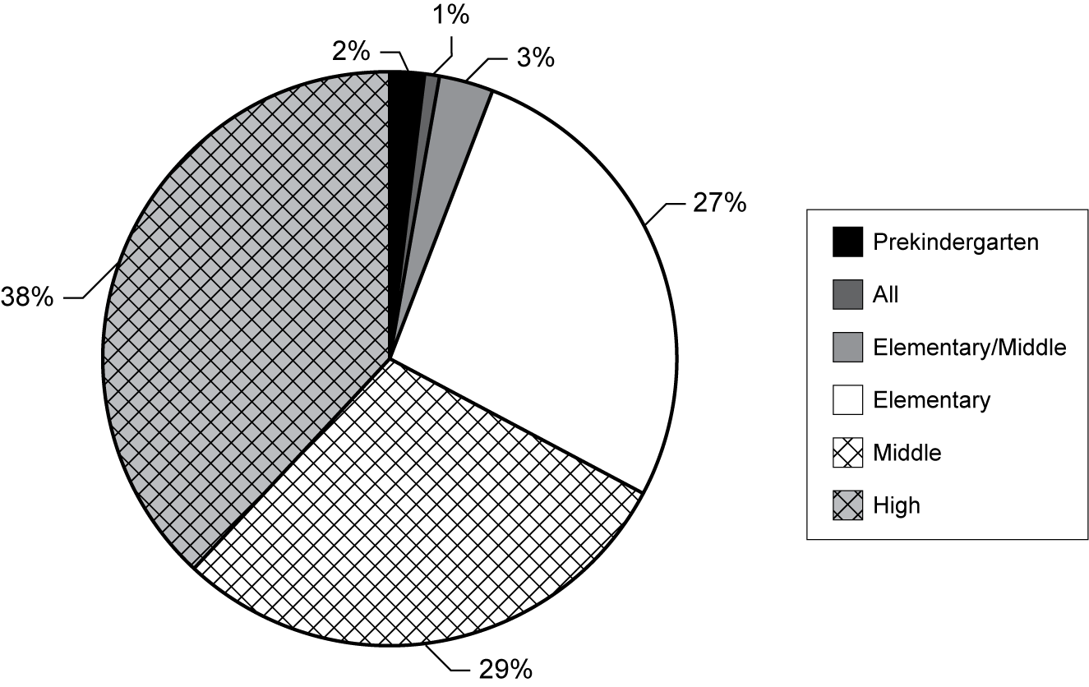
Exhibit reads: Two percent of TTT teachers reported they were assigned to teach at the prekindergarten level.
Source: Transition to Teaching TTT teacher survey, 2005–06.
Lessons Learned: Facing the Challenges of Participant Placement and Retention in
High-Need LEAs
A number of grantees reported a challenge in ensuring that participants were hired by the high-need LEAs associated with the TTT project, and then retaining the participants in those positions. This challenge emerged from two sources: the LEAs, whose job openings and hiring practices differed, and the participants, who bring expectations in terms of job location and work environment.
- Hiring
About 20 percent of grantees reported a problem with hiring in high-need LEAs, often because there were simply not enough high-need districts in the area; in other cases, LEAs faced budget cuts or decreasing student enrollment, resulting in teacher layoffs and reduced hiring needs. As one grantee explained, “With inadequate funding, many districts are laying off rather than hiring new teachers or simply absorbing much of the teacher attrition by increasing class size. This has made it exceedingly difficult for newly licensed teachers to find employment.” Another noted that the lack of openings in partnering LEAs forced some participants to “seek jobs in other areas, frequently getting offers from Title I campuses that are not in a district that fits ‘high need.’”
In addition, the hiring process within some districts impeded participants’ placement. In some cases, LEAs provided late notice of available teacher positions; in addition, a small number of grantees reported that LEAs did not take TTT participants seriously, sometimes hiring participants only as a last resort. One grantee reported that LEAs’ understandings of the highly qualified teacher provisions further complicated the hiring process: “Local school system interpretations of the ‘highly qualified teacher’ definition in NCLB prevent most of our partnership school districts from hiring lateral entry teachers. We have a significant number of participants who are actively seeking employment, but cannot be hired until they are fully licensed due to the school system’s interpretation of NCLB.”
- Placement and Retention
From the participant perspective, grantees described an additional challenge related to placement and retention: gaining and maintaining commitment to the high-need schools within identified high-need LEAs. One program with a focus on urban LEAs reported losing over 30 percent of participants who reported in surveys that they believed “they were not adequately prepared for the challenges of teaching in an urban setting.” Rural locations also provide a special challenge, as these placements may require relatively extensive travel between a school and the site of TTT preparation; such remote sites also create challenges as the TTT project seeks to provide on-site support to teachers of record. These rural locations also proved less popular for participants whose engagement required relocation with their families: some participants were concerned that they were moving to an area with fewer resources.

Participants also reported on their subject area assignments (see Exhibit 45). The largest percentage of grantee teachers reported they were assigned and teaching mathematics (21 percent) and special education students (21 percent), and the smallest percentages of teachers indicated they were assigned to and teaching foreign languages and social studies.
- Percentage of TTT Teachers by Subject
Area Assignment
Exhibit reads: Twenty-one percent of TTT teachers reported they were assigned to teach mathematics.
Source: Transition to Teaching TTT teacher survey, 2005–06.
Twelve percent of former paraprofessionals were assigned to teach mathematics, compared with 25 percent of recent college graduates and 25 percent of midcareer professionals. This was most likely related to some projects concerted efforts to recruit individuals with strong content backgrounds in mathematics and the lack of earned content degrees in this field among recruited paraprofessionals. Interesting, though, in the field of special education, 30 percent of TTT teachers who were paraprofessionals were teachers of record, compared with 15 percent from the recent college graduate category and 23 percent who described themselves as midcareer professionals. In addition, more teachers of record assigned to K–5 classrooms were former paraprofessionals (20 percent) than recent college graduates (13 percent) or midcareer professionals (9 percent) (see Exhibit 46). This finding is consistent with knowledge gathered from surveys of paraprofessionals describing their work, which tends to be in elementary school classrooms alongside teachers where they assist teachers by tutoring students or working with small groups of students in the subject areas of reading and mathematics. Paraprofessionals may also have had the opportunity to aid regular teachers in classrooms with more special education students and thus have been somewhat inclined to prepare for teaching students with special learning needs.
- Percentage of TTT Teachers Reporting Main Teaching Assignment Field, by Target Group
Target Group | English Language Arts  (Percent) | Mathematics (Percent) | Science (Percent) | Social Studies (Percent) | Foreign Language (Percent) | ESL/ Bilingual (Percent) | Special Education (Percent) | General  K–5 (Percent) | Other  (Percent)
Paraprofessionals | 3 | 12 | 10 | 0 | 3 | 5 | 30 | 20 | 15
Recent college graduates | 7 | 25 | 13 | 4 | 7 | 5 | 15 | 13 | 11
Midcareer professionals | 6 | 25 | 12 | 4 | 1 | 3 | 23 | 9 | 17
Other | 15 | 9 | 2 | 6 | 0 | 15 | 18 | 25 | 10
Note: “Other target group” refers to TTT teachers who did not provide information that would permit their grouping by target group.
Exhibit reads: Three percent of former paraprofessionals now participating as teachers of record were assigned to teach English language arts.
Source: Transition to Teaching Evaluation TTT teacher survey, 2005–06.
A number of TTT teachers reported being assigned to teach subjects outside of and in addition to their main assignment field: 26 percent who were recent college graduates, 20 percent who were midcareer professionals, and 12 percent who were paraprofessionals (see Exhibit 47). These teachers were most likely working in secondary and middle schools where there were not enough highly qualified teachers for each subject area. When these assignments were further analyzed by subject area, the data indicated that the teachers most likely to be taking on additional assignments were teachers of foreign languages and English; mathematics was third on the list (see Exhibit 48).
- Percentage of TTT Teachers Reporting Teaching
Assignments Outside of Main Teaching Field, by Target Groups
Exhibit reads: Twenty-six percent of TTT teachers who were recent college graduates were assigned to teach classes in other subjects outside of and in addition to their main teaching assignment field.
Source: Transition to Teaching TTT teacher survey, 2005–06.
- Percentage of TTT Teachers Who Teach a Subject
Outside of Their Primary Assignment Subject,
by Primary Teaching Subject
Exhibit reads: Thirty-two percent of TTT teachers whose primary assignment was teaching Foreign Language classes reported they also teach subjects outside their assigned area.
Source: Transition to Teaching TTT teacher survey, 2005–06.

Mentoring and Other Supports for Newly Hired Teachers

Highlights
- Forty-six percent of TTT teachers reported they received some kind of support from the TTT project before they became teachers of record in the classroom. Thirty-seven percent said the TTT support began concurrently with assuming their responsibilities as teachers. About 17 percent reported the project began its support some time after they became teachers of record.
- Sixty-three percent of TTT teachers reported having a mentor in 2005–06 (the year in which they were surveyed). This is slightly lower than reported by teachers in the workforce. Survey participants could have been hired between 2002 and 2004, they may have had mentors in one of those beginning teaching years but not in the one in which they were surveyed.
- At the three-year mark, TTT projects reported relatively high one-year retention rates (87-94 percent) and a two-year rate of 74 percent among newly hired teachers. These retention rates are consistent generally with the most recent studies of beginning teacher mobility (Smith and Ingersoll, 2004; Marvel, et al., 2006). They are also notable because these teachers are in the schools with the greatest needs. While attrition in TTT projects was reported to be low in a given project year, it did occur and was due to a variety of concerns, not all directly related to the project components, placement or requirements. Participants did indicate, when asked, that working conditions in schools would be most likely to cause them to consider giving up teaching.

TTT Project Support for TTT Participants
Support, in its broadest sense, refers to the range of programmatic means by which TTT projects offer assistance and encouragement to participants, both before and after they attain teacher-of-record status. TTT projects provide various kinds of support to participants at each step of their journey to realize full certification. Since participants begin teaching at different points in their project experience, and the length of projects vary, it is helpful to be more descriptive about this support. Forty-six percent of TTT teachers reported they received some kind of support from the TTT project before they became teachers of record in the classroom. Thirty-seven percent said the TTT support began concurrently with assuming their responsibilities as teachers. About 17 percent reported the project began its support some time after they became teachers of record.
Once their participants are hired and teaching, TTT projects provide support to newly hired teachers who are participating in the project or by facilitating support through participating organizations. Nearly all projects reported they offered some degree of site-based mentoring and 62 percent offered mentoring once a week or more often. Most projects (89 percent) provided support through organized meetings with groups of participants, ranging in frequency from once or twice a semester (23 percent) to once or twice a month (37 percent) and once or twice a week (24 percent). In addition, 77 percent of grantees provided supervision to teachers, with 39 percent providing this once or twice a month. Also, most projects (89 percent) organized workshops or classes for participants (see Exhibit 49).
- Percentage of FY 2002 TTT Grantees Reporting Frequency and Type of Support Offered
Type of Support | Once or Twice a Semester (Percent) | Once or Twice a Month (Percent) | Once or Twice a Week (Percent) | Almost Daily (Percent) | Not Provided (Percent)
Site-based mentoring | 11 | 21 | 38 | 24 | 6
Meetings with other participants | 23 | 37 | 24 | 4 | 11
Project-provided supervisors | 17 | 39 | 13 | 8 | 23
Workshops/classes focused on teaching | 30 | 28 | 30 | 1 | 11
Other | 23 | 5 | 7 | 8 | 57
Exhibit reads: Eleven percent of FY 2002 grantees reported offering site-based mentoring once or twice a semester.
Source: Transition to Teaching Annual Performance Report, 2004–05.
The duration of the support offered to TTT participants varied from one to three years; in other words, grantees provided different levels of support to participants as they progressed toward fulfilling the three-year retention goal. Mentoring, the type of support most widely provided, was offered for one year by 36 percent of grantees, two years by 41 percent and three years by 23 percent. For both cohort meetings and workshops or classes, similar percentages of grantees reported offering these supports for one, two, and three years. More grantees (41 percent) provided project supervisory support in participants’ first year as teacher of record than in the second and third years of teaching (see Exhibit 50). It is important to keep in mind that some types of support were provided by participating organizations, others by collaboration with the grantee, and still others by the grantee itself.
- Percentage of FY 2002 TTT Grantees
Offering Support, by Number of Years
Exhibit reads: FY 2002 grantees provided a range of other kinds of support to participants: 32 percent did so for one year; 12 percent for two years; and 56 percent for three years.
Source: Transition to Teaching Annual Performance Report, 2004–05.
As has been reported, approximately 40 percent of participants indicated that the promise of support—both during teaching and as they worked toward teacher certification—was important in their decision to participate in TTT. Elaborating on the types of support actually received, high numbers of project teachers of record from all three target groups reported experiencing beginning teacher support and attending seminars for beginning teachers, while small percentages reported reduced teaching schedules or reduced preparations (see Exhibit 51). Sixty-six percent of paraprofessionals reported having common planning time, compared to recent college graduates and midcareer professionals at 44 percent and 41 percent respectively, and more than half of participants across target groups reported regular supportive communication with their school administrators. TTT projects reported a variety of relationships with schools and districts regarding this support. Some projects instituted mentoring programs, including the training of mentors. Others relied on existing programs and supplemented them with focused seminars. Supports such as reduced schedule, fewer class preparations (for example, teaching four rather than five unique classes in a subject), and common planning time were the purview of the school and its administrator and may also be related to teacher contracts.
- Percentage of TTT Teachers Reporting
Types of Support Experienced During TTT Participation,
by Target Group
 | Paraprofessionals  (Percent) | Recent College Graduates  (Percent) | Midcareer Professionals  (Percent)
Beginning teacher support | 80 | 88 | 80
Reduced schedule | 5 | 5 | 2
Reduced preparations | 7 | 12 | 8
Common planning time | 66 | 44 | 41
Seminars for beginning teachers | 79 | 78 | 80
Extra classroom assistance | 34 | 31 | 30
Regular communication with administrators | 73 | 63 | 66
Exhibit reads: Eighty percent of TTT teachers who were paraprofessionals reported benefiting from a beginning teacher support program while participating in their TTT projects.
Source: Transition to Teaching TTT teacher survey, 2005–06.

Grantee Snapshot: Support for New Teachers in the Intercultural Development Research Association Project (Texas)
In Texas, the Intercultural Development Research Association (IDRA)—a project focused on addressing shortages, particularly in bilingual education and ESL, attempts to address mentoring at university, district, and school levels. Texas’ New Teacher Support and Mentoring Program is mandated for all new teachers in the state and includes mentoring of novices by pairing them with veteran teachers. Mentors are expected to provide support by assisting new teachers in lesson planning, classroom management, and activities that promote professional development and by observing in-class instruction and providing formative feedback. This state-initiated program—which specifies some requirements and guidelines—is carried out at the district level, resulting in varied implementation. According to an IDRA representative, “In reality this [mentoring] does not always happen, so we help them.” To address gaps in district-provided mentoring, IDRA offers participants ongoing, specialized support services designed to focus specifically on issues of bilingual instruction or to supplement district-provided support.

Mentoring in TTT Projects
A literature review by Ingersoll and Kralik (2004) notes that mentoring is such a key component of induction programs for new teachers that the terms have become synonymous; further, an analysis of data of the Schools and Staffing Survey by Smith and Ingersoll (2004) suggests that teachers’ experiences with some kind of support while in their first three years of teaching have increased greatly from 1990–2000 and that the likelihood of teacher turnover decreases when mentoring is combined with other supports, such as common planning time, collaboration, and time to network. While not required to create and offer a mentorship component, the TTT projects recognize the importance of supporting participants in meeting this requirement and have explored a variety of options toward meeting the needs of participants, including providing a mentoring component and facilitating one with a participating district.
Among TTT participants, 63 percent reported having a mentor during the year they were surveyed. By comparison, 73 percent of teachers in the workforce who came into teaching through alternative programs and 71 percent of teachers who came through traditional routes reported having a mentor in the year they were surveyed (see Exhibit 52). The differences reported by TTT teachers and other groups of teachers, while seeming substantial, may actually be due to the variation within TTT projects as to when participants begin teaching and when and for how long mentoring is provided through the TTT or other existing programs. Also, the surveyed teachers for this evaluation could have been hired and teaching at any time from 2002–04; during any one of those years, a higher percentage may have worked with a mentor than in the year during which they were surveyed on this support.
- Percentage of Teachers Reporting Having
a Mentor This Year*
*Note: “This year” refers to the survey year. For TTT teachers, 2005–06; for teachers surveyed by SASS, 2003–04.
Exhibit reads: Seventy-one percent of traditional route teachers in the workforce reported having a mentor in the 2003–04 year.
Source: Transition to Teaching TTT teacher survey, 2005–06; Schools and Staffing Public School Teacher Survey, 2003–04.
There was some variation in mentoring reported also according to the type of grant recipient. For example, 70 percent of TTT teachers in nonprofit grantees reported they had a mentor, 58 percent of TTT teachers participating through district grantees had mentors, and teachers of record in grantees administered by IHEs and state grantees reported having a mentor at about the same level
(64 percent–68 percent).
Largely, participants reported that mentoring was provided by the school districts in which they were placed (54 percent) or the TTT project (35 percent) (see Exhibit 53). In a few projects, participants are supported with mentors from two sources, the school district and the TTT project. Usually, the TTT project planned for this, instituting a complementary induction program to that existing in the district. However, sometimes, the TTT project added seminars and other supports when participants were not satisfied or assisted in existing mentor programs. Although the source of support could have been confusing for them, most participants reported they knew the source.
- Percentage of TTT Teachers
Reporting Entities Providing Mentoring
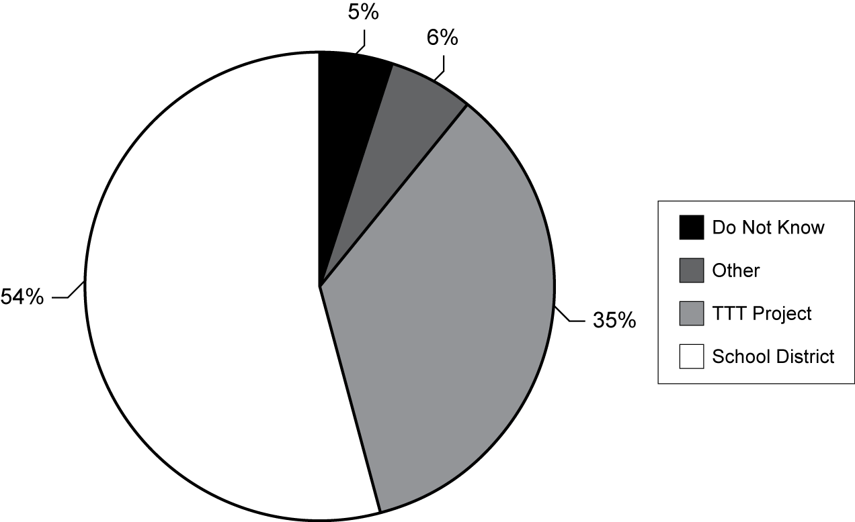
Exhibit reads: Five percent of TTT teachers reported they did not know who provided a mentor for them.
Source: Transition to Teaching TTT teacher survey, 2005–06.
Participants who received mentoring support had varying degrees of interaction with their mentors (see Exhibit 54). These reports were consistent with what grantees reported (see Exhibit 49).
- Percentage of TTT Teachers Reporting
Frequency of Mentor Meetings
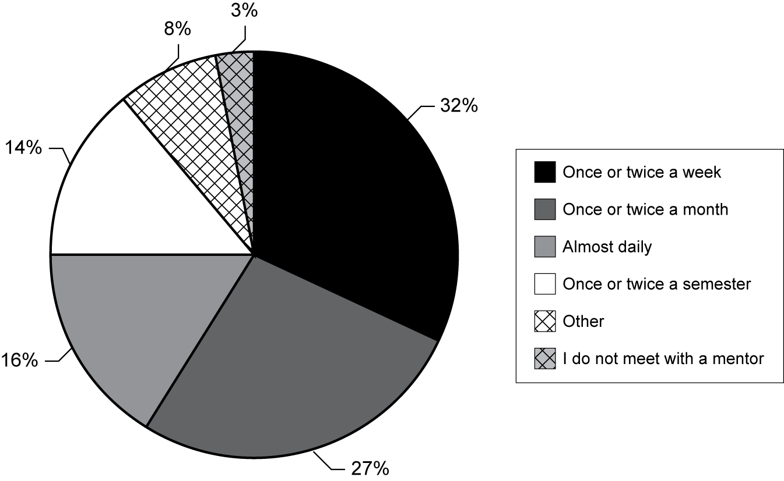
Exhibit reads: Thirty-two percent of TTT teachers reported their mentors met with them once or twice a week.
Source: Transition to Teaching TTT teacher survey, 2005–06.

Implementing Mentoring Approaches and Challenges
As with other components of alternative certification programs, a valuable literature base exists that describes the elements of mentoring, but little scientific research indicates its effectiveness. Per Mayer et al. (2003) and confirmed through the TTT evaluation site visits, mentoring is the alternative certification component implemented with the least consistency. One reason is that it can be managed in multiple ways: participants may avail themselves of a mentoring initiative in their home school or through the TTT sponsor, or university partners may provide mentors. The frequency of mentoring activity may also be “beyond the control” of an alternative certification program. Mentors may be full- or part-time; paid or volunteer; classroom teachers, retired school personnel, or education faculty; or may even be the project director.
In a review of program literature, features of induction programs were identified that were commonly referenced by experts in the field, including the use of veteran teachers and training that includes how to work with adults, how to conduct classroom observations, how to give feedback, and how to help teachers create professional development plans (U.S. Department of Education, 2004). Experts agreed, according to the review, that mentors should be compensated, and they also recommended frequent interactions with mentees but didn’t provide any benchmarks in terms of frequency. Other kinds of support were also recommended for new teachers. For example, assistance with assessment was considered to be a central role for a mentor. Finally, the experts in this analysis agreed that mentoring benefits are most likely to reach students when the mentoring process focuses on instructional practice.
There are a number of examples illustrating the variation in mentoring arrangements and services for participants in TTT projects that emerged from site visits and TTT project interim reports, where project directors listed their objectives and progress made, as well as challenges.
The District of Columbia Public Schools project stated an objective to “develop a mentoring capacity within DCPS” as an outgrowth of the TTT project. DCPS and American University jointly developed a mentoring manual that is used throughout the two-year mentor course that prepares mentor teachers. Still, training of mentors has proved a challenge: the late assignment of candidates to schools (in fall rather than summer) has delayed recruitment of school-based mentors and resulted in their not receiving full training until well into the school year. DCPS and American University worked with principals in the placement schools to ensure that mentor recruitment coincides with participant recruitment.
The University of Kansas Center for Research planned to offer “a two-year induction and mentoring program that supplements the curriculum modules and strengthens the growth of these teachers.” To accomplish this objective, the project developed a triad structure for mentoring that included an in-house assigned mentor, a KU faculty member, and a TTT staff member. However, consistency proved difficult: according to the interim report, some participants reported feeling “over mentored” while others reported that they did not receive needed support. According to the report, plans to restructure the mentoring component were underway.
When GRREC-WKU participants are teachers of record, they become eligible for a statewide mentoring program that includes a one-hour professional development course that is held four times during the semester and a three-hour content course. Participants must complete the mentoring program to earn their permanent certificates. The GRREC project underwrites and augments the mentoring time supported by the state funding, and a TTT mentor continues to work with program participants for an additional 12 semester hours after they receive their master of arts degrees.
Because many state departments of education mandate that induction programs be provided for first-year teachers, some TTT grantees “hand off” participants to local schools and districts where these programs are to be realized. Unfortunately, both content and quality of induction programs in schools vary dramatically. Some participants reported that their district’s programs felt more like a “checklist,” whereas others described their induction programs as simply an assigned time to learn district policies and procedures. Because districts have some flexibility in planning programs, some are designed to meet once a week and others may be designed to meet once a month. Consequently, for TTT participants enrolled in state or regional programs or in programs that serve multiple districts, it is much more difficult to ensure that they receive adequate amounts of support at the district and school levels.
Site visitors to the eight TTT projects found a surprising lack of understanding in some districts about the content of preparation that is delivered to TTT participants, such that some participants reported that they are required to sit through the same classes, seminars, or presentations during induction that have already been offered through their TTT training. At several of the sites, participants also reported that information or practices taught in their induction sessions contradicted what was taught in their TTT training. As a result, these participants described being torn between the philosophy of their TTT training and that offered by the mentoring program.

Retention Outcomes
TTT projects focus their recruitment efforts toward the hiring exigencies of high-need schools in high-need districts and attempt to retain participants in the teaching profession for three years in those schools, attracting them with tuition reimbursements and other support incentives. Participants receiving financial support or incentives were asked to remain in high-need schools in high-need LEAs for this period; otherwise, they were subject to forfeiting their scholarship funds. While success relative to this objective cannot be fully determined at this early stage, and we could not follow individual teachers tracking their retention rates, grantees did report on their retention rates over three project years of the grant (see Exhibit 55). One-year retention rates were strong. Two-year rates were not affected by either size of grantee or features such as the amount and duration of mentoring activities offered (see Exhibit 56).
- Percentage of Participants Who Became Teachers
of Record in 2002 and 2003 and Their Retention Status,
by Year Entering the TTT Project (2002 and 2003)
Note: TTT projects may enroll more than one cohort of participants in a given project year.
Exhibit reads: Ninety-four percent of participants who entered the TTT project in 2002 and became teachers of record in 2002 were reported to still be teaching in 2003.
Source: Transition to Teaching Annual Performance Report, 2004–05.
- Percentage of Teachers Who Became Teachers of
Record in 2002 and Were Still Teaching in 2004 by the
Duration of Site-Based Mentoring Offered by FY 2002
TTT Grantees
Exhibit reads: The percentage of teachers who were hired in 2002 and still teaching in 2004 and who received mentoring support for three years from the TTT project was 87 percent.
Source: Transition to Teaching Annual Performance Report, 2004–05.
On the APR, almost three-quarters of grantees (72 percent) indicated that the support they provided to participants, such as mentoring or induction programs, enhanced participant retention. Incentives, in the form of scholarships, stipends, or bonuses, were also important for retention, as reported by 57 percent of grantees. Methods of preparation, including online course work or evening classes, were indicated as important to participant retention by 41 percent of grantees. Few grantees indicated that features related to location—of the school placement, including its high-need status, or of the TTT project itself—were among the top three methods used for retention of participants by the project (see Exhibit 57). This was consistent with grantees reports, noted earlier, about attractive features of their projects, when they highlighted both incentives and support.
- Percentage of FY 2002 TTT Grantees
Ranking Retention Methods Among Top Three Used
Exhibit reads: Seventy-two percent of grantees ranked the teaching support provided through their project as one of the top three retention methods used.
Source: Transition to Teaching Annual Performance Report, 2004–05.
As has been reported, some grantees indicated there were participants who found the high-need school environment too demanding and, for their part, some participants indicated they were unhappy in their schools due to poor administration and lack of support. Still, when asked to assess whether they agreed that the TTT projects fulfilled their expectations, TTT teachers, regardless of target group, tended to agree and even strongly agree, that they received the incentives expected; that the project enabled them to obtain immediate employment; that they obtained placement at a level and subject area they were prepared to teach; and that they were receiving adequate support from the TTT project.
Grantees reported that participants leave the project for various reasons ranging from school site-specific factors (e.g., issues with administration, students, working conditions) to conditions that may affect the teacher workforce more broadly (e.g., concerns about salary or advancement opportunities). Grantees also indicated that a predominant reason given by participants was something other than project experience or working conditions and had more to do with personal issues. TTT teachers indicated some administrative misassignments and lack of mentoring consistency were important reasons for becoming disenchanted with their schools and the TTT project. Exhibit 58 summarizes the number of times grantees cited these reasons for participants’ decisions to leave TTT and teaching.
- Frequency with which Grantees Reported
Participants’ Top Reasons for Not Completing Their
Teaching Assignments and Leaving the Project
Exhibit reads: “Administrative issues” was cited 28 times by grantees as a reason given by TTT participants who left the project.
Source: Transition to Teaching Annual Performance Report, 2004–05.
With the incentives offered by the TTT grantees, and the relatively good fit for level and subject assignment they are able to afford, there were reportedly few project dropouts in a typical year. For example, for participants who enrolled in the TTT projects in 2003 and became teachers of record in 2003, grantees reported a total of 536 participants left between the second and third years of the project out of a total estimated 6,700 participants. This represents 8 percent of the total number of participants in the third project year, as reported by the grantees. IHE grantees and local grantees reported the largest number of “leavers” which seems proportionate to the larger number of grantees represented in both of these categories (see Exhibit 59).
- Percentage of FY 2002 TTT Grantees
Reporting Range of Participants Who Left the
Project After 1 Year (2003–04)
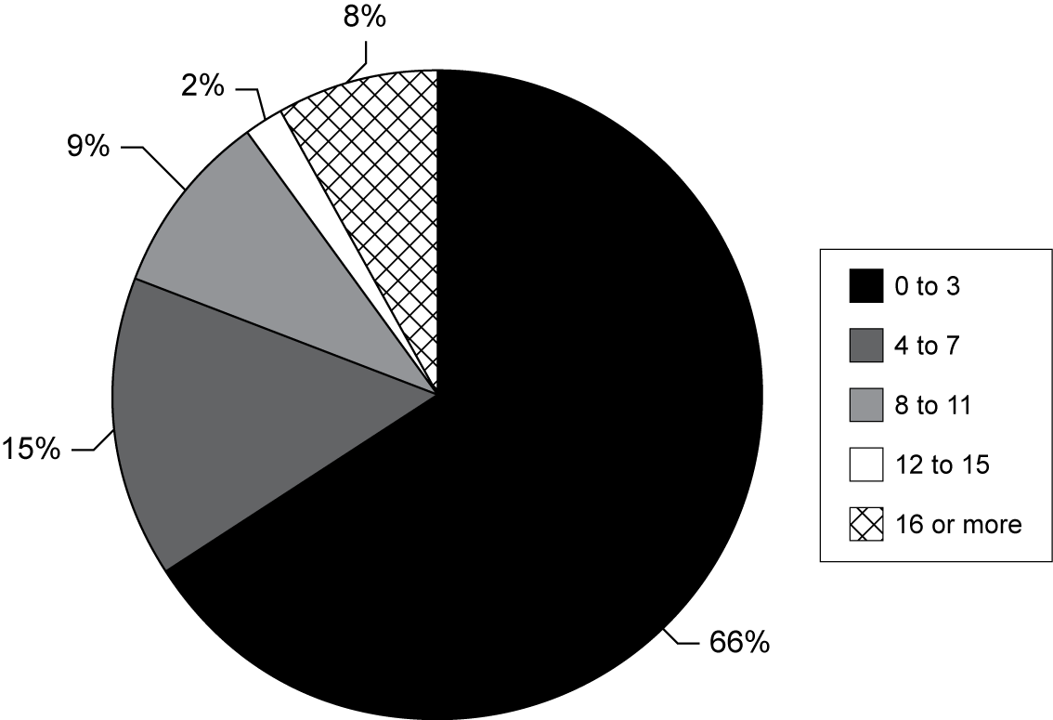

Exhibit reads: Sixty-six percent of FY2002 grantees reported having up to three participants leave who enrolled in the TTT project in 2003 and became teachers of record in 2003 and then dropped out in 2004.
Source: Transition to Teaching Annual Performance Report, 2004–05.

Teacher Satisfaction and Future Plans

Highlights
- If pressed to choose a pathway other than TTT, 33 percent of TTT teachers reported that they would have pursued a traditional teacher education route, and 33 percent said they would seek another alternative teacher preparation program. Without TTT, 20 percent of participants would not have entered teaching at all.
- When presented with a set of areas related to the demands and responsibilities of a teacher, 66 percent of TTT teachers reported that they felt well or very well prepared to teach their subject matter.
- TTT teachers identified workload management as the most challenging aspect of teaching that they encountered in the first three months of teaching.
Individuals have a greater variety of options when they choose to enter teaching than ever before. TTT-sponsored alternate routes coexist in districts and in states with other approaches to recruit various targeted groups into teaching, such as military service members. As data from annual surveys indicate, 48 states and the District of Columbia have some kind of approved alternate route program (Feistritzer, 2006). Teacher education programs in private, public, and for profit IHEs offer many options for those who want to be teachers. Further, in some states, such as Florida, a legislative mandate to offer an alternate route in each school district is currently in place. Therefore, it is of some interest to explore why some individuals choose a TTT project and whether they would select another option or would give up the idea of becoming a teacher if TTT did not exist.
If pressed to choose a pathway other than TTT, 33 percent of TTT teachers reported that they would have pursued a traditional teacher education route, and 33 percent said they would seek another alternative teacher preparation program (see Exhibit 60). Without TTT, 20 percent of participants would not have entered teaching at all. These choices, when examined by teacher characteristics such as age, subject area, and target group show some interesting differences.
Paraprofessionals, among targeted groups, were least likely to say they would not have taught without the TTT alternative (14 percent) compared with recent college graduates (22 percent) and midcareer professionals (24 percent). Teachers who were born in the 1980s were much more likely to say they would have simply not taught if TTT was not available, indicating that those still in their 20s believe they have time to pursue other options. Finally, teachers of social studies and foreign languages reported they were least likely to have expected to find another route and most likely to have simply not taught.
- TTT Teachers’ Choice of
Preparation Pathway Without TTT

Exhibit reads: Thirty-three percent of TTT teachers reported they would have participated in a traditional teacher preparation program if the TTT project had not been available.
Source: Transition to Teaching TTT teacher survey, 2005–06.

Interest in Teaching and Perspective on Preparedness
To better understand possible influences on retaining teachers who enter through alternate routes to teaching, TTT participants were asked a series of questions about their reasons for entering teaching and their sense of preparedness for teaching. At the top of the list of participants’ reported reasons for becoming a teacher was the desire to work with young people, and the “value” that society places on teaching (see Exhibit 61). Notably, the “only field ever considered” reason was ranked last. This reasoning is implicit in the population that TTT is trying to reach, but it is still important to note that the participants recruited and teaching through the efforts of TTT grantees are individuals who have not always seen themselves as fitting the “teacher” profile. Rather, they have made a specific decision at a point in time to enter the profession.
- Percentage of TTT Teachers Reporting the Extent to Which Specific Reasons Influenced Their Becoming a Teacher
Reason | Extent
Reason | To a great extent  (Percent) | To a moderate/small extent  (Percent) | Not at all  (Percent)
Working with young people | 64 | 35 | 1
Value to society | 54 | 43 | 3
Subject-matter interest | 49 | 45 | 6
Job security | 29 | 51 | 20
Teacher in elementary or secondary school | 29 | 49 | 22
Long summer vacation | 27 | 58 | 15
Family | 24 | 46 | 30
Work schedule | 21 | 65 | 14
Employment mobility | 16 | 49 | 35
College professor/advisor | 13 | 43 | 44
Salary/benefits | 10 | 61 | 29
Preparation program in college | 9 | 30 | 61
Only field ever considered | 3 | 19 | 78
Exhibit reads: Sixty-four percent of TTT teachers reported that “working with young people” influenced their decision to become a teacher “to a great extent.”
Source: Transition to Teaching TTT teacher survey, 2005–06.
Teacher self-efficacy is an area that has been examined in a number of studies of alternate route teachers (Zientek et al., 2006). Of primary concern is whether one’s preparation and content knowledge expertise are commensurate with the demands of the classroom and the school environment. In TTT projects participants experience different sequences and delivery modes, but most are required to demonstrate their content knowledge through teacher assessments. When presented with a set of areas related to the demands and responsibilities of a teacher, 66 percent of TTT teachers reported that they felt well or very well prepared to teach their subject matter (see Exhibit 62). A similar set of challenges was presented to teachers in the most recent SASS, and there appeared to be some differences in the views among these groups of teachers. TTT teachers and teachers entering the profession from alternate routes in the workforce responded very similarly in terms of their perceptions of preparedness. However, teachers prepared in traditional routes already in the workforce reported they felt much better prepared to face these challenges than did TTT teachers. Some challenges for which TTT teachers did not feel as well prepared were “selecting and adapting curriculum materials,” “assessing students,” and “classroom management and discipline.”
- TTT Teachers’ Perceived Level of Preparation to
Face Challenges in Their First Year of Teaching
 | Extent of Being Prepared
Challenges | Well or very well prepared  (Percent) | Somewhat prepared  (Percent) | Not at all prepared  (Percent)
Collaborate with other teachers | 67 | 26 | 7
Teach subject matter | 66 | 27 | 7
Meet state/local standards | 57 | 32 | 11
Communicate with parents | 55 | 32 | 13
Instructional methods | 51 | 39 | 10
Lesson planning | 51 | 40 | 9
Use of computers | 50 | 31 | 19
Non-teaching duties | 50 | 32 | 18
Select and adapt curriculum/materials | 47 | 39 | 14
Assess students | 45 | 44 | 11
Classroom management/discipline | 44 | 44 | 12
Other | 19 | 9 | 72
Note: Respondents did not specify “other” in the survey; they responded to more than one challenge. In other places in the survey, respondents did provide some comments related to level of preparation, indicating that a mismatch of expectations regarding their teaching environment was a likely reasons for feeling unprepared.
Exhibit reads: Sixty-seven percent of TTT teachers felt “well or very well prepared” to “collaborate with other teachers” in their first year of teaching.
Source: Transition to Teaching TTT teacher survey, 2005–06.
Based on the type of grant recipient in which TTT teachers were participating, some differences in feelings of preparedness regarding the teaching of subject matter were reported. Nearly three-quarters (74 percent) of TTT teachers participating in IHE grantees’ projects reported feeling well or very well prepared to teach their subject matter in the first year of teaching. The percentage reporting this sense of preparedness declined to about two thirds for other grantee types, but the differences were not significant (see Exhibit 63).
- Percentage of TTT Teachers Reporting Their Feelings of Preparedness for Teaching Their Subject, by Type of Grant Recipient
Exhibit reads: Seventy-four percent of TTT teachers from IHE-based TTT grants reported being “well prepared” or “very well prepared” to teach their subject during their first year of teaching.
Source: Transition to Teaching Annual Performance Report and TTT teacher survey, 2004–05 and 2005–06.
In addition to describing their sense of preparedness to take on challenges, TTT teachers identified workload as the most challenging aspect of teaching that they encountered in the first three months of teaching (see Exhibit 64).
- Percentage of TTT Teachers Reporting
Extent of Challenges in the First Three Months of Teaching
Teaching Challenges | Extent of Challenge Experienced in the First Three Months
Teaching Challenges | Very challenging  (Percent) | Somewhat/moderately challenging  (Percent) | Not at all challenging  (Percent)
Managing the workload | 38 | 56 | 6
Controlling classroom behavior | 37 | 49 | 14
Scheduling your time | 35 | 59 | 6
Planning lessons | 25 | 64 | 11
Meeting curriculum goals | 24 | 68 | 8
Using technology | 22 | 48 | 30
Student nonacademic problems | 18 | 61 | 21
Applying methods of teaching | 14 | 73 | 13
Communicating with parents | 13 | 59 | 28
Teacher peer relationships | 12 | 45 | 43
Meeting state/local standards | 12 | 69 | 19
Assessing student achievement | 10 | 76 | 14
Other | 10 | 4 | 86
Exhibit reads: Thirty-eight percent of TTT teachers reported that “managing the workload” was “very challenging” during their first three months of teaching.
Source: Transition to Teaching TTT teacher survey, 2005–06.

Future Plans
When considering a series of factors that would cause them to leave teaching related to working conditions, salary and support systems, TTT teachers rated factors similarly regarding their possible impact on such a decision (see Exhibit 65). TTT teachers found moderately challenging the many responsibilities, including general working conditions, they faced in the classroom.
- Percentage of TTT Teachers Reporting
Extent to Which Factors Would Cause Them to Leave Teaching
Factors | Extent
Factors | To a great extent  (Percent) | To a moderate or small extent  (Percent) | Not at all  (Percent)
Other | 29 | 6 | 65
Low Salary | 25 | 59 | 16
Working Conditions | 24 | 61 | 15
Administration-related issues | 21 | 64 | 15
Poor support systems | 21 | 60 | 19
Lack of opportunity for advancement | 14 | 55 | 31
Student-related issues | 9 | 58 | 33
Physical condition of school building | 9 | 57 | 34
Parent/teacher relationship issues | 5 | 55 | 40
Lack of prestige | 3 | 39 | 58
Colleague-related issues | 3 | 46 | 51
Exhibit reads: Twenty-nine percent of TTT teachers reported that “other factors” (e.g., personal issues and mismatch of assignments) would influence them “to a great extent” in making a decision to leave teaching.
Source: Transition to Teaching TTT teacher survey, 2005–06.
When asked about long-term plans for remaining in teaching, nearly 50 percent of TTT teachers reported they would stay as long as they were able; clearly, this implies different amounts of time depending on the age of the participant, but it is similar to other teachers in the workforce. Twenty percent of TTT teachers reported that they were undecided, which was significantly different from the 14 percent of teachers in the workforce trained in traditional programs (see Exhibit 66). This response by TTT teachers may reflect a “wait-and-see” attitude, especially for those in their first year of teaching. The difference between the percentage of TTT teachers (15 percent) and traditionally trained teachers in the workforce (24 percent) who planned on staying until retirement was also significantly different.
- Percentage of TTT Teachers Reporting the Amount of Time They Plan to Remain in Teaching, in Comparison With SASS Data on Alternative Route Teachers and Traditional Route Teachers
Exhibit reads: Forty-nine percent of teachers trained in traditional programs reported they planned to stay in teaching “as long as I am able.”
Source: Transition to Teaching TTT teacher survey, 2005–06; SASS Public School Teacher Survey, 2003–04.

CONCLUSION
This report has described the progress made by the first cohort of five-year TTT grantee (FY 2002) projects in the first three years of the grant period. It has provided general characteristics of the projects and described the unique approaches taken in response to the challenge of recruiting and selecting nontraditional populations for teaching positions in high-need schools located in high-need LEAs to fill positions in high-need subject areas.
In this concluding chapter, based on the data reported by grantees and participants, we describe the dynamic nature of the TTT project. With a broader perspective on the context in which TTT projects exist, the resources they need to meet their objectives, and the changes they have made based on feedback and assessment, implications for further research and recommendations related to the TTT program can be generated. The chapter highlights some additional areas for investigation that have emerged, but were out of the scope of this evaluation. Finally, actions that might be taken on behalf of the program to strengthen its reach and success in bringing nontraditional participants into teaching in high-need schools in high-need LEAs are recommended.

The TTT Project: A Complex System
In Chapter I, a framework was introduced that illustrated the areas addressed by TTT projects with respect to their participants’ needs. In general, TTT projects are actively involved in each of these components shown below. The framework also illustrates the importance of participant characteristics to each component.
- Grantee Component Framework: Addressing Participant Needs
TTT Project Components
1. Recruitment and Selection of Participants
Participant Characteristics
2. Preparation and Certification*
3. Hiring, Placement and Support for Retention
4. New Teacher Satisfaction

*Certification component: timing to certification may vary according to state requirements and individual candidate’s fulfillment of requirements.
Framework reads: TTT project activities begin with recruitment and selection of participants from a wide range of applicants. Some projects provide training and support for certification prior to hiring, while others support participants as soon as they are hired and placed in schools at levels and subjects corresponding to their specialization. Projects support teachers of record and participants through orientation, field experience, internships, and focused course work. Some projects provide mentoring and others facilitate it through existing sources. If a project achieves its goals for participants, satisfaction is expressed through retention for three years, certification, and recommendations by “word of mouth” to other prospective applicants.
What was verified through the evaluation is that there is no one model of how TTT teachers are prepared, although there are models that share similar features. TTT projects have a dynamic nature, functioning more like complex systems (Davis, Luce-Kapler, and Sumara, 2000). Complex systems “are self-organizing, self-maintaining, dynamic and adaptive” (Grumet, 2004). Briefly, the following section identifies the areas that seem to impinge on maintaining TTT projects.
TTT projects operate within a context which influences their development and successes. This context encompasses policies and practices related to teacher preparation and certification and the labor market for teachers within a given area. More specifically:
- Demand for teachers by subject area and grade level, which sometimes changed from year to year or differed among high-need LEAs because of changing student populations, district layoffs, an increased percentage of teachers considered highly qualified and other factors, thus altering the focus of recruitment and preparation for the TTT project
- Hiring policies and practices in schools and LEAs, which facilitated or delayed the placement of participants as teachers of record as well as the assignment of mentors
- State policies that support or constrain alternate routes, which facilitated or delayed approval of the project itself and thus affected the start and completion dates for participants; state policies regarding the requirements for specializations, such as special education, also affected projects that were seeking to facilitate the certification of needed special education teachers
- Other teacher preparation routes, which competed for qualified candidates by offering different program durations, elements, and incentives
TTT projects receive federal funding that offers the potential for enhanced goal achievement, but their capacity to accomplish goals is based on more than the size of the grant received from ED. Instead, outcomes were reportedly related to 1) the resources that a project draws upon, and 2) the ways in which human (leaders, providers, participants), material (funds, technology, facilities), and social (individual and institutional background and experiences) resources are actually put to use to address the project’s objectives (Cohen and Ball, 1999; Floden et al., 1995; Newmann et al., 2000).
This report has illustrated the ways projects vary, primarily as a function of four features: vision or design, grant recipient, organizational representatives, and participants.
Projects have a vision or design for teacher preparation focused on specified target groups and high-need subject areas, schools, and LEAs. As depicted in the framework of components, this vision manifests in a design for the project that encompasses cycles of recruitment and selection, preparation, placement and support, certification, and retention. This report has elaborated on that framework to include several more nuanced elements of TTT project vision or design that emerged from projects’ development efforts:
- Selectivity, including entrance requirements as well as processes used to establish the requirements, recruit and review applications, and make selection decisions
- Sequence of preparation, indicating the arrangement, timing, and duration of course work, professional development, and fieldwork
- Eligibility for teaching, determined by requiring courses or professional development, reviewing transcripts, or some combination of these
- Specific types of support, including mentoring, induction programs, professional development, and online communities
The type of grant recipient influences the perspective a project takes on needs (whether local, statewide, or national), the kind of authority it has, the types of and relationships with partner organizations. As illustrated in this report, the grant recipient may be a state department of education (or a consortium of SEAs), IHE, LEA, or for profit or nonprofit entity. Grant recipients report progress and outcomes to the Department, manage financial matters, ensure that participants meet project obligations, and maintain productive relationships with and among project partners. The ways grant recipients exercise authority give them a unique approach to project control (or responsibility) and accountability. This report has revealed the implications of the type of grant recipient for:
- Degree of flexibility, as state-based projects had greater leverage to tap resources and set standards for program requirements than IHEs, LEAs, and consortia, which worked within state policy constraints while making use of partner and community resources
- Drawing on experience, as the TTT grant was used in some cases to enhance projects that were part of an existing alternate route program, and in other cases, to develop a new project that drew on individual or institutional experiences with teacher preparation and support
Projects encompass numerous organizations and their representatives who carry out the day-to-day activities of recruitment and selection, preparation, placement and support, certification, and retention. Depending on its objectives and infrastructure, a grantee might seek assistance with one or more aspects of the project’s design. Some projects used the established partnerships with individuals and entities within the grantee, which filled the roles of guiding project development, delivering course work, providing mentoring and other support, and evaluating progress toward objectives. Maintaining effective relationships among partners funded by a grant proved a complex undertaking for some project directors, who managed and negotiated with participating organizations to ensure that services were delivered efficiently and effectively.
Participants in teacher preparation have certain experiences and characteristics that they both bring to and gain from teacher preparation programs. This report has provided descriptive data regarding participants’ demographics and educational and work backgrounds. While projects enroll midcareer professionals, recent college graduates, and paraprofessionals, they are otherwise diverse in terms of participant characteristics. This parallels the participant diversity reported in other studies, and underscores the idea that the project itself—its goals and practices—must be considered as context when describing the “typical” alternate route participant (Allen, 2003; Clewell et al., 2001; Zeichner, 2005). Additionally, this report has described participants’ goals and plans for teaching and project-related perceptions, stating that participants were drawn to TTT projects by the offer of incentives and found support a strong reason to stay.
As reported by project directors, continuous improvement is a hallmark of successful and sustainable TTT projects. Continuous improvement cycles are the ongoing efforts of projects to identify problem areas and make changes with approval of TTT program staff. This report has indicated that TTT grantees collect data and seek feedback both informally and formally; they gather information directly from participants, partners, and providers as well as through external evaluations. The report has indicated that the majority of these changes occurred in several areas:
- Organization and structure, as projects added new personnel and partners in response to the changing demands of policies and LEA and participant needs
- Recruitment, with Web-based and face-to-face strategies proving most effective
- Targeted applicant pool, which projects expanded by seeking target groups, using online recruitment and application methods, and offering teaching opportunities at additional grade levels and for additional subject areas
The outcomes of the interactions among the components described in this
chapter—encompassing projects’ capacities situated in context—in turn shape the project as it changes its structure or objectives based on results. For TTT, the outcomes of interest are recruiting nontraditional candidates, placing participants in high-need schools in high-need LEAs in assignments that match their certification areas, and helping them attain certification and remain in teaching for three years. While these results cannot be fully reported until the end of the grant period, this report indicates that participants largely felt well prepared and supported and planned to stay in teaching beyond the three-year TTT commitment. Additionally, this report has noted project-level outcomes, with particular successes related to the development of infrastructure (partnerships, advisory groups, online courses) to carry out project activities.
This emerging model of TTT projects as complex systems has illustrated the issues that are common to projects, while at the same time indicating that the interactions among these elements within a specific context account for much of the differences among projects. Each project works within the guidelines articulated in the NCLB legislation to be responsive to the needs of the context in which it operates. Using this model as a framework at the outset for future studies may provide a clearer picture of the resources, activities, actors, and outcomes of TTT and other alternate routes to teacher certification.

Areas for Further Investigation
This interim evaluation was limited by its design and by the number of years of project data that could be gathered given the reporting timeline. However, the data that were gathered and the case studies conducted were helpful in surfacing areas for further investigation
- Cost of preparing teachers through various delivery models. An abiding question raised by economists studying teacher preparation is: how much does it cost to produce a new teacher? When attempting to answer this question, researchers typically look to the cost of attending traditional teacher preparation programs; however, there are more factors to be considered, according to Hull, such as the high rate of individuals who complete preparation programs but do not immediately become teachers (2004). Alternate routes provide a short-cut to certification in terms of time but may have other hidden costs that need to be factored into an estimate of the per-teacher cost. More study is needed to determine if there are efficiencies to be found in specific approaches or delivery systems modeled in alternate route programs. One specific aspect of this investigation also worth pursuing is that of the level of incentive that is useful in recruiting and retaining new teachers. Many states and districts are offering various incentives, such as a bonus to ameliorate the high cost of living in a large urban district, yet little research is being done to explore the role of such incentives in recruitment and retention.
- Factors contributing to the success of participants. TTT projects have demonstrated successful recruitment of participants of all ages and backgrounds into teaching. Some participants followed the prescribed “program” and were hired and retained, while others had less than satisfactory experiences. Further investigation would be valuable in understanding why some TTT participants do better than others. Recent research that followed participants over three years indicated school context was critical to the success of new teachers (Humphrey and Wechsler, 2006). More studies exploring this factor, as well as the role of particular components of alternate route programs in participant success, would be helpful to those who are planning and implementing alternate routes.
- Sustaining alternate routes. TTT projects wrote a great deal in their APRs and in their interim evaluations about the collaborative work with their partnering organizations. Project directors emphasized this was essential to their success, indicating the need for sufficient resources to implement alternate routes successfully. Further investigation is needed to explore how these arrangements can be sustained and continued. According to some reports, although states have approved alternate routes, some of these do not become operational or fade away as programs over time. Does the type of sponsor or grant recipient make any difference in sustainability? Is there something different about the way that TTT projects are developed and operated that will result in their sustainability?

Recommendations
The Transition to Teaching grant program supports a wide variety of alternate route approaches that exist within the broader population of state-, district- and university-provided options for those wishing to become teachers. As the data on the third project year activities were being collected through the APRs, the case studies, and the interim reports, it became clear that changes were being made to improve on the approaches. In conjunction with project monitors and through participation in grantee meetings, project management received support, particularly in the areas of recruitment and evaluation. Still, some lessons learned and challenges faced in the first three years of operations indicate the potential for some changes and new directions for the TTT program as a whole. Some of these are more appropriately addressed to the Congress as it plans for reauthorization of NCLB and considers options to strengthen the TTT program within the Office of Innovation and Improvement (OII).
1. In deliberations leading to reauthorization, consider giving the program office (OII) the authority to award shorter planning grants to prospective entities. Awarding one-year planning grants to entities planning to create new alternate routes would allow them the time to develop a business plan, pilot effective recruitment approaches, and obtain formal commitments from participating LEAs. Many FY 2002 projects indicated that the first year was a start-up and planning year, in terms of operations. Recruitment takes time and substantial resources and the yield is small each year considering the effort made. During this planning year, TTT projects could be asked to establish more of a “business plan” and finalize the targeted number of participants based on numbers of teachers needed. This planning year could also include project mentoring by program staff to establish the groundwork for evidence-based evaluations. There is some precedent for this option. For example, in the PT3 grant program, initial catalyst grants were awarded. Many of the IHE programs awarded these used the catalyst grant period to build strong models planning the integration of technology in teacher preparation programs and courses.
2. Use discretionary funds now available to OII and TTT to invest in the documentation and dissemination of effective practices for alternate route projects. Just as the FY 2002 grants were awarded, ED also produced a book of promising practices for alternate routes and established a national clearinghouse to gather annual data and provide access to policy and research reports. These information dissemination activities have proved valuable to many in this field. Four years later, and with the accumulated experience of the more than 100 grantees being documented, it makes sense to consider maintaining this type of clearinghouse or establishing a clearinghouse function within the program’s Web site or within the ED’s labs and centers that focuses on effective components of alternate routes. Through such a resource, alternate route project directors and evaluators would be able to find, for example, research studies on induction (including the latest data from the Institute of Education Sciences [IES] study on induction programs) and descriptions of effective induction activities in TTT projects, along with evidence about their success.
3. Encourage OII and TTT grantees to stimulate a dialogue at the state and district level about policies regarding alternate routes. In their interim evaluations and in narrative APR responses about promising practices and challenges, project directors indicated the importance of working through policy differences that could affect their program options, their targeted recruitment, and their success in producing certified teachers. For example, a number of projects raised the concern that they might not be able to continue special education options due to changes in certification requirements in their states. In addition, a recent Government Accountability Office (GAO) report on Troops-to-Teachers indicated that additional collaboration among alternate routes that share recruiting populations might enhance recruitment success. Finally, in the case studies conducted for this interim report, we learned that such collaboration might ameliorate the confusing situation that sometimes faces applicants to teaching when there are competing routes, for example, regarding requirements to become highly qualified, regarding costs, and regarding mentoring. Project directors indicated that when they try to take advantage of existing mentoring and induction components in their states and districts, they face challenges in providing a high-quality program that is most closely related to the needs of their own project participants and does not include duplicative components.
4. Use discretionary funds now available to OII to conduct a small-scale investigation of the importance of the level of incentives to project participation. While the incentives provided by TTT are helpful, they do not ameliorate the high and rising cost of tuition at public and private colleges where most participants complete their academic requirements. The program could be enhanced by more information on what level of incentive is most appealing to participants and what makes sense given the cost of recruiting and supporting participants through to certification. Through this study, ED could explore some options, for example, removing the cap of $5,000 to allow flexibility to projects recruiting from different populations with varying financial needs; investigating the relationship between different levels of funding and participation; and exploring whether professional development-type online programs are less expensive to operate and to participate in. The $5,000 cap is specified in the authorizing legislation and any alterations to this would require a change during the reauthorization process.
5. In deliberations preceding reauthorization, reexamine the definition of high-need LEAs and high-need schools. Project grantees reported several challenges in this regard, most notably, they were able in some cases to identify many districts and schools that needed teachers, but all of them did not meet the narrow definition. Projects reported many more applications than expected, but some participants did not want to teach in designated high-need schools, so they earned certification through the TTT route but did not make a commitment as to the school in which they would be teaching. ED could examine the impact of the current definition on total number of participants hired and retained and work with a group of experienced project directors to recommend additional criteria to assist grantees and participants. There should be a way to develop an approach so that unfilled teaching positions do not remain so and participants who wish to become highly qualified through alternate routes are not turned away, without penalizing the neediest schools.

References
Allen, M. (2003). Eight questions on teacher preparation: What does the research say? Denver, Colo.: Education Commission of the States.
Birkeland, S., and Peske, H. (2004). Literature review on alternative certification. Retrieved April 2, 2005, from http://www.teach-now.org/NEAFullText.pdf.
Clewell, B. C., and Villegas, A. M. (2001). Evaluation of the Dewitt Wallace-Reader’s Digest Fund’s pathways to teaching careers program. Washington, D.C.: The Urban Institute.
Cohen, D., and Ball, D. L. (1999). Instruction, capacity, and improvement (CPRE Research Report No. RR-043). Philadelphia: University of Pennsylvania Consortium for Policy Research in Education.
Feistritzer, E. (2005). Alternative teacher certification: A state-by-state analysis. Retrieved April 3, 2005, from http://www.ncei.com.
Feistritzer, E. (2006). Alternative teacher certification: A state-by-state analysis. Retrieved March 3, 2006, from http://www.teach-now.org.
Feistritzer, E. (2006). Characteristics of alternate routes to certification. Presented at the Third Annual Conference of the National Center for Alternative Certification, San Diego, Calif.
Floden, R., Goertz, M., and O’Day, J. (1995). “Capacity building in systemic reform.” Phi Delta Kappan, 77(1), 19–21.
Hull, J. W. (Spring 2004). Filling in the gaps. Threshold. Retrieved Dec. 10, 2004 www.ciconline.org.
Humphrey, D. C., and Wechsler, M. E. (September 2005). “Insights into alternative certification: Initial findings from a national study.” Teachers College Record. Retrieved March 24, 2006, from http://www.tcrecord.org ID Number 12145.
Ingersoll, R. M., and Kralik, J. M. (2004). The impact of mentoring on teacher retention: What the research says. Denver, Colo.: Education Commission of the States.
Loeb, S., and Reininger, M. (2004). Public policy and teacher labor markets; What we know and why it matters. East Lansing: The Education Policy Center, Michigan State University.
Lutz, F. W., and Hutton, J. B. (1989). “Alternative teacher certification: Its policy implications for classroom and personnel practice.” Educational Evaluation and Policy Analysis,
11, 237–254.
Marvel, J., Lyter, D. M., Peltola, P., Strizek, G. A., and Morton, B. A. (2006). Teacher attrition and mobility. Results from the 2004–05 Teacher Follow-up Survey (NCES 2007–307). Washington, D.C.: U.S. Department of Education, National Center for Education Statistics.
Mayer, D. P., Decker, P. T., Glazerman, S., and Silva, T. W. (2003). Identifying alternative certification programs for an impact evaluation of teacher preparation. Cambridge, Mass.: Mathematica Policy Research, Inc.
Newmann, F., King, B., and Youngs, P. (2000). “Professional development that addresses school capacity: Lessons from urban elementary schools.” American Journal of Education, 108, 259-299.
Rice, J. K. (2003). Teacher quality: Understanding the effectiveness of teacher attributes. Washington, D.C.: Economic Policy Institute.
Rotherman, A. J. (2005). Lashing ourselves to the mast: Rethinking teacher certification and licensure. Presented at Alternative Teacher Certification: A Forum for Highlighting Rigorous Research, Washington, D.C.
Seftor, N. S., and Mayer, D. P. (2003). The effect of alternative certification on student achievement: A literature review, final report. Cambridge, Mass.: Mathematica Policy Research, Inc.
Shen, J. (1997). “Has the alternative certification policy materialized its promise? A comparison between traditionally and alternatively certified teachers in public schools.” Educational Evaluation and Policy Analysis, 19(3), 276–283.
Smith, T. M., and Ingersoll, R. M. (2004). “What are the effects of induction and mentoring on beginning teacher turnover?” American Educational Research Journal, 41(3), 681–714.
U.S. Department of Education, Institute of Education Sciences. (2004) Identification and description of promising models of teacher induction. Washington, D.C.
U.S. Department of Education, National Center for Education Statistics, Schools and Staffing Survey, 2003–04, Public School Teachers Data File. Retrieved April 10, 2006, from http://nces.ed.gov/surveys/sass.
Wilson, S., Floden, R., and Ferrini-Mundy, J. (2001). Teacher preparation research: Current knowledge, gaps, and recommendations. Seattle: Center for the Study of Teaching and Policy, University of Washington.
Zeichner, K. (2005). The characteristics of candidates in alternative teacher certification programs. Presented at Alternative Teacher Certification: A Forum for Highlighting Rigorous Research, Washington, D.C.
Zientek, L., Capraro, R., and Capraro, M. M. (2006). Do teachers differ by certification route? Novice teachers’ sense of self-efficacy, commitment to teaching, and preparedness to teach. Presented at the annual meeting of the American Educational Research Association, San Francisco, Calif.

DEFINITIONS
These definitions were used for the APR and the TTT Teacher Survey. As the federal program has developed, some of the objectives for the grantees have changed and if we were undertaking the survey today, some slight changes would be made in the definitions, for example, “certification” would be used instead of “full certification.”
Bonus—a supplementary amount of money provided to the participant outside of funds provided to fund the cost of participation.
Certification—a regular or standard teaching certificate issued by the state of employment. Full certification excludes those teaching on waivers or with an emergency or temporary certificate. Teachers in an approved alternate route program may be considered by their state to be highly qualified, yet they may still be seeking full certification.
High-need local education agency (LEA)—Section 2103(3). Under this definition, the term
“high-need LEA” means an LEA
(1)(a) that serves not fewer than 10,000 children from families with incomes below the poverty line; OR
(1)(b) for which not less than 20 percent of the children served by the agency are from families with incomes below the poverty line: AND
(2)(a) for which there is a high percentage of teachers not teaching in the subjects or grade levels that the teachers were trained to teach; OR
(2)(b) for which there is a high percentage of teachers with emergency, provisional or temporary certification or licensing.
LEA—Local education agency. The local education agency is generally the same as a school district.
Loan repayment—use of project funds to repay the participant’s academic loans.
Midcareer professional—refers to a TTT participant who is transitioning from a previous career to teaching (including military retirees and excluding paraprofessionals).
Paraprofessional—refers to a TTT participant who is hired as a paraprofessional and who (a) has had no less than two years previous experience in the classroom (for example, a teacher’s aide) and (b) has postsecondary education (four semesters) or demonstrated competence in a field or academic subject for which there is a significant shortage of qualified teachers.
Participating LEAs—Local education agencies that are committed partners of the project.
Practice or student teaching—clinical internship in the classroom prior to assuming responsibility for a classroom as teacher of record.
Recent college graduate—refers to a TTT participant who graduated from college with a bachelor’s degree within the past three years and whose undergraduate major was in a field other than education.
Stipend—an amount of money paid directly to a participant for a particular purpose pertaining to his or her participation in a project.
Teacher of record—an individual who is under contract to fill an allocated FTE spell-out and paid on a teacher’s salary schedule or a reduced salary schedule.
Tuition/scholarship—an amount of money paid on behalf of the participant to defray all or partial costs for project course work.
Categories for Reporting on Race or Ethnicity of Participants∗
American Indian or Alaska Native—A person having origins in any of the original peoples of North and South America (including Central America) and maintaining cultural identification through tribal affiliation or community recognition.
Asian—A person having origins in any of the original peoples of the Far East, Southeast Asia or the Indian subcontinent, including Cambodia, China, India, Japan, Korea, Malaysia, the Philippine Islands, Thailand and Vietnam.
Black or African American—A person having origins in any of the black racial groups of Africa. Includes people who indicate their race as “Black or African Am.” or provide written entries such as African American, Afro-American, Kenyan, Nigerian or Haitian.
Hispanics or Latinos are those people who classified themselves in one of the specific Spanish, Hispanic, or Latino categories listed on the Census 2000 questionnaire—”Mexican, Mexican Am., Chicano,” “Puerto Rican”, or “Cuban” -as well as those who indicate that they are “other Spanish/Hispanic/Latino.” Persons who indicated that they are “other Spanish/Hispanic/Latino” include those whose origins are from Spain, the Spanish-speaking countries of Central or South America, the Dominican Republic or people identifying themselves generally as Spanish, Spanish-American, Hispanic, Hispano, Latino, and so on.
Origin can be viewed as the heritage, nationality group, lineage, or country of birth of the person or the person’s parents or ancestors before their arrival in the United States.
People who identify their origin as Spanish, Hispanic, or Latino may be of any race. Thus, the percent Hispanic should not be added to percentages for racial categories. Tallies that show race categories for Hispanics and non-Hispanics separately are available.
Native Hawaiian or Pacific Islander—A person having origins in any of the original peoples of Hawaii, Guam, Samoa or other Pacific islands.
White—A person having origins in any of the original peoples of Europe, North Africa or the Middle East.

Participant Sample
Prior to developing this sampling plan, the evaluation team conducted a first review of applications submitted by the 92 grantees to the TTT program staff. Based on this review, key features for categorizing the population of grantees were identified. Two of the features—the extent of preparation provided before becoming a teacher of record and the type of participant (paraprofessional, recent college graduate, midcareer professional)—stood out as important. The sampling plan called for a sample that was stratified to enable comparisons between participants who differed with respect to those two features.
The first variable, the extent of support provided before becoming a teacher of record, divided the population into two groups: (1) participants who became a teacher of record during their first three months of participation and (2) participants who did not become a teacher of record until three months or more after beginning to receive support from TTT. This division was believed to be a potentially important source of variation in the experiences of TTT participants. The recent proliferation of alternate routes and the use of alternate routes by districts to address NCLB highly qualified teacher requirements was expected to have generated programs of varying length and intensity in terms of preparation. This approach was considered to clarify how much of the current TTT teacher population was hired and teaching immediately as compared with the proportion undertaking preparation that was more similar to traditional programs.
The second variable, the type of participant or participant target group, distinguishes respondents based on whether they were recruited from among paraprofessionals, recent college graduates, or midcareer professionals. We suspected that professional background affects individual experiences and determined that it would be important to stratify the sample accordingly to ensure sufficient representation from which to make comparisons.
TTT project directors were enlisted to assist the evaluation team in identifying the population of participants from which the sample was to be drawn. Specifically, project directors were asked to submit rosters of all participants who were or could have been teachers of record as of
Sept. 30, 2004. If grantees started late or did not have any participants hired in schools as of
Sept. 30, 2004, they were exempt from the sample. Also exempt were any grantees whose grants were terminated. According to the rosters, the population of participants who met these criteria included 5,284 persons.
Using this information, the evaluation team stratified the population of participants by the two basic variables identified above as essential to distinguishing the participants in the TTT program: extent of support provided before becoming a teacher of record and affiliation with one of the three TTT target groups. The team then drew a sample of 1,339 participants using systematic sampling within each stratum.
Survey administration began in April 2005 and continued through March 2006. During this period, AIR conducted extensive follow-up efforts to encourage sample members to complete written surveys, including mail, telephone, and e-mail contact. In many cases, TTT project directors contributed to follow-up efforts. One limitation was that TTT projects did not always have complete or up to date contact information, especially for participants who had recently moved. TTT project directors also identified a total of 24 sample members who had been included on project rosters by accident. In December of 2005, a $10 incentive was mailed to all remaining nonrespondents, which increased the number of responses significantly.
When survey administration closed in March 2006, a total of 756 TTT teacher surveys had been received. Analysis of survey responses revealed that 78 surveys had come from persons who were not eligible to complete the survey. Some had dropped out of the TTT program and had been included by mistake. Others completed the preservice components of their programs but were unable to find positions as teachers of record by Sept. 30, 2004—the cutoff for eligibility for the TTT teacher survey. After removing these 78 sample members, the total number of valid surveys was 678. The number of ineligible responses suggests that the population of participants who were eligible to complete the survey was 4,980, and not 5,284—the original estimate based on rosters.
The final response rate, after excluding ineligible responses, was 55 percent. Thus, while the TTT teacher survey results contained in this report are intended to be representative of the population of 4,980 TTT participants who had become teachers of record through TTT by Sept. 30, 2004, the results must be used cautiously. Respondents and nonrespondents may have had different experiences with their TTT projects. Rosters gathered from TTT projects did not include demographic information about participants, so we were not able to conduct an analysis of the extent to which respondents and nonrespondents were similar demographically.

Snapshots of the Eight TTT Sites Visited
TTT Grantee Name | Program Characteristics
California: Baldwin Park Unified School District (BPUSD)—Project ACE (Accelerating Credentialed Educators) | - Partners: BPUSD, Azusa Pacific University (APU), California State University-Los Angeles, California Polytechnic State University.  - Participants: Participants are “classified employees” who serve as paraprofessionals within schools or who had “emergency credentials” under state of California rules, including recent college graduates that already work as either instructional aides or long-term substitute teachers in the district.  - Recruitment Methods: Formally presented at California School Employee Association (CSEA) meetings, flyers posted in schools, word of mouth.  - Recruitment Focus: Bilingual and special education were primary focus at the time of the visit, but participants were also seeking endorsements in other subjects.  - Program Delivery: Varies by partner delivering the training.  - Admissions Requirements: All applicants must have already completed 60 credit hours of postsecondary course units with a cumulative grade point average (GPA) of 2.5.  - Program Requirements: Students age 25 and older may attend the accelerated 18-month bachelor of arts program in Human Development offered at APU. Those under age 25 complete course work at California Polytechnic State University or California State University-Los Angeles. Upon completion of all course work, participants can serve as teachers of record (first year as interns). All participants must pass the California Basic Educational Skills Test (CBEST) and other credentialing exams by the end of their second year of teaching.  - How to Ensure “Highly Qualified”: All participants must complete the CBEST in addition to the content exams. All courses offered at APU and other participating institutions are designed to align with the state standards for teacher certification.  - Placement: Schools within the BPUSD. Participants apply through normal channels and receive no special treatment.  - Induction: APU hires a group of mentors to work with each cohort of students. Project ACE seeks mentors from schools.
Florida: Orange County Public Schools (OCPS)—Alternative Certification Program (ACP) | - Partners: OCPS, NOVA Southeastern University, University of Central Florida, Barry University.  - Participants: Participants may be midcareer professionals, recent college graduates, or paraprofessionals with experiences assisting teachers.  - Recruitment Methods: Word of mouth, e-mail, Web site, OCPS teacher recruitment fair, flyers.  - Recruitment Focus: Attract paraprofessionals to be teachers; attract paid teachers of record in OCPS.  - Program Delivery: TTT candidates take courses at participating universities and at OCPS. The courses are taught by university professors, ACP staff, and training specialists.  - Admissions Requirements: Professional teachers of record must hold at least a bachelor’s degree to participate, and paraprofessionals must have at least an associate degree or have taken equivalent college course work.  - Program Requirements: Participants are required to commit to teaching three years in an urban cohort school or an OCPS Title I school. Participants must pass the College Level Academic Skills Test or the Florida Professional Education Exam, and the Florida Subject Area Exam, as well as meet other requirements as designated by law. In addition, as part of their certification requirement, TTT paraprofessionals must complete a 16-week internship or clinical, in which they are observed by ACP staff and coaches, and in which they shadow a teacher, gradually taking over responsibilities. TTT teachers are given three years to complete the TTT program and can progress through the program by taking courses at their own pace while teaching. Some participants have completed the program in less than a year. In addition to taking the required ACP courses, TTT paraprofessionals must complete course requirements needed to obtain a bachelor’s degree, a process which can last between three and four years.  - How to Ensure “Highly Qualified”: Participants must pass the General Knowledge exam. Participants are highly qualified because they either have degree majors with the requisite course content or they have passed the subject area exam.

APPENDIX C: SNAPSHOTS OF THE EIGHT TTT SITES VISITED
(CONTINUED)
TTT Grantee Name | Program Characteristics
Florida: Orange County Public Schools (OCPS)—Alternative Certification Program (ACP)  (Continued) | - Placement: TTT participants are required to follow the same applicant procedures as other teachers in the district. In this case, all of the participants are already placed in schools and most have been teaching for at least one year, but less than two years, before entering the ACP/TTT program.  - Induction: Participants are assigned a mentor provided by the district. Mentors are required to visit classrooms nine times over the duration of the program.
Kentucky: Green River Regional Education Cooperative (GRREC) Alternative Route to Certification | - Partners: GRREC, 18 eligible local school districts, Western Kentucky University (WKU).  - Participants: Participants are recent college graduates or midcareer professionals interested in receiving teacher certification and a master of arts degree in education (M.Ed.).  - Recruitment Methods: District referrals, brochures, word of mouth, personal contact, newspaper, posters, flyers, TV, Public Service Announcements, Job Fairs, Office of Employment and Training resources, and regional public informational meeting. Program staff provides comprehensive recruitment materials to participating districts.  - Recruitment Focus: Special education, other high-need subject areas.  - Program Delivery: Entering as a cohort group, participants can choose from two different tracks: (1) middle and high school curriculum and instruction (CandI) or (2) special education. Entering participants take summer (or fall) courses at WKU and begin teaching in the fall at the school where they were recruited and hired. Participants take additional courses throughout the year and the following summer (and fall, if necessary). All courses are offered on campus, through regional hubs, or online where possible. Special education teachers take 8 of 10 courses online and CandI teachers take at least 2 of 10 courses online. The program staff also offers periodic professional development sessions for the participants. After completing their comprehensive exams and certification, participants receive both their certification and an M.Ed.  - Admissions Requirements: All content area certifications require passing the PRAXIS II exam, a passing GRE score, a bachelor of arts degree in their content area prior to enrollment, and an undergraduate GPA of at least 2.5.  - Program Requirements: Course requirements are specific to the WKU M.Ed. pathways. PRAXIS is not required prior to enrollment for special education participants but it must be completed before graduation. Also, applicants are not accepted into the TTT program until they are guaranteed employment by a participating district, and commit to at least three years of teaching.  - How to Ensure “Highly Qualified”: Participants are subject to rigorous screening prior to enrolling in the program and must successfully complete the WKU M.Ed. program. They are not fully certified until they successfully pass comprehensive exams, and complete the Kentucky Teacher Internship Program (KTIP), the state-mandated induction and certification program.  - Placement: A TTT selection and placement committee from among the participating districts selects the TTT participants they would like to hire after the nonqualifying candidates have been eliminated. Districts select candidates; candidates rate their choices. Each district is awarded a position and there are at-large positions based on total funded positions.  - Induction: TTT participants are assigned a mentor by their local district or school during the first semester, who often becomes the state-designated KTIP mentor for the remainder of the induction period. TTT resources cover the cost of the first semester and additional hours above the state-sponsored mentoring. As part of KTIP, TTT teachers take a one-hour professional development course four times during the semester and a three-hour content course. A TTT mentor continues to work with participants for an additional 12 semester hours after they receive their master’s degree. Only during their third year, after they sign a letter of commitment, does the TTT program allow the district to assume more responsibility for the participants. WKU professors also provide field-based mentoring during the first semester. KTIP has a prescribed set of performance objectives that all new teachers must meet.
Maryland: Maryland State Department of Education (MSDE)—Maryland Alternative Routes to Certification Options (MARCO) | - Partners: MSDE, University of Maryland-University College (UMUC), Prince George’s County Public Schools (PGCPS), Bowie State University.  - Participants: Career changers, both recent college graduates and individuals changing careers at midlife. They may or may not be residents of Prince George’s County.  - Recruitment Methods: Internet postings, newspaper advertisements, attendance at area job fairs, word of mouth.  - Recruitment Focus: Elementary education; science, math, and foreign languages at the secondary level.  - Program Delivery: Distance education model: all courses completed online. Although course completion is self-paced, MARCO uses the cohort model in which individuals must start and complete the course series at the same time.  - Admissions Requirements: Entry into the MARCO program requires a bachelor’s degree with a GPA of 3.0 or higher in the content area in which they seek certification. Candidates must also pass the Praxis I and II exams prior to admission. Once their eligibility is verified by PGCPS, candidates must also complete UMUC’s graduate application.  - Program Requirements: Participant course work consists of nine hours of online graduate courses and a four-week summer internship (Professional Development School Training) in summer school classes under the supervision of mentors and facilitators. During the first year of teaching, MARCO teachers, like all Maryland teachers, are also required to complete additional course units in reading studies.  - How to Ensure “Highly Qualified”: All participants must pass the Praxis I and II exams prior to admission into the program.  - Placement: Elementary and secondary schools located in PGCPS. Participants are interviewed by PGCPS following participation in the summer internship. They are interviewed and selected by principals of schools where vacancies exist once they complete all course work and the summer inservice.  - Induction: The district assigned mentors in the first year of the project. Bowie State University assumed this responsibility and provides trained mentors to each participant. Mentors work with participants during their first two years of teaching and are required to meet with mentees at least twice monthly. Participants are also still assigned an in-school mentor by the district during their first year of teaching.
Montana: Montana State University, Bozeman—Northern Plains Transition to Teaching (NPTT) | - Partners: Wyo. Professional Teaching Standards Board, South Dakota Department of Education and cultural affairs, Troops-to-Teachers, Mont. Office of Public Instruction, Mont. Board of Public Education, Mont. School Boards Association, Mont. Education Association-Mont. Federation of Teachers.  - Participants: Midcareer professionals including military service members; seeks Native Americans interested in teaching particularly in rural areas.  - Recruitment Methods: News publicity, aggressive marketing via local media outlets, NPTT Web site, attendance at regional conferences, face-to-face meetings, Military News magazine.  - Recruitment Focus: Science, math, English, and other areas of need in rural schools served.  - Program Delivery: Distance education model: all courses completed online.  - Program Requirements: In total, eight courses, 24 credit hours. Breaks down into 18 credits in course work (qualifications and internship courses), and six credits of resident teaching internship and six credit hours of continuing preparation courses. Participants are eligible for the one-year mandatory teaching internship after nine credits are completed.  - How to Ensure “Highly Qualified”: Participants must pass content test and complete all requirements for state licensure and certification. NPTT assists in developing participant’s professional portfolio used to verify eligibility for full licensure.  - Placement: NPTT assists by “getting the word out” about eligible cohorts to high need school districts, but ultimately the participants are responsible for locating vacancies, submitting applications, and procuring employment.
Montana: Montana State University, Bozeman—Northern Plains Transition to Teaching (NPTT) (Continued) | - Induction: NPTT seeks recommendations from its partner districts, schools, state departments and the University Student Teaching Office for master teachers that are fully licensed, have at least five years of teaching experience, and are familiar with both the site and subject of participants to act as mentors. Attempts are made to identify, interview, and match mentors. However, this is difficult due to the small size of the schools and the rural nature of the district. Meanwhile, other support is provided through online advising. The program is putting in place a mentor training component.
South Carolina: South Carolina State Department of Education (SCSDE) Program of Alternative Certification for Educators (PACE) | - Partners: SCSDE, Center for Education Recruitment, Retention, and Advancement (CERRA), school districts throughout the state of South Carolina.  - Participants: Career changers mostly, though recent college graduates may apply if they have at least two years of work experience.  - Recruitment Methods: Includes information sessions conducted by SCSDE and CERRA in geographic areas that have high teacher turnover rates, as well as monthly sessions at the SCSDE; newspaper ads posted in local newspapers in geographic areas that have high teacher turnover rates; word of mouth; SCSDE and CERRA Web site; program brochures; partnership with state employment agency.  - Recruitment Focus: Twelve critical subject areas identified statewide in 2003 and geographic areas experiencing teacher shortages and high teacher turnover.  - Program Delivery: With participants passing through the program as a cohort, the program content, consisting primarily of SCSDE-developed instructional modules, is administered simultaneously by SCSDE instructors at five regional locations throughout the state. The program consists of a preliminary 10-day summer (or winter) institute and follow-up 10-day summer institute during the first year and six Saturday seminars during the first two years. During the third year, participants also take three graduate courses (pre-approved by the SCSDE) from any authorized IHE.  - Admissions Requirements: PACE is open to any individual who is seeking to meet South Carolina’s certification requirements and currently holds a bachelor’s degree or above in the content area in which they wish to teach. They must also have two years of prior work experience in any field prior to enrollment.  - Program Requirements: After application materials are reviewed by certification analysts, applicants are notified of their PACE qualification area and are then required to pass the appropriate PRAXIS II content exam. Upon completion of this test, participants are issued a “statement of eligibility” which is forwarded to potential school districts, who then hire them after a three-year commitment is made.  - How to Ensure “Highly Qualified”: Participants must pass the state exam, Principles of Learning and Teaching (PLT). They must pass the Praxis II subject exam before being admitted into the program. All TTT teachers must complete the regular state evaluation process (ADEPT) before becoming fully certified. Assessment is integrated into every phase of PACE training as participants are tested at each training session.  - Placement: To enter the program, participants must be employed and already placed in a South Carolina public school district.  - Induction: Induction varies by school district and is the responsibility of each local district.
Texas: Intercultural Development Research Association (IDRA) Texas-Teacher Excellence for All Students (T-TExAS) | - Partners: University of Texas-Pan American (UTPA), Texas State University (TSU), University of St. Thomas-Houston, University of Texas at Brownsville, Austin Independent School District (ISD), Harlingen CISD, Houston ISD, Los Fresnos CISD, Brownsville ISD, San Antonio ISD.  - Participants: Midcareer professionals and recent college graduates, including those with B.A. degrees from universities outside of the United States.  - Recruitment Methods: Postings on the IDRA Web site, newspaper announcements, radio and television ads (in both English and Spanish), university recruitment fairs and interest meetings, word of mouth, referrals from Austin and Houston ISD personnel directors, university faculty advising, school district recruitment fairs.  - Recruitment Focus: Bilingual and ESL teacher shortages.
Texas: Intercultural Development Research Association (IDRA) Texas-Teacher Excellence for All Students (T-TExAS) (Continued) | - Program Delivery: Adheres to the “cohort model,” in which a group of participants enters the program and completes it together. Course work is completed at the IHEs located within the participating school districts, and varies by site.  - Admissions Requirements: Prior to being admitted to the program, applicants must pass the Texas Academic Skills Program, have satisfactory written and spoken English and Spanish skills, and have at least a four-year college degree. For applicants whose degrees were obtained outside the United States, IDRA reviews all credentials to ensure that they are equivalent to U.S. requirements  - Program Requirements: Applicants must interview with school districts and receive a letter of intent to hire prior to starting T-TExAS training. Actual course requirements vary by TTT site; however, in general, program participants must complete the required course work, professional development training, platicas (seminars on classroom issues), required exams, and a mandatory internship teaching bilingual education or English as a Second Language (ESL) in high-need districts.  - How to Ensure “Highly Qualified”: All participants are required to complete course work and must complete the Texas Examination of Educator Standards, in addition to the content exams. Spanish-proficient, foreign-educated candidates must pass English-based exams to be certified.  - Placement: Most are hired by districts as part of the IDRA partnership agreement when fully certified, though placement strategies vary by district. Candidates are interviewed, hired, and placed through the combined efforts of the school and district, with the district office working to meet the needs of the principals. While most stay in their internship schools or districts, some are placed elsewhere. Across all sites, participants are responsible for following the school districts’ normal hiring procedures.  - Induction: Across all sites, support comes from the university, district, and schools in assisting first year teachers with mentors. The New Teacher Support and Mentoring Program, mandated by the state of Texas, requires districts to provide assistance to all first year teachers. IDRA also offers supplementary mentors who observe classrooms and assist with classroom planning or management issues. IDRA also offers monthly group discussions focused on issues of primary importance to the first year teachers.
Virginia: Newport News Public Schools (NNPS)—Old Dominion University (ODU) Partnership | - Partners: Newport News Public Schools (NNPS), Old Dominion University (ODU)  - Participants: Participants in the current TTT cohorts include career changers, former substitute teachers, paraprofessionals with classroom experience, recent college graduates, and military personnel. The first cohort was certifying in math and science; the second cohort was certifying in English, mathematics, social studies, science, and special education and content areas (K–12) with a master’s degree in either literacy or special education; and the third cohort was certifying in English, mathematics, social studies, science, and special education and content areas (pre-K–12) with a master’s degree in either literacy or special education.  - Recruitment Methods: The most successful recruitment methods used are the Internet and the TTT Web site. Informational flyers are also sent to human resource agencies, state job fairs, NNPS and ODU job fairs, various other career fairs sponsored by Troops-to-Teachers, and higher education offices across the state. NNPS and the TTT program also recruit teachers at the NNPS annual teacher recruitment fair.  - Recruitment Focus: High-need areas (particularly in math, science, social studies, English, and special education).  - Program Delivery: Participants, prior to becoming teachers of record, matriculate through a five-week face-to-face summer institute.  - Admissions Requirements: Participants must hold a bachelor’s degree or higher, have a 2.5 minimum GPA, and pass the PRAXIS I and II exams.  - Program Requirements: While TTT participants do not participate in field placements before becoming teachers of record, they must have a teaching placement prior to entering the program, and make a three-year commitment to NNPS. In the five-week summer institute, participants take education course work in pedagogy, human growth and development, curriculum and instruction in their content area, organizing and developing portfolios, and behavior management techniques for students with disabilities (for students majoring in special education). TTT participants then have the option of obtaining a master’s degree in literacy education or a master’s degree in special education.
Virginia: Newport News Public Schools (NNPS)—Old Dominion University (ODU) Partnership (Continued) | - How to Ensure “Highly Qualified”: Participants must pass the required PRAXIS exams depending on their area of specialization. Participants meet with content area specialists during the summer institute. Participants are monitored by the TTT program and their assigned school-based and university-based mentors.  - Placement: Subsequent to completion of the summer institute, TTT teachers are required to go through the same placement procedures as other prospective NNPS teachers. TTT teachers participate in the NNPS recruitment fair or apply through the human resources office. Interested principals call and interview teachers they are interested in hiring. TTT teachers must have a position before they can be admitted to the TTT program.  - Induction: First-year teachers are part of a mentoring triad with a PathWise mentor (from the school district) and an ODU university liaison (partnership coach). TTT participants meet on a regular basis with content specialists, resource teachers, and the program coordinator and participate in formal professional development. All three years, TTT participants have ODU-TTT support.

EVALUATION METHODOLOGY
The TTT program evaluation merges data from three main sources to provide a comprehensive analysis of the TTT program that addresses the key evaluation topics and describes the elements in the TTT framework: an online Annual Performance Report, a TTT teacher survey and case studies of eight TTT grantees. Interim reports submitted by grantees in 2005 were informative regarding project objectives, progress made through the third project year towards accomplishing these objectives, and challenges related to each project component.
Evaluation Topics: To guide the evaluation, the U.S. Department of Education (ED) identified two levels of inquiry: the project level and the participant level. ED initially posed evaluation questions to guide the evaluation design and data collection; in preparation for this report and the final analyses of data, AIR, with further guidance and recommendations from ED, refined the original questions and organized them within three evaluation topics: (1) the features of TTT projects; (2) the characteristics and experiences of TTT participants; and (3) the relationship between participant characteristics and project features.
Annual Performance Report
AIR developed an online performance reporting system for TTT grantees called the APR that was used by ED to document grantee progress toward the TTT program’s goals of recruiting/selecting, training/preparing/placing, and supporting/retaining highly qualified teachers in high-need LEAs across the country. The APR was focused on the third project year of the FY 2002 projects and was administered to and completed by all TTT project directors. Most of the APR items addressed project characteristics, however, a number of items were focused on the participants who were engaged in project activities and those who were teaching in the current project year. Project directors had an opportunity to enter data online for the full year, completing and finalizing their entries in October 2005.
Once collected, APR data were analyzed in several ways. APR data were broken down into groups of grantees as defined by the grant recipient, the scope, and the three different types of TTT participants (paraprofessionals, recent college graduates and midcareer professionals). Qualitative data and lessons learned submitted through the APR were examined to extract examples and challenges in meeting the program and grantee goals.
TTT Teacher Survey
The TTT Teacher Survey was the second main data collection instrument developed for the evaluation. It provided information from the perspective of the teachers of record placed in high-need schools in high-need districts as a result of participation in a TTT project. The survey was developed to complement and put into context the data collected from the APR instrument by exploring the perceptions of TTT program participants concerning the effectiveness of recruiting efforts, the adequacy of the preparation they received prior to teaching, the helpfulness of the support they received after they became teachers of record, the importance of program retention strategies on their decision to remain in the field, and their satisfaction with the process of earning certification. The survey also included questions about teacher preparation experiences and instructional activities. Finally, the TTT teacher survey included a limited number of items drawn from the Schools and Staffing Survey (SASS), a national survey of teachers conducted most recently during the
2003–04 school year.
Similar to the development of the APR instrument, the TTT teacher survey items were designed to link to the evaluation questions and to the programmatic goals of the TTT program. The survey analysis compared and contrasted the experiences of participants according to their target group (paraprofessionals, recent college graduates, or midcareer professionals) and the extent of support provided prior to their becoming teachers of record.
Due to the large number of participants who had become teachers of record through TTT over the first three years (5,284 were originally documented for us by the FY 2002 grantees) the evaluation team drew a sample, using a sampling plan that allowed the team to sufficiently address the evaluation questions while minimizing the burden on respondents. More detail about the sampling approach, the response rates by grantee, and the condition of the sample is provided in Appendix B.
Case Studies
Given the complexity of the TTT program, which involves individual TTT projects that range in scope, geographical reach (single district to multiple states), design, and organization and that operate within a variety of local contexts, an evaluation relying solely on administrative reports and a survey of participant perceptions would be incomplete. To obtain enhanced views of the organization, implementation, and outcomes of the alternative approaches to preparing highly qualified teachers, this evaluation included two-day site visits to each of eight TTT projects. The eight sites were selected based on recommendations from the TTT program office. While on site, AIR researchers conducted interviews and focus groups with project directors, representatives from key partners, faculty and participants using protocols that were developed to address the key evaluation questions.
AIR visited the following eight TTT grantees in fall 2004 and winter of 2005 during the third year of the grant implementation:
1. Maryland State Department of Education
2. Green River Regional Education Cooperative (Kentucky)
3. Baldwin Park Unified School District (California)
4. Orange County Public Schools (Florida)
5. Intercultural Development Research Association (Texas)
6. South Carolina State Department of Education
7. Montana State University, Bozeman
8. Newport News Public Schools-Old Dominion University (Virginia)
The data collected from these site visits were used as an important source for refining research questions and informing tabulations of quantitative data, and they serve as a source of complementary data on practices in different TTT sites. An overview of findings from these eight sites is included in Appendix C.
Interim Reports
The FY 2002 grantees submitted an interim report with accompanying evaluation reports and budget summaries at the end of the third year of funding. A standardized form was used to cull grantee objectives from these reports along with reported progress on each objective, and challenges identified by grantees in each component of the project.
Schools and Staffing Survey 2003–04
The Schools and Staffing Survey (SASS), conducted most recently during the
2003–04 school year, is given to a nationwide random sampling of teachers. It asks a wide range of questions, including questions relating to teachers’ background, teaching experiences, and opinions. The participants of this survey can be broken down into traditional route teachers, or those who received a conventional college-level teacher’s degree, and alternative route teachers, those who became teachers through different routes.
In this report, we compared four SASS variables to essentially congruent variables from the Annual Performance Report (APR) and Participant Survey. Specifically, we compared the racial breakdown of teachers, preparation for teaching challenges, future career plans, and experience with mentoring. In all cases where comparisons to SASS were made, we tested the results of both traditional and alternative route teachers for significance against our own corresponding survey items. At times we made thorough comparisons between SASS and our own data, though sometimes SASS data is merely referenced as being similar to our own.

A “high-need” local education agency (LEA) is defined as an LEA: that serves not fewer than 10,000 children from families with incomes below the poverty line; for which not less than 20 percent of the children served by the agency are from families below the poverty line; and for which there is a high percentage of teachers not teaching in the academic subjects that the teachers were trained to teach; or for which there is a high percentage of teachers with emergency, provisional, or temporary certificates or licensing. A “high-need” school is defined as a school which is: located in an area in which the percentage of students from families with incomes below the poverty line is 30 percent or more; or located in an area with a high percentage of out-of-field teachers; within the top quartile of elementary schools and secondary schools statewide, as rated by the number of unfilled, available teacher positions at the schools; located in an area in which there is a high teacher turnover rate; or located in an area in which there is a high percentage of teachers who are not certified. Accessed on Oct. 23, 2006 from the Web at http://www.teach-now.org/Federal_Section/Transitions-to-Teaching/TTT_e.asp.
Eligible applicants for TTT awards are: a state education agency (SEA); a high-need LEA; a for-profit or nonprofit organization that has a proven record of effectively recruiting and retaining highly qualified teachers, in a partnership with a high-need LEA or an SEA; an institution of higher education (IHE) in a partnership with a high-need LEA or an SEA; a regional consortium of SEAs; or a consortium of high-need LEAs.
The Department uses these definitions for projects of different scope: national or regional projects that serve eligible high-need LEAs in more than one state; statewide projects that serve eligible high-need LEAs statewide or eligible high-need LEAs in more than one area of a state; and local projects that serve one eligible high-need LEA or two or more eligible high-need LEAs in a single area of a state.
A “high-need” LEA is defined as an LEA that serves not fewer than 10,000 children from families with incomes below the poverty line; for which not less than 20 percent of the children served by the agency are from families below the poverty line; and for which there is a high percentage of teachers not teaching in the academic subjects that the teachers were trained to teach; or for which there is a high percentage of teachers with emergency, provisional, or temporary certification or licensing. A “high-need” school is defined as a school which is located in an area in which the percentage of students from families with incomes below the poverty line is 30 percent or more; or located in an area with a high percentage of out-of-field teachers; within the top quartile of elementary schools and secondary schools statewide, as rated by the number of unfilled, available teacher positions at the schools; located in an area in which there is a high teacher turnover rate; or located in an area in which there is a high percentage of teachers who are not certified. Accessed on Oct. 23, 2006 from the Web at http://www.teacher-now.org/Federal_Section/Transitions-to-Teaching/TTT_e.asp.
When the evaluation began, there were 94 grantees in the survey population. However, two grants were removed from the data file prior to data analysis when their grant status changed.
Appendix D contains a description of the evaluation methodology and the evaluation questions.
AIR visited the following eight TTT grantees in fall 2004 and winter of 2005 during the third year of the grant implementation: 1. Maryland State Department of Education Project MARCO 2. Green River Regional Education Cooperative (Kentucky) Project GRREC 3. Baldwin Park Unified School District (California) BPUSD—Project ACE 4. Orange County Public Schools (Florida) Project—ACP 5. Intercultural Development Research Association (Texas) Project—T-TExAS 6. South Carolina State Department of Education Project—PACE 7. Montana State University, Bozeman Northern Plains Transition to Teaching (NPTT) 8. Newport News Public Schools (Virginia) NNPS/ODU Partnership
Eligible applicants for TTT awards are an SEA; a high-need LEA; a for-profit or nonprofit organization that has a proven record of effectively recruiting and retaining highly qualified teachers, in a partnership with a high-need LEA or an SEA; an institution of higher education (IHE) in a partnership with a high-need LEA or an SEA; a regional consortium of SEAs; or a consortium of high-need LEAs.
For the APR, grantees indicated the “type” of project as local, state or regional or national. This report also refers to this as “scope,” meaning the geographic reach of TTT in terms of the potential impact on LEAs, whether in the local area, in multiple areas of a state, or across the region or country. The ED categories for scope are: national or regional projects that serve eligible high-need LEAs in more than one state; statewide projects that serve eligible high-need LEAs statewide or eligible high-need LEAs in more than one area of a state; and local projects that serve one eligible high-need LEA or two or more eligible high-need LEAs in a single area of a state.
See http://nces.ed.gov/surveys/RuralEd/definitions.asp for detailed codes.
The online APR was used to gather data up to May 2005 of the third project year. Project directors updated their information in September 2005 and many had not completed expending funds for scholarships and salaries.
Occupations were collapsed into six variables. The “other” category consists of retired, unemployed, and other unspecified occupations. K–12 school staff includes both instructional and noninstructional staff. Service occupations include protective, food, and personal care services, per the U.S. Department of Labor categorization. Service occupations also include production, craft or repair, health-related technicians, and technician or research assistants. Professional occupations include scientist, mathematician, engineer, lawyer or other legal professions, technology sector occupations, nonprofits, human resources, social worker or counselor, and health-field worker. The “unknown” variable refers to participants whose prior occupation was not known by grantees.
This instrument was developed by Martin Haberman to assist alternate route projects to select applicants. More information can be found at http://www.habermanfoundation.org/newsletter/fall_2003.pdf, obtained on June 12, 2006.
The portfolio pathway is the approach used by this TTT project to document the ways in which participants have met the state’s certification requirements. A portfolio consists of evidence of satisfactory completion of courses, projects, and professional development according to a set of standard categories of skill and knowledge.
Six factors were: academic course record, GPA, oral skills, interview, written skills and prior major or field.
When eligible participants were rostered for the TTT teacher survey, the total was under 5,000 (see Appendix B). The discrepancy between the list of eligible TTT teachers provided for the survey (those hired to teach between 2002 and 2004) and these figures is likely due to (1) the APR item format, (2) estimation for the APR versus use of roster for the sample, and (3) loss of participants by 2004.
 These categories and definitions are taken from the U.S. Census Bureau.
These case studies were conducted between fall 2004 and spring 2005 to coincide with the collection of data on the online APR for the third project year. Before publication on the AIR Web site, the case study descriptions were reviewed by the respective project directors. Since the publication there have been no further updates gathered from these sites, other than informally through conversations with the project directors.
The case study report can be found on the AIR Web site at http://www.air.org/publications/pubs_ehd_higher_ed.aspx.

