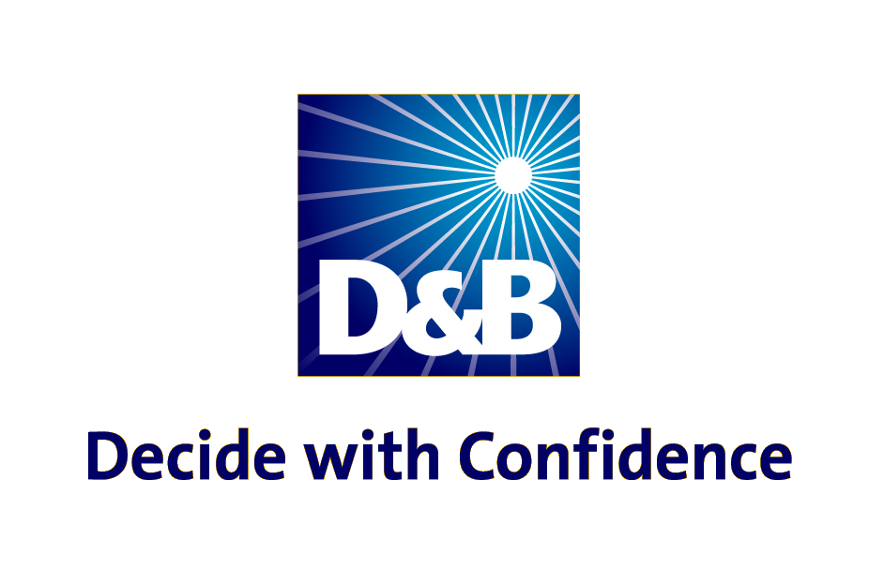
Dun & Bradstreet
DUNS Number Guide

Most potential and existing US Government Contractors, Grantees and Loan Recipients are required to obtain a DUNS Number for US Government registration purposes. The DUNS Number verifies the legal name, physical address and tradestyle (DBA) of each location and is the key to starting the CCR registration process.

Data Universal Numbering System (DUNS) Number: The DUNS Number is a unique nine-digit identification number provided by Dun & Bradstreet (D&B). The DUNS Number is randomly issued, never used twice and is site specific. Each distinct physical location of an entity is assigned its own DUNS Number worldwide.

Obtaining a DUNS Number is a quick and easy process. It is the responsibility of the US Government contractor, grantee or loan recipient to obtain their existing DUNS Number or to take the steps required to request a new DUNS Number. To confirm your current status with D&B, all US locations should contact the D&B Government Customer Response Center (GCRC) using the toll-free number or the online webform process. International locations (non-US) are asked to use the online internet link only. Obtaining a DUNS Number is absolutely FREE for all entities doing business with the Federal Government. The process to request a DUNS Number takes about 15 minutes when calling and responses to webform submittals online are returned within 1-2 business days. The following information is requested to obtain a DUNS Number:

- Legal Company Name  - Headquarters Company Name and Address  - Tradestyle or DBA Company Name  - Physical Address, City, State and Zip Code | - Mailing Address  - Telephone Number  - Contact Name and Title  - Number of Employees at your physical location

All DUNS requests should contact D&B by following the below instructions. Within 24 hours of issuance, the DUNS Number is generally available for starting CCR registration.
All US locations  (including US Virgin Islands and Puerto Rico)  can call toll free at 866-705-5711  Federal contractors - Press Option 3  Grantees - Press Option 4  Loan recipients - Press Option 5  or use the online webform process at http://fedgov.dnb.com/webform | All International (non-US) locations  (including Guam, Marianas Islands and American Samoa) should use the online webform process at http://fedgov.dnb.com/webform

Managing your DUNS Number: D&B will periodically contact DUNS Numbered locations to verify a company’s information for accuracy. Organizations with multiple DUNS Numbers may request a FREE family tree listing from D&B to help determine which branch/division/subsidiary location has an existing DUNS Number and if the information on file at D&B is current. D&B recommends organizations with multiple DUNS Numbers have a single point of contact for controlling DUNS Number requests to ensure the appropriate branches/divisions/subsidiaries have the accurate DUNS Numbers for Federal purposes.

