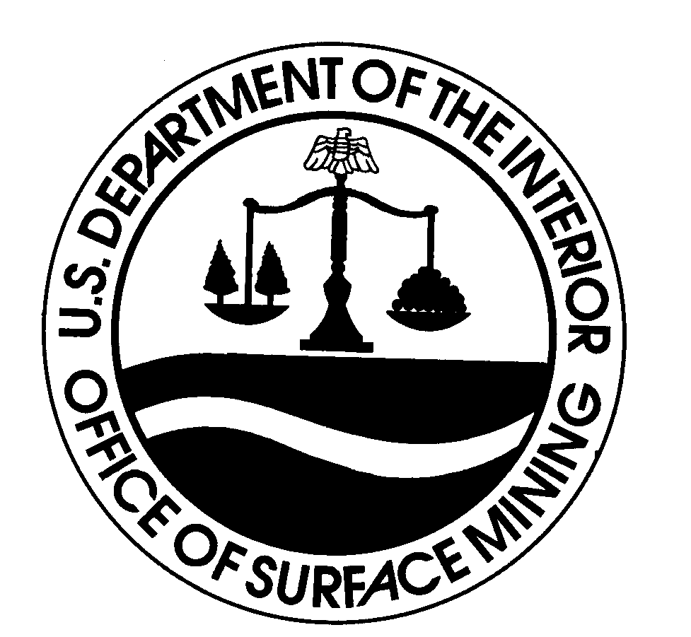 | U.S. DEPARTMENT OF THE INTERIOR  OFFICE OF SURFACE MINING RECLAMATION AND ENFORCEMENT  DIRECTIVES SYSTEM | Subject Code:  Assigned in accordance with Appendix B
Transmittal Number:
Assigned by Directives Coordinator
Date:
Date of Signature
Subject: SAMPLE

Approval: Title: Director

1. Purpose.

2. Summary of Changes.

3. Definitions.

a. First Definition.

b. Additional Definitions.

4. Policy.

5. Responsibilities.

6. Procedures.

7. Reporting Requirements.

8. Effect on Other Documents.

9. References.

10. Effective Date.

11. Distribution.

12. Appendices.

Contact:

