Damage Diagram

Get the total picture of what steroids can do to your brain and body. Complete this diagram by matching the side effect with the body part. Draw a line from the side effect listed on the left to the matching body part on the right.

Side Effects:
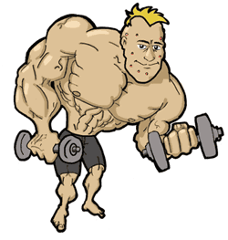
- Baldness can be caused by steroid abuse.
- Because of how steroids act on the limbic system in the brain, mood swings, including homicidal rage, can occur.
- Taking “roids” can cause pimples to pop up.
- Females who take steroids can become more masculine. Their voices can deepen.
- A condition called atherosclerosis can be caused by steroid use. This condition can lead to a heart attack or stroke.
- When the body’s hormone balance is disrupted by taking steroids, males can develop breasts, a condition called gynecomastia.
- Increased levels of hormones signal bones to stop growing.

http://teens.drugabuse.gov

