barberry hawthorn
Crataegus berberifolia Torr. & Gray
Plant Symbol = CRBE2

Contributed By: USDA NRCS National Plant Data Center

Alternative Name
barberryleaf hawthorn, bigtree hawthorn

Uses
Erosion Control: Because it tolerates a wide variety of sites, it can be planted to stabilize banks, for shelterbelts, and for erosion control.

Wildlife: It provides excellent cover and nesting sites for many smaller birds. The small fruits are eaten by many birds especially cedar waxwings, fox sparrows, and ruffed grouse; rodents and other smaller birds. White tailed deer and mule deer browse the young twigs and leaves.

Beautification: Excellent in group plantings, deciduous screens, groupings, and tall barrier hedge; seasonal accent tree and landscape tree for its attractive leaves.

Status

Please consult the Plants Web site and your State Department of Natural Resources for this plant’s current status, such as, state noxious status and wetland indicator values.

Description
Crataegus berberifolia Torr. & Gray, barberry hawthorn, is native to Arkansas and Louisiana and is related to Crataegus crus-galli (Cockspur hawthorn). It is a small tree that grows twenty to thirty feet high, twenty to thirty-five feet wide; with wide-spreading, horizontal, thorny branches. Leaves are broadest near the tip, thick, leathery, shiny dark green above, usually not lobed and smooth. Flowers ranging from white to red produced in clusters. Fruits are broadest above the middle or rounded, dull red or green.

Adaptation
Although Crataegus berberifolia generally requires no special soil requirements, it prefers a moist, well-drained, slightly acid soils and full sunlight. It is adaptable to poor soils, various soil pH’s, compacted soils, drought, heat and winter salt spray. Adapted to USDA Hardiness Zone 4.
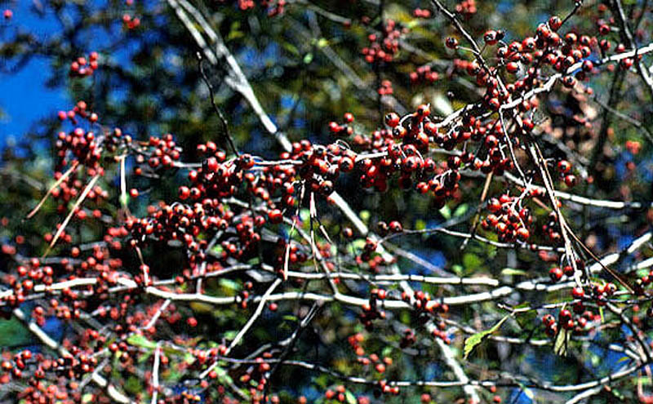
Native Trees of Texas
Department of Horticulture
Texas A&M University

Establishment
Propagation from Seed or Grafting: Barberry hawthorn can be propagated by seeds or by stem cuttings grafted onto seedling rootstock. Propagation using seeds requires acid scarification for two to three hours followed by three months warm stratification and another three months prechilling. Seeds are planted in drill rows eight to twelve inches apart and covered with 1/4 inch of soil.

Containerized trees should be planted when they are no more than eight feet tall, in the fall or spring. Balled and burlapped trees should be planted in early spring.

Grafts are budded on seedling understock in August and September.

Management
Seedlings develop taproot, thus should not be kept in seedbeds longer than one year. If transplanted in autumn, amend soil, fertilize, water thoroughly, mulch adequately and avoid winter salt spray. Pruning should be done in the winter or early spring in order to maintain a clear shoot leader on young trees and/or remove the weakest branches to allow more light to pass through. Suckers or stems arising from the roots should be removed when they become noticeable.

Pest and Potential Problems
Cedar hawthorn rust affects the fruit, foliage and stems. Potential pests include leaf blotch miner.

Cultivars, Improved and Selected Materials (and area of origin)
Consult your local nurseries to choose the right cultivar for your specific landscape. Contact your local Natural Resources Conservation Service (formerly Soil Conservation Service) office for more information. Look in the phone book under ”United States Government.” The Natural Resources Conservation Service will be listed under the subheading “Department of Agriculture.”

References
Dirr, M.A. 1990. Manual of woody landscape plants: their identification, ornamental characteristics, culture, propagation and uses. 3rd ed. Stipes, Champaign, Illinois.

Duncan, W.H. & M.B. Duncan 1988. Trees of the Southeastern United States. University of Georgia Press, Athens, Georgia.

Elias, T.S. 1989. Field guide to North American trees. Revised ed. Grolier Book Clubs Inc., Danbury, Connecticut.

Flint, H.L. 1983. Landscape plants for eastern North America. John Wiley and Sons, Inc, New York, New York.

Harrar, E.S. & J.G. Harrar. 1962. Guide to southern trees. 2nd ed. Dover Publications, Inc., New York, New York.

Little, E.E. 1996. National Audubon Society field guide to North American trees: Eastern region. Alfred A. Knopf, New York, New York.

Texas A&M University 2002. Native trees of Texas. Department of Horticulture, College Station, Texas. Accessed: 11jan02. <http://aggie-horticulture.tamu.edu/ornamentals/natives/indexscientific.htm>

USDA Forest Service 1974. Seeds of woody plants in the United States. Agricultural Handbook 450. USDA, Washington, DC.

USDA Forest Service 1990. Silvics of North America. Agricultural Handbook 654. Forest Service, USDA, Washington, DC.

Young, J. A. & C.G. Young. 1992. Seeds of woody plants in North America. Revised and enlarged ed. Dioscorides Press, Portland, Oregon.

Prepared By

Alfredo B. Lorenzo
Formerly, Southern University and A&M College, College of Agricultural, Family and Consumer Sciences, Baton Rouge, Louisiana

Species Coordinator
Lincoln M. Moore
USDA, NRCS, National Plant Data Center, Baton Rouge, Louisiana

Edited: 09jan02 jsp; 24feb03 ahv; 05jun06 jsp

For more information about this and other plants, please contact your local NRCS field office or Conservation District, and visit the PLANTS Web site<http://plants.usda.gov> or the Plant Materials Program Web site <http://Plant-Materials.nrcs.usda.gov>

The U.S. Department of Agriculture (USDA) prohibits discrimination in all its programs and activities on the basis of race, color, national origin, sex, religion, age, disability, political beliefs, sexual orientation, and marital or family status. (Not all prohibited bases apply to all programs.) Persons with disabilities who require alternative means for communication of program information (Braille, large print, audiotape, etc.) should contact USDA's TARGET Center at 202-720-2600 (voice and TDD).
To file a complaint of discrimination write USDA, Director, Office of Civil Rights, Room 326-W, Whitten Building, 14th and Independence Avenue, SW, Washington, DC 20250-9410 or call 202-720-5964 (voice or TDD). USDA is an equal opportunity provider and employer.
Read about Civil Rights at the Natural Resources Convervation Service.

