November 7, 2008

Dr. Raymond Orbach
Under Secretary for Science
U.S. Department of Energy
1000 Independence Ave., SW
Washington, DC 20585

Dear Dr. Orbach,

At the recent FESAC meeting members passed a resolution expressing their warm appreciation for your leadership at the Office of Science over the past seven years. With the start of ITER construction, we’ve entered a new era, brought about in no small part by your tireless efforts and enthusiasm. We recall your account of the signing ceremony and how genuinely moved you were to be part of that historical event. Your steady support was clearly instrumental in arriving at that moment. We also recognize the role you’ve played in raising the visibility of DOE Science and note the marked improvement in the outlook for the physical sciences in the United States. We offer our thanks for the advocacy that you’ve provided within the government as well as for the advice and guidance that you’ve given us during these critical years.

Sincerely,
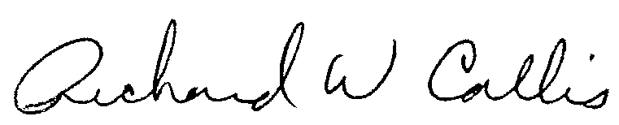
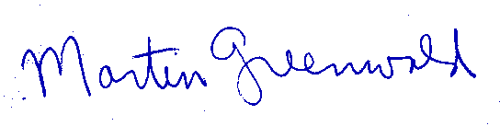

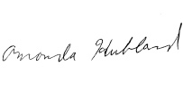
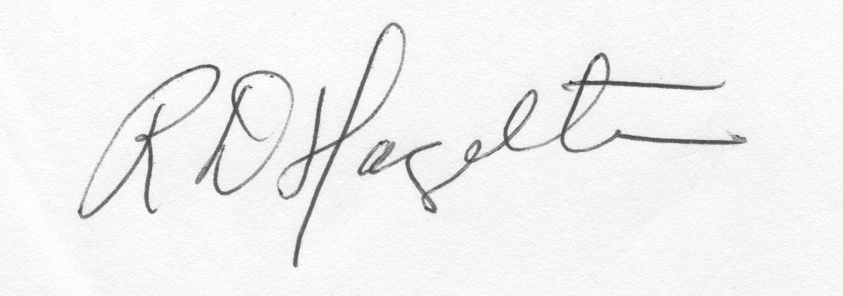
Martin Greenwald (Chair) Riccardo Betti (Vice-Chair) Richard W. Callis
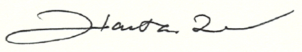

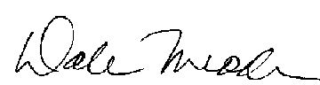
Richard D. Hazeltine Amanda Hubbard Hantao Ji
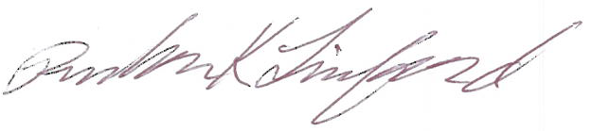

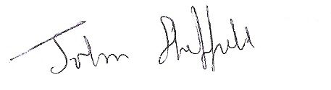

Rulon K. Linford Dale M. Meade Kathryn McCarthy


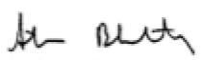
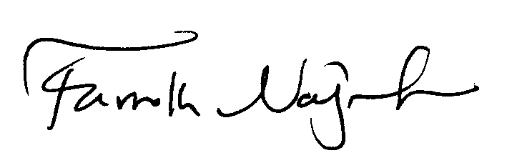
John Sheffield Edward Thomas Jr. Nermin Uckan


Michael Zarnstorff Amitava Bhattacharjee Farrokh Najmabadi

John W. Steadman

