Washington

http://www.k12.wa.us

Districts and schools

Number of districts (CCD) | 1993-94 | 2003-04
 | 296 | 296

Number of public schools (CCD) | 1993-94 | 2003-04
Elementary | 1,087 | 1,187
Middle | 298 | 357
High | 371 | 460
Combined | 90 | 220
Other | 14 | 17
Total | 1,860 | 2,241

Number of charter schools (CCD) | 2003-04
 | -

Finances

Total current expenditures  (CCD, in thousands of dollars, adjusted for inflation to 2002-03) | 1993-94 | 2002-03
Instructional | $3,722,094 | $4,381,186
Noninstructional | 287,699 | 357,911
Support | 2,224,474 | 2,620,468
Total | 6,234,267 | 7,359,565

Per-pupil expenditures  (CCD, adjusted for inflation to 2002-03) | 1993-94 | 2002-03
 | $6,807 | $7,252

Sources of Funding
(CCD, 2002-03)

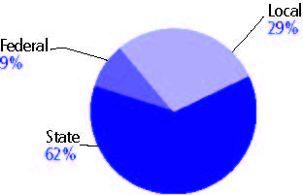

Title I allocation 2002-03 (ED; Includes Title I, Part A) | $157,166,797

Students

Public school enrollment (CCD) | 1993-94 | 2003-04
Pre-K | 5,087 | 11,352
K-8 | 655,337 | 687,896
9-12 | 255,528 | 322,101
Total (K-12) | 910,865 | 1,009,997

Race/ethnicity (CCD) | 1993-94 | 2003-04
American Indian/Alaskan Native | 3% | 3%
Asian/Pacific Islander | 6 | 8
Black, non-Hispanic | 4 | 6
Hispanic | 7 | 12
White, non-Hispanic | 80 | 71

Students with disabilities (OSEP) | 1993-94 | 2003-04
 | 9% | 10%

Students with limited  English proficiency (NCELA) | 1993-94 | 2003-04
 | 3% | 7%

Migrant students (OME) | 1993-94 | 2003-04
 | 3% | 5%

Eighth-grade students enrolled in Algebra I for high school credit (NAEP) | 1996 | 2003
 | 26% | 20%

Students eligible to participate in the Free or Reduced-Price Lunch Program, 2003-04 (CCD) | 362,256

All schools by percent of students eligible to participate in the Free or Reduced-Price Lunch Program, 2003-04† (CCD)
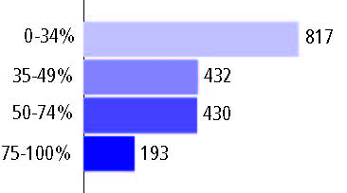
† 369 schools did not report

Staff

Number of FTE teachers (CCD) | 1993-94 | 2003-04
Elementary | 22,741 | 25,175
Middle | 8,665 | 10,630
High | 11,064 | 13,758
Combined | 1,176 | 1,388
Other | 246 | 417
Total | 43,892 | 51,368

Number of FTE non-teacher staff (CCD) | 1993-94 | 2003-04
Instructional aides | 7,940 | 10,051
Instructional coordinators | 656 | 546
Administrators | 3,455 | 3,662
Other | 30,391 | 42,211
Total | 42,442 | 56,470

Percentage of teachers with a major in the main subject taught, grades 7-12 (SASS) | 1994 | 2000
English | 64% | 65%
Mathematics | 49 | 55
Science | 83 | 79
Social Studies | 75 | 77

Percentage of core courses taught by highly qualified teachers, 2003-04 (As defined and reported by states, collected by ED)
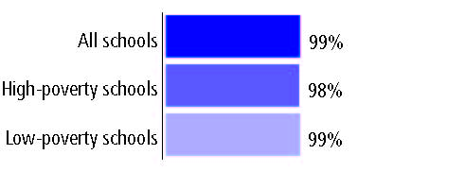

Outcomes

 | 1993-94 | 2000-01
High school dropout rate (NCES) | n/a | 4%
Avg. freshman graduation rate (NCES) | 80% | 69
College-going rate (IPEDS/NCES) | 57 | 45

NAEP state results
Reading, Grade 4 | 1994 | 2005
Proficient level or above | 27% | 35%
Basic level or above | 59 | 69
Math, Grade 8 | 1996 | 2005
Proficient level or above | 26% | 36%
Basic level or above | 67 | 75

Statewide Accountability Information:

State Accountability Website: http://reportcard.ospi.k12.wa.us/Reports/WASLTrend.aspx?&schoolId=1&reportLevel=State

State assessment for NCLB accountability: Washington Assessment of Student Learning (WASL)

State student achievement levels: Level 1, Level 2, Level 3, Level 4

 |  | 2001-02  Annual measurable  objective starting point | Target  2003-04
Grade 4 | Reading | 52.2% | 52.2%
 | Mathematics | 29.7 | 29.7
Grade 7 | Reading | 30.1 | 30.1
 | Mathematics | 17.3 | 17.3
High school | Reading | 48.6 | 48.6
 | Mathematics | 24.8 | 24.8

2003-04 NCLB accountability results, applied to 2004-05 school year
AYP outcomes and consequences | Title I schools |  | All schools |  | All districts
Made AYP | 866 | 89% | 2,042 | 86% | 267 | 90%
Identified for improvement:
Year 1 | 39 | 4% | 120 | 5% | 29 | 10%
Year 2 | 17 | 2% | 21 | 1% | 0 | 0
Corrective action | 15 | 2% | 15 | 1% | 0 | 0
Restructuring | 0 | 0 | 0 | 0 | 0 | 0
Exited improvement status (made AYP twice after missing twice or more, includes total “made” above) | 6 | 1% | 6 | * | 0 | 0

Other indicator, 2003-04 | State target | State outcome
Elementary Indicator: Attendance | Meet or progress toward unexcused absence rate of 1% or less | Met
Middle Indicator: Attendance | Meet or progress toward unexcused absence rate of 1% or less | Met
High School Indicator: Graduation rate | 66% or higher | Met

NCLB choice participation | Number of Title I students | Percent of eligible students
Title I school choice: | 377 | 1%
Supplemental educational services: | 250 | 2%

Student Achievement 2003-04

Washington Assessment of Student Learning, used for NCLB accountability
Grade 3

Reading
Proficient Level or above for:
All students | n/a
Economically disadvantaged students | n/a
Migrant students | n/a
Students with disabilities | n/a
Students with limited English proficiency | n/a
Black, non-Hispanic students | n/a
Hispanic students | n/a
White, non-Hispanic students | n/a

Trend Data Not Available

Washington Assessment of Student Learning, used for NCLB accountability
Grade 3

Mathematics
Proficient Level or above for:
All students | n/a
Economically disadvantaged students | n/a
Migrant students | n/a
Students with disabilities | n/a
Students with limited English proficiency | n/a
Black, non-Hispanic students | n/a
Hispanic students | n/a
White, non-Hispanic students | n/a

Trend Data Not Available

Washington Assessment of Student Learning, used for NCLB accountability
Grade 4

Reading
Proficient Level or above for:
All students | 74%
Economically disadvantaged students | 62
Migrant students | 43
Students with disabilities | 39
Students with limited English proficiency | 37
Black, non-Hispanic students | 62
Hispanic students | 54
White, non-Hispanic students | 80

Student achievement trend: Reading percent proficient level or above

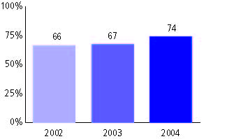

Washington Assessment of Student Learning, used for NCLB accountability
Grade 4

Mathematics
Proficient Level or above for:
All students | 60%
Economically disadvantaged students | 45
Migrant students | 32
Students with disabilities | 29
Students with limited English proficiency | 27
Black, non-Hispanic students | 38
Hispanic students | 39
White, non-Hispanic students | 66

Student achievement trend: Mathematics percent proficient level or above

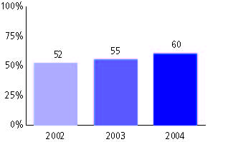

Washington Assessment of Student Learning, used for NCLB accountability
Grade 5

Reading
Proficient Level or above for:
All students | n/a
Economically disadvantaged students | n/a
Migrant students | n/a
Students with disabilities | n/a
Students with limited English proficiency | n/a
Black, non-Hispanic students | n/a
Hispanic students | n/a
White, non-Hispanic students | n/a

Trend Data Not Available

Washington Assessment of Student Learning, used for NCLB accountability
Grade 5

Mathematics
Proficient Level or above for:
All students | n/a
Economically disadvantaged students | n/a
Migrant students | n/a
Students with disabilities | n/a
Students with limited English proficiency | n/a
Black, non-Hispanic students | n/a
Hispanic students | n/a
White, non-Hispanic students | n/a

Trend Data Not Available

Washington Assessment of Student Learning, used for NCLB accountability
Grade 6

Reading
Proficient Level or above for:
All students | n/a
Economically disadvantaged students | n/a
Migrant students | n/a
Students with disabilities | n/a
Students with limited English proficiency | n/a
Black, non-Hispanic students | n/a
Hispanic students | n/a
White, non-Hispanic students | n/a

Trend Data Not Available

Washington Assessment of Student Learning, used for NCLB accountability
Grade 6

Mathematics
Proficient Level or above for:
All students | n/a
Economically disadvantaged students | n/a
Migrant students | n/a
Students with disabilities | n/a
Students with limited English proficiency | n/a
Black, non-Hispanic students | n/a
Hispanic students | n/a
White, non-Hispanic students | n/a

Trend Data Not Available

Washington Assessment of Student Learning, used for NCLB accountability
Grade 7

Reading
Proficient Level or above for:
All students | 61%
Economically disadvantaged students | 43
Migrant students | 26
Students with disabilities | 16
Students with limited English proficiency | 17
Black, non-Hispanic students | 42
Hispanic students | 38
White, non-Hispanic students | 66

Student achievement trend: Reading percent proficient level or above

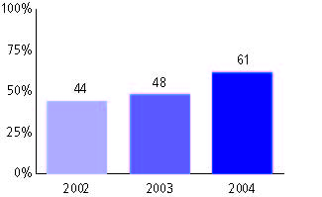

Washington Assessment of Student Learning, used for NCLB accountability
Grade 7

Mathematics
Proficient Level or above for:
All students | 46%
Economically disadvantaged students | 27
Migrant students | 13
Students with disabilities | 8
Students with limited English proficiency | 8
Black, non-Hispanic students | 21
Hispanic students | 22
White, non-Hispanic students | 52

Student achievement trend: Mathematics percent proficient level or above

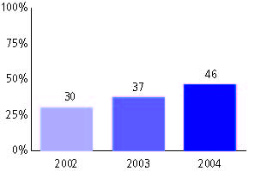

Washington Assessment of Student Learning, used for NCLB accountability
Grade 8

Reading
Proficient Level or above for:
All students | n/a
Economically disadvantaged students | n/a
Migrant students | n/a
Students with disabilities | n/a
Students with limited English proficiency | n/a
Black, non-Hispanic students | n/a
Hispanic students | n/a
White, non-Hispanic students | n/a

Trend Data Not Available

Washington Assessment of Student Learning, used for NCLB accountability
Grade 8

Mathematics
Proficient Level or above for:
All students | n/a
Economically disadvantaged students | n/a
Migrant students | n/a
Students with disabilities | n/a
Students with limited English proficiency | n/a
Black, non-Hispanic students | n/a
Hispanic students | n/a
White, non-Hispanic students | n/a

Trend Data Not Available

Washington Assessment of Student Learning, used for NCLB accountability
High school

Reading
Proficient Level or above for:
All students | 65%
Economically disadvantaged students | 46
Migrant students | 28
Students with disabilities | 15
Students with limited English proficiency | 17
Black, non-Hispanic students | 43
Hispanic students | 41
White, non-Hispanic students | 70

Student achievement trend: Reading percent proficient level or above

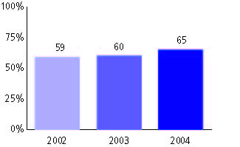

Washington Assessment of Student Learning, used for NCLB accountability
High school

Mathematics
Proficient Level or above for:
All students | 44%
Economically disadvantaged students | 25
Migrant students | 11
Students with disabilities | 6
Students with limited English proficiency | 10
Black, non-Hispanic students | 16
Hispanic students | 20
White, non-Hispanic students | 49

Student achievement trend: Mathematics percent proficient level or above

