Iowa

http://www.state.ia.us/educate

Districts and schools

Number of districts (CCD) | 1993-94 | 2003-04
 | 397 | 371

Number of public schools (CCD) | 1993-94 | 2003-04
Elementary | 862 | 786
Middle | 289 | 291
High | 375 | 366
Combined | 22 | 37
Other | 5 | 11
Total | 1,553 | 1,491

Number of charter schools (CCD) | 2003-04
 | -

Finances

Total current expenditures  (CCD, in thousands of dollars, adjusted for inflation to 2002-03) | 1993-94 | 2002-03
Instructional | $1,985,429 | $2,174,018
Noninstructional | 144,510 | 267,011
Support | 1,090,517 | 1,210,993
Total | 3,220,456 | 3,652,022

Per-pupil expenditures  (CCD, adjusted for inflation to 2002-03) | 1993-94 | 2002-03
 | $6,460 | $7,574

Sources of Funding
(CCD, 2002-03)

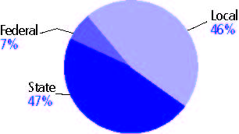

Title I allocation 2002-03 (ED; Includes Title I, Part A) | $62,955,699

Students

Public school enrollment (CCD) | 1993-94 | 2003-04
Pre-K | 5,030 | 6,907
K-8 | 333,743 | 318,124
9-12 | 142,601 | 152,565
Total (K-12) | 476,344 | 470,689

Race/ethnicity (CCD) | 1993-94 | 2003-04
American Indian/Alaskan Native | * | 1%
Asian/Pacific Islander | 2% | 2
Black, non-Hispanic | 3 | 5
Hispanic | 2 | 5
White, non-Hispanic | 93 | 88

Students with disabilities (OSEP) | 1993-94 | 2003-04
 | 11% | 14%

Students with limited  English proficiency (NCELA) | 1993-94 | 2003-04
 | 1% | 3%

Migrant students (OME) | 1993-94 | 2003-04
 | * | 2%

Eighth-grade students enrolled in Algebra I for high school credit (NAEP) | 1996 | 2003
 | 20% | 19%

Students eligible to participate in the Free or Reduced-Price Lunch Program, 2003-04 (CCD) | 144,220

All schools by percent of students eligible to participate in the Free or Reduced-Price Lunch Program, 2003-04† (CCD)

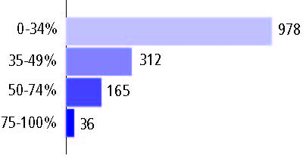

Staff

Number of FTE teachers (CCD) | 1993-94 | 2003-04
Elementary | 14,651 | 16,276
Middle | 6,521 | 7,180
High | 10,523 | 11,145
Combined | 538 | 714
Other | 114 | 253
Total | 32,347 | 35,568

Number of FTE non-teacher staff (CCD) | 1993-94 | 2003-04
Instructional aides | 4,945 | 9,095
Instructional coordinators | 372 | 472
Administrators | 2,496 | 3,039
Other | 20,848 | 20,740
Total | 28,661 | 33,346

Percentage of teachers with a major in the main subject taught, grades 7-12 (SASS) | 1994 | 2000
English | 80% | 70%
Mathematics | 74 | 73
Science | 86 | 89
Social Studies | 81 | 80

Percentage of core courses taught by highly qualified teachers, 2003-04 (As defined and reported by states, collected by ED)

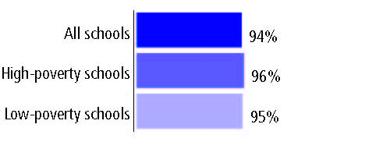

Outcomes

 | 1993-94 | 2000-01
High school dropout rate (NCES) | 3% | 3%
Avg. freshman graduation rate (NCES) | 87 | 83
College-going rate (IPEDS/NCES) | 64 | 65

NAEP state results
Reading, Grade 4 | 1994 | 2005
Proficient level or above | 35% | 33%
Basic level or above | 69 | 67
Math, Grade 8 | 1996 | 2005
Proficient level or above | 31% | 34%
Basic level or above | 78 | 76

Statewide Accountability Information:

State Accountability Website: http://www.state.ia.us/educate/stateboard/doc/pocketcard03.pdf

State assessment for NCLB accountability: Iowa Tests of Basic Skills and the Iowa Tests of Educational Development (ITED)

State student achievement levels: Low, Intermediate, High

 |  | 2001-02  Annual measurable  objective starting point | Target  2003-04
Grade 4 | Reading | 65% | 65%
 | Mathematics | 64 | 64
Grade 8 | Reading | 61 | 61
 | Mathematics | 63 | 63
High school | Reading | 69 | 69
 | Mathematics | 69 | 69

2003-04 NCLB accountability results, applied to 2004-05 school year
AYP outcomes and consequences | Title I schools |  | All schools |  | All districts
Made AYP | 700 | 96% | 1,359 | 92% | 350 | 95%
Identified for improvement:
Year 1 | 8 | 1% | 59 | 4% | 9 | 2%
Year 2 | 2 | * | 7 | 1% | 0 | 0
Corrective action | 0 | 0 | 0 | 0 | 0 | 0
Restructuring | 0 | 0 | 0 | 0 | 0 | 0
Exited improvement status (made AYP twice after missing twice or more, includes total “made” above) | 0 | 0 | 0 | 0 | 0 | 0

Other indicator, 2003-04 | State target | State outcome
Elementary Indicator: Attendance | Meet or progress toward 95% | Met
Middle Indicator: Attendance | Meet or progress toward 95% | Met
High School Indicator: Graduation rate | Meet or progress toward 90% | Met

NCLB choice participation | Number of Title I students | Percent of eligible students
Title I school choice: | 60 | 2%
Supplemental educational services: | 75 | 7%

Student Achievement 2003-04

Iowa Tests of Basic Skills and the Iowa Tests of Educational Development, used for NCLB accountability
Grade 3

Reading
Proficient Level or above for:
All students | n/a
Economically disadvantaged students | n/a
Migrant students | n/a
Students with disabilities | n/a
Students with limited English proficiency | n/a
Black, non-Hispanic students | n/a
Hispanic students | n/a
White, non-Hispanic students | n/a

Trend Data Not Available

Iowa Tests of Basic Skills and the Iowa Tests of Educational Development, used for NCLB accountability
Grade 3

Mathematics
Proficient Level or above for:
All students | n/a
Economically disadvantaged students | n/a
Migrant students | n/a
Students with disabilities | n/a
Students with limited English proficiency | n/a
Black, non-Hispanic students | n/a
Hispanic students | n/a
White, non-Hispanic students | n/a

Trend Data Not Available

Iowa Tests of Basic Skills and the Iowa Tests of Educational Development, used for NCLB accountability
Grade 4

Reading
Proficient Level or above for:
All students | 77%
Economically disadvantaged students | 61
Migrant students | 41
Students with disabilities | 31
Students with limited English proficiency | 42
Black, non-Hispanic students | 50
Hispanic students | 52
White, non-Hispanic students | 80

Student achievement trend: Reading percent proficient level or above

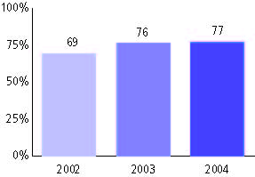

Iowa Tests of Basic Skills and the Iowa Tests of Educational Development, used for NCLB accountability
Grade 4

Mathematics
Proficient Level or above for:
All students | 77%
Economically disadvantaged students | 62
Migrant students | 50
Students with disabilities | 39
Students with limited English proficiency | 49
Black, non-Hispanic students | 46
Hispanic students | 56
White, non-Hispanic students | 80

Student achievement trend: Mathematics percent proficient level or above

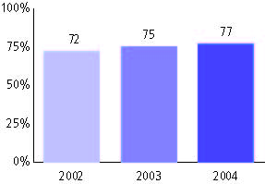

Iowa Tests of Basic Skills and the Iowa Tests of Educational Development, used for NCLB accountability
Grade 5

Reading
Proficient Level or above for:
All students | n/a
Economically disadvantaged students | n/a
Migrant students | n/a
Students with disabilities | n/a
Students with limited English proficiency | n/a
Black, non-Hispanic students | n/a
Hispanic students | n/a
White, non-Hispanic students | n/a

Trend Data Not Available

Iowa Tests of Basic Skills and the Iowa Tests of Educational Development, used for NCLB accountability
Grade 5

Mathematics
Proficient Level or above for:
All students | n/a
Economically disadvantaged students | n/a
Migrant students | n/a
Students with disabilities | n/a
Students with limited English proficiency | n/a
Black, non-Hispanic students | n/a
Hispanic students | n/a
White, non-Hispanic students | n/a

Trend Data Not Available

Iowa Tests of Basic Skills and the Iowa Tests of Educational Development, used for NCLB accountability
Grade 6

Reading
Proficient Level or above for:
All students | n/a
Economically disadvantaged students | n/a
Migrant students | n/a
Students with disabilities | n/a
Students with limited English proficiency | n/a
Black, non-Hispanic students | n/a
Hispanic students | n/a
White, non-Hispanic students | n/a

Trend Data Not Available

Iowa Tests of Basic Skills and the Iowa Tests of Educational Development, used for NCLB accountability
Grade 6

Mathematics
Proficient Level or above for:
All students | n/a
Economically disadvantaged students | n/a
Migrant students | n/a
Students with disabilities | n/a
Students with limited English proficiency | n/a
Black, non-Hispanic students | n/a
Hispanic students | n/a
White, non-Hispanic students | n/a

Trend Data Not Available

Iowa Tests of Basic Skills and the Iowa Tests of Educational Development, used for NCLB accountability
Grade 7

Reading
Proficient Level or above for:
All students | n/a
Economically disadvantaged students | n/a
Migrant students | n/a
Students with disabilities | n/a
Students with limited English proficiency | n/a
Black, non-Hispanic students | n/a
Hispanic students | n/a
White, non-Hispanic students | n/a

Trend Data Not Available

Iowa Tests of Basic Skills and the Iowa Tests of Educational Development, used for NCLB accountability
Grade 7

Mathematics
Proficient Level or above for:
All students | n/a
Economically disadvantaged students | n/a
Migrant students | n/a
Students with disabilities | n/a
Students with limited English proficiency | n/a
Black, non-Hispanic students | n/a
Hispanic students | n/a
White, non-Hispanic students | n/a

Trend Data Not Available

Iowa Tests of Basic Skills and the Iowa Tests of Educational Development, used for NCLB accountability
Grade 8

Reading
Proficient Level or above for:
All students | 69%
Economically disadvantaged students | 50
Migrant students | 33
Students with disabilities | 20
Students with limited English proficiency | 26
Black, non-Hispanic students | 37
Hispanic students | 42
White, non-Hispanic students | 72

Student achievement trend: Reading percent proficient level or above

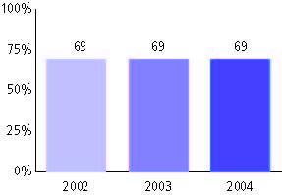

Iowa Tests of Basic Skills and the Iowa Tests of Educational Development, used for NCLB accountability
Grade 8

Mathematics
Proficient Level or above for:
All students | 72%
Economically disadvantaged students | 52
Migrant students | 40
Students with disabilities | 24
Students with limited English proficiency | 34
Black, non-Hispanic students | 34
Hispanic students | 43
White, non-Hispanic students | 75

Student achievement trend: Mathematics percent proficient level or above

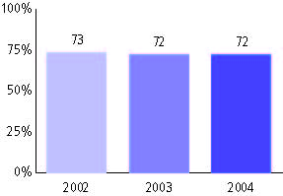

Iowa Tests of Basic Skills and the Iowa Tests of Educational Development, used for NCLB accountability
High school

Reading
Proficient Level or above for:
All students | 77%
Economically disadvantaged students | 60
Migrant students | 37
Students with disabilities | 29
Students with limited English proficiency | 34
Black, non-Hispanic students | 50
Hispanic students | 51
White, non-Hispanic students | 79

Student achievement trend: Reading percent proficient level or above

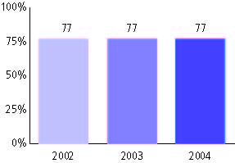

Iowa Tests of Basic Skills and the Iowa Tests of Educational Development, used for NCLB accountability
High school

Mathematics
Proficient Level or above for:
All students | 79%
Economically disadvantaged students | 62
Migrant students | 44
Students with disabilities | 32
Students with limited English proficiency | 41
Black, non-Hispanic students | 44
Hispanic students | 52
White, non-Hispanic students | 81

Student achievement trend: Mathematics percent proficient level or above

