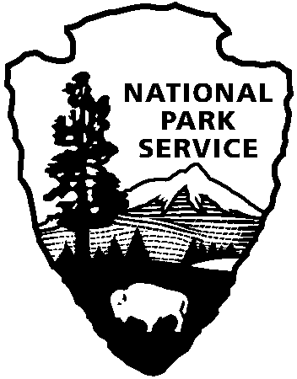
Office of Public Affairs

1849 C Street NW
Washington, DC 20240

202 208-6843 phone
202 219-7291 fax

National Park Service
U.S. Department of the Interior

FOR IMMEDIATE RELEASE – March 3, 2009
Contact: Steve Elkinton (202) 354-6938
David Barna (202) 208-6843

New National Trail Projects Funded in Parks

WASHINGTON, D.C. – Grant awards in a National Park Service program are headed to five projects where national historic and scenic trails intersect with national park units.

“Connect Trails to Parks” will soon distribute $333,000 to these projects, said Dan Wenk, acting director of the National Park Service. The grant program was established during the 40th anniversary of the National Trails System in 2008.

Wenk said, “This grant program will enable our visitors to better appreciate both the national parks and the national trails that touch or cross the parks through new connections, better information systems, and upgraded facilities. It is wonderful way to commemorate the anniversary of the National Trails System.”

In addition to operating park areas across the U.S. and territories, the National Park Service plays a vital role in operating the 50,000-mile National Trails System. This trails system dates from legislation in 1968 that created the Appalachian and Pacific Crest National Scenic Trails. Today, the National Trails System is comprised of eight national scenic trails (NSTs), 18 national historic trails (NHTs), and more than 1,050 national recreation trails (NRTs).

The five selected projects restore or improve existing trails and trailhead connections, provide better wayside and interpretive services, or provide planning services for important trail gateways. Wenk said nine more project grants will be awarded later this year.

Connect Trails to Parks Grants

Project Title | Trail(s) | Park | Location | Award Amount
Marsh-Billings Rockefeller Connector  Trail to Appalachian NST | Appalachian NST | Marsh-Billings-Rockefeller National Historical Park | Woodstock, VT | $60,000
Rehabilitate Historic Jesup Path | Dorr Mountain NRT | Acadia National Park | Bar Harbor, ME | $99,000
Provide Planning and Coordination for Lions Park Trail and Transportation Hub | Old Spanish NHT Slickrock NRT | Arches National Park | Moab, UT | $100,000
Monument Valley Historical Trails, Waysides, and Kiosks | Oregon, California, Mormon Pioneer, and Pony Express NHTs | Scotts Bluff Nat. Monument | Gering, NE | $20,000
Rehabilitate White Rock Falls Trailhead and Visitor Parking Area | Appalachian NST | Blue Ridge Parkway (milepost 18) | Waynesboro, VA | $54,000
The decade 2008 to 2018 has been declared "A Decade for the National Trails," building to the trails system's 50th anniversary. Many of these projects will help individual trails and their constituent National Park sites to achieve goals associated with this commemorative decade.

For more information about the National Park Service please visit www.nps.gov.

For more information about the National Trails System please visit www.nps.gov/nts.

