
The White House Closing the Circle Awards
2007 Nominations
Deadline: January 31, 2007
REGISTRATION PROCESS: Step 1: Complete ---> Step 2: Review ---> Step 3: Print
Instructions: This is the first of three steps. For Step 1: Complete the nomination form below. Once completed, click "Review Nomination" (Please note: Completing this page and clicking "Review Nomination" does not complete your registration. You must review the nomination and submit it in Step 2.)
Please note: for your assistance, sample entries appear to the right of each field.
Warning: do not use your Return key to jump between fields (this action will cause your application to be submitted). Use your Tab key to jump to the next field.
Top of Form

Agency
 |  | * U.S. Postal Service Nominees: Please Link Here to Submit Your Data.
Field Activity
Name: |  |  | US Camp Swampy
Location: |  |  | Nowhere, AZ
Point of Contact (used to contact winner)
Name: |  |  | Mr. John Smith
Address: |  |  | 123 Anywhere Street
 |  |  | Suite 100
City: |  |  | Nowhere
State: |  |  | AZ
ZIP: |  |  | 11111-2233
Phone: |  |  | 123-456-7890
Fax: |  |  | 123-654-9870
Email: |  |  | jsmith@nowhere.com
Media Contact (agency public affairs representative)
Name: |  |  | Ms. Jane Johnson
Address: |  |  | 555 Anyroad Dr.
 |  |  | Suite 555
City: |  |  | Nowhere
State: |  |  | AZ
ZIP: |  |  | 99887-6655
Phone: |  |  | 123-555-5487
Fax: |  |  | 123-555-4567
Email: |  |  | jjohnson@nowhere.com
Award Category (choose only one)
Waste/Pollution Prevention
Recycling
Green Purchasing
Environmental Management Systems
Sustainable Design/Green Buildings
Alternative Fuel and Fuel Conservation in Transportation
Electronics Stewardship
Nominee
Team Nomination
Individual Nomination
Team/Individual: |  |   Complete name as it would appear on the award certificate.  For Team: Indicate only the name of the team (not individuals) not to exceed 6 words in length. | Individual: Mr. Stephen Jones  Team: Camp Swampy P2 Team
Address: |  |  | 555 Street Road
 |  |  | Apartment 111
City: |  |  | Nowhere
State: |  |  | AZ
ZIP: |  |  | 12345-4455
Phone: |  |  | 123-445-6655
Fax: |  |  | 123-445-9988
Email: |  |  | sjones@nowhere.com
Title of Nomination (i.e. "Closed-Loop Used Oil Recycling")

Note: Complete title as it would appear on the award certificate. Title must not exceed 6 words in length.
Nomination Description
Please include your "Nomination Narrative Document".
File Requirements
- Allowable file types:
  - MS Word Document (.doc)
  - Rich Text File (.rtf)
- Size: not to exceed 4 pages and 1 Megabyte (including any embedded TIFF, GIF, or JPG images)
- Font: size 12 Times New Roman or equivalent font.
Important note: Before uploading the Nomination Narrative Document please include a copy of this application page in the document. On your browsers EDIT menu, SELECT ALL, then ôcopy and paste¤ this completed Nomination Form on the first page of your Nomination document. The application page will not count against the 4-page limit in the submission.
Nomination Narrative Document
File name should not contain the following characters:
pound (#), ampersand (&), exclamation point (!), arrows (< >), or parentheses ( ).

Continue to Step 2 - Review Nomination
Each applicant will be subject to a review of background information on their environmental compliance status and enforcement history. This process will include consideration of information in the Environmental Protection Agency's, Online Tracking Information System (OTIS) which is available online at: www.epa.gov/idea/otis as well as other available compliance and enforcement information. Applicants should review their compliance status and history prior to submission and may provide information for consideration in the compliance screen where they believe the OTIS data is incorrect. In general, chronic non-compliance and/or recent or ongoing criminal or certain civil enforcement activity will be considered a basis for disqualification.
Please click Review Nomination to Proceed to Step 2

Bottom of Form

2007 WHITE HOUSE CLOSING THE CIRCLE AWARDS

BACKGROUND

Nominee’s Name: Mr. Awni M. Almasri
Title: Regional Environmental Program Director
Employing Organization: Commander Navy Region, Southwest Asia (CNRSWA)
E-mail: awni.almasri@me.navy.mil

POSITION DESCRIPTION

In addition to being the Regional Environmental Director for CNRSWA and the Installation Environmental Program Director for Naval Support Activity (NSA) Bahrain, Mr. Almasri is also the Regional Environmental Coordinator (REC) for COMUSNAVCENT and CNRSWA Area of Responsibility (AOR) and the Navy On-Scene Coordinator (NOSC).

As the only Professional Environmental Engineer within NAVCENT/CNRSWA, Mr. Almasri continually manages broad and complex multi-media environmental programs in diverse cultural, physical and geo-political environments.

Master of knowledge and skills serving as a recognized expert and consultant to NAVCENT, COMFIFTHFLT, CNRSWA, Marine Emergency Mutual Aid Center (MEMAC), Regional Organization for the protection of Marine Environment (ROPME) and the Arabian Gulf Cooperative Council (GCC) countries; having responsibility for the myriad of international environmental issues, specifically, dealing with hazardous waste and, spill preparedness and response.

Mr. Almasri’s position requires exercising considerable judgment and ingenuity in interpreting, adapting and applying the broad and general policy outlined in the Overseas Environmental Baseline Guidance Document (OEBGD) and the Final Governing Standards (FGS) for each Country within the region.

ACCOMPLISHMENTS

The primary mission of CNRSWA, NSA Bahrain and its 79 tenant commands is to provide critical logistical support to US forces operating in the Arabian Gulf Region. The environmental mission aims at enhancing the quality of life of the installation populous as well as the surrounding communities while maintaining compliance with applicable laws and regulations.

Mr. Almasri has demonstrated successful management skills during his tenure as the REPD and REC for CNRSWA. Mr. Almasri’s management abilities are responsible for the successful integration of pollution prevention programs across diverse civilian and military activities at NSA Bahrain reducing costs and increasing the environmental compliance of the facility.

Waste Reduction/Recycling Program

In addition to regularly collected recycling materials of paper, aluminum cans, glass, wood, tires,
scrap metals, cardboard, batteries, and plastic bottles, Mr. Almasri introduced a tremendously
beneficial program to collect re-usable clothes for the needy local and third country national population in Bahrain. This continuing program has helped to clothe hundreds of people in the community.

Mr. Almasri’s hazardous waste management expertise and the implementation of pollution prevention (P2) initiatives including used oil recycling, wash/reuse of dirty rags, aerosol can puncturing, and reuse of perused washed drums were responsible for the magnificent reduction of over 75% in shipboard hazardous waste disposal, and over $850,000 in savings and disposal cost avoidance when compared to the disposal cost of hazardous waste via the Defense Reutilization and Marketing service (DRMS).
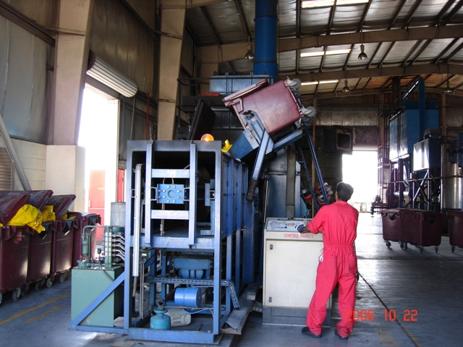
Received over 390 tons of hazardous waste (HW) for disposal. However, as a result of effective HW management skills and Pollution Prevention (P2) techniques to reduce, minimize and recycle, the HW disposal quantity was reduced to about 94 tons achieving over 75% reduction.

Washed and made available for reuse over 97 tons of oily rags reducing disposal cost by over $160,000 and reducing overall shipboard hazardous waste disposal quantity by over 35%. Also diverted over 45 tons of aerosol cans, oil filters, batteries, and fluorescent light bulbs reducing hazardous waste disposal costs by over $115,000.

Provided ships with over 2,200 Recycled (Pre-used) empty
dums free-of-charge. This program alone has achieved a disposal cost avoidance of over $90,000 and procurement cost avoidance of over $110,000. The cost to dispose of a used empty drums via DRMS is over $50.00 whereas the cost to wash a pre-used drum is $8.00. The cost to procure a new United Nation (UN) certified HW drum is $75-100.

CATEGORY | (TONS) | CATEGORY | (TONS)
Used Oil | 98.00 | Aerosol Cans | 4.20
Dirty Towels | 97.00 | Batteries | 22.00
Fluorescent Bulbs | 16.50 | Toner Cartridges | 2.25
Fuel/Oil Filters | 27.00 | Total | 266.95

Mr. Almasri's proactive and organized approach to recycling contributed to the remarkable solid waste reduction, pollution prevention, conservation of natural resources and the improvement of the overall quality of life at NSA Bahrain.

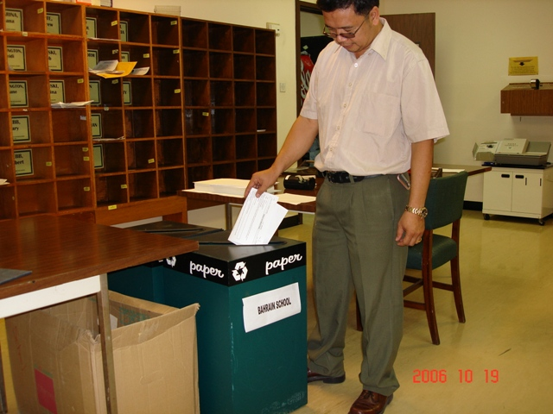
Diverted over 425, 55-gal, drums (over 98 tons) of used oil from the hazardous waste stream through recycling and reuse. This initiative reduced hazardous waste disposal quantity by over 25% and reduced disposal cost by over $180,000. A drum of used oil cost an average of $325-450 if processed via the Defense reutilization and Marketing service (DRMS). Where as the recycling cost of each drum is less than $20.00.

Recycled over 760 tons of solid waste reducing disposal quantity by over 30% achieving a disposal cost avoidance of $45,000 and generating over $15,000 of revenue that was used to purchase recycling equipment and to provide P2 and recycling awareness training to base personnel and surrounding community.

CATEGORY | (TONS) | CATEGORY | (TONS)
Mixed Paper | 19.30 | Tires | 14.14
Cardboard | 85.75 | Electrical Scrap | 0.79
Scrap Metal | 84.96 | PET Bottles | 0.65
Aluminum Cans | 7.03 | Mixed Plastic | 28.52
Aluminum Scrap | 0.79 | Scrap Wood | 517.64
Brass | 2.33 | Textiles | 1.00
 |  | TOTAL | 762.90

Reused over 50 tons of HAZMATs that were categorized by generator for disposal. These HAZMATs were made available to customers free of charge. This program has reduced our disposal cost by over $125,000 and saved over $60,000 of HAZMATprocurement funds.

CATEGORY | QUANTITY  (TONS) | CATEGORY | QUANTITY  (TONS)
Paint | 1.11 | Refrigerant Cylinder | 0.08
Detergent | 3.01 | Desiccant | 0.36
Solvents-Alcohol/Thinner | 0.23 | Anti Fire Fighting Foam | 0.45
Used HAZWASTE Drums | 44.23 | Fire Extinguisher/Dry Chem | 0.63
Lead Acid Batteries | 0.26 | Compressed Gas Cylinders | 0.71
 |  | TOTAL | 51.07

When the DRMS contractor was unable to export HW out of Bahrain, Mr. Almasri was quick to successfully negotiate an agreement with the HN in January 2006 to locally incinerate approximately 25-40% of the HW generated by U.S. Forces within the AOR. Over 30 tons of HW was processed this past year through the local Waste Incinerator, Bahrain Waste Treatment Company (BWTC). This new program has not just minimized our potential liabilities resulting from shipping the waste overseas, but also resulted in a cost avoidance of over $80.00K in less than 9 months and alleviated the need for additional HW storage capabilities.

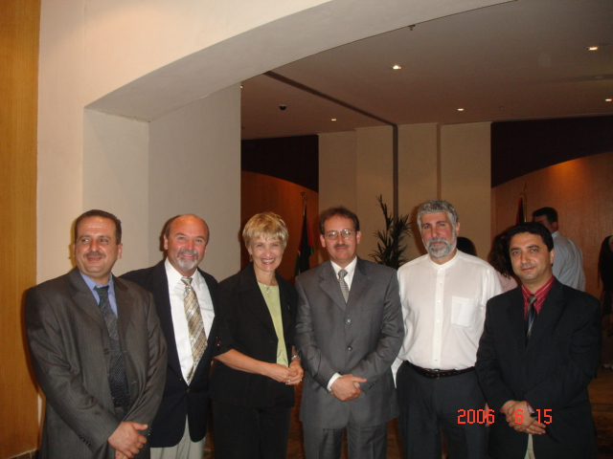
Education, Outreach, and Partnering

Mr. Almasri’s expertise in US Navy environmental programs, specifically pollution prevention and hazardous waste minimization is internationally recognized. He represents the US Navy in this AOR in all environmental related issues. Mr. Almasri represented the US Navy in June 2006 to assist the State of Israel and the Kingdom of Jordan in developing a model Environmental Management System (EMS) for the ports of Aqaba/Jordan and Eilat/Israel. His contribution and sharing of the US Navy’s EMS related experience in this AOR are vital to the successful completion of this important EMS joint model for Israel and Jordan.

Due to the high turn over of personnel at NSA Bahrain, Mr. Almasri developed base and shop specific HAZCOM Program to reduce exposure risk and ensure personnel safety and awareness of the type of HAZMATs in their respective shops. Developed the base’s only Authorized Use List (AUL) which proved invaluable in the development of the base’s centralized Hazardous Materials Reutilization and Inventory Management program (CHRIMP). Shop-level personnel in charge of handling hazardous waste are provided with the necessary training including HAZWOPER, HAZCOM, Pollution Prevention (P2), EMS, Recycling, and Spill Response.

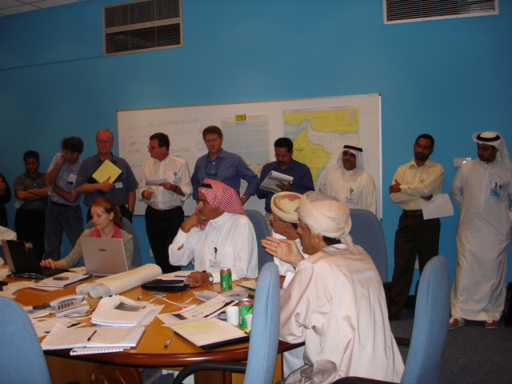
Mr. Almasri’s forward thinking and planning proved invaluable at the recent incident at the Iraqi Khor Al Amaya Oil Terminal (KAAOT) involving fire and oil spill in March 2006. His oil spill response mechanism was the only mechanism available to provide quick response to the incident.

Mr. Almasri participated in several HN sponsored training workshops and seminars. Recently, he represented the US Navy at the Desalination Plant Protection Workshop in Saudi Arabia, Incident Commander training in Bahrain, Off Shore Arabia in the UAE and many others.

Recognizing the need for environmental consciousness, Mr. Almasri developed a variety of programs to improve environmental conditions. His innovative programs provide comprehensive environmental training to the base population, schools, local community groups, business and industry, and local government to increase awareness and public understanding of environmental issues to ensure future generations can enjoy the same resources we do today. He trained over 85 HN officials representing government and private sectors.

COMMUNITY SERVICE:

While Mr. Almasri’s technical achievements are commendable, his role as an environmental ambassador between the navy and the host nation cannot be overlooked and is equally important in evaluating his tenure at NSA Bahrain.

In addition to regularly collected recycling materials, Mr. Almasri introduced a tremendously beneficial program to collect re-usable clothes for the needy local and third country national population in Bahrain. This continuing program has helped to clothe hundreds of people in the community.

In April and June 2006, Mr. Almasri conducted equipment deployment spill response exercises to test the CNRSWA and COMFIFTHFLT readiness. Officials from several organizations in Bahrain and other Gulf countries participated in the exercise.

In March and September 2006, he conducted a week long environmental awareness training classes to emphasize the skills necessary to properly handle hazardous waste. The training also focused on pollution prevention and recycling issues. Attendees included, base personnel, representatives from the local fire department, Ministry of the Environment, Bahrain Defense Force (BDF), and local health and safety organizations.

Mr. Almasri is the recognized technical authority for interpretation of requirements and development of region-wide environmental standards, procedures and instructions to guide operating personnel. He interprets, develops new hypotheses, approaches, or concepts for each country within the region. Environmental regulations for overseas activities, especially the Middle East, are broad, vague and generic requiring a high level of expertise to correctly interpret regulations and guidance.

