1. Introduction
Global Biodiversity
Information Facility
Secretariat

Universitetsparken 15
DK-2100 Copenhagen Ø
Denmark

Tel.:+45 35 32 14 70
Fax:+45 35 32 14 80
Email:gbif@gbif.org
Web:www.gbif.org

The Global Biodiversity Information Facility (GBIF) is an intergovernmental initiative established to making data about known living organisms available via the Internet (data.gbif.org). GBIF is implemented as an inter-operable network of biodiversity databases, and thus it is a tool for the conservation and sustainable use of biodiversity at the national and global levels. . GBIF membership comprises countries and international organisations. Since its creation in 2001, 49 countries and 39 international organisations have joined GBIF.

GBIF and the CBD Secretariat signed a Memorandum of Cooperation in July 2003. The goals of this agreement include facilitating the development and implementation of technologies and best practices that will be necessary to access, share and disseminate biodiversity data via the Internet.

More information:
www.cbd.int
www.gbif.org
data.gbif.org

Parties to the CBD are required to submit their 4th national reports by March 2009. This is an opportunity for countries to take stock of the progress achieved to date in the implementation of the CBD, including progress towards the 2010 Biodiversity Target. This brief tutorial outlines the support and tools the GBIF network could provide to CBD Parties to elaborate their national reports, in particular:
- Chapter I - Overview of biodiversity status, trends and threats.
- Chapter IV - Conclusions: progress towards the 2010 Target and implementation of the Strategic Plan.
- Appendix III - Progress towards targets of the Global Strategy for Plant Conservation and Programme of Work on Protected Areas.

2. Chapter I
In the first chapter, Parties are requested to provide an analysis or synthesis of the status and trends of, and major threats to, various components of biodiversity in their country. The data available using the GBIF Network can be a valuable starting point to assess the country's biodiversity at the SPECIES level.
① To obtain an estimation of the number of species for a given biological group, based on the information available in the GBIF network, the first step is to visit the GBIF Data Portal: data.gbif.org.
② Click on the orange column in the centre of the page: Explore countries.
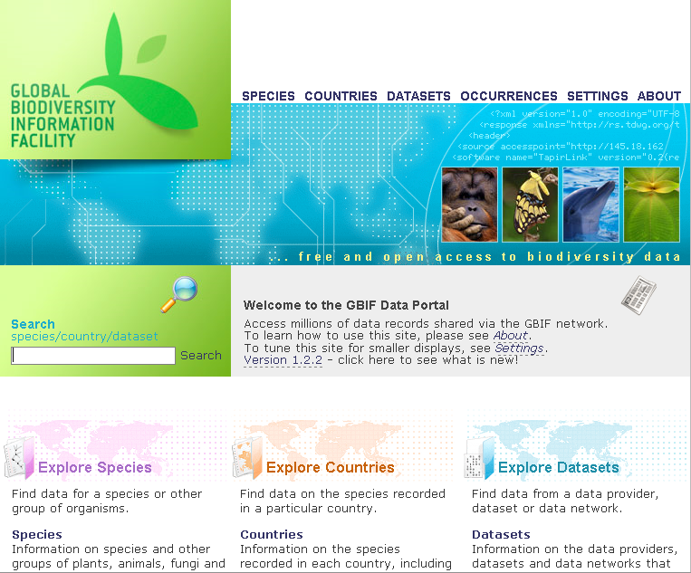

③ Read, understand and accept the Data User Agreement.
④ Browse the list of countries, and click on the name of the country of your choice.
⑤ In the pink ‘Actions’ box, click on explore occurrences to narrow your search.
⑥ Add a search filter, choosing ‘Classification’ from the dropdown menu.
Fig 1. The GBIF Data Portal
Browse the 'All kingdoms' tree and select the group of your interest by clicking on its name. Then click on the ‘Add Filter’ button. Run the query clicking on the button labelled ‘search’ on the right.
⑦ On the pink ‘Actions’ box, under 'Download', click on ‘species in results’. You will obtain a list of species for a selected group and country.
These national values in turn can be compared with the global estimated number of species for those groups. To obtain global figures please check:
- The Living Planet Index, by WWF:
http://assets.panda.org/downloads/living_planet_report.pdf
- The Global Environmental Outlook, by the UN Environment Programme:
http://www.unep.org/geo/
- The Millennium Ecosystem Assessment
http://www.millenniumassessment.org/
- Previous editions of the Global Biodiversity Outlook, by the CBD:
http://www.cbd.int/gbo/

3. Chapter IV, Subsection A
In this subsection, Parties are requested to assess progress towards the 2010 Target at the national level, using the provisional framework for goals and targets adopted by decision VIII/15 of the CBD.

To assess the level of achievement of these goals and targets some indicators for assessing the 2010 Target are reproduced in the report guidelines. One of these, included in several targets is: "Trends in the abundance and distribution of selected species". The goals and targets of which progress this indicator may be used for assessing are:

Goal 1. Promote the conservation of the biological diversity of ecosystems, habitats and biomes.
Target 1.1. At least 10% of each of the world's ecological regions effectively conserved.
Target 1.2. Areas of particular importance to biodiversity protected.
Goal 2. Promote the conservation of species diversity.
Target 2.1. Restore, maintain or reduce the decline of populations of species of selected taxonomic groups.
Target 2.2. Status of threatened species improved.
Goal 3. Promote the conservation of genetic diversity.
Target 3.1. Genetic diversity of crops, livestock, and of harvested species of trees, fish and wildlife and other valuable species conserved, an associated indigenous and local knowledge maintained.
Goal 4. Promote sustainable use and consumption.
Target 4.1. Biodiversity-based products derived from sources that are sustainably managed, and production areas managed consistent with the conservation of biodiversity.
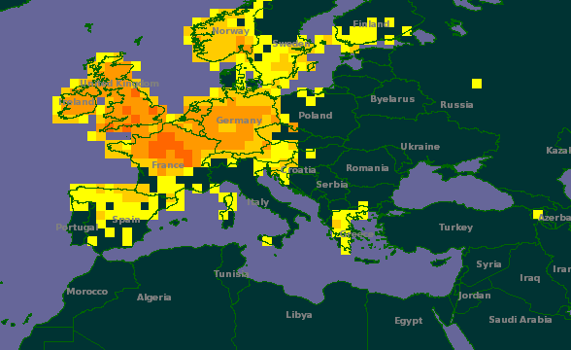
Fig 2. Map representing density of records in the GBIF Data Portal.
Goal 5. Pressures from habitat loss, land use change and degradation, an unsustainable water use, reduced.
Target 5.1. Rate of loss and degradation of natural habitats decreased.
Goal 6. Control threats from invasive alien species.
Target 6.1. Pathways for major potential alien invasive species controlled.
Target 6.2. Management plants in place for major alien species that threaten ecosystems, habitats or species.
GBIF mediated data can be useful as a starting point for some of these assessments. To obtain a list of occurrences for a species, consult the GBIF Data Portal following the steps provided above, but instead of browsing the taxonomy provide a scientific name using the empty box near 'Scientific name is'. Click on the ‘search’ button on the right.
To download the list of occurrences for the specified species in the country, click on ‘Download spreadsheet of results’.

4. Appendix III, Subsection A
In Subsection A of Appendix III, Parties are invited to provide an overview of progress towards the 16 Targets contained in the Global Strategy for Plant Conservation. GBIF Data can be a relevant source to measure the achievement of three of those targets:

- Target 1: A widely accessible working list of known plant species, as a step towards a complete world flora.
- Target 8: 60 per cent of threatened plant species in accessible ex situ collections, preferably in the country of origin, and 10 per cent of them included in recovery and restoration programmes.
- Target 9: 70 per cent of the genetic diversity of crops and other major socio-economically valuable plant species conserved, and associated indigenous and local knowledge maintained.

Follow the instructions provided above to obtain a list of plant species for your country. To determine if a given threatened or crop species is conserved in an ex-situ collection recorded in the GBIF Network, click on ‘Specify data providers to be included in search’ after having stated your search criteria.

For further assistance please contact Alberto González-Talaván (atalavan@gbif.org) or Beatriz Torres (btorres@gbif.org)

Data from GBIF could be also used for Chapters II and III, when relevant data is used to illustrate progress in implementation of NBSAPs and mainstreaming.

