ID&R Conference − MSIX Pop Quiz

How much do you know about MSIX? Circle the correct choice for each of the test items shown below.

- MSIX …
  - Is an acronym for “Migrant Student Information Exchange”
  - Was proceeded by the MSRTS
  - Was once called the MSIE
  - A and B only
  - All of the above

- An authorized user of MSIX can NOT be a …
  - School counselor
  - School cafeteria worker
  - Migrant education specialist
  - Recruiter

- MSIX users can notify another State when a child is arriving in their area.
  - True
  - False

- The Certificate of Eligibility (COE) is a source of MSIX data.
  - True
  - False

- States enter COE data directly into MSIX to share information with other States.
  - True
  - False

- MSIX replaces the State’s existing migrant student databases (e.g., NGS, COESTAR, MIS2000).
  - True
  - False

- The primary purpose of MSIX data is to effect the …
  - Enrollment, placement, and graduation of migrant children
  - Recruitment, enrollment, and accrual of credits for migrant children
  - Enrollment, placement, and accrual of credits for migrant children
  - None of the above

- When incorrect information is entered on the COE, it may cause …
  - Merges and splits of student records in MSIX
  - Additional State human resources to correct MSIX data
  - MSIX to provide incorrect information a student
  - None of the above; the COE data and MSIX data are not related.
  - All of the above

- Development of MSIX …
  - Is the culmination of the Records Exchange Initiative
  - Is the first of four goals of the Records Exchange Initiative
  - Is the first step in replacing the EDEN/EDFacts system
  - A and B only

- Recruiters play an important role in ensuring that MSIX data is correct.
  - True
  - False
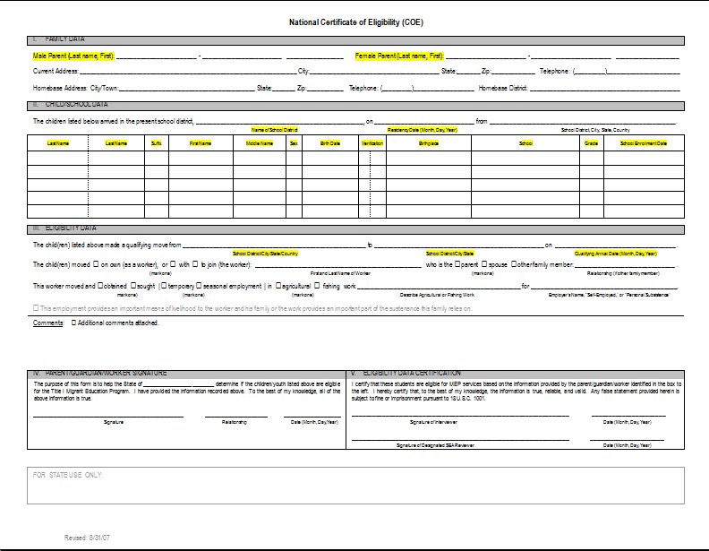

ID&R Conference − Breakout Sessions

Breakout Session 1

What do you see as challenges to getting accurate data on the COE? How can these challenges be addressed?

Breakout Session 2

Name two instances where having access to MSIX data or capabilities would have made a difference in recruiting a child?

Breakout Session 3

What are some ways to ensure data quality from the COE to MSIX?

Breakout Session 4

How could MSIX help you do a better job in recruiting or serving migrant children?

ID&R Conference MSIX Session Evaluation

Date: October 19, 2007 Location: Kansas City, MO

Instructor: Include all who facilitated the session

Name/State (Optional):

For each question below, circle a number from 1 to 7 on the scale, where 1 represents the lowest possible rating and 7 the highest rating. Circle NA for “not applicable” if the item does not apply.

Session Content and Objectives:

- All objectives of the session were covered. 1 2 3 4 5 6 7 NA

- The session was directly applicable to my needs. 1 2 3 4 5 6 7 NA

3. The session covered what I expected. 1 2 3 4 5 6 7 NA

- I will be able to apply what I learned when
I return to my office. 1 2 3 4 5 6 7 NA

Session Facilitators:

5. The facilitators demonstrated expertise in the subject area. 1 2 3 4 5 6 7 NA

6. The facilitators’ delivery of the materials was clear
and effective. 1 2 3 4 5 6 7 NA

- The facilitators’ attention to questions/comments added to
my learning. 1 2 3 4 5 6 7 NA

Written and Audio-Visual Materials:

8. The session written materials added to my learning. 1 2 3 4 5 6 7 NA

9. The written materials provided for the session will be useful
as resources/references. 1 2 3 4 5 6 7 NA

- The audio-visual materials used were appropriate and
added to the session content. 1 2 3 4 5 6 7 NA

- The environment was comfortable—including seating,
lighting, and temperature. 1 2 3 4 5 6 7 NA

- Do you feel comfortable in your knowledge of the purpose and value of MSIX? If not, what other information or tools would be helpful?

- What were the most helpful aspects of the session?

- What suggestions would you offer for ways to improve the session?

- Please describe one specific thing you learned in the session that will be most important for you to apply in your job.

- Other comments

