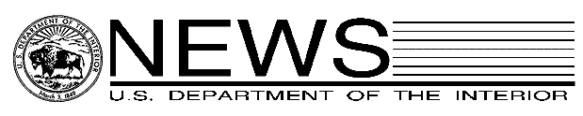

Office of the Assistant Secretary – Indian Affairs

FOR IMMEDIATE RELEASE CONTACT: Nedra Darling
October 31, 2005 202-219-4152

MEDIA ADVISORY

Cason to Speak at NCAI 62nd Annual Convention

WASHINGTON – Interior Associate Deputy Secretary James E. Cason will appear November 1 at the National Congress of American Indians (NCAI) 62nd Annual Convention in Tulsa, Okla. The NCAI convention is the oldest and largest annual meeting of American Indian and Alaska Native tribal leaders held in the United States.

Cason will discuss Bureau of Indian Affairs (BIA) programs and policy initiatives including trust reform, the proposed restructuring of the Office of Indian Education Programs (OIEP), the national search for a new OIEP Director and the implementation of the No Child Left Behind Act in BIA-funded schools, and the Bureau’s Fiscal Year 2006 budget outlook.

WHO: James E. Cason, Associate Deputy Secretary, U.S. Department of the Interior.

WHAT: Associate Deputy Secretary Cason will speak on BIA programs and policy at the
National Congress of American Indians (NCAI) 62nd Annual Convention.

WHEN: 11:00 a.m. (local time) on Tuesday, November 1, 2005.

WHERE: Tulsa Convention Center, Hall C, 100 Civic Center, Tulsa, Okla.
Phone: (918) 596-7177.

CREDENTIALS: This invitation is extended to working media representatives, who are required to display sanctioned media credentials for admittance to the event.

-DOI-

