Olympic National Park News Release

Olympic National Park

600 East Park Avenue
Port Angeles, WA 98362

360-565-3099 phone
360-565-3015 fax
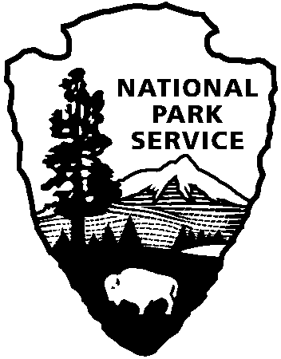
National Park Service
U.S. Department of the Interior

July 31, 2008
For Immediate Release
Patti Wold 360-565-3099

Memorial Service in Celebration of the Life of Firefighter Andrew “Andy” Palmer

A memorial service celebrating the life of Andrew Palmer will be held at 10:00 a.m., Monday, August 4, 2008, in McCurdy Pavilion at Ford Worden State Park. Andy, 18, was fatally injured in a tree falling accident while on a fire assignment in Northern California.

The Palmer family welcomes those who mourn Andy’s loss to attend the service. In lieu of flowers, donations may be made in Andy’s name. A scholarship fund has been created in Andy’s memory to be shared by the Port Angeles and Port Townsend High Schools. Make your donations to the Port Townsend High School Scholarship Foundation, 538 Calhoun Street, Port Townsend, WA 98368. Donations may also be made to the National Wildland Firefighter Foundation http://wffoundation.org/.

Fort Worden is on the Olympic Peninsula in Port Townsend, Washington. The nearest large airport is Seatac. The Edmonds to Kingston ferry is the most direct ferry route to the area. Allow additional travel time due to road work on the peninsula and traffic congestion related to the service.

All uniformed personnel are asked to meet at the McCurdy Pavilion at 0845.

Fire Service agencies bringing engines should plan to meet at Blue Heron Middle School,
3939 San Juan Ave in Port Townsend. The engine procession will depart the school at 0830.

An area inside the Pavilion will be designated for the media. Media representatives planning to attend should arrive by 9:00 a.m. in order to check in and set up prior to the service. The Palmer family will not be available to talk to the media the day of the service.

The service is scheduled to last approximately one hour with a reception following.

-NPS-

