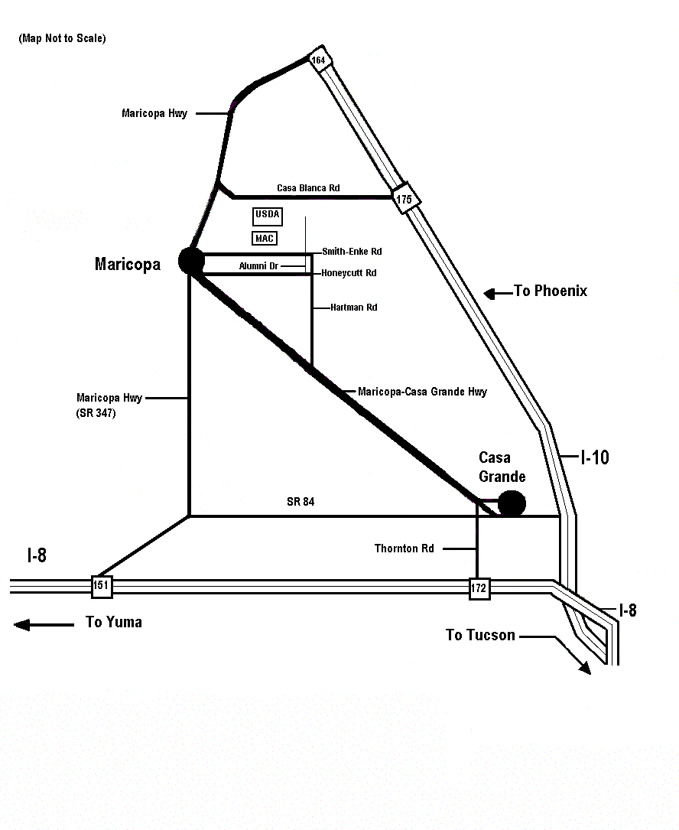

From Phoenix:
1. South on I-10, Take Exit 164
2. Take Maricopa Hwy to Maricopa
3. Turn left (East) at the 3rd stop light onto Smith-Enke Rd
4. Travel 4 miles
5. Turn left (North) on Cardon Lane to U. S. Arid-Land Ag. Res. Center

From Tucson:
1. North on I-10, Take Exit 199 (I-8) to San Diego
2. Take Exit 172 onto Thornton Rd
3. Go North on Thornton Rd to Cottonwood
4. Turn East (left) onto Cottonwood (becomes Maricopa-CG Hwy)
5. Go to Hartman Rd (approx. 14 miles), turn right (North)
6. Go to Honeycutt, turn left (West)
7. Go .4 mile, turn right (north) on Alumni (dirt road)—this turn is just before the telephone pole with 3 transformers on it
8. Go to Alumni & Smith-Enke. Turn left (East) onto Smith-Enke
9. Turn right (North) on Cardon Lane to U. S. Arid-Land Ag. Res. Center

From Yuma:
1. Take Exit 151 into Maricopa
2. Turn right (East) onto Smith-Enke Rd
3. Travel approx 5 miles
4. Turn left (North) on Cardon Lane to U. S. Arid-Land Ag. Res. Center

U. S. Arid-Land Agricultural Research Center

21881 North Cardon Lane
Maricopa, AZ 85238
Tel: 520-316-6300

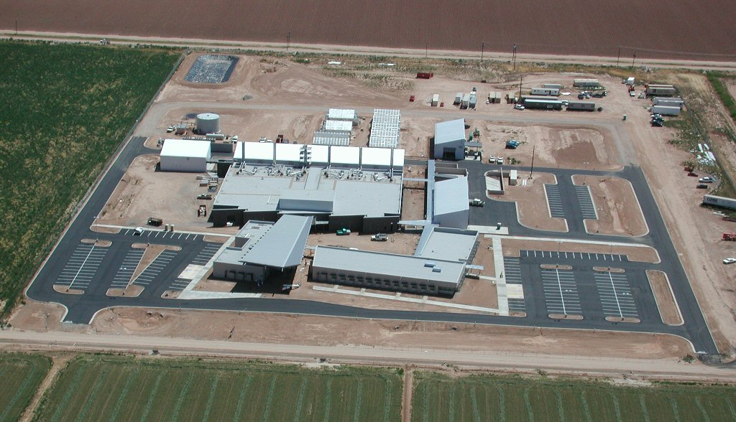
GPS Coordinates:

Latitude = 33.077006 (N 33° 04’ 37’’)
Longitude =-111.973722 (W 111° 58’ 26’’)

Maricopa, AZ

