Overview:

These electronic UFP-QAPP Worksheets are provided as a tool to be used when developing a QAPP for environmental data collection. These worksheets must be used together with the UFP-QAPP Manual and, as appropriate, the Quality Assurance/Quality Control Compendium: Minimum QA/QC Activities. Simply completing the applicable worksheets will not generate an acceptable QAPP. Additional tables, figures, maps, graphics, and text should be incorporated into the QAPP, around the worksheets, to provide a complete description of the project plan.

The use of these worksheets is not required. However, their use will standardize the organization and presentation of the information required to be documented by a QAPP.

Downloading and extracting the zip file:

The electronic worksheet program is contained in the QAPP_elec.zip file. You can download the zip file by clicking on the link. The zip file is a compressed file containing a number of files necessary to install the electronic worksheet program.

After downloading and saving the zip file (to a directory of your choice), you must “extract” the programs included in the zip file. If you’re using the Windows XP operating system, clicking on the zip file will open a window for extracting the file. Click the file name, followed by clicking the button “Extract all files.” This will open another window named “Extraction Wizard.” Click “next” and you will be prompted to select a destination folder for the extracted files.

We strongly recommend you set up a separate folder for the extracted files!

The following instructions are for installing the program using the files extracted and saved from the zip file.

(Note: if you’re using an older version of the Windows operating system, you may need to obtain a program for un-zipping the compressed file.)

Installation:

- If you have Microsoft Word 2000 or above (Word 2003 is preferred), double-click on the installation file “QAPP Setup.”
- If you do not have Microsoft Word 2000 or above, copy the "Data" folder and "QAPP Workbook.doc" file to your hard drive (make sure they are saved in the same folder).

Using the Worksheets:

- The security setting on MS Word must be set at medium or lower. You can check your security setting in Word by clicking on Tools, Macro, and Security.
- Open the Word file (QAPP Workbook.doc). When you open the file, you will be asked to disable/enable macros. Select “Enable.” If you do not get a prompt about enabling macros, your security setting is incorrect (see #1).
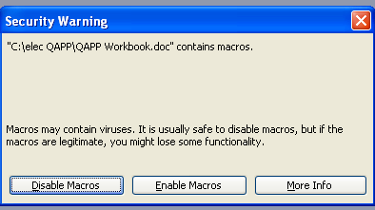
- You will notice a new menu item on top of the file, to the right of the normal Word menu items, called QAPP. This contains the special menu items for the electronic worksheets, allowing you to copy tables, add or delete rows from tables, etc.
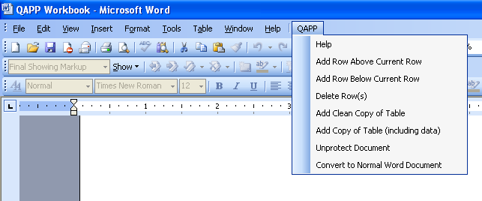
- The file that you open (QAPP Workbook.doc) is read-only. After you have opened the file, save a copy under a new name. The copy must be located in the same directory as the QAPP Workbook.doc (i.e., the “Data” folder should be in the same folder as the copy).
- When you first open the file, check under the QAPP menu to make certain the document is protected (i.e., QAPP menu will include “Unprotect Document” as an option). ONLY USE THE QAPP MENU ITEM TO PROTECT AND UNPROTECT THE DOCUMENT. There is a bug in Microsoft Word that might cause data to be lost if other methods are used to unprotect or protect the document.
- When the document is protected, you may only enter information in the grey boxes. When the document is unprotected, you may make changes as you would any normal Word document. This includes inserting or deleting table columns, changing column sizes, adding extra text/footnotes, etc. You can protect or unprotect the document using the QAPP menu and clicking “Unprotect Document” or “Protect Document.” ONLY USE THE QAPP MENU ITEM TO PROTECT AND UNPROTECT THE DOCUMENT.
- Blue underlined text contains hyperlinks to Help files. Click on the text and relevant sections or glossary terms from the UFP-QAPP Manual will appear. Click the “Back” button to go back to the QAPP file. If this takes you back to the front cover of the QAPP, click the “Tab” key to go back to where you were working in the document.
- Additional rows may be inserted into any table by using the “Add Row Above Current Row” or “Add Row Below Current Row” function under the QAPP menu. You may also delete extra rows in a table by placing the cursor in a row and selecting “Delete Row(s)” from the QAPP menu.
- Blank copies of any table can be inserted directly after the original version of the table by selecting “Add Clean Copy of Table” or “Add Copy of Table (including data)” under the QAPP menu. This feature is useful when multiple copies of the same table are needed.
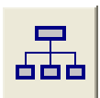
- For Worksheet #5, click on the organizational chart icon for instructions regarding how to insert an existing organizational chart or create a new one using MS Organization Chart Tool. Selecting the icon unprotects the document and disables the electronic worksheet functions, so once the organizational chart is complete, protect the document again by selecting “Protect Document” under the QAPP menu.
- Several worksheets have table entries for “Matrix,” “Analytical Group,” “Concentration Level,” “QC Sample,” and “Data Quality Indicator (DQI).” A drop-down list of choices is provided in each to speed up completion of the worksheets and ensure consistency. For example, under “Matrix,” choices include groundwater, soil, sediment, etc. In addition, selecting a specific DQI in Worksheet #12 will filter the potential QC Samples available in the “QC Sample and/or Activity Used to Assess Measurement Performance” column for that same row.
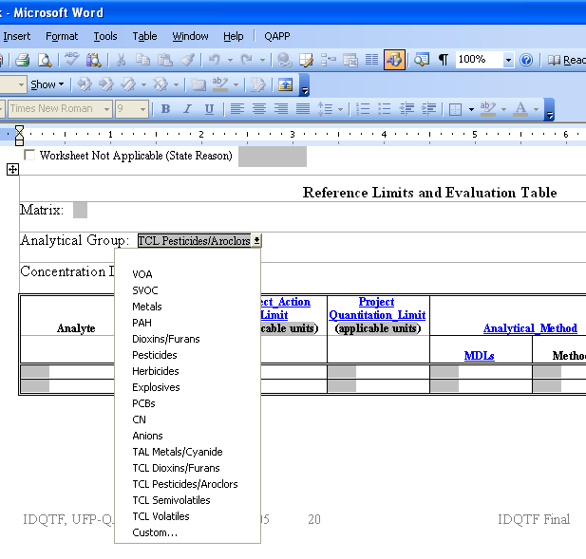
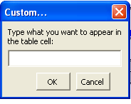
For all drop-down lists, there is a “Custom” option to be used when the choice you want is not on the list. Select “Custom” and a box will open. Type text in the box and click “OK.” If the “Custom” option does not work, move the cursor outside the cell you are in, then move it back and try again.
- Worksheet #15 allows you to enter analyte-specific information. Select the “Analytical Group,” then move your cursor to the “Analyte” column. Clicking your mouse will let you select from a list of analytes from the analytical group you selected. The CAS Number for that analyte will automatically be entered in the adjacent column. This process should be repeated on the next row for each analyte you wish to include. Selecting TAL Metals/Cyanide or a TCL list will automatically generate a complete list of the appropriate analytes and associated CAS numbers.
- Several worksheets, such as #10 and #11, consist of a box with prompts. The prompts serve as tools to assist with the completion of the required QAPP elements. They are for your benefit only and may be deleted.

Completing the QAPP:

When you have completed the worksheets, under the QAPP menu, select “Convert to Normal Word Document.” This will eliminate all of the coding and produce a normal Microsoft Word document. All fields, such as page numbers and the Table of Contents, will be updated automatically at this point. You may type in additional text, insert maps or figures, and finalize formatting.

Version History:

June 2006, v1.1 – Fixed a bug associated with MS Word 2000 and the conversion of QAPP workbooks into normal MS Word documents.

October 2005, v1.0 – Original Version

Questions/Problems: Contact Nicole Weymouth (NWeymouth@versar.com) at Versar, Inc.

