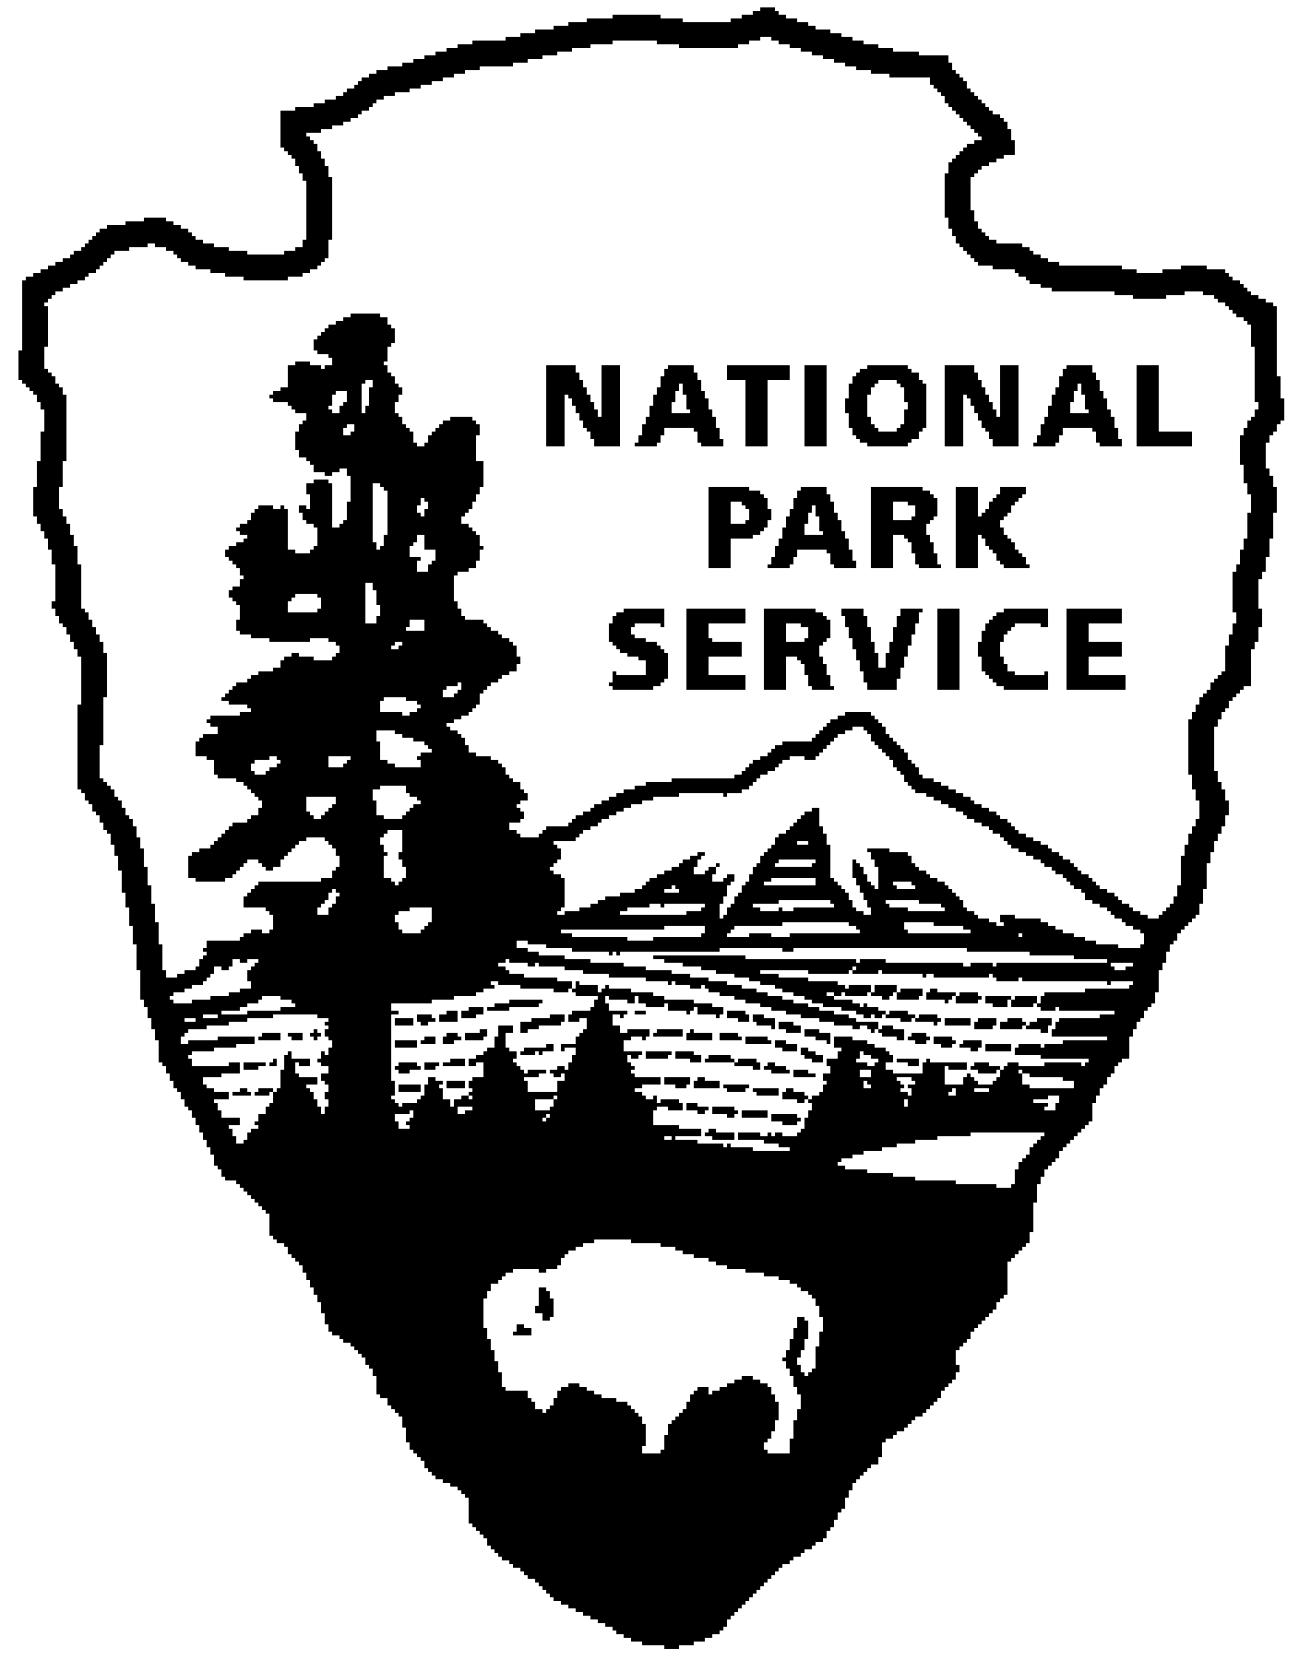  National Park Service  U.S. Department of the Interior  Superintendent’s Compendium  Of Designations, Closures, Permit Requirements and Other Restrictions Imposed Under Discretionary Authority.  Approved:  __/s/ Adrienne A. Coleman___  Adrienne A. Coleman, Superintendent  November 9, 2004 | Rock Creek Park |  | 3545 Williamsburg LN, NW  Washington, DC 20008  202.895.6000 phone  202.895.6015 fax  www.nps.gov/rocr  rocr_superintendent@nps.gov

In accordance with regulations and the delegated authority provided in Title 36, Code of Federal Regulations (“36 CFR”), Chapter 1, Parts 1-7, authorized by Title 16 United States Code, Section 3, the following regulatory provisions are established for the proper management, protection, government and public use of those portions of Rock Creek Park and areas administered by Rock Creek Park under the jurisdiction of the National Park Service. Unless otherwise stated, these regulatory provisions apply in addition to the requirements contained in 36 CFR, Chapter 1, Parts 1-7.

I. 36 CFR §1.5 – VISITING HOURS, PUBLIC USE LIMITS, CLOSURES, AND AREA DESIGNATIONS FOR SPECIFIC USE OR ACTIVITIES

(a)(1) The following visiting hours and public use limits are established for all or for the listed portions of the park, and the following closures are established for all or a portion of the park to all public use or to a certain use or activity:

Visiting Hours:

Unless otherwise designated, all park land is open between the hours of sunrise and sunset. The Rock Creek Park Nature Center and Planetarium is open Wednesday through Sunday, 9 am to 5 pm, closed on all federal holidays. The Old Stone House is open Wednesday through Sunday, 12 pm to 5 pm, closed on federal holidays. The Peirce Barn/Peirce Mill complex buildings are open Saturday and Sunday, 12 pm to 4 pm, closed on federal holidays. Carter Barron Amphitheatre open Memorial Day to Labor Day, day of event only.

Public Use Limits:

Picnic areas numbered 1, 6,7,8,9,10,13,14,23,and 24 require a reservation permit and are limited to no more than 75 people. Picnic areas 2,3,4,5,11,12,15,16,17,18,19,20,21,22 operate as first-come, first-served, and limited to no more than 25 people. Further picnic regulations listed under (a)(2).

Alcoholic beverages are prohibited from all park areas administered by Rock Creek Park, except authorized concession sales at Carter Barron Amphitheatre, Rock Creek Park Golf Course clubhouse and Rock Creek Tennis Stadium. Justification for alcohol closure in Rock Creek Park attached as appendix A.

Smoking is prohibited in all buildings, offices, historic structures, and stables.

Coolers, scooters, rollerblades, bicycles, glass containers, picnic baskets, pets and cans are prohibited inside Carter Barron Amphitheatre and Rock Creek Tennis Stadium.

Service animals for the disabled are allowed inside Carter Barron Amphitheater and Rock Creek Tennis Stadium when officially assisting a disabled person.

Photography and audio and video recording of events at Carter Barron Amphitheatre and Rock Creek Tennis Stadium are prohibited.

Old Stone House visitor limit is 25 people. Peirce Mill visitor limit is 20 people, with no more than 5 people at one time on the third floor.

Fires permitted only in grills or fireplaces, visitors may bring own grill and fuel in designated picnic areas only.

Parking allowed only in designated parking areas.

Weddings allowed by permit at Meridian Hill Park or the garden at the Old Stone House, limit of 50 people, no chairs, balloons or decorations allowed, receptions not allowed. See Permit section for contact info.

Washing vehicles within Rock Creek Park is prohibited.

Repair or maintenance of vehicles (other than short-term emergency repairs) by private individuals or commercial businesses within Rock Creek Park is prohibited.

Closures: .

Unless otherwise designated, all park land is closed between the hours of sunset and sunrise except for vehicular traffic on park roads. Buses, commercial vehicles, and trucks over ½ ton are prohibited on park roads unless given specific permission in writing by the superintendent.

The parks along 16th street, including Meridian Hill Park, are closed midnight to 5:00 am from May through October, and 9:00 pm to 5:00 am November through April.

Sections of Beach Drive, and Bingham and Sherrill Drives are closed to motor vehicle traffic on weekends and federal holidays. Sherrill, Bingham, Ross and Morrow Drives are closed to motor vehicle traffic when snow or ice is present.

Carter Barron Amphitheatre parking lot is closed from midnight until 5 am.

The following areas have been designated for a specific use or activity, under the conditions and/or restrictions as noted:

- Docking or Mooring Areas:
    - Mooring of boats at the dock at Washington Harbour on the Georgetown Waterfront is prohibited between midnight and 6 am, as determined by the Superintendent, Rock Creek Park, dated January 30, 2002, 36 CFR 1.5, consistent with the determination by the Superintendent, C&O Canal NHP, dated June 22, 1998, and the Regional Director’s memorandum dated November 20, 1997.

- Picnic areas:

Picnicking is prohibited in Dumbarton Oaks Park, Fort Stevens, and Battleground Cemetery. Picnic areas numbered 1, 6,7,8,9,10,13,14,23,and 24 require a reservation permit and are limited to no more than 75 people. Picnic areas 2,3,4,5,11,12,15,16,17,18,19,20,21,22 operate as first-come, first-served, and limited to no more than 25 people. Large group picnics of 25 or more people are not allowed outside of numbered picnic areas unless the superintendent provides an exception in writing. Informal picnics of fewer than 25 people are allowed in all other lawn areas except for the 4 park areas listed above.

- Bicycle Use Areas/Routes:

Bicycle use is restricted to paved roads and the paved multi-use trails extending from Wise Road to Joyce Road and from Broad Branch Road to Virginia Ave. Operating a bicycle abreast of another bicycle is prohibited except on sections of roads closed for recreational use.

The following restrictions and/or conditions are in effect for the specific uses or activities noted:

Dogs must be on leash within park areas, and park visitors must comply with District of Columbia leash laws. Dogs are prohibited from tennis courts and playgrounds.

Camping is prohibited within all park areas.

All park areas are closed to the viewing of wildlife with an artificial light.

All park areas are closed to swimming, wading and bathing by people or household pets

Archery target practice is prohibited.

Canopies, tents or shade structures anchored to the ground, awnings or portable pavilions are prohibited except where written permission is obtained from the Superintendent.

Fishing is prohibited on Rock Creek north of the Porter Street bridge.

Hitchhiking is prohibited within all areas of the park.

Removing or damaging natural or cultural resources is prohibited.

II. 36 CFR §1.6 – ACTIVITIES THAT REQUIRE A PERMIT

NOTE: The term “permit” covers a variety of instruments allowing us to manage activities within Rock Creek Park. The following definitions apply within areas administered by Rock Creek Park:

Permits to reserve picnic areas or sports fields within Rock Creek Park are obtained from the District of Columbia Parks and Recreation Department, 202.673.7646. DC charges an administrative processing fee for these free reservation permits.

Permits for first amendment rights demonstrations, special events, or filming within any park area in the National Capitol Region (NCR) are required by 36 CFR to be processed through the NCR Park Programs Division. To obtain an application, contact 202.619.7225. For information on Rock Creek Park areas for these permits, contact the Special Park Uses office at 202.895.6000.

Permits for construction, educational programs (not led by a park ranger) or to use or cross park land are obtained from the Environmental Protection Specialist for Rock Creek Park, 202.895.6000. Permits for rights of way are obtained from the National Capitol Regional Office of the National Park Service, 202.619.xxxx.

Permits for scientific research and collecting may be obtained through the following process:
- Contact Rock Creek Park Natural Resources Management Office, 202.895.6077.
- Apply online: www.science.nature.nps.gov/research.

Reservation permits required for picnic areas 1, 6,7,8,9,10,13,14,23,and 24, and for use of sports fields. Contact number: 202.673.7646 for picnic permits and 202.767.8363 for sports permits.

Special Park Use permits required for construction within park land, to stage equipment, to cross park land with cables or other utilities, or to use park land for access to an adjoining site. Contact Environmental Protection Specialist at 202.895.6000.

The following is a compilation of those activities for which a permit from the superintendent is required:

- §1.5(d) The following activities related to Public Use Limits:

Weddings are allowed by permit at Meridian Hill Park or the gardens of Old Stone House, fee charged, contact Special Park Use Office at 202.895.6000.

Special events or First Amendment Rights demonstrations of more than 25 people require a free permit from the NCR Park Programs Office, 202.619.7225.

Groups larger than 10 horses and riders need a free permit from the Special Park Uses office, 202.895.6000.
Special events will not be permitted at Georgetown Waterfront Park, except for limited use of the area for viewing regattas or other water events.
- §2.5(e) Research Specimen collection (Collection of plants, fish, wildlife, rocks or minerals)
Permits for scientific research can be applied for online, at www.science.nature.nps.gov/research. For more information, contact the Natural Resources Office at 202.895.6077.
Operation of a public address system in connection with a public gathering or special event for which a permit has been issued pursuant to §7.96(g). Amplified sound not allowed in picnic areas. Amplified sound as part of special events must operate within decibel limits specified in permit conditions.

- §7.96(g) Conduct a sports event, pageant, regatta, public spectator attraction, entertainment, ceremony, and similar events – apply for a free permit through the NCR Park Programs Office, 202.619.7225.

- §7.96(g) Public assemblies, meetings, gatherings, demonstrations, parades and other public expressions of views – apply for a free permit through the NCR Park Programs Office, 202.619.7225.

- §7.96(k) Sale or distribution of printed matter that is not solely commercial advertising is only allowed as part of a first amendment rights event, and must follow specifications in permit conditions.

- §2.62(b) Memorialization - (Scattering ashes from human cremation) is not allowed within Rock Creek Park.

- §4.11(a) Exceeding of established vehicle load, weight and size limits. Commercial trucks over ½ ton and busses are prohibited on roadways within Rock Creek Park.

- §5.3 Engaging in or soliciting any business is not allowed within Rock Creek Park except under the provisions of a permit, contract, or written agreement with the National Park Service.

- §5.5(a) Commercial filming of motion pictures or television involving the use of professional casts, settings or crews, other than bona fide newsreel or news television requires a free permit, apply at the NCR Park Programs Office, 202.619.7225.
- (b) Still photography of vehicles, or other articles of commerce or models for the purpose of commercial advertising requires a free permit, apply at the NCR Park Programs Office, 202.619.7225.

- §5.6(b) Commercial vehicles are prohibited on roadways within Rock Creek Park.

III. GENERAL REGULATIONS

36 CFR §2.1 – PRESERVATION OF NATURAL, CULTURAL AND ARCHEOLOGICAL RESOURCES

Standing dead wood or dead wood on the ground may not be collected for use as fuel for campfires or other uses.

No fruits, nuts, berries, seeds, mushrooms or cut greenery may be gathered or collected for personal or business use or consumption in Rock Creek Park.

No artifacts, portions of structures or architectural elements may be collected within the park.

Recreational activities that damage or harm natural, cultural, or archeological resources are prohibited. Examples include geocaching, orienteering, bungee jumping, rock climbing, and riding bicycles off paved surfaces.

2.1 (b) Hiking and pedestrian uses are restricted to designated foot, horse, and paved recreational trails in the park as shown on the map in the park brochure.

36 CFR §2.2 - WILDLIFE PROTECTION

(b) (1) Hunting is not permitted on any park property.

(b) (3) Trapping is not permitted on any park property.

(d) Transporting of lawfully taken wildlife through the park is not permitted.

(e) All park areas are closed to the viewing of wildlife with the use of an artificial light.

36 CFR §2.3 – FISHING

(a) District of Columbia fishing laws and/or regulations apply throughout the park.

Commercial fishing is not allowed within the park. Fishing is not allowed on Rock Creek or its tributaries north of the Porter street bridge on Rock Creek.

36 CFR §2.4 – WEAPONS, TRAPS, AND NETS

A permit is required to possess, carry or use a weapon, trap or net. The superintendent will only issue a permit to use, carry or possess a weapon, trap, or net under the following circumstances:

(1) When necessary to support approved/permitted research activities.
- For employees, agents or cooperating officials – for official duty.
- Archery target practice prohibited.

36 CFR §2.11 – PICNICKING

Picnicking is prohibited in Dumbarton Oaks Park, Fort Stevens, and Battleground Cemetery. Picnic areas numbered 1, 6,7,8,9,10,13,14,23,and 24 require a reservation permit and are limited to no more than 75 people. Picnic areas 2,3,4,5,11,12,15,16,17,18,19,20,21,22 operate as first-come, first-served, and limited to no more than 25 people. Large group picnics of 25 or more people are not allowed outside of numbered picnic areas unless the superintendent provides an exception in writing. Informal picnics of less than 25 people are allowed in all areas except for the 4 park areas listed above.

36 CFR 2.13 – FIRES

(a)(1) The lighting or maintaining of fires is generally prohibited, except as provided for in the following designated areas or receptacles, and under the conditions noted:

Designated Areas: Fires allowed within fire grates in established picnic areas.

Receptacles Allowed: Individual grills allowed in established picnic groves. Charcoal must be doused with water and disposed of in a trash can after the fire is completely out.

Established Conditions for Fires: Fires allowed unless high fire danger has been declared and public notice given that fires are banned within the park.

(a)(2) The following restrictions are in effect for the use of stoves or lanterns:
- Charcoal must be doused with water completely and disposed of in a trash receptacle.

(b) Fires must be extinguished according to the following conditions:
- Douse completely with water.
- Firewood may not be collected within the park.

(c) High fire danger closures will be in effect as noted:
- When the superintendent declares high fire danger and issues a public notice that fires are banned within the park.

36 CFR §2.14 – SANITATION and REFUSE

The use of government refuse receptacles or facilities for dumping household, commercial or industrial refuse, brought as such from private or municipal property is not allowed.

36 CFR §2.15 – PETS

Pets may not be left unattended tied to an object.

Pet excrement must be disposed in accordance with the following conditions:
- Visitors with pets must pick up all pet waste and dispose of it in a trash receptacle.

36 CFR §2.16 – HORSES and PACK ANIMALS

(a) The use of horses or pack animals is permitted on the following trails, routes or areas:
- Established horse trails within Rock Creek Park (see attached map)
- Equitation field
- Horses are not allowed on foot or bicycle trails.

(b) Free-trailing or loose-herding is not permitted on the Rock Creek Park trails or routes.

(c) Other conditions concerning the use of horses or pack animals:
- Horse trailers and tow vehicles must be parked legally in designated parking spaces.
- Groups larger than 10 horses and riders need a free permit from the Special Park Uses office, 202.895.6000.

36 CFR §2.19 – WINTER ACTIVITIES

(a) The following park roads and/or parking areas normally open to motor vehicle traffic may be used for skiing, snowshoeing, sledding, tobogganing, and similar winter activities under the conditions noted:
- Sections of Beach Drive, Sherrill Drive, Ross Drive, Morrow Drive or Bingham Drive and portions of Glover Road are closed to motor vehicles. (Non-motorized winter activities allowed)

(b) The towing of persons on skis, sled or other similar device by motor vehicle or snowmobile is not allowed .

36 CFR §2.20 – SKATING, SKATEBOARDS and SIMILAR DEVICES

The use of roller skates, skateboards, roller skis, coasting vehicles, or similar devices are allowed in the following areas:
- Paved multi-use trails
- Roads closed to motor vehicle traffic on weekends or federal holidays.

36 CFR §2.21 – SMOKING

(a) All buildings, structures or facilities are closed to smoking. Smokers in outside area must dispose of fully extinguished smoking materials in proper trash containers.

36 CFR §2.22 – PROPERTY

The following describes areas where property may be left unattended for periods longer than 24 hours, and the conditions under which property may be left:
- Property is not allowed to be left unattended for periods longer than 24 hours within Rock Creek Park, unless the property is part of an activity under a special park use permit (for example, a contractor working on construction within the park may receive permission under the permit to store equipment in a staging area.)

36 CFR §2.23 – RECREATION FEES

Recreation fees, in accordance with 36 CFR part 71, are established for the following entrance fee areas, and/or for the use of the following specialized sites, facilities, equipment or services, or for participation in the following group activity, recreation events or specialized recreation uses:

Entrance Fee Areas: N/A

Daily Site Use Fee Areas: Parking at Thompson’s Boat House, fee charged through metered spaces.

36 CFR §2.35 –ALCOHOLIC BEVERAGES and CONTROLLED SUBSTANCES

(a)(3)(i) The following public use areas, portions of public use areas, and/or public facilities within the park are closed to consumption of alcoholic beverages, and/or to the possession of a bottle, can or other receptacle containing an alcoholic beverage that is open, or has been opened, or whose seal has been broken or the contents of which have been partially removed:

Alcoholic beverages are prohibited from all park areas administered by Rock Creek Park, except Carter Barron Amphitheatre, Rock Creek Park Golf Course clubhouse and Rock Creek Tennis Stadium. Justification for alcohol closure in Rock Creek Park attached as appendix A.

36 CFR §2.37 – NONCOMMERCIAL SOLICITING

The solicitation or demand for gifts, money, goods or services requires a permit under §2.50, §2.51, or §2.52, and is subject to the terms and conditions specified therein.

NOTE: This section generally prohibits soliciting or demanding gifts, money goods or services except in accordance with a permit. The term “soliciting” includes asking, begging and non-verbal gestures, such as a hand out or palm up. [48 FR 30271, June 30, 1983]

36 CFR §2.62 – MEMORIALIZATION

(a) Authorization from the Director of the National Park Service is required to install a monument, memorial, tablet, structure, or other commemorative installation in a park area.

(b) The scattering of ashes from cremated human remains is not allowed within Rock Creek Park.

36 CFR §3.6 – BOATING OPERATIONS

- (h) Launching boats is prohibited within Rock Creek Park unless water levels are at least 2 feet deep. Boats are not allowed to go over Peirce Mill Dam under any conditions. Canoes, kayaks or other similar human powered boats are allowed.

(l) Vessels must meet the following size, length or width restrictions:
- Must be less than 20 feet in length, motors not allowed.
- Hand launch only

36 CFR §3.21 – SWIMMING AND BATHING

All Rock Creek Park areas are closed to swimming, bathing and wading by people and pets.

36 CFR §4.10 – TRAVEL ON PARK ROADS AND ROUTES

(a) Park roads, open for travel by motor vehicle are those indicated in the following publication: Rock Creek Park brochure.

(b) Off-road vehicle travel is not allowed.

36 CFR §4.11 – VEHICLE LOAD, WEIGHT AND SIZE LIMITS

(a) The following load, weight and size limits, which are more restrictive than State law, apply to the roads indicated under the terms and conditions, and/or under permit as noted:
- Buses and large trucks over ½ ton are not allowed on park roads.

36 CFR §4.21 – SPEED LIMITS

(b) The following speed limits are established for the routes/roads indicated:
- Speed limit is 25 mph on all park roads unless otherwise posted.

36 CFR §4.30 – BICYCLES

(a) Bicycle use is permitted on park roads, parking areas, and on the following designated paved routes:
- Multi-use paved recreational trails
- Sections of park roads closed to motor vehicle traffic on weekends and federal holidays.

(b) The following routes are closed to bicycle use:
- All unpaved trails.
- Off-trail or off road areas.

(c) Riding a bicycle abreast of another rider is permitted on the following routes, under the conditions noted:
- Paved park roads and parking areas.
- Bicycles may not be ridden abreast of another rider on multi-use paved recreational trails.
Bicycles must be operated at speeds reasonable for existing conditions. Speed should not exceed 15 mph on paved multi-user trails or 25 mph on paved roadways.

36 CFR §4.31 – HITCHHIKING

Hitchhiking is not permitted.

Appendices:
- Justification for banning alcohol within Rock Creek Park
- Determinations for closure referred to in this document.
- Memoranda on docking at Washington Harbor referred to in this document.

