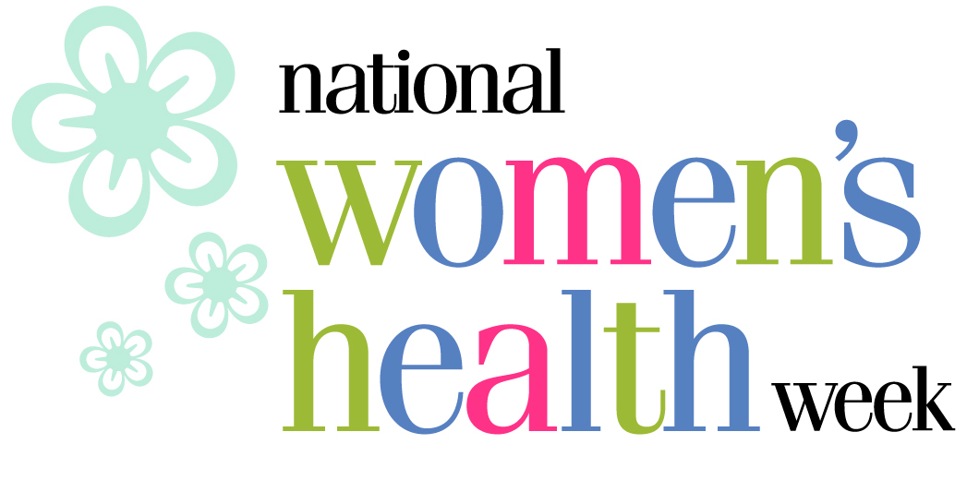

Sample Newsletter Text

Newsletter Sent to Individuals
The 10th annual National Women’s Health Week will kick off on Mother’s Day, May 10, and will be celebrated until May 16 with the theme “It’s Your Time.” The weeklong health observance empowers women across the country to make their health a top priority and take simple steps for a longer, healthier and happier life. Check out http://www.womenshealth.gov/whw for local events in your area and for more information on how you can participate. Or contact Elizabeth Osborn at eosborn@hagersharp.com or 202-842-3600 x257.

Newsletter Sent to Other Organizations
National Women’s Health Week 2009 is approaching and [insert your organization] urges you to take part! The 10th annual initiative kicks off on Mother’s Day, May 10 and is celebrated until May 16, 2009. With the theme “It’s Your Time,” National Women’s Health Week encourages women to make their health a top priority and take simple steps for a longer, healthier and happier life.

There are several ways you can be a National Women’s Health Week partner, including: encouraging women in your community to visit their doctor or other health care professional, holding a free screening or health event, listing your activity on http://www.womenshealth.gov/whw, putting information in your newsletter, disseminating women’s health information or having a health display in your facilities. For more information or promotional materials, or to register your activities, please go to http://www.womenshealth.gov/whw or contact Elizabeth Osborn at eosborn@hagersharp.com or 202-842-3600 x257.

