USGS EMERGENCY CALL CENTER

EMPLOYEE REPORTING

Reporting By Telephone
The USGS Emergency Call Center enables employees to report their status to supervisors in the event of an emergency. The procedure for the use of the system follows:

- A situation occurs for which the employee call-in process is triggered.

- As soon as safely possible to do so, call the USGS call center at 866 854 8987. TTY operation is available at 800 725 7024 for the hearing / speech impaired.

- The operator will ask a series of questions:
  - your name,
  - your organization information,
  - your location,
  - a method to contact you (phone or email),
  - when you expect to be available for return to work,
  - any needs or other information you wish to relay,
  - if you wish to report in for any other employees
    - If this is the case, you should inform the operator of the names of the other employees you would like to report for.
    - Please be prepared to answer the same questions for them as you did for yourself.

- Proceed through the call answering the questions.

- If you have a change in your situation, please call back with updated information.

The information from your call will be recorded by the operator, and then provided to USGS for access by supervisors and managers, so that we can account for all personnel as quickly as possible following an emergency event.

Please remember that for urgent assistance, such as emergency medical attention, you should contact local emergency response personnel via 911 or other local contact numbers.

If your situation changes, please provide an update by contacting the USGS call center at 866-854-8987, or via the internet at

http://www.lexitelcom.com/USGS/EmployeeCalls.aspx

Reporting via the Internet

Employees can alternately report their status in the event of an emergency via the Internet. If a situation occurs for which the employee call-in process is triggered, you have Internet access, as soon as safely possible to do so, follow the steps below.

Step 1: Direct your Internet browser to http://www.lexitelcom.com/USGS/EmployeeCalls.aspx

You will see the following screen:

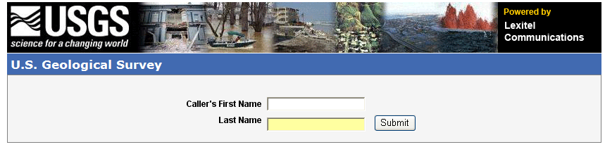
Figure 1 Log-in screen for caller's first and last name

Fill in your name as it appears in the Lotus Notes database (i.e. don’t use ‘Bill’ for ‘William’). Click the ‘Submit’ button.

Your browser will be redirected to another page, shown on the following page of this document. Proceed through the web page complete your report.
Information on how to complete each field follows in steps 2 through 11.

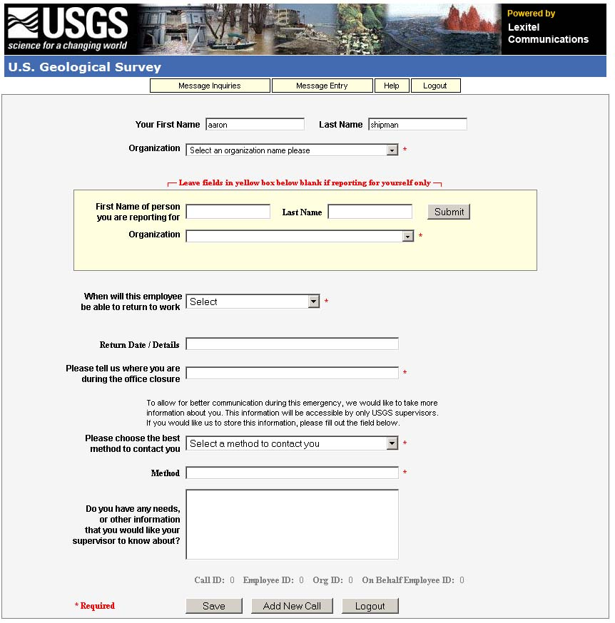
Figure 2 Overview of employee report-in data entry fields
Step 2 – Organization Fields: Find the box labeled “Organization”. Click on the arrow at the right of the “Organization” box to open a drop down list. Select your organization name from the drop down box, click on it to fill the box, and move to the next field. If your organization is not shown, proceed to step 2a.

Step 2a – Organization Fields: If the correct organization name is not listed, please select “My organization is not listed, I will type it below.” When you do, more fields will become visible, as illustrated below. Enter your organization ID, organization name, duty station, state, and then move to the next field. If you don’t know your organization ID, use 999999.

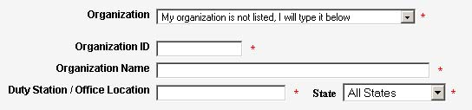

Step 3 – Reporting for other employees: If you are reporting for another person, enter that person’s first and last name in the fields provided. Click ‘submit’, and then select that person’s organization from the drop down menu, in a similar fashion as above.

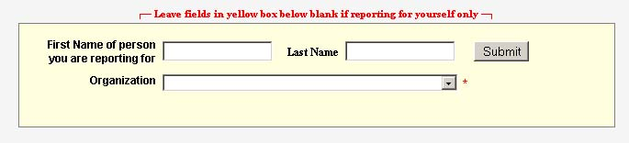
Figure 3 Entry fields to be used if reporting in for another person

Step 4 – When will this employee be able to return to work: The next field follows “When will this employee be able to return to work”. Click the arrow to open a drop down list of choices. Select the choice which best applies to the person you are reporting for (yourself, or someone else). Then move to the next field.
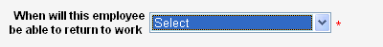
Figure 4 Entry field for estimated date of return to work

Step 5 – Return Date / Details: If you wish to enter more detailed information about when you expect to be available for work, you can enter a specific date or other information in the “Return Date/Details” field provided. Then move to the next field.
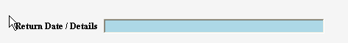
Type information here

Figure 5 Entry field to indicate specific date for return to work

Step 6 – Please tell us where you are during the office closure: Type in your current location, e.g., home, evacuated to Pittsburgh. Street address, city, state, zip code – all would be helpful

Type information here

Figure 6 Entry field for employee's location during the emergency

Step 7 – Contact method / Contact information: Please provide information on the best method for USGS to contact you during the emergency. Clicking the arrow at the right side of the box will open a drop down box of options – by email, by telephone, other, or that you prefer not to provide this information. You are encouraged but not required to provide a contact method. However, if you do not, your supervisor may not be able to relay important information to you. Select the response which applies for yourself (or the person you are reporting for). When you do, a subsequent box will be highlighted, into which you can enter email address, telephone number, or other method. If you select “I do not wish to provide this information” you do not need to retype anything in the second box.

Figure 7 Entry field to indicate best method for contact, i.e., phone, email

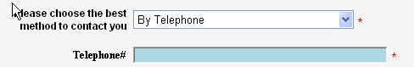
Type information here
Figure 8 Based on previous entry, option to enter phone number or email address specifics

Step 8 – Do you have any needs or other information…: If you wish to include a message to your supervisor, ask a question, or provide other information, type in the blank text box provided.
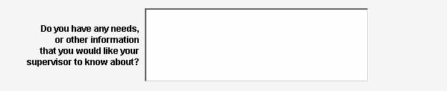
Type information here

Figure 9 Entry field for questions, assistance requests, or other information to be relayed to supervisor

Step 9 – Saving your report: If satisfied with the information you have noted, please click on the “Save” button to submit your report-in message.

Figure 10 Save button submits the information previously provided

Step 10 – Reporting for others: If you wish to report for someone else, click on the “Add New Call" button.
Figure 11 Add new call button allows additional reporting for another employee

Step 11 - Logout: When you are done reporting for yourself or others, select the “Logout” button.
Figure 12 Logout button exits you from the reporting process

If your situation changes, please provide an update by contacting
the USGS call center at 866-854-8987,
or, via the internet at http://www.lexitelcom.com/USGS/EmployeeCalls.aspx

