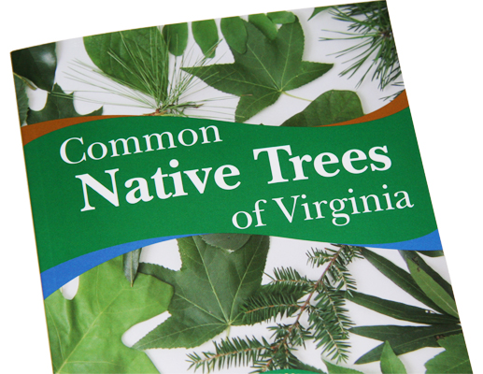

Common Native
Trees of Virginia
Tree Identification Book

The most common native tree species found in Virginia’s forests are described in this handsome book. This tool for tree identification uses non-technical descriptions, with images of leaves, twigs, flowers and/or fruit to aid in identification.
The book contains a key to identify the tree species, a range map for each of the species, and information on Virginia’s State Forests, where you can walk or hike the trails to see many of the species highlighted in the book.
Depending on the quantity ordered, your book(s) will be mailed by the US Postal Service or shipped via United Parcel Service. Therefore, please enter both mailing and shipping address if they are different.
ORDER FORM
Quantity | Item |  | Unit Price | Cost |  | Shipping
 | Common Native Trees of Virginia |  | $1.00 each |  |  | Number of Books | Shipping Charge
 | Shipping Charge (enter amount from chart) |  |  |  |  | 1 $2.00  2-5 $4.00  6-10 $7.00  11-25 $9.00  26-50 $12.00  51-75 $15.00  76-100 $18.00  101-150 $23.00  151-200 $32.00  201-300 $45.00  301-400 $63.00  401-500 $81.00  501-1000 $135.00
Total Amount Due:
Payment Method: |  | Check or Money Order Enclosed (Payable to State Forester)
 |  | Send Invoice (for school or business customers only)
Name:
School (if applicable):
Mailing Address:
Shipping Address:
Same as Mailing
Phone No.:
E-Mail:

Return Order Form and Payment to: Virginia Department of Forestry
900 Natural Resources Drive, Suite 800
Charlottesville, VA 22903
www.dof.state.va.us

