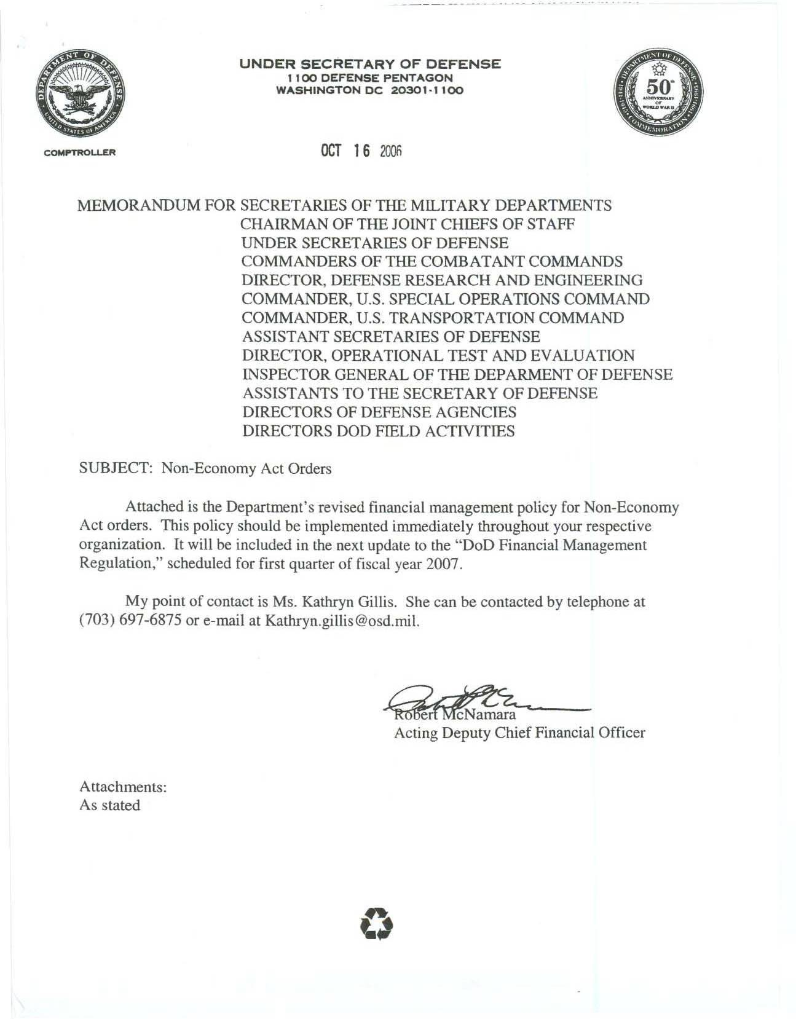
UNDER SECRETARY OF DEFENSE
1100 DEFENSE PENTAGON
WASHINGTON DC 20301•1100
Oct 16 2006

MEMORANDUM FOR SECRETARIES OF THE MILITARY DEPARTMENTS
CHAIRMAN OF THE JOINT CHIEFS OF STAFF
UNDER SECRETARIES OF DEFENSE
COMMANDERS OF THE COMBATANT COMMANDS
DIRECTOR, DEFENSE RESEARCH AND ENGINEERING
COMMANDER, U.S. SPECIAL OPERATIONS COMMAND
COMMANDER. U.S. TRANSPORTATION COMMAND
ASSISTANT SECRETARIES OF DEFENSE
DIRECTOR. OPERATIONAL TEST AND EVALUATION
INSPECTOR GENERAL OF THE DEPARMENT OF DEFENSE
ASSISTANTS TO THE SECRETARY OF DEFENSE
DIRECTORS OF DEFENSE AGENCIES
DIRECTORS DOD FIELD ACTIVITIES

SUBJECT: Non-Economy Act Orders

Attached is the Department's revised financial management policy for Non-Economy
Act orders. This policy should be implemented immediately throughout your respective
organization. It will be included in the next update to the "DoD Financial Management
Regulation," scheduled for first quarter of fiscal year 2007.

My point of contact is Ms. Kathryn Gillis. She can be contacted by telephone at
(703) 697-6875 or e-mail at Kathryn.gillis@osd.mil.

Robert McNamara
Acting Deputy Chief Financial Officer
Attachments:
As stated

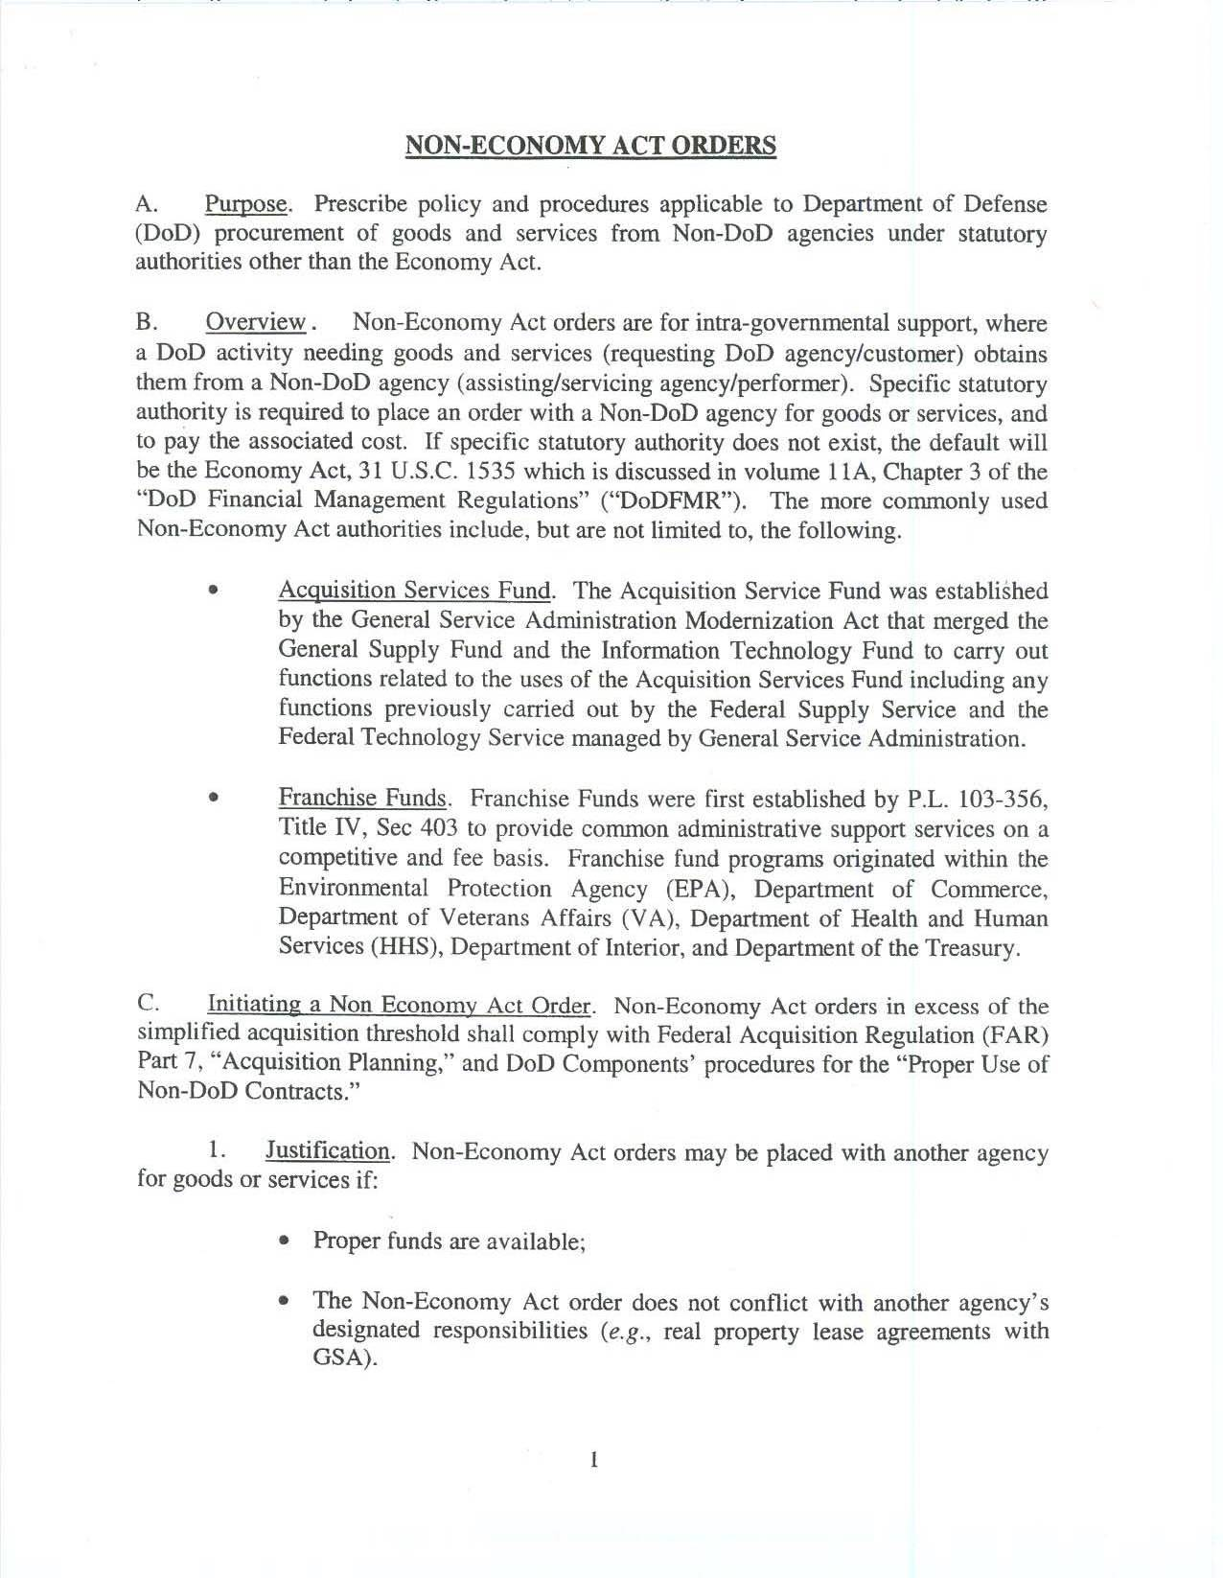
NON-ECONOMY ACT ORDERS
A. Purpose Prescribe policy and procedures applicable to Department of Defense
DoD) procurement of goods and services from Non-DoD agencies under statutory
authorities other than the Economy Act.

B. Overview. Non-Economy Act orders are for intra-governmental support, where
a DoD activity needing goods and services (requesting DoD agency/customer) obtains
them from a Non-DoD agency (assisting/servicing agency/performer). Specific statutory
authority is required to place an order with a Non-DoD agency for goods or services, and
to pay the associated cost. If specific statutory authority does not exist, the default will
he the Economy Act, 31 U.S.C. 1535 which is discussed in volume h A, Chapter 3 of the
"DoD Financial Management Regulations" ("DoDFMR"). The more commonly used
Non-Economy Act authorities include, but are not limited to, the following.

• Acquisition Services Fund The Acquisition Service Fund was established
by the General Service Administration Modernization Act that merged the
General Supply Fund and the Information Technology Fund to carry out
functions related to the uses of the Acquisition Services Fund including any
functions previously carried out by the Federal Supply Service and the
Federal Technology Service managed by General Service Administration.
• Franchise Funds. Franchise Funds were first established by P.L. 103-356.
Title IV, Sec 403 to provide common administrative support services on a
competitive and fee basis. Franchise fund programs originated within the
Environmental Protection Agency (EPA), Department of Commerce,
Department of Veterans Affairs (VA), Department of Health and Human
Services (HHS), Department of Interior, and Department of the Treasury.

C. Initiating a Non Economy Act Order. Non-Economy Act orders in excess of the
simplified acquisition threshold shall comply with Federal Acquisition Regulation (FAR)
Part 7. "Acquisition Planning," and DoD Components' procedures for the "Proper Use of
Non-DoD Contracts."
1. Justification Non-Economy Act orders may be placed with another agency for goods or services if:

• Proper funds are available;
• The Non-Economy Act order does not conflict with another agency's
designated responsibilities (e.g., real property lease agreements with
GSA).
Page 1
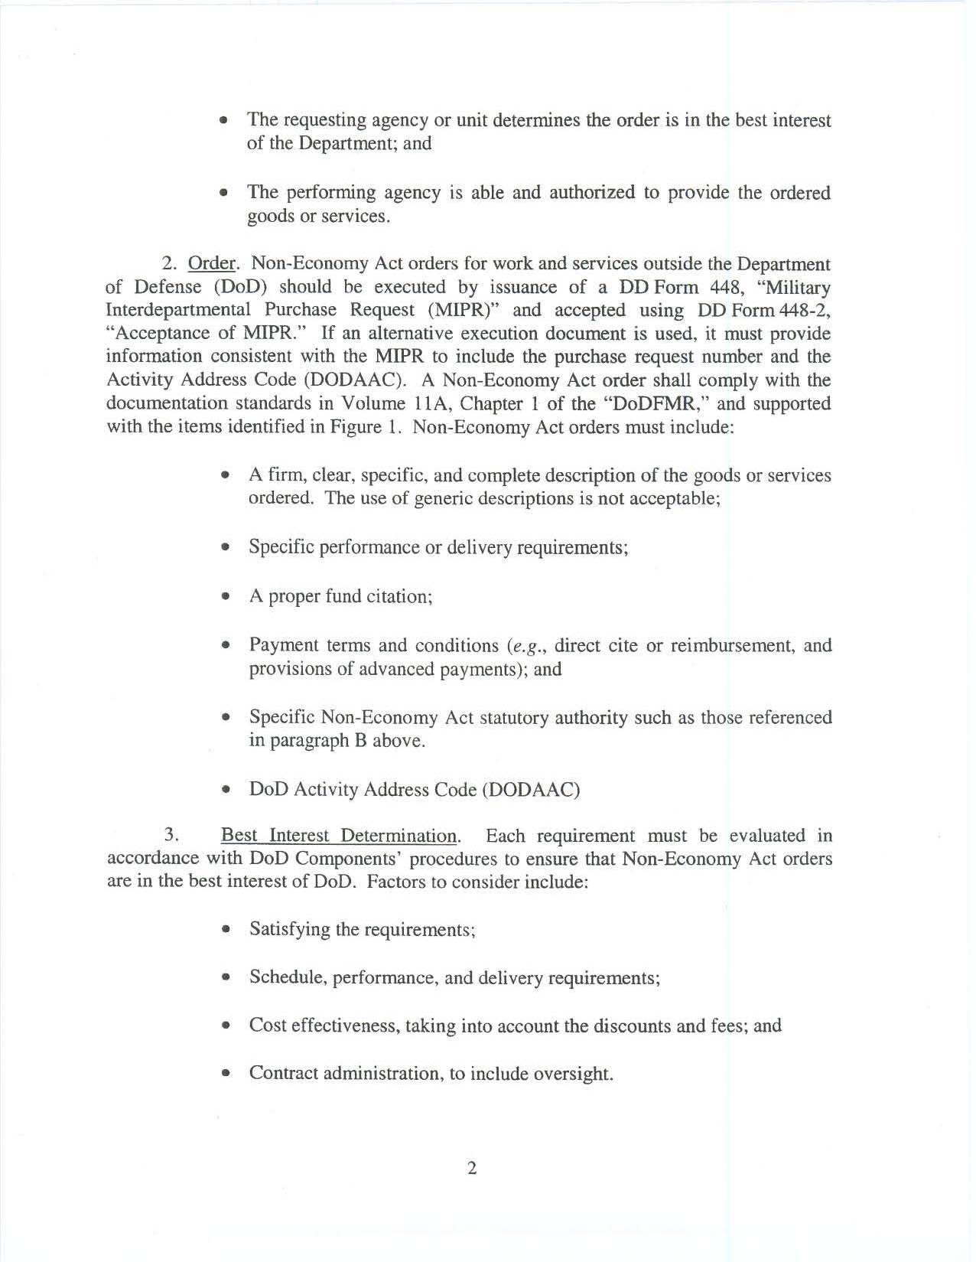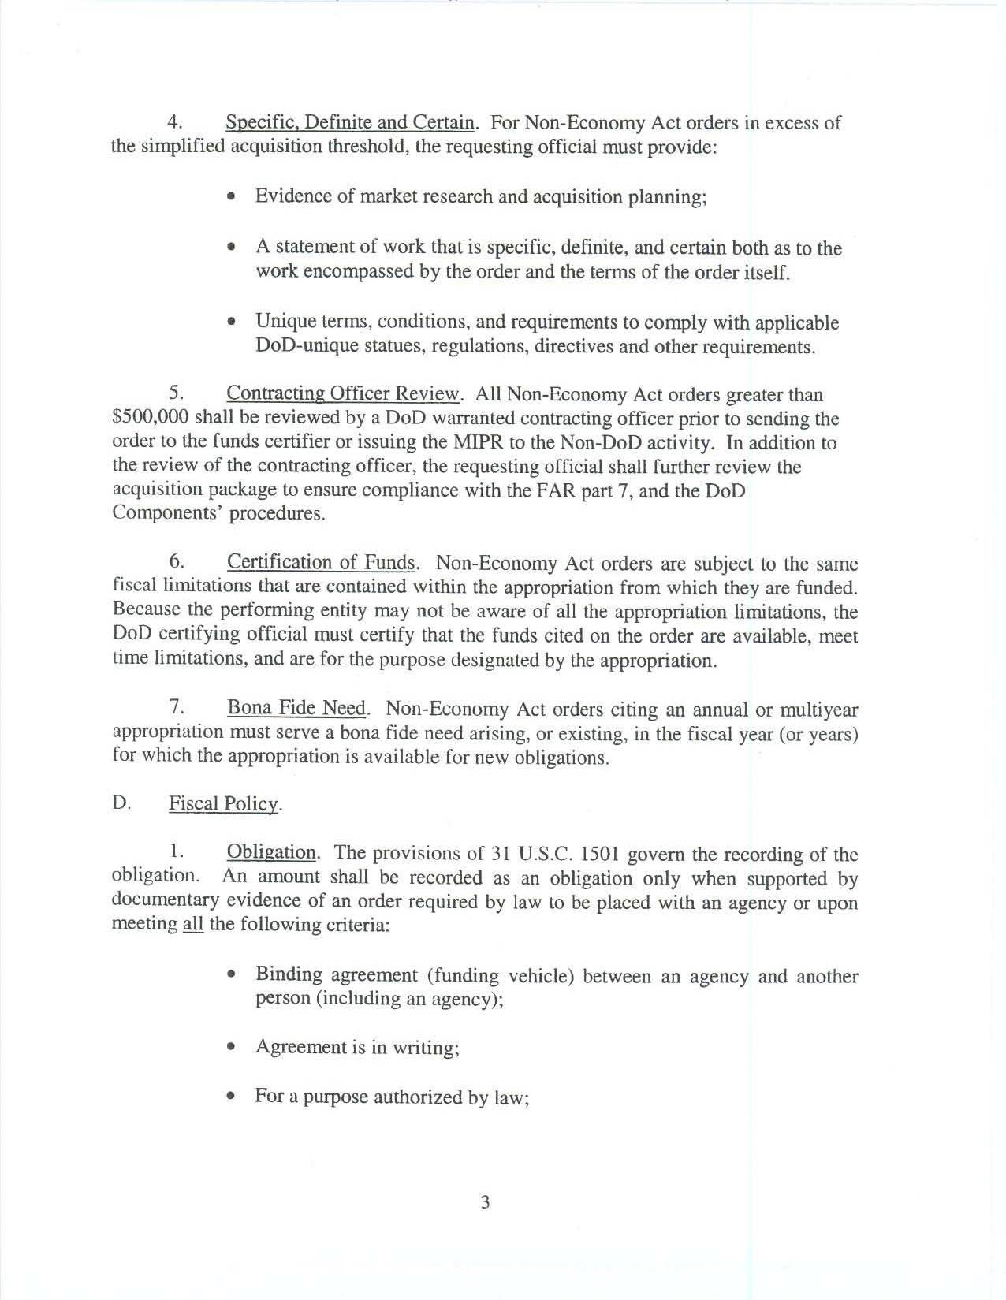
• The requesting agency or unit determines the order is in the best interest of the Department; and
• The performing agency is able and authorized to provide the ordered goods or services.

2. Order. Non-Economy Act orders for work and services outside the Department
Of Defense (DoD) should he executed by issuance of a DD Form 448, "Military
Interdepartmental Purchase Request (MIPRY' and accepted using DD Form 448-2.
'Acceptance of MIPR." If an alternative execution document is used, it must provide
information consistent with the MIPR to include the purchase request number and the
Activity Address Code (DODAAC). A Non-Economy Act order shall comply with the
documentation standards in Volume I IA. Chapter 1 of the "DoDFMR." and supported
with the items identified in Figure 1. Non-Economy Act orders must include:

• A firm, clear, specific, and complete description of the goods or services ordered. The use of generic descriptions is not acceptable;
• Specific performance or delivery requirements;
• A proper fund citation;
• Payment terms and conditions (e.g., direct cite or reimbursement, and provisions of advanced payments); and
• Specific Non-Economy Act statutory authority such as those referenced in paragraph B above.
• DoD Activity Address Code (DODAAC)

3. Best Interest Determination Each requirement must be evaluated in
accordance with DoD Components' procedures to ensure that Non-Economy Act orders
are in the best interest of DoD. Factors to consider include:

• Satisfying the requirements;
• Schedule, performance, and delivery requirements;
• Cost effectiveness, taking into account the discounts and fees; and
• Contract administration, to include oversight.
Page 2
4. Specific Definite and Certain For Non-Economy Act orders in excess of
the simplified acquisition threshold, the requesting official must provide:
• Evidence of market research and acquisition planning:
• A statement of work that is specific, definite, and certain both as to the work encompassed by the order and the terms of the order itself.
• Unique terms, conditions, and requirements to comply with applicable DoD-unique statues, regulations, directives and other requirements.

5. Contracting Officer Review. All Non-Economy Act orders greater than
$500,000 shall be reviewed by a DoD warranted contracting officer prior to sending the
order to the funds certifier or issuing the MIPR to the Non-DoD activity. In addition to
the review of the contracting officer, the requesting official shall further review the
Acquisition package to ensure compliance with the FAR part 7, and the DoD
Components' procedures.

6. Certification of Funds Non-Economy Act orders are subject to the same
fiscal limitations that are contained within the appropriation from which they are funded.
Because the performing entity may not he aware of all the appropriation limitations, the
DoD certifying official must certify that the funds cited on the order are available, meet
time limitations, and are for the purpose designated by the appropriation.

7. Bona Fide Need Non-Economy Act orders citing an annual or multiyear
appropriation must serve a bona fide need arising, or existing, in the fiscal year (or years)
For which the appropriation is available for new obligations.

D. Fiscal Policy.

1. Obligation The provisions of 31 U.S.C. 1501 govern the recording of the
Obligation. An amount shall be recorded as an obligation only when supported by
documentary evidence of an order required by law to be placed with an agency or upon
meeting all the following criteria:

• Binding agreement (funding vehicle) between an agency and another person (including an agency):
• Agreement is in writing;
• For a purpose authorized by law:
Page 3
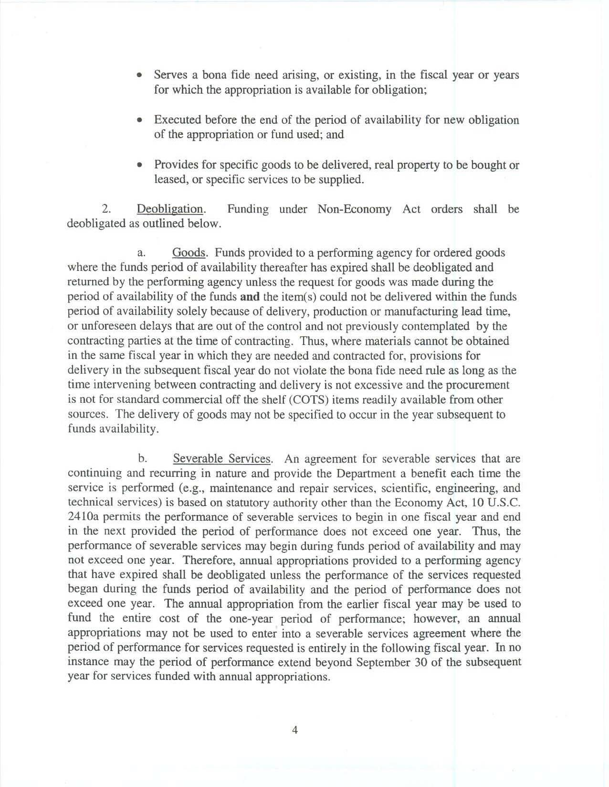
• Serves a bona fide need arising, or existing, in the fiscal year or years
for which the appropriation is available for obligation;
• Executed before the end of the period of availability for new obligation
of the appropriation or fund used: and
• Provides for specific goods to be delivered, real property to be bought or
leased, or specific services to be supplied.

2. Deobligation. Funding under Non-Economy Act orders shall be
deobligated as outlined below.

a. Goods Funds provided to a performing agency for ordered goods
where the funds period of availability thereafter has expired shall be deobligated and
returned by the performing agency unless the request for goods was made during the
period of availability of the funds and the item(s) could not be delivered within the funds
period of availability solely because of delivery, production or manufacturing lead time,
or unforeseen delays that are out of the control and not previously contemplated by the
contracting parties at the time of contracting. Thus, where materials cannot be obtained
in the same fiscal year in which they are needed and contracted for, provisions for
delivery in the subsequent fiscal year do not violate the bona fide need rule as long as the
time intervening between contracting and delivery is not excessive and the procurement
is not for standard commercial off the shelf (COTS) items readily available from other
sources. The delivery of goods may not he specified to occur in the year subsequent to
Funds availability.
b. Severable Services An agreement for severable services that are
continuing and recurring in nature and provide the Department a benefit each time the
'service is performed (e.g., maintenance and repair services, scientific, engineering, and
technical services) is based on statutory authority other than the Economy Act. 10 U.S.C.
2410a permits the performance of severable services to begin in one fiscal year and end
in the next provided the period of performance does not exceed one year. Thus, the
performance of severable services may begin during funds period of availability and may
not exceed one year. Therefore, annual appropriations provided to a performing agency
that have expired shall be deobligated unless the performance of the services requested
began during the funds period of availability and the period of performance does not
exceed one year. The annual appropriation from the earlier fiscal year may be used to
fund the entire cost of the one-year period of performance; however, an annual
appropriations may not be used to enter into a severable services agreement where the
period of performance for services requested is entirely in the following fiscal year. In no
instance may the period of performance extend beyond September 30 of the subsequent
year for services funded with annual appropriations.
Page 4
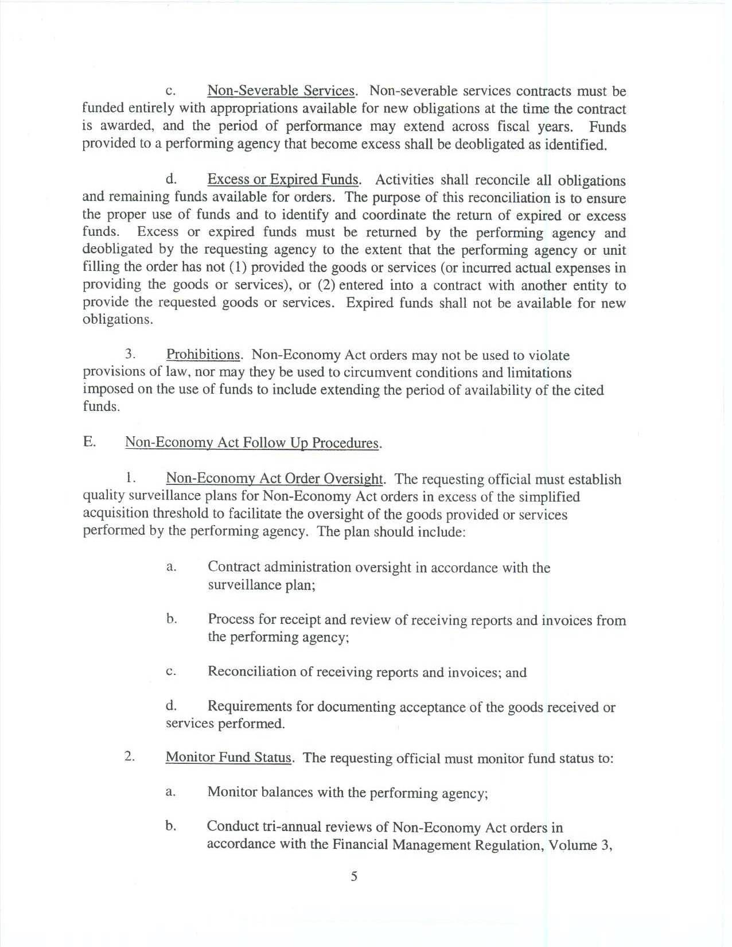
c. Non-Severable Services Non-severable services contracts must be funded entirely with appropriations available for new obligations at the time the contract is awarded, and the period of performance may extend across fiscal years. Funds provided to a performing agency that become excess shall be deobligated as identified.
d. Excess or Expired Funds Activities shall reconcile all obligations and remaining funds available for orders. The purpose of this reconciliation is to ensure the proper use of funds and to identify and coordinate the return of expired or excess funds. Excess or expired funds must he returned by the performing agency and deobligated by the requesting agency to the extent that the performing agency or unit filling the order has not (1) provided the goods or services (or incurred actual expenses in providing the goods or services), or (2) entered into a contract with another entity to provide the requested goods or services. Expired funds shall not be available for new obligations.

3. Prohibitions Non-Economy Act orders may not be used to violate provisions of law, nor may they be used to circumvent conditions and limitations imposed on the use of funds to include extending the period of availability of the cited funds.

E. Non-Economy Act Follow Up Procedures

I. Non-Economy Act Order Oversight The requesting official must establish quality surveillance plans for Non-Economy Act orders in excess of the simplified acquisition threshold to facilitate the oversight of the goods provided or services performed by the performing agency. The plan should include:
a. Contract administration oversight in accordance with the surveillance plan;
b. Process for receipt and review of receiving reports and invoices from the performing agency:
c. Reconciliation of receiving reports and invoices; and
d. Requirements for documenting acceptance of the goods received or services performed.

2. Monitor Fund Status The requesting official must monitor fund status to:
a. Monitor balances with the performing agency:
b. Conduct tri-annual reviews of Non-Economy Act orders in accordance with the Financial Management Regulation, Volume 3.
Page 5

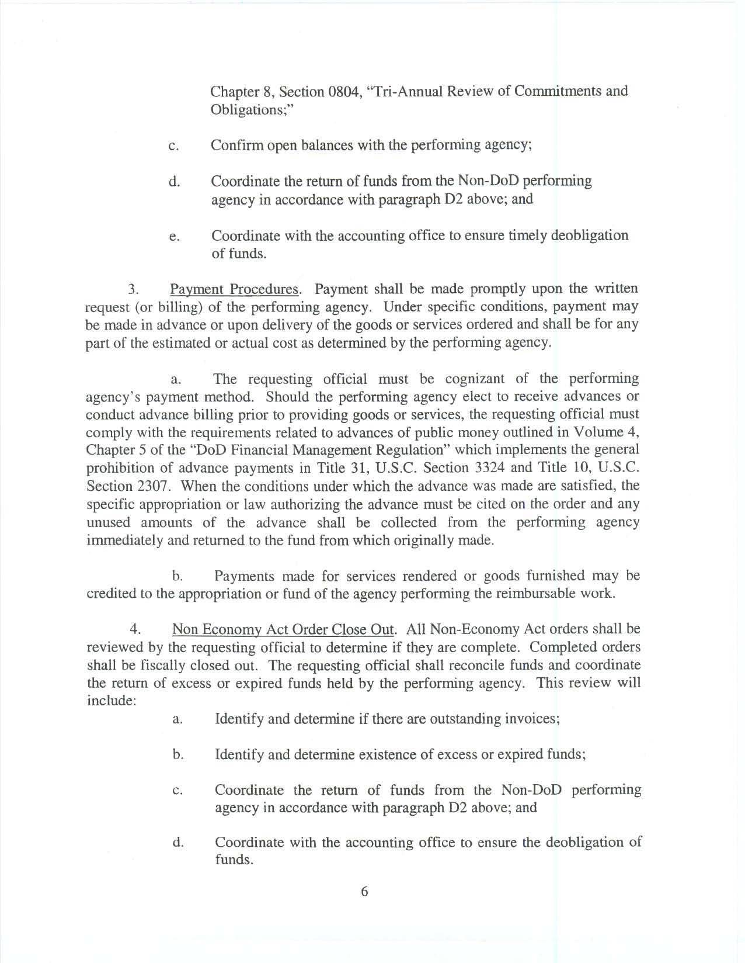
Chapter 8. Section 0804, "Tri-Annual Review of Commitments and Obligations;"
c. Confirm open balances with the performing agency;
d. Coordinate the return of funds from the Non DoD performing agency in accordance with paragraph D2 above; and
e. Coordinate with the accounting office to ensure timely deobligation of funds.

3. Payment Procedures Payment shall be made promptly upon the written request (or billing) of the performing agency. Under specific conditions, payment may he made in advance or upon delivery of the goods or services ordered and shall be for any part of the estimated or actual cost as determined by the performing agency.
a. The requesting official must be cognizant of the performing agency's payment method. Should the performing agency elect to receive advances or conduct advance billing prior to providing goods or services, the requesting official must comply with the requirements related to advances of public money outlined in Volume 4, Chapter 5 of the "DoD Financial Management Regulation" which implements the general prohibition of advance payments in Title 31, U.S.C. Section 3324 and Title 10, U.S.C. Section 2307. When the conditions under which the advance was made are satisfied, the specific appropriation or law authorizing the advance must be cited on the order and any unused amounts of the advance shall be collected from the performing agency immediately and returned to the fund from which originally made.
b. Payments made for services rendered or goods furnished may be credited to the appropriation or fund of the agency performing the reimbursable work.

4. Non Economy Act Order Close Out All Non Economy Act orders shall be reviewed by the requesting official to determine if they are complete. Completed orders shall be fiscally closed out. The requesting official shall reconcile funds and coordinate the return of excess or expired funds held by the performing agency. This review will include:
a. Identify and determine if there are outstanding invoices;
b. Identify and determine existence of excess or expired funds;
c. Coordinate the return of funds from the Non DoD performing agency in accordance with paragraph D2 above; and
d. Coordinate with the accounting office to ensure the deobligation of funds.
Page 6

